**TeamCompetishun** Product Management Intern -Assignment

**Name**: MERAVATH PAVAN KUMAR-**IIITDM JABALPUR**

**Roll No**: 20BCS130

* **INTRODUCTION**
* Competishun aims to elevate the user experience and boost engagement by introducing a new community feature, inspired by Reddit. This feature is designed to create a dynamic and interactive space where users can come together to discuss various competitions, share valuable tips, and engage in meaningful interactions.
* The Reddit-like community feature will provide Competishun users with a platform to connect, communicate, and collaborate with others who share similar interests and passions for competitions. By fostering this sense of community, Competishun can create a more vibrant and engaged user base.
* In this project, we will outline the key functionalities and components of the community feature, highlight strategies to encourage user participation and moderation, and discuss potential challenges along with our proposed solutions. This project aims to take Competishun to the next level of user engagement and community-building.

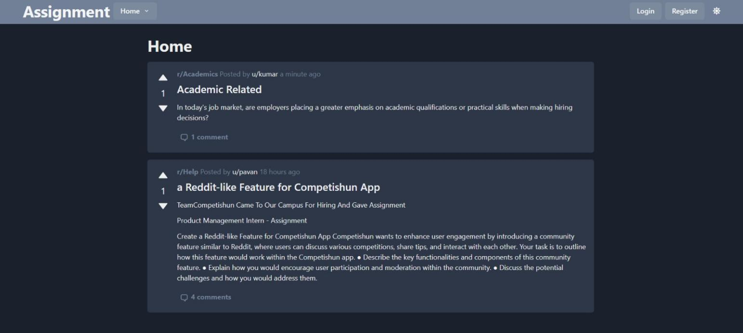

* **KEY FEATURES**
  + User Registration
* **Description**: The Reddit-like feature in the Competishun app requires users to register before they can actively participate. The registration process entails providing an email and a password, ensuring user authenticity.
* **Purpose**: Registration enables user identification, personalization, and the ability to post, comment, and interact within the community.

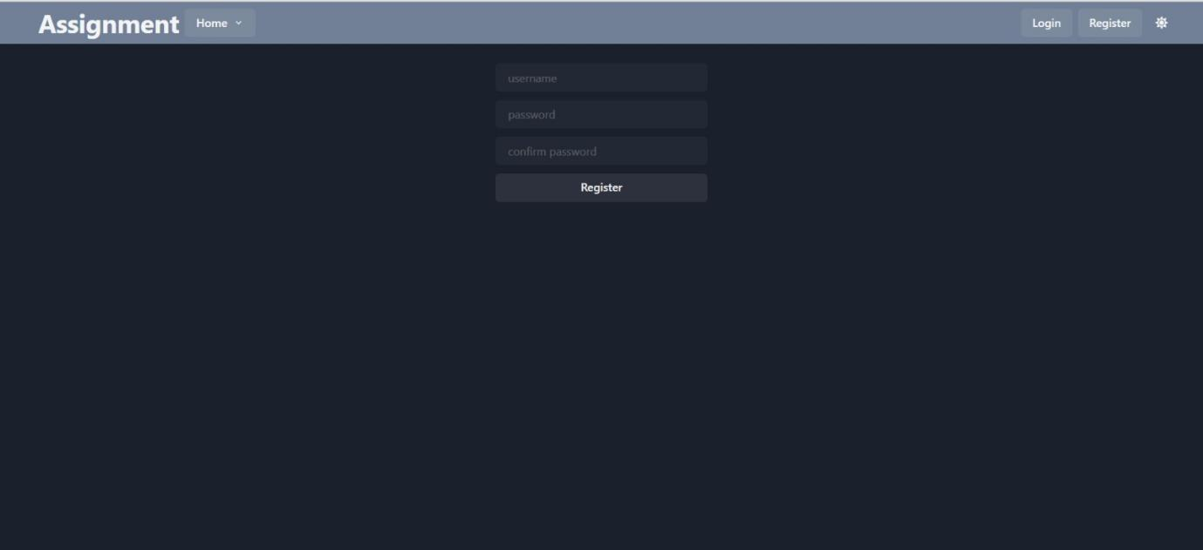**REGISTRATION INTERFACE**

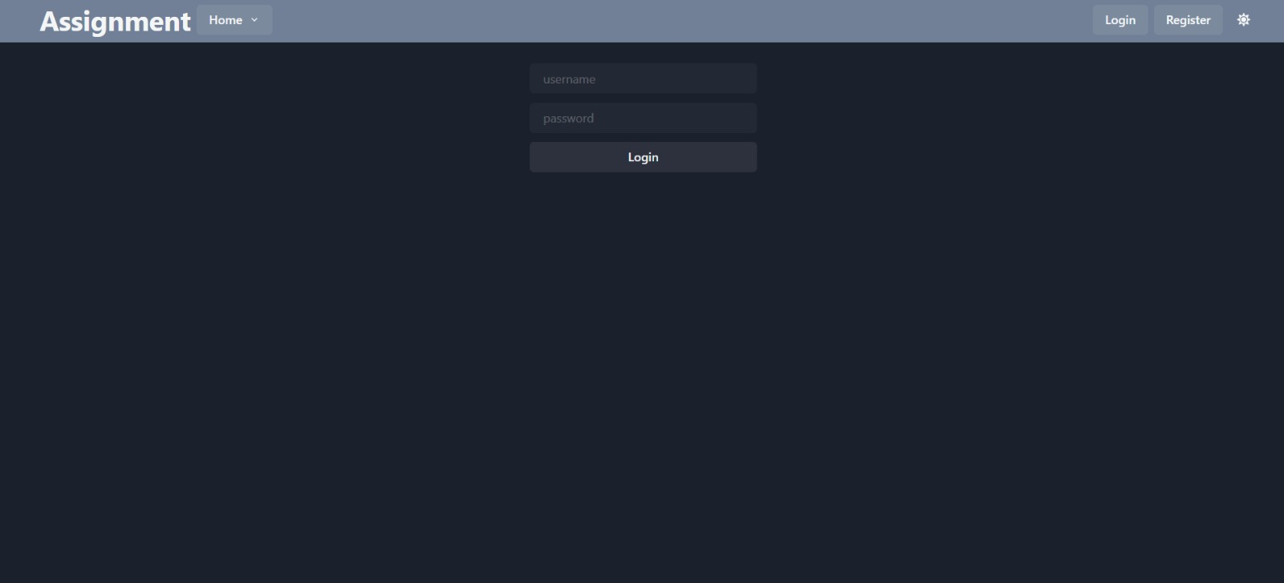**LOGIN INTERFACE**

* Post Creation:
* **Description**: Registered users can create posts within the community. Posts can be related to various competition topics, and users can provide detailed content for discussion.
* 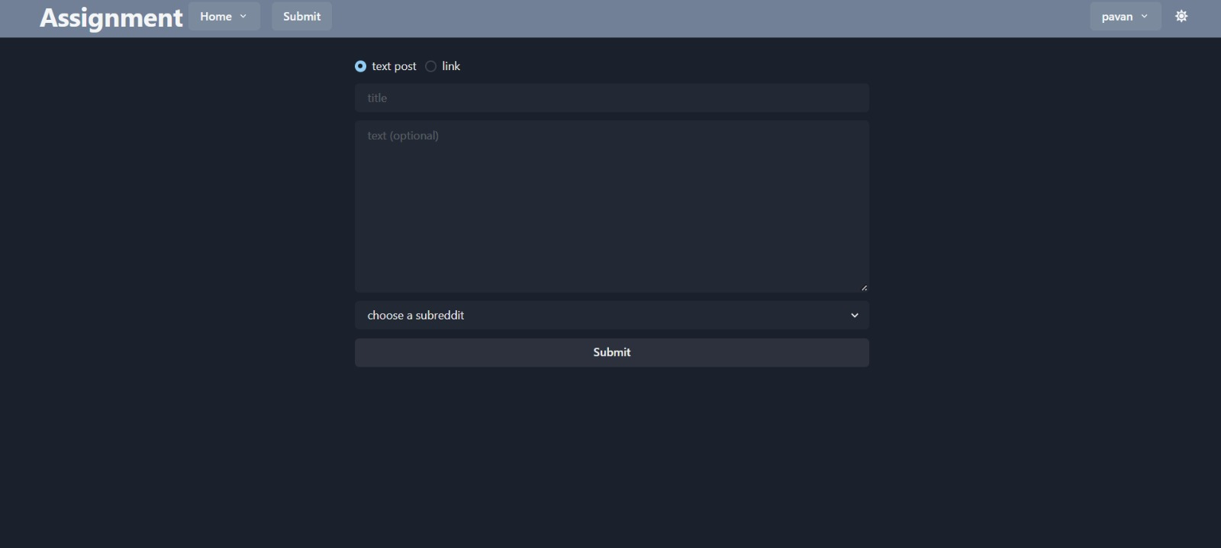**Purpose**: Post creation allows users to initiate discussions, seek advice, and share experiences with the community.
* Commenting System:
* **Description**: Users can comment on posts and replies to engage in conversations. These comments are visible to the original poster and other users. Each comment displays the author's name and the posting time.
* 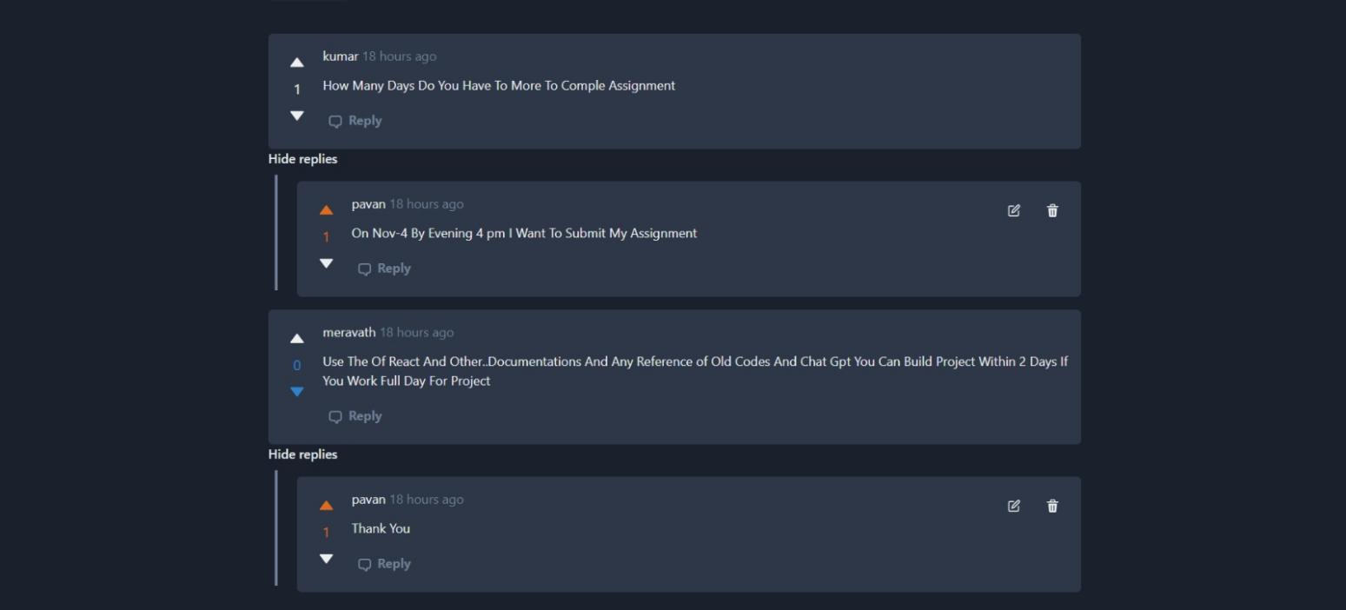**Purpose**: The commenting system facilitates conversations, feedback, and discussions among community members.

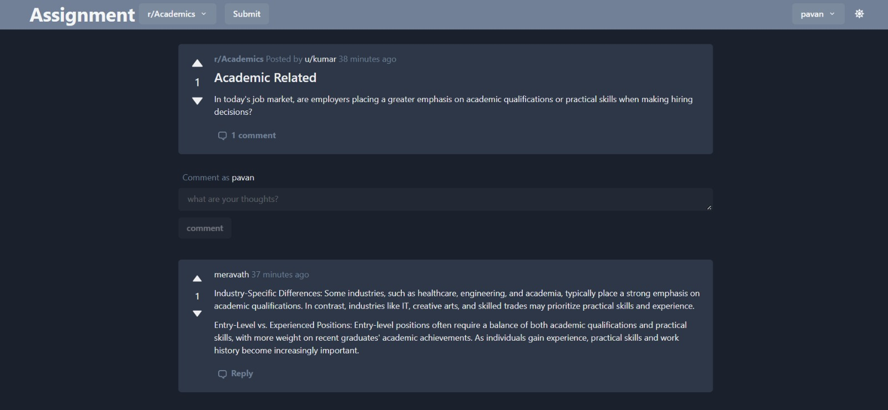

* Edit and Delete Posts/Comments:
* **Description**: Original posters have the privilege to edit and delete their posts or comments. This capability ensures content control and correction.
* **Purpose**: Editing and deletion options empower users to manage their contributions and maintain content quality.

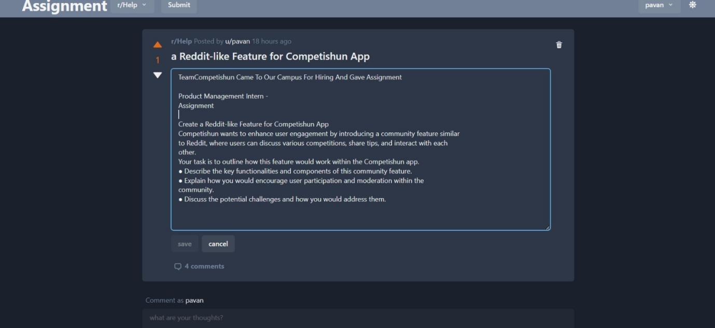**EDIT POST**

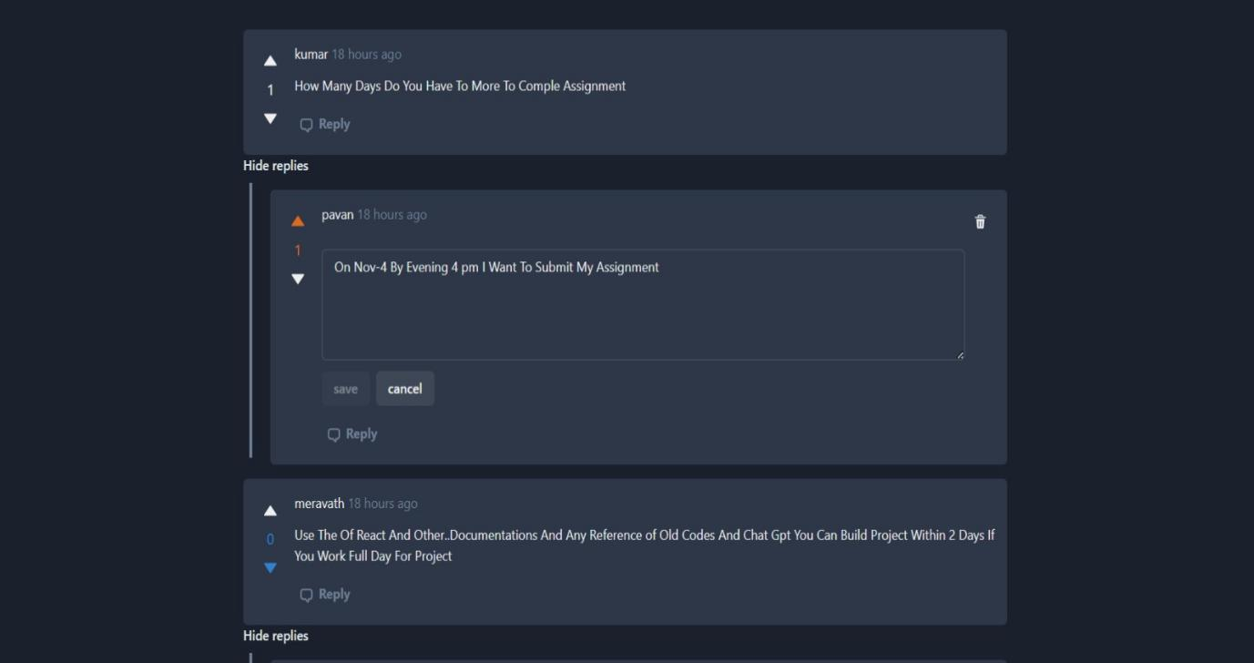**EDIT COMMENT**

* Up/Down voting System:
* **Description**: Registered users have the option to up/down vote comments they find valuable or agree with. Upvoting influences the ranking of comments, ensuring that the most upvoted comments appear at the top.
* **Purpose**: The upvoting system highlights the most relevant and appreciated comments, making them more visible and encouraging quality contributions.

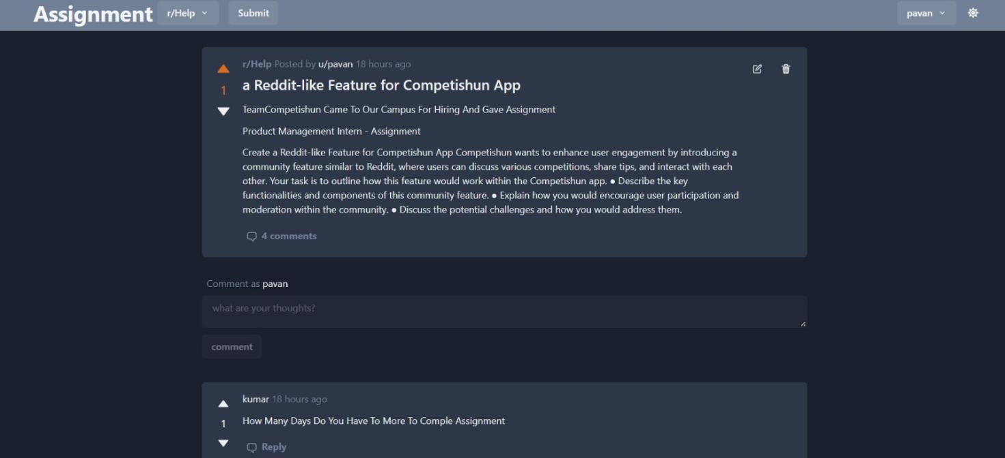

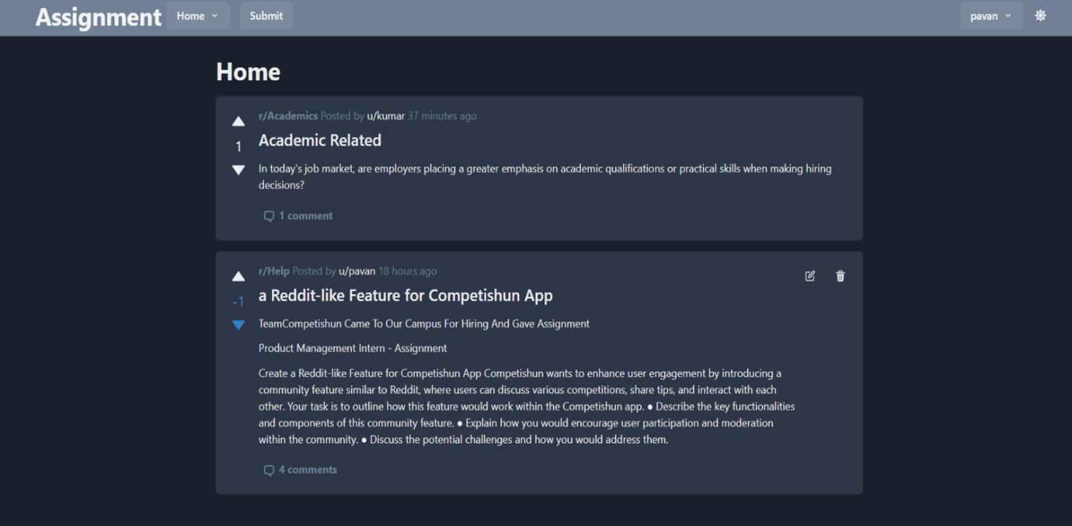

* Subreddit Categories:
* **Description**: Users can categorize their posts into different subreddits, such as politics, entertainment, and more. This categorization simplifies content discovery by allowing users to filter posts by topic.
* 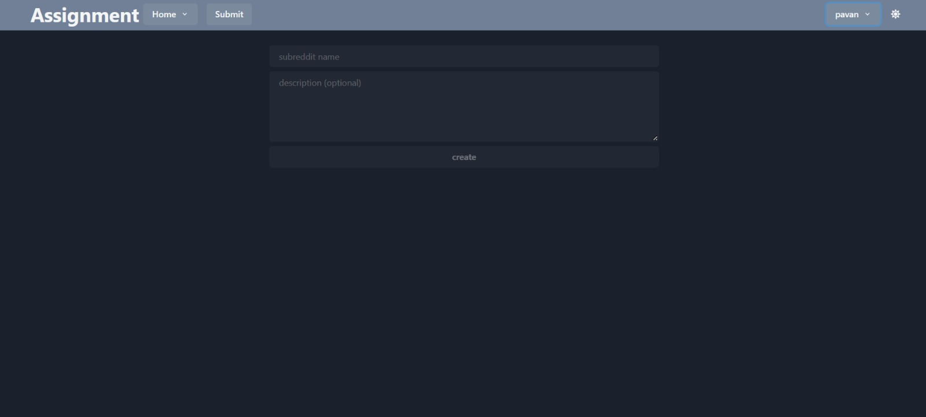**Purpose**: Subreddit categories streamline content organization and help users find posts that match their interests.

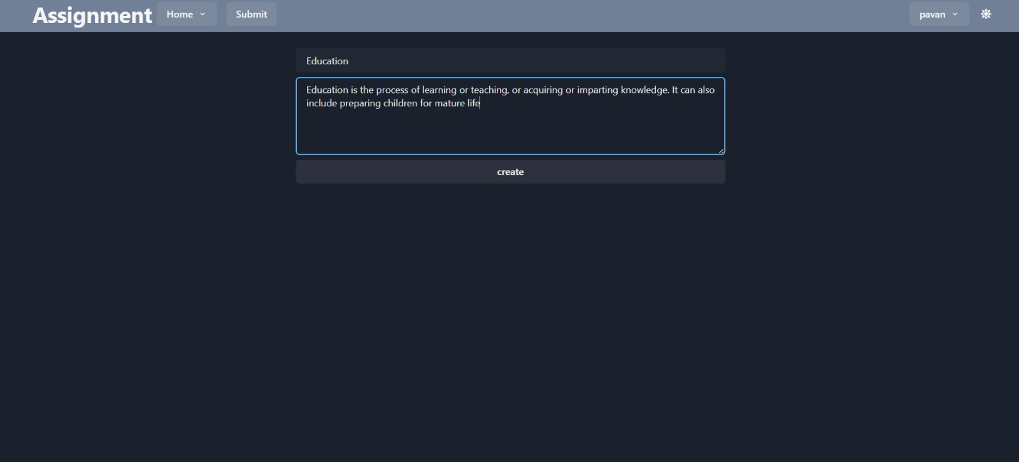

* **TECHNOLOGIES USED**
* **FRONTEND TECHNOLOGIES:** HTML, CSS, JAVASCRIPT, REACTJS
* **BACKEND TECHNOLOGIES:** NODEJS, EXPRESSJS
* **DATABASE:** POSTGRESQL







* **CONTACT INFORMATION**

**NAME: MERAVATH PAVAN KUMAR**

**PHONE: 7981561617**

**EMAIL: [20bcs130@iiitdmj.ac.in](mailto:20bcs130@iiitdmj.ac.in)**

**[RESUME](https://drive.google.com/file/d/1uoIpZ99vMDcYwQZ-K9lJPbfXstkxZQDa/view?usp=drive_link)**

**[Git_Hub_Link](https://github.com/pavankumar130/Reddit-like)**