M.Pavan kumar 192312142
Nanoelectronics ECA3101

Exp. 1. Simulation of scattering and absorption of Multi-layer Sphere and Core-Shell Nanoparticle using Mie-Plot tool.
Aim:
To simulate and analyze the scattering, absorption, and extinction characteristics of multi-layerspheres and core–shell nanoparticles using the Mie-Plot tool.

Case study 1:Scattering and absorption Spectra for a single-layer sphere(core only).
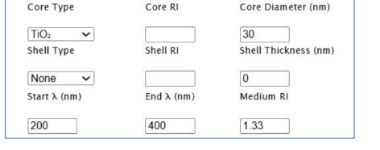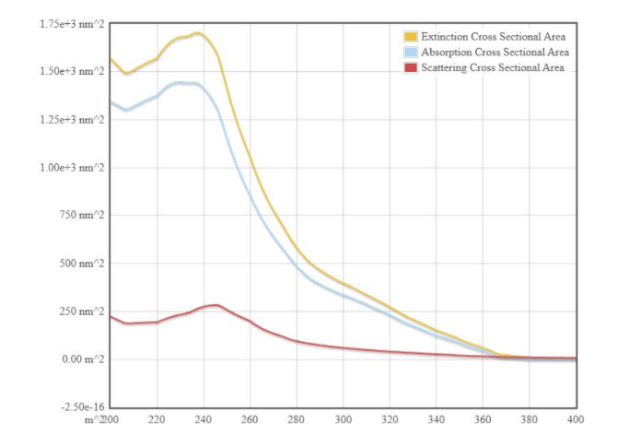
Impact of Figure:
- Demonstrates the basic interaction of light with a homogeneous spherical nanoparticle.
- Shows that scattering increases with particle size and wavelength-dependent resonance.
- Serves as the baseline for comparing more complex nanoparticle structures.

Case study 2: Simulate the optical response of a gold(Au) nanoparticle of 50 nm diameter in water medium.
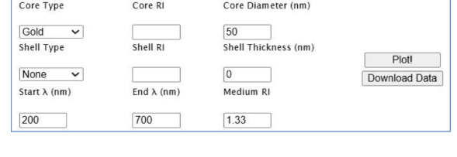
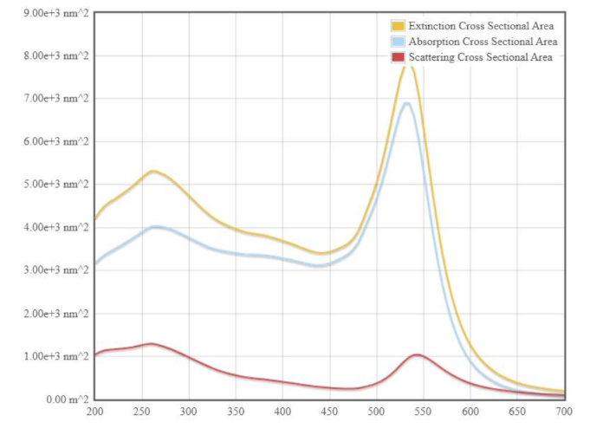

Impact of Figure:
- Illustrates how the addition of a shell modifies the optical response.
- Shows enhanced absorption and shifted scattering peaks due to the core-shell interface.
- Confirms that shell thickness and material composition influence light propagation.

Case Study 3: Simulate a core–shell nanoparticle with a gold core (30 nm) and silicashell(10nm). 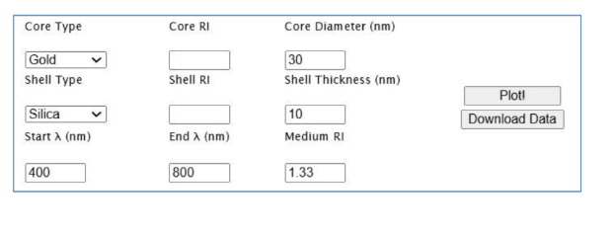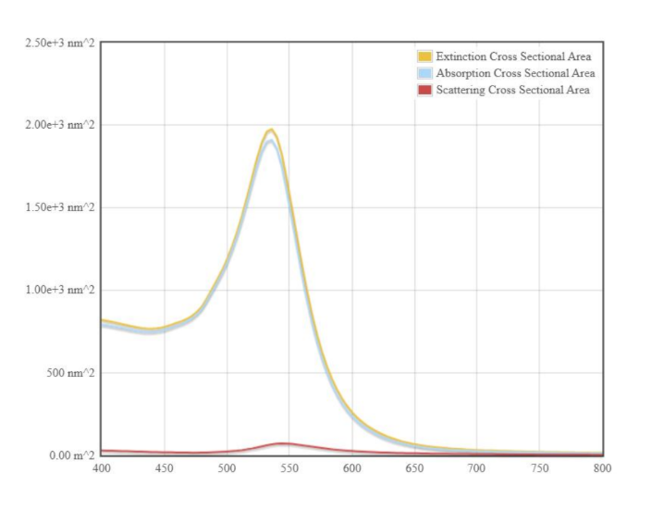
Impact of Figure:
- Displays multiple resonance peaks produced by the layered structure.
- Demonstrates improved control over scattering and absorption characteristics.
- Indicates stronger light confinement and enhanced optical tunability.

Conclusion
The MiePlot simulation successfully demonstrates that the scattering and absorption properties of nanoparticles strongly depend on their structural design. Compared to a single-layer sphere, core-shell and multi-layer nanoparticles exhibit enhanced and tunable optical responses due to their layered composition.
Exp. 8. Simulation of VI Characteristics of FINFET, CNTFET and GFET using NanoHub.
Aim:
To Obtain the VI Characteristics of FinFET by varying the Gate Channel length andoxidethickness

- FINFET
Case Study 1: Simulate & obtain the current spectrum characteristics for the last bias point of FinFET. Analyze the performance for different Oxide layer thicknesses
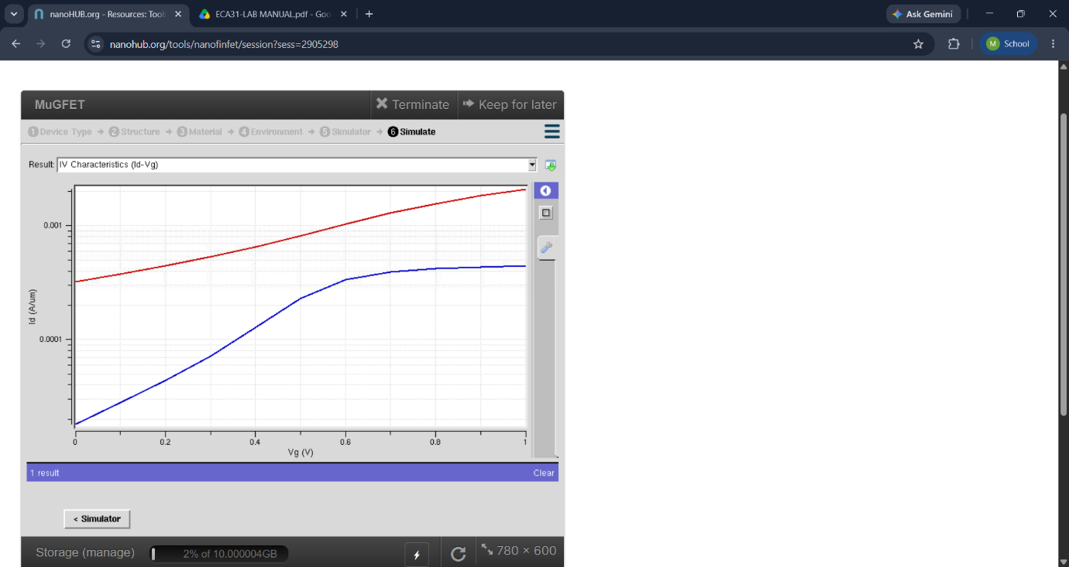
Impact/Inference of the figure:
- As increases, the drain current increases.
- At low , FINFET operates mainly in the linear region.
- As increases, the device enters the saturation region, where the drain current changes more slowly.
- The figure demonstrates the excellent gate control of FINFET.
- The multi-gate structure helps reduce short-channel effects and leakage current.

Case Study 2: Simulate & obtain the electron density per sheet characteristics of FinFET.
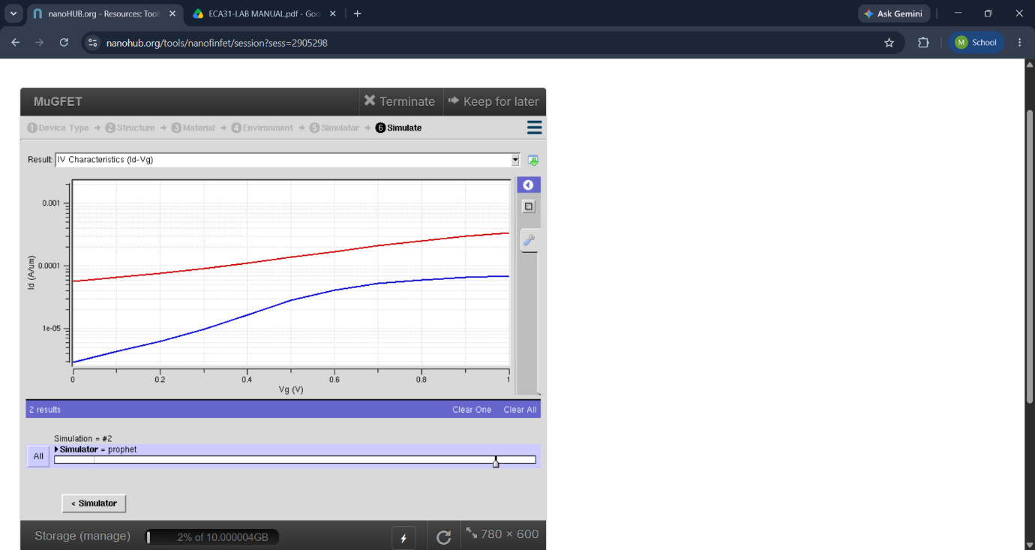
Impact of Figure:
- Demonstrates excellent gate control over the channel current.
- Shows low leakage current and high ON/OFF current ratio.
- Indicates improved switching performance compared to conventional MOSFETs.
- Confirms FINFET's suitability for low-power and high-performance integrated circuits.

Aim:
To obtain the density of states and conductance of CNTFET by varying the diameter andlength.

b) CNTFET
Case study 1: Simulate & Obtain the VI characteristics of CNT-FET by varying Schottky barrier and oxide thickness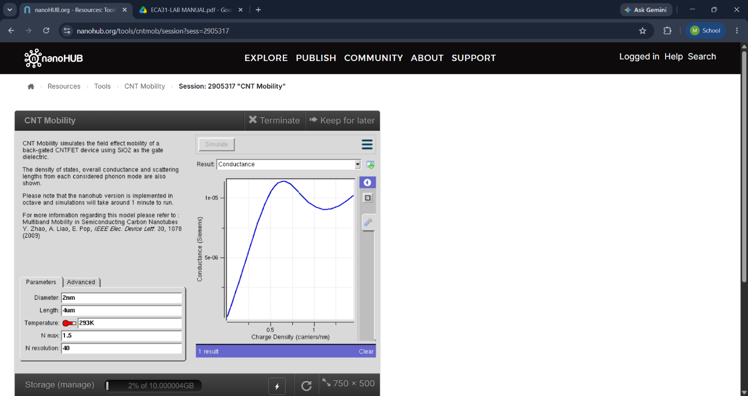
Impact/Inference of the figure:
- As increases, the drain current increases.
- At low , the CNTFET operates in the linear region.
- With increasing , the device approaches the saturation region.
- CNTFET provides high carrier mobility because carbon nanotubes act as the conducting channel.
- It can achieve high current drive with low power consumption.

Case study 2: Simulate & Obtain the VI characteristics of CNT-FET by varying CNT
diameter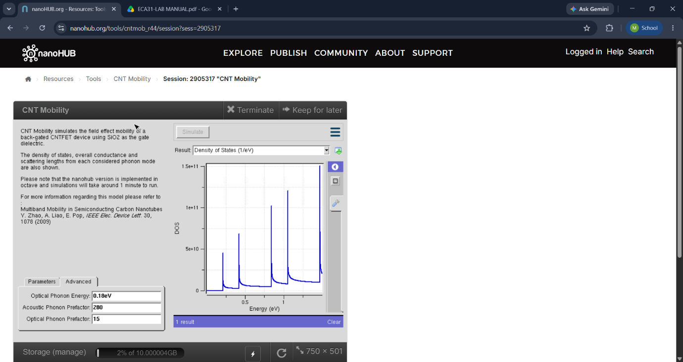
Impact of Figure:
- Shows higher drive current due to the excellent electrical conductivity of carbon nanotubes.
- Demonstrates near-ballistic electron transport, resulting in faster switching.
- Indicates reduced power consumption and improved carrier mobility.
- Highlights CNTFET as a promising device for next-generation nanoelectronics.

Aim:
To simulate the Voltage-Current (VI) characteristics of a Graphene FieldEffect Transistor (GFET) using appropriate simulation tools, analyze its performance undervarying gate voltages and drain-source voltages, and understand its behavior as a high- mobility semiconductor device.

(c) GFET
Case Study 1:How does varying the gate voltage (Vgs) affect the drain current (Ids) in aGFET?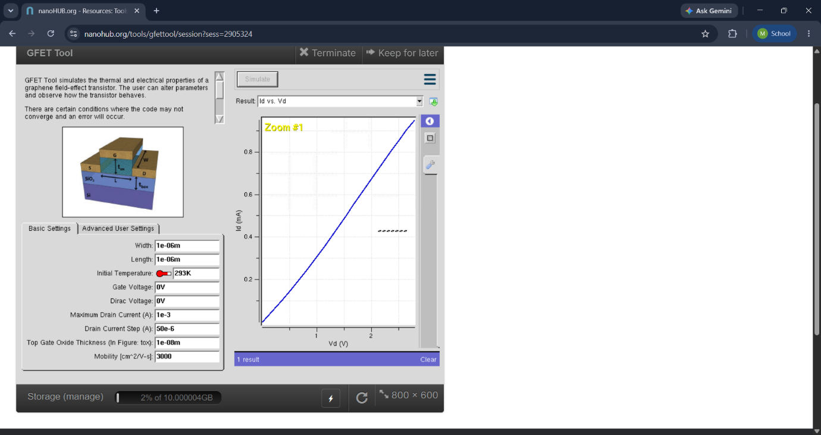
Figure 1: GFET – Characteristics
The first figure shows the variation of drain current with drain-to-source voltage for different gate voltages.
- As increases, the drain current changes accordingly.
- Increasing gate voltage changes the carrier concentration in the graphene channel.
- The figure demonstrates the good electrical conductivity and carrier transport of graphene.
- GFET can operate at high speed because graphene has very high carrier mobility.
Case Study 2: What factors determine the maximum drain current (Ids,max ) in a Graphene Field Effect Transistor (GFET)?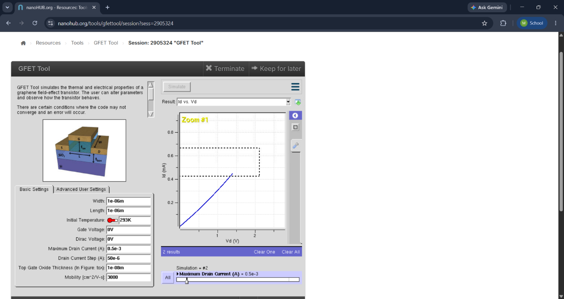
Figure 2: GFET Transfer Characteristics
The second figure represents the variation of drain current with gate-to-source voltage .
- The drain current varies significantly with gate voltage.
- The minimum-current point is associated with the charge-neutrality (Dirac) point of graphene.
- Current can increase on either side of the Dirac point because graphene supports both electron and hole conduction.
- The characteristic demonstrates the ambipolar behavior of GFET.

Case Study 3: To investigate how the mobility of charge carriers in a Graphene Field- Effect Transistor (GFET) with a mobility of 2000 cm2/V·s influences its current-voltage (VI)
characteristics.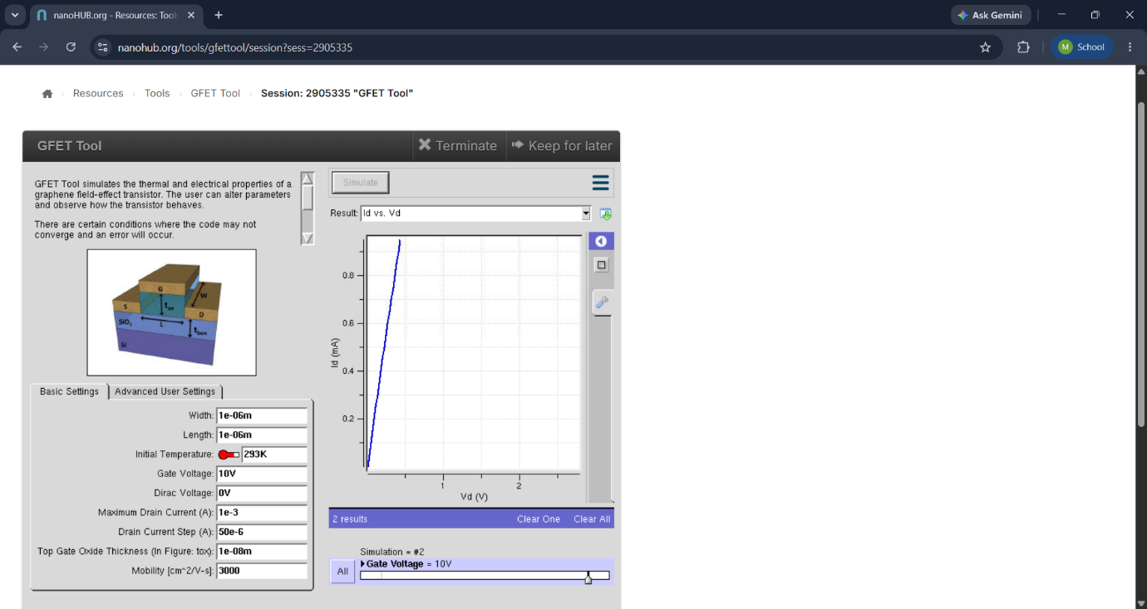
Impact of Figure:
- Illustrates extremely high carrier mobility and rapid current response.
- Shows linear current variation at low bias voltages because of graphene's unique electronic properties.
- Demonstrates excellent high-frequency performance.
- Indicates the potential of GFETs for RF, analog, and high-speed communication applications.

Conclusion
The NanoHub simulation successfully demonstrates the V-I characteristics of FINFET, CNTFET, and GFET. The results show that FINFET provides excellent gate control with low leakage current, CNTFET delivers high drive current and fast switching due to its superior carrier transport, and GFET exhibits very high carrier mobility suitable for high-frequency applications.

Exp. 9. Simulation of Tunneling Magnetoresistance (TMR) by Varying Barrier Heightusing NanoHUB.
Aim: To obtain the Tunnelling Magnetoresistance (TMR) by varying barrier height. Software: NanoHub Online Tube

Case Study 1: Characteristics of TMR with barrier height of 0.85eV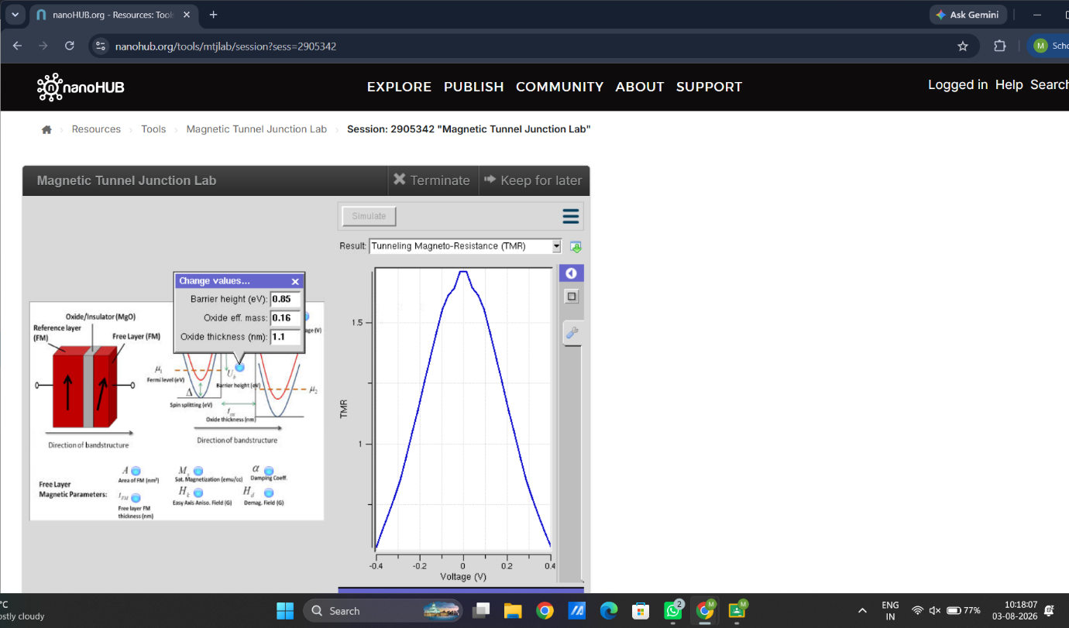
Impact of Figure:
- Shows how the TMR ratio changes as the barrier height is varied.
- Demonstrates that increasing the barrier height significantly influences tunneling probability.
- Indicates that barrier height is a key parameter in controlling magnetoresistance performance.

Case Study 2: Characteristics of TMR with barrier height of 1.0eV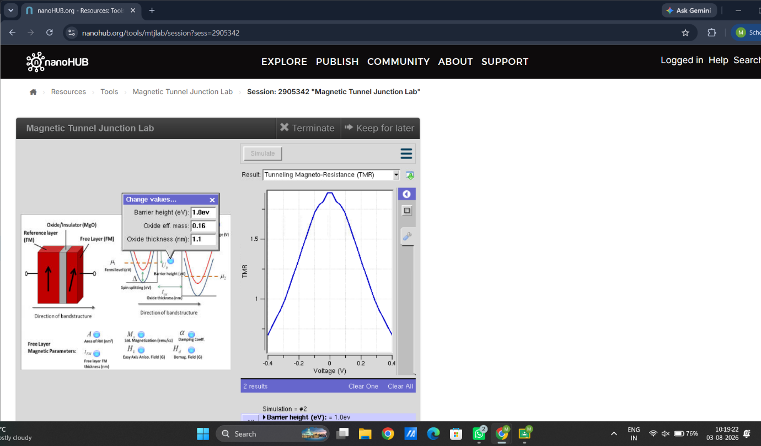
Impact of Figure:
- Illustrates the nonlinear relationship between current and applied voltage.
- Shows that tunneling current decreases as the barrier height increases.
- Confirms the quantum tunneling behavior of electrons through the insulating barrier.

Conclusion
The NanoHub simulation successfully demonstrates the effect of barrier height on Tunneling Magnetoresistance (TMR) in a magnetic tunnel junction. The results show that barrier height significantly influences the tunneling current and the TMR ratio by controlling the probability of electron tunneling. Higher barrier heights reduce tunneling current while affecting the resistance difference between parallel and antiparallel magnetic states.

