M.Pavan kumar 192312142
Nanoelectronics ECA3101
Exp. 5. Band Structure Simulation for Graphene and CNTs using NanoHub.
Aim:
To simulate the band structure of nanowire for various materials.

Case Study 1: Simulate the band-structure of InAs circular nanowire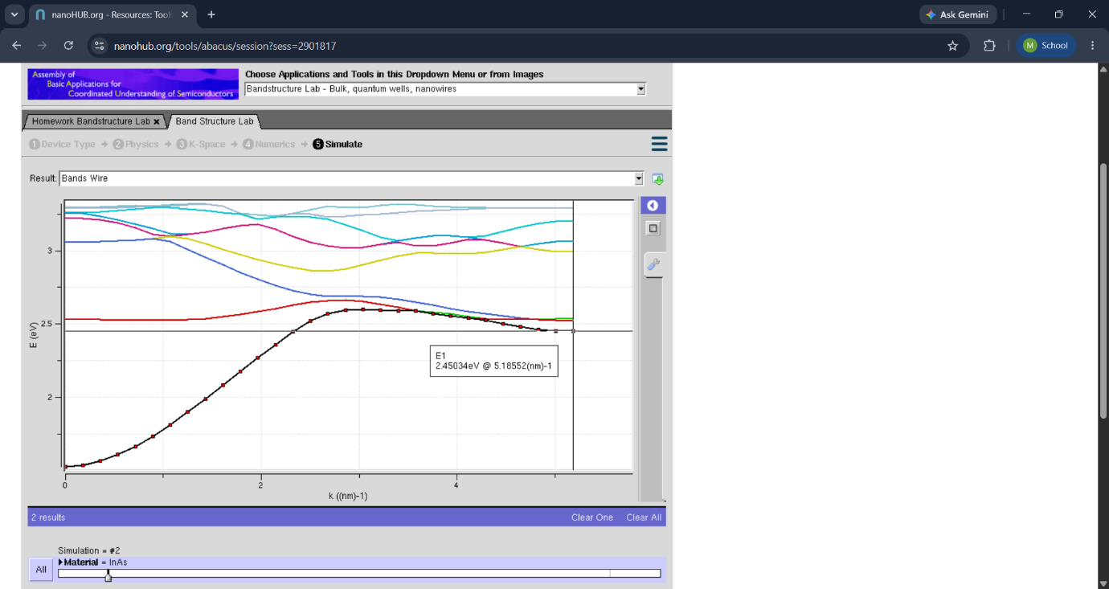
Impact of Figure:
- Illustrates the two-dimensional honeycomb arrangement of carbon atoms.
- Demonstrates the basic atomic structure responsible for graphene's unique electronic properties.
- Provides the foundation for understanding graphene's band structure.

Case Study 2: Simulate the band-structure of AlGaAs circular nanowire

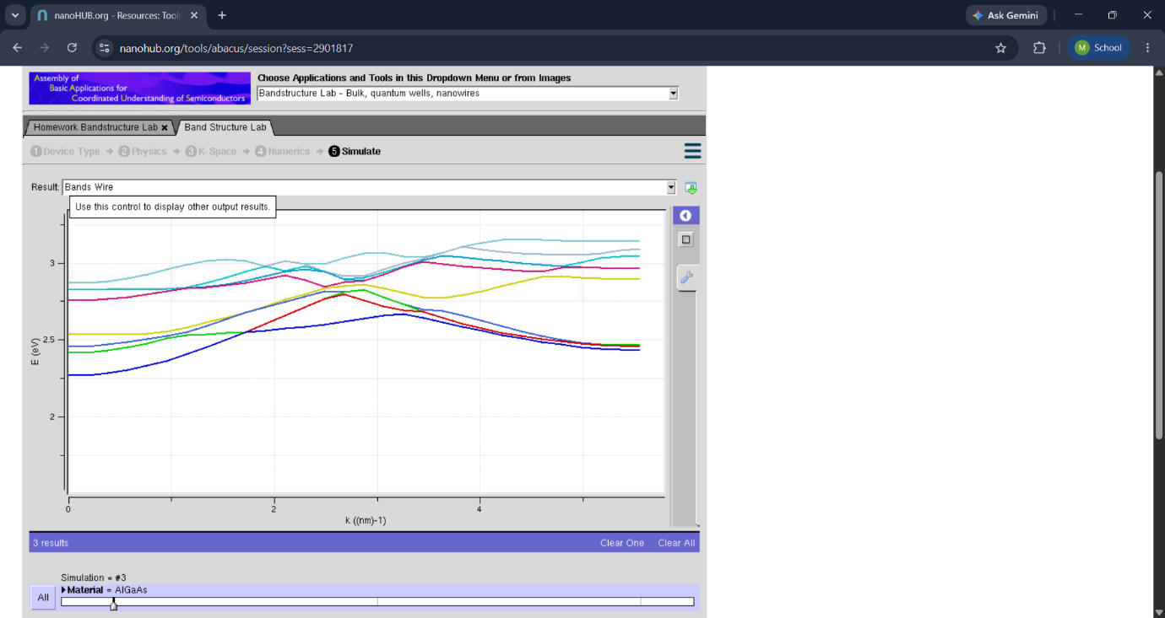
Impact of Figure:
- Illustrates the cylindrical structure formed by rolling a graphene sheet.
- Demonstrates how chirality and diameter influence the electronic properties of CNTs.
- Provides the structural basis for CNT band structure analysis.

Conclusion
The NanoHub simulation successfully demonstrates the band structures of graphene and carbon nanotubes (CNTs) and their unique electronic properties. The results show that graphene exhibits a zero band gap with linear energy dispersion at the Dirac point, resulting in exceptionally high electron mobility, while CNTs can behave as either metallic or semiconducting materials depending on their chirality and diameter.

Exp-6 Demonstration of quantum tunnelling.
Aim
To demonstrate the phenomenon of quantum tunneling using simulation and study how particles tunnel through a potential barrier by analyzing the effects of barrier height, barrier width, and particle energy on the tunneling probability.
Case study 1 : Analysis the transmission co-efficient Vs Energy characteristics on refined grid
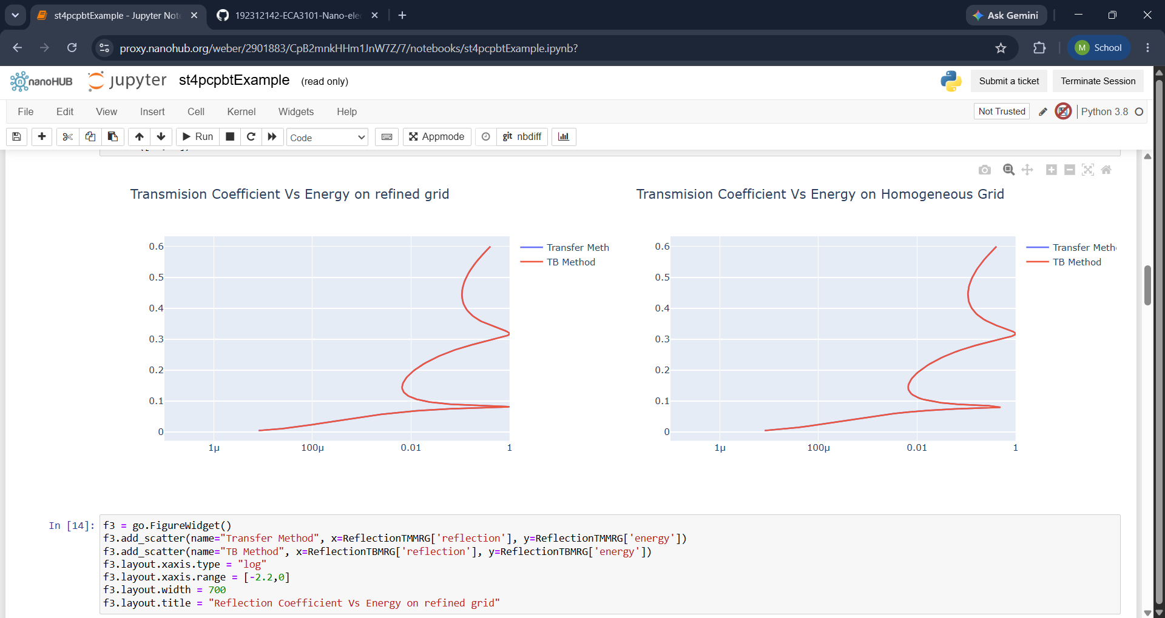
Impact of Figure:
- Shows the wavefunction penetrating and decaying inside the potential barrier.
- Demonstrates that there is a finite probability of finding the particle within and beyond the barrier.
- Confirms the wave nature of particles in quantum mechanics.

Case study 2 : Analysis the Reflection co-efficient Vs Energy on Homogeneous Grid
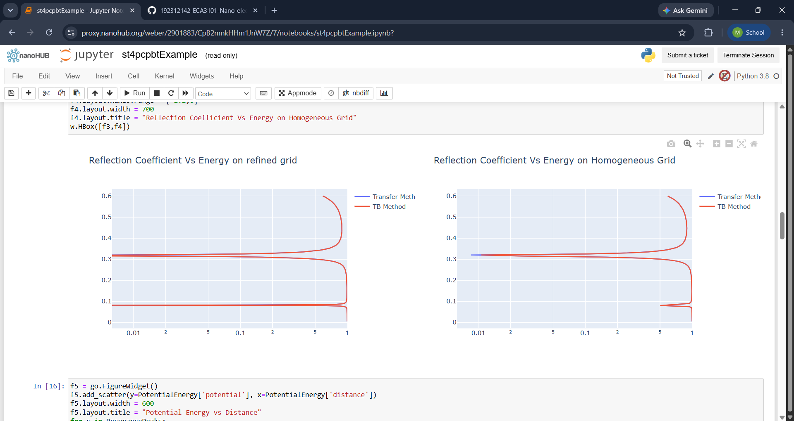
Impact of Figure:
- Illustrates that tunneling probability decreases as the barrier height increases.
- Demonstrates the strong dependence of tunneling on barrier energy.
- Confirms the exponential reduction in transmission through higher barriers.

Conclusion
The simulation successfully demonstrates the quantum tunneling phenomenon, where particles can pass through a potential barrier even when their energy is lower than the barrier height. The results show that the tunneling probability decreases with increasing barrier height and barrier width, while it increases with higher particle energy.

Exp. 7. MOSFET Scaling Analysis and Subthreshold Swing Calculation using NanoHub.
Aim:
To study the current-voltage characteristics and transconductance efficiency of a single-gateMOSFET using the NanoHUB FetToy Simulator.

Case 1: Increase in VG :
● Observation: As VG increases, the drain current (ID ) also increases exponentiallydue to the MOSFET entering the saturation region earlier.
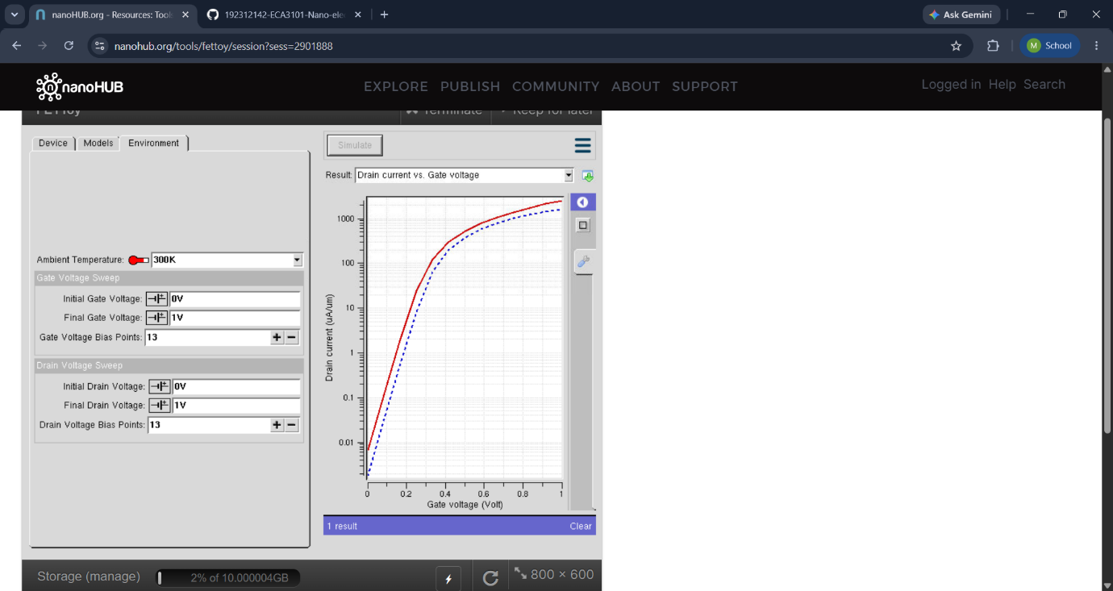
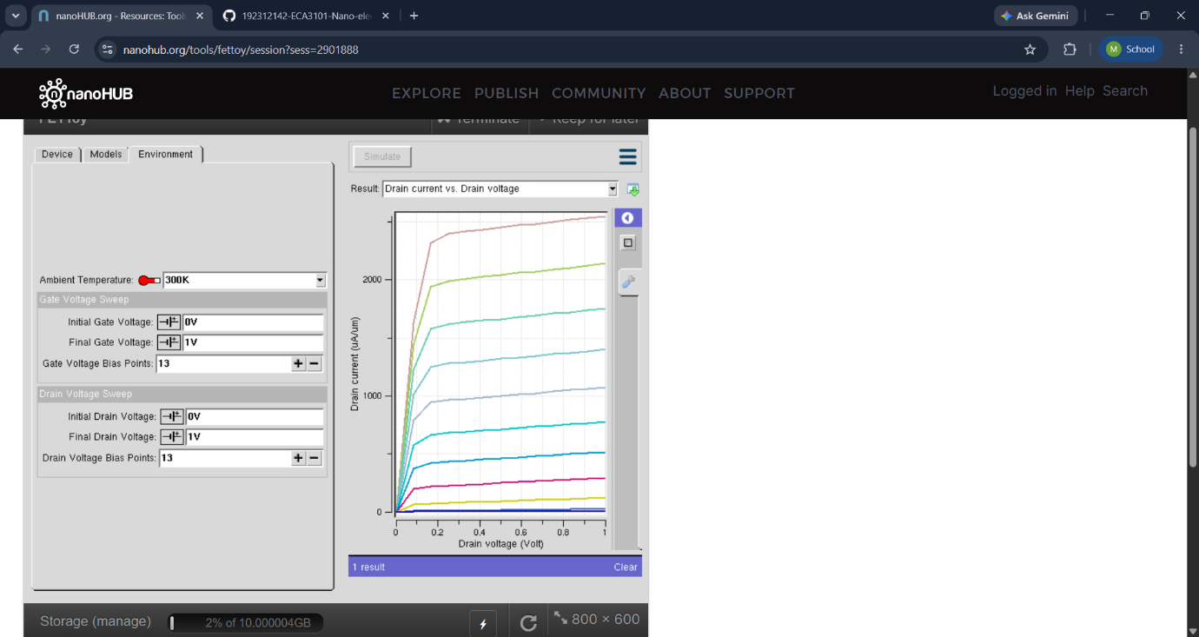
Impact of Figure:
- Illustrates the physical structure of the MOSFET used in the simulation.
- Demonstrates the gate, source, drain, and channel regions.
- Provides the basis for understanding scaling effects on device performance.

Case 2: Variation in VD :
● Observation: Drain current (ID ) saturates for higher VD at a fixed VG
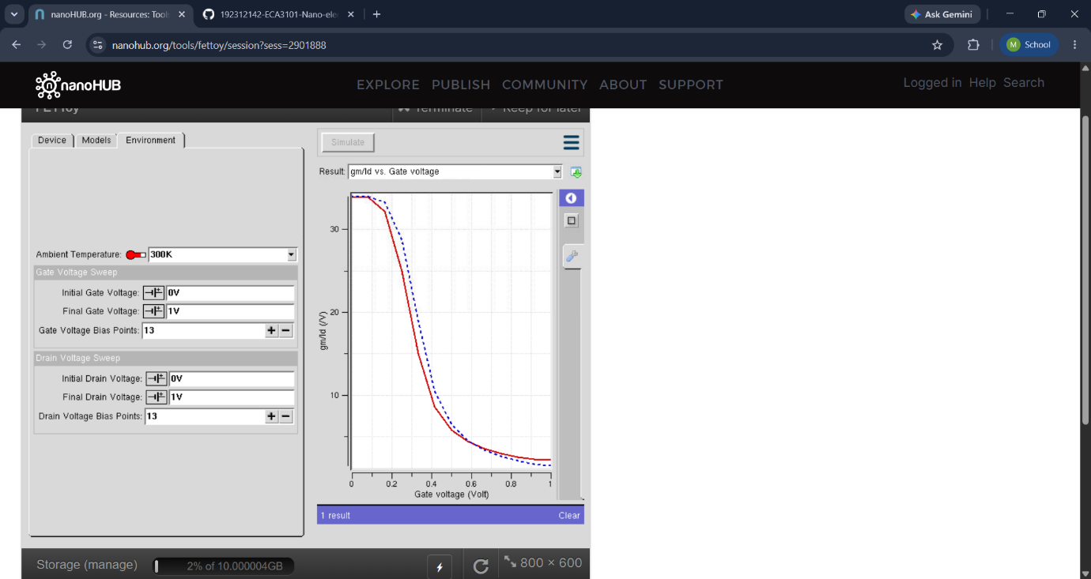
Impact of Figure:
- Illustrates the exponential increase in drain current below the threshold voltage.
- Demonstrates the subthreshold conduction phenomenon.
- Shows the importance of subthreshold swing in determining switching efficiency.

Conclusion
The NanoHub simulation successfully demonstrates the effects of MOSFET scaling on device performance and the calculation of subthreshold swing. The results show that reducing the channel length improves switching speed and device integration but also increases leakage current and short-channel effects. The subthreshold swing analysis indicates that a lower subthreshold swing enables faster switching and lower power consumption.

