M.Pavan kumar 192312142
Nanoelectronics ECA3101
Exp. 2. Simulation of Density of States of Quantum Well Structure with
Various Nanometer Thickness.
Aim: To simulate density of states of quantum well structure with various nano meter thickness. Software: NanoHub Online Tool

Case Study 1: Simulate the density of states of quantum well of thickness 0.5 nm

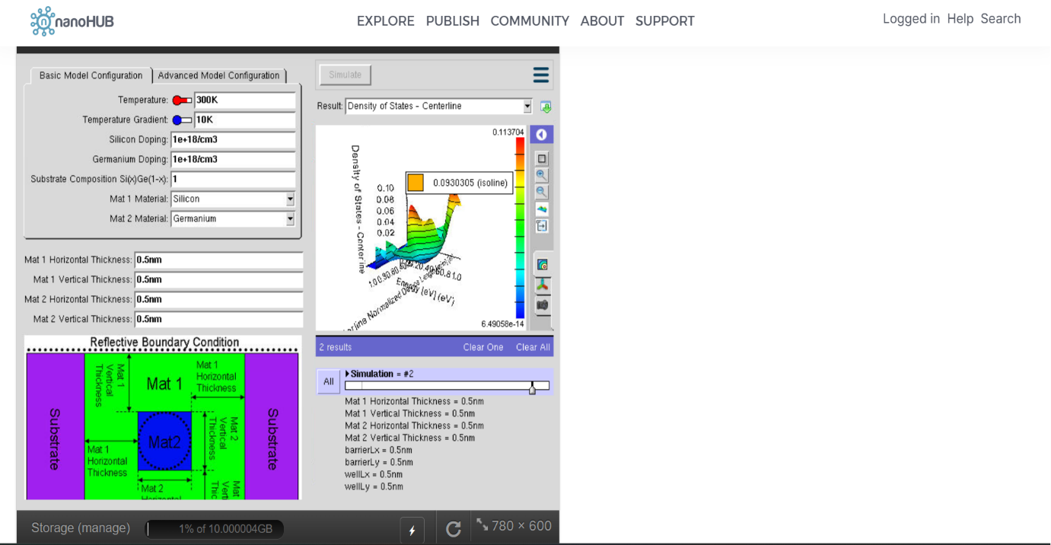

Impact of Figure:
- Illustrates the layered semiconductor structure used to confine charge carriers.
- Demonstrates quantum confinement within the thin well region.
- Provides the basic model for analyzing the density of states.

Case Study 2: Simulate the density of states of quantum well of thickness 0.6 nm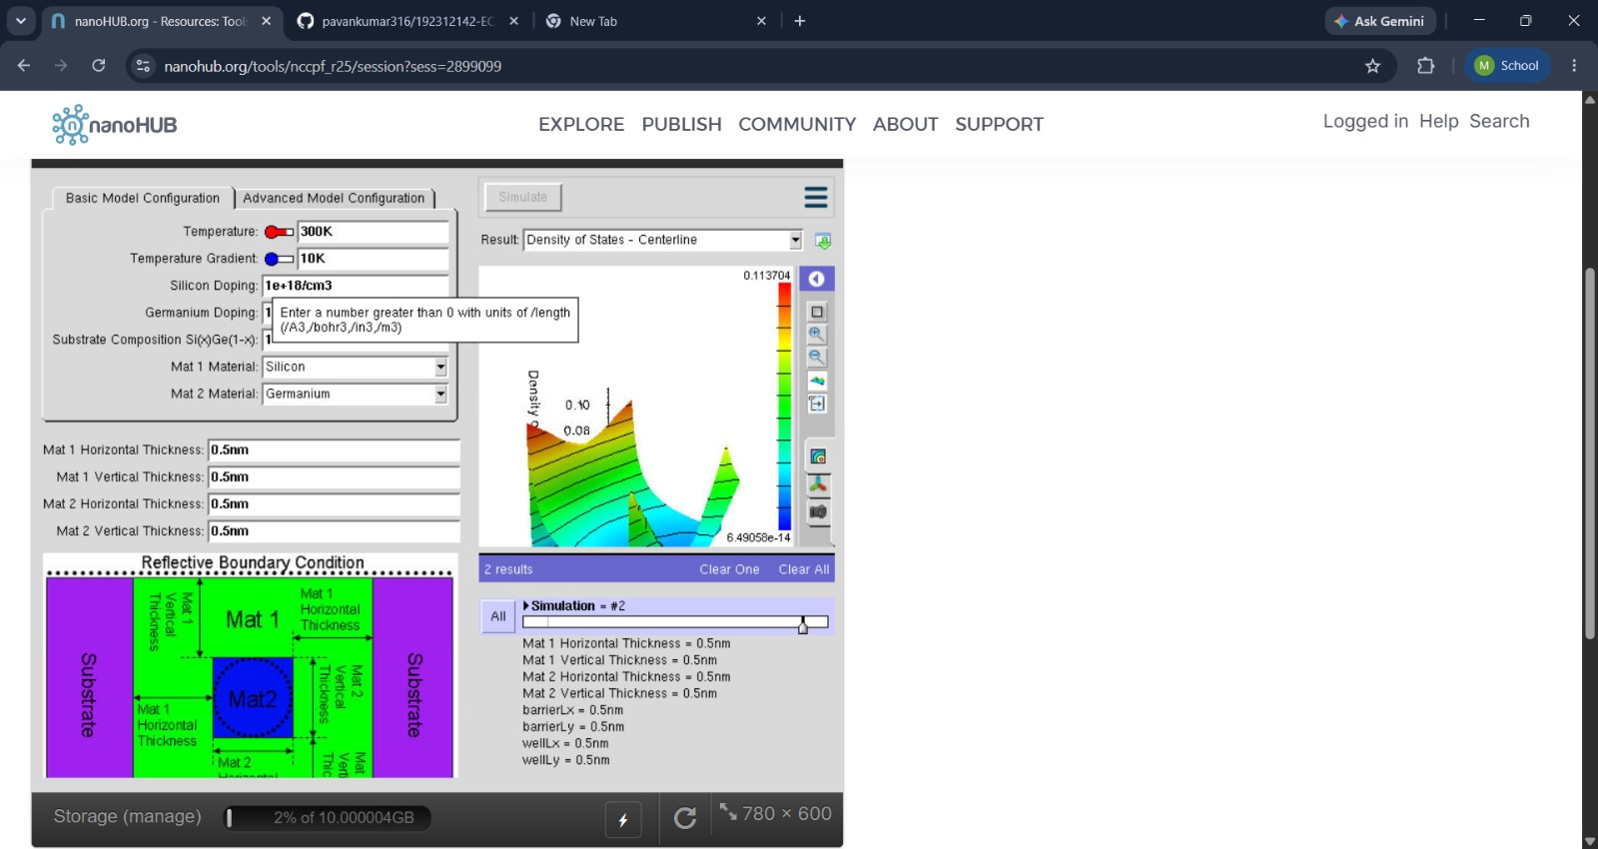
Impact of Figure:
- Illustrates a reduction in energy level spacing as the well thickness increases.
- Shows the appearance of additional allowed energy states.
- Demonstrates the effect of reduced quantum confinement.

Conclusion
The simulation of the Density of States (DOS) of a Quantum Well Structure successfully demonstrates the effect of quantum well thickness on the electronic energy levels. The results show that thinner quantum wells exhibit stronger quantum confinement, resulting in discrete energy levels and larger energy spacing, while thicker wells produce closely spaced energy levels that approach bulk semiconductor behavior.

Exp. 3. Simulation of Energy States of Quantum Dot using NanoHub.
Aim:
To obtain the energy states of Quantum dots.
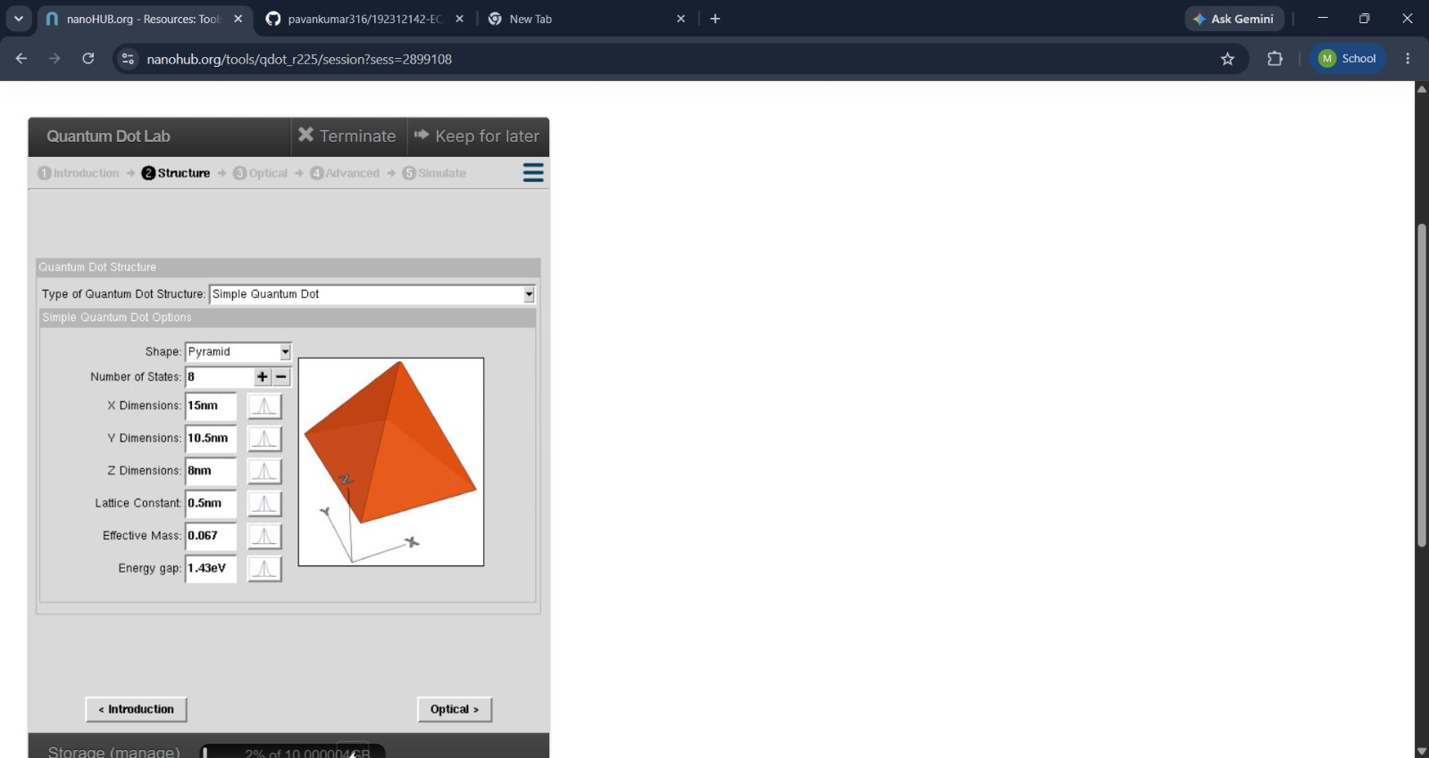
Impact of Figure:
- Illustrates the nanoscale structure of the quantum dot.
- Demonstrates three-dimensional confinement of electrons and holes.
- Provides the basic model for studying discrete energy states.

Case Study 1: Simulate the energy states of cylindrical quantum dots of X=15 nm, Y = 10.5nm
and Z = 8 nm.
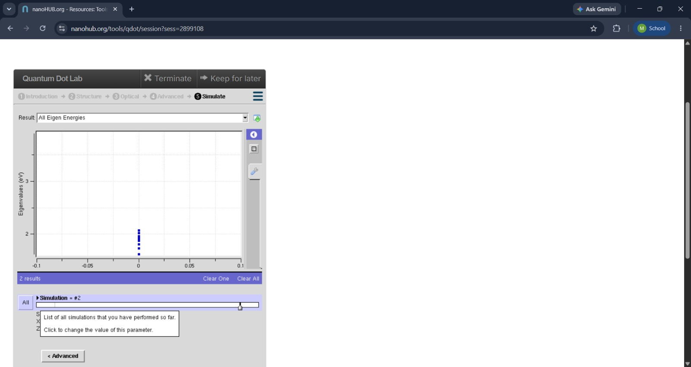
Impact of Figure:
- Shows the formation of discrete (quantized) energy levels due to quantum confinement.
- Demonstrates that electrons can occupy only specific energy states.
- Confirms the atomic-like behavior of quantum dots.

Case Study 2: Simulate the energy states of two layer cuboid quantum dots

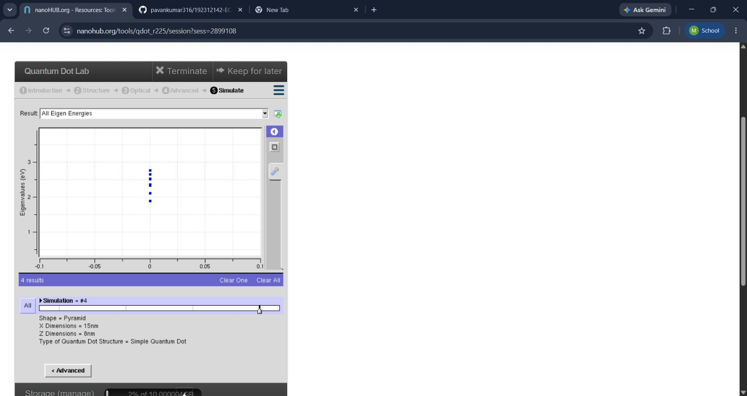
Impact of Figure:
- Illustrates the effect of quantum dot size on energy levels.
- Shows that smaller quantum dots have larger energy spacing.
- Demonstrates stronger quantum confinement as the dot size decreases.

Conclusion
The NanoHub simulation successfully demonstrates the energy states of a quantum dot and the effect of quantum confinement on its electronic properties. The results show that electrons occupy discrete, quantized energy levels, and the spacing between these levels depends on the size of the quantum dot. Smaller quantum dots exhibit stronger quantum confinement and larger energy spacing, while larger quantum dots have closely spaced energy levels

Exp. 4. Kronig Penney Model
Aim:
To simulate Energy functional vs Energy graph using Kronig Penne y model

Case Study 1: Simulate the output for Triangular well

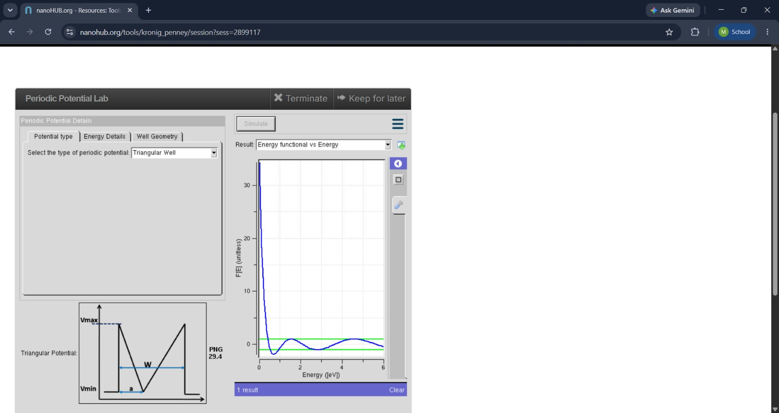

Impact of Figure:
- Illustrates the periodic arrangement of potential wells and barriers in a crystal lattice.
- Demonstrates the model used to represent electrons in a periodic potential.
- Provides the foundation for understanding energy band formation.

Case Study 2: Simulate the output for Sinusoidal Potential
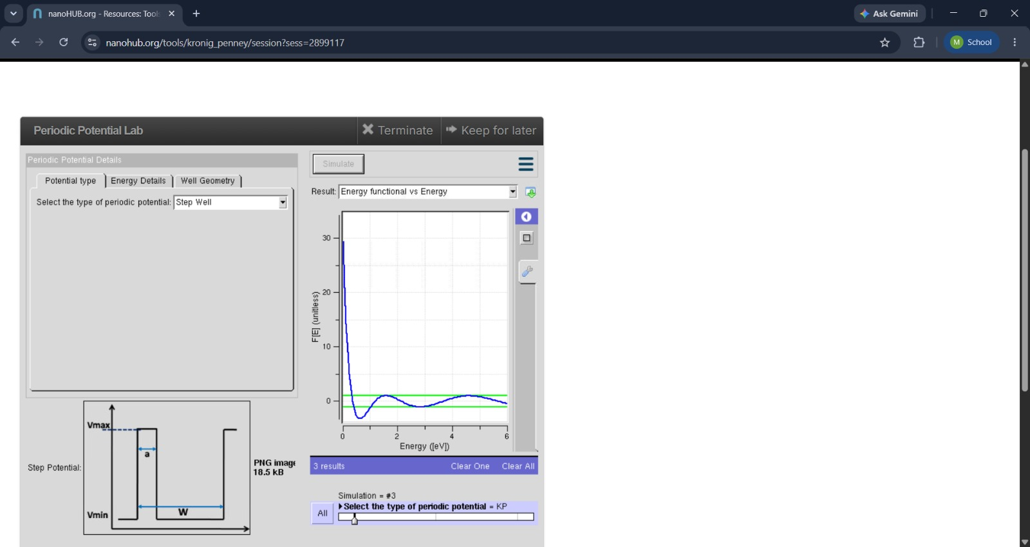
Impact of Figure:
- Shows the formation of allowed energy bands and forbidden band gaps.
- Demonstrates that electrons can occupy only specific energy ranges.
- Confirms the effect of periodic potential on electron motion.

Conclusion
The Kronig–Penney Model successfully demonstrates the formation of allowed energy bands and forbidden band gaps in a periodic crystal lattice. The simulation shows that the periodic potential experienced by electrons leads to quantized energy bands, and that the width and height of the potential barriers significantly influence the band structure. The results confirm that band engineering is essential for controlling the electrical properties of semiconductor materials.

