MQTT and Raspberry PI Pico W

MQTT is a messaging protocol for the Internet of Things (IoT). It is designed to use minimal network bandwidth and a reduced code for transporting messages from/to IoT devices.

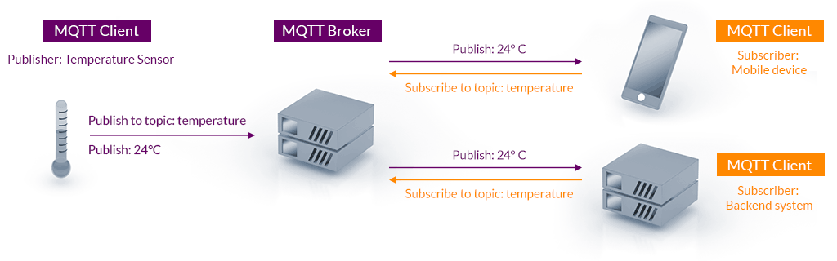

Installations:-

Update and upgrade your os
sudo apt update -y && sudo apt upgrade -y

Install Mosquitto using following command
sudo apt install mosquitto mosquitto-clients -y

Check that Mosquitto is correctly running:
sudo systemctl status mosquitto.service
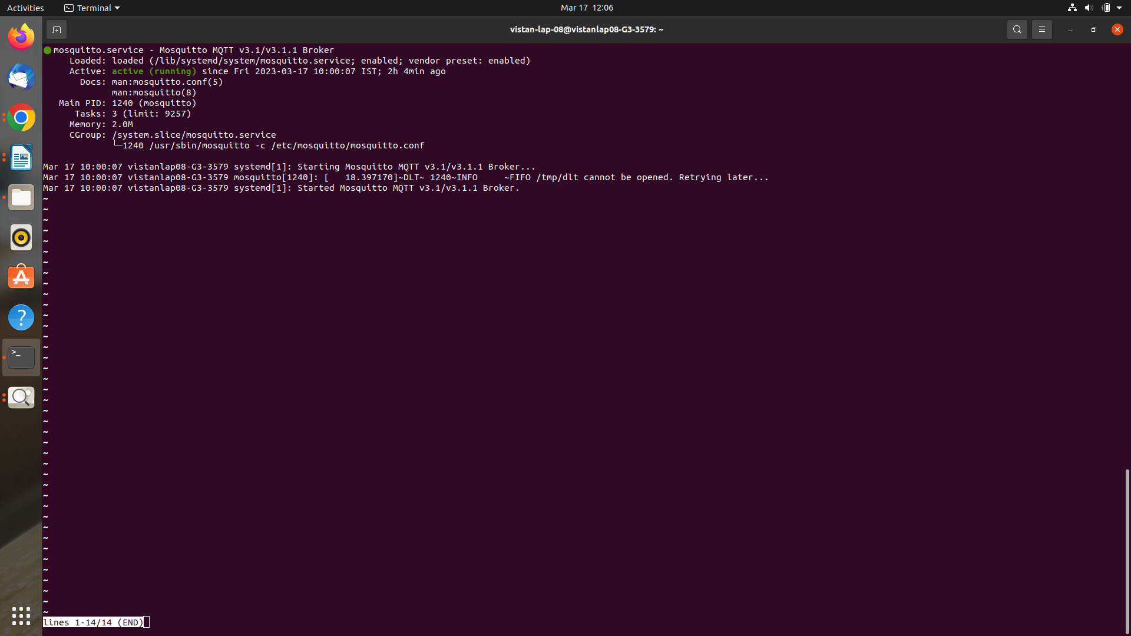

To Set Username and Password:-
sudo mosquitto_passwd -c /etc/mosquitto/credentials
(The process will automatically request a password)
Password:- picopassword

Mosquitto Configurations to be done:-
open
sudo nano /etc/mosquitto/mosquitto.conf

and append the following lines

allow_anonymous false
password_file /etc/mosquitto/credentials
listener 1883

Restart the Mosquitto service:-
sudo systemctl restart mosquitto.service

Set Up Raspberry PI Pico W for MQTT

In Pico make sure you have installed MicroPython
Connect to WIFI using following code
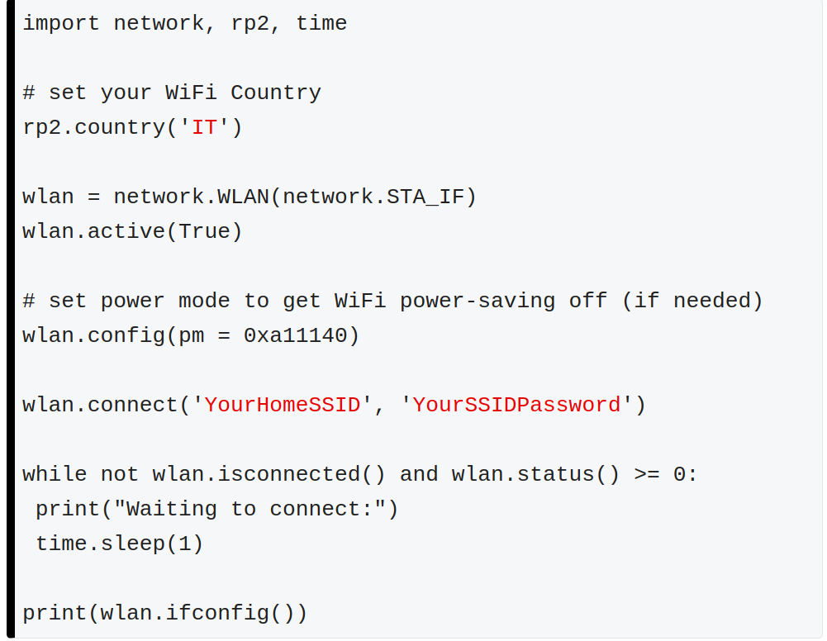

Make sure to change SSID and Password as per your network.
Once the network is connected in micropython using the above code it will display ipaddress details
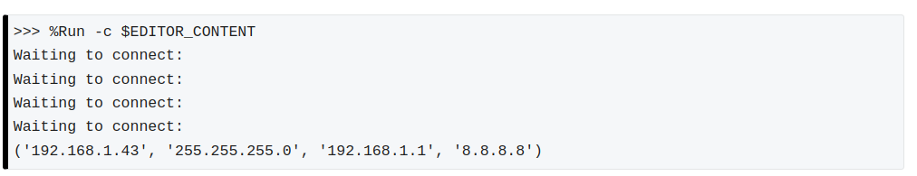

Once the WiFi connection works, save these 2(netman.py & umqttsimple.py) files in your Pico(MicroPython)

netman.py
(https://peppe8o.com/download/micropython/webserver-tutorial/netman.py)
import network, rp2
import time

def connectWiFi(ssid,password,country):
rp2.country(country)
wlan = network.WLAN(network.STA_IF)
wlan.config(pm = 0xa11140)
wlan.active(True)
wlan.connect(ssid, password)
# Wait for connect or fail
max_wait = 10
while max_wait > 0:
if wlan.status() < 0 or wlan.status() >= 3:
break
max_wait -= 1
print('waiting for connection...')
time.sleep(1)

# Handle connection error
if wlan.status() != 3:
raise RuntimeError('network connection failed')
else:
print('connected')
status = wlan.ifconfig()
print( 'ip = ' + status[0] )
return status

umqttsimple.py
(https://peppe8o.com/download/micropython/w5100s-evb-pico/umqttsimple.py)

import usocket as socket
import ustruct as struct
from ubinascii import hexlify

class MQTTException(Exception):
pass

class MQTTClient:
def __init__(
self,
client_id,
server,
port=0,
user=None,
password=None,
keepalive=0,
ssl=False,
ssl_params={},
):
if port == 0:
port = 8883 if ssl else 1883
self.client_id = client_id
self.sock = None
self.server = server
self.port = port
self.ssl = ssl
self.ssl_params = ssl_params
self.pid = 0
self.cb = None
self.user = user
self.pswd = password
self.keepalive = keepalive
self.lw_topic = None
self.lw_msg = None
self.lw_qos = 0
self.lw_retain = False

def _send_str(self, s):
self.sock.write(struct.pack("!H", len(s)))
self.sock.write(s)

def _recv_len(self):
n = 0
sh = 0
while 1:
b = self.sock.read(1)[0]
n |= (b & 0x7F) << sh
if not b & 0x80:
return n
sh += 7

def set_callback(self, f):
self.cb = f

def set_last_will(self, topic, msg, retain=False, qos=0):
assert 0 <= qos <= 2
assert topic
self.lw_topic = topic
self.lw_msg = msg
self.lw_qos = qos
self.lw_retain = retain

def connect(self, clean_session=True):
self.sock = socket.socket()
addr = socket.getaddrinfo(self.server, self.port)[0][-1]
self.sock.connect(addr)
if self.ssl:
import ussl

self.sock = ussl.wrap_socket(self.sock, **self.ssl_params)
premsg = bytearray(b"\x10\0\0\0\0\0")
msg = bytearray(b"\x04MQTT\x04\x02\0\0")

sz = 10 + 2 + len(self.client_id)
msg[6] = clean_session << 1
if self.user is not None:
sz += 2 + len(self.user) + 2 + len(self.pswd)
msg[6] |= 0xC0
if self.keepalive:
assert self.keepalive < 65536
msg[7] |= self.keepalive >> 8
msg[8] |= self.keepalive & 0x00FF
if self.lw_topic:
sz += 2 + len(self.lw_topic) + 2 + len(self.lw_msg)
msg[6] |= 0x4 | (self.lw_qos & 0x1) << 3 | (self.lw_qos & 0x2) << 3
msg[6] |= self.lw_retain << 5

i = 1
while sz > 0x7F:
premsg[i] = (sz & 0x7F) | 0x80
sz >>= 7
i += 1
premsg[i] = sz

self.sock.write(premsg, i + 2)
self.sock.write(msg)
# print(hex(len(msg)), hexlify(msg, ":"))
self._send_str(self.client_id)
if self.lw_topic:
self._send_str(self.lw_topic)
self._send_str(self.lw_msg)
if self.user is not None:
self._send_str(self.user)
self._send_str(self.pswd)
resp = self.sock.read(4)
assert resp[0] == 0x20 and resp[1] == 0x02
if resp[3] != 0:
raise MQTTException(resp[3])
return resp[2] & 1

def disconnect(self):
self.sock.write(b"\xe0\0")
self.sock.close()

def ping(self):
self.sock.write(b"\xc0\0")

def publish(self, topic, msg, retain=False, qos=0):
pkt = bytearray(b"\x30\0\0\0")
pkt[0] |= qos << 1 | retain
sz = 2 + len(topic) + len(msg)
if qos > 0:
sz += 2
assert sz < 2097152
i = 1
while sz > 0x7F:
pkt[i] = (sz & 0x7F) | 0x80
sz >>= 7
i += 1
pkt[i] = sz
# print(hex(len(pkt)), hexlify(pkt, ":"))
self.sock.write(pkt, i + 1)
self._send_str(topic)
if qos > 0:
self.pid += 1
pid = self.pid
struct.pack_into("!H", pkt, 0, pid)
self.sock.write(pkt, 2)
self.sock.write(msg)
if qos == 1:
while 1:
op = self.wait_msg()
if op == 0x40:
sz = self.sock.read(1)
assert sz == b"\x02"
rcv_pid = self.sock.read(2)
rcv_pid = rcv_pid[0] << 8 | rcv_pid[1]
if pid == rcv_pid:
return
elif qos == 2:
assert 0

def subscribe(self, topic, qos=0):
assert self.cb is not None, "Subscribe callback is not set"
pkt = bytearray(b"\x82\0\0\0")
self.pid += 1
struct.pack_into("!BH", pkt, 1, 2 + 2 + len(topic) + 1, self.pid)
# print(hex(len(pkt)), hexlify(pkt, ":"))
self.sock.write(pkt)
self._send_str(topic)
self.sock.write(qos.to_bytes(1, "little"))
while 1:
op = self.wait_msg()
if op == 0x90:
resp = self.sock.read(4)
# print(resp)
assert resp[1] == pkt[2] and resp[2] == pkt[3]
if resp[3] == 0x80:
raise MQTTException(resp[3])
return

# Wait for a single incoming MQTT message and process it.
# Subscribed messages are delivered to a callback previously
# set by .set_callback() method. Other (internal) MQTT
# messages processed internally.
def wait_msg(self):
res = self.sock.read(1)
#self.sock.setblocking(True)
if res is None:
return None
if res == b"":
raise OSError(-1)
if res == b"\xd0": # PINGRESP
sz = self.sock.read(1)[0]
assert sz == 0
return None
op = res[0]
if op & 0xF0 != 0x30:
return op
sz = self._recv_len()
topic_len = self.sock.read(2)
topic_len = (topic_len[0] << 8) | topic_len[1]
topic = self.sock.read(topic_len)
sz -= topic_len + 2
if op & 6:
pid = self.sock.read(2)
pid = pid[0] << 8 | pid[1]
sz -= 2
msg = self.sock.read(sz)
self.cb(topic, msg)
if op & 6 == 2:
pkt = bytearray(b"\x40\x02\0\0")
struct.pack_into("!H", pkt, 2, pid)
self.sock.write(pkt)
elif op & 6 == 4:
assert 0

# Checks whether a pending message from server is available.
# If not, returns immediately with None. Otherwise, does
# the same processing as wait_msg.
def check_msg(self):
self.sock.setblocking(False)
return self.wait_msg()

Run the MQTT publishing test
In Terminal (local where you installed MQTT)
mosquitto_sub -d -t hello -u -P

Reference Links:-

For Installing MQTT
https://peppe8o.com/mqtt-and-raspberry-pi-pico-w-start-with-mosquitto-micropython/

To Connect WIFI
https://peppe8o.com/getting-started-with-wifi-on-raspberry-pi-pico-w-and-micropython/

netman.py
https://peppe8o.com/download/micropython/webserver-tutorial/netman.py

umqttsimple.py
https://peppe8o.com/download/micropython/w5100s-evb-pico/umqttsimple.py

For Installing Paho MQTT:-
https://www.emqx.com/en/blog/how-to-use-mqtt-in-python

For subscribing MQTT
https://techoverflow.net/2021/12/27/python-mqtt-subscribe-minimal-example-paho-mqtt/

ROS2 Publishing using MQTT
https://answers.ros.org/question/393787/how-to-spin-ros2-publisher-node-and-non-ros-function-asynchronously/

