Task-3
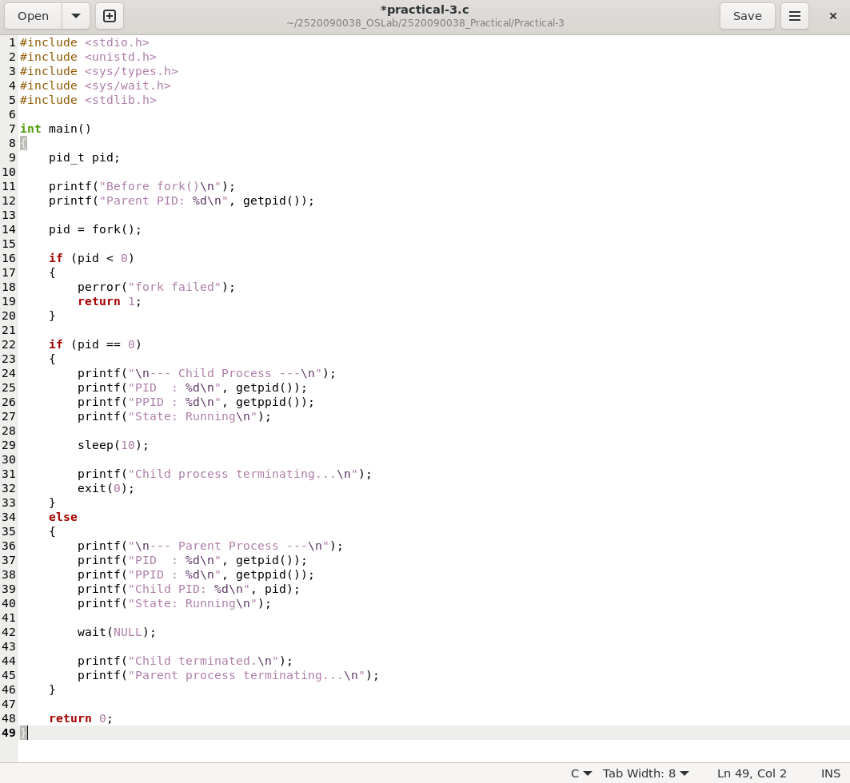

Compilation, Input & Output :
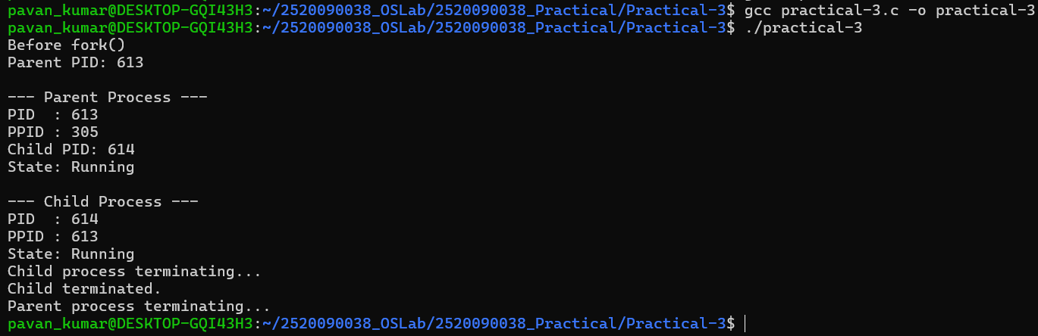
Task-2

Input & Output :

Experiment 1 :
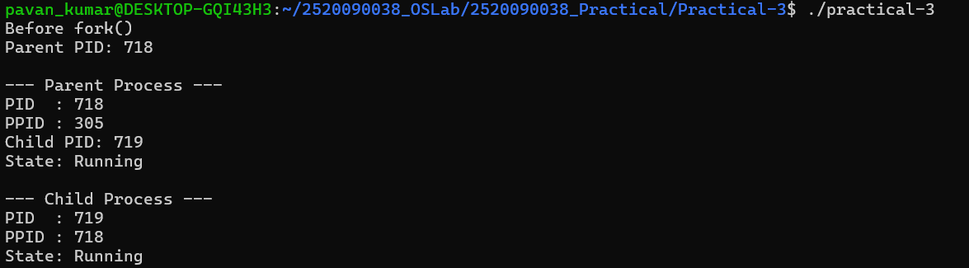
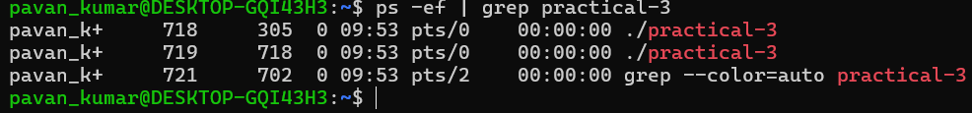
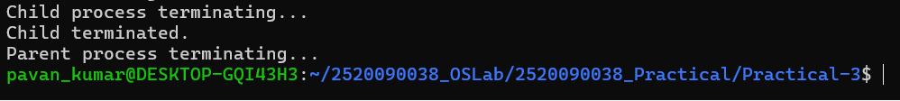

Experiment 2 :
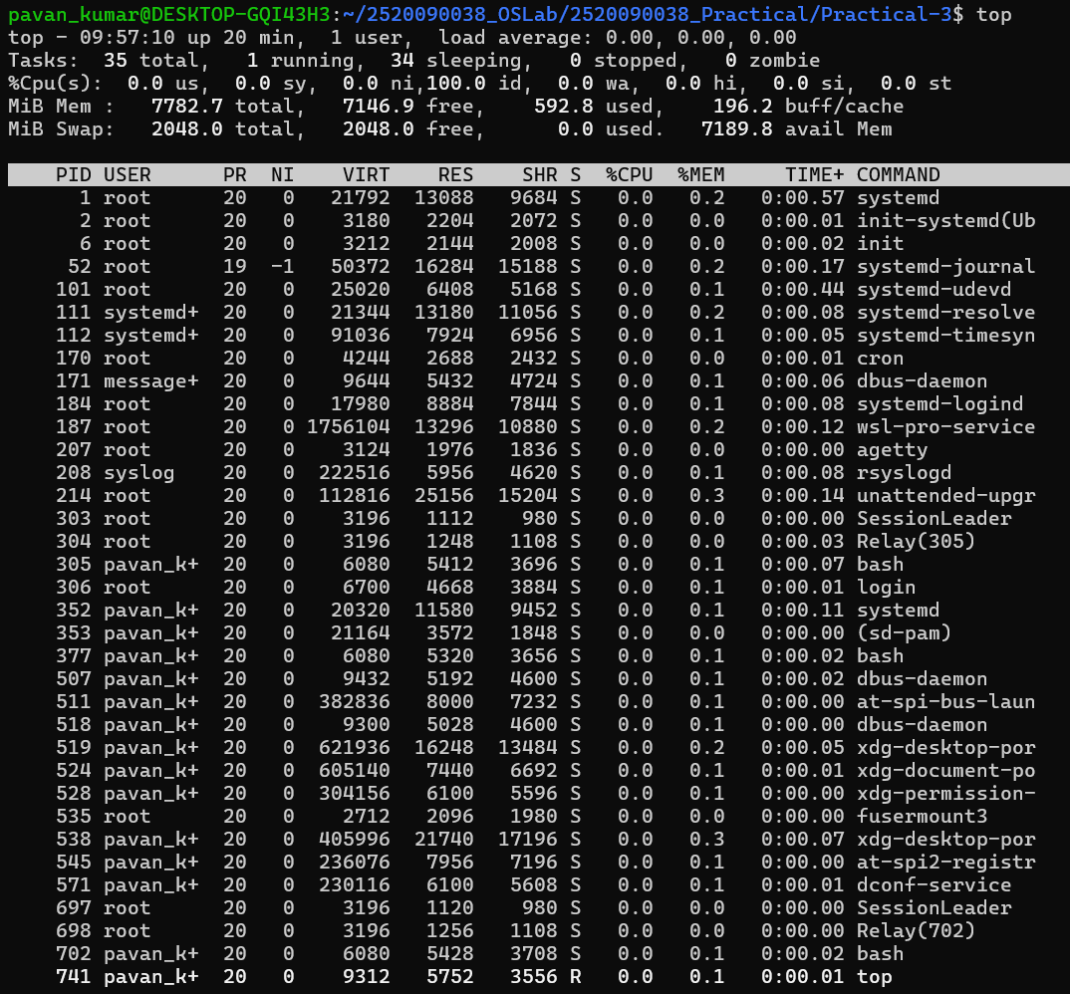

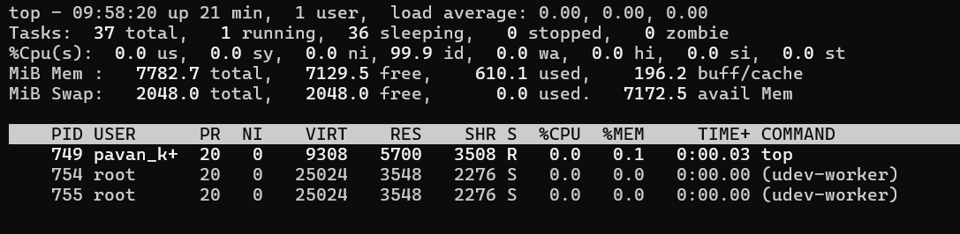

Experiment – 3 : 