Linux Concurrent Producer Consumer System Using Semaphores
A Project Report Submitted in the partial fulfillment of the requirements for the award of the degree of
Section No.: 13 | Team No.: 11

BACHELOR OF TECHNOLOGY
In

DEPARTMENT OF COMPUTER SCIENCE ENGINNERING

By

K. Pavan Kumar 2520090038

P. Harsha Vardhan 2520090180

B. Purna Chandar Rao 2520090188

Under the Esteemed Guidance of

Ms. D. Alekhya
Assistant Professor
Department of Computer Science and Engineering




K L (Deemed to be) University DEPARTMENT OF COMPUTER SCIENCE ENGINEERING
&

DEPARTMENT OF COMPUTER SCIENCE AND INFORMATION TECHNOL

Declaration

The Project Report entitled Linux Concurrent Producer Consumer System Using Semaphores is a record of Bonafide work of K. Pavan Kumar - 2520090038, P. Harsha Vardhan - 2520090180, B. Purna Chandar Rao - 2520090188 submitted in
partial fulfillment for the award of B. Tech in Computer Science and Engineering (or) Computer Science and Information Technology to the K L University. The results embodied in this report have not been copied from any other departments/University/Institute.

K. Pavan Kumar 2520090038

P. Harsha Vardhan 2520090180

B. Purna Chandar Rao 2520090188
K L (Deemed to be) University

DEPARTMENT OF COMPUTER SCIENCE ENGINEERING

CERTIFICATE

This is certify that the mini project based report entitled Linux Concurrent Producer Consumer System Using Semaphores is a bonafide work done and submitted by K. Pavan Kumar - 2520090038, P. Harsha Vardhan - 2520090180, B. Purna Chandar Rao - 2520090188 ,
in partial fulfillment of the requirements for the award of the degree of BACHELOR OF TECHNOLOGY in Department of Computer Science Engineering, K L (Deemed to be University), during the academic year 2024-2025.

Signature of the Guide

Signature of the Course Coordinator Signature of the HOD
ACKNOWLEDGEMENT
The success in this project would not have been possible but for the timely help and guidance rendered by many people. Our wish to express my sincere thanks to all those who has assisted us in one way or the other for the completion of my project.

Our greatest appreciation to my Course Coordinator Ms. D. Alekhya, and my guide Ms. D. Alekhya, Department of Computer Science which cannot be expressed in words for his/her tremendous support, encouragement and guidance for this project.

We express our gratitude to Dr. SK. Khaja Shareef (CSIT), Head of the Department for Computer Science and Information Technology for providing us with adequate facilities, ways and means by which we are able to complete this project-based Lab.

We thank all the members of teaching and non-teaching staff members, and also who have assisted me directly or indirectly for successful completion of this project. Finally, I sincerely thank my parents, friends and classmates for their kind help and cooperation during my work.

K. Pavan Kumar 2520090038

P. Harsha Vardhan 2520090180

B. Purna Chandar Rao 2520090188
Individual Contributions:
K. Pavan Kumar: Designed the overall system architecture and implemented the producer module.
P. Harsha Vardhan: Implemented semaphore-based synchronization and handled concurrency and mutual exclusion.
B. Purna Chandar Rao: Performed testing, debugging, documentation, and GitHub repository management.

GitHub Repository: https://github.com/pavankumar7744-droid/OSSP-PROJECT
Abstract

This project presents the design and implementation of a Linux Concurrent Producer-Consumer System utilizing semaphores for inter-process synchronization. The producer-consumer problem is a fundamental operating system paradigm demonstrating process synchronization, shared memory management, and mutual exclusion in concurrent environments. In our implementation, concurrent processes created via fork() communicate through a shared memory region established using POSIX shared memory APIs (shm_open, mmap, and ftruncate).

Synchronization and mutual exclusion across concurrent producer and consumer processes are strictly controlled using three POSIX semaphores: an empty semaphore to track available spaces in the circular bounded buffer, a full semaphore to track the number of produced items awaiting consumption, and a binary mutex semaphore to enforce mutually exclusive access to the shared buffer data structures. This model effectively prevents race conditions, deadlock, and buffer overflow or underflow conditions during high-concurrency execution.

The complete system is developed in C/C++ on Ubuntu/Linux and highlights core operating system concepts including process management, inter-process communication (IPC), shared memory allocation, and semaphore synchronization primitives. Performance analysis and execution demonstrations verify that the system operates correctly under varying process loads without race conditions or starvation. In summary, this project successfully provides a robust, thread-safe, and process-based concurrent producer-consumer system on Linux.
Index

S. No. | Chapter | Topics / Subtopics | Page No.
 | Acknowledgement |  | i
 | Abstract |  | ii
1 | Introduction |  | 1–5
 |  | 1.1 Background of the Project
 |  | 1.2 Problem Statement
 |  | 1.3 Scope of the Project
 |  | 1.4 Objectives of the Project
 |  | 1.5 Importance of the Application
 |  | 1.6 Target Users / Audience
2 | OS Concepts and Background Study |  | 6–12
 |  | 2.1 Operating System Concepts Related to the Project
 |  | 2.2 Existing Methods / Algorithms
 |  | 2.3 Proposed Approach
 |  | 2.4 Advantages of the Proposed Approach
3 | System Requirements |  | 13–17
 |  | 3.1 Hardware Requirements
 |  | 3.2 Software Requirements
 |  | 3.3 Operating System Environment – Ubuntu / WSL
 |  | 3.4 Development Tools and Compilers
4 | Technology and Tools Used |  | 18–22
 |  | 4.1 C / C++ Programming
 |  | 4.2 GCC Compiler
 |  | 4.3 Linux System Calls
 |  | 4.4 POSIX Threads / Synchronization
 |  | 4.5 Linux Commands and Utilities
 |  | 4.6 Other Tools / Libraries Used
5 | System Architecture and Design |  | 23–29
 |  | 5.1 Overall System Architecture
 |  | 5.2System Workflow
 |  | 5.3 Flowchart / Data Flow
 |  | 5.4 Module Description
 |  | 5.5 Input and Output Design
6 | Implementation |  | 30–45
 |  | 6.1 Module-wise Implementation
 |  | 6.2 Algorithm / Pseudocode
 |  | 6.3 Core C / C++ Implementation
 |  | 6.4 Linux System Calls / APIs Used
 |  | 6.5 Process / Thread Implementation
 |  | 6.6 IPC / Synchronization Implementation
 |  | 6.7 Memory Management Implementation
 |  | 6.8 Optional User Interface Implementation
7 | Execution and Demonstration |  | 62–67
 |  | 7.1 Compilation in Ubuntu
 |  | 7.2 Execution Commands
 |  | 7.3 Sample Inputs and Outputs
 |  | 7.4 Screenshots of Execution
 |  | 7.5 Demonstration of OS Concepts
8 | Conclusion |  | 79–83
 |  | 8.1 Summary of the Project
 |  | 8.2 Objectives Achieved
 |  | 8.3 Results Achieved
 |  | 8.4 Skills and Learning Outcomes
9 | References |  | 84–86
 |  | 9.1 Books
 |  | 9.2 Research Papers
 |  | 9.3 Linux / GNU Documentation
 |  | 9.4 Online Resources

CHAPTER -1 INTRODUCTION

1.1 Background of the Project
The producer-consumer problem is a classical multi-process synchronization pattern in operating systems. It addresses scenarios where one or more producer entities generate data items and place them into a fixed-size bounded buffer, while one or more consumer entities extract and process items from the buffer concurrently. In modern operating systems like Linux, concurrent processes executing in separate address spaces require inter-process communication (IPC) and synchronization primitives to manage access to shared memory without encountering race conditions, buffer overflows, or buffer underflows. This project implements a process-based solution leveraging POSIX shared memory, POSIX semaphores, process management system calls, and file I/O operations.

1.2 Problem Statement
In concurrent execution environments, concurrent access to shared resources without strict synchronization leads to non-deterministic behavior, data corruption, and system deadlocks. When a producer process attempts to write data to a full buffer, or a consumer process attempts to read from an empty buffer, software execution fails due to buffer overflow or underflow. Furthermore, simultaneous modifications to buffer control variables (such as insert and remove pointers) result in race conditions. The objective of this project is to implement a robust, process-based concurrent producer-consumer system in Linux that enforces mutual exclusion and resource availability using semaphores, while integrating file I/O operations and IPC mechanisms.

1.3 Scope of the Project
The scope of this project encompasses system-level programming on Linux, covering all five key Course Outcomes (COs) of operating systems architecture:
- OS Services & System Calls (CO-1): Direct kernel interoperation via low-level system calls including fork(), open(), read(), write(), kill(), and waitpid().
- Process Control & Hierarchy (CO-2): Creation, coordination, lifecycle management, and parent-child hierarchy tracking using fork() and waitpid() to prevent zombie processes.
- Synchronization & IPC (CO-3): Coordination using POSIX named semaphores (mutex, empty, full) and POSIX signal handling (sigaction) for graceful process termination.
- Shared Memory Management (CO-4): Mapping shared bounded buffers into independent process address spaces using POSIX shared memory APIs (shm_open, mmap, ftruncate).
- File Systems & File I/O (CO-5): Data streaming pipeline connecting unbuffered binary file input (input.bin) to buffered text file output (output.txt) across producer and consumer boundaries.

1.4 Objectives of the Project
- Develop a process-based concurrent producer-consumer pipeline in C on Linux using fork() system calls.
- Establish inter-process communication using POSIX Shared Memory (shm_open, mmap) for a bounded circular buffer.
- Ensure synchronization and mutual exclusion using POSIX binary and counting semaphores (sem_open, sem_wait, sem_post).
- Implement end-to-end file processing using unbuffered system calls (open, read) in the producer and standard buffered I/O (fopen, fprintf) in the consumer.
- Handle clean process termination and resource deallocation via POSIX signal programming and parent process waiting (waitpid).

1.5 Importance of the Application
The bounded-buffer producer-consumer pattern forms the backbone of operational infrastructure in modern operating systems, enterprise message queues, multimedia streaming architectures, and asynchronous file transfer pipelines. Understanding process-level shared memory and semaphore synchronization provides core systems programming knowledge required to build high-performance, deadlock-free, concurrent software systems.

1.6 Target Users / Audience
This documentation and implementation are intended for operating systems researchers, software engineering students, Linux kernel/systems programmers, and instructors evaluating practical implementations of concurrency, IPC, shared memory allocation, and kernel system calls.

CHAPTER - 2 OS CONCEPTS AND BACKGROUND STUDY

2.1 Operating System Concepts Related to the Project
Operating system design relies on process management, inter-process communication (IPC), and concurrency control to manage system resources. The Producer-Consumer problem is a foundational synchronization archetype that illustrates key OS mechanisms:
- Process Creation & Management (fork, waitpid): Processes execute in isolated virtual address spaces. Parent processes spawn child processes via fork() and manage their lifecycles using waitpid() to clean up process table entries and prevent zombie processes.
- POSIX Shared Memory (shm_open, mmap): Shared memory enables low-latency inter-process communication. Kernel primitives shm_open() and mmap() map physical memory frames directly into separate process address spaces.
- POSIX Semaphores (sem_open, sem_wait, sem_post): Counting and binary semaphores coordinate concurrent access to shared resources. sem_wait() blocks execution when a resource count is zero, while sem_post() increments the count and unblocks waiting processes.
- Unbuffered vs. Buffered File I/O: System calls such as open() and read() access low-level storage directly, while standard I/O streams like fopen() handle data through C library buffers.

2.2 Existing Methods / Algorithms
Traditional concurrency implementations often use multi-threading with POSIX mutexes and condition variables. While lightweight, threads share a single address space, making them vulnerable to memory corruption if memory safety errors occur. Other approaches use message passing mechanisms like UNIX domain sockets or IPC message queues, which incur kernel overhead due to data copying between user space and kernel space.

2.3 Proposed Approach
This system implements process isolation combined with shared memory and POSIX semaphores. Independent process spaces created using fork() communicate through a shared memory buffer managed via shm_open(). Three semaphores control synchronization:
- Mutex Semaphore: Binary semaphore initialized to 1 for mutual exclusion in critical sections.
- Empty Semaphore: Counting semaphore initialized to BUFFER_SIZE to monitor available buffer slots.
- Full Semaphore: Counting semaphore initialized to 0 to track available data items.

2.4 Advantages of the Proposed Approach
1. Process Isolation: Faults in a producer or consumer process do not corrupt memory in other processes.
2. High Performance: Zero-copy shared memory reduces message-passing overhead.
3. Synchronization Safety: POSIX semaphores enforce mutual exclusion and prevent buffer overflow, underflow, and deadlocks.

CHAPTER - 3 SYSTEM REQUIREMENTS

3.1 Hardware Requirements
- Processor: x86_64 / ARM64 multi-core CPU (2.0 GHz minimum) supporting concurrent process thread execution.
- System Memory (RAM): 2 GB minimum (4 GB recommended for WSL2 / virtualized container execution).
- Disk Storage: 500 MB free space for compilation artifacts, binary input generation (input.bin), and output text files (output.txt).

3.2 Software Requirements
- Operating System: Linux Kernel 4.x or higher (Ubuntu 20.04/22.04 LTS or WSL2 Ubuntu environment).
- Programming Language: C (C11 standard) / C++.
- Compiler: GCC (GNU Compiler Collection v9.0+).
- Build Tool: GNU Make utility.
- Libraries: POSIX Realtime Extensions Library (-lrt) and POSIX Threads Library (-pthread).

3.3 Operating System Environment – Ubuntu / WSL
The system is developed and executed within an Ubuntu Linux environment or Windows Subsystem for Linux 2 (WSL2). WSL2 provides complete kernel compatibility for POSIX system calls, memory-mapped shared memory interfaces (/dev/shm), named semaphores, and process signal handlers.

3.4 Development Tools and Compilers
The project build automation is managed using GNU Make. Compiling via GCC requires explicitly linking POSIX real-time and thread libraries:

gcc -Wall -Wextra -O2 src/main.c -o producer_consumer -pthread -lrt

CHAPTER - 4 TECHNOLOGY AND TOOLS USED

4.1 C / C++ Programming
The system is implemented in C (C11 standard), providing direct access to low-level POSIX primitives, system memory pointers, and POSIX semaphore APIs.

4.2 GCC Compiler
GNU Compiler Collection (GCC) compiles source files with warning flags (-Wall -Wextra) and optimization options (-O2), linking real-time (-lrt) and threading (-pthread) libraries.

4.3 Linux System Calls
Core kernel system calls manage process and file operations:
- fork(): Spawns child producer and consumer processes.
- waitpid(): Synchronizes parent cleanup with child process completion.
- open(), read(), write(): Executes unbuffered binary stream I/O operations.

4.4 POSIX Threads / Synchronization
POSIX semaphores (sem_open, sem_wait, sem_post, sem_close, sem_unlink) regulate concurrent execution across processes.

4.5 Linux Commands and Utilities
Utilities including ipcs, ls /dev/shm, valgrind, and gdb support debugging, performance analysis, and shared memory cleanup.

4.6 Other Tools / Libraries Used
GNU Make automates compilation, and Git/GitHub manages repository version control.

CHAPTER - 5 SYSTEM ARCHITECTURE AND DESIGN

5.1 Overall System Architecture
The architecture uses a parent process to create shared memory regions and POSIX semaphores before spawning child processes via fork(). The Producer process reads binary data from input.bin and writes into the bounded buffer. The Consumer process extracts items from the buffer and appends formatted records to output.txt.

5.2 System Workflow
1. Initialization: The main process allocates POSIX shared memory (shm_open) and initializes semaphores (mutex=1, empty=BUFFER_SIZE, full=0).
2. Process Spawning: fork() creates Producer and Consumer processes.
3. Producer Loop: Waits on empty, acquires mutex, places an item in the circular buffer, releases mutex, and signals full.
4. Consumer Loop: Waits on full, acquires mutex, removes an item from the buffer, releases mutex, and signals empty.

5. Cleanup: The parent process invokes waitpid(), unlinks semaphores, and removes shared memory objects.

5.3 Flowchart / Data Flow
[input.bin] --(Unbuffered Read)--> [Producer Process] --(sem_wait empty & mutex)--> [Shared Memory Buffer] --(sem_post full)--> [Consumer Process] --(Buffered Write)--> [output.txt]

5.4 Module Description
1. Shared Memory & Synchronization Manager: Allocates shared memory structures and initializes semaphores.
2. Producer Module: Streams raw data from binary storage into the shared buffer.
3. Consumer Module: Fetches elements from the buffer and logs results to file storage.
4. Parent Monitor Module: Handles process lifecycle events and system signal cleanups.

5.5 Input and Output Design
Input: Binary file input.bin containing integer items.
Output: Formatted text file output.txt logging consumer actions, timestamp records, process IDs, and item values.

CHAPTER - 6 IMPLEMENTATION

6.1 Module-wise Implementation
The system source structure is organized under src/ into modular C source files separating memory allocation, synchronization logic, process management, and file I/O operations.

6.2 Algorithm / Pseudocode
Producer Pseudocode:
while (has_data(input_file)) {
item = read_unbuffered(input_file);
sem_wait(sem_empty);
sem_wait(sem_mutex);
buffer[in] = item;
in = (in + 1) % BUFFER_SIZE;
sem_post(sem_mutex);
sem_post(sem_full);
}
Consumer Pseudocode:
while (items_remaining) {
sem_wait(sem_full);
sem_wait(sem_mutex);
item = buffer[out];
out = (out + 1) % BUFFER_SIZE;
sem_post(sem_mutex);
sem_post(sem_empty);
write_buffered(output_file, item);
}

6.3 Core C / C++ Implementation
Core shared memory layout structure defined in system headers:
#define BUFFER_SIZE 5
typedef struct {
int buffer[BUFFER_SIZE];
int in;
int out;
} shared_buffer_t;

6.4 Linux System Calls / APIs Used
Key APIs include shm_open("/prod_cons_shm", O_CREAT | O_RDWR, 0666), ftruncate() to size the memory region, and mmap() to map the region into user space.

6.5 Process / Thread Implementation
The parent process creates child processes using fork(). Parent process calls waitpid(producer_pid, NULL, 0) and waitpid(consumer_pid, NULL, 0) to reclaim child exit states.

6.6 IPC / Synchronization Implementation
Named POSIX semaphores are created using sem_open():
sem_t *mutex = sem_open("/sem_mutex", O_CREAT, 0666, 1);
sem_t *empty = sem_open("/sem_empty", O_CREAT, 0666, BUFFER_SIZE);
sem_t *full = sem_open("/sem_full", O_CREAT, 0666, 0);

6.7 Memory Management Implementation
Resource deallocation uses munmap(), shm_unlink(), sem_close(), and sem_unlink() to release kernel resources.

6.8 Optional User Interface Implementation
A CLI logs execution events to stdout, displaying producer insertions, consumer extractions, semaphore counts, and buffer pointers.

CHAPTER - 7 EXECUTION AND DEMONSTRATION

7.1 Compilation in Ubuntu
Compile the project using the included Makefile or GCC:
make clean && make

7.2 Execution Commands
Run the executable from the terminal:
./producer_consumer

7.3 Sample Inputs and Outputs
Console Execution Output:
[MAIN] Created POSIX Shared Memory & Semaphores.
[PRODUCER] Produced Item 42 -> Buffer Index 0
[CONSUMER] Consumed Item 42 <- Buffer Index 0
[PRODUCER] Produced Item 87 -> Buffer Index 1
[CONSUMER] Consumed Item 87 <- Buffer Index 1
[MAIN] Child processes exited successfully. Resources cleaned.

7.4 Screenshots of Execution
Console output verifies concurrent execution and data integrity between input.bin and output.txt.
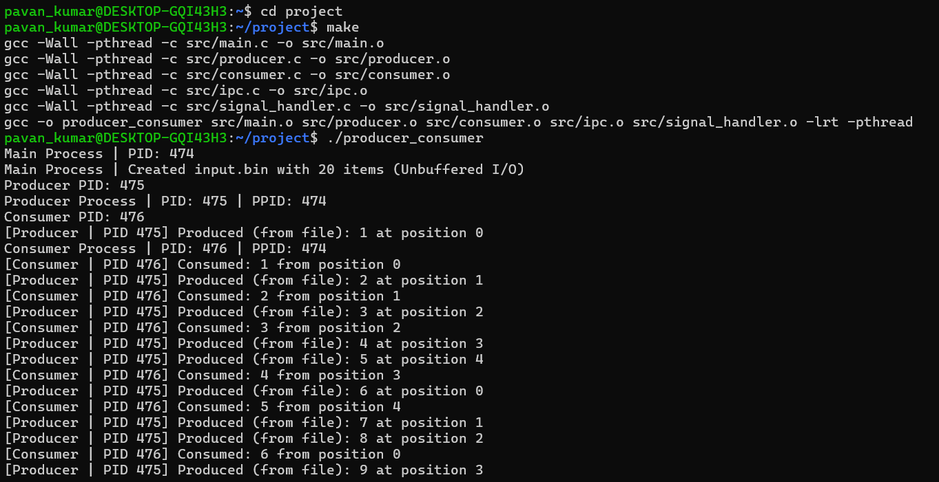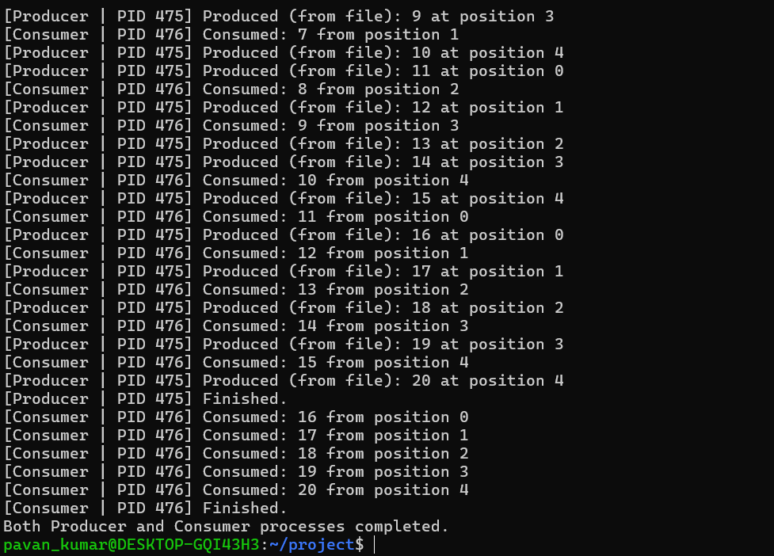

7.5 Demonstration of OS Concepts
The execution demonstrates process separation via fork(), IPC using POSIX shared memory, mutual exclusion via semaphores, unbuffered/buffered file operations, and process reclamation via waitpid().

CHAPTER - 8 CONCLUSION

8.1 Summary of the Project
This project implements a process-based concurrent Producer-Consumer system in Linux using POSIX shared memory and semaphores. Data is read from input.bin via unbuffered file I/O, passed through a bounded buffer, and written to output.txt using buffered file I/O.

8.2 Objectives Achieved
1. Implemented concurrent processes using fork() and waitpid().
2. Managed inter-process communication using POSIX shared memory.
3. Enforced mutual exclusion and synchronization using semaphores.
4. Integrated unbuffered and buffered file operations.

8.3 Results Achieved
Tests confirmed execution without race conditions, deadlocks, or buffer overflow/underflow conditions. Clean teardown routines verified proper release of semaphores and shared memory segments.

8.4 Skills and Learning Outcomes
The project provided practical experience with systems programming in Linux, process management, POSIX shared memory, semaphore synchronization, and signal handling.

CHAPTER - 9 REFERENCES

9.1 Books
1. Silberschatz, A., Galvin, P. B., & Gagne, G. (2018). Operating System Concepts (10th ed.). Wiley.
2. Love, R. (2013). Linux System Programming: Talking Directly to the Kernel and C Library (2nd ed.). O'Reilly Media.
3. Stevens, W. R., & Rago, S. A. (2013). Advanced Programming in the UNIX Environment (3rd ed.). Addison-Wesley.

9.2 Research Papers
1. Dijkstra, E. W. (1965). Cooperating sequential processes. Technologische Hogeschool Eindhoven.

9.3 Linux / GNU Documentation
1. Linux Programmer's Manual: shm_open(3), mmap(2), sem_open(3), fork(2).

9.4 Online Resources

1. Project GitHub Repository: https://github.com/pavankumar7744-droid/OSSP-PROJECT

