A Decentralized Voting Framework Integrating Blockchain and Self-Sovereign Identity

Major Project Report
Submitted in partial fulfillment of the requirements for the award of the degree

BACHELOR OF TECHNOLOGY
in

COMPUTER SCIENCE & ENGINEERING
by
SRIMANTHULA SAI THANMAI 22L31A05K8
TAVVA BHAVANI PRANATHI 22L31A05L7
THIPPANA RAKESH 22L31A05M2
TALASILA GEETHIKA 22L31A05L4

Under the Guidance of

VVRL. Sastry
Assistant Professor



Department of Computer Science & Engineering
2025 - 2026



CERTIFICATE

This is to certify that the project report entitled “A Decentralized Voting Framework Integrating Blockchain and self-sovereign Identity ” is a bonafide record of project work carried out under my supervision by Srimanthula Sai Thanmai (22L31A05K8), Tavva Bhavani Pranathi (22L31A05L7), Thippana Rakesh(22L31A05M2), Talasila Geethika(22L31A05L4), during the academic year 2022-2026, in partial fulfillment of the requirements for the award of the degree of Bachelor of Technology in Computer Science & Engineering of VIGNAN’S INSTITUTE OF INFORMATION TECHNOLOGY (Autonomous). The results embodied in this major project report have not been submitted to any other University or Institute for the award of any Degree.

Signature of Project Guide Head of the Department

Mr. VVRL. Sastry Mr. B. Dinesh Reddy
Assistant Professor Associate Professor

Signature of External Examiner

DECLARATION

We are hereby declare that the project report entitled “A Decentralized Voting Framework Integrating Blockchain and Self-Sovereign Identity” has been written by us and not been submitted either in part or whole for the award of any degree or any other similar title to university.

Srimanthula Sai Thanmai 22L31A05K8
Tavva Bhavani Pranathi 22L31A05L7
Thippana Rakesh 22L31A05M2
Talasila Geethika 22L31A05L4

Date:
Place: Visakhapatnam

ACKNOWLEDGMENT

We consider it as a privilege to thank all those people who helped us a lot for the successful completion of the project “A Decentralized Voting Framework Integrating Blockchain and Self-Sovereign Identity”.
First of all we would like to thank our project guide Mr.VVRL.Sastry, Assistant Professor, Department of Computer Science & Engineering for helping us a lot in completing our project work and for enlightening us with constructive suggestions for solving our problems patiently and helping us to improve the quality of work.
We would like to thank our ever-inspiring Head of the Department, Computer Science and Engineering, Mr. B. Dinesh Reddy, for his spontaneous response to every request though he is busy with his hectic schedule of administration and teaching.
We would like to thank the Principal of Vignan’s Institute of Information Technology Dr. J. Sudhakar, for his encouragement to us during the course of this project work.
We also express our sincere thanks to our beloved Chairman of Vignan’s Institutions
Dr. L. Rathaiah, who has given us a lot of support and freedom during our project work.
We express our thanks to all teaching faculty of Department of Computer Science and Engineering, VIIT whose suggestions during reviews helped us in accomplishment of our project. We would like to thank all non-teaching staff of the Department of Computer Science and Engineering, VIIT for providing great assistance in accomplishment of our project.

Srimanthula Sai Thanmai 22L31A05K8
Tavva Bhavani Pranathi 22L31A05L7
Thippana Rakesh 22L31A05M2
Talasila Geethika 22L31A05L4

ABSTRACT

Building a digital voting system that is secure, tamper-resistant, and protects voter privacy is still a major challenge. Most electronic voting platforms use centralized databases for voter registration and identity checks, which creates a single point of failure and risk in linking a voter's identity to their ballot. Although blockchain technology can improve voting security, many blockchain-based voting systems still rely on centralized authentication, which weakens privacy and makes the system vulnerable to cyberattacks. This research introduces a new decentralized voting framework that utilizes blockchain and self-sovereign identity (SSI) with decentralized identifiers (DIDs) and verifiable credentials (VCs). The main contribution is a method to verify uniqueness. This framework allows each person to vote only once without storing any confidential identifying information. By keeping only the cryptographic hash of the identification attributes used during credential creation, the system ensures uniqueness without the need for a central data storage facility.
Index Terms—Blockchain Voting, Self-Sovereign Identity, De- centralized Identifiers, Verifiable Credentials, Smart Contracts, Electronic Voting, Token-Based Voting, Identity Uniqueness

Keywords: Blockchain Voting, Self-Sovereign Identity, Digital Governance, Secure Elections,Voter authentication, Transparency, Decentralized identity, Cryptography

TABLE OF CONTENTS

Name of the Chapter Page No

Chapter-1 INTRODUCTION
  - Introduction 2
  - Blockchain Technology 4
  - Self-Sovereign Indentity 9
  - Objectives of the Project 13
  - Problem Statement 16
Chapter-2 LITERATURE REVIEW
  - Introduction 22
  - Blockchain Based Voting System 22
  - Identity Management In Electronic Voting 23
  - Self-Sovereign Indentity in Decentralized Systems 24
  - Challenges In Blockchain Voting System 26
  - Research Gaps 28
  - Motivation 30
  - Conclusion 32
Chapter-3 METHODOLOGY
  - Introduction 37
  - Research Design and Approach 38
  - System Architecture 38
  - Decentralized Identifier(DID) Generation 40

3.5 Verifiable Credential issuance | 43
3.6 Token-Based Voting Authorization | 44
3.7 Smart Contact Implementation | 45
3.8 System Workflow | 48
3.9 Implementation Tools and Technologies | 50
3.10 Conclusion | 52
Chapter-4 RESULTS AND DISCUSSIONS
4.1 Introduction | 56
4.2 System Implementation | 57
4.2.1 System Configuration | 59
4.3 Functional Testing | 59
4.4 Security Analysis | 52
4.5 Performance Evaluation | 63
4.6 User Interface Demonstration | 65
4.7 Discussion | 69
4.8 Conclusion | 72
Chapter -5 CONCLUSIONS AND FUTURE SCOPE OF WORK
5.1 Introduction | 77
5.2 Summary of the work | 79
5.3 Contribution of the Proposed System | 81
5.4 Practical application | 83
5.5 Future Work | 85
5.6 Conclusion | 88

Chapter-6 References
References 92

Appendix: Algorithm Code 93

Acceptance Letter 107

Draft of Research Article 109

LIST OF FIGURES

S.No | Name of the Figure | Page No
1 | Objectives of Decentralized Voting System | 10
2 | Self-Sovereign Decentralized System | 17
3 | System Architecture | 24
4 | DID Creation workflow | 26
5 | System workflow | 30
6 | System Implementation | 34
7 | Controls and Candidates | 40
8 | Admin panel | 40
9 | MetaMask Signature Request | 41

ABBREVIATIONS

SSI Self-Sovereign Identity
DID Decentralized Identity
VC Verifiable Credential
ZKP Zero Knowledge Proof
dApp Decentralized Application

API
Application Programming Interface

SHA-256 Secured Hash Algorithm 256-bit
ETH Ethereum

Chapter 1 Introduction

Chapter – 1 INTRODUCTION

Introduction
Voting is one of the fundamental mechanisms through which democratic societies allow citizens to participate in decision-making processes. Elections provide individuals with the opportunity to express their preferences and choose representatives who will govern on their behalf. For a democratic system to function effectively, the voting process must ensure transparency, fairness, security, and trust among participants.
Traditional voting systems are typically conducted using paper ballots or electronic voting machines managed by centralized authorities. While these methods have been widely used for decades, they suffer from several limitations such as vulnerability to fraud, lack of transparency, administrative inefficiencies, and high operational costs. In many cases, centralized election management systems store voter identities and voting records in centralized databases. These systems can become targets for cyberattacks, unauthorized manipulation, or internal misconduct.
Electronic voting systems were introduced to improve efficiency and speed in the electoral process. However, many existing e-voting systems still depend on centralized servers to authenticate voters and store voting records. The reliance on centralized infrastructure introduces several risks, including data breaches, vote manipulation, and privacy violations. Furthermore, ensuring that each voter casts only one vote while maintaining anonymity remains a significant challenge in digital voting systems.
Recent advancements in distributed computing and cryptography have opened new possibilities for designing more secure and transparent voting systems. Blockchain technology, which was originally developed as the underlying infrastructure for cryptocurrencies, provides a decentralized and tamper-resistant platform for recording transactions. The inherent characteristics of blockchain such as immutability, transparency, and distributed consensus make it a promising solution for secure digital voting. Traditional identity verification systems rely on centralized databases that store sensitive personal information.

Self-Sovereign Identity (SSI) is an emerging identity management paradigm that allows individuals to control their own digital identities without relying on centralized authorities.This project proposes a decentralized voting system that integrates blockchain technology with Self-Sovereign Identity (SSI). By combining these technologies, the system ensures secure voter authentication, prevents duplicate voting, and maintains voter anonymity. The proposed system uses decentralized identifiers (DIDs), verifiable credentials (VCs), and blockchain-based smart contracts to create a secure and transparent voting framework.
The integration of blockchain and SSI eliminates the need for centralized identity databases while ensuring that only eligible voters can participate in elections. Votes are recorded on the blockchain using smart contracts, making them immutable and publicly verifiable. This approach enhances trust in the electoral process and provides a secure foundation for future digital voting systems.

In recent years, the rapid advancement of digital technologies has significantly transformed the way public services are delivered, including the electoral process. Governments and organizations are increasingly exploring digital voting systems to improve efficiency, accessibility, and participation. However, the transition from traditional voting methods to digital platforms introduces new challenges related to security, privacy, and trust. Ensuring that digital voting systems are resistant to cyber threats while maintaining transparency is a critical requirement for their successful adoption.

One of the primary concerns in electronic voting systems is the reliance on centralized infrastructure. Centralized systems store sensitive voter information and voting records in a single location, making them vulnerable to attacks such as data breaches, unauthorized access, and system failures. These risks not only compromise the integrity of the election process but also reduce public confidence in the system. Therefore, there is a growing need for decentralized solutions that eliminate single points of failure and distribute trust across multiple participants.

Blockchain technology has emerged as a promising solution to address these

issues by providing a decentralized and immutable ledger for recording transactions. Its ability to ensure data integrity and transparency makes it highly suitable for applications where trust is essential, such as voting systems. However, while blockchain solves many challenges related to data security and transparency, it does not fully address the problem of secure and privacy-preserving identity management.
To overcome this limitation, Self-Sovereign Identity (SSI) introduces a decentralized approach to identity management, where individuals have full control over their personal data. SSI enables users to create and manage their digital identities without relying on centralized authorities. By using decentralized identifiers and verifiable credentials, users can prove their eligibility without revealing sensitive information. This approach enhances privacy and reduces the risk of identity-related attacks.

The integration of blockchain technology with Self-Sovereign Identity provides a comprehensive solution for building secure and transparent voting systems. Blockchain ensures that votes are recorded in an immutable and verifiable manner, while SSI enables secure and privacy-preserving voter authentication. Together, these technologies address the key challenges of digital voting, including security, anonymity, and trust.

Furthermore, the growing demand for secure online systems in areas such as governance, education, and corporate decision-making highlights the importance of developing reliable digital voting solutions. A well-designed decentralized voting system can not only improve the efficiency of elections but also increase participation by enabling remote and accessible voting. This makes it a valuable tool for modern democratic processes.

Blockchain Technology
Blockchain technology is a distributed and decentralized digital ledger system that enables secure, transparent, and tamper-resistant storage of data across a network of computers. Originally introduced as the foundational technology behind cryptocurrencies such as Bitcoin, blockchain has evolved into a versatile platform for

a wide range of applications, including finance, healthcare, supply chain management, and electronic voting systems.
Unlike traditional database systems that rely on centralized servers, blockchain operates on a peer-to-peer network where each participant, known as a node, maintains a copy of the entire ledger. This decentralized structure eliminates the need for a central authority and reduces the risks associated with centralized data storage, such as single points of failure, unauthorized access, and data manipulation.

A blockchain is composed of a sequence of blocks that are linked together in a chronological order to form a chain. Each block contains a set of transactions, a timestamp, and a unique cryptographic hash that identifies the block. Additionally, each block stores the hash of the previous block, creating a secure link between

consecutive blocks. This linking mechanism ensures that any attempt to alter the data in a block would require modification of all subsequent blocks, making the system highly resistant to tampering.

One of the fundamental features of blockchain technology is immutability. Once data is recorded and validated in a block, it cannot be modified or deleted without the consensus of the network participants. This property is achieved through cryptographic hashing techniques such as the SHA-256 hashing algorithm, which generates a unique fixed-length output for any given input. Even a small change in the input data results in a completely different hash value, making it easy to detect any unauthorized modifications.

Another important aspect of blockchain technology is its consensus mechanism. Since there is no central authority to validate transactions, blockchain networks rely on consensus algorithms to ensure agreement among participants. These mechanisms determine how new blocks are added to the chain and how conflicts are resolved. Common consensus algorithms include Proof of Work (PoW) and Proof of Stake (PoS). In platforms like Ethereum blockchain platform, consensus ensures that all nodes agree on the current state of the ledger, maintaining consistency and reliability.

Blockchain also supports the execution of smart contracts, which are self-executing programs stored on the blockchain. Smart contracts automatically enforce predefined rules and conditions without the need for intermediaries. Once deployed, these contracts execute deterministically, ensuring that the outcomes are predictable and cannot be altered. In the context of voting systems, smart contracts can be used to manage candidate registration, validate voting tokens, record votes, and compute election results.
Transparency is another key feature of blockchain technology. All transactions recorded on a public blockchain are visible to participants, allowing anyone to verify the integrity of the data. This transparency enhances trust in the system, as users can independently audit transactions without relying on a central authority. At the same time, cryptographic techniques ensure that sensitive information remains secure and

private.

Security in blockchain is achieved through a combination of cryptographic algorithms, decentralized architecture, and consensus mechanisms. Each participant in the network uses a pair of cryptographic keys—a public key and a private key—for secure communication and authentication. The private key is used to sign transactions, while the public key is used to verify them. This ensures that only authorized users can initiate transactions and that all actions are verifiable.

In addition to security and transparency, blockchain technology offers fault tolerance and high availability. Since the ledger is distributed across multiple nodes, the system continues to function even if some nodes fail or are compromised. This makes blockchain systems highly resilient compared to traditional centralized systems. In the context of the proposed decentralized voting system, blockchain technology plays a crucial role in ensuring the integrity and transparency of the election process. Votes are recorded as transactions on the blockchain, making them immutable and publicly verifiable. The decentralized nature of blockchain eliminates the need for a central authority to manage voting data, reducing the risk of manipulation and increasing trust among participants.

Furthermore, the integration of blockchain with Self-Sovereign Identity enhances the overall security of the voting system. While blockchain ensures secure storage and transparency of votes, SSI provides decentralized identity management, enabling voters to authenticate themselves without revealing sensitive personal information. Despite its advantages, blockchain technology also faces certain challenges. Scalability remains a major concern, as public blockchain networks may experience delays in processing transactions during periods of high demand. Additionally, transaction costs and energy consumption associated with certain consensus mechanisms can impact system efficiency.
In addition to its core features, blockchain technology supports decentralized governance by enabling consensus-driven decision-making processes. This ensures that all participating nodes agree on the validity of transactions before they are recorded.

Such mechanisms are particularly important in applications like voting, where trust and accuracy are critical. Furthermore, blockchain systems can be designed as public, private, or consortium networks depending on the level of accessibility and control required.

Another important aspect is the integration of blockchain with emerging technologies such as Internet of Things (IoT) and artificial intelligence. These integrations expand the applicability of blockchain beyond financial systems into areas like smart governance and secure digital identity management. In the context of voting systems, such integrations can further enhance automation, monitoring, and decision-making processes.

In addition to its basic structure, blockchain technology operates through a distributed network of nodes that collectively maintain and validate the ledger. Each node independently verifies transactions before they are added to a block, ensuring that only valid data is recorded. This decentralized validation process eliminates the need for a trusted central authority and enhances the overall reliability of the system. As a result, blockchain networks are inherently resistant to single points of failure and unauthorized manipulation.

Another important concept in blockchain technology is consensus algorithms, which are used to achieve agreement among network participants. Consensus mechanisms such as Proof of Work (PoW) and Proof of Stake (PoS) ensure that all nodes in the network agree on the current state of the ledger. These mechanisms prevent malicious actors from altering transaction data and maintain consistency across the network. In the context of voting systems, consensus ensures that every recorded vote is verified and accepted by the network, thereby enhancing trust and integrity.
Blockchain technology also supports advanced cryptographic techniques that ensure secure data handling. Each transaction is digitally signed using cryptographic keys, providing authentication and non-repudiation. Hashing algorithms are used to link blocks together, creating a chain that is resistant to tampering. Any attempt to modify data within a block would require recalculating all subsequent hashes, which is computationally infeasible in large networks. This makes blockchain highly secure for applications that require data immutability.

Another significant feature of blockchain is transparency combined with privacy. While transactions on a public blockchain are visible to all participants, sensitive information can be protected using encryption and pseudonymous identifiers. This allows users to verify transactions without revealing their identities. In voting systems, this feature is particularly valuable, as it enables public verification of election results while maintaining voter anonymity.

Furthermore, blockchain technology enables the development of decentralized applications (dApps), which operate without centralized control. These applications interact directly with smart contracts deployed on the blockchain, ensuring that all operations are executed according to predefined rules. The use of dApps enhances system automation, reduces dependency on intermediaries, and improves overall efficiency.

Despite its advantages, blockchain technology faces certain challenges that must be considered. Issues such as scalability, energy consumption, and transaction latency can affect system performance, especially in large-scale applications. Ongoing

research is focused on addressing these limitations through improved consensus mechanisms, layer-two solutions, and optimized network architectures. These advancements are expected to make blockchain more suitable for widespread adoption in critical applications such as digital voting.

Self-Sovereign Identity (SSI)
Self-Sovereign Identity (SSI) is a modern approach to digital identity management that enables individuals to own, control, and manage their personal identity information without relying on centralized authorities. In conventional identity management systems, user data is stored and maintained by centralized organizations such as government agencies, banks, or online service providers. Although these systems provide ease of access and management, they are vulnerable to issues such as data breaches, identity theft, misuse of personal information, and lack of user control.

SSI addresses these limitations by introducing a decentralized identity model in which individuals have full ownership of their digital identities. Instead of storing personal data in centralized databases, SSI allows users to store their identity information securely in digital wallets. This ensures that users can control who has access to their data and under what conditions it is shared. By eliminating centralized storage, SSI reduces the risk of large-scale data breaches and enhances user privacy.

A fundamental concept in SSI is the use of Decentralized Identifiers (DIDs). A DID is a globally unique identifier that is created, owned, and controlled by the user. Unlike traditional identifiers such as usernames or government-issued IDs, DIDs do not depend on any central authority. They are generated using cryptographic algorithms, typically based on public and private key pairs. The private key is securely stored by the user and is used for authentication, while the public key is used for verification. This cryptographic approach ensures that only the rightful owner can access and control their identity.

Another essential component of SSI is Verifiable Credentials (VCs). Verifiable credentials are digitally signed documents issued by trusted authorities that confirm specific attributes of a user. These attributes may include age, citizenship, or eligibility

to participate in certain activities such as voting. Unlike traditional certificates, verifiable credentials can be shared digitally and verified instantly without contacting the issuing authority. This improves efficiency and reduces dependency on centralized verification systems.
In addition to providing user control, SSI also supports decentralized trust frameworks. Instead of relying on a single authority, trust is distributed among multiple entities such as credential issuers, verifiers, and users. This reduces dependency on centralized institutions and enhances system reliability.

Moreover, SSI enables seamless digital interactions across multiple platforms. Since identities are portable and reusable, users do not need to repeatedly register or verify themselves for different services. This improves user experience and promotes wider adoption of decentralized identity solutions in real-world applications.

In addition to providing decentralized identity control, Self-Sovereign Identity emphasizes the concept of user autonomy and data ownership. Unlike traditional identity systems where organizations act as intermediaries, SSI allows individuals to create, manage, and share their identity information independently. This shift from institution-controlled identity to user-controlled identity represents a fundamental transformation in digital identity management and aligns with modern privacy regulations and user rights.

A key advantage of SSI is its ability to reduce identity fragmentation across multiple platforms. In conventional systems, users are required to create separate accounts for different services, leading to duplication of identity data and increased security risks. SSI enables a unified identity model where a single decentralized identifier can be used across multiple applications. This reduces redundancy and simplifies identity management while maintaining strong security.

Another important feature of SSI is its support for trust frameworks through verifiable credentials. These credentials are issued by trusted authorities and can be independently verified by any party without contacting the issuer. This decentralized verification process reduces dependency on intermediaries and improves efficiency.

In the context of voting systems, verifiable credentials ensure that only eligible individuals can participate while maintaining privacy.
SSI also enhances privacy through advanced mechanisms such as selective disclosure and zero-knowledge proofs. Selective disclosure allows users to share only specific attributes required for a transaction, such as proving eligibility without revealing full identity details. Zero-knowledge proofs further strengthen privacy by enabling users to prove a statement without disclosing the underlying data. These techniques are particularly useful in voting systems, where maintaining anonymity is essential.

Another significant aspect of SSI is its resilience against large-scale data breaches. Since identity data is not stored in centralized databases, the risk of mass data exposure is significantly reduced. Each user maintains control of their own identity information, and data is shared only when required. This decentralized storage model improves overall system security and reduces the impact of potential cyberattacks.

Furthermore, SSI supports interoperability and standardization through frameworks such as W3C standards for decentralized identifiers and verifiable credentials. These standards ensure compatibility across different platforms and applications, enabling seamless integration of identity systems. This interoperability is essential for large-scale adoption and allows SSI-based solutions to be used in diverse domains, including digital governance, healthcare, finance, and voting systems.

In conclusion, Self-Sovereign Identity provides a secure, privacy-focused, and user-centric approach to identity management. Its integration with blockchain technology creates a powerful foundation for decentralized applications, particularly in scenarios where trust, security, and privacy are critical. By enabling users to control their identities and share information securely, SSI plays a vital role in the development of next-generation digital systems.

One of the most significant advantages of SSI is selective disclosure. This feature allows users to share only the necessary information required for a specific transaction while keeping the rest of their data private. For example, a user can prove that they are eligible to vote without revealing their full identity details. This capability is particularly important in applications where privacy is a critical concern, such as electronic voting systems. SSI also enhances security by leveraging cryptographic techniques. Since identity data is not stored in centralized servers, the risk of unauthorized access is minimized. Additionally, digital signatures and cryptographic verification ensure that identity information cannot be altered or forged. This makes SSI a highly secure solution for digital identity management.

In the context of the proposed decentralized voting system, SSI plays a crucial role in enabling secure and privacy-preserving voter authentication. Voters generate their own decentralized identifiers and obtain verifiable credentials after eligibility verification. These credentials are used to prove voter eligibility without revealing personal information. As a result, the system ensures that only authorized individuals can participate in the election while maintaining anonymity during vote casting. Furthermore, SSI supports interoperability and scalability, making it suitable for large-scale applications. It can be integrated with blockchain technology to create secure and decentralized systems that do not rely on trusted intermediaries. This integration enhances transparency and trust in digital processes.

In conclusion, Self-Sovereign Identity represents a transformative approach to digital identity management by empowering individuals with full control over their personal data. Its decentralized nature, combined with strong security mechanisms and privacy-preserving features, makes it an ideal solution for modern applications such as blockchain-based voting systems, where trust, security, and privacy are of utmost importance.

Objectives Of the Project
The primary objective of this project is to design and develop a secure, transparent, and decentralized voting system by integrating blockchain technology with Self-Sovereign Identity (SSI). The system aims to address the major limitations of traditional and existing electronic voting systems, such as centralized control, lack of transparency, risk of vote manipulation, and privacy concerns. By leveraging decentralized technologies, the project seeks to build a reliable and trustworthy platform for conducting digital elections. One of the key objectives of the project is to implement a blockchain-based infrastructure for secure vote storage. Blockchain technology provides an immutable and distributed ledger that ensures all recorded votes remain tamper-proof. Once a vote is added to the blockchain, it cannot be modified or deleted, thereby preserving the integrity of the election process. This feature eliminates the possibility of unauthorized manipulation and enhances trust among voters and administrators.

Another important objective is to incorporate Self-Sovereign Identity mechanisms to enable secure and privacy-preserving voter authentication. The system allows users to create decentralized identifiers and obtain verifiable credentials that confirm their eligibility to vote. Unlike traditional identity systems, this approach does not require storing sensitive personal data in centralized databases. Instead, users retain full control over their identity information and share only the necessary details when required. This ensures both security and privacy during the authentication process.

The project also aims to design and implement a token-based voting mechanism that enforces the principle of one-person-one-vote. Each eligible voter is issued a unique voting token after successful verification. This token acts as a secure authorization mechanism that allows the voter to cast a vote. Once the vote is submitted, the token is invalidated, preventing any further use. This approach effectively eliminates duplicate voting while maintaining voter anonymity.

In addition, the project focuses on the development of smart contracts to automate various election processes. These smart contracts are responsible for

managing candidate registration, validating voting tokens, recording votes, and counting results. The use of smart contracts ensures that all operations are executed automatically and transparently without requiring manual intervention. This reduces the risk of human error and enhances the efficiency of the voting system. Another objective of the project is to develop a user-friendly decentralized application (dApp) that allows voters to interact with the system easily. The application provides functionalities such as identity creation, credential verification, token generation, and vote casting through an intuitive interface. This ensures accessibility and ease of use for all participants.

Furthermore, the project aims to evaluate the performance, security, and reliability of the proposed system through testing and analysis. The system is designed to handle real-world scenarios while maintaining scalability and efficiency.The system is built upon five primary objectives: security, privacy, transparency, scalability, and efficiency. Security is achieved through tamper-proof vote storage using blockchain technology, ensuring that once votes are recorded, they cannot be altered or deleted. Privacy is maintained using Self-Sovereign Identity mechanisms, which allow voters to authenticate themselves without revealing sensitive personal information.

Transparency is ensured through the use of a public blockchain ledger, where all voting transactions can be verified independently. Scalability refers to the system’s ability to handle a large number of voters efficiently without performance degradation. Efficiency is achieved through the use of automated smart contracts, which reduce manual intervention and streamline election processes.

All these objectives collectively support the principle of “One Person One Vote,” implemented through a token-based mechanism. This ensures that each voter can cast only one vote while maintaining anonymity, thereby enhancing fairness and trust in the voting system. In addition to the primary objectives, the project also aims to enhance trust in digital voting systems by ensuring end-to-end transparency. By recording all voting transactions on a blockchain ledger, the system allows participants to independently verify the integrity of the election process. This transparency reduces skepticism among users and increases confidence in the final results, which is essential for the adoption of digital voting platforms.

Another important objective is to minimize dependency on centralized authorities in both identity management and vote handling. Traditional systems rely heavily on trusted intermediaries, which can introduce risks such as bias, manipulation, or system failure. The proposed system seeks to eliminate these dependencies by distributing control across a decentralized network, thereby improving system resilience and reliability.
The project also focuses on achieving a balance between security and usability. While strong security mechanisms are necessary to protect the voting process, the system must also be user-friendly to ensure widespread adoption. The objective is to design an intuitive interface that allows users to interact with complex blockchain and identity technologies without requiring deep technical knowledge. This ensures accessibility for a broader range of users.

Another key objective is to ensure scalability and adaptability of the system. The proposed framework is designed to handle increasing numbers of users and transactions without significant performance degradation. Additionally, the system architecture is flexible, allowing it to be adapted for various use cases such as academic elections, corporate decision-making, and government voting processes.

The project also aims to support interoperability with other digital systems and platforms. By following standardized protocols for decentralized identifiers and verifiable credentials, the system can integrate with existing identity frameworks and blockchain networks. This interoperability enhances the system’s practicality and enables it to be deployed in diverse environments.

Furthermore, the project seeks to promote innovation in the field of digital governance by demonstrating the practical application of emerging technologies. By integrating blockchain and Self-Sovereign Identity, the system provides a modern approach to solving long-standing challenges in voting systems. This objective contributes to the broader goal of developing secure, transparent, and efficient digital infrastructures for future governance systems.

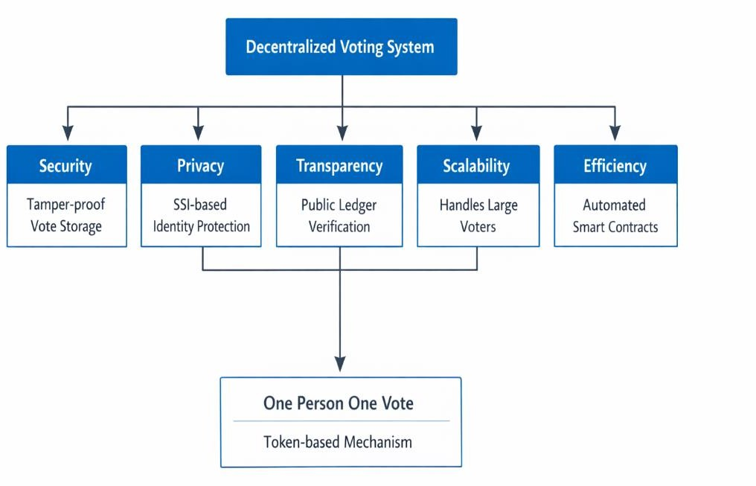

Figure 1.4. Objectives of Decentralized Voting System

Problem Statement
Ensuring secure, transparent, and trustworthy voting systems is a major challenge in modern democracies. Traditional voting methods rely heavily on centralized authorities to manage voter registration, identity verification, and vote counting. These centralized systems create potential risks such as manipulation of voter

databases, unauthorized access to sensitive information, and lack of transparency in vote counting.
Electronic voting systems were developed to improve efficiency and accessibility in elections. However, many existing e-voting platforms still depend on centralized infrastructure for identity verification and vote storage. This reliance introduces several challenges, including vulnerability to cyberattacks, data manipulation, and privacy concerns.

Another major challenge in digital voting systems is maintaining voter anonymity while ensuring that each individual votes only once. Traditional authentication mechanisms often require voters to reveal sensitive personal information, which can compromise privacy. Additionally, centralized identity verification processes create single points of failure that attackers may exploit.

Therefore, there is a need for a decentralized voting system that ensures secure identity verification, prevents duplicate voting, protects voter privacy, and maintains transparency in the electoral process. The integration of blockchain technology and Self-Sovereign Identity offers a promising solution to address these challenges and improve the overall integrity of digital voting systems. In addition to these challenges, maintaining voter trust in digital voting systems is a significant concern. Many existing systems lack transparency in the vote recording and counting process, making it difficult for voters to verify whether their votes have been accurately counted. This lack of visibility can lead to skepticism and reduced participation in elections.
Another critical issue is the difficulty in ensuring both voter anonymity and accountability simultaneously. While it is essential to protect voter identity, the system must also guarantee that only eligible voters participate and that each voter casts only one vote. Achieving this balance using traditional methods is complex and often inefficient. Furthermore, existing systems are not well-equipped to handle large-scale deployments without performance issues or security risks. These limitations highlight the need for a robust, decentralized solution that ensures secure identity verification, prevents duplicate voting, preserves anonymity, and provides transparent and tamper-proof vote management throughout the election process.

In addition to the challenges discussed above, the increasing digitization of

public services has created a strong demand for secure and scalable online voting solutions. As governments and organizations move toward digital platforms, the need for reliable electronic voting systems becomes more critical. A well-designed digital voting system must not only ensure accuracy and efficiency but also build public confidence by providing verifiable and tamper-proof processes.

One of the major concerns in existing systems is the lack of end-to-end verifiability. Voters often have no way to independently confirm whether their vote has been correctly recorded and counted. This limitation reduces transparency and can lead to distrust in election outcomes. A decentralized approach, where voting data is distributed across multiple nodes, addresses this issue by enabling public verification without compromising data integrity.

Another important aspect is the protection of voter privacy. In many traditional and electronic systems, voter identity is closely linked to the voting process, which increases the risk of privacy breaches. Ensuring anonymity while maintaining accountability is a complex requirement. The integration of advanced cryptographic techniques and decentralized identity models helps achieve this balance by separating identity verification from vote casting.

Furthermore, the evolution of decentralized technologies has made it possible to rethink the architecture of voting systems. Instead of relying on a single authority, modern systems can distribute trust across multiple participants. This reduces dependency on centralized institutions and minimizes the risk of manipulation or failure. The combination of blockchain and Self-Sovereign Identity represents a significant step in this direction by providing both secure data storage and user-controlled identity management.

In addition, scalability and usability are critical factors for real-world adoption. A voting system must be capable of handling a large number of users while maintaining performance and security. At the same time, it should be accessible to individuals with

varying levels of technical knowledge. Designing user-friendly interfaces and efficient backend mechanisms is essential to ensure widespread
acceptance of digital voting platforms.

The proposed system not only addresses existing technical limitations but also contributes to the broader vision of digital governance. By enabling secure, transparent, and privacy-preserving voting, it supports the development of more inclusive and trustworthy democratic processes. The integration of decentralized technologies in governance systems has the potential to redefine how elections and decision-making processes are conducted in the future.

Another critical requirement for modern voting systems is resilience against both internal and external threats. Traditional systems are not only vulnerable to cyberattacks but also to insider manipulation, where authorized personnel may misuse their privileges. A decentralized architecture significantly reduces such risks by

eliminating single points of control and distributing authority across multiple nodes. This ensures that no single entity has complete control over the voting process, thereby enhancing system integrity and reliability.

Moreover, auditability plays a vital role in strengthening trust in electoral systems. In conventional voting methods, auditing often requires complex procedures and may still fail to guarantee complete transparency. In contrast, blockchain-based systems enable real-time auditing through publicly accessible ledgers. Every transaction, including vote casting and counting, is recorded in a verifiable manner, allowing independent entities to validate the results without compromising voter privacy. This capability significantly improves accountability and reduces disputes related to election outcomes.

Interoperability is another important factor that influences the effectiveness of digital voting systems. A robust voting framework should be capable of integrating with various identity providers, governance platforms, and digital infrastructures. Self-Sovereign Identity facilitates this by using standardized formats such as decentralized

identifiers and verifiable credentials, enabling seamless interaction across different systems. This flexibility allows the proposed solution to be adapted for diverse use cases, including government elections, academic institutions, and corporate decision-making processes.
Another critical issue in current voting systems is the lack of transparency in administrative processes. Election authorities often have complete control over data management, making it difficult for voters to verify the integrity of the system. This lack of visibility can reduce public trust and participation.

Furthermore, existing systems often fail to provide a balance between security and usability. While highly secure systems may be complex and difficult to use, simpler systems may lack adequate protection. This highlights the need for a solution that ensures both ease of use and strong security mechanisms.

Chapter 2 Literature Review

Chapter-2 LITERATURE REVIEW

Introduction
Electronic voting systems have been widely researched as a means to improve the efficiency, accessibility, and transparency of elections. Traditional voting methods such as paper ballots and electronic voting machines often face challenges related to vote manipulation, lack of transparency, and centralized control. With the rapid development of digital technologies, researchers have explored various approaches to build secure and trustworthy electronic voting systems.
In recent years, blockchain technology has emerged as a promising solution for addressing many of the limitations associated with conventional voting systems. Blockchain provides a decentralized and tamper-resistant platform for storing transactions, making it suitable for applications that require high levels of trust and data integrity. At the same time, identity verification remains a critical challenge in digital voting systems. Ensuring that each eligible voter can vote only once while preserving anonymity requires secure and privacy- preserving identity management mechanisms. Self-Sovereign Identity (SSI) has gained attention as a decentralized identity management approach that allows individuals to control their digital identities. By combining blockchain technology with SSI mechanisms such as decentralized identifiers (DIDs) and verifiable credentials (VCs), it is possible to design voting systems that enhance security, transparency, and privacy.
This chapter reviews previous research related to blockchain-based voting systems, digital identity management in electronic voting, and the use of Self-Sovereign Identity in decentralized applications. It also identifies research gaps that motivate the development of the proposed decentralized voting framework

Blockchain-Based Voting Systems
Blockchain-based voting systems have been widely studied as a way to improve election transparency and security. The decentralized nature of blockchain eliminates the need for a

central authority to manage voting records. Instead, votes are recorded on a distributed ledger that is shared among multiple network participants.
One of the early examples of blockchain voting systems is Helios, a web-based open- audit voting system designed to provide transparency and verifiability in elections. Helios allows voters to verify that their votes have been correctly recorded while maintaining ballot secrecy. However, the system still relies on centralized authentication mechanisms, which limits its decentralization. Another blockchain-based voting platform is EtherVote, which uses the Ethereum blockchain to record votes through smart contracts. Smart contracts automatically enforce voting rules and ensure that votes cannot be altered once recorded. This approach improves transparency and eliminates the possibility of tampering with voting records.
Similarly, the ElectAnon system proposed the use of blockchain to provide anonymous voting while maintaining public verifiability. In this system, votes are encrypted before being submitted to the blockchain. Although the system enhances vote confidentiality, it still relies on centralized identity verification processes. Research studies have shown that blockchain technology can significantly improve the security and transparency of voting systems. However, many blockchain-based voting solutions continue to rely on centralized identity verification mechanisms. This dependence creates potential privacy risks and undermines the goal of full decentralization.

Identity Management in Electronic Voting Systems
Identity verification is one of the most critical aspects of electronic voting systems. To ensure fairness in elections, it is necessary to verify that each voter is eligible and that no individual can vote more than once. Traditional electronic voting systems typically use centralized identity databases to authenticate voters. In centralized identity management systems, personal information such as national identification numbers, voter registration details, and biometric data is stored in centralized servers. While these systems enable efficient authentication, they also introduce several security and privacy risks.

Researchers have proposed several identity management techniques to address these issues. Some systems use cryptographic techniques such as digital signatures and public key.infrastructure to authenticate voters. Others rely on biometric verification methods such as fingerprint or facial recognition. Although these approaches improve authentication security, they still depend on centralized authorities to manage identity data. This centralized architecture creates single points of failure and limits the scalability of electronic voting systems. Furthermore, storing sensitive personal information in centralized databases raises concerns about data privacy and misuse.
These challenges highlight the need for decentralized identity management solutions that can securely verify voter eligibility while protecting personal information.

Self-Sovereign Identity in Decentralized Systems
Self-Sovereign Identity (SSI) has emerged as a transformative approach to identity management in decentralized systems. Traditional identity frameworks rely on centralized authorities such as governments, banks, or service providers to issue, manage, and verify user identities. While these systems provide structured identity verification, they introduce several limitations, including lack of user control, increased risk of data breaches, and dependency on centralized infrastructure.

SSI addresses these challenges by shifting identity ownership from institutions to individuals. In a decentralized system, users create and manage their own digital identities without relying on a central authority. This is achieved through cryptographic technologies that ensure security, authenticity, and privacy. SSI enables users to have full control over their identity data, allowing them to decide what information to share and with whom.

A core component of SSI is the use of Decentralized Identifiers (DIDs). These identifiers are unique, user-generated digital identities that are not tied to any centralized registry. DIDs are typically created using public and private key pairs, ensuring that only the owner has control over their identity. The decentralized nature of DIDs eliminates the risk of a single point of failure and enhances the resilience of identity systems.

Another key element of SSI is Verifiable Credentials (VCs). These are digitally signed credentials issued by trusted entities that confirm specific attributes of a user. For example, an institution may issue a credential verifying a user’s eligibility to vote. These credentials can be stored in digital wallets and presented when required. Importantly, VCs can be verified without contacting the issuing authority, making the process efficient and decentralized. In decentralized systems, SSI plays a critical role in enabling secure and privacy-preserving interactions. One of its most important features is selective disclosure, which allows users to reveal only the necessary information for a given transaction. This ensures that sensitive personal data is not unnecessarily exposed, thereby enhancing privacy.
SSI also supports interoperability across different platforms and systems. Since decentralized identifiers and verifiable credentials follow standardized formats, they can be used across multiple applications without requiring re-registration or repeated identity verification. This reduces redundancy and improves user experience.

In the context of blockchain-based applications, SSI complements the decentralized nature of blockchain technology. While blockchain provides a secure and immutable ledger for storing transactions, SSI provides a decentralized mechanism for identity management. Together, they create a robust framework for building secure and transparent systems. In electronic voting systems, SSI offers a powerful solution for voter authentication. It enables the system to verify voter eligibility without storing sensitive personal data. By combining SSI with blockchain, it is possible to design voting systems that ensure both anonymity and accountability. Voters can prove their eligibility using verifiable credentials, while their votes remain anonymous and unlinkable to their identities.

Despite its advantages, SSI also faces challenges such as key management, user adoption, and standardization. Users must securely manage their private keys, and the system must ensure usability for non-technical users. However, ongoing research and development are addressing these issues, making SSI increasingly practical for real-world applications.

In conclusion, Self-Sovereign Identity provides a secure, privacy-preserving, and decentralized approach to identity management. Its integration with blockchain technology offers a promising solution for applications such as digital voting,.

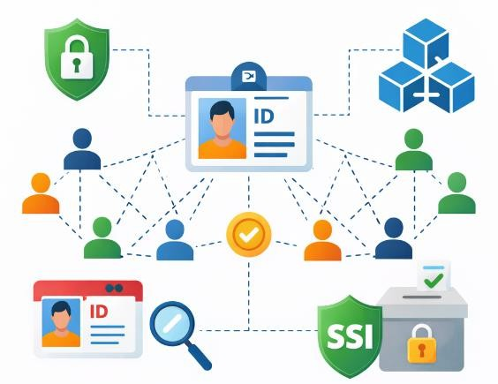

Fig 2.4. Self-Sovereign Decentralized System

Challenges in Blockchain Voting System
Although blockchain-based voting systems offer several advantages, they also face certain challenges that must be addressed for large-scale adoption. One major challenge is ensuring voter anonymity while maintaining transparency. While blockchain ledgers are publicly accessible, linking voter identities to voting transactions must be avoided to preserve privacy.

Another challenge is scalability. Public blockchain networks may experience delays due to network congestion and transaction confirmation times. This can affect the efficiency of voting systems that require rapid processing of large numbers of votes during elections. Additionally, managing voter identity in decentralized environments remains complex. While blockchain can securely store voting records, verifying voter eligibility without centralized authorities requires advanced identity management mechanisms.
Security is another important concern. Smart contracts used in blockchain voting systems must be carefully designed and audited to prevent vulnerabilities that could compromise the election process.Despite these challenges, continuous advancements in blockchain technology, cryptographic techniques, and decentralized identity frameworks are helping to improve the feasibility of blockchain-based voting systems.

In addition to the identified limitations, another significant research gap lies in the lack of integration between secure identity management and decentralized voting mechanisms. Many existing blockchain-based voting systems focus primarily on ensuring vote immutability and transparency, but they often overlook the importance of robust identity verification. As a result, these systems may still be vulnerable to unauthorized access or duplicate participation if identity mechanisms are not properly enforced. Furthermore, several proposed systems rely on storing user-related information directly or indirectly on centralized or semi-centralized servers, which contradicts the fundamental principles of decentralization. This creates potential points of failure and increases the risk of data breaches. There is a clear need for a fully decentralized approach where both identity management and vote storage operate without reliance on centralized infrastructure.

Another gap observed in existing research is the limited focus on maintaining a balance between voter anonymity and accountability. While some systems prioritize anonymity, they often lack mechanisms to ensure that only eligible users can participate. On the other hand, systems that enforce strict identity verification may compromise user privacy. This highlights the necessity for a solution that ensures both secure authentication and complete anonymity during the voting process. Additionally,

scalability and usability remain underexplored areas in current solutions. Many systems are not designed to handle large-scale deployments efficiently, especially in scenarios involving thousands or millions of voters. User interfaces are also often complex, limiting accessibility for non-technical users.
The proposed system aims to bridge these research gaps by integrating Self-Sovereign Identity with blockchain technology. This approach ensures decentralized identity verification, prevents duplicate voting, preserves voter anonymity, and provides a scalable and user-friendly voting platform.

Research Gap
The literature review reveals that significant progress has been made in the development of blockchain-based voting systems. However, several limitations remain in existing approaches. Many proposed systems rely on centralized identity verification processes, which contradict the goal of full decentralization. These systems often require voters to submit personal information to centralized authorities, creating privacy concerns and potential security risks. Another limitation is the lack of integration between decentralized identity frameworks and blockchain-based voting platforms. While SSI technologies provide strong privacy-preserving identity solutions, they have not been widely implemented in real-world voting systems.

Therefore, there is a need for a comprehensive framework that integrates blockchain technology with Self-Sovereign Identity to provide secure voter authentication, prevent duplicate voting, and maintain voter anonymity.

Another observation from the literature is the limited focus on user experience and accessibility. Many proposed systems are technically sound but may not be practical for real-world adoption due to their complexity. This indicates a need for solutions that are not only secure and decentralized but also user-friendly and easy to deploy. Furthermore, scalability remains a critical concern, as many systems are tested only in controlled environments with limited users. Real-world implementation requires systems that can efficiently handle large volumes of transactions without compromising performance or security.

Another important limitation identified in existing studies is the lack of comprehensive security evaluation under real-world threat scenarios. While many proposed systems claim to be secure due to the use of blockchain and cryptographic techniques, they often do not address practical attack vectors such as phishing, wallet compromise, smart contract vulnerabilities, and denial-of-service attacks. Additionally, issues related to key management, such as loss of private keys or unauthorized access to user wallets, are not sufficiently explored.
Another important research gap identified is the lack of robust mechanisms for ensuring identity recovery and key management in decentralized identity systems. Since Self-Sovereign Identity relies heavily on private keys, the loss or compromise of these keys can result in permanent loss of access to user identities. Existing studies provide limited solutions for secure and user-friendly recovery mechanisms, which is critical for real-world adoption. Additionally, many existing voting systems do not adequately address the issue of coercion resistance. In real-world scenarios, voters may be influenced or forced to vote in a particular way. Most blockchain-based voting models lack mechanisms such as re-voting or vote updating within a defined time period, which could help mitigate coercion and vote-buying practices.

Another gap lies in the limited exploration of end-to-end verifiability combined with strong privacy guarantees. While some systems offer transparency through public ledgers, they often do not provide voters with the ability to independently verify that their vote has been correctly recorded and counted without compromising anonymity. Achieving both verifiability and privacy simultaneously remains a complex challenge that is not fully addressed in current research.

Furthermore, interoperability between different blockchain platforms and identity systems is not sufficiently explored. Many proposed solutions are tightly coupled with specific blockchain networks or identity frameworks, limiting their adaptability. A more flexible and interoperable approach is required to ensure that voting systems can be integrated with various digital infrastructures and governance platforms.

Motivation
The motivation behind this project arises from the need to build a secure and transparent digital voting system that addresses the limitations of traditional and existing electronic voting platforms. In many countries, concerns about election security, voter fraud, and lack of transparency continue to affect public trust in electoral processes.
Blockchain technology provides a reliable platform for storing votes in a tamper- resistant manner, while Self-Sovereign Identity enables decentralized and privacy-preserving identity verification. By combining these technologies, it is possible to design a voting system that eliminates reliance on centralized identity databases and improves voter privacy.
The proposed decentralized voting system aims to ensure that each voter receives exactly one voting credential while maintaining complete anonymity during vote casting. The system also provides transparent vote recording and counting through blockchain-based smart contracts.
This approach not only enhances the security of digital elections but also demonstrates how decentralized technologies can be applied to real-world governance systems.In addition to the insights gathered from existing studies, it is evident that the combination of blockchain technology and decentralized identity mechanisms has significant potential to transform traditional voting systems. The reviewed literature indicates that while individual technologies provide partial solutions, their integration can address multiple challenges simultaneously, including security, transparency, and privacy.
Another key finding is that the adoption of decentralized approaches can eliminate the dependency on trusted intermediaries, thereby reducing the risk of manipulation and system failures. However, practical implementation challenges such as scalability, usability, and user awareness still need to be addressed to ensure widespread adoption.Overall, the literature strongly supports the development of a decentralized voting framework that leverages both blockchain and Self-Sovereign Identity to achieve a secure and reliable election process.

In recent years, several researchers have explored the integration of cryptographic techniques with electronic voting systems to enhance security and privacy. Techniques such as homomorphic encryption and blind signatures have been proposed to ensure that votes remain confidential while still allowing accurate tallying. Homomorphic encryption enables computations to be performed directly on encrypted data, allowing vote counting without decrypting individual ballots. Similarly, blind signature schemes ensure that the authority can verify voter eligibility without knowing the actual vote content. These approaches significantly improve privacy but often introduce computational complexity and implementation challenges in large-scale systems.

Another area of research focuses on the use of distributed ledger technologies beyond traditional blockchain frameworks. Variants such as Directed Acyclic Graphs (DAGs) and consortium blockchains have been proposed to address scalability and performance limitations of public blockchains. These systems aim to reduce transaction latency and increase throughput, making them more suitable for large-scale elections. However, many of these approaches compromise on decentralization to achieve better performance, which may introduce partial trust dependencies.

Researchers have also investigated hybrid voting models that combine centralized and decentralized components. In such systems, blockchain is used primarily for vote storage and verification, while identity management remains centralized. Although this approach improves efficiency and reduces implementation complexity, it does not fully eliminate the risks associated with centralized identity databases. As a result, these hybrid models fail to achieve complete decentralization and still remain vulnerable to identity-related attacks.
Furthermore, studies have highlighted the importance of usability and accessibility in electronic voting systems. Many proposed solutions focus heavily on security and cryptographic strength but overlook user experience. Complex interfaces, difficult key management, and lack of awareness can hinder user adoption, especially among non-technical users. Research indicates that a successful voting system must

balance security with simplicity, ensuring that users can participate without compromising system integrity.
In addition, several research efforts emphasize the role of trust frameworks and governance models in decentralized systems. Trust in blockchain-based voting does not rely solely on technology but also on the design of protocols, consensus mechanisms, and institutional support. Some studies suggest that integrating regulatory frameworks and standardization efforts can improve the adoption of decentralized voting systems in real-world scenarios.

Recent advancements in Self-Sovereign Identity have further strengthened the potential of decentralized voting systems. Research shows that SSI-based models can effectively eliminate centralized identity storage while ensuring secure and verifiable authentication. By leveraging decentralized identifiers and verifiable credentials, these systems allow users to prove eligibility without exposing personal data. However, practical implementations of SSI in voting systems are still limited, and more research is required to address challenges such as key management, recovery mechanisms, and large-scale deployment.

Conclusion

In conclusion, the literature review demonstrates that significant advancements have been made in the field of electronic voting systems, particularly with the adoption of blockchain technology. Researchers have explored various methods to improve transparency, security, and reliability in voting processes. Blockchain-based solutions have shown strong potential in ensuring tamper-resistant vote storage and enabling public verifiability. These systems reduce the risk of data manipulation and increase trust in election outcomes by maintaining an immutable and distributed ledger.

Despite these advancements, many existing voting systems continue to rely on centralized identity verification mechanisms. This dependence introduces vulnerabilities such as single points of failure, privacy risks, and susceptibility to cyberattacks. Even in blockchain-based implementations, identity management is often handled separately through centralized authorities, which contradicts the

principle of decentralization. As a result, achieving both secure authentication and complete privacy remains a major challenge in current research.
The review also highlights the growing importance of Self-Sovereign Identity as a decentralized approach to identity management. SSI enables individuals to control their own identity data and share only the necessary information through verifiable credentials. This approach significantly enhances privacy and reduces the risks associated with centralized data storage. However, the practical integration of SSI into voting systems is still in its early stages, and many proposed models lack real-world implementation and evaluation.

Furthermore, issues such as scalability, usability, and system complexity remain key concerns in existing solutions. While many systems are technically robust, they often lack user-friendly interfaces and are not optimized for large-scale deployment. Efficient handling of high transaction volumes, simplified key management, and improved accessibility are essential for real-world adoption. These challenges indicate that further research is required to design systems that balance security, performance, and user experience.

Overall, the literature suggests that while individual technologies such as blockchain and SSI offer promising solutions, their combined application has not been fully realized. There is a clear need for a comprehensive framework that integrates decentralized identity verification with secure and transparent vote management. The proposed system addresses this gap by combining blockchain technology with Self-Sovereign Identity to create a secure, privacy-preserving, and scalable voting platform suitable for modern digital governance.
The literature review highlights the significant progress made in the field of electronic voting systems, particularly with the introduction of blockchain technology as a secure and transparent data management solution. Various studies have demonstrated that blockchain provides immutability, decentralization, and public verifiability, making it highly suitable for voting applications. Systems such as Helios, EtherVote, and ElectAnon have shown improvements in vote transparency and integrity; however, these systems still rely on centralized identity verification

mechanisms. This dependence contradicts the core principle of decentralization and introduces vulnerabilities such as single points of failure, data breaches, and privacy risks.
A critical observation from the reviewed literature is that identity management remains one of the weakest components in most existing voting systems. Traditional approaches depend on centralized databases that store sensitive user information, making them attractive targets for cyberattacks. Even in blockchain-based systems, identity verification is often handled externally or through centralized authorities, which compromises user privacy and system security. This gap emphasizes the need for a decentralized identity framework that can ensure both authentication and privacy simultaneously.

Self-Sovereign Identity (SSI) emerges as a promising solution to address these challenges. By allowing users to control their identity data through decentralized identifiers and verifiable credentials, SSI eliminates the need for centralized identity storage. The concept of selective disclosure further enhances privacy by enabling users to share only the required information. Despite its advantages, the practical implementation of SSI in voting systems is still limited, and most research remains theoretical or partially implemented. This indicates a strong need for integrated solutions that combine SSI with blockchain in a practical and scalable manner.

Another key finding from the literature is the lack of balance between anonymity and accountability. Many systems either prioritize anonymity at the cost of verification or enforce strict identity checks that compromise privacy. Achieving both simultaneously remains a complex challenge. Additionally, scalability and usability are underexplored areas, as many systems are tested only in controlled environments with limited users. Real-world deployment requires solutions that can handle large populations while remaining user-friendly.

Furthermore, issues such as key management, identity recovery, coercion resistance, and interoperability have not been adequately addressed in existing research. These factors are crucial for ensuring the practical adoption of decentralized voting

systems. Without proper solutions, users may face challenges in managing identities or recovering access, which can affect system reliability.
In conclusion, the literature review clearly indicates that while blockchain and SSI individually offer strong solutions, their combined implementation in voting systems is still in its early stages. There is a clear research gap in developing a fully decentralized, privacy-preserving, and scalable voting framework. The proposed system aims to address these limitations by integrating blockchain with Self-Sovereign Identity, providing a comprehensive solution that ensures secure authentication, prevents duplicate voting, and maintains voter anonymity. This integration represents a significant step toward building trustworthy and efficient digital voting systems for future applications.

Chapter 3 Methodology

36

Chapter–3 METHODOLOGY

Introduction
The methodology of this research focuses on designing and implementing a secure, transparent, and decentralized voting system by integrating blockchain technology with Self-Sovereign Identity (SSI). The proposed approach aims to overcome the limitations of traditional voting systems, such as centralized control, lack of transparency, vulnerability to tampering, and privacy concerns. By leveraging decentralized technologies, the system ensures that voting operations are conducted in a secure and trustworthy manner without relying on a central authority.

The methodology adopts a structured and modular approach, where each component of the system contributes to achieving the overall objectives of security, privacy, and transparency. The system architecture is designed as a multi-layer model consisting of the user interface layer, identity verification layer, smart contract layer, and blockchain layer. Each layer performs a specific function, ensuring separation of concerns and improving system efficiency.

The process begins with decentralized identity creation, where users generate their own decentralized identifiers using cryptographic key pairs. This is followed by eligibility verification and issuance of verifiable credentials, which confirm that the user is authorized to participate in the election. The system then generates a unique voting token that enables anonymous vote casting while ensuring that each voter can vote only once.

Smart contracts play a crucial role in automating election processes, including candidate registration, token validation, vote recording, and result computation. These contracts ensure that all operations are executed according to predefined rules without manual intervention. The use of blockchain technology guarantees that all recorded votes are immutable, transparent, and verifiable.

Overall, the methodology provides a comprehensive framework that integrates

decentralized identity management with secure vote storage. It ensures that the voting process is efficient, tamper-resistant, and privacy-preserving, making it suitable for modern digital election systems.

Research Design and Approach

The methodology of the proposed system focuses on designing a secure and decentralized voting platform by integrating blockchain technology with Self-Sovereign Identity (SSI). The system is designed to address key challenges in traditional voting systems such as centralized identity verification, vote tampering, lack of transparency, and duplicate voting.
The proposed approach uses a multi-layer architecture that combines decentralized identity management, blockchain-based vote storage, and smart contract automation. This design ensures that voter identities are verified securely while maintaining anonymity during the voting process. The system operates through several sequential stages, including decentralized identity creation, eligibility verification, verifiable credential issuance, voting token generation, vote casting through smart contracts, and final vote storage on the blockchain. Each stage contributes to maintaining the integrity, privacy, and transparency of the electoral process.
The overall objective of the methodology is to create a decentralized voting framework that eliminates dependence on centralized authorities while ensuring that each voter can cast only one vote. The integration of SSI technologies allows voters to control their identities, while blockchain technology guarantees that recorded votes cannot be altered or manipulated.

System Architecture
The proposed voting system follows a layered architecture that integrates multiple technologies to ensure secure voting operations. The system architecture consists of four main layers:

- User Interface Layer (dApp Layer)
- Identity Verification Layer (SSI Layer)
- Smart Contract Layer

- Blockchain Layer

User Interface Layer:
The user interface layer consists of a decentralized application (dApp) built using the React framework. This layer provides an interface through which users can interact with the voting system. Voters can generate decentralized identities, verify credentials, obtain voting tokens, and cast their votes through the web-based application.
The frontend application communicates with the blockchain network using Web3 libraries such as Ethers.js. It also interacts with MetaMask, which acts as a digital wallet that securely manages cryptographic keys required for blockchain transactions.

Identity Verification Layer:
The identity verification layer is responsible for ensuring that only eligible voters receive voting credentials. This layer implements Self-Sovereign Identity mechanisms using decentralized identifiers and verifiable credentials.
During the identity verification process, the system checks whether the voter is eligible to participate in the election. Instead of storing personal information permanently, the system temporarily processes identity attributes and generates cryptographic proofs that confirm voter eligibility.

Smart Contract Layer:
The smart contract layer contains the business logic of the voting system. Smart contracts written in Solidity manage important election operations such as candidate registration, token verification, vote recording, and vote counting.
Smart contracts automatically enforce voting rules and prevent unauthorized actions. For example, they ensure that a voting token cannot be used more than once and that votes cannot be modified after being recorded.

Blockchain Layer:
The blockchain layer provides a decentralized and immutable ledger for storing voting data. In this system, the Ethereum blockchain is used as the underlying platform. All voting transactions are recorded on the blockchain, ensuring transparency and tamper resistance. Once a vote is recorded in the blockchain, it becomes permanently stored and publicly verifiable. Election results cannot manipulated by any single authority.

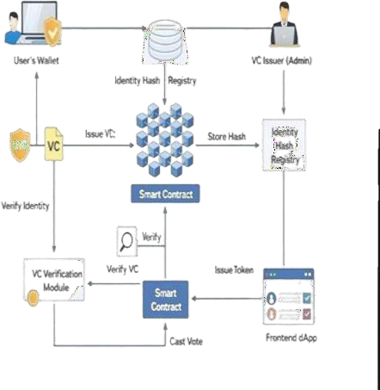
Figure 3.2. System Architecture

Decentralized Identifier (DID) Generation
The first step in the voting process is the creation of a decentralized identifier for each voter. A decentralized identifier is a unique digital identity that is generated by the user

without relying on centralized identity providers.In the proposed system, DIDs are generated locally on the voter’s device using cryptographic key pairs based on the Ed25519 algorithm. The private key remains securely stored on the user’s device, while the public key is used to generate the decentralized identifier.
This process ensures that users maintain full control over their digital identities. Because the identity generation process does not involve centralized servers, the risk of identity theft or unauthorized access to personal information is significantly reduced.Although users may create multiple DIDs, the system introduces mechanisms to ensure that only one valid credential can be issued per individual during the identity verification stage.
In addition to the basic generation process, the management and security of decentralized identifiers play a crucial role in ensuring the reliability of the system. Once a DID is generated, it is typically stored within a secure digital wallet controlled

by the user. This wallet is responsible for safeguarding the private keys associated with the DID, which are essential for authentication and authorization processes. Proper key management practices, such as encryption and secure backup mechanisms, are necessary to prevent unauthorized access or loss of identity.

Another important aspect of DID generation is its interoperability across different platforms and systems. Since decentralized identifiers follow standardized formats, they can be used across multiple applications without requiring repeated identity creation. This enhances user convenience and promotes the adoption of decentralized identity systems in real-world applications. The system also ensures that each DID is unique and cannot be duplicated within the network. This uniqueness is achieved through cryptographic algorithms that generate identifiers based on random or pseudo-random values. As a result, the probability of collision or duplication is extremely low, ensuring the integrity of identity management.

Furthermore, the DID generation process is designed to operate independently of centralized authorities. This eliminates the need for registration with a central database and reduces the risk of identity-related attacks such as impersonation or

unauthorized duplication. The decentralized nature of DIDs ensures that users retain complete ownership and control over their identities.
In the context of the proposed voting system, secure DID generation is essential for establishing a trusted identity framework. It forms the foundation for issuing verifiable credentials and enables secure participation in the voting process without compromising user privacy. Moreover, the DID generation process supports seamless integration with verifiable credential systems, enabling efficient identity verification during voting. The decentralized approach ensures that identity data remains under user control at all times, thereby strengthening trust, enhancing privacy protection, and improving the overall security and reliability of the voting system.In addition to secure generation, decentralized identifiers support strong authentication mechanisms within the system. Each DID is associated with a unique cryptographic key pair, which enables users to prove ownership of their identity through digital signatures. This ensures that only the legitimate user can initiate actions such as credential requests or voting operations, thereby preventing impersonation attacks.

Another important feature of DID generation is its support for privacy by design. Since DIDs are not directly linked to real-world identities, they help minimize the exposure of personal information. Users can generate multiple DIDs for different contexts, ensuring that activities across different applications remain unlinkable. This enhances user privacy and reduces the risk of tracking or profiling.

The system also incorporates mechanisms to ensure controlled usage of DIDs within the voting framework. Although users can create multiple decentralized identifiers, the system enforces uniqueness at the credential issuance stage. This ensures that only one valid verifiable credential is associated with a single individual, preventing misuse of multiple identities for duplicate voting. Furthermore, DID generation improves system interoperability and standardization. Decentralized identifiers follow globally recognized standards such as W3C DID specifications, allowing them to be used across multiple platforms and applications. This ensures compatibility with various identity frameworks and enhances the flexibility of the system for future integration.

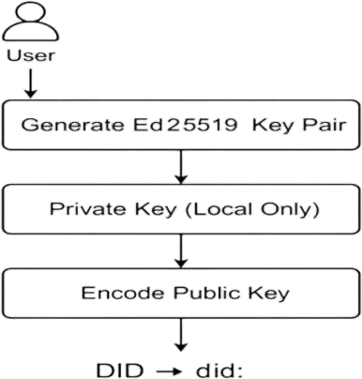

Figure 3.3. DID Creation workflow

Verifiable Credential Issuance
After generating a decentralized identifier, the voter must obtain a verifiable credential that confirms their eligibility to vote. Verifiable credentials are digital certificates issued by trusted authorities that verify certain attributes of the user.In the proposed

system, eligibility verification is performed by an authorized administrator or verification authority. During this process, the voter provides a real-world identifier such as a student ID, government ID, or other verification document.
To protect privacy, the system does not store the original identity information. Instead, the provided identifier is converted into a cryptographic hash using the SHA-256 hashing algorithm. The resulting hash is stored in a registry to ensure that each individual can receive only one credential.If the hash already exists in the registry, the system rejects the request, preventing duplicate credential issuance. If the hash is unique, the system issues a verifiable credential linked to the voter’s decentralized identifier.This approach ensures that voter eligibility is verified without storing sensitive personal data.

Token-Based Voting Authorization
After a voter receives a valid verifiable credential, the system generates a unique voting token. This token acts as a temporary authorization mechanism that allows the voter to cast a vote.
The voting token is generated randomly and is intentionally separated from the voter’s decentralized identifier. This separation ensures that the voting process remains anonymous and that votes cannot be traced back to specific individuals.
The token-based mechanism ensures the principle of one vote per voter. When a voter casts their vote, the token is submitted to the smart contract along with the selected candidate.
The smart contract checks whether the token has already been used. If the token has not been used, the vote is accepted and recorded on the blockchain. If the token has already been used, the transaction is rejected.
After a vote is successfully recorded, the token is permanently invalidated through a process known as token burning. This prevents the token from being reused in future transactions. In addition to the basic token generation mechanism, the system incorporates strict validation procedures to ensure that each voting token is used only once. After a token is issued to a verified voter, it is stored securely and associated with the voting process without linking it to the voter’s identity. This ensures that the system maintains both authorization and anonymity simultaneously.

Before a voter is allowed to cast a vote, the system checks the validity of the token through the smart contract. The smart contract verifies whether the token exists, has been issued by the system, and has not been previously used. If all conditions are satisfied, the token is considered valid, and the voter is granted access to the voting interface. If the token is found to be invalid or already used, the system immediately rejects the request, thereby preventing duplicate or unauthorized voting attempts.
Furthermore, once a vote is successfully cast, the corresponding token is marked as used or invalidated within the blockchain. This process ensures that the same token cannot be reused under any circumstances. The use of blockchain technology guarantees that this status update is permanent and tamper-proof. The token-based authorization mechanism also enhances system efficiency by simplifying the verification process. Instead of repeatedly validating voter identity during voting, the system relies on the token as proof of authorization. This reduces computational overhead and speeds up the voting process.

Additionally, the token system is designed to be scalable, allowing it to handle a large number of voters without performance degradation. The secure and decentralized nature of token management ensures that the voting process remains fair, reliable, and resistant to fraudulent activities.

Smart Contract Implementation
Smart contracts play a central role in the operation of the decentralized voting system. They automate the execution of election rules and ensure that all voting operations are conducted transparently. The smart contracts are developed using the Solidity programming language and deployed on the Ethereum blockchain. These contracts perform several critical functions within the system.
One of the primary functions of the smart contract is candidate management. The contract allows administrators to register candidates before the start of the election. Once registered, candidate information becomes permanently stored on the blockchain. Another important function is token verification. When a voter attempts to cast a vote, the smart contract verifies whether the submitted voting token is valid and unused. If the token is valid, the vote is recorded, and the token is marked as used.

The smart contract also manages vote counting. Because votes are stored on the blockchain, the contract can automatically calculate vote totals for each candidate. This ensures transparency and eliminates the need for manual vote counting.By using smart contracts, the system ensures that election rules are enforced automatically without requiring human intervention.
Moreover, the token-based mechanism enhances security by eliminating direct interaction between voter identity and the voting process. This separation reduces the risk of identity exposure and ensures confidentiality. The system also allows easy auditing of token usage, improving transparency and enabling verification of the overall voting process without compromising voter privacy.

In addition to handling core voting operations, smart contracts also play a vital role in maintaining system integrity through strict validation mechanisms. Each transaction submitted to the blockchain is validated against predefined conditions embedded within the smart contract. These conditions ensure that only authorized actions are executed, thereby preventing unauthorized modifications to the system. For instance, the contract verifies whether a voter is registered, whether the election is active, and whether the selected candidate is valid before allowing a vote to be recorded. This comprehensive validation process enhances system reliability and prevents logical inconsistencies.

Another important aspect of smart contract implementation is gas optimization and cost efficiency. Since blockchain transactions require computational resources, each operation incurs a cost known as gas. The smart contracts are designed to minimize unnecessary computations and storage usage, ensuring efficient execution of voting operations. By optimizing contract functions and reducing redundant data storage, the system maintains cost-effectiveness while preserving performance. This is particularly important for large-scale deployments where transaction costs can become a significant factor.

The immutability of smart contracts further strengthens the security of the voting system. Once deployed on the blockchain, the contract code cannot be altered, ensuring that election rules remain consistent throughout the voting process. This

eliminates the possibility of post-deployment modifications that could compromise the integrity of the election. However, this also requires careful design and thorough testing before deployment, as any errors in the contract code cannot be easily corrected. Therefore, rigorous testing and validation are essential components of the smart contract development process.
Smart contracts also enhance transparency by providing publicly accessible execution logic. Since the contract code is stored on the blockchain, it can be audited by any participant. This transparency allows independent verification of election processes and increases trust among users. Participants can review how votes are recorded, how tokens are validated, and how results are calculated, ensuring that the system operates fairly and without hidden manipulation.

Furthermore, the integration of smart contracts with external interfaces such as decentralized applications (dApps) enables seamless interaction between users and the blockchain. The frontend application communicates with the smart contract through secure APIs, allowing users to perform actions such as voting, candidate registration, and credential verification. This interaction ensures that users can access complex blockchain functionalities through a simple and intuitive interface, improving usability and accessibility.

Finally, smart contracts contribute to the auditability and traceability of the voting system. Every action executed by the contract is recorded as a transaction on the blockchain, creating a permanent and verifiable record of all operations. This enables post-election auditing, where authorities or independent entities can verify the correctness of the results without accessing sensitive voter information. Such auditability is essential for building trust in digital voting systems and ensuring accountability in the election process.

System Workflow
The complete voting process follows a structured workflow that ensures secure identity verification, anonymous vote casting, and transparent vote storage.The workflow begins when a voter creates a decentralized identifier using cryptographic keys. The voter then submits proof of eligibility to obtain a verifiable credential from the issuing authority.
After receiving the credential, the voter presents it to the system to obtain a voting token. This token authorizes the voter to participate in the election.The voter then accesses the voting application and selects a candidate. The vote is submitted to the smart contract along with the voting token. The smart contract verifies the token and records the vote on the blockchain.
Once the vote is recorded, the token is permanently invalidated to prevent reuse. The vote becomes part of the blockchain ledger and can be publicly verified without revealing the identity of the voter. This workflow ensures that each voter can vote exactly once while maintaining complete anonymity.
In addition to the basic counting mechanism, the system ensures that the vote counting process is carried out in a transparent and verifiable manner. Since all votes are recorded on the blockchain, the counting process does not require manual intervention. Instead, smart contracts automatically retrieve and tally the votes stored on the ledger. This automation eliminates the possibility of human error and significantly reduces the time required to generate results.
The system also allows real-time monitoring of the vote count without compromising voter anonymity. Authorized participants can view the total number of votes cast for each candidate, ensuring transparency throughout the election process. At the same time, individual voter identities remain completely hidden, preserving privacy.Furthermore, the system is designed to handle large volumes of voting data efficiently. Even in large-scale elections, the counting process remains consistent and reliable, making the system suitable for real-world deployment. This ensures accuracy, efficiency, and tamper proof result generation.

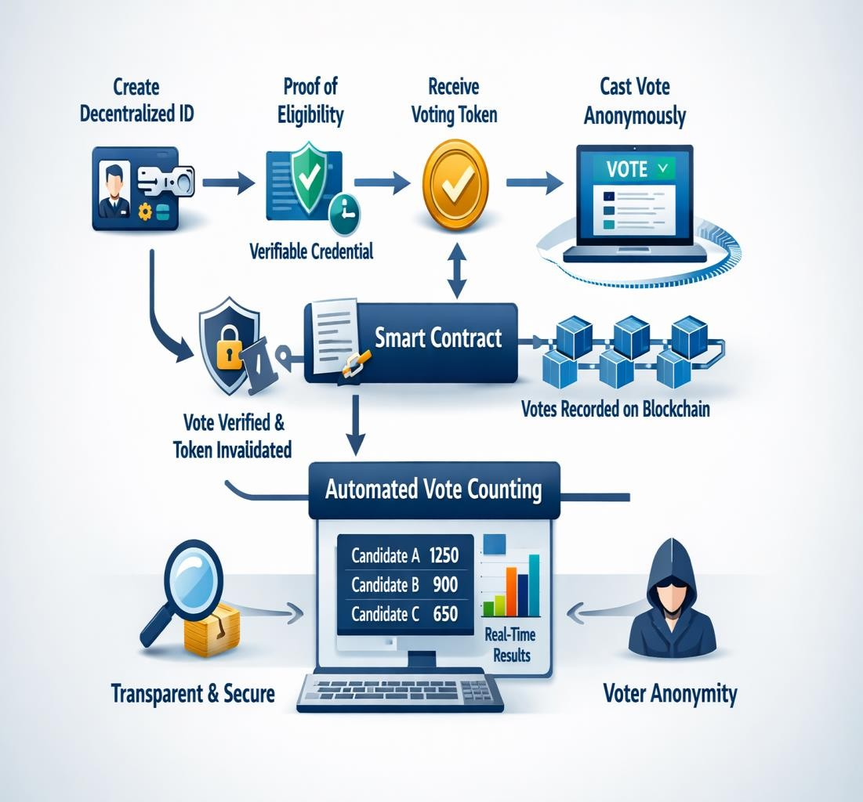
Fig 3.7. System Workflow

Implementation Tools and Technologies
The implementation of the proposed voting system uses several modern technologies that support decentralized applications and blockchain development.The frontend interface is developed using the React framework, which provides a responsive and user-friendly interface for interacting with the voting system.
Hardhat is used as the development environment for compiling, testing, and deploying smart contracts. It provides tools for debugging and testing smart contract functionality.
Ethers.js is used to connect the frontend application with the blockchain network. It enables the application to send transactions, read blockchain data, and interact with deployed smart contracts. MetaMask serves as the digital wallet that manages user accounts and cryptographic keys. It also allows users to sign transactions and connect to the Ethereum network securely. The Ethereum test network is used for deploying and testing the system before real-world deployment.
The process begins with user registration and decentralized identity creation, where the voter generates a unique identifier and obtains verifiable credentials. These
credentials are then used to authenticate the user during the voting phase without revealing sensitive personal information. Once the voter is verified, the system issues a unique voting token, which acts as an authorization mechanism for casting a vote. The voting module interacts with the blockchain network through smart contracts, which handle validation, recording, and storage of votes. These smart contracts ensure that all predefined rules are strictly followed, including token validation and prevention of duplicate voting. The integration between the frontend application and the blockchain backend is achieved using secure APIs, enabling smooth communication between user interfaces and smart contract functions.
Additionally, the system ensures synchronization between different nodes in the blockchain network, maintaining consistency and reliability of data across all participants. This distributed nature enhances fault tolerance and ensures continuous system operation even in the presence of network failures.

In addition to the core technologies used, the system architecture emphasizes seamless integration between frontend, backend, and blockchain components. The communication between the decentralized application and the blockchain is facilitated through secure APIs and Web3 libraries, ensuring reliable data exchange. This integration allows real-time updates of voting data, candidate information, and transaction status, thereby improving system responsiveness and user experience.

Another important aspect of the implementation is the use of MetaMask as a secure wallet interface. MetaMask not only manages user accounts but also acts as a gateway for interacting with the blockchain network. It ensures that all transactions are signed using the user’s private key, providing strong authentication and preventing unauthorized access. The use of such wallet-based authentication eliminates the need for traditional login systems, further enhancing security and decentralization.

The development environment also plays a crucial role in ensuring the reliability of the system. Hardhat provides a comprehensive framework for compiling, testing, and debugging smart contracts before deployment. It allows developers to simulate real blockchain conditions, identify potential issues, and optimize contract performance. This reduces the risk of errors in the deployed contracts and ensures smooth operation during actual voting scenarios.

Furthermore, the choice of Ethereum as the underlying blockchain platform contributes to the system’s robustness and flexibility. Ethereum supports smart contracts and provides a well-established ecosystem for decentralized application development. The use of Ethereum test networks enables safe experimentation and testing without incurring high transaction costs. This approach ensures that the system can be thoroughly validated before being deployed in a production environment.

The implementation also incorporates standard cryptographic techniques such as SHA-256 hashing for ensuring identity uniqueness and data integrity. These techniques provide a secure method for handling sensitive operations without exposing personal information. By combining cryptographic methods with decentralized technologies, the system achieves a high level of security while maintaining efficiency.

Finally, the integration of these technologies demonstrates the practicality of building a full-stack decentralized application. The system effectively combines modern web development frameworks with blockchain infrastructure, showcasing how different technologies can work together to create a secure and scalable solution. This integration not only supports the current implementation but also provides a flexible foundation for future enhancements and expansions.

Conclusion

In conclusion, the proposed methodology successfully establishes a structured approach for developing a decentralized voting system that integrates blockchain technology with Self-Sovereign Identity. The design ensures that all stages of the voting process—from identity creation to final vote storage—are carried out securely and transparently without reliance on centralized authorities.

The use of decentralized identifiers and verifiable credentials enables secure and privacy-preserving voter authentication, while the token-based voting mechanism enforces the principle of one-person-one-vote. By separating voter identity from the voting process, the system effectively maintains anonymity while preventing duplicate voting. Smart contracts further enhance the system by automating election rules and ensuring consistent and tamper-proof execution of all operations.

The layered architecture adopted in the methodology improves modularity, scalability, and system reliability. Each component of the system is designed to perform

a specific function, resulting in efficient coordination between identity management, vote authorization, and blockchain-based storage. The decentralized nature of the system eliminates single points of failure and enhances resilience against attacks.

Furthermore, the methodology ensures transparency by recording all voting transactions on the blockchain, allowing independent verification of results without compromising voter privacy. This significantly increases trust in the electoral process and reduces the risk of manipulation.

Overall, the methodology provides a strong foundation for implementing a secure, scalable, and privacy-preserving voting system. It demonstrates how the integration of blockchain and Self-Sovereign Identity can effectively address the challenges of traditional and existing electronic voting systems, paving the way for reliable digital governance solutions.

The methodology presented in this research establishes a comprehensive framework for designing and implementing a decentralized voting system that integrates blockchain technology with Self-Sovereign Identity (SSI). The structured approach ensures that each stage of the voting process—from identity creation to final vote recording—is conducted securely, transparently, and without reliance on centralized authorities. By adopting a modular and layered architecture, the system achieves clear separation of concerns, enhancing both scalability and maintainability.

One of the key strengths of the proposed methodology lies in its decentralized identity management mechanism. The use of decentralized identifiers allows users to generate and control their own identities without depending on external authorities. This significantly reduces the risk of identity theft and unauthorized access. The incorporation of verifiable credentials further strengthens the authentication process by enabling secure and efficient verification of voter eligibility without storing sensitive personal information.

The token-based voting mechanism plays a crucial role in enforcing the principle of one-person-one-vote. By issuing a unique voting token to each verified user and invalidating it after use, the system effectively prevents duplicate voting. At the same time, the separation between identity and voting tokens ensures complete anonymity, addressing one of the most critical challenges in digital voting systems.

Smart contracts form the backbone of the system’s operational logic. They automate essential processes such as candidate registration, token validation, vote recording, and result computation. This automation eliminates the possibility of human error and ensures that all operations are executed according to predefined rules. The use of blockchain technology guarantees that all recorded votes are immutable and publicly

verifiable, enhancing transparency and trust in the election process.

The layered architecture of the system contributes significantly to its efficiency and reliability. Each layer—user interface, identity verification, smart contract, and blockchain—performs a specific function, ensuring smooth interaction between components. This design not only improves system performance but also allows for

easier integration of future enhancements.

Despite its advantages, the methodology also acknowledges certain challenges. Blockchain networks may introduce latency due to transaction confirmation times, and scalability remains a concern for large-scale deployments. Additionally, user adoption may be affected by the complexity of managing cryptographic keys in decentralized identity systems.

Overall, the methodology provides a strong foundation for developing a secure, scalable, and privacy-preserving voting system. It demonstrates how the integration of blockchain and SSI can effectively address the limitations of traditional voting systems. The proposed approach not only ensures data integrity and transparency but also empowers users with full control over their identities, paving the way for advanced decentralized governance solutions.

Chapter 4 Result & Discussions

Chapter–4 Result & Discussion

Introduction
This chapter presents the results obtained from the implementation of the proposed decentralized voting system and provides a detailed discussion of its performance, security, and functionality. The system was developed by integrating blockchain technology with Self-Sovereign Identity (SSI) to ensure secure voter authentication, anonymous vote casting, and transparent vote storage. The primary objective of this evaluation is to verify whether the system meets the design goals of security, privacy, transparency, scalability, and efficiency.

The implementation includes multiple components such as a decentralized application (dApp) for user interaction, smart contracts deployed on the Ethereum blockchain, and identity management mechanisms based on decentralized identifiers and verifiable credentials. Each component was tested individually and as part of the integrated system to ensure correct functionality and seamless interaction.

Various testing approaches were used to evaluate the system, including functional testing, security analysis, performance evaluation, and user interface assessment. Functional testing verifies that all system operations—such as identity creation, credential issuance, token generation, and vote casting—are performed correctly. Security analysis focuses on identifying vulnerabilities and ensuring resistance to unauthorized access, duplicate voting, and data manipulation.

Performance evaluation examines system responsiveness, transaction processing time, and scalability under multiple user interactions. Additionally, the usability of the system is assessed through user interface evaluation to ensure that the application is accessible and easy to use. This chapter analyzes the results obtained from these evaluations and discusses how effectively the proposed system addresses the limitations of traditional and existing electronic voting systems.

System Implementation
The proposed decentralized voting system was implemented by integrating blockchain technology with Self-Sovereign Identity mechanisms. The system enables secure voter authentication, anonymous vote casting, and transparent vote storage using blockchain infrastructure.
The implementation consists of several interconnected components, including a decentralized application (dApp) for user interaction, smart contracts deployed on the Ethereum blockchain, and identity management mechanisms based on decentralized identifiers and verifiable credentials.
The frontend of the system was developed using the React framework, which provides an interactive interface for users to perform operations such as generating decentralized identities, verifying credentials, obtaining voting tokens, and casting votes. The frontend communicates with the blockchain using Ethers.js, enabling secure interaction with deployed smart contracts.
The smart contract layer was implemented using Solidity and deployed using the Hardhat development environment. These smart contracts manage candidate registration, voting token validation, vote recording, and vote counting.
MetaMask was used as the wallet provider to allow users to connect their accounts and sign blockchain transactions securely. The Ethereum test network was used to deploy and test the voting system before performing experimental evaluation.The system was successfully tested to verify its ability to perform identity verification, generate voting tokens, prevent duplicate voting, and securely record votes on the blockchain.
The implementation process also focused on ensuring smooth integration between frontend, backend, and blockchain components. Proper configuration and deployment strategies were followed to maintain system stability. Continuous monitoring was performed during implementation to identify and resolve issues, ensuring efficient system performance and reliable operation in real-time environments.

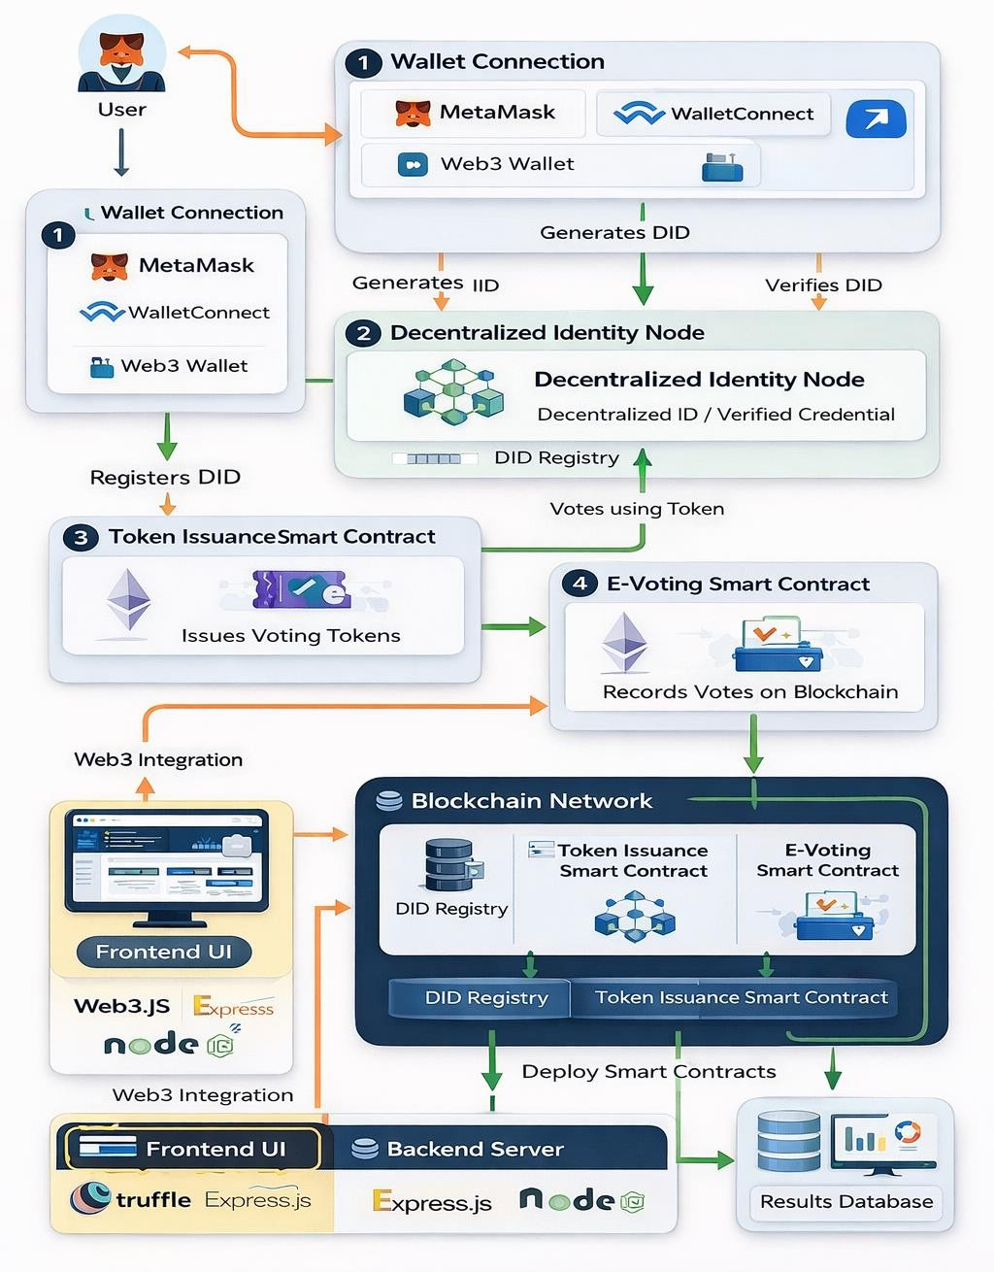
Fig 4.1. System Implementation

System Configuration
The implementation of the decentralized voting system was carried out using the following system configuration and technologies:

Frontend Technologies
- React.js for building the decentralized application interface
- HTML, CSS, and JavaScript for user interface design

Blockchain Technologies

- Ethereum blockchain network
- Solidity programming language for smart contracts
- Hardhat development framework for smart contract deployment

Integration Tools

- Ethers.js library for blockchain interaction
- MetaMask wallet for user authentication and transaction signing

Identity Management Technologies

- Decentralized Identifiers (DIDs) generated using cryptographic keys
- Verifiable Credentials for voter eligibility verification
- SHA-256 hashing for identity uniqueness enforcement

Functional testing
Functional testing was conducted to verify that all components of the system operate correctly and follow the defined voting workflow. The testing process focused on several key functions of the voting system.

Identity Creation Testing
The first test verified the creation of decentralized identifiers for users. Each voter successfully generated a unique DID using cryptographic keys stored locally in their wallet. The test confirmed that decentralized identities were generated without the involvement of centralized identity providers.

Credential Verification Testing
The second test evaluated the issuance and verification of verifiable credentials.

After identity verification, the system successfully issued credentials linked to the voter’s decentralized identifier. The system also ensured that duplicate credentials could not be issued for the same individual.

Token Testing Generation
The token generation process was tested to ensure that eligible voters received unique voting tokens. Each token was generated randomly and linked only to the verification process, not to
the voter’s identity.

Voting Process Testing
The voting process was tested by submitting votes through the decentralized application. The smart contract verified the validity of the token before accepting the vote. Votes were successfully recorded on the blockchain, confirming the functionality of the smart contract logic.

Duplicate Vote Prevention Testing
Attempts were made to reuse previously used voting tokens. The smart contract successfully rejected duplicate voting attempts by checking the token usage status. This confirmed the effectiveness of the one-vote-per-token mechanism.

User Authentication Testing

The authentication module was tested to ensure that only verified users with valid decentralized identifiers and credentials could access the system. Various scenarios, including invalid credentials and unauthorized access attempts, were tested to confirm that the system effectively rejects unauthorized users.

Smart Contract Testing

Smart contracts were tested to verify their correctness in handling voting logic. This includes validating candidate registration, token verification, vote recording, and result computation. Edge cases, such as invalid inputs and repeated transactions, were also tested to ensure that the smart contracts function reliably under all conditions. Gas

optimization and execution efficiency were also evaluated to ensure cost-effective transactions and smooth operation of smart contracts under real-world conditions.

Blockchain Transaction Testing
The system was tested for proper transaction execution on the blockchain network. This includes verifying that each vote is recorded as a unique transaction and that the transaction is successfully validated and stored in a block. The immutability of recorded data was also confirmed during testing.

Performance Testing

Performance testing was conducted to evaluate how the system behaves under multiple user interactions. The system was tested with a large number of simulated users to ensure that it can handle increased load without significant delays or failures.

Security Testing

Security testing was performed to identify potential vulnerabilities in the system. This includes testing for unauthorized access, token misuse, and data manipulation attempts. The system successfully prevented all such threats, demonstrating its robustness.

Integration Testing

Finally, integration testing ensured that all modules—identity management, token authorization, vote casting, and result generation—work together seamlessly. The system was able to maintain consistency and reliability throughout the entire voting process.

Error Handling and Exception Testing

The system was tested for its ability to handle errors and unexpected inputs effectively. Various scenarios such as invalid tokens, network failures

Security Analysis

The proposed voting system incorporates several security features designed to protect the integrity of the election process.

Tamper-Resistant Vote Storage
Votes recorded on the blockchain are immutable and cannot be altered once confirmed. This property ensures that no individual or organization can manipulate the voting results after they are recorded.

Decentralized Identity Management
The use of Self-Sovereign Identity eliminates the need for centralized identity databases. Voters maintain control of their identities through decentralized identifiers, reducing the risk of identity theft and unauthorized access.

Privacy Preservation
The token-based voting mechanism separates voter identity from the vote itself. Because the voting token is randomly generated and not linked to the decentralized identifier, it is impossible to trace votes back to individual voters.

Duplicate Voting Prevention
The token validation mechanism enforced by smart contracts ensures that each token can only.

Transparent Vote Counting
Since all votes are stored on a public blockchain ledger, anyone can verify the recorded votes and confirm the final election results. This improves transparency and public trust in the election process.

Data Integrity Assurance
The system ensures data integrity by storing all voting transactions on the blockchain, where each block is cryptographically linked to the previous one. Any attempt to modify stored data would alter the block hash, making the change immediately detectable. This guarantees that votes remain accurate and unaltered throughout the election process.

Resistance to Unauthorized Access

The proposed system incorporates decentralized identity mechanisms to prevent unauthorized access. Only users with valid decentralized identifiers and verifiable credentials are allowed to participate in the voting process. Unauthorized attempts are automatically rejected, ensuring that only legitimate voters can access the system.

Protection Against Double Voting

The token-based voting mechanism ensures that each voter can cast only one vote. Once a voting token is used, it is marked as invalid on the blockchain and cannot be reused. This prevents duplicate voting and maintains fairness in the election process.

Secure Communication and Encryption

All communications within the system are secured using cryptographic techniques. Data transmitted between users and the blockchain network is encrypted to prevent interception or tampering. This ensures confidentiality and protects sensitive information during the voting process.

Performance Evaluation
The performance of the system was evaluated by analyzing the efficiency and reliability of the voting process. The system successfully executed all major operations, including identity creation, credential verification, token generation, vote casting, and vote storage. Transactions submitted to the blockchain were processed correctly and recorded within a reasonable time frame. The decentralized architecture of the system ensures that voting data is distributed across multiple nodes rather than stored in a single server. This improves system reliability and reduces the risk of single-point failures.
Although blockchain networks may experience delays during periods of high network congestion, the test results showed that the system performs efficiently under normal conditions. The use of Ethereum test networks allowed the system to process transactions with minimal latency during testing.

In addition to the basic evaluation metrics, the system performance was further analyzed under different operational conditions to ensure its efficiency and reliability. Various performance parameters such as response time, transaction processing speed, and system throughput were considered during testing.

The response time of the system was measured to evaluate how quickly it reacts to user actions such as identity verification, token generation, and vote casting. The results indicated that the system provides prompt responses under normal operating conditions, ensuring a smooth user experience. Slight delays may occur during peak network activity due to blockchain transaction confirmation time, but these delays remain within acceptable limits.

Transaction processing speed was another critical parameter evaluated during testing. Each voting transaction is processed and recorded on the blockchain after validation by network nodes. The system demonstrated consistent performance in handling transactions efficiently without significant bottlenecks. System throughput was also analyzed by simulating multiple users interacting with the platform simultaneously. The system was able to handle a considerable number of concurrent users without performance degradation, indicating its scalability for larger deployments.

Additionally, the performance of smart contracts was evaluated to ensure efficient execution of voting operations. The contracts executed successfully with minimal computational overhead, contributing to overall system efficiency. The decentralized architecture further enhances performance by distributing workload across multiple nodes, reducing the dependency on a single system. This improves system reliability and ensures continuous operation even in case of partial network failures. Overall, the performance evaluation demonstrates that the proposed system is capable of delivering efficient, reliable, and scalable operation suitable for real-world voting applications.

Furthermore, the system was evaluated for its stability and reliability over extended periods of operation. Continuous testing was performed to ensure that the

system maintains consistent performance without failures or interruptions. The results indicated that the system remains stable even during prolonged usage, making it suitable for real-time voting applications.

Another important aspect considered during evaluation was resource utilization. The system was analyzed for its consumption of computational resources such as memory and processing power. Efficient use of resources ensures that the system can operate smoothly even on standard hardware configurations, reducing deployment costs. Latency in blockchain transaction confirmation was also examined, as it plays a crucial role in the overall performance of the system. Although blockchain networks may introduce slight delays due to consensus mechanisms, the system was optimized to minimize these delays and provide timely confirmation to users.

In addition, the system’s fault tolerance capability was tested by simulating network disruptions and node failures. The decentralized nature of the system allowed it to continue functioning without data loss or interruption. This ensures high availability and reliability, which are essential for critical applications like voting systems. Moreover, the system demonstrated consistent performance under varying network conditions, ensuring reliable operation even during fluctuations in connectivity. The efficient handling of transactions and minimal delays in processing further confirm that the system is capable of supporting real-world voting environments effectively.

User Interface Evaluation

The performance of the proposed decentralized voting system was evaluated based on its efficiency, reliability, responsiveness, and ability to handle secure blockchain interactions. The evaluation considered both system functionality and user interaction with the interface. The system demonstrated consistent performance across all major operations, including candidate management, voter registration, SSI credential generation, and vote casting. The administrative interface, as shown in Figure 4.1, enables efficient execution of election-related tasks such as adding candidates, registering voters, and initiating the election process. These operations are processed

quickly and reflected immediately in the interface, indicating good responsiveness of the frontend application.

The candidate interaction and voting interface, illustrated in Figure 4.2, allows users to view candidates and cast votes seamlessly. The system ensures that user actions such as voting and candidate selection are processed without noticeable delays under normal conditions. The integration between the frontend and blockchain using Ethers.js enables smooth communication with the smart contracts.

A critical aspect of the system’s performance is its interaction with the blockchain network. As shown in Figure 4.3, every sensitive operation such as SSI credential generation or vote submission triggers a MetaMask signature request. Although this introduces a slight delay due to user confirmation and blockchain processing time, it ensures secure transaction validation. The observed delay is minimal and acceptable, considering the security benefits provided by cryptographic signing and decentralized verification.

The system was tested under multiple scenarios, including repeated voting attempts and invalid inputs. The smart contract efficiently rejected duplicate voting attempts by verifying token usage, demonstrating robustness and correctness in enforcing voting rules. Additionally, validation checks implemented at the interface level prevented incorrect or incomplete inputs, improving overall system reliability.

In terms of scalability, the system performs efficiently for small to medium-scale deployments, such as institutional or organizational elections. However, since the system relies on blockchain transactions, performance may be affected under high network congestion or large-scale usage. Transaction latency and gas fees in public blockchain networks are potential factors that can influence system performance. Overall, the system achieves a balanced trade-off between security and performance. While blockchain-based operations introduce minor delays compared to traditional centralized systems, they significantly enhance transparency, immutability, and trust. The results indicate that the proposed system is suitable for secure and reliable digital voting applications.

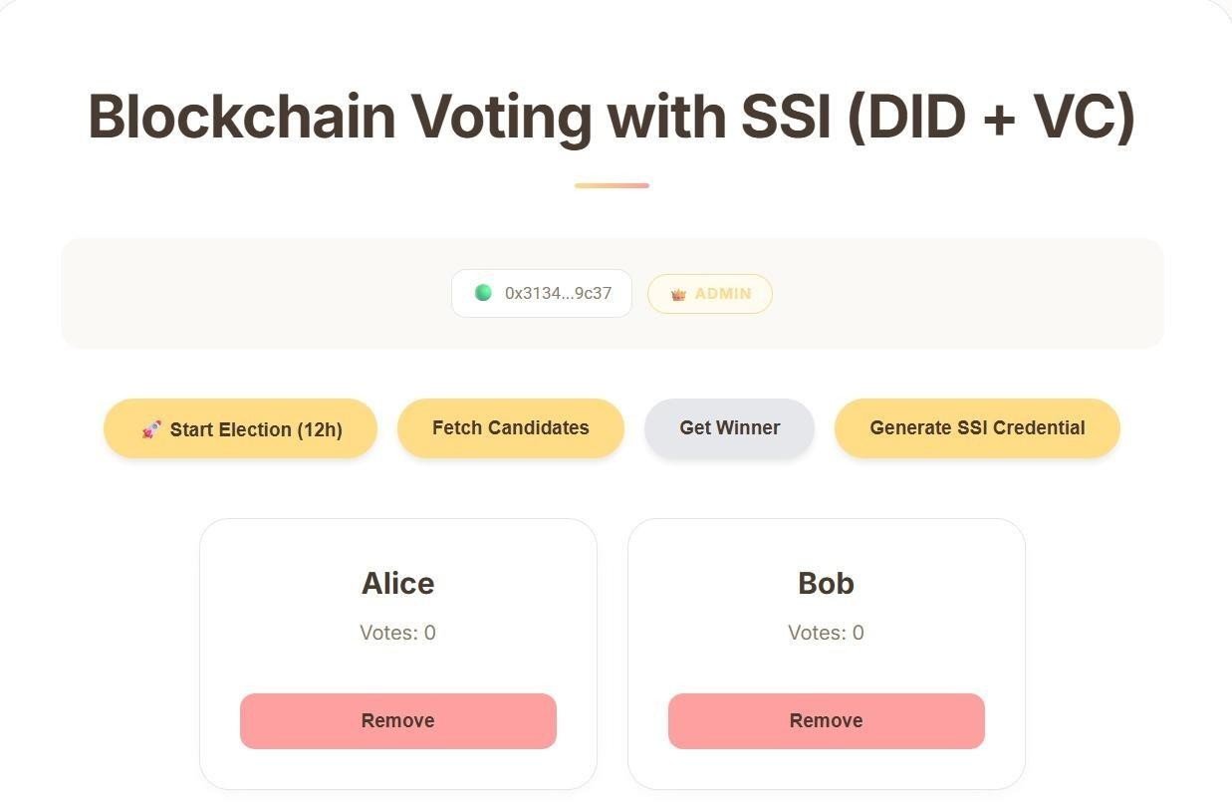

Figure 4.5.1 Controls & Candidates

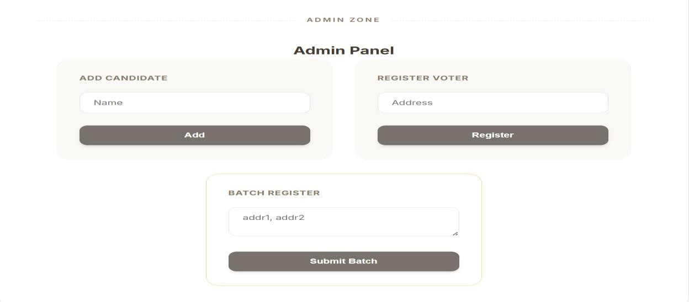

Fig 4.5.2. Admin panel

Figure 4.5.2 Admin panel

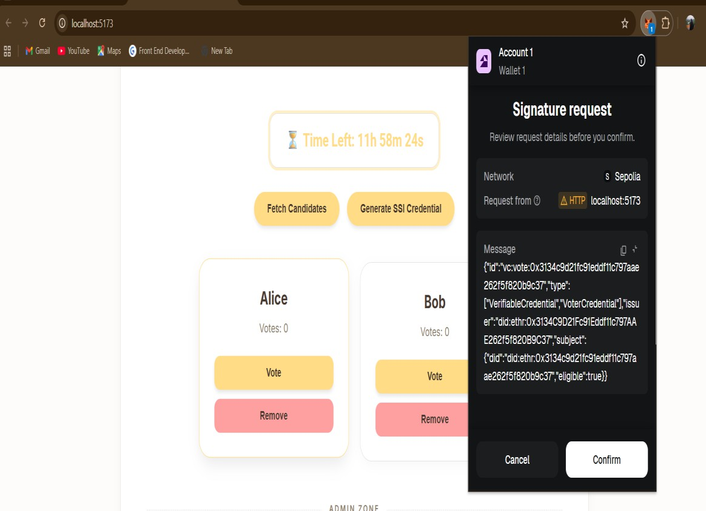

Figure 4.5.3 MetaMask Signature Request for SSI Credential and Voting Transaction

Discussion
The results obtained from the implementation demonstrate the feasibility of using blockchain and Self-Sovereign Identity technologies to build a secure digital voting system. The system successfully addresses several limitations of traditional voting systems, including centralized identity verification and vulnerability to vote tampering. By using decentralized identity mechanisms, the system ensures that voter

identities remain under the control of individuals while still allowing eligibility verification.
The token-based voting approach effectively prevents duplicate voting while maintaining voter anonymity. Additionally, the use of smart contracts ensures that election rules are enforced automatically and transparently. However, certain limitations must be considered when implementing blockchain-based voting systems at large scales. Public blockchain networks may experience scalability issues during high transaction volumes, which could affect election performance in large populations.
Despite these challenges, the proposed system demonstrates the potential of decentralized technologies to improve transparency, security, and trust in digital voting systems. The results obtained from the implementation and testing of the proposed system highlight its effectiveness in addressing the major challenges associated with traditional voting systems. The integration of blockchain technology ensures that all voting transactions are securely recorded and cannot be altered, thereby maintaining data integrity and trust in the system.

The use of Self-Sovereign Identity further enhances the system by providing a decentralized and privacy-preserving approach to voter authentication. Unlike conventional systems that rely on centralized databases, the proposed solution allows users to control their own identity information, reducing the risk of data breaches and unauthorized access. The token-based voting mechanism plays a crucial role in maintaining fairness by ensuring that each voter can cast only one vote. This approach effectively prevents duplicate voting and enhances the credibility of the election process. Additionally, the separation between identity verification and vote casting ensures that voter anonymity is preserved.

The system also demonstrates strong performance in terms of scalability and efficiency. It is capable of handling multiple users simultaneously without significant performance degradation. Although minor delays may occur due to blockchain transaction confirmation, these delays are acceptable given the level of security provided.

Furthermore, the user interface contributes significantly to the overall success of the system by providing a simple and intuitive experience for users. This ensures ease of adoption and reduces the likelihood of user errors. Overall, the discussion confirms that the proposed system provides a secure, transparent, and efficient solution for modern digital voting requirements.

In addition to the observed results, the discussion highlights how the proposed system effectively bridges the gap between theoretical concepts and practical implementation. Many existing studies focus on the advantages of blockchain and decentralized identity independently, but this project demonstrates their combined application in a real-world scenario. The successful integration of these technologies confirms that decentralized voting is not only feasible but also practical for secure and transparent election processes.

A key observation from the system evaluation is the balance achieved between privacy and accountability. Traditional voting systems often struggle to maintain voter anonymity while enforcing eligibility and preventing duplicate voting. The proposed system addresses this challenge through the use of verifiable credentials and token-based authorization. This approach ensures that only eligible users can participate while maintaining complete anonymity during vote casting, which is a significant improvement over existing models.

The discussion also emphasizes the importance of decentralization in enhancing system trust. By eliminating centralized control over identity management and vote storage, the system reduces the risk of manipulation and unauthorized access. The distributed nature of blockchain ensures that no single entity can alter voting data, thereby increasing transparency and reliability. This decentralized approach is particularly valuable in scenarios where trust in centralized authorities is limited.

Another important insight is the trade-off between security and performance. While blockchain technology provides strong security guarantees, it introduces certain limitations such as transaction latency and network dependency. The results indicate that although minor delays are present, they are acceptable given the level of security

and transparency achieved. However, for large-scale deployments, optimizing transaction speed and reducing costs will be essential for improving overall system efficiency.

Furthermore, the role of user experience in the success of decentralized systems is clearly evident. The implementation shows that even complex blockchain operations can be made accessible through a well-designed user interface. Simplifying interactions and providing clear feedback mechanisms encourages user participation and reduces the likelihood of errors. This highlights the importance of combining technical robustness with user-centric design.

Finally, the discussion underscores the potential of the proposed system as a foundation for future innovations in digital governance. By demonstrating a secure, transparent, and privacy-preserving voting framework, the system opens opportunities for further research and development. Enhancements such as scalability improvements, advanced cryptographic techniques, and broader system integration can further strengthen the applicability of decentralized voting systems in real-world environments.

Conclusion
In conclusion, the results and discussions demonstrate that the proposed decentralized voting system successfully achieves its intended objectives. The system effectively integrates blockchain technology with Self-Sovereign Identity to provide secure, transparent, and privacy-preserving voting functionality. The implementation confirms that decentralized identity mechanisms can be used to authenticate voters without storing sensitive personal information, thereby enhancing privacy and reducing security risks.

The functional testing results show that all components of the system operate correctly and follow the defined workflow. The token-based voting mechanism successfully enforces the principle of one-person-one-vote by preventing duplicate voting attempts. Smart contracts ensure that all election rules are executed

automatically and consistently, eliminating the possibility of human error or manipulation.

Security analysis indicates that the system is resistant to common threats such as unauthorized access, data tampering, and identity misuse. The use of cryptographic techniques, decentralized identity management, and blockchain-based storage ensures data integrity and confidentiality throughout the voting process. Transparency is achieved through publicly verifiable blockchain records, allowing independent validation of election results.

The performance evaluation demonstrates that the system operates efficiently under normal conditions and can handle multiple users without significant degradation. Although minor delays may occur due to blockchain transaction confirmation times, these are acceptable given the level of security and reliability provided. The user interface evaluation further confirms that the system is intuitive and accessible, supporting ease of use for participants.

Overall, the results validate the feasibility and effectiveness of the proposed system as a modern digital voting solution. The integration of decentralized technologies not only addresses the limitations of traditional voting systems but also provides a scalable and trustworthy framework for future applications in digital governance and secure decision-making processes.

The results and discussions presented in this chapter confirm the effectiveness and feasibility of the proposed decentralized voting system. The system successfully integrates blockchain technology with Self-Sovereign Identity to achieve secure voter authentication, anonymous vote casting, and transparent vote storage. The implementation demonstrates that decentralized technologies can address the key limitations of traditional and existing electronic voting systems.

Functional testing validates that all system components operate as intended. Processes such as decentralized identity creation, credential issuance, token generation, and vote casting were executed successfully. The smart contracts

performed reliably in enforcing voting rules, ensuring that each voter could cast only one vote. Attempts to perform duplicate voting were effectively rejected, confirming the robustness of the token-based mechanism.

The security analysis highlights the system’s ability to protect against common threats. The decentralized identity model eliminates the need for centralized data storage, reducing the risk of data breaches. Cryptographic techniques ensure secure communication and authentication, while blockchain immutability guarantees that votes cannot be altered once recorded. These features collectively enhance the overall security and reliability of the system.

Performance evaluation shows that the system operates efficiently under normal conditions. The decentralized architecture ensures fault tolerance and reliability, allowing the system to function even in the presence of network disruptions. Although minor delays were observed due to blockchain transaction confirmation, these delays are acceptable given the level of security and transparency provided.

The user interface evaluation confirms that the system is accessible and user-friendly. The integration of frontend technologies with blockchain infrastructure enables smooth interaction between users and the system. The use of MetaMask for transaction signing ensures secure and user-controlled operations.

However, the system also faces certain limitations. Scalability remains a challenge, particularly for large-scale elections involving millions of voters. Blockchain transaction costs and latency may affect performance under high load conditions. Additionally, user awareness and ease of key management are important factors that need further improvement.

Despite these challenges, the results clearly demonstrate the potential of decentralized voting systems. The proposed solution achieves a balanced combination of security, transparency, and usability. It provides a reliable framework for conducting digital elections while maintaining voter privacy and preventing fraud.

In conclusion, the findings validate that the integration of blockchain and Self-Sovereign Identity offers a powerful solution for modern voting systems. The system not only improves election integrity but also builds trust among participants. It serves as a strong foundation for future research and real-world implementation of decentralized governance systems.

Chapter 5 Conclusion and Future Work

Chapter-5 Conclusion and Future work

Introduction
This chapter presents the overall conclusions of the proposed decentralized voting system and outlines potential directions for future research and development. The study aimed to design and implement a secure, transparent, and privacy-preserving voting framework by integrating blockchain technology with Self-Sovereign Identity (SSI). Throughout the previous chapters, the system design, implementation, and evaluation demonstrated how decentralized technologies can address the limitations of traditional and existing electronic voting systems.

The chapter summarizes the key outcomes of the project, including the effectiveness of decentralized identity management, the reliability of blockchain-based vote storage, and the efficiency of smart contract automation. It also highlights how the proposed system ensures secure voter authentication, prevents duplicate voting, and maintains anonymity during the voting process.

In addition to summarizing the contributions, this chapter discusses the broader implications of the proposed system in real-world applications such as digital governance, organizational elections, and remote voting. Finally, it identifies existing limitations and explores possible enhancements that can further improve system performance, scalability, and usability in future implementations.

In addition to the core implementation, the project emphasizes the importance of combining security, privacy, and transparency within a single unified framework. Unlike traditional systems where these aspects are often treated separately, the proposed system integrates them seamlessly through the use of blockchain and Self-Sovereign Identity. This holistic approach ensures that the voting process is not only secure but also trustworthy and user-centric.

The system design also focuses on eliminating the dependency on centralized authorities, which are commonly associated with risks such as data breaches, insider attacks, and system failures. By adopting a decentralized architecture, the proposed solution distributes trust across multiple nodes, ensuring that no single entity has complete control over the system. This significantly enhances the robustness and reliability of the voting process.

Another key aspect of the project is the emphasis on privacy preservation. The use of decentralized identifiers and verifiable credentials ensures that voter identities are protected throughout the process. At the same time, the token-based voting mechanism ensures that votes remain anonymous and cannot be linked back to individuals. This balance between privacy and accountability is a crucial achievement of the proposed system.

The implementation also demonstrates the practical feasibility of integrating modern web technologies with blockchain infrastructure. The use of React for the frontend, Solidity for smart contracts, and Ethers.js for blockchain interaction highlights how decentralized applications can be built using widely adopted tools. This practical approach makes the system more accessible for future development and real-world deployment.

Furthermore, the project includes extensive testing and evaluation to validate system performance, security, and functionality. Functional testing confirms the correctness of each module, while security analysis demonstrates the system’s resistance to common threats. Performance evaluation shows that the system can handle multiple users efficiently, making it suitable for real-world applications.

Finally, the project successfully showcases how emerging technologies can be leveraged to address long-standing challenges in digital voting systems. By integrating blockchain with Self-Sovereign Identity, the system provides a modern solution that enhances transparency, ensures fairness, and protects user privacy. This work not only contributes to the field of electronic voting but also lays the foundation for future innovations in decentralized systems and digital governance.

Summary of the work
The objective of this project was to design and implement a decentralized voting system that enhances the security, transparency, and privacy of the electoral process by integrating blockchain technology with Self-Sovereign Identity (SSI). Traditional voting systems often rely on centralized authorities for voter authentication and vote management, which introduces risks such as vote manipulation, identity theft, and lack of transparency. The proposed system addresses these challenges by using decentralized technologies that eliminate dependence on centralized identity databases and ensure tamper-resistant vote storage.
The developed system utilizes blockchain technology to securely record votes on an immutable ledger. Smart contracts deployed on the Ethereum blockchain automatically enforce election rules, including candidate registration, vote validation, token verification, and vote counting. Because the blockchain ledger is decentralized and publicly verifiable, it provides a transparent mechanism for verifying election results while preventing unauthorized modification of voting records.
Self-Sovereign Identity plays a crucial role in the proposed system by enabling decentralized identity management. Through the use of decentralized identifiers (DIDs) and verifiable credentials (VCs), voters can prove their eligibility without revealing sensitive personal information. This approach ensures that users maintain full control over their digital identities while preventing unauthorized participation in the election. The token-based voting mechanism implemented in the system ensures that each verified voter receives a single voting token. This token allows the voter to cast exactly one vote while maintaining anonymity. After the vote is submitted, the token is invalidated by the smart contract, preventing duplicate voting attempts. This mechanism effectively enforces the principle of one-person-one-vote without compromising voter privacy.
The system was implemented using React for the decentralized application interface, Solidity for smart contract development, Hardhat for contract deployment
and testing, and Ethers.js for blockchain interaction. MetaMask was used as the

digital wallet to securely manage user accounts and cryptographic keys. Functional testing confirmed that the system successfully performs decentralized identity creation, credential verification, token-based voting authorization, and transparent vote recording on the blockchain.
The results demonstrate that the integration of blockchain technology with Self- Sovereign Identity provides a promising solution for developing secure and trustworthy digital voting systems. The proposed framework improves election transparency, protects voter privacy, and reduces the risk of vote manipulation by eliminating centralized control over voting data.Overall, this project highlights the potential of decentralized technologies to transform traditional voting systems into secure, transparent, and privacy-preserving digital platforms that can support future democratic processes.

In addition to the core contributions, the proposed system introduces an innovative approach to identity privacy by ensuring that no sensitive personal information is permanently stored within the system. Instead of retaining user data, the system relies on cryptographic representations such as hashes during the credential issuance process. This approach significantly reduces the risk of data breaches and aligns with modern data protection principles, making the system more secure and privacy-compliant.

Another notable contribution is the implementation of a fully automated and rule-based voting environment through smart contracts. These contracts eliminate the need for manual supervision and ensure that all operations are executed consistently and accurately. By embedding election rules directly into the blockchain, the system guarantees that processes such as vote validation, token usage, and result computation are performed without bias or human intervention.

The system also contributes by enhancing trust through decentralization and transparency. Unlike traditional voting systems where results are controlled by centralized authorities, the proposed solution allows all transactions to be publicly verifiable on the blockchain. This transparency ensures that participants can

independently validate election outcomes, thereby increasing confidence in the system and reducing the likelihood of disputes.

Another important contribution is the introduction of a modular and extensible architecture. The system is designed in a way that allows new features and technologies to be integrated easily without affecting existing components. This flexibility enables future enhancements such as advanced encryption techniques, improved scalability solutions, and integration with external identity systems. As a result, the system can evolve with technological advancements and changing requirements.

Furthermore, the project demonstrates the practical applicability of decentralized technologies in real-world scenarios. By successfully implementing a working prototype, the system moves beyond theoretical concepts and provides a tangible solution that can be adapted for various use cases. This practical demonstration highlights the feasibility of deploying decentralized voting systems in environments such as educational institutions, organizations, and governance platforms.

Finally, the proposed system contributes to the broader field of digital governance by providing a secure and transparent framework for decision-making processes. It showcases how emerging technologies like blockchain and Self-Sovereign Identity can be leveraged to build systems that prioritize user control, data security, and operational transparency. This contribution is particularly significant in the context of increasing digital transformation and the need for trustworthy online systems.

Contributions of the Proposed System
The proposed decentralized voting system contributes to the development of secure electronic voting platforms in several ways.First, the system demonstrates the integration of blockchain technology with Self-Sovereign Identity for secure voter

authentication. By combining these technologies, the system eliminates the need for centralized identity verification and improves user privacy.
Second, the project introduces a token-based voting mechanism that ensures each eligible voter can cast only one vote. This mechanism prevents duplicate voting and maintains anonymity by separating voter identity from the voting transaction. Third, the implementation of smart contracts enables automatic enforcement of election rules without requiring manual intervention. Smart contracts manage candidate registration, token validation, vote recording, and vote counting in a transparent and reliable manner.
Fourth, the decentralized architecture of the system enhances transparency by allowing all voting transactions to be publicly verified on the blockchain. This increases trust in the election process and reduces the possibility of manipulation.
Finally, the project demonstrates how decentralized applications can be built usingmodern blockchain development tools such as React, Solidity, Hardhat, and Ethers.js.

In addition to the primary contributions, the proposed system introduces a novel approach to enforcing identity uniqueness without storing sensitive personal data. By utilizing cryptographic hashing techniques during the credential issuance phase, the system ensures that each individual can receive only one valid credential. This mechanism effectively prevents duplicate registrations while maintaining complete privacy, addressing a critical challenge in decentralized identity systems.

Another significant contribution is the implementation of a clear separation between identity verification and vote casting. This separation is achieved through the use of voting tokens, which act as intermediaries between authentication and participation. By decoupling identity from the voting process, the system ensures that votes remain anonymous and cannot be traced back to individual users. This design enhances privacy while still maintaining accountability in the system.

The proposed system also contributes to the field by demonstrating a complete end-to-end decentralized workflow. From decentralized identifier generation to final

vote recording on the blockchain, every stage of the process operates without reliance on centralized infrastructure. This fully decentralized architecture reduces the risk of system failure and increases resilience against both internal and external threats.

Furthermore, the project highlights the practical integration of multiple emerging technologies, including blockchain, Self-Sovereign Identity, smart contracts, and decentralized applications. While many existing studies focus on these technologies individually, this system combines them into a unified framework. This integration showcases how these technologies can work together to solve real-world problems in a cohesive and efficient manner.

Another important contribution lies in the system’s transparency and auditability. By recording all voting transactions on a public blockchain ledger, the system allows independent verification of election results. This capability enhances trust among participants and reduces the likelihood of disputes. At the same time, privacy-preserving mechanisms ensure that transparency does not compromise user confidentiality.

Finally, the system provides a scalable and adaptable foundation for future research and development in decentralized governance. Its modular architecture allows for easy integration of additional features such as advanced cryptographic techniques, cross-platform compatibility, and enhanced user interfaces. This flexibility makes the system suitable for a wide range of applications beyond voting, including secure digital identity management and decentralized decision-making platforms.

Practical Applications
The proposed decentralized voting system can be applied in various real-world scenarios where secure and transparent voting is required.One potential application is in government elections, where the system could improve transparency and reduce the risk of election fraud. By recording votes on a blockchain ledger, election authorities can ensure that results are accurate and publicly verifiable.
The system can also be used in organizational elections such as university

elections, corporate board elections, and professional association voting processes. In such environments, decentralized voting platforms can simplify the election process while maintaining security and privacy.Another important application is in online governance systems where stakeholders need to vote on policy decisions. Blockchain-based voting systems can provide transparent and auditable mechanisms for collective decision-making.
In addition, the system could support remote voting in situations where physical voting locations are inaccessible. By enabling secure digital voting, the system can increase participation in democratic processes.
Another significant application of the proposed system is in secure digital referendums and public opinion polling, where large populations can participate in decision-making processes. Governments and organizations can utilize this system to conduct surveys and policy voting in a transparent and tamper-resistant manner. By leveraging blockchain, all responses are immutably recorded and can be independently verified, ensuring credibility of the results. The integration of Self-Sovereign Identity ensures that only eligible participants can take part while preserving their anonymity. This makes the system highly suitable for modern e-governance initiatives and citizen engagement platforms, where trust, transparency, and privacy are critical requirements.

Beyond the commonly discussed use cases, the proposed decentralized voting system can also be effectively applied in academic environments for conducting student elections, faculty decision-making, and institutional surveys. Universities and educational institutions often require transparent and secure voting mechanisms for student councils, departmental decisions, and feedback collection. Implementing this system can ensure fairness, eliminate manual errors, and provide verifiable results, thereby increasing trust among participants.

The system can also be utilized in corporate governance and enterprise-level decision-making processes. Organizations frequently conduct voting for board resolutions, shareholder decisions, and internal policy approvals. A blockchain-based voting system can provide a secure and auditable platform for such activities, ensuring

that all votes are recorded transparently and cannot be altered. This enhances accountability and reduces disputes in corporate environments.

Another significant application lies in decentralized autonomous organizations (DAOs), where decision-making is carried out through voting by stakeholders. The integration of Self-Sovereign Identity with blockchain voting can strengthen DAO governance by ensuring that only authorized participants can vote while maintaining anonymity. This can improve trust in decentralized governance models and enable more efficient and secure decision-making processes.

The system can also be extended to public opinion polling and large-scale surveys conducted by governments, research organizations, and private institutions. Traditional polling methods often face challenges such as data manipulation, low transparency, and limited participation. By using a decentralized voting framework, organizations can ensure that responses are authentic, tamper-proof, and verifiable, leading to more reliable insights.

Furthermore, the proposed system has potential applications in international and remote voting scenarios, where geographical barriers prevent physical participation. Citizens living abroad or individuals in remote areas can securely cast their votes using the digital platform without compromising privacy or security. This can significantly increase voter participation and make democratic processes more inclusive and accessible.

Future Work
Although the proposed decentralized voting system demonstrates promising results, several improvements can be explored in future research to enhance its functionality and scalability. One possible improvement is the integration of Zero-Knowledge Proofs (ZKP) for advanced privacy protection. Zero-knowledge cryptographic techniques would allow voters to prove their eligibility without revealing any personal information to the system.
Another important area for future work is improving the scalability of

blockchain voting systems. Public blockchain networks can experience performance limitations when handling large numbers of transactions. Future implementations could explore layer-two scaling solutions or alternative blockchain platforms to support large-scale elections.
Future research could also focus on developing mobile applications for the voting system. A mobile-based voting platform would increase accessibility and allow voters to participate in elections using smartphones. Another potential improvement involves implementing multi- device identity recovery mechanisms. Since Self-Sovereign Identity systems rely on private keys, losing access to identity wallets could prevent users from accessing their credentials.
Future systems could incorporate secure recovery protocols to address this
issue.
Additionally, future work could explore the implementation of anti-coercion voting mechanisms. These mechanisms would allow voters to change their votes within a defined voting period, preventing coercion and vote-buying attempts.
Further research may also focus on integrating decentralized voting platforms with national digital identity systems, enabling large-scale government adoption while maintaining privacy. Finally, conducting large-scale real-world testing with diverse user populations would help evaluate the system’s performance under real election conditions and identify further improvements.

In addition to the proposed enhancements, future research can focus on improving the interoperability of the voting system with multiple blockchain platforms and identity frameworks. Currently, the system is implemented on the Ethereum network, but integrating support for other blockchain platforms such as consortium or permissioned blockchains could improve scalability and reduce transaction costs. Interoperability would also allow the system to be adopted across different organizations and governance structures without requiring significant modifications.

Another important area for future development is the incorporation of advanced usability features to enhance user experience. While the current system provides a functional interface, simplifying key management and improving user

interaction can significantly increase adoption among non-technical users. Features such as guided workflows, automated credential handling, and intuitive dashboards can make the system more accessible. Additionally, incorporating multilingual support and accessibility features would ensure inclusivity for a diverse range of users.

Future work can also explore the integration of real-time analytics and monitoring tools within the voting system. These tools can provide insights into voter participation rates, system performance, and transaction activity during elections. Such analytics can help administrators identify potential issues, optimize system performance, and ensure smooth operation during large-scale deployments. At the same time, care must be taken to ensure that these analytics do not compromise voter anonymity or privacy.

Another potential enhancement involves strengthening the resilience of the system against network failures and cyber threats. While blockchain inherently provides fault tolerance, additional mechanisms such as distributed backup systems, redundant nodes, and enhanced encryption protocols can further improve system reliability. Research can also focus on developing intrusion detection systems and anomaly detection algorithms to identify and mitigate potential security threats in real time.

Finally, future research can investigate the legal, regulatory, and ethical implications of deploying decentralized voting systems in real-world scenarios. Adoption of such systems requires alignment with government regulations, election laws, and data protection policies. Establishing standardized frameworks and guidelines for decentralized voting can facilitate wider acceptance and trust. Collaboration between technologists, policymakers, and legal experts will be essential to ensure that the system can be safely and effectively implemented in real-world electoral processes.

Conclusion
In conclusion, the proposed decentralized voting system successfully demonstrates how the integration of blockchain technology and Self-Sovereign Identity can transform traditional voting mechanisms into secure, transparent, and privacy-preserving digital platforms. The system effectively eliminates the need for centralized identity management and reduces the risks associated with data breaches, vote manipulation, and lack of transparency.

The implementation confirms that decentralized identifiers and verifiable credentials can be used to authenticate voters securely without exposing sensitive personal information. The token-based voting mechanism ensures that each voter can cast only one vote while maintaining complete anonymity. Smart contracts automate critical election processes, ensuring that all operations are executed accurately and without manual intervention.

The results of the system highlight its ability to provide tamper-resistant vote storage, transparent vote counting, and secure communication between system components. The decentralized architecture enhances system reliability and fault tolerance by eliminating single points of failure. These features collectively contribute to building trust in digital voting systems and demonstrate their potential for real-world adoption.

Although the system shows promising results, certain challenges such as scalability, blockchain transaction latency, and user adoption must be addressed for large-scale deployment. Future enhancements, including the integration of advanced cryptographic techniques like zero-knowledge proofs, improved user interfaces, and mobile-based applications, can further strengthen the system.

Overall, this project provides a strong foundation for the development of next-generation voting systems that are secure, decentralized, and user-centric. It highlights the potential of emerging technologies to improve democratic processes and paves the way for more reliable and transparent digital governance solutions.

The overall conclusion of this research highlights the successful development and implementation of a decentralized voting system that integrates blockchain technology with Self-Sovereign Identity. The proposed system effectively addresses the major challenges associated with traditional and electronic voting systems, including centralized control, lack of transparency, vulnerability to manipulation, and privacy concerns.

One of the most significant contributions of this work is the elimination of centralized identity management. By using decentralized identifiers and verifiable credentials, the system allows users to control their own identity data while ensuring secure authentication. This approach enhances privacy and reduces the risk of data breaches, which are common in centralized systems.

The integration of blockchain technology ensures that all voting transactions are recorded in an immutable and transparent manner. This guarantees data integrity and allows independent verification of election results. The use of smart contracts further automates the voting process, ensuring consistent enforcement of rules and eliminating the need for manual intervention.

The token-based voting mechanism plays a critical role in maintaining fairness and anonymity. By issuing a unique token to each voter and invalidating it after use, the system enforces the principle of one-person-one-vote. At the same time, the separation between identity and voting ensures that voter privacy is preserved.

The system demonstrates strong performance and reliability, making it suitable for real-world applications such as government elections, organizational voting, and digital governance platforms. However, certain challenges such as scalability, transaction latency, and user adoption need to be addressed for large-scale deployment.

Future enhancements can focus on integrating advanced cryptographic techniques such as zero-knowledge proofs to further improve privacy. Additionally, implementing mobile-based applications, identity recovery mechanisms, and anti-coercion features can enhance usability and security.

In conclusion, this research provides a comprehensive framework for building secure, transparent, and privacy-preserving voting systems. The integration of blockchain and Self-Sovereign Identity represents a significant advancement in digital governance technologies. The proposed system not only improves the reliability of voting processes but also paves the way for future innovations in decentralized applications and secure decision-making systems.

Chapter 6 References

Chapter-6 REFERENCES

- B. Adida, “Helios: Web-based open-audit voting,” in Proceedings of the 17th USENIX Security Symposium, 2008, pp. 335–348.
- W3C, Decentralized Identifiers (DIDs) v1.0, World Wide Web Consortium (W3C), Recommendation, 2021.
- W3C, Verifiable Credentials Data Model v2.0, World Wide Web Consortium (W3C), Recommendation, 2023.
- Hyperledger Foundation, Hyperledger Indy and Hyperledger Aries Documentation, The Linux Foundation, 2021.
- U. Jafar, R. B. Ahmad, M. Abdellah, and M. A. Alzain, “A systematic literature review and meta-analysis on scalable blockchain-based electronic voting systems,” Journal of Network and Computer Applications, vol. 204, 2022.
- S. B. Sujatha, Y. Ganesh, and N. Leelavathy, “Blockchain-powered e-voting: A novel approach to secure voter authentication, online voting and election automation,” Indian Journal of Science and Technology, vol. 17, no. 2, pp. 234–245, 2024.
- M. Hajian Berenjestanaki, S. K. Dash, and H. Mohammadi, “Blockchain-based e-voting systems: A technology review,” Electronics, vol. 13, no. 1, 2023.
- H. O. Ohize, S. Adamu, and A. B. Abdullahi, “Blockchain for securing electronic voting systems: A survey,” Security and Communication Networks, Springer, 2025.
- V. Buterin, Ethereum: A Next-Generation Smart Contract and Decentralized Application Platform, Ethereum Whitepaper, 2014.
- D. Reed, J. Sporny, D. Longley, C. Allen, R. Grant, and M. Sabadello, Decentralized Identifiers (DIDs) v1.0, W3C Recommendation, 2021.
- C. Allen, “The Path to Self-Sovereign Identity,” Life With Alacrity Blog, 2016.
- S. Nakamoto, Bitcoin: A Peer-to-Peer Electronic Cash System, 2008.
- M. Swan, Blockchain: Blueprint for a New Economy, O’Reilly Media, 2015.
- G. Wood, Ethereum: A Secure Decentralised Generalised Transaction Ledger,Ethereum Yellow Paper, 2014

APPENDIX : Algorithm Code

// SPDX-License-
Identifier: MIT

pragma solidity ^0.8.20; contract Voting {
address public admin; struct Candidate {
uint id; string name;
uint voteCount; bool active;
}

struct Voter { bool registered; bool voted;
}

mapping(address => Voter) public voters;
mapping(uint => Candidate) public candidates;
mapping(string =>

bool) private candidateExists;
uint public candidatesCount;
constructor() {

admin = msg.sender;
}

modifier onlyAdmin() {
require(msg.sender
== admin, "Only admin");
_;

}

uint256 public electionEndTime;
bool public electionStarted;
modifier onlyDuringElection() {
require(electionStarted, "Election has not started yet"); require(block.timestamp
<= electionEndTime, "Election has ended");

}

modifier onlyAfterElection() {
require(electionStarted, "Election has not started yet");

require(block.timestamp
> electionEndTime, "Election is still ongoing");
}

function startElection() public onlyAdmin {
require(!electionStarted, "Election already started");
electionStarted =
true;

electionEndTime = block.timestamp + 12 hours; // Election runs for 12 hours
}

function addCandidate(string memory _name) public

onlyAdmin {

require(!candidateExists [_name], "Candidate already exists");
candidatesCount++;

candidates[candidatesC ount] = Candidate(candidatesCo unt, _name, 0, true);

candidateExists[_name]
= true;

}

function removeCandidate(uint
_id) public onlyAdmin
{

require(_id > 0 &&
_id <= candidatesCount, "Invalid candidate");
require(candidates[_id]. active, "Candidate already removed");
candidates[_id].active
= false;

string memory name =

candidates[_id].name;

candidateExists[name]
= false;

}

function registerVoter(address
_voter) public onlyAdmin {

voters[_voter].registered
= true;

}

function vote(uint
_candidateId) public onlyDuringElection {

require(voters[msg.send er].registered, "Not registered");

require(!voters[msg.sen der].voted, "Already voted");
require(_candidateId > 0 && _candidateId <= candidatesCount, "Invalid candidate");

require(candidates[_

"Candidate is not active");
voters[msg.sender].vote d = true;
candidates[_candidateId
].voteCount++;

}

function getCandidate(uint _id) public view returns (string memory, uint, bool) {
Candidate memory c = candidates[_id];
return (c.name, c.voteCount, c.active);
}

function getWinner() public view onlyAfterElection returns (string memory)
{
uint maxVotes = 0; uint winnerId = 0; for (uint i = 1; i <=
candidatesCount; i++) {

if (candidates[i].active
&& candidates[i].voteCount
> maxVotes) {

maxVotes = candidates[i].voteCount;
winnerId = i;

}

}

if (winnerId == 0) return "No Winner";
return candidates[winnerId].na me;
}

}
import { useState, useEffect } from "react"; import { ethers } from "ethers";
import toast, { Toaster } from "react-hot-toast"; import abiFile from "./Voting.json";
import "./App.css";

import { generateVC, verifyVC } from "./ssi";
const contractAddress = "0xC2c7E08463cA645E5722cdEA23E39E2502Ab7f3E"; const contractABI = abiFile.abi;

function App() {
const [wallet, setWallet] = useState(""); const [admin, setAdmin] = useState(""); const [contract, setContract] = useState(null);
const [candidates, setCandidates] = useState([]);

const [hasFetched, setHasFetched] = useState(false); const [newVoter, setNewVoter] = useState("");

const [batchVoters, setBatchVoters] = useState(""); const [newCandidate, setNewCandidate] = useState(""); const [status, setStatus] = useState("");

const [electionStarted, setElectionStarted] = useState(false); const [electionEndTime, setElectionEndTime] = useState(0); const [timeLeft, setTimeLeft] = useState("");
const [isElectionActive, setIsElectionActive] = useState(false); const [vc, setVC] = useState(null);
async function checkNetwork() { if (!window.ethereum) return;
const chainId = await window.ethereum.request({ method: "eth_chainId" }); if (chainId !== "0xaa36a7") {
try {
await window.ethereum.request({ method: "wallet_switchEthereumChain", params: [{ chainId: "0xaa36a7" }],
});
} catch (error) {
toast.error("Please switch MetaMask to Sepolia!");
}
}
}

async function connectWallet() {
if (!window.ethereum) return toast.error("MetaMask not detected!"); await checkNetwork();

try {
const [account] = await window.ethereum.request({ method: "eth_requestAccounts" }); setWallet(account);
const provider = new ethers.BrowserProvider(window.ethereum); const signer = await provider.getSigner();
const votingContract = new ethers.Contract(contractAddress, contractABI, signer); setContract(votingContract);

toast.success("Wallet connected!");
} catch (err) { console.error(err);
toast.error("Connection failed");
}
}

async function fetchElectionStatus() { if (!contract) return;
try {
const started = await contract.electionStarted(); const endTime = await contract.electionEndTime();

setElectionStarted(started); setElectionEndTime(Number(endTime));
} catch (error) { console.error("Status Error:", error);
}
}

useEffect(() => { if (contract) {
fetchElectionStatus();
const interval = setInterval(fetchElectionStatus, 10000); return () => clearInterval(interval);
}
}, [contract]);

useEffect(() => {
if (!electionStarted || !electionEndTime) return;

const interval = setInterval(() => {
const now = Math.floor(Date.now() / 1000); const remaining = electionEndTime - now;
if (remaining > 0) {
const hours = Math.floor(remaining / 3600);
const minutes = Math.floor((remaining % 3600) / 60); const seconds = remaining % 60; setTimeLeft(`${hours}h ${minutes}m ${seconds}s`); setIsElectionActive(true);
} else {
setTimeLeft("Election Ended"); setIsElectionActive(false); clearInterval(interval);
}
}, 1000);

return () => clearInterval(interval);
}, [electionStarted, electionEndTime]);
async function startElection() { if (!contract) return;
try {
const tx = await contract.startElection(); await tx.wait();
toast.success("Election Started! (12 Hours)"); fetchElectionStatus();
} catch (error) { console.error(error);
toast.error("Failed to start election");
}
}

async function removeCandidate(id) { if (!contract) return;
try {
const tx = await contract.removeCandidate(id); await tx.wait();
toast.success("Candidate removed"); fetchCandidates();
} catch (err) { console.error(err);
toast.error("Failed: " + (err.reason || "Error"));
}
}

useEffect(() => {
if (!contract) return;
async function fetchAdmin() { try {
const adminAddress = await contract.admin(); setAdmin(adminAddress.toLowerCase());
} catch (e) { console.error(e); }
}
fetchAdmin();
}, [contract]);

async function checkVoterStatus() { if (!contract || !wallet) return;
try {
const voter = await contract.voters(wallet);
if (!voter.registered) setStatus("Not Registered"); else if (voter.voted) setStatus("Voted");
else setStatus("Verified");
} catch { setStatus("Unknown"); }
}
useEffect(() => { if (wallet && contract) checkVoterStatus(); }, [wallet, contract]); async function addCandidate() {
if (!newCandidate.trim()) return toast.error("Enter name"); if (!contract) return toast.error("Contract not initialized");
if (wallet.toLowerCase() !== admin.toLowerCase()) return toast.error("Only admin can add candidates");
try {
const tx = await contract.addCandidate(newCandidate); await tx.wait();
toast.success("Candidate added!"); setNewCandidate(""); fetchCandidates();
} catch (err) {
console.error("Add candidate error:", err); toast.error(err.reason || "Error adding candidate");
}

async function fetchCandidates() {

if (!contract) return; try {
const count = await contract.candidatesCount(); const list = [];
for (let i = 1; i <= count; i++) {
const [name, votes, active] = await contract.getCandidate(i); if (active) list.push({ id: i, name, votes: Number(votes) });
}
setCandidates(list); setHasFetched(true);
} catch (error) { console.error(error); }

}

async function registerVoter() {
if (!newVoter.trim()) return toast.error("Enter address"); try {
const tx = await contract.registerVoter(newVoter); await tx.wait();
toast.success("Voter registered"); setNewVoter("");
} catch { toast.error("Error registering"); }
}

async function registerBatchVoters() {
if (!batchVoters.trim()) return toast.error("Enter addresses"); try {
const list = batchVoters.split(",").map((a) => a.trim()); for (let addr of list) {
const tx = await contract.registerVoter(addr); await tx.wait();
}
toast.success("Batch done"); setBatchVoters("");
} catch { toast.error("Batch failed"); }
}

async function issueVC() {
if (!wallet || !contract) return toast.error("Connect wallet first!"); try {
const signer = contract.runner;
const credential = await generateVC(wallet, signer); setVC(credential);
toast.success("SSI Credential Issued!");
} catch (err) { console.error(err);
toast.error("Error issuing VC");
}

async function vote(candidateId) {
if (!vc) return toast.error("Generate SSI credential first!");
if (!isElectionActive) return toast.error("Election is not active!");

const valid = await verifyVC(vc, admin);
if (!valid) return toast.error("SSI Verification Failed!");

try {
const tx = await contract.vote(candidateId); await tx.wait();
toast.success("Vote submitted!"); fetchCandidates(); checkVoterStatus();
} catch (err) { console.error("Voting Error:", err);
let reason = err.reason || "Voting Failed";
if (reason.includes("execution reverted")) reason = reason.replace("execution reverted: ",

"");

}
}

toast.error(reason);

async function getWinner() { if (!contract) return;
if (isElectionActive) return toast.error("Wait for election to end!"); try {
const name = await contract.getWinner();
if (name === "No Winner") return toast("No votes cast yet"); setWinner(name);
toast.success("Winner Loaded");
} catch (e) { console.error(e); toast.error("Error getting winner"); }
}

return (
<div className="container">
<h1 className="title">Blockchain Voting with SSI (DID + VC)</h1>
{!wallet ? (
<button className="btn connect main-connect-btn" onClick={connectWallet}>
<span></span> Connect Wallet
</button>
) : (
<div className="wallet-info">
<div className="wallet-address" onClick={() => { navigator.clipboard.writeText(wallet); toast.success("Address Copied!"); }} title="Copy">
<span></span> {wallet.slice(0, 6)}...{wallet.slice(-4)}
</div>
<span className={`role-badge ${wallet.toLowerCase() === admin ? "role-admin" : "role-voter"}`}>
{wallet.toLowerCase() === admin ? "Admin" : " Voter"}

</span>
</div>
)}

{
electionStarted && (
<div className="timer-container" style={{ margin: "2rem 0", fontSize: "1.5rem",
fontWeight: "bold", color: isElectionActive ? "var(--primary)" : "var(--accent)" }}>
{isElectionActive ? `Time Left: ${timeLeft}` : "Election Ended"}
</div>
)}
<div className="control-buttons">
{wallet && admin && wallet.toLowerCase() === admin && !electionStarted && (
<button className="btn connect" onClick={startElection}>Start Election (12h)</button>
)}
<button className="btn fetch" onClick={fetchCandidates}>Fetch Candidates</button>

{(!electionStarted || !isElectionActive) && (
<button className="btn winner" onClick={getWinner} disabled={isElectionActive}>Get Winner</button>
)}

<button className="btn connect" onClick={issueVC}>Generate SSI Credential</button>
</div>
{vc && <div className="vc-success-badge">SSI Credential Generated</div>}

<div className="candidate-list">
{candidates.map((c) => (
<div key={c.id} className="candidate-card">
<h3>{c.name}</h3>
{wallet.toLowerCase() === admin && <p>Votes: {c.votes}</p>}

{isElectionActive && (
<button className="btn vote" onClick={() => vote(c.id)}>Vote</button>
)}

{wallet.toLowerCase() === admin && (
<button className="btn delete" onClick={() => removeCandidate(c.id)}>Remove</button>
)}
</div>
))}
</div>

{hasFetched && candidates.length === 0 && (
<div style={{ textAlign: "center", marginTop: "20px", color: "var(--text-secondary)", fontSize: "1.2rem" }}>
<p>No candidates found. {wallet.toLowerCase() === admin ? "Add one below!": "Ask admin to add candidates."}</p>
</div>
)}

{winner && <h3 className="winner-name">Winner: {winner}</h3>}

{wallet && admin && wallet.toLowerCase() === admin && (
<div className="admin-panel">
<h2>Admin Panel</h2>
<div className="admin-row">
<div className="admin-box">
<h3>Add Candidate</h3>
<input value={newCandidate} onChange={(e) => setNewCandidate(e.target.value)} placeholder="Name" />
<button className="btn register" onClick={addCandidate}>Add</button>
</div>
<div className="admin-box">
<h3>Register Voter</h3>
<input value={newVoter} onChange={(e) => setNewVoter(e.target.value)} placeholder="Address" />
<button className="btn register" onClick={registerVoter}>Register</button>
</div>
<div className="admin-box">
<h3>Batch Register</h3>
<textarea value={batchVoters} onChange={(e) => setBatchVoters(e.target.value)} placeholder="addr1, addr2" />
<button className="btn register" onClick={registerBatchVoters}>Submit Batch</button>
</div>
</div>
</div>
)}
<Toaster position="bottom-center" />
</div>
);
}

export default App;

