AI Testing in Healthcare

Solving QA Challenges with Prompt Engineering

Author: Pavan Kumar Pabbisetty

GitHub: https://github.com/pavankumarinfo/ai-testing-healthcare

# Introducing AI Testing in Healthcare: Solving QA Challenges with Prompt Engineering

**Author's Note**

The concepts, frameworks, and problem statements shared in this whitepaper are based on my personal experience designing QA innovation tools in the healthcare domain. ChatGPT was used only as a formatting and summarization assistant during the drafting process. All core ideas originated from my independent work, vision, and ongoing experimentation. This paper reflects my intention to openly share these innovations with the wider HealthTech and AI QA community.

GitHub Repository: https://github.com/pavankumarinfo/ai-testing-healthcare

## Abstract

Healthcare software systems are evolving rapidly with the integration of AI, especially large language models (LLMs). However, traditional quality assurance (QA) practices struggle to meet the safety, compliance, and efficiency demands of AI-enabled tools. This whitepaper introduces a structured framework for **AI-driven QA in healthcare**, focused on **prompt engineering** as a new foundation for test generation, traceability, and automation. We propose foundational concepts such as structured prompt chaining, semantic logging, AI-assisted test transformation, and shift-left strategies to reduce manual testing overhead and unlock safe, auditable LLM deployments in healthcare.

## Problem Statement

AI systems in healthcare face a triple challenge: maintaining clinical safety, ensuring regulatory compliance, and accelerating delivery cycles. Traditional QA methods - including scripted automation - fall short when:

* - Validating non-deterministic generative outputs
* - Maintaining traceability across prompt chains
* - Handling manual-to-automation conversion at scale
* - Managing multi-team collaboration with varied tools and workflows

Without a new QA foundation that incorporates AI-native techniques, HealthTech solutions risk deploying unverified models, increasing both regulatory and reputational risks.

## Vision & Solution Direction

We introduce **AgentTest** - a conceptual framework and evolving prototype for AI-driven prompt testing. Its goal is to integrate seamlessly into HealthTech product pipelines while offering modular, auditable, and automation-friendly prompt workflows.

AgentTest and similar systems will support:

* - **Structured Prompt Chains** - Break AI logic into verifiable test steps
* - **Prompt Assertions** - One-shot, few-shot, and structured response validations
* - **Semantic Logging** - Audit-ready test execution records in structured format
* - **Prompt Replay and Regression Checks** - Support iterative development and rollback
* - **AI Test Case Generation** - Transform human-readable cases (e.g., JAMA exports) into executable Python code or test formats
* - **Customization Hooks** - Adapt to project-specific constraints and healthcare workflows

## The Shift-Left Opportunity: Time, Trust, and Transformation

Traditional QA in healthcare often suffers from long feedback loops - from test design to execution - even with automated scripting. AI-powered QA introduces the ability to **generate, validate, and iterate faster**, allowing earlier discovery of issues and higher-quality releases.

By designing small, focused tools - such as prompt transformers or semantic loggers - QA teams can:

* - Save time and effort
* - Improve traceability and reproducibility
* - Reduce cost of late-stage bug discovery
* - Empower more stakeholders to participate in QA cycles

Everything begins with **baby steps** - simple use cases and repeatable patterns. These seeds can evolve into a fully AI-integrated QA culture for HealthTech.

## Key AI Testing Concepts Covered

* - **Guardrails** for prompt safety and output filtering
* - **Replay Memory** for reproducible regression detection
* - **Prompt Chains** for modular test composition
* - **Structured Output Chaining** across agent flows
* - **Test Case Transformation** between manual automation formats

## Real-World Use Cases (Healthcare Focus)

* - Validating outputs of AI-based clinical assistants
* - Converting structured test plans (e.g., JAMA, Excel) into Python/Robot Framework code
* - Auditing agent decisions using structured semantic logs
* - Detecting regressions in health advisory bots over time
* - Teaching QA teams to think in prompt-based testing models

## Conclusion: Building Better AI QA Starts in Healthcare

Healthcare demands **accuracy, transparency, and traceability**. As AI enters this space, we must equip QA teams with tools to evaluate not only functionality, but also compliance, safety, and edge behavior.

By integrating prompt engineering with structured QA methods, we can:

* - Enable shift-left testing
* - Improve reproducibility
* - Reduce human effort
* - Deliver safer, more reliable AI systems

**AgentTest** is a vision-in-progress - one that reflects a growing need across industries to rethink how we test generative systems. Healthcare, with its safety-first ethos, is the ideal starting point.

## Appendix A: Origin of This Whitepaper

This framework was born from my work designing QA systems for HealthTech platforms. Between 2022-2025, I observed patterns of inefficiency in traditional manual testing, and began prototyping ways to use prompts and AI tools to reduce repetition, increase coverage, and improve auditability.

This paper represents a consolidation of those insights - refined and structured using AI writing assistance, but rooted entirely in my original thinking and firsthand experience as a QA automation engineer and AI practitioner.

## Appendix B: Future Vision - Red Team and Ethical AI Testing

As AI transforms software, QA must go beyond correctness and evolve into **intentional adversarial testing**. Inspired by Red Team practices, the future of QA includes:

* - Testing for misuse, manipulation, and bias
* - Auditing for emergent behaviors under edge-case inputs
* - Ensuring AI remains accountable, teachable, and resettable

AI is not inherently safe - it must be guided like a young engineer. By treating it as a **malleable, retrainable agent**, we can build systems that **serve, not surprise**. This philosophy may define the ethical future of AI QA.

GitHub Repository: https://github.com/pavankumarinfo/ai-testing-healthcare

## References

* - MBZUAI Research on AI Safety and Prompt Evaluation
* - Anthropic and OpenAI Prompt Engineering Techniques
* - Guardrails and LLMOps literature
* - Author: Pavan Kumar Pabbisetty (https://github.com/pavankumarinfo)

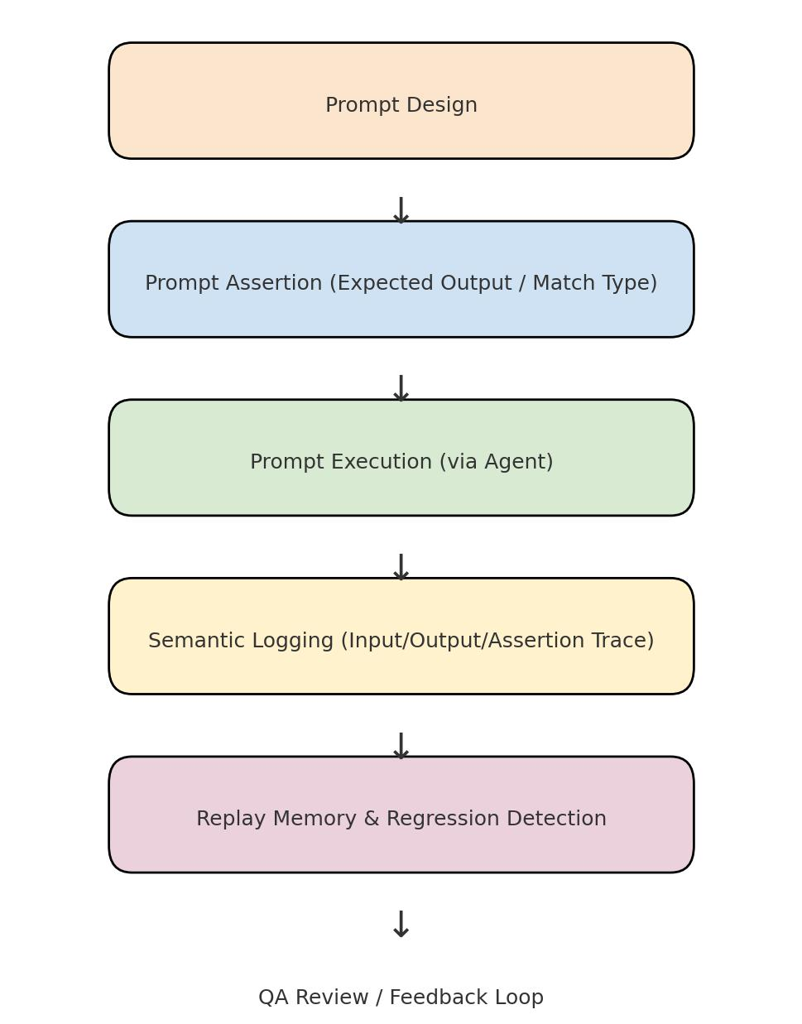

*Figure 1. Prompt Testing Workflow in AgentTest QA Model*