CS3235 — LLM / Multimodal AI Projects
Mini-Project 3
PatraAI
Indian Document Understanding Tool

Final Project Report
Extracting fields, summarising, translating and answering questions about Indian government documents
Submitted by
Name | Pavan Kumar K N
USN | 1RVU23CSE331
Course | CS3235 — LLM / Multimodal AI Projects
Title | PatraAI — Indian Document Understanding Tool (Mini-Project 3)
GitHub | https://github.com/pavankumarkn04/PatraAI
Date | November 2026

Abstract
PatraAI is a web application that helps people understand Indian government documents such as notices, circulars, scholarship letters, certificates and application forms. The user uploads a PDF, Word file or image. PatraAI extracts the key details with the page each came from, writes a short summary, translates the results into Kannada, Hindi, Tamil, Telugu or Malayalam with AI4Bharat IndicTrans2, and answers questions asked in English or any of these five languages.
BharatGen Patram, the vision-language model named in the project sheet, needs more memory than the project laptop has, so a smaller multimodal model (qwen3.5:4b, run with Ollama) does the reading and answering. The application can switch to Patram through one setting when a GPU server is available. Everything runs on a laptop without a GPU.
On 45 hand-checked test cases from 18 real public documents, PatraAI reached 64.4% field-extraction accuracy and 66.7% question-answering accuracy. Most errors came from scanned Kannada and Malayalam pages that OCR read badly, and from long documents where the right page did not reach the model.
Table 1: Key results
What was measured | Result
Test cases | 45 cases over 18 real public documents in 6 languages
Field-extraction accuracy | 64.4% (29 of 45)
Question-answering (QA) accuracy | 66.7% (30 of 45)
Answer cited the correct page | 66.7%
Automated software tests | 98, all passing
Speed-up from optimisation | analysis 23% less time, translation 50% less time

Keywords: document understanding, OCR, multimodal LLM, retrieval-augmented generation, IndicTrans2, Indian languages

Table of Contents
Abstract ii
Table of Contents iii
1. Problem Definition and Relevance 1
1.1 Why this is hard 1
2. Model and Dataset Selection 1
2.1 BharatGen Patram 1
2.2 AI4Bharat IndicTrans2 2
2.3 Why qwen3.5:4b 2
2.4 Evaluation dataset 2
3. Working End-to-End Application 2
3.1 Features 4
4. GenAI, RAG and Agentic Integration 4
4.1 Structured extraction 4
4.2 Question answering with retrieval (RAG) 4
4.3 Agentic loop for the answer language 4
4.4 Checks against hallucination 4
5. Quantitative Testing and Error Analysis 5
5.1 Method 5
5.2 Results 5
5.3 Failure analysis 6
5.4 Speed 7
5.5 Automated tests 7
6. Demo, Documentation and Repository 7
6.1 How to run 8
6.2 Demo script 8
7. Limitations and Future Work 8
8. Conclusion 9
References 9
Appendix A. Test Cases and Results 10

1. Problem Definition and Relevance
Government notices, circulars, scholarship letters, certificates and application forms decide who is eligible for something, which documents to submit and by when. In India they are issued in English and in regional languages, are often scanned, and can run to many pages. A reader who knows only one of these languages may not be able to find the key details.
PatraAI is a general tool for any such document. It shows the key details with the page they came from, a short summary, translations and answers to questions. When the document does not contain an answer, it says so instead of guessing.

1.1 Why this is hard
- Many scripts and old fonts. Six scripts are supported, and many Kannada PDFs use old fonts whose text cannot be copied correctly, so those pages must be read with OCR.
- Scanned pages. Pages that are only pictures need OCR before anything else can happen.
- Small model, no GPU. On a laptop CPU the model writes only about 9 tokens per second, so prompts must be short and its output must be checked for invented numbers.
- Cross-language questions. A question in Kannada about an English document must be answered in Kannada from English text.

2. Model and Dataset Selection
The project sheet specifies BharatGen Patram and AI4Bharat IndicTrans2, and asks to check each model's availability, licence, languages and GPU needs before using it.
Table 2: Models and their roles
Task | Model | Used?
Read documents, extract fields, summarise, answer questions | BharatGen Patram 7B (specified) | No: needs a GPU server
Same tasks (actually used) | qwen3.5:4b via Ollama, on the laptop CPU | Yes
Translate English into 5 Indian languages | AI4Bharat IndicTrans2 (200M), on the laptop CPU | Yes
Backup if a model reply fails | gemma4:e4b | Only as a retry

2.1 BharatGen Patram
Patram-7B needs about 15.3 GB of memory for its weights alone, but the laptop has 15.2 GB of RAM and no GPU. There is no hosted service or smaller (quantised) version, and Ollama cannot run its custom architecture, so it could not run here. PatraAI still supports it: one setting (HF_CHAT_COMPLETIONS_URL) sends all requests to a Patram server, and the application always shows which model actually answered.

2.2 AI4Bharat IndicTrans2
IndicTrans2 translates the summary, the extracted details and the answers from English into Kannada, Hindi, Tamil, Telugu and Malayalam on the CPU. Numbers, dates and codes are protected so translation never changes them.

2.3 Why qwen3.5:4b
It fits in the laptop's memory (3.4 GB; the 9.6 GB gemma4:e4b did not), it reads both text and page images, so one model handles OCR and analysis, and Ollama can make it reply in a fixed JSON structure.

2.4 Evaluation dataset
The test set has 45 test cases over 18 real public documents. Each case has one expected field value, one question with its answer, and the page numbers, all checked by hand against the document; none came from the model. 42 cases use original files and 3 use derived files (a 3-page excerpt and one page saved as an image).
Table 3: Coverage of the test dataset
Coverage | Test cases
Languages | English 25, Hindi 7, Kannada 6, Tamil 3, Malayalam 2, English + Punjabi 2
Formats | Searchable PDF 18, scanned PDF 7, mixed searchable and scanned PDF 8, scanned PDF with text layer 3, old-font PDF 3, long 83-page PDF 3, Word 2, image 1
Document types | 16 types, including circulars, government orders, scholarship notices, admission brochures, certificates and application forms

No public Telugu government document with real (Unicode) text could be found, so Telugu documents are not tested. Telugu questions and translation are supported and covered by automated tests.

3. Working End-to-End Application
PatraAI is a one-page Streamlit web application. It runs entirely on the user's computer: documents are not sent to any outside service and uploads are not saved to disk.
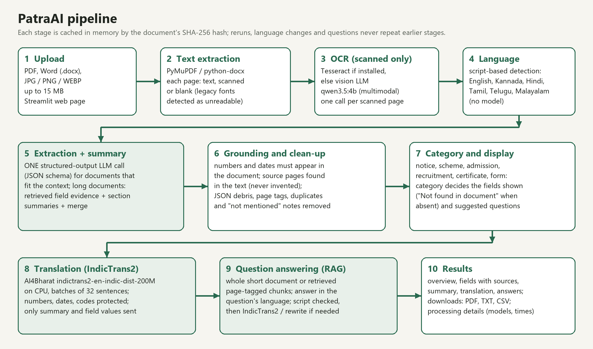
Figure 1: The PatraAI pipeline. Shaded steps use AI models; the other steps are ordinary code.

The application reads the text of each page (using OCR only for scanned pages), detects the language, asks the model for the fields and a summary, checks the output against the document, and then translates and answers questions on request. Every step is cached, so changing the language or asking another question does not repeat earlier work.
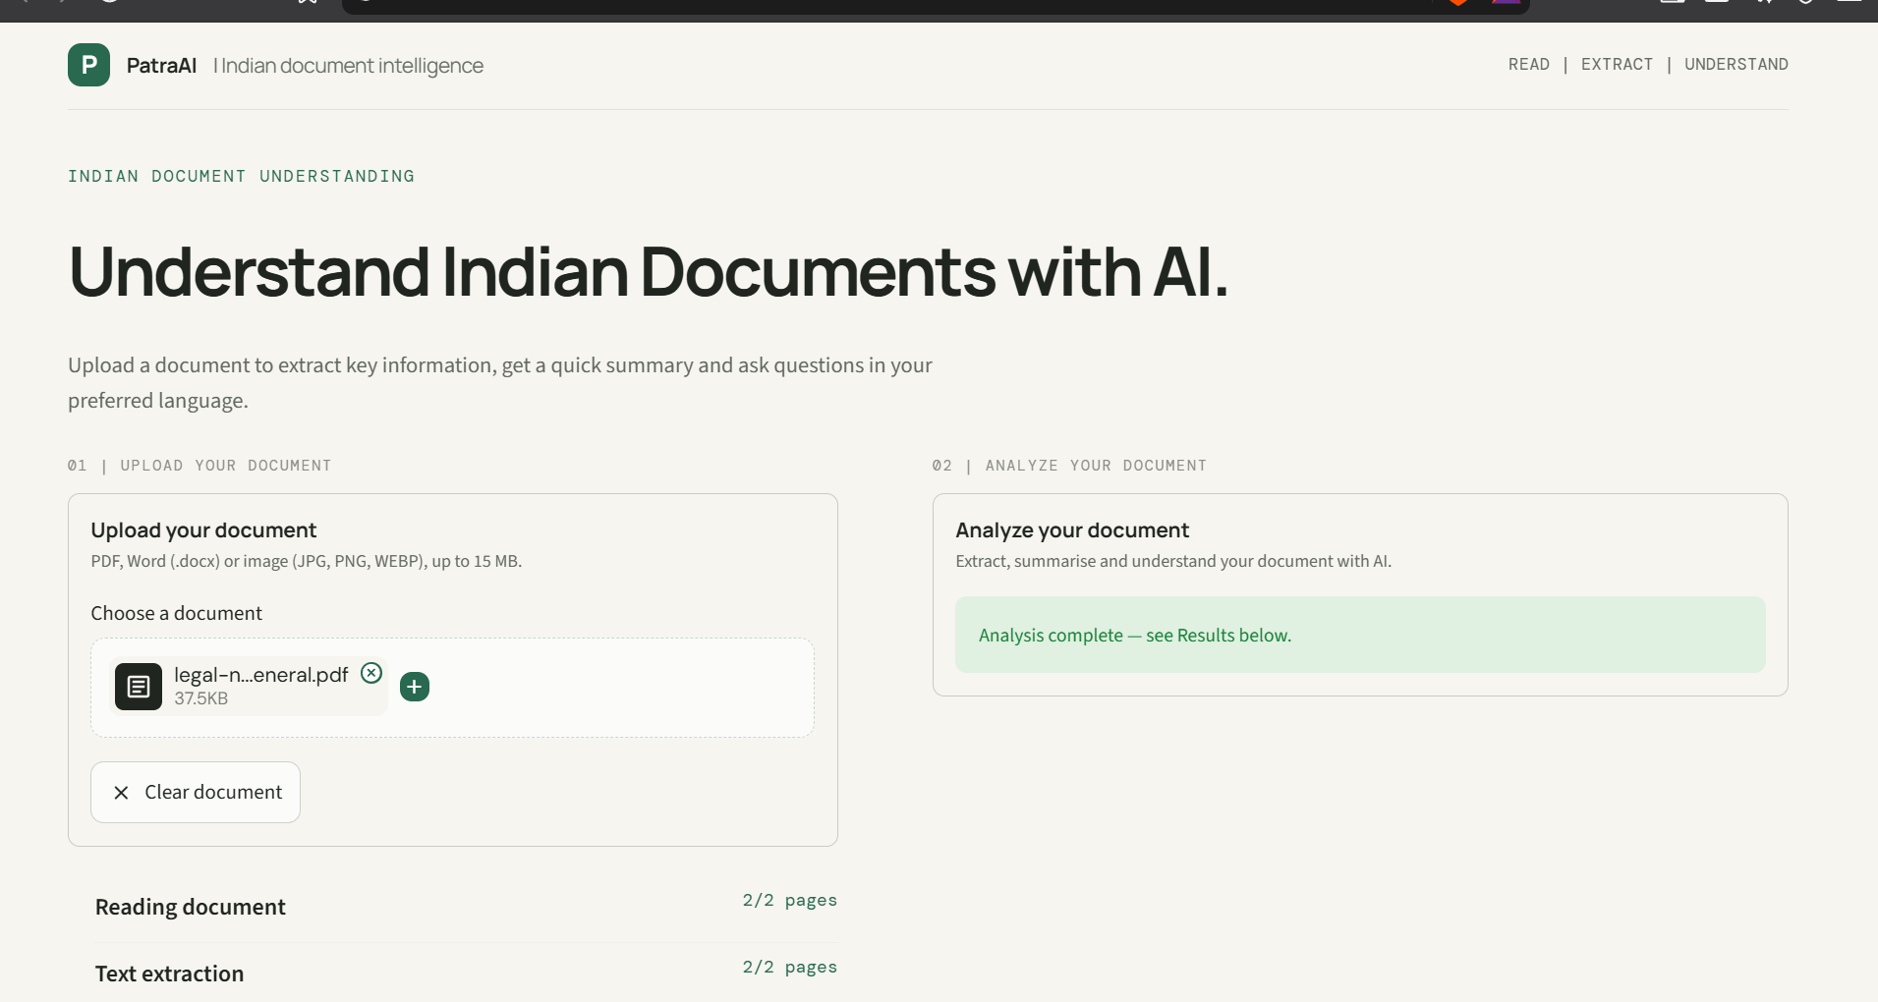  Figure 2: Upload panel with page-by-page progress. | 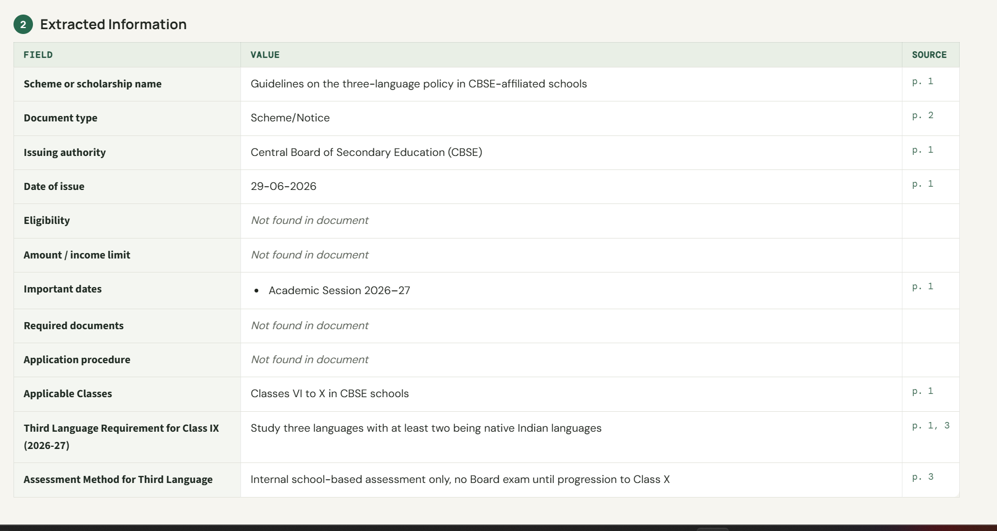  Figure 3: Extracted information with source pages.
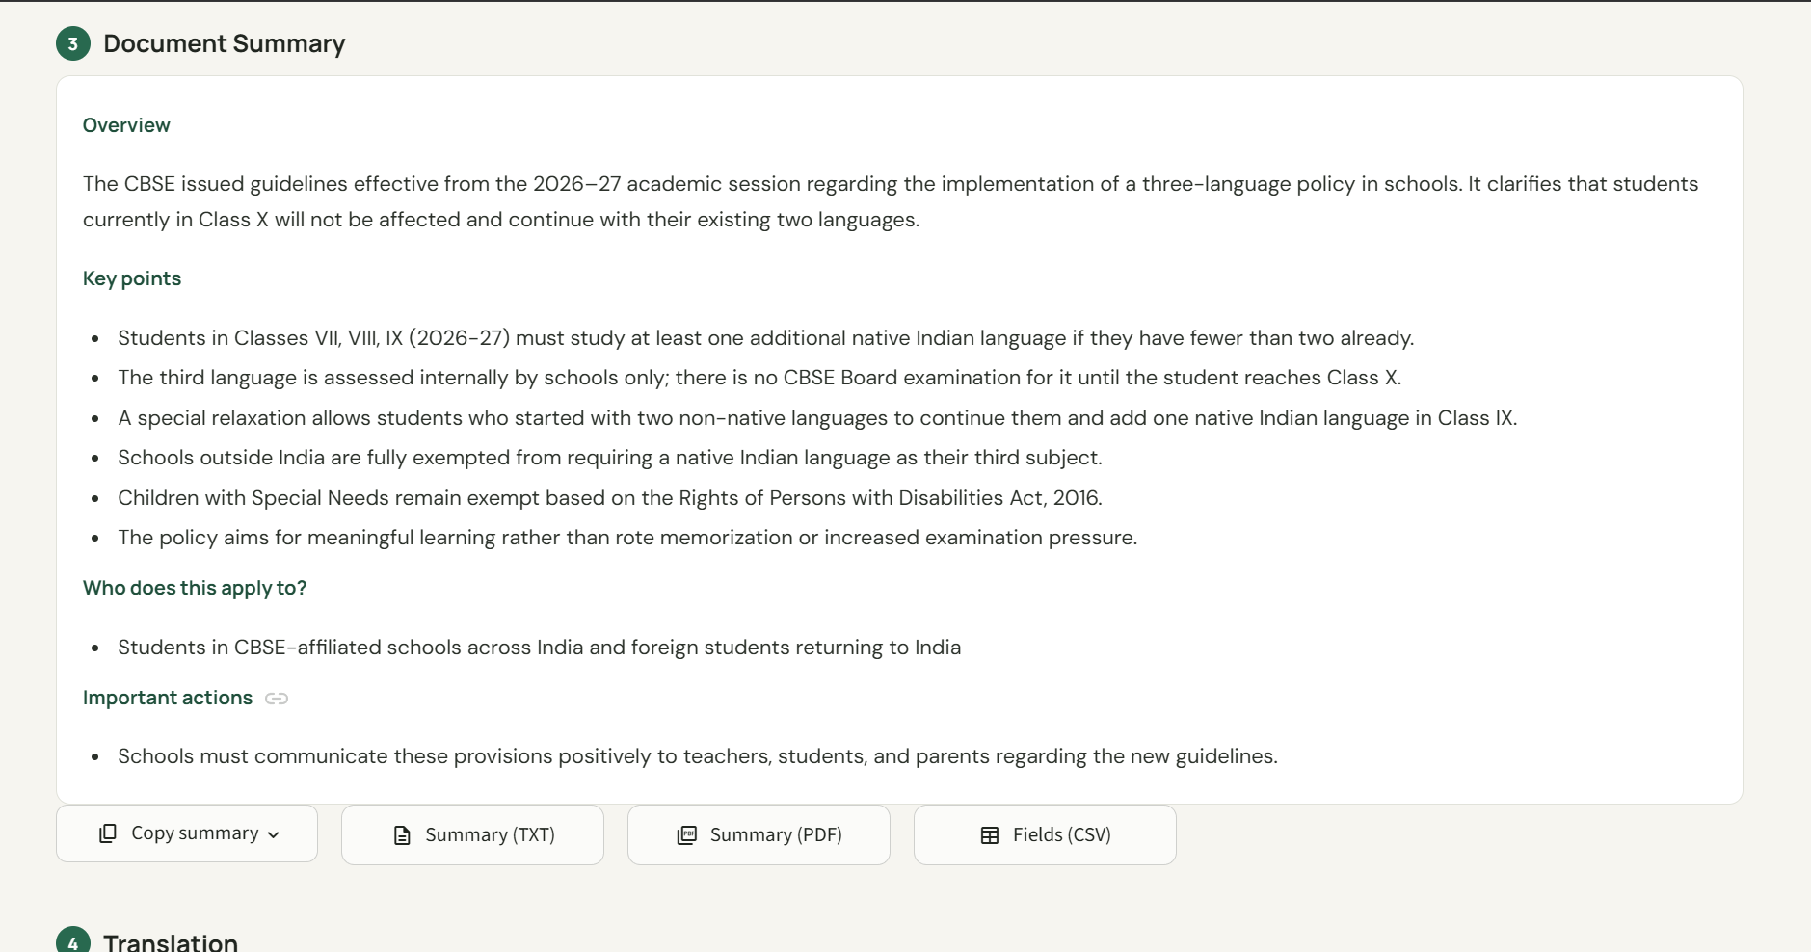  Figure 4: Short summary with downloads. | 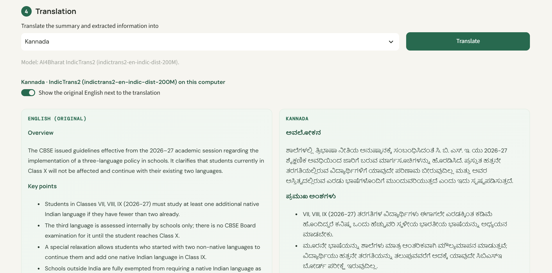  Figure 5: Translation with IndicTrans2.

3.1 Features
- Inputs: searchable and scanned PDFs of any length, Word (.docx) files and images (JPG, PNG, WEBP), up to 15 MB.
- Results: overview, extracted information with source pages, summary, translation, questions and processing details (models used and time taken).
- Languages: English, Kannada, Hindi, Tamil, Telugu and Malayalam; each answer can follow the language of its question.
- Downloads: all results as a PDF, the summary as TXT or PDF, and the fields as CSV.

4. GenAI, RAG and Agentic Integration

4.1 Structured extraction
For a document that fits in the model's context, one request returns both the fields and the summary as JSON in a fixed structure. For long documents, the passages most likely to contain each field are selected first, and the summary is built from up to five section summaries.

4.2 Question answering with retrieval (RAG)
- Short documents are given to the model whole.
- Long documents are split into page-tagged chunks, and the chunks that best match the question are retrieved.
- The model answers only from those chunks and must cite the pages.
- If the answer is not there, PatraAI says "Not found in the uploaded document".

4.3 Agentic loop for the answer language
- Detect the question's language from its script or words.
- Generate the answer in that language (or the language the user chose).
- Check the answer's script in code; if it is wrong, translate it with IndicTrans2 or ask the model to rewrite it.
- If it is still wrong, show an error instead of an answer in the wrong language.

4.4 Checks against hallucination
- A value containing a number that is not in the document is removed.
- A date must be printed in the document; it is never calculated.
- Source pages are found by searching the document text, not taken from the model.

5. Quantitative Testing and Error Analysis

5.1 Method
- Each test document goes through the same pipeline as the website.
- The predicted field and answer are compared with the hand-checked value. Formatting differences are accepted ("₹1,300/-" matches "Rs. 1300"); a different number or date is not.
- "Not found" counts as wrong. Whether the answer cited the right page is scored separately.
The evaluation code is in evaluation/benchmark.py and evaluation/scoring.py. Every case was run once with qwen3.5:4b on the laptop CPU; cases interrupted when the laptop went to sleep were run again. For long Hindi, Kannada and Tamil documents the evaluation searched with the English question only, while the website also searches with a translated question, so those results may understate the website.

5.2 Results
Table 4: Overall results
Metric | Result
Test cases evaluated | 45 of 45
Field-extraction accuracy | 64.4% (29 of 45)
QA accuracy | 66.7% (30 of 45)
Answer cited the correct page | 66.7%
Processing errors | 0

Table 5: Results by document language
Language | Cases | Field accuracy | QA accuracy
English | 25 | 76.0% | 88.0%
English + Punjabi | 2 | 100.0% | 100.0%
Hindi | 7 | 57.1% | 71.4%
Kannada | 6 | 33.3% | 16.7%
Malayalam | 2 | 50.0% | 0.0%
Tamil | 3 | 33.3% | 0.0%

English documents did best. Searchable PDFs reached 72.2% field and 83.3% QA accuracy, while scanned PDFs reached only 42.9% and 28.6%. All Kannada documents needed OCR, and the only Tamil document has 83 pages. Tamil and Malayalam have only 3 and 2 cases, so their figures are rough.

5.3 Failure analysis
All 31 wrong field and answer checks were traced to a root cause by checking the text PatraAI read from the page, whether the right page reached the model, and what the model returned.
Table 6: Root causes of the wrong results
Root cause | Wrong checks | Where it happened
Right page not found in a long document | 10 | Admission brochure (English); Vacancy circular (Hindi); Public policy document (Tamil)
Scanned page read badly (OCR) | 10 | Government circular (Kannada); Gazette notification (Malayalam)
Another number taken as the reference number | 4 | Vacancy circular (Hindi); Government scheme order (English); Gazette notification (Malayalam)
Model missed a value that was in the text | 4 | Vacancy circular (Hindi); Scholarship notification (English); Application form + certificate format (English); Educational document (English)
A check or the scorer was too strict | 3 | Official circular / letter (Hindi); Scholarship notification (English); Government scheme order (English)

- Right page not found in a long document. Long documents are searched by matching words, so the page with the answer was sometimes not selected. In a 127-page brochure and an 83-page Tamil document the model never saw that page and correctly said it could not find the answer.
- Scanned page read badly (OCR). On scanned Kannada and Malayalam pages, the small vision model used for OCR read numbers well but garbled many words. On one scanned circular it could not read the first page at all, so every check on that document failed.
- Another number taken as the reference number. Government orders quote many other orders and registration numbers. The model sometimes returned one of these instead of the document's own reference number.
- Model missed a value that was in the text. The right text reached the model, but it left a value out (for example a list of required documents), or a quick text-matching shortcut quoted the wrong amount.
- A check or the scorer was too strict. The date check dropped a correct date written with a Hindi month name, and the scorer rejected two correct results because they were written differently from the expected text. True accuracy is therefore slightly higher than reported.
Wrong page references are not counted above: 15 answers cited the wrong page or none, and 12 of these were also wrong answers.
Table 7: Examples of wrong results
Document type | Check | Expected | Predicted | Cause
Government circular (Kannada) | issuing department | Department of State Educational Research and Training | DSERT | ರಾಜ್ಯ ಶೈಕ್ಷಣಿಕ ಸಂಶೋಧನೆ ಮತ್ತು ತರಬೇತಿ ಇಲಾಖೆ | Government of Karnataka, Department of School Education and Literacy | OCR
Admission brochure (English) | amount | ₹ 1300/- | Rs. 1300 | (nothing) | Page not found
Government scheme order (English) | reference number | G.O.MS.No. 26 | G.O.Ms.No.26 | G.O.Rt.No. 326, G.O.Ms.No.9, Comp. No. 2858012 | Wrong number picked
Application form + certificate format (English) | required documents | Voter ID | Aadhaar | IT returns | RoR | (nothing) | Model missed it
Official circular / letter (Hindi) | date | 24 अक्टूबर, 2025 | 24 October 2025 | (nothing) | Too strict

5.4 Speed
The same five documents were timed before and after the speed work. Analysis now takes 23% less time and translation 50% less time, with the same accuracy. The main changes were one combined model call with shorter instructions, reading the prompt in advance while the user looks at the preview, caching every step, and translating in batches.
Table 8: Speed before and after optimisation
Document | Analysis | Translation (Kannada + Hindi) | Fields correct
Government order (1 page) | 76 s → 58 s | 43 s → 32 s | 2/2 → 2/2
Press release (4 pages) | 107 s → 84 s | 59 s → 36 s | 3/3 → 3/3
Word document | 92 s → 78 s | 121 s → 40 s | 1/2 → 1/2
Scheme order (7 pages) | 195 s → 148 s | 104 s → 62 s | 2/3 → 2/3
Hindi circular (7 pages) | 149 s → 109 s | 53 s → 21 s | 2/3 → 2/3
Total | 618 s → 476 s | 380 s → 191 s | unchanged

5.5 Automated tests
98 automated tests (pytest) check page handling and OCR routing, cleaning of model output, language detection, translation, the scoring rules and the web page itself, using stand-in model services. All 98 pass.

6. Demo, Documentation and Repository
GitHub repository: https://github.com/pavankumarkn04/PatraAI
- README.md: setup, models, how the pipeline works, results and limitations.
- Indian.py and the other .py files: the web application and its processing code.
- evaluation/: the 45 test cases and 18 documents, the scorer, and the results (every check and prediction).
- tests/ and docs/: 98 automated tests; this report and the screenshots.

6.1 How to run
- Install Python 3.11 and Ollama. Accept the IndicTrans2 terms on Hugging Face and put a read token in a .env file (HF_TOKEN=...).
- Double-click Start PatraAI.bat. It installs missing packages, downloads the models the first time and opens the application in the browser.
- Double-click Stop PatraAI.bat to stop it.

6.2 Demo script
- Upload a government PDF and show the page preview.
- Click Analyze. Show the extracted details with their source pages, and the summary.
- Change the response language (for example to Kannada); the results appear without analysing again.
- Ask a question in Kannada or Hindi and show the answer, its language and its source page.
- Ask something the document does not say; the answer is "Not found in the uploaded document".
- Upload a scanned page or photo (OCR runs only for scanned pages) and download the results as a PDF.

7. Limitations and Future Work
- Patram was not run. It needs a GPU server; comparing it with qwen3.5:4b on the same test cases is the main next step.
- OCR of Indian scripts. The small vision model garbles Kannada and Malayalam words on scanned pages. Tesseract with Indian-language packs is supported but was not installed for this evaluation.
- Long documents. Word-matching retrieval can miss the right page, especially in Indian-language documents; multilingual retrieval would help.
- Evaluation scope. Long Hindi, Kannada and Tamil documents were searched with the English question only; Telugu documents are not tested, and Tamil and Malayalam have few cases.
- Speed. On a CPU, a typical document takes about 1–2.5 minutes and a 100-page document several minutes; a GPU would make it interactive.

8. Conclusion
PatraAI works end to end on real Indian government documents: it reads searchable, scanned, old-font and Word files, extracts details with their source pages, summarises, translates with IndicTrans2 and answers questions in six languages. On 45 hand-checked test cases it reached 64.4% field-extraction accuracy and 66.7% QA accuracy (76.0% and 88.0% on English documents). Its main weaknesses, OCR of scanned Indian-language pages and retrieval in long documents, are the clearest next steps, together with running Patram on a GPU server.

References
[1] BharatGen. Patram-7B-Instruct model card. https://huggingface.co/bharatgenai/patram-7b-instruct
[2] AI4Bharat. IndicTrans2 (en-indic-dist-200M). https://huggingface.co/ai4bharat/indictrans2-en-indic-dist-200M
[3] J. Gala et al. IndicTrans2: Towards High-Quality and Accessible Machine Translation Models for all 22 Scheduled Languages of India. TMLR, 2023.
[4] Qwen team. Qwen3.5 models, served with Ollama. https://ollama.com
[5] PatraAI project repository. https://github.com/pavankumarkn04/PatraAI

Appendix A. Test Cases and Results
Field, Answer and Page show whether the expected field, the answer and the cited page were correct. Case numbers follow evaluation/dataset/cases.jsonl in the repository.
Table 9: All test cases and results
No. | Document type | Language | Question | Field | Answer | Page
1 | Admission brochure | English | Who issued this information brochure? | Yes | No | No
2 | Admission brochure | English | What is the application fee for General Category candidates from Maharashtra State? | No | Yes | Yes
3 | Admission brochure | English | What is the parental annual income limit for the reservation scheme for Maharashtra State candidates? | No | Yes | Yes
4 | Press release / notice | English | What is the date of the press release? | Yes | Yes | Yes
5 | Press release / notice | English | Out of the three languages, how many must be Bhartiya Bhashas? | Yes | Yes | Yes
6 | Press release / notice | English | In how many scheduled Bhartiya Bhashas are dedicated R3 textbooks for Class VI being made available? | Yes | Yes | No
7 | Vacancy circular | Hindi | Which office issued this circular? | Yes | Yes | Yes
8 | Vacancy circular | Hindi | How many posts of Assistant Director (Language) are to be filled? | Yes | No | No
9 | Vacancy circular | Hindi | What is the maximum age limit for appointment on deputation? | No | Yes | Yes
10 | Vacancy circular | Hindi | Who signed the vacancy circular? | No | No | No
11 | Official circular / letter | Hindi | Which department issued this circular? | Yes | Yes | Yes
12 | Official circular / letter | Hindi | Which post is to be filled on deputation? | No | Yes | Yes
13 | Official circular / letter | Hindi | What is the pay matrix range for the post? | Yes | Yes | Yes
14 | Government circular | Kannada | Which department issued this circular? | No | No | No
15 | Government circular | Kannada | For how many days was the bridge programme conducted in June? | No | No | No
16 | Government circular | Kannada | On which Saturday of every month should the head teachers' meeting on FLN be held? | No | No | No
17 | Government circular | Kannada | What is the date of this circular? | Yes | Yes | Yes
18 | Government circular | Kannada | How many self-learning activity modules were prepared for students? | No | No | No
19 | Government circular | Kannada | Which module is scheduled for January 2027? | Yes | No | Yes
20 | Scholarship notification | English | What is the parental annual income limit for this scholarship? | No | Yes | Yes
21 | Scholarship notification | English | What is the maximum scholarship amount per annum? | Yes | No | No
22 | Scholarship notification | English | To whom should applications of Backward Classes (BC) students be sent? | Yes | Yes | No
23 | Scholarship notification | English | What is the letter number? | Yes | Yes | Yes
24 | Government scheme order | English | How much financial assistance is given per child per annum under the scheme? | No | Yes | Yes
25 | Government scheme order | English | How much is deducted at source per student? | Yes | Yes | Yes
26 | Government scheme order | English | Which classes are covered by the scheme? | Yes | No | Yes
27 | Public policy document | Tamil | How many schools did the School Education Department have as of March 2024? | No | No | No
28 | Public policy document | Tamil | How many students were there as of March 2024? | Yes | No | No
29 | Public policy document | Tamil | What share of total state expenditure is allocated to school education? | No | No | No
30 | Gazette notification | Malayalam | What is the G.O. number of this notification? | No | No | Yes
31 | Gazette notification | Malayalam | Under which Act is this notification issued? | Yes | No | No
32 | Notification with schedule table | English | What is the last date for online application submission and fee payment? | Yes | Yes | Yes
33 | Notification with schedule table | English | When is the certificate verification of eligible candidates? | Yes | Yes | Yes
34 | Government order | English | What amount is administratively sanctioned in this order? | Yes | Yes | Yes
35 | Government order | English | Who signed this government order? | Yes | Yes | Yes
36 | Official proceedings / letter | English | What honorarium does the District Collector receive as chairperson of the district committee? | Yes | Yes | Yes
37 | Official proceedings / letter | English | On which dates were certificate verification and interviews originally scheduled for all institutions? | Yes | Yes | Yes
38 | Government certificate (prescribed format) | English | Who can issue this certificate? | Yes | Yes | Yes
39 | Government certificate (prescribed format) | English | Which website gives the latest guidelines on the Central List of OBCs? | Yes | Yes | Yes
40 | Application form + certificate format | English | What is the gross annual family income limit for the EWS certificate? | Yes | Yes | Yes
41 | Application form + certificate format | English | Above what size of agricultural land is a family excluded? | No | Yes | No
42 | Application form | English + Punjabi | What is the RTS service number of this form? | Yes | Yes | Yes
43 | Application form | English + Punjabi | When was this form last revised? | Yes | Yes | Yes
44 | Educational document | English | Which BharatGen model is suggested for the Indian Document Understanding Tool? | Yes | Yes | Yes
45 | Educational document | English | How many representative test cases are required? | No | Yes | Yes

