[Home](http://docs.google.com/home.html)

[Bikes](http://docs.google.com/bike.html)

[Cars](http://docs.google.com/car.html)

[ContactUs](http://docs.google.com/contactus.html)

[AboutUs](http://docs.google.com/aboutus.html)

## Cars Collections

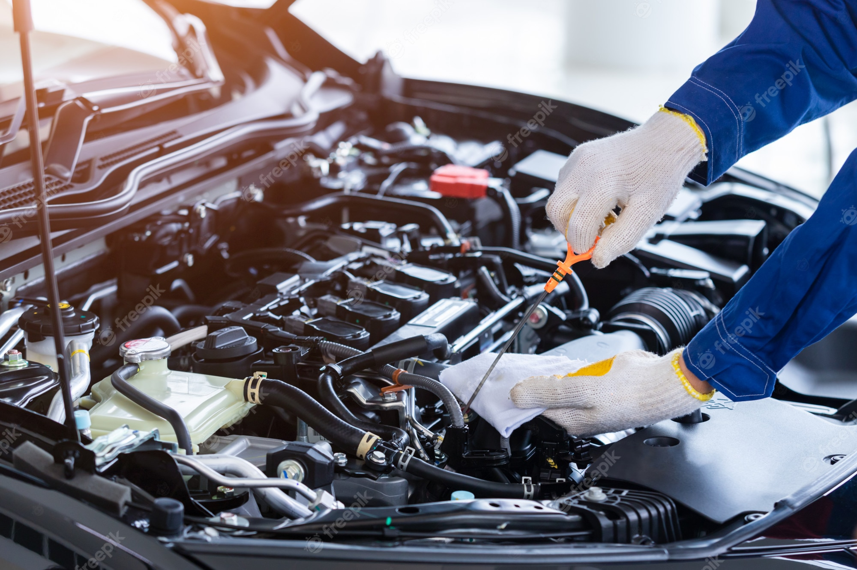

engine repair

Type: car

depending on engine problem

estimated price

PRICE: 14000rs

PRICE: 30000rs

[Book](http://docs.google.com/address.html)

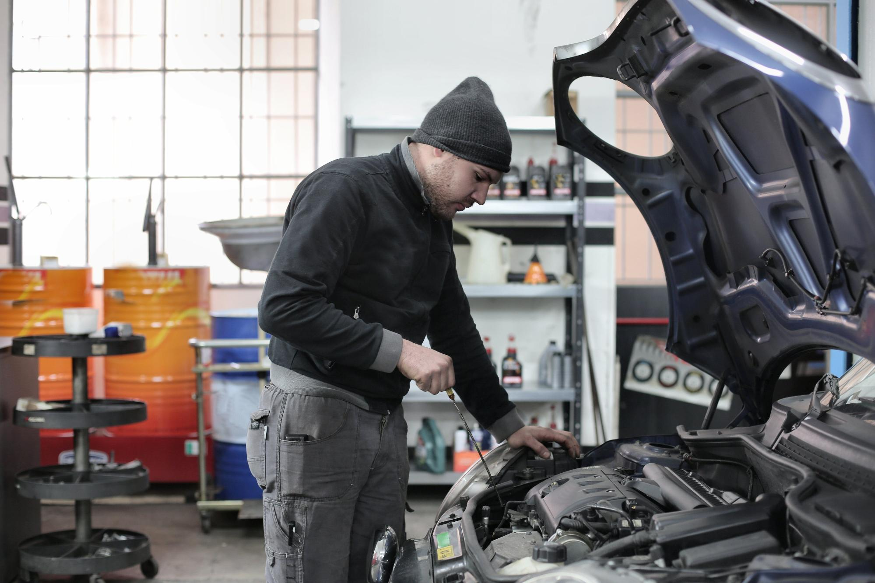

oil tank

vehical oil tank repair with professional worker

estimated price:5000 to 10000

[Book](http://docs.google.com/address.html)



tyre

tyre repairs and new tyre with low price

depending up on the vehical tyre condition

estimated price

PRICE: 3,500rs

PRICE: 4,600rs

[Book](http://docs.google.com/address.html)

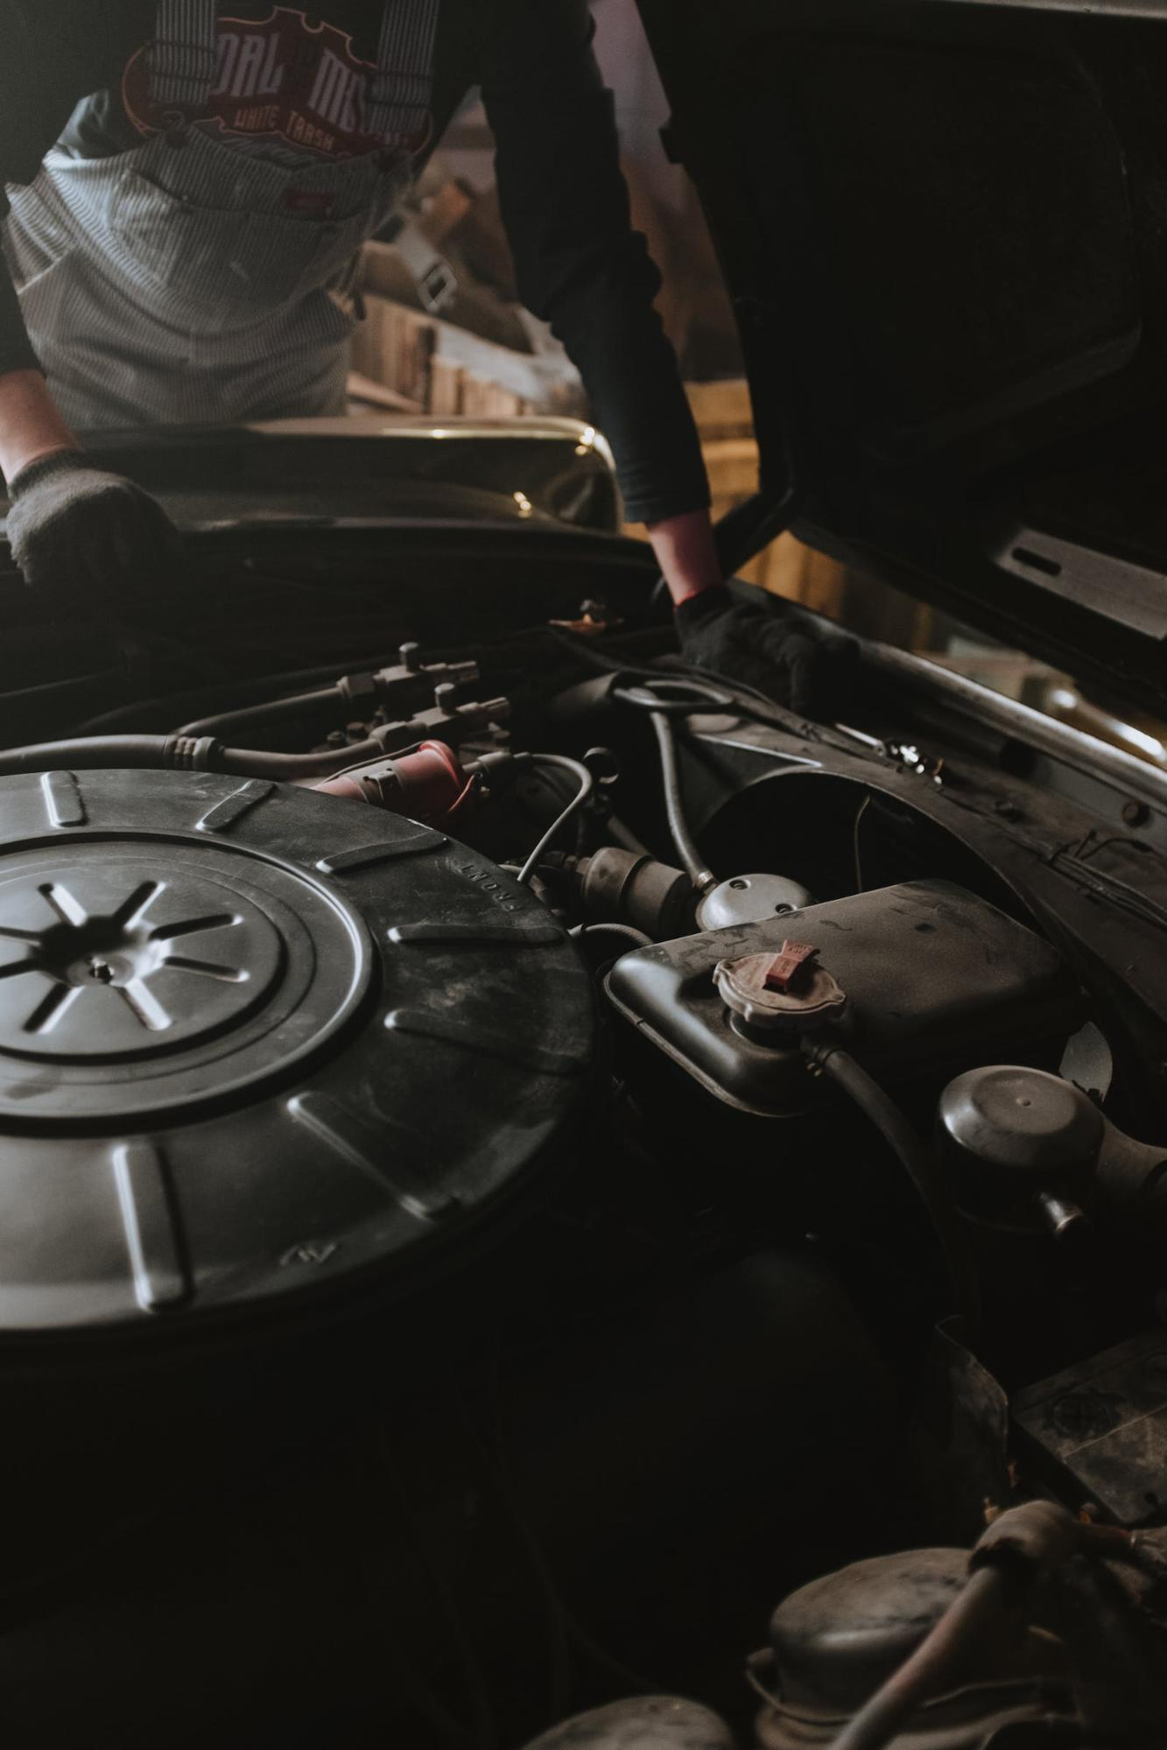

carburetor

cost depend onthe condition

estimated price

PRICE: 500rs

PRICE: 1000rs

[Book](http://docs.google.com/address.html)

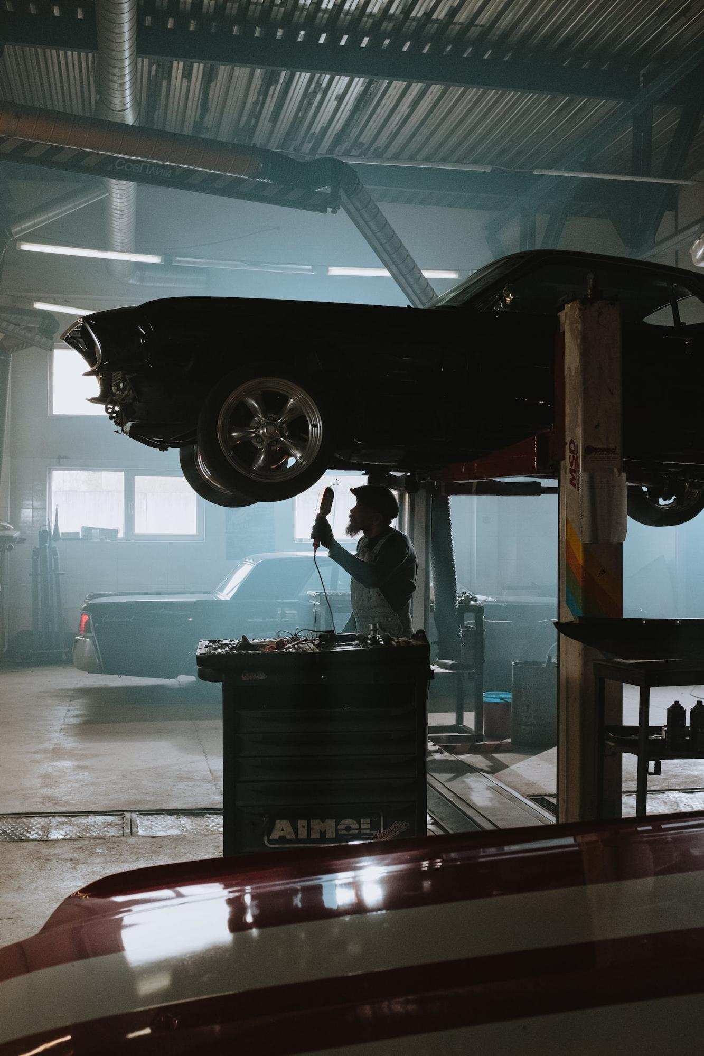

full repair

car full service

estimated price

PRICE: 20000rs

PRICE: 40000rs

[Book](http://docs.google.com/address.html)



Tire repairs and changes

Without good, inflated tires, you loose speed, control, and fuel efficiency, hence the need to get them patched if there's a leak (for example, if you run over a nail), or replaced if they're too worn

estimated price

PRICE: 10000rs

PRICE: 20000rs

[Book](http://docs.google.com/address.html)



The Ignition System

A car's ignition system includes its battery, starter, and the ignition itself. If they aren't working, the car won't start, or might end up stopping in the middle of the road. Luckily, swapping a battery out is simple.

estimated price

PRICE: 1400rs

PRICE: 3000rs

[Book](http://docs.google.com/address.html)

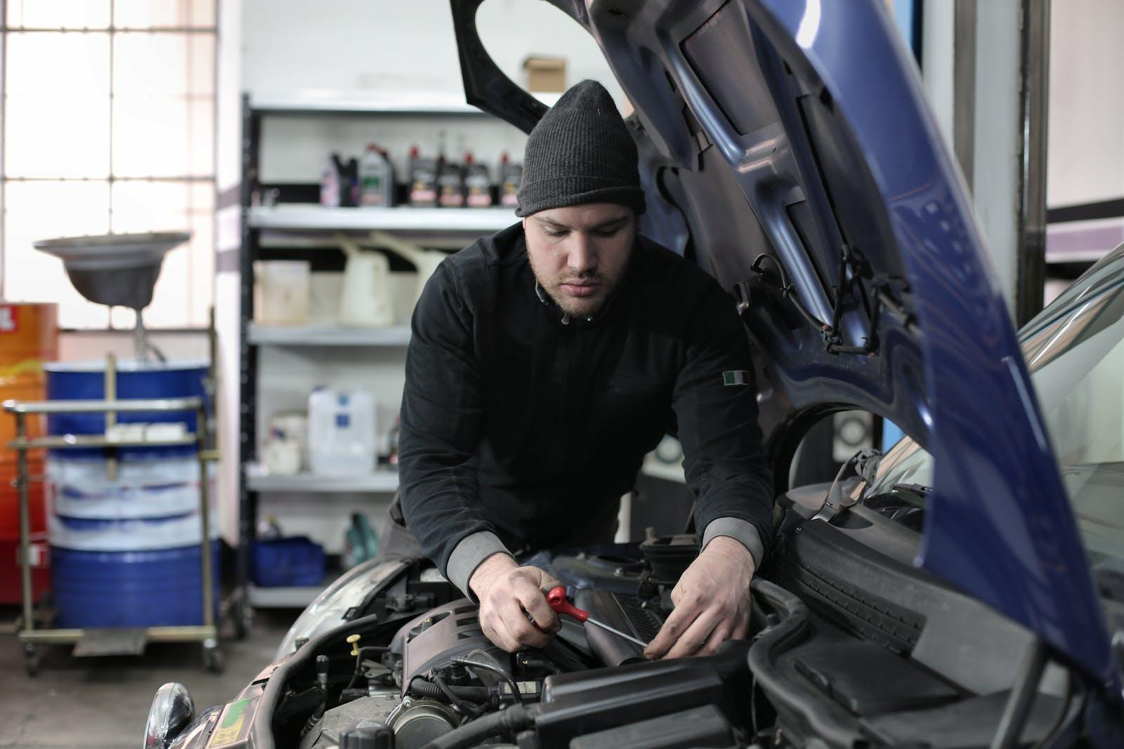

The Electrical System

Along the same lines as batteries, other electrical components in your car that commonly need replacement are fuses and light bulbs.

estimated price

PRICE: 1000rs

PRICE: 3000rs

[Book](http://docs.google.com/address.html)



car modification

car modification is done by professional eorkers as customers need

estimated price

PRICE: 30000 rs

PRICE: 40000rs

[Book](http://docs.google.com/address.html)

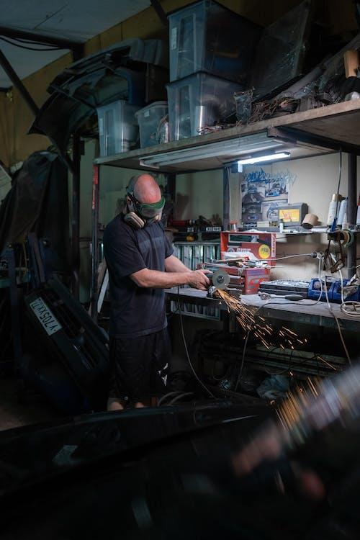

TurboCharger Service centers.

service

estimated price

PRICE: 10000rs

PRICE: 30000rs

[Book](http://docs.google.com/address.html)