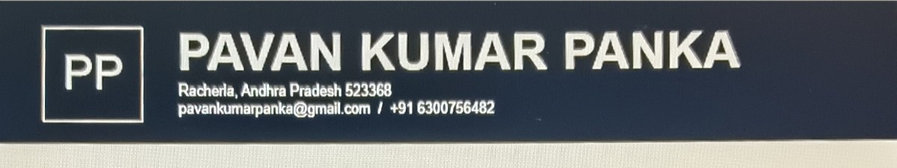
SUMMARY
Highly-motivated employee with desire to take on new challenges. Strong work ethic,
adaptability, and exceptional skills, Adept at working effectively unsupervised and quikly mastering new skills.
SKILLS
Computer Alded Engineering | • Time management
Computer Alded Design | Problem resolution
Computer Alded Manufacturing | Decision-making
Mechanical design | • Leadership
Rapid Manufecturling  Machine Handling | Multitasking Abilities

EDUCATION
Bachelor of Technology: Mechanical Engineing Expected in 07/2026
R V.R. 8 J.C College of Engineering —Guntur, Andhra Pradesh
GP4: 7.02
Higher Schooling: Mathematics Physics Chemistry (MPC)  Sree jeevan jyothi Junior College — Giddaluru, Andhra Pradesh  PERCENTAGE: 53.5% | 08/2022
Schooling | 08/2020
Spandana high School—Racherla,Andhra Pradesh
GPA:9.63/10.0

CERTIFICATES
Electric Vehicle in SkillDzire
Product design in SkillDzire
Basics of Catia v5 in SKILL LYNC

ACHIEVEMENTS
NPTEL Certificatrion in Rapid manufacturing
NPTEL Certification in Introduction to Industry 4.0 and Industrial Internet of Things
Coordinates of Mech Mantra event in Yantralayam

PROJECT
Four Point Walking Assistive Cane(Ergonomics design and simulation based project)

LANGUAGES
Telugu: English:

Native Intermediate (B1)

Hindi:
Beginner

