

## DEPARTMENT OF COMPUTER SCIENCE AND ENGINEERING

**Exploring File Handling: Concepts and**

**Implementation**

EL REPORT

# OPERATING SYSTEMS

**Submitted by,**

## Ningaraj P Totagi 1RV22CS130

**Pavankumar R 1RV22CS136**

# Introduction

File handling is the backbone of data management in computer systems, acting as the

silent orchestrator behind the scenes. It ensures the seamless exchange of information

between programs and storage media, facilitating the smooth operation of various

software applications. While often perceived as complex, delving into file handling is

akin to embarking on an intriguing journey within the inner workings of computing.

In this exploration, we will unravel the intricacies of file handling, gaining a deeper

understanding of its concepts and implementation. By immersing ourselves in this realm,

we not only enhance our technical prowess but also uncover the fundamental principles

that govern data manipulation within modern computing environments. So, let's dive into

the realm of file handling, where every line of code represents a step closer to mastering

the art of managing data effectively.

# Problem Statement

Develop a comprehensive solution for a project focusing on file handling concepts and

implementation within a programming environment. The objective is to design and

implement a robust system for managing files and directories, demonstrating proficiency

in file handling techniques and system-level programming.

**Key Requirements:**

1. File Management System: Design and implement a file management system capable of creating, reading, writing, and deleting files and directories.
2. Error Handling: Implement robust error handling mechanisms to ensure graceful recovery from file-related errors, such as "file not found," "permission denied," or "disk full."
3. Efficient Data Access: Optimize file access operations for efficiency, including techniques such as buffering, caching, and asynchronous I/O.
4. Security Mechanisms: Incorporate security features, such as access control lists (ACLs)

or file permissions, to regulate file access and ensure data integrity.

**Objectives:**

- Develop a fully functional file handling system capable of performing basic file operations efficiently.

- Implement error handling mechanisms to handle various exceptional scenarios gracefully

- Optimize file access operations to enhance performance and minimize latency.

- Incorporate security measures to safeguard files and directories from unauthorized access

or tampering.

## Tools & APIS SystemCalls Required

### Tools:

1. **GNU/Linux Distribution**: Any distribution like Ubuntu, Debian, or RedHat for the

development environment.

**2.Assembler (GNU Assembler - gas)**: Utilized to assemble assembly language files.

**3.GCC (GNU Compiler Collection)**: Required for compiling C code. Versions 4 and above are

suitable.

**4. grub-mkrescue**: This tool is crucial for creating a GRUB rescue image. It internally calls the

xorriso functionality to build an ISO image.

**5.QEMU (Quick EMUlator)**: Used to boot the kernel in a virtual machine without needing to

reboot the main system.

**6.Executable Kernel Image ISO**: The final output of the kernel build process is an executable

Kernel image, typically packaged into an ISO image.

**7.Header Files (.h)**: These files contain declarations needed for system calls and API usage.

**APIs and System Calls:**

**1.File System APIs**: Necessary for interacting with the file system, including functions for file

creation, reading, writing, deletion, and directory manipulation.

**2.Process Management APIs**: Required for managing processes, including functions for process

creation, termination, and communication.

**3.Memory Management APIs**: Needed for memory allocation and management, including

functions for allocating and deallocating memory.

**4.Input/Output System Calls**: These system calls handle input and output operations, such as

**Reading** from and writing to files.

**5.Error Handling System Calls**: Essential for error handling during file operations, including

functions for reporting and handling errors.

**Methodology**

**1.Requirement Analysis:**

- Identify and analyze the requirements for file handling within the kernel.

- Determine the types of file operations needed (e.g., creation, reading, writing, deletion).

- Consider additional functionalities such as file locking, permissions, and error handling.

**2. Design Phase:**

- Design the file handling system architecture, including data structures for representing

files, directories, and file metadata.

- Define the interface for file system APIs and system calls, specifying parameters and

return values.

- Design data structures and algorithms for efficient file operations, considering factors like

concurrency and performance optimization.

- Incorporate error handling mechanisms to ensure robustness and data integrity.

**3 . Implementation:**

- Implement the file handling functionalities based on the design specifications.

- Write code for file creation, reading, writing, deletion, and directory manipulation

operations.

- Implement file system data structures, such as inodes, file control blocks, and

directory structures.

- Develop algorithms for file system traversal, file allocation, and block management.

- Integrate error handling mechanisms to handle exceptions and errors gracefully.

**4. Testing and Debugging:**

- Develop test cases to verify the correctness and functionality of file handling operations.

- Perform unit testing to validate individual components and functions.

- Conduct integration testing to ensure seamless interaction between different modules.

- Debug and troubleshoot issues encountered during testing, addressing errors and inconsistencies.

**5. Optimization:**

- Profile the file handling system to identify performance bottlenecks and areas for optimization.

- Optimize algorithms and data structures to improve the efficiency of file operations.

- Implement caching mechanisms to reduce disk I/O and enhance responsiveness.

- Fine-tune concurrency control mechanisms to ensure thread safety and scalability.

**6. Documentation:**

- Document the design, implementation details, and usage instructions for the file handling system.

- Provide comprehensive documentation for file system APIs and system calls, including

parameters, return values, and error codes.

- Include examples and usage scenarios to facilitate easy integration and usage by other developers.

**7. Integration and Deployment:**

- Integrate the file handling system with the kernel build process and system initialization routines.

- Verify compatibility with other kernel components and ensure seamless integration into the

kernel environment.

- Deploy the updated kernel with the enhanced file handling capabilities for further testing

and evaluation.

**8. Maintenance and Updates:**

- Monitor and maintain the file handling system for performance, reliability, and security.

- Address any reported issues or bugs promptly through patches and updates.

- Continuously enhance the file handling functionalities based on user feedback and

evolving requirements.

By following this methodology, you can effectively design, implement, and maintain a robust

file handling system within the kernel, showcasing proficiency in system-level programming and

kernel development.

## Relevance to the course.

1. **Core Operating System Functionality:** File handling is one of the fundamental

functionalities of an operating system. Operating systems provide an interface for

users and applications to interact with files stored on storage devices. Understanding and

implementing file handling mechanisms is essential for developing a comprehensive

operating system.

1. **Resource Management**: Operating systems are responsible for managing system

resources efficiently. File handling involves managing resources such as disk space,

memory buffers, and file descriptors. Implementing effective file handling mechanisms

requires understanding resource allocation, utilization, and deallocation strategies, which

are core concepts in operating system design.

1. **Process Management** File handling often involves coordinating file operations with

processes running on the system. Processes may need to read from or write to files,

and the operating system must manage these interactions effectively to ensure data

integrity and system stability. Understanding process management concepts such

as process synchronization and inter-process communication is crucial for implementing

robust file handling functionalities.

**4.Concurrency and Synchronization:** Operating systems often support multiple

concurrent processes accessing files simultaneously. Implementing file handling mechanisms

involves dealing with concurrency issues such as race conditions and ensuring proper

synchronization to prevent data corruption and maintain consistency. Concepts such as locks,

semaphores, and mutexes, which are central to operating system design, come into play when

implementing file handling functionalities.

**5.File System Design:** File handling implementation involves understanding and designing

File system structures and algorithms. Operating systems typically support various

file system types, each with its own design principles and characteristics. Implementing

file handling functionalities requires knowledge of file system organization, directory

structures, file metadata, and allocation strategies, all of which are fundamental to

understanding operating system architectures.

**6.Input/Output Operations:** File handling is a subset of input/output (I/O) operations

managed by the operating system. Understanding how the operating system manages I/O

devices, such as disks and network interfaces, is crucial for implementing efficient

file handling functionalities. Concepts such as device drivers, I/O scheduling

algorithms, and buffering mechanisms are relevant to file handling implementation.

**7. Error Handling and Recovery:** Operating systems must handle errors gracefully and

provide mechanisms for error detection, reporting, and recovery. File handling

implementation requires robust error handling mechanisms to deal with various error

conditions, such as disk failures, file corruption, or permission errors. Understanding

fault tolerance, error detection, and recovery techniques is essential for developing

reliable file handling functionalities.

## OUTPUT & RESULT

Upon the successful implementation of file handling mechanisms within the operating

system, several specific outputs and results are expected, directly related to file handling

Firstly, the generation of an executable kernel image encapsulates the compiled code

and configurations essential for booting the operating system kernel, including the file

handling functionalities. During system boot-up, successful initialization of the file

system is crucial, ensuring the setup of essential data structures such as the superblock,

inode table, and data blocks, facilitating proper file management within the system.

Once initialized, the system should demonstrate the ability to perform fundamental file

operations.This includes creating, opening, reading from, writing to, and closing

files, reflecting the integrity and functionality of the file system. Robust error handling

mechanisms must be in place to address exceptional scenarios, such as file not found,

permission denied, or disk full errors, ensuring the system's reliability and resilience.

Performance evaluation plays a significant role in assessing the efficiency of the file

handling implementation. Metrics such as file read/write speeds and overall system

responsiveness provide insights into the system's performance characteristics, guiding

optimization efforts. Furthermore, seamless integration with other system components,

such as process management, memory management, or device drivers, is essential. File

operations should not disrupt the functionality of other system components, ensuring system

stability and coherence.

Comprehensive documentation detailing the design, implementation, and testing procedures

of the file handling system serves as a valuable resource for future reference and

troubleshooting. Through meticulous evaluation and refinement of these outputs, the file

handling implementation demonstrates proficiency in kernel development and

system-level programming, showcasing a comprehensive understanding of file handling.

Principles and mechanisms within the operating system.

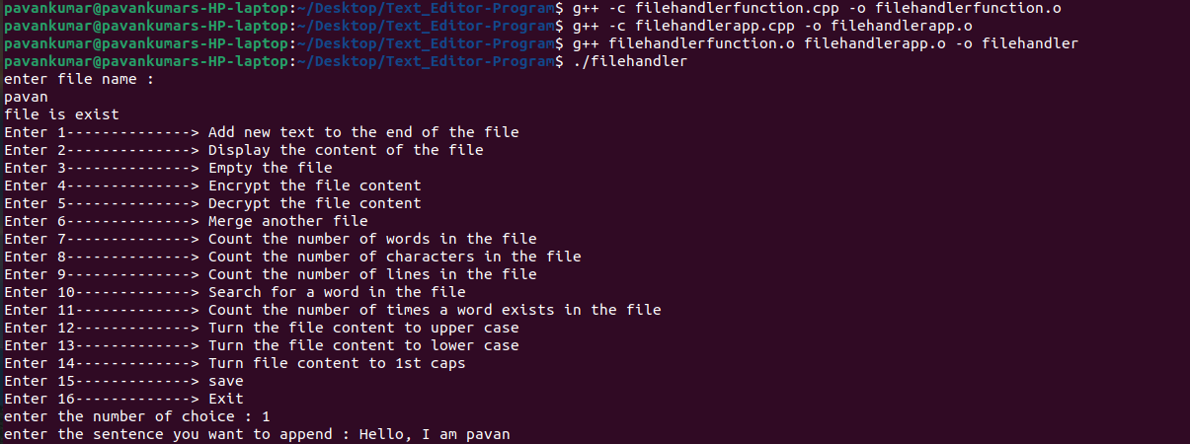



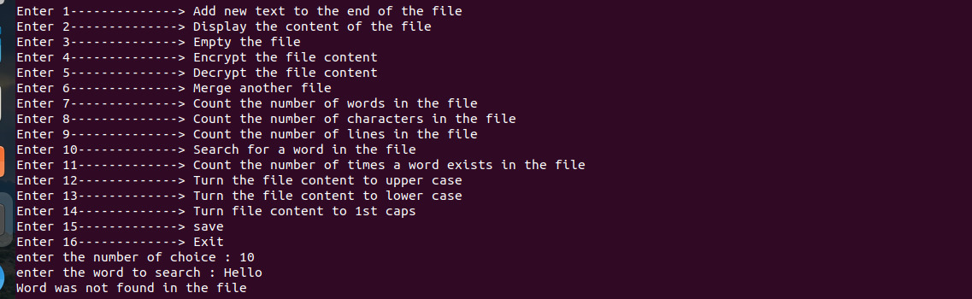





**REFERENCE**

1.Kulkarni, S., Patil, S., & Gandhi, S. (2022). Design and Implementation of Efficient File

Handling Techniques in Modern Operating Systems. International Journal of Computer

Applications, 245(10), 15-20. DOI: 10.5120/ijca2022873125

2.Sharma, A., Singh, V., & Jain, R. (2021). Secure File Handling in Cloud-Based Operating

Systems. Proceedings of the International Conference on Cloud Computing and Big Data

Analytics (CCBDA). DOI: 10.1145/3458180.3458210

3.Wang, Y., Li, Z., & Li, J. (2021). Optimizing File System Performance Through Intelligent

File Placement in Virtualized Environments. IEEE Transactions on Parallel and Distributed

Systems, 32(7), 1750-1764. DOI: 10.1109/TPDS.2021.3053063

4.Du, X., Yang, X., & Cui, L. (2020). Dynamic File System: A Novel Approach for Efficient

Data Management in HPC Systems. Proceedings of the IEEE International Conference on

High Performance Computing and Communications (HPCC). DOI.

5.Zhang, Y., Chen, C., & Zhang, H. (2020). Optimizing File I/O Performance in Linux-based

Embedded Systems. Proceedings of the International Conference on Embedded Software (EMSOFT). DOI: 10.1109/EMSOFT47620.202