Features of AUTOTHRASH SIMULATION
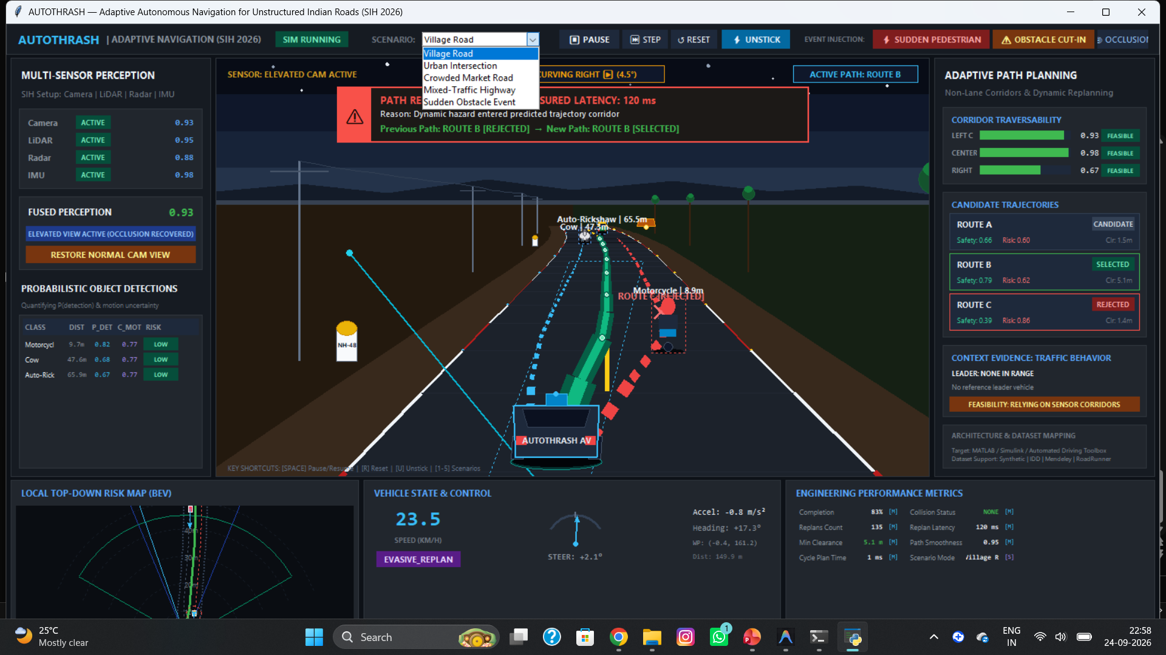
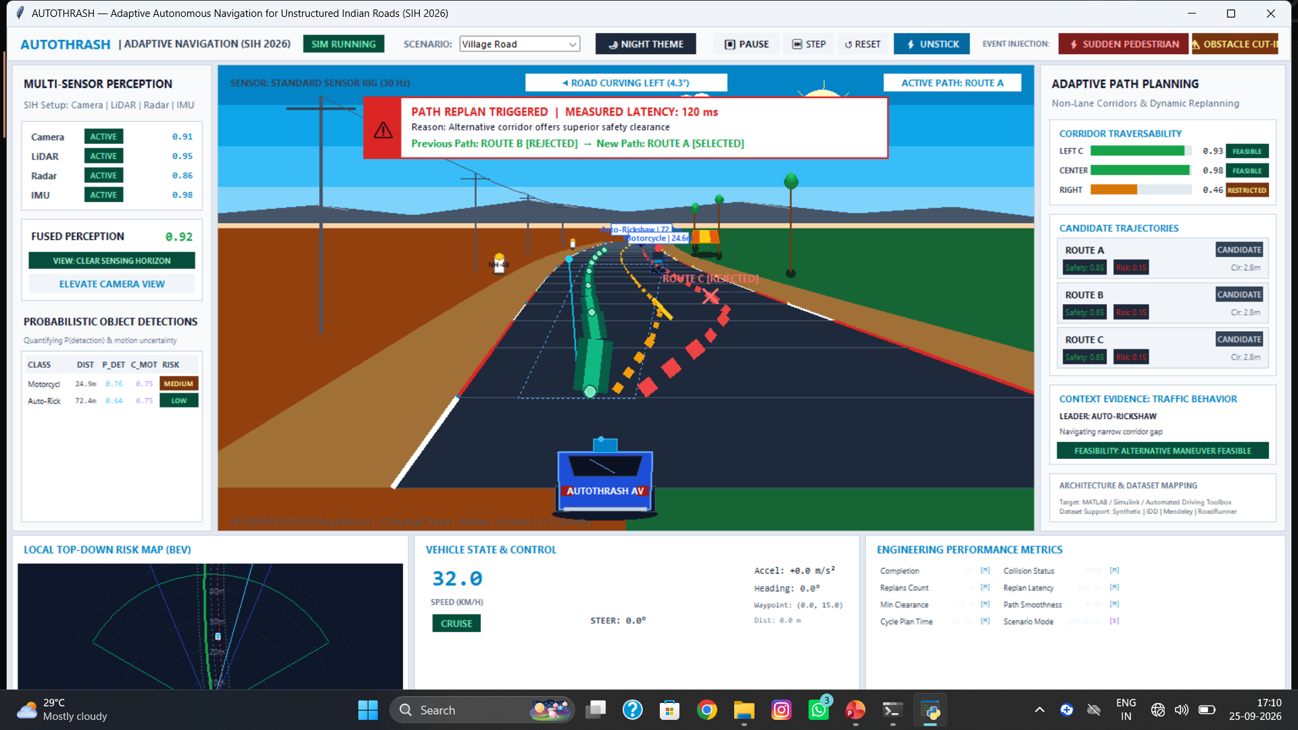
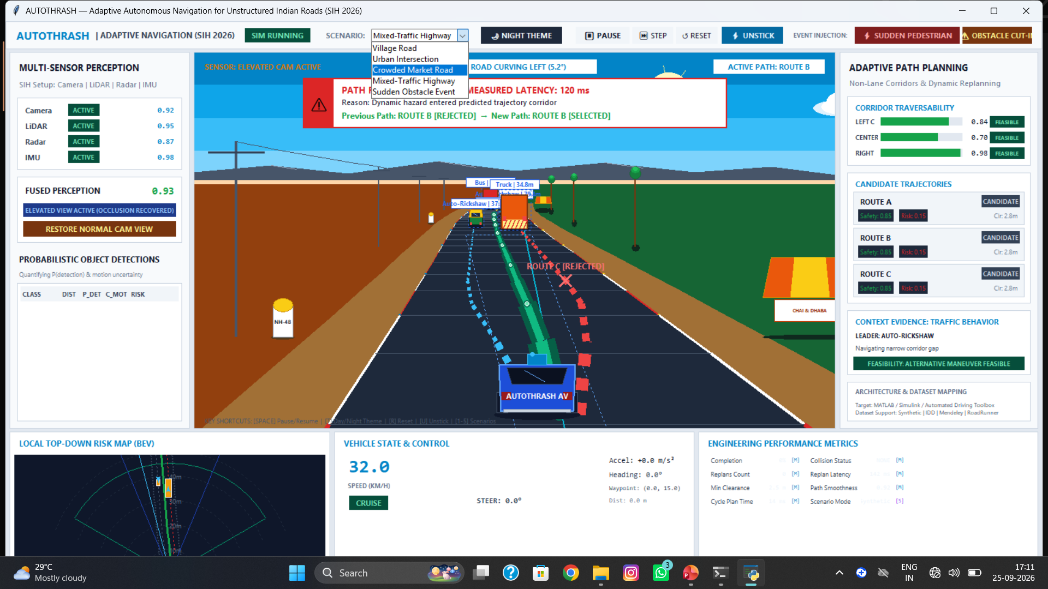
➢ MULTI SENSORS , ELEVATE CAMERA FOR OCCLUSION DETECTION
➢ BEV , STEERING ANGLE ,(ARTIFICIAL OBSTACLES, PEDESTRIANS), SPEED
➢ DAY & NIGHT THEME , SCENARIOS
➢ PROBABILISTIC OBJECT DETECTION , CORRDIOR TRAVERSABILITY , CANDIDATE TRAJECTORIES
➢ UNSTICK – TO ESCAPE FROM A PHYSICS GLICH, IMPOSSIBLE LOOP

SMART INDIA HACKATHON 2026 | PROBLEM STATEMENT SIH26037
AUTOTHRASH

Adaptive Path Planning and Collision Avoidance for Unstructured Indian Roads
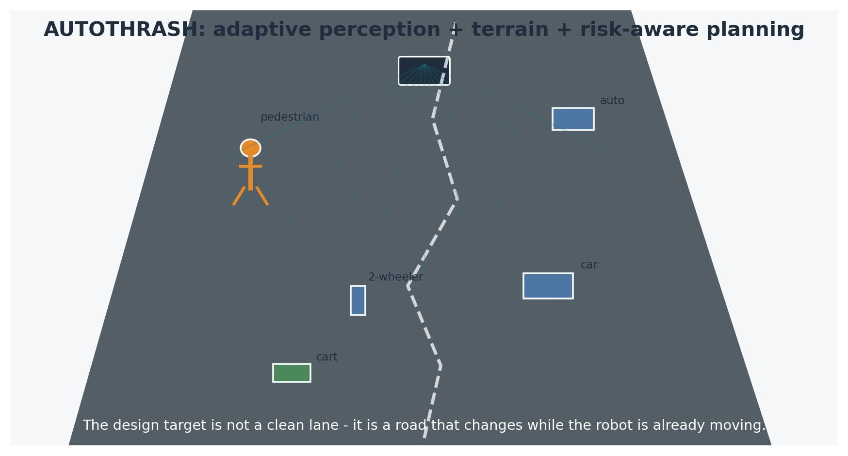
Original explanatory visual created for this dossier. Source concept: project work to date.
What this document is
A consolidated technical and research dossier of the AUTOTHRASH concept as developed so far. It combines the submitted SIH deck, the design decisions discussed during development, and a small set of external technical sources used to justify the architecture.
Team: AIT_OnRoad_Innovators | Theme: Smart Automation | Category: Software + Hardware
Important status note: the document distinguishes between components already specified in the concept, components intended for simulation/prototyping, and claims that still require experimental validation. It is written to support judge discussion, not to imply completed field performance that has not yet been measured.
DOCUMENT STATUS | Working technical dossier | Version 1.1 | 20 September 2026
Contents
1. Executive summary 4
2. What the submitted SIH concept establishes 5
3. Problem framing: why unstructured roads change the autonomy problem 6
4. Research synthesis and design rationale 7
5. AUTOTHRASH concept: the continuous adaptation loop 8
6. Technical architecture 9
7. Probability-aware perception and route reasoning 10
8. Adaptive viewpoint: elevating camera / mast concept 11
9. Terrain-aware planning, collision avoidance and trajectory control 12
10. Runtime decision logic 13
11. Feasibility and viability 14
12. Risks and planned mitigations 15
13. Expected impact and applications 16
14. Innovation map and what is actually novel in the project 17
15. Validation plan: how to turn the idea into evidence 18
16. What has not been proven yet 19
17. Suggested judge-facing narrative 20
18. References and research notes 21

Project status and scope
This dossier records the project as it stands now: a research-backed concept moving into software simulation and prototype development. It deliberately separates what is already defined from what still has to be built and measured.
Current working prototype A software-first dashboard/simulation is the primary demonstrator: chaotic scene -> perception -> confidence -> candidate routes -> risk-aware choice -> changed scene -> replanning.
Implementation path Simulation first, then controlled small-UGV experiments, then broader hardware and sensor validation.
Engineering principle A confidence estimate is useful only when it changes a decision: sense differently, reject a corridor, slow down, replan, or stop.

1. Executive summary
AUTOTHRASH is a proposed adaptive navigation framework designed around one observation: the hardest part of autonomy on an Indian road is not simply finding a short path. The harder problem is deciding what to trust, what has changed, whether the visible road is actually traversable, and whether the current plan remains safe as people and vehicles behave unpredictably.
The framework therefore closes the usual gap between perception and planning. It treats perception confidence, occlusion, terrain, traffic interaction and collision risk as live inputs to navigation. Instead of assuming a stable scene, the robot repeatedly perceives, estimates uncertainty, changes the sensing strategy when necessary, evaluates terrain and traffic, generates candidate routes, executes a conservative motion command, and checks whether actual motion still agrees with the planned trajectory.
Design layer | Core question | AUTOTHRASH response
Perception | What is around me, and how reliable is the observation? | Object detection/tracking, sensor-health checks, confidence and uncertainty estimation.
Adaptive sensing | Can the current viewpoint see enough? | Use complementary sensors and an adaptive/elevating viewpoint when crowding or occlusion justifies it.
Terrain | Is the visible surface actually safe to traverse? | Estimate traversability before path commitment, including ambiguity such as pothole vs shadow.
Planning | Which corridor is safest, not merely shortest? | Risk-aware candidate corridors / probability-route scoring with uncertainty and traffic context.
Execution | Did the robot move as expected? | Planned-vs-actual trajectory monitoring, replanning, slowing or safe stop as required.
One-line judge takeaway
AUTOTHRASH is not trying to make a conventional autonomous vehicle "drive better"; it changes the navigation loop so that uncertainty itself influences sensing, planning and motion.

2. What the submitted SIH concept already establishes

The uploaded submission deck defines the project around SIH26037, "Adaptive Path Planning and Collision Avoidance," and names the framework as an adaptive, uncertainty-aware, terrain- and trafficaware navigation approach. The deck explicitly places sensor confidence, terrain traversability, traffic context and collision risk inside the navigation loop.
Source-to-dossier rule
The deck is treated as the primary record of what the team formally submitted. Additional sections below expand the same concept; they do not replace the submitted architecture with a different project.

3. Problem framing: why unstructured roads change the autonomy problem

The target environment is explicitly broader than a marked-lane highway. The project discussion has centered on Indian urban roads, village roads, market areas, intersections, narrow roads and mixed-traffic corridors where cars, buses, trucks, auto-rickshaws, two-wheelers, bicycles, pedestrians, pushcarts and animals may share the same usable space. Direction changes, informal merging, opposite-direction movement and unmarked crossings can make the free-space map change within seconds.
Observed challenge | What breaks | Design consequence
Heterogeneous traffic | A single motion model does not describe every road user. | Track object classes separately and reason about likely movement, not just presence.
Occlusion and incomplete view | A detected free corridor may disappear behind a bus, auto or dense crowd. | Estimate scene visibility and activate a wider / elevated viewpoint when the benefit outweighs the cost.
Weak road structure | Lane boundaries may be missing or unreliable. | Represent traversability and candidate corridors rather than relying only on lane following.
Terrain ambiguity | A dark patch, shadow or puddle may be confused with a pothole or rough patch. | Make terrain assessment a gating decision before path commitment.
Uncertain sensing | One modality may fail or degrade. | Use complementary sensing and confidence-aware behavior rather than trusting one stream blindly.
Rapidly changing hazards | A path can become unsafe after it is planned. | Compare planned and actual trajectory continuously; replan when the deviation or risk rises.
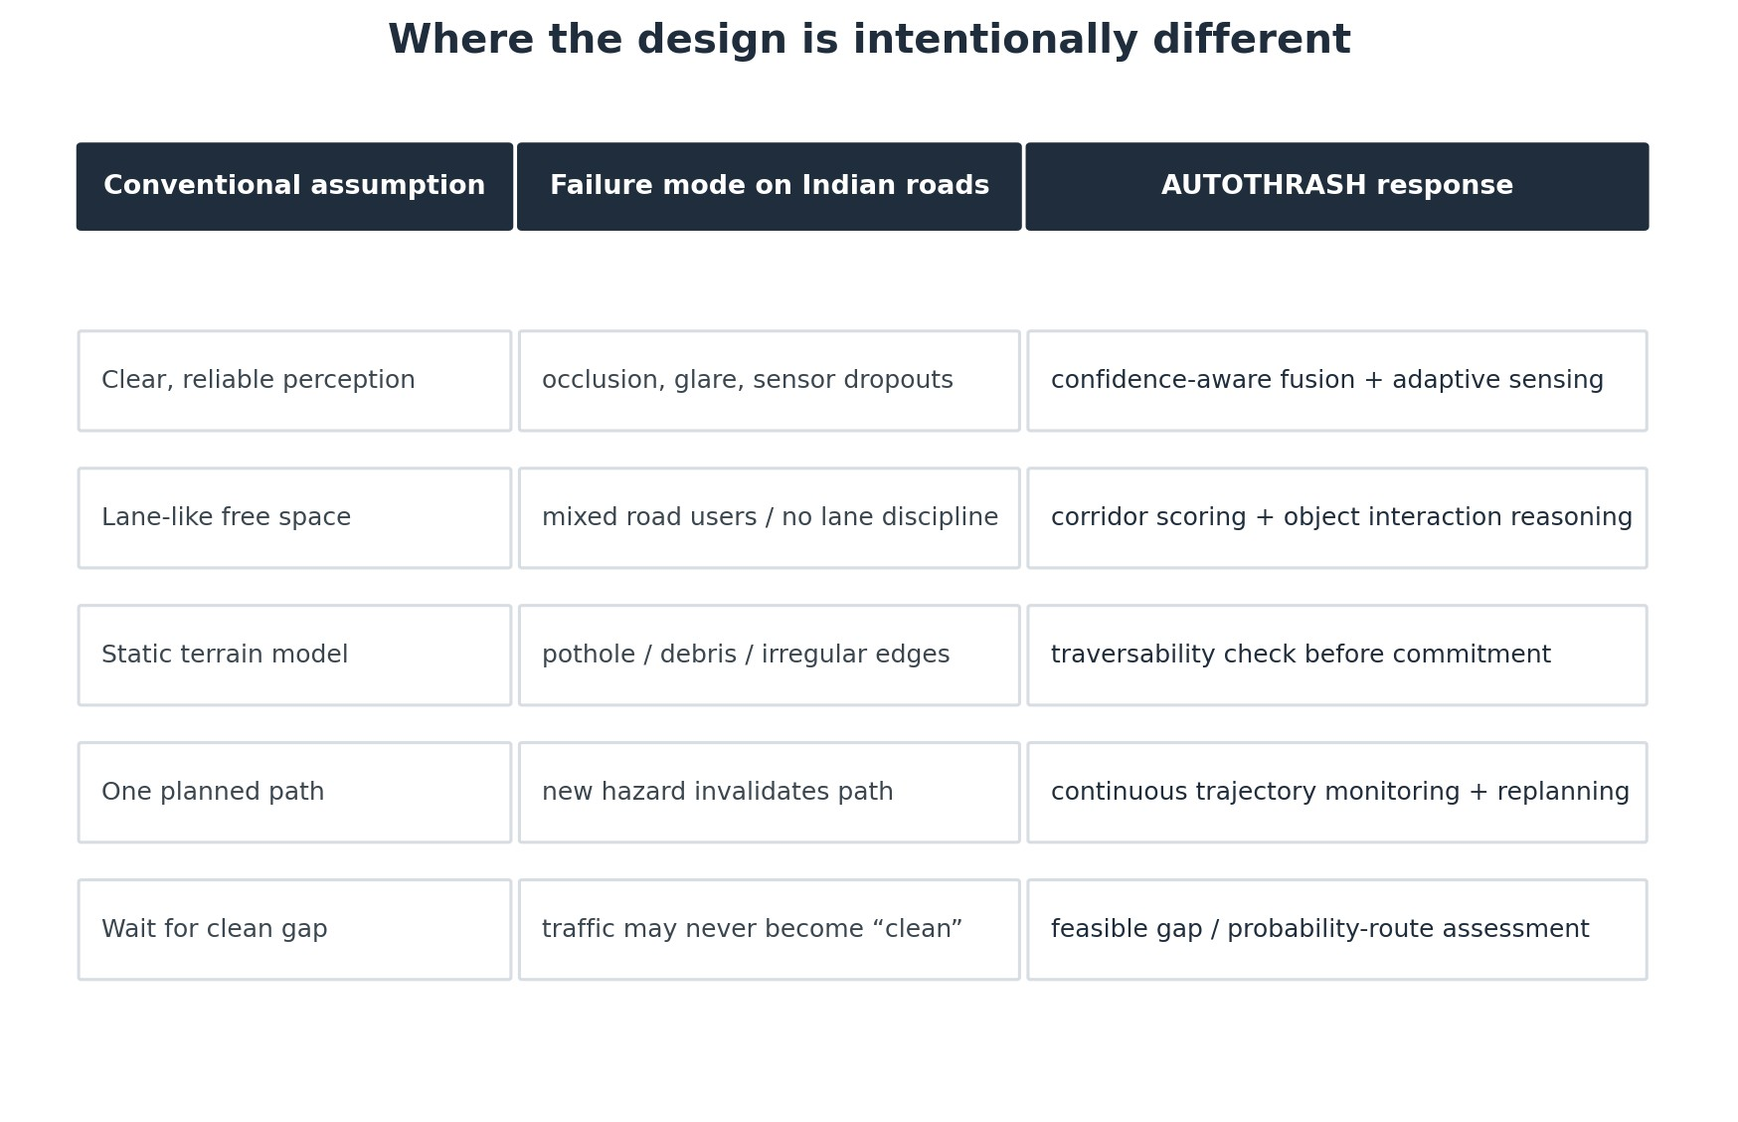
Design comparison developed from the project gap analysis.

4. Research synthesis and design rationale
Research takeaway
The sources used for this dossier point in the same direction: autonomous systems benefit from complementary sensing, modular navigation software, confidence-aware perception, and simulation before field validation. The dossier therefore treats ROS 2/Nav2, camera-LiDAR-radar sensing, object detection and MATLAB/Simulink as implementation options within a staged engineering process - not as proof that the full stack has already been built.
A small review of current technical literature and official software documentation supports several parts of the AUTOTHRASH architecture. The point is not to claim that the framework is novel simply because it uses familiar technologies. The value is in how the pieces are arranged around uncertainty and adaptation.

4.1 Multi-sensor perception is a robustness problem
Recent reviews of autonomous driving sensing describe the complementary nature of cameras, LiDAR, radar and inertial/localization sensors, while also emphasizing practical issues such as calibration, spatiotemporal alignment, environmental degradation and real-time constraints. In other words, adding sensors does not automatically solve perception; the system still has to reason about what each sensor can and cannot currently tell it. [R1-R3]

4.2 Navigation frameworks already support modular planning
ROS 2 and Nav2 provide a modular basis for robotics applications: computation can be divided into nodes, while navigation can be organized around perception, planning, control, recovery and behaviortree logic. Nav2 also exposes plugin interfaces for planners, controllers, costmaps and behaviors. That makes it a reasonable integration target for a first-year team that needs to test modules separately before combining them. [R4-R6]

4.3 Object detection is one input, not the final decision
Modern YOLO-style object detection outputs object classes, locations and confidence scores. That fits the project need for per-object confidence, but the framework deliberately goes one step further: object confidence is treated as an input to scene risk and route selection rather than as a final answer by itself.
[R7]

4.4 Simulation is part of feasibility, not a cosmetic demo
MathWorks provides sensor-fusion and tracking examples specifically because difficult driving scenarios can be tested in simulation before they are repeated in the physical world. That supports the project roadmap of validating perception, prediction, terrain and path-planning logic in simulation first and only then moving to a small UGV. [R8]
Research conclusion
The literature does not prove AUTOTHRASH. It strengthens the engineering case for its architecture: complementary sensing, explicit uncertainty, modular navigation software, simulation-first validation, and continuous replanning are all defensible building blocks.

5. AUTOTHRASH concept: the continuous adaptation loop
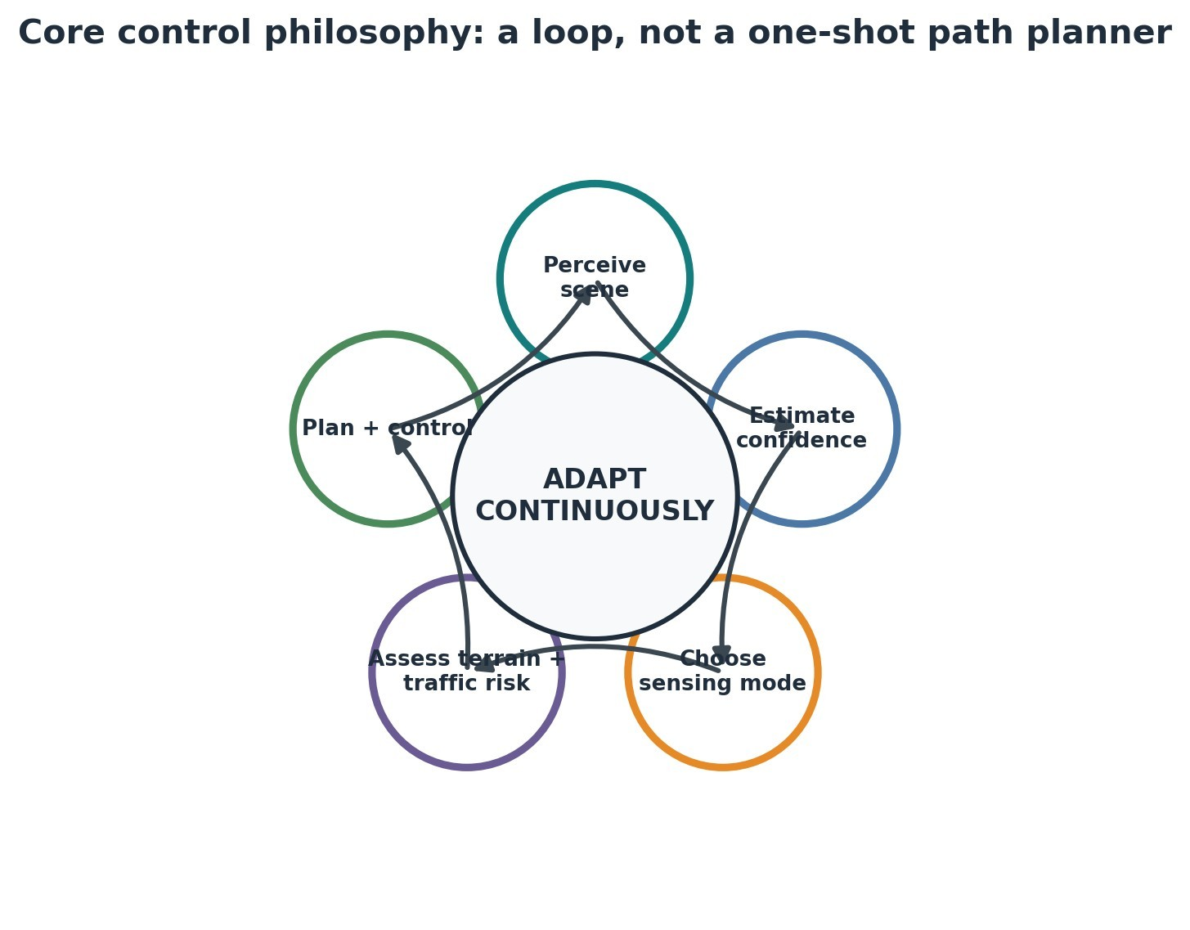
The intended control philosophy is a repeating loop, not a single pass from sensor to steering command.
The central idea is to make uncertainty actionable. A confidence value should change what the system does. For example, a scene with low visual confidence or heavy occlusion can trigger a different sensing mode. A terrain estimate with high ambiguity can reduce speed or reject a candidate corridor. A sudden increase in collision risk can invalidate the current path and force replanning.

5.1 Four signature innovations discussed during development
Innovation | Why it exists | Expected benefit
Adaptive / elevating camera mast | A fixed viewpoint can lose situational awareness in a crowded scene. | Gain a higher viewpoint only when occlusion or visibility makes it worthwhile; retract when not needed.
Thermal sensing as complementary evidence | Visual contrast may be poor in some conditions and certain objects may be hard to separate. | Provide an additional cue so the system is less dependent on RGB alone.
Probability-aware perception and route scoring | A detection confidence and an interaction-risk estimate are not the same thing. | Carry uncertainty forward into corridor selection instead of treating all detections as equally certain.
Planned-vs-actual trajectory monitoring | A valid plan can become invalid after a person or vehicle moves. | Detect deviation early, then replan, slow or stop safely.

6. Technical architecture
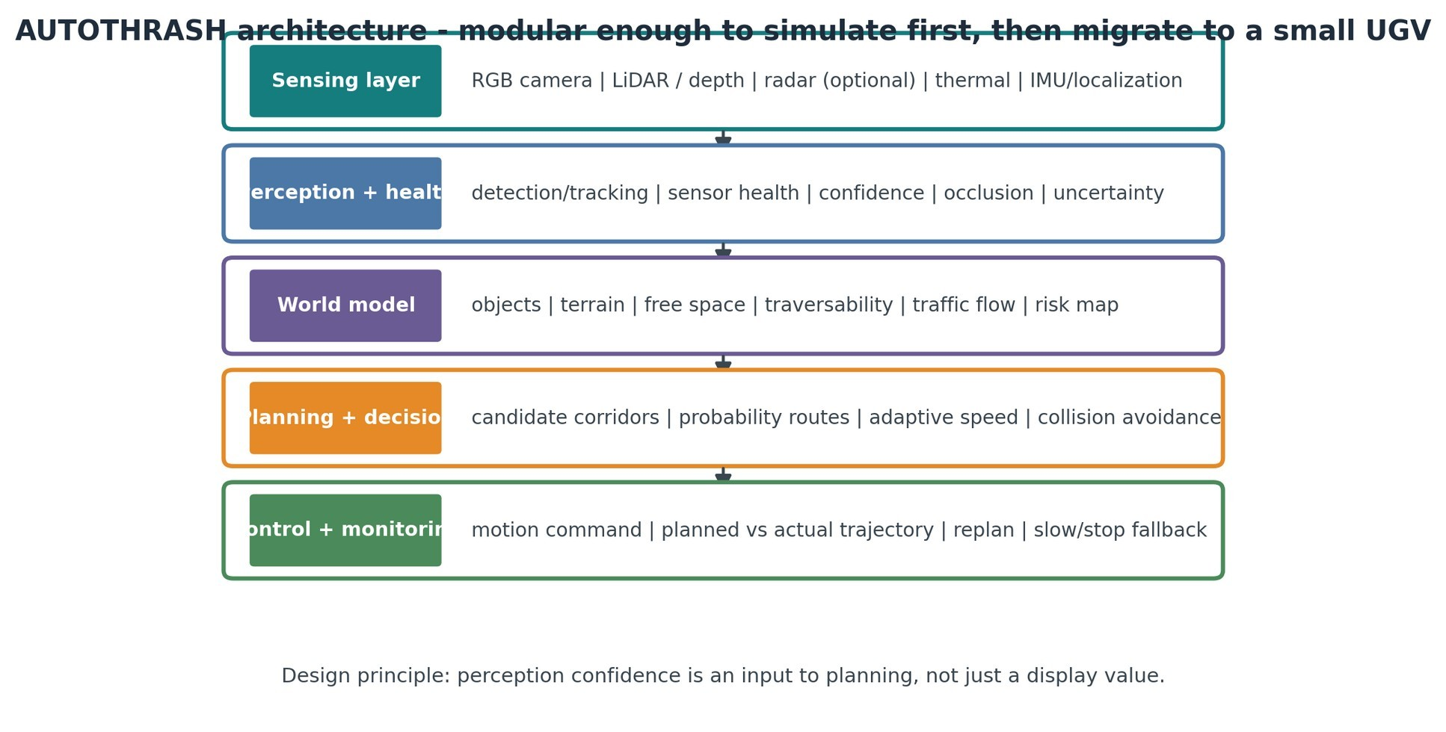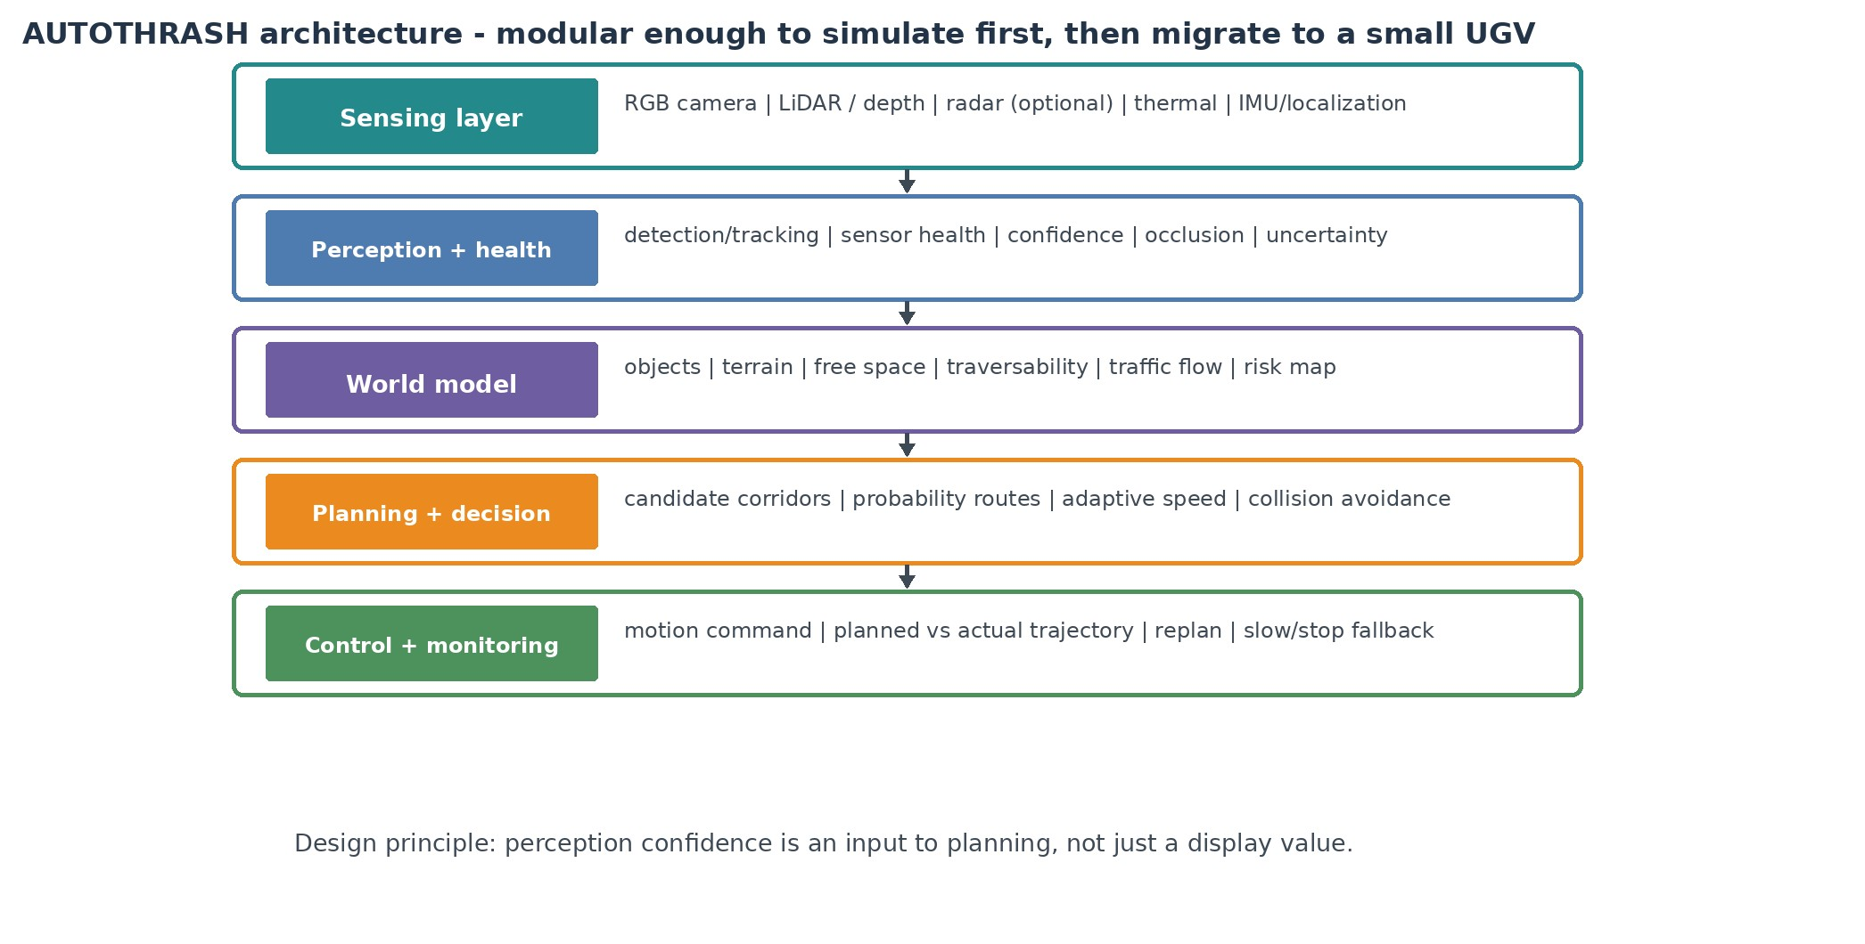
Proposed modular architecture for simulation, then small-UGV integration.

6.1 Perception inputs
Input | Primary role | Failure / limitation considered
RGB camera | Semantic context, object classes, visible road users, surface cues | Lighting, occlusion, blur, weather, false positives.
LiDAR / depth | Geometry, obstacle range, 3D structure, free-space support | Range/coverage limits, rain/fog effects, calibration burden.
Radar (optional / as appropriate) | Relative motion and complementary ranging | Multipath / clutter and lower semantic detail.
Thermal camera | Complementary thermal cue in difficult visual conditions | Adds cost and calibration/processing work; used as supporting evidence.
IMU / localization | Robot motion estimate and pose consistency | Drift and synchronization requirements.

6.2 Software stack and roles
Technology | Planned role
Python | Rapid prototyping, perception experiments, scoring logic, analysis.
C++ | Performance-critical ROS 2 nodes and lower-latency components where needed.
ROS 2 | Modular communication layer and integration framework for sensing, planning and control.
OpenCV | Image processing and computer-vision utilities.
YOLO-style detector | Object detection / confidence generation; exact model to be selected after benchmarking.
Nav2 / behavior logic | Navigation orchestration, planners/controllers, recovery and replanning architecture.
MATLAB / Simulink or equivalent simulation | Scenario generation, sensor-fusion experiments and metricdriven validation.

7. Probability-aware perception and route reasoning
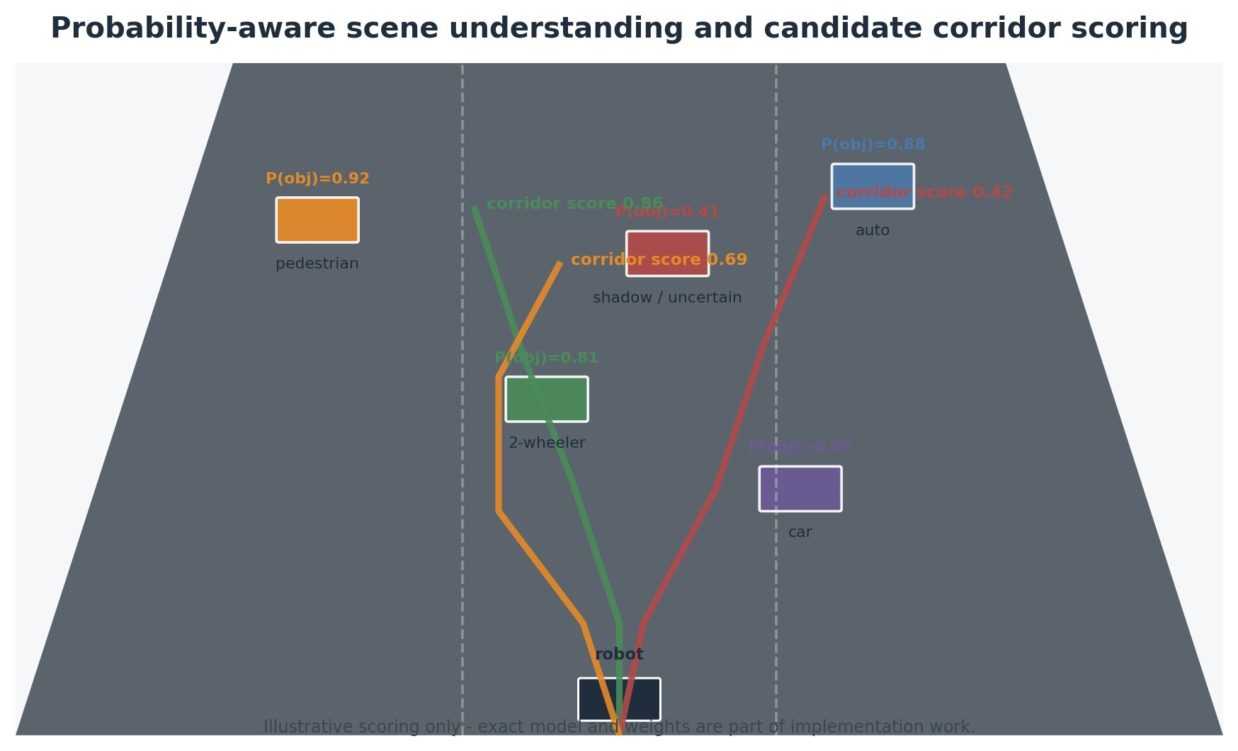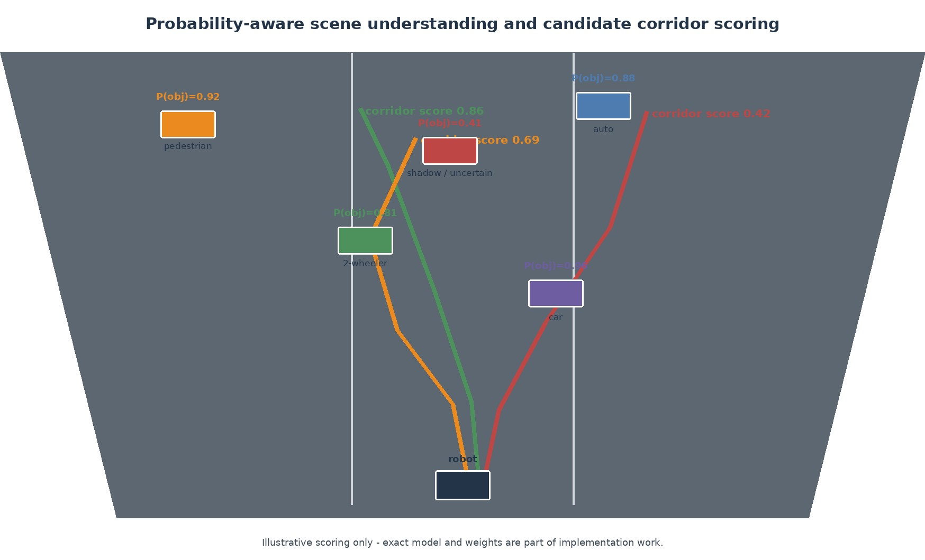
Illustrative project-level view: each object has a confidence estimate and each candidate corridor can receive a risk-aware score.
The project discussion repeatedly used the ideas of "single-object probability," "multiple-object probability" and "probability routes." In a clean engineering interpretation, these can be implemented as layers rather than as one mysterious number.
Layer | Interpretation in AUTOTHRASH | Example use
Single-object confidence | Confidence that a detected object belongs to a class and is correctly localized. | A pedestrian detection at 0.92 may be treated differently from an uncertain 0.41 detection.
Multi-object / interaction confidence | Confidence in the combined scene interpretation: e.g., pedestrian + auto + two-wheeler interactions around a candidate corridor. | Raise risk when several uncertain actors overlap a narrow passage.
Candidate corridor score | A route-level score that combines collision risk, traversability, uncertainty and progress. | Prefer a corridor with slightly longer distance if its risk is materially lower.
Dynamic update | Scores change as new sensor data arrives. | A route selected 1 second ago can be rejected if an object moves into the corridor.
Proposed scoring model - for implementation, not a validated result
A practical implementation can define a weighted route score such as: RouteScore = wS*Safety + wT*Traversability + wC*Confidence - wU*Uncertainty + wP*Progress. The weights should be tuned empirically in simulation and then re-tested on the UGV.

8. Adaptive viewpoint: elevating camera / mast concept

One of the clearest differentiators developed for the concept is the idea that sensing hardware should not always operate from one fixed viewpoint. In normal traffic the mast can remain low. When the system detects severe occlusion or dense crowding, it can raise the camera to increase visibility, then retract once the scene becomes sufficiently open.
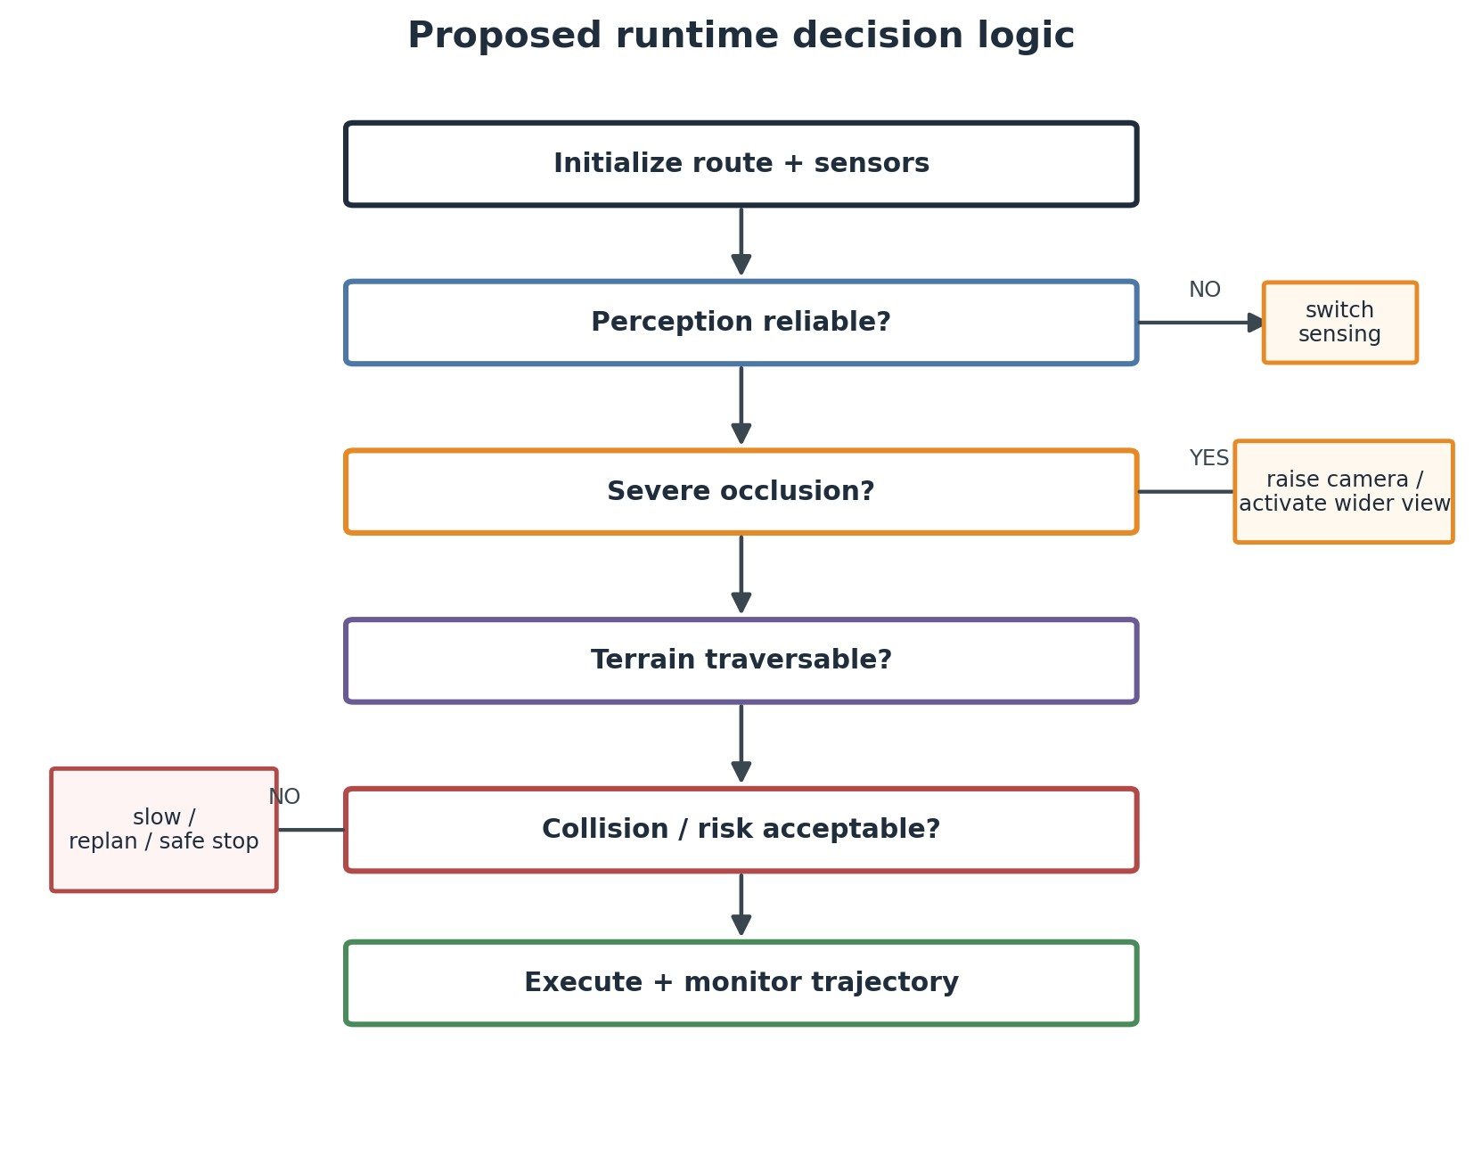
Decision logic showing the intended sensing adaptation branch.
8.1
Why the mast is not just a mechanical novelty
The key argument is algorithmic: the navigation stack monitors visibility and uncertainty, then requests a change in sensing geometry. This creates a feedback relationship between perception quality and hardware configuration. It also creates a measurable engineering question: does the wider viewpoint reduce uncertainty enough to justify its deployment time, power and mechanical complexity? 8.2 Prototype strategy
- Begin with a bench-mounted or manually actuated mast before attempting autonomous extension/retraction.
- Use the mast first for perception experiments: compare visible object count, occlusion rate and corridor confidence with mast low vs. elevated.
- Add actuation and control only after the sensing benefit is demonstrated.
- Keep a fixed low-view fallback so the vehicle is not dependent on the mast being available.

9. Terrain-aware planning, collision avoidance and trajectory control

9.1 Terrain comes before path commitment
The submitted deck makes an unusually strong wording choice: traversability is estimated before path commitment - not after. That means the planner should not simply find geometric free space; it should distinguish between space that is visible and space that is actually suitable for motion.
Terrain / road cue | Reason it matters | Planner action
Pothole / depression | Wheel passage may cause instability or become unsafe at speed. | Penalize or reject corridor depending on depth/confidence.
Uneven edge / missing shoulder | A visually open area may not be physically traversable. | Reduce corridor score near uncertain edges.
Shadow / dark patch | May create false obstacle / terrain classifications. | Use complementary depth/geometry and uncertainty rather than binary labeling.
Debris / temporary obstruction | May appear after route generation. | Treat as dynamic obstacle and reevaluate.

9.2 Collision avoidance is dynamic
The project is not limited to static obstacle avoidance. Object tracking and motion prediction are used to estimate how road users may move. Candidate corridors are then scored against predicted collision risk rather than only current geometry. The exact prediction model is still an implementation choice and should be benchmarked against simpler baselines first.
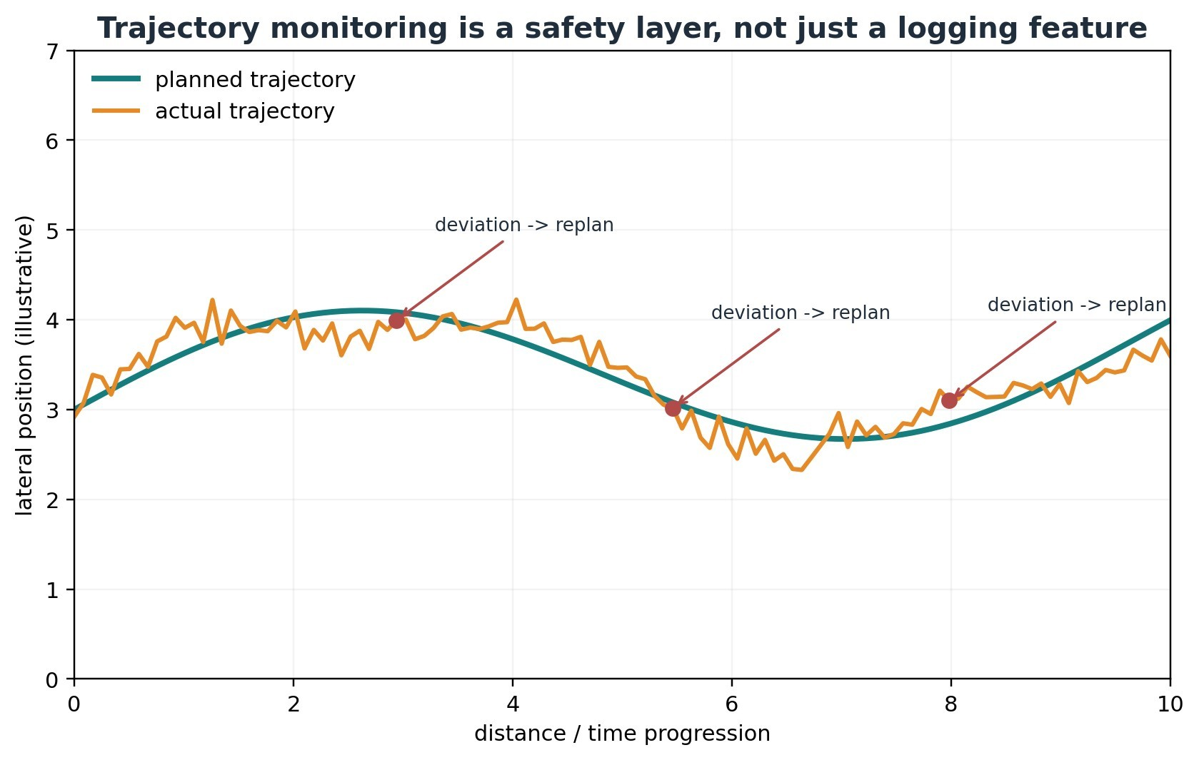
Illustrative planned-vs-actual monitoring. The real implementation should trigger replanning from defined deviation/risk thresholds.

10. Runtime decision logic
Proposed decision flow aligned with the submitted deck and expanded with explicit fallback behavior.
- Initialize route, localization and sensor streams.
- Assess sensor health, visibility and confidence before trusting the scene model.
- If severe occlusion is present, activate the appropriate complementary / elevated sensing mode.
- Estimate objects, motion and terrain; build a local world model.
- Check terrain traversability before committing to a corridor.
- Generate candidate paths and score them with collision risk, confidence, uncertainty, traversability and progress.
- Execute the selected motion command with adaptive speed.
- Compare planned trajectory with actual motion and re-evaluate risk continuously.
- If the current corridor becomes unsafe, replan. If no acceptable corridor remains, slow down or perform a safe stop.
Important engineering boundary
The flowchart is an architecture proposal. It becomes a validated control policy only after thresholds, timing, sensor-failure cases and performance metrics are measured in simulation and on the UGV.

11. Feasibility and viability
The submitted roadmap is deliberately staged. This is important for a first-year team because it avoids the common trap of building a visually impressive vehicle before proving that the decision logic works.
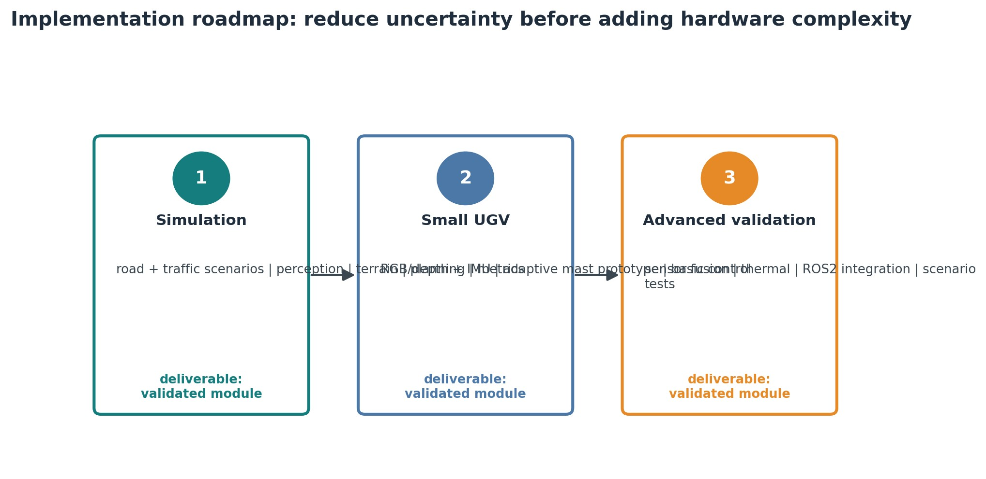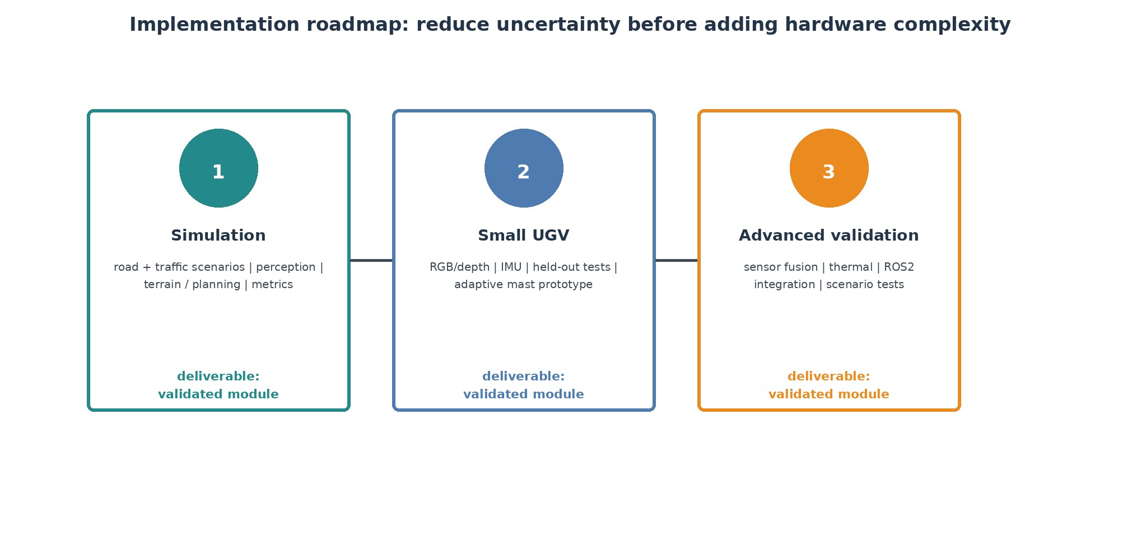
Three-stage implementation roadmap carried forward from the submitted feasibility slide.
11.1
Phase 1 - simulation
- Build representative road scenes: mixed traffic, occlusion, narrow corridors, unmarked crossings and terrain ambiguity.
- Implement object detection/tracking, uncertainty scores, traversability logic and candidate-path evaluation.
- Measure route success, collision margin, replanning frequency, trajectory deviation and false terrain rejection.
- Use recorded sensor data where possible so the same scene can be replayed after algorithm changes. 11.2 Phase 2 - small UGV
- Integrate RGB/depth sensing and IMU first.
- Demonstrate basic autonomous motion in controlled spaces before adding complex traffic scenarios.
- Prototype the adaptive mast and compare view quality quantitatively.

11.3 Phase 3 - advanced validation
- Add full multi-sensor fusion, thermal support and ROS 2 integration.
- Repeat the same benchmark scenarios with hardware-in-the-loop or physical tests. • Document failure cases and tune thresholds from measured data, not intuition.

12. Risks and planned mitigations
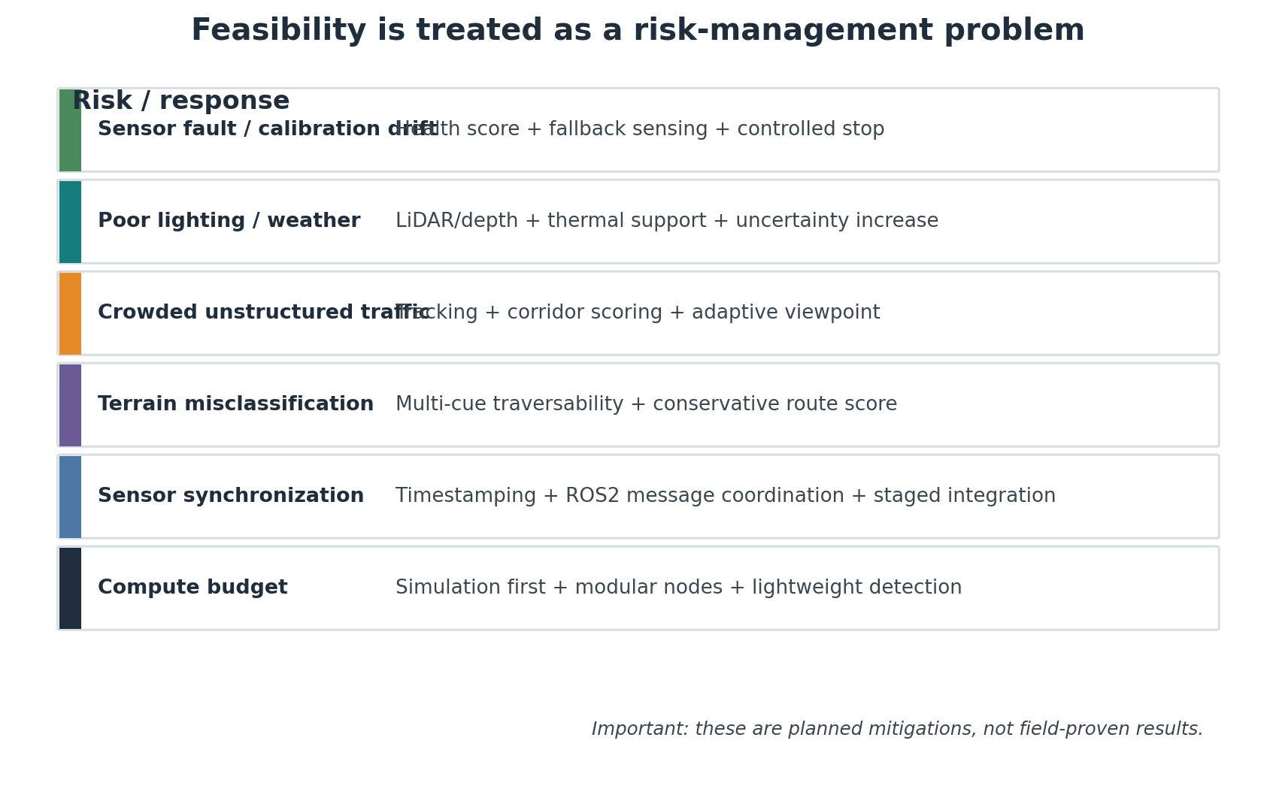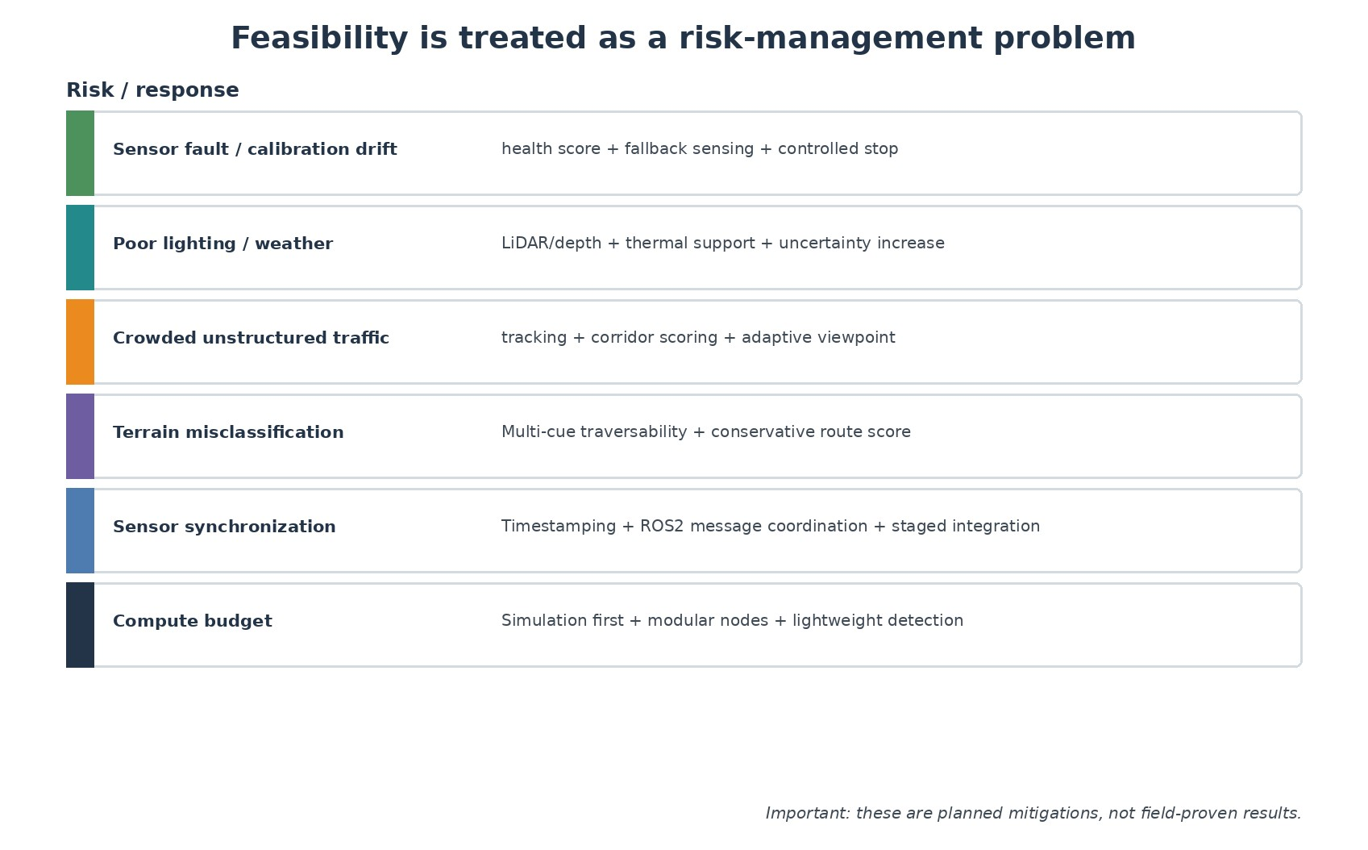
Risk/response matrix based on the risks already listed in the submitted feasibility slide.
The most important part of the feasibility story is that the team has already identified where the concept can fail. Sensor faults, adverse conditions, unpredictable traffic, terrain misclassification and multi-sensor synchronization are not hidden behind the word "AI"; they are treated as explicit engineering work packages.
Risk | What the judge should expect to see | Evidence to collect
Sensor fault | Graceful degradation rather than total failure. | Fault-injection tests; compare performance with one modality disabled.
Adverse conditions | Confidence falls and behavior becomes more conservative. | Lighting/weather simulation or controlled trials; confidence vs. behavior curves.
Traffic unpredictability | Planner adapts without freezing whenever the road is not empty. | Scenario replay with moving pedestrians/two-wheelers/autos.
Terrain error | Unsafe surface cues are filtered by multiple evidence sources. | Pothole/shadow/debris classification confusion matrix.
Synchronization | Timestamps and node timing stay bounded. | Sensor timestamp logs, latency distribution, missed-frame counts.

13. Expected impact and applications
The submitted concept identifies five immediate benefits: safety, terrain awareness, occlusion handling, robustness and traffic adaptability. Those benefits follow naturally from the architecture because the system is designed to change its behavior when information quality changes.
Application | Why AUTOTHRASH fits
Last-mile autonomous UGV delivery | Narrow or mixed road sections are exactly where lane-centric assumptions can become weak.
Infrastructure inspection | Road condition and uncertain edges can be treated as part of the planning problem rather than ignored.
Surveillance / patrol | Occlusion-aware perception and conservative routing are valuable when the environment is visually cluttered.
Search-and-rescue support | A changing viewpoint and complementary sensors can help in partially occluded environments.
Semi-structured highway support | Adaptive sensing and continuous replanning can complement more conventional structured-road autonomy.
Impact statement for judges
The strongest claim is not "fully autonomous anywhere." The stronger and more defensible claim is: the framework is designed to remain useful when road structure and perception quality are changing, and it provides explicit fallback behavior when confidence is low.

14. Innovation map and what is actually novel in the project

Element | Common building block? | Project-level differentiation
Camera + LiDAR / depth | Yes. | Used in a confidence-aware adaptation loop rather than as a fixed stack.
Object detection | Yes. | Object confidence is carried into route/risk reasoning.
Sensor fusion | Yes. | Fusion is paired with health/uncertainty assessment and fallback behavior.
Terrain traversability | Established idea. | Explicitly placed before path commitment as a route gate.
Adaptive/elevating viewpoint | Less common project-level combination. | Viewpoint becomes a controllable response to occlusion/visibility confidence.
Probability routes | Project-specific framing. | Candidate corridors are scored by a combination of safety, uncertainty, terrain and traffic context.
Planned-vs-actual monitoring | Established robotics pattern. | Positioned as a persistent safety loop for a changing road scene.
This comparison is intentionally conservative. Individual techniques already exist in research and industry. The project contribution being investigated is the way confidence, occlusion, terrain and traffic context are tied together for mixed and uncertain road conditions.
Metric | Why it matters | Target direction
Collision / near-collision count | Safety outcome. | Lower is better; zero collision in validated test set.
Minimum collision margin | Shows how close the planner comes to unsafe interaction. | Higher safety margin is better.
Replanning latency | Measures whether adaptation can happen fast enough. | Lower without unstable oscillation.
Route success rate | Checks whether the robot can still reach the destination. | Higher.
False terrain rejection | Too much conservatism can make the system unusable. | Lower while maintaining safety.
Trajectory deviation | Measures execution consistency. | Lower unless deviation is a deliberate avoidance maneuver.
Confidence calibration | Tests whether confidence relates to actual reliability. | Better calibration over time.
Graceful degradation | Measures behavior after a sensor is intentionally weakened/removed. | Useful behavior remains available rather than abrupt failure.

15. Validation plan: how to turn the idea into evidence
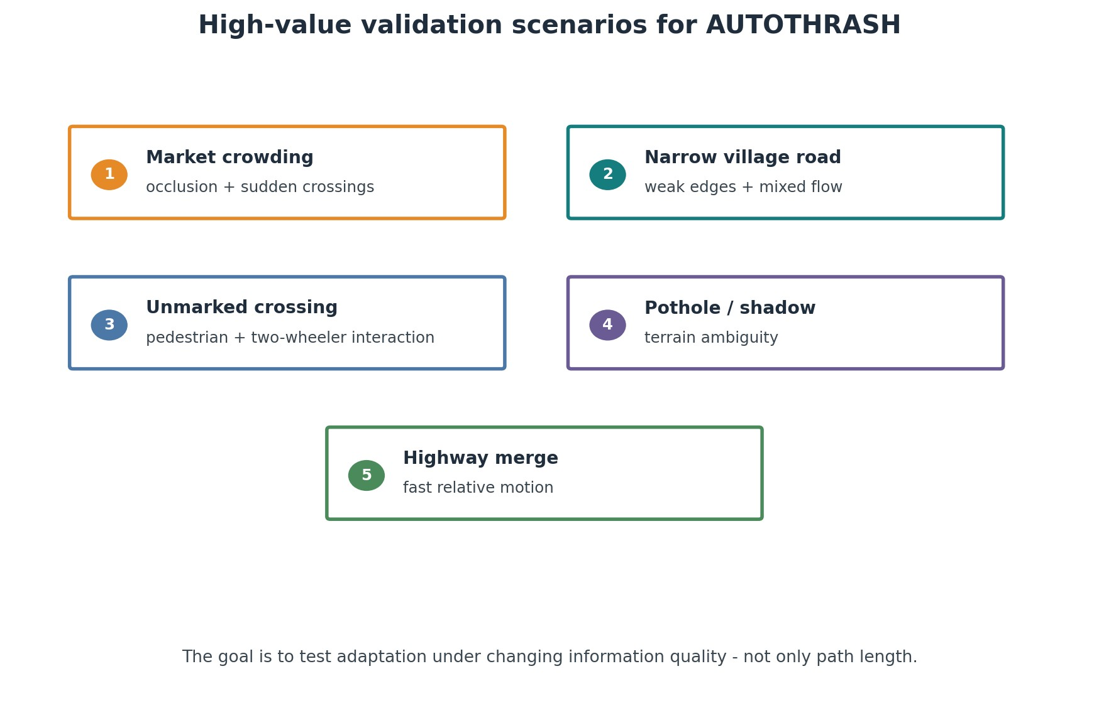
Five high-value test scenarios derived from the target environment described in the project.

16. What has not been proven yet
A strong technical dossier should make its boundaries clear. The following items are concept or planned validation items, not results claimed by this document:
- No field-validated collision-avoidance performance is claimed here.
- No specific object-detector model or confidence threshold is treated as final.
- No exact probability-route weighting has been experimentally tuned yet.
- No assumption is made that the adaptive mast is mechanically solved; the mast is a prototype direction to be validated.
- Thermal sensing is treated as complementary evidence, not as a guarantee for adverse-weather perception.
- ROS 2 / Nav2 is identified as a suitable modular implementation path, not as proof that integration has already been completed.
- No claim is made that the system is ready for public-road deployment; the roadmap is simulation -> controlled UGV -> advanced validation.
Why this strengthens the pitch
Judges generally trust a prototype plan more when the team can name its unknowns. The project can therefore be presented as a research-and-engineering framework with a concrete path to measurement, rather than as a finished autonomous driving product.

17. Suggested judge-facing narrative
The project can be explained in a simple five-step story:
- Indian road autonomy fails when the environment does not behave like a clean lane-following benchmark.
- The first problem is therefore not only planning; it is knowing how reliable the current perception is.
- AUTOTHRASH connects confidence, occlusion, terrain and traffic context to adaptive sensing and risk-aware planning.
- The planner does not commit blindly: it scores candidate corridors, monitors actual motion and can replan, slow down or stop.
- The implementation is deliberately staged so the team can prove each part in simulation and on a small UGV before attempting harder scenarios.
A concise visual for the "why different?" question during judge discussion.
One sentence to remember
We are designing for the moment when the map is uncertain, the road is shared, and the original plan is no longer trustworthy.

18. References and research notes

Selected source trail (verified 20 September 2026)
[R1] Qian, H. et al. (2025). A Review of Multi-Sensor Fusion in Autonomous Driving. Sensors 25(19), 6033. https://doi.org/10.3390/s25196033
[R2] Viktor, P. & Kiss, G. (2026). Sensors in Self-Driving Vehicles: A Detailed Literature Review and New Trends. Sensors 26(7), 2153. https://doi.org/10.3390/s26072153
[R3] Ibanez-Guzman, J. & Li, Y. (2025). LiDAR and cameras in autonomous driving. Nature Reviews Electrical Engineering 2, 515516. https://doi.org/10.1038/s44287-025-00176-4
[R4] ROS 2 Documentation - Nodes and interfaces. https://docs.ros.org/en/lyrical/Concepts/Basic/About-Nodes.html
[R5] Nav2 Documentation - Behavior Trees and replanning. https://docs.nav2.org/rolling/getting_started/navigation_concepts/ behavior_trees/
[R6] Nav2 Documentation - Navigation plugins. https://docs.nav2.org/rolling/configuration_and_development/navigation_plugins/
[R7] Ultralytics YOLO Documentation - Object detection and confidence outputs. https://docs.ultralytics.com/tasks/detect
[R8] MathWorks - Robotics and Autonomous Systems. https://www.mathworks.com/help/overview/robotics-and-autonomoussystems.html
[R9] MathWorks - Navigation Toolbox. https://www.mathworks.com/help/nav/
[R10] Kong, H. et al. (2019). Multi-Sensor Fusion in Automated Driving: A Survey. IEEE Access 8, 2847-2868. https://doi.org/10.1109/ACCESS.2019.2962554
The submitted deck states that its references are verified academic and technical sources. For this consolidated dossier, the research trail below was used to support the architecture-level discussion. URLs are included so the team can open the source pages during preparation.
Defined now | Prototype next | Validation later | Not claimed
Problem framing and target environment | Interactive web simulation / route replanning demo | Sensor and planner benchmarks | Public-road readiness
Sensor-fusion architecture | ROS 2 module decomposition | Hardware-in-loop / UGV tests | Field performance percentages
Probability-aware route concept | Candidate-path scoring logic | Measured thresholds and weights | Validated probability values
Adaptive camera-mast concept | Perception-only mast experiment | Mechanical + safety validation | Completed autonomous mast hardware
Terrain / risk-aware planning | Scenario-based test suite | Repeated controlled experiments | Universal solution for every road condition

