Design Document for the Ecommerce Mini project:
Problem Statement:A basic CRUD application Console Application
Design an application using which we can manage products(Any kind of products like we have in ecommerce sites) We should be able to Create new products in a category Update its attributes,Delete it, Display products according to the category selected
Application should provide options at the begining to select from given options like View products, Add Product etc.

Database Design:
Tables:
Category(categoryId, CategoryName)
Product(productId, productName, Price,Size,Color)

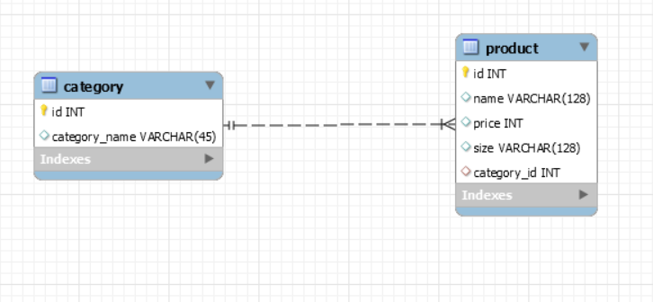
In the above the Category Id(product) map to the id(category) establishes the Many to one relationship.
1) one category contain many products
2)Many products belong to one category.

App Structure:

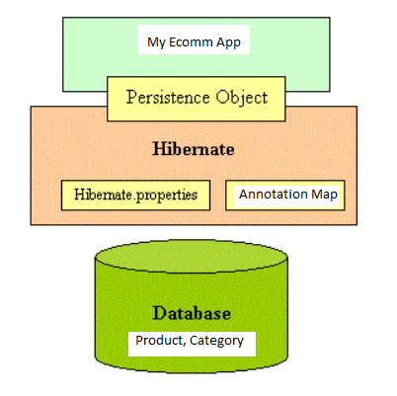

Application Working Sample
The console of the application will be similar to below.

-> ~~Welcome to SimpleEcomm!!~~
->List of Categories
1) Electronics
2)Home and Furniture
3)Clothing
4)Sports
5) Baby and Kids

Select your category!
->1
Select your option on category
1)Add 2)delete 3) updateName 4)List
->4
Here are your list of products
1)Mobile 2)TV 3) Laptop 4) Speaker
Select your product
-> 2
You selected TV
Price: 1000 Rs
Size: Big
Color: grey

select your option
1)create
2)update
3)delete

