**Deleting Orphaned Disks in Azure**

**V1.0**

**Change Log:**

|  |  |  |  |  |
| --- | --- | --- | --- | --- |
| **Date** | **Version** | **Creator** | **Approver** | **Changes** |
| **11/10/2016** | 1.0 | Pavan Mayakuntla |  |  |
|  |  |  |  |  |
|  |  |  |  |  |
|  |  |  |  |  |
|  |  |  |  |  |
|  |  |  |  |  |
|  |  |  |  |  |
|  |  |  |  |  |

Table of Contents

1.1 Introduction to Orphaned Disks 4

1.2 Prerequisites to run the tool 4

1.3 Identifying Orphaned Disks 5

1.3.1 Prerequisites 5

1.3.2 Running Orphaned Disk cleanup in report mode 6

1.4 Deleting Orphaned Disks 8

1.4.1 Prerequisites 8

1.4.2 Run Azure Orphaned disk clean up script in delete mode 8

# Introduction to Orphaned Disks

Azure stores Azure Virtual Machine OS and data disks in Azure storage accounts. When a VM is deleted from Azure portal, the underlying OS and data disks may not get deleted. Such disks continue to consume Azure storage and accounts for cost for storing them. These disks are called Orphaned Disks. This tool helps identify and delete the Orphaned disks.

# Prerequisites to run the tool

* Minimum version of PowerShell version should be >1.5.0
  + Checking PowerShell module version

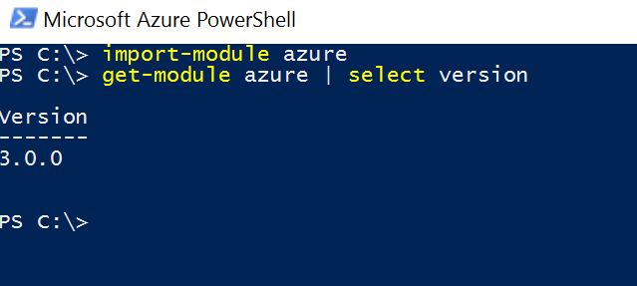

* If the above version is less than 1.5.0, update the PowerShell as below
  + - Install Microsoft Web Platform Installer from <https://www.microsoft.com/web/downloads/platform.aspx?lang>=
    - Once you install it, go to Products -> Click ‘Add’ against “Microsoft Azure PowerShell -> Install
  + 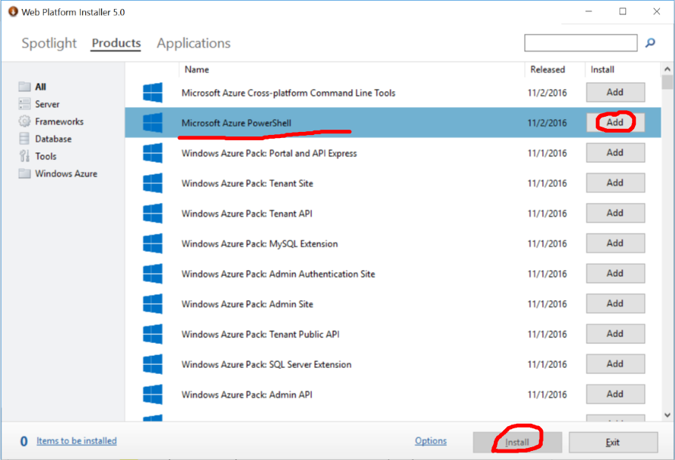

# Identifying Orphaned Disks

Get-AzureOrphanedDisks.ps1 is a powershell tool that help identify Orphaned Disks.

# Prerequisites

* Review if PowerShell 1.5.0 exists at minimum by going through step 1.2 above
* Save list of subscription names (not subscription IDs) in a text file to scan for Orphaned Disks. E.g, the below file contains 2 subscriptions.

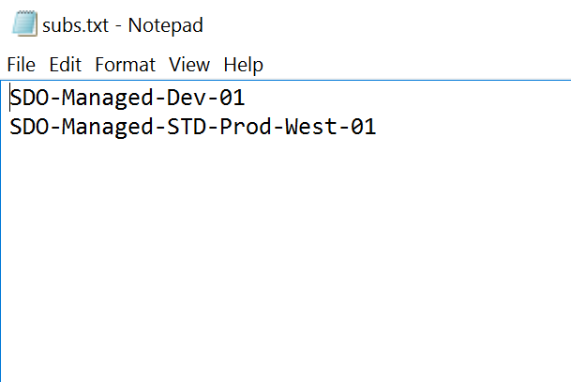

* Access to the subscriptions listed in the text file. The person invoking the script should have access to all the subs to query orphaned disks in them.

# Running Orphaned Disk cleanup in report mode

* Run the script as below:
  + **PS C:\Scripts> .\Get-AzureOrphanedDisks-v4.ps1 -SubList C:\Temp\subs.txt**

Where:

C:\Temp\Subs.txt contains list of subscriptions to scan and identify Orphaned disks.

* The script scans each subscription provided in the subscription list, and reports the list of Orphaned Disks. The script checks both Classic and ARM storage accounts for orphaned VHDs. The script writes the list of identified orphaned disks into CSV file. Location of the CSV file can be found from output of the script.

**PS P:\pavan\ps> .\Get-AzureOrphanedDisks-V1.ps1 -SubList .\subs.txt**

**20161024 01:09:31 : INFO : Starting the script (USER: pavanma, COMPUTER: PAVANMA-WIN10)**

**Transcript started, output file is c:\temp\Get-AzureOrphanedDisks-LogFile-20161024-010931.log**

**20161024 01:09:32 : INFO : Orphaned disk (if found) list will be saved to c:\temp\OrphanedDisks-20161024-010931.csv**

**20161024 01:09:40 : INFO : Found Orphaned VHDs in sub 'SDO-Managed-Dev-01'**

**20161024 01:09:40 : INFO : Scanning for last modified time stamp of the VHDs. Takes couple of minutes..**

**20161024 01:33:44 : INFO : Ending the script. Please check Orphaned disk list at c:\temp\OrphanedDisks-20161024-010931.csv**

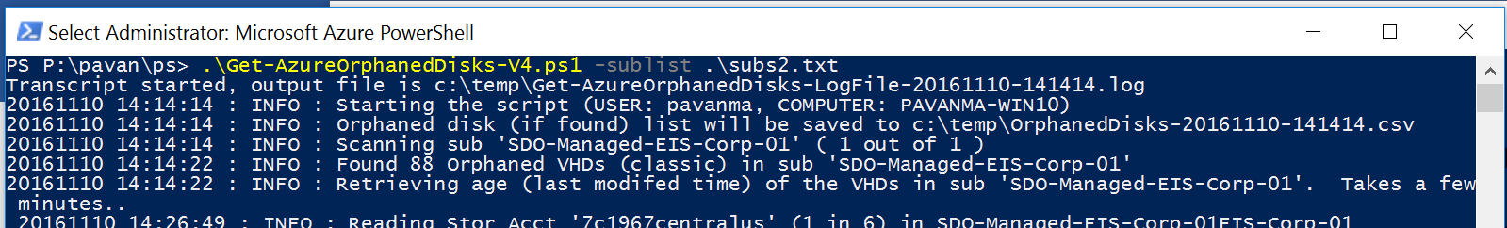

* **Important Note: The script may take long time based on Azure responsiveness, no.of storage accounts in the subscriptions, and network responsiveness. We advise you to run the script from a server (instead of your laptop) to give more time.**
* Open the above CSV file (opens in Excel) to see list of Orphaned Disks. Sample output:

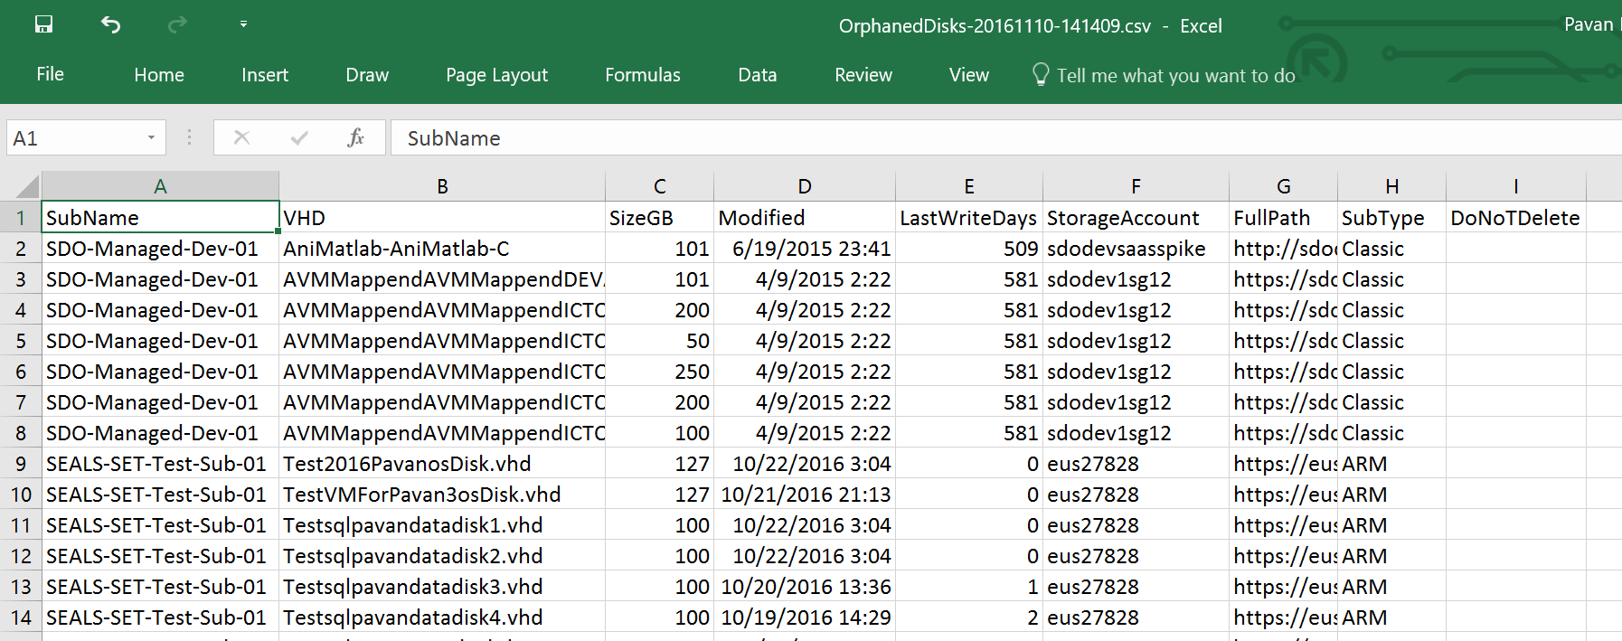

Where:

* **SubName:** Name of the subscription in which the Orphaned VHD exists
* **VHD:** Name of the Orphaned VHD file
* **SizeGB:** Size of the VHD in GB
* **Modified:** Last modified TimeStamp of the VHD
* **LastWriteDays:** Age of the VHD since last modification
* **StorageAccount:** Name of the storage account in which the VHD exists
* **FullPath:** Path to the Orphaned VHD file. From the path, you can find location of the VHD by Storage Account-> Container -> Blob
* **SubType:** tells whether the VHD is on classic/ARM subscription/Storage Account. By default, the script scans both Classic/ARM storage account (if any) in a given subscription.
* **DoNotDelete:** Helpful in delete mode (next section 1.4) if you want to skip deleting any VHD. By default, this column will be empty. This CSV can be supplied to the script to delete the orphaned VHDs. If you do not want to delete specific VHDs, specify ‘Y’ or ‘Yes’ against DoNotDelete column and run the script in delete mode.

# Deleting Orphaned Disks

# Prerequisites

* + Run the script/tool in report mode (refer to previous section) and make a note of Orphaned Disks list location
  + Open the Orphaned Disk list i.e., CSV file that got generated in report mode. Review each VHD file that will be deleted. **If you want to skip a VHD from deletion, fill column ‘DoNotDelete’ with Y or Yes.** In another words, all VHDs with DoNotDelete=Yes **will NOT be deleted**. Once DoNotDelete is set as per the requirement, save the file as is in .CSV format to supply to the script (next step)
* 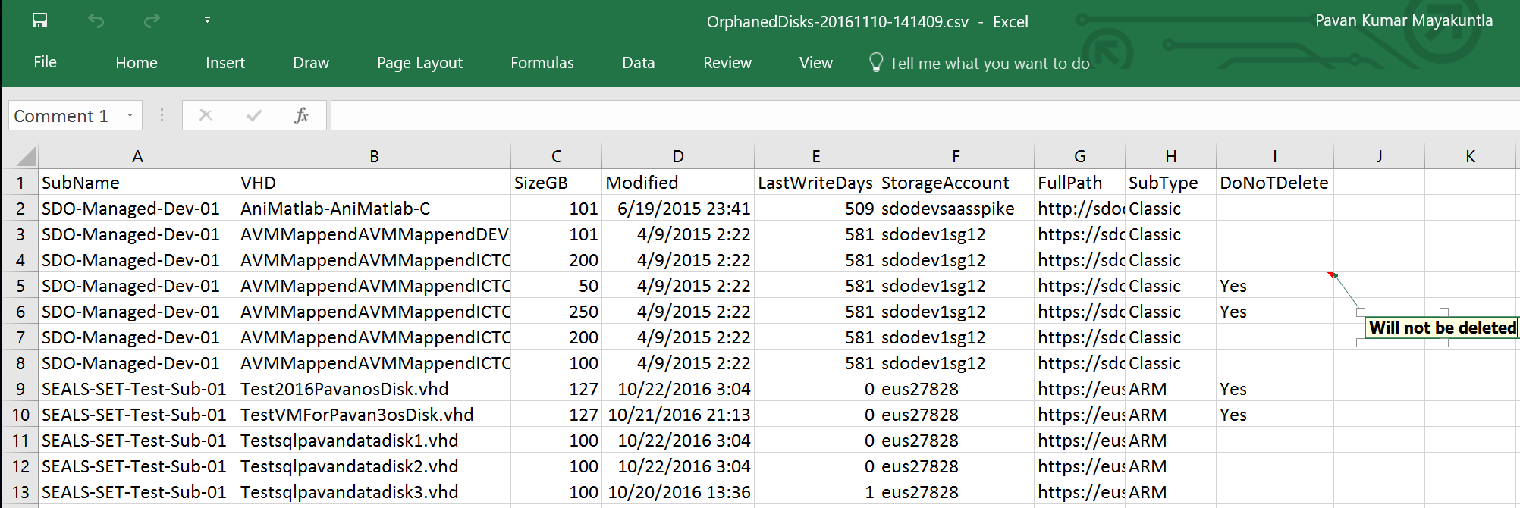



# Run Azure Orphaned disk clean up script in delete mode

* + - Run as below by supplying the above CSV file.

PS C:\temp> .\Get-AzureOrphanedDisks-V1.ps1 -DeleteInFile

c:\temp\OrphanedDisks-20161022-030506.csv

* + - Script deletes all VHDs EXCEPT the VHDs with column ‘DoNotDelete’=Yes.