Tables

Books (isbn, book_name, author, pub_yr, category,rental_price, status)

Customer (cust_id,cust_name, cust_address,books_issued)

Staff (staff_id, staff_name, position, salary)

Branch (mgr_id, br_id, br_address, br_phone)

Issue (issue_id, issue_book_name, issue_date , isbn, cust_id)

Return (return_id, due_date, return_date, return_book_name, isbn, cust_id)

1.write a query to display the isbn, book name and issue date which are issued on particular date.

3. write a query to display the average price of books which are belonging to particular category.

4. write a query to display the manager id, branch address, staff name, salary. If sal is null then display ‘no sal’ else print salary+10%sal

5. write a query to display staff details and isbn, book name of the books taken by them.

6. write a query to display customer details along with return date who has returned the books after the due date.

7. Write a query to display the book code, title, published date of the books which is been published in the month of December.

8. Write a query to display the customer id, name and number of remaining books he/she can take with “REMAININGBOOKS” as alias name.

**Hint:**Assuming a member can take maximum 3 books. For example, Ramesh has already taken 2 books; he can take only one book now. Hence display the remaining books as 1 in below format.

9. List the customer id and name, the name of the taken book from particular branch.

10.  Lists students who have not read books.

11. List the id,name of the customers and the number of books they read sorted by BookCount. Also list the customers who have never read a book.

12. Display issue id,issued customer name whose isbn number is xxxx.

6. Display the unique list of Book code and Book name from the Book transaction.

A. SELECT DISTINCT(BT.BOOK_CODE),BM.BOOK_NAME FROM BOOK_MASTERS BM,BOOK_TRANSACTIONS BT WHERE(BM.BOOK_CODE=BT.BOOK_CODE);

List the id,name of the customers and the number of books they read sorted by BookCount. Also list the customers who have never read a book.

13. Display Staff Code, Staff Name, and Department Name for those who have taken more than one book.

1. Display the isbn, book_name, author, pub_yr of category ‘STORY BOOKS’ that were published during the period of 2001 to 2005 which belongs to ‘HYDERABAD’ branch.

select isbn,book_name,author,pub_yr,c_name,br_name

from books join category using (c_id)

join branches using (br_id)

where c_name like 'STORY BOOKS' and pub_yr between 2001 and 2005

and br_address like 'HYDERABAD';

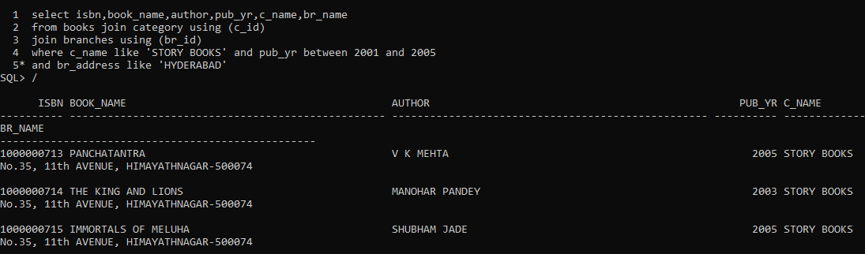

2. Display Book Name, Author Name for those authors who wrote more than one book from Chennai branch.

SELECT book_name, author, br_address FROM books

JOIN branches USING (br_id)

WHERE author IN (SELECT author FROM books

GROUP BY author HAVING COUNT(author)>2)

AND br_address='CHENNAI'

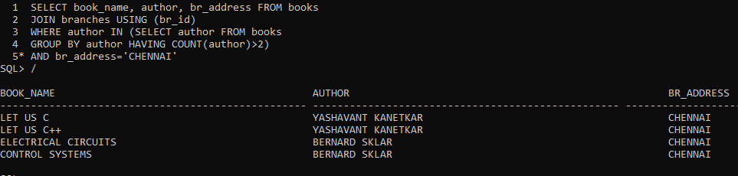

3. Create a query that will display book id, book name, customer name along with issue date for all customers whose expected book return date is some day.

SELECT bt.isbn, b.book_name, c.cust_name, bt.issue_date

FROM book_transactions bt JOIN books b ON (bt.isbn=b.isbn)

JOIN customers c ON (c.cust_id=bt.cust_id)

WHERE bt.expected_return=to_date('28-NOV-18')

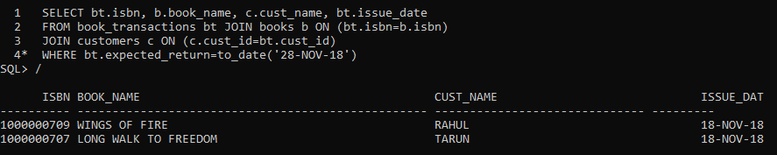

4. Write a Procedure to accept book number and check it in database. Then check whether book is return expected date or out of date. If out of date then it will calculate fine of Rs.2/-day. If the book is not available then display the book is not available in the library.

CREATE OR REPLACE PROCEDURE get_fine(p_isbn NUMBER) IS

v_book_id NUMBER;

v_expected_return book_transactions.expected_return%type;

v_actual_return book_transactions.actual_return%type;

v_days NUMBER;

v_fine NUMBER;

BEGIN

select isbn,expected_return,actual_return

into v_book_id,v_expected_return,v_actual_return

from book_transactions where isbn=p_isbn;

v_days:=v_actual_return-v_expected_return;

IF(v_days>0) THEN

v_fine:=v_days*2;

dbms_output.put_line(v_book_id||' '||v_expected_return||' '||v_actual_return||' '||v_days||' '||v_fine);

ELSE

dbms_output.put_line(v_book_id||' '||v_expected_return||' '||v_actual_return||' '||' '||'returned on expected date');

END IF;

EXCEPTION

WHEN NO_DATA_FOUND THEN

dbms_output.put_line('Book not available');

END;

Write a query to display the customer id, name and number of remaining books he/she can take with “REMAININGBOOKS” as alias name.

**Hint:**Assuming a member can take maximum 3 books. For example, Ramesh has already taken 2 books; he can take only one book now. Hence display the remaining books as 1 in below format.