https://www.softpost.org/bamboo/configuring-stages-jobs-and-tasks-in-bamboo/

In this Bamboo Tutorial, we will have a look at below topics.

1. [Introduction](https://www.softpost.org/bamboo/introduction-to-bamboo/)
2. [Installation](https://www.softpost.org/bamboo/bamboo-installation/)
3. [Creating projects and plans](https://www.softpost.org/bamboo/creating-new-build-plan-and-project-in-bamboo/)
4. [Cloning (Copying) a build plan](https://www.softpost.org/bamboo/cloning-a-build-plan-in-bamboo/)
5. [Configuring visible projects in Bamboo](https://www.softpost.org/bamboo/configuring-visible-projects-in-bamboo/)
6. Configuring the build plan – [Editing build plan](https://www.softpost.org/bamboo/editing-build-plan-in-bamboo/), [Changing the plan name](https://www.softpost.org/bamboo/changing-build-plan-name-in-bamboo/), [Disable plan](https://www.softpost.org/bamboo/disabling-the-build-plan-in-bamboo/), [Delete the build plan](https://www.softpost.org/bamboo/deleting-the-build-plan-in-bamboo/), [Configuring stages, Jobs and Tasks](https://www.softpost.org/bamboo/configuring-stages-jobs-and-tasks-in-bamboo/), [Configuring build plan repositories](https://www.softpost.org/bamboo/configuring-build-plan-repositories-in-bamboo/), [Adding Scheduled build trigger](https://www.softpost.org/bamboo/adding-scheduled-build-trigger-in-bamboo/), [Adding Repository polling trigger](https://www.softpost.org/bamboo/repository-polling-trigger-in-bamboo/), [Adding new branch](https://www.softpost.org/bamboo/adding-new-branch-for-a-build-plan-in-bamboo/), [Running a branch](https://www.softpost.org/bamboo/running-build-plan-on-a-branch-in-bamboo/), [Branch actions in Bamboo](https://www.softpost.org/bamboo/branch-actions-in-bamboo/), [Configuring build plan permissions](https://www.softpost.org/bamboo/configuring-build-plan-permissions-in-bamboo/), [Configuring build notifications](https://www.softpost.org/bamboo/configuring-build-notifications-in-bamboo/), [Expiry of the build history](https://www.softpost.org/bamboo/expiry-of-the-build-history-in-bamboo/), [Passing parameters and variables to the build](https://www.softpost.org/bamboo/passing-parameters-and-variables-to-the-build-in-bamboo/)
7. Java project tasks – [Adding Maven build plan](https://www.softpost.org/bamboo/adding-maven-task-in-bamboo/), [Adding Gradle build plan in Bamboo](https://www.softpost.org/bamboo/adding-gradle-build-in-bamboo/)
8. Visual Studio .Net Project tasks – [Adding MSBuild task in Bamboo](https://www.softpost.org/bamboo/adding-msbuild-task-in-bamboo/), [Adding MSTest task](https://www.softpost.org/bamboo/adding-mstest-task-in-bamboo/)
9. Command line builds in Bamboo – [Linux shell build](https://www.softpost.org/bamboo/linux-shell-command-build-in-bamboo/), [Windows batch command build](https://www.softpost.org/bamboo/windows-batch-command-build-in-bamboo/), [Windows Powershell build](https://www.softpost.org/bamboo/windows-powershell-build-in-bamboo/)
10. [Running the build plans manually](https://www.softpost.org/bamboo/running-the-build-plans-manually-in-bamboo/)
11. Viewing the [build history](https://www.softpost.org/bamboo/build-history-of-a-build-plan-in-bamboo/) and [build logs](https://www.softpost.org/bamboo/viewing-the-build-logs-in-bamboo/)
12. [Bamboo Reports](https://www.softpost.org/bamboo/reports-in-bamboo/)
13. [Authors Page in Bamboo](https://www.softpost.org/bamboo/viewing-commit-authors-in-bamboo/)
14. [Executing Selenium tests in Bamboo](https://www.softpost.org/bamboo/executing-selenium-tests-in-bamboo/)
15. [Creating and viewing artifacts](https://www.softpost.org/bamboo/creating-the-artifacts-for-the-build-in-bamboo/)
16. [Running customized build plan](https://www.softpost.org/bamboo/running-customized-build-in-bamboo/)
17. [Build queue in Bamboo](https://www.softpost.org/bamboo/build-queue-in-bamboo/)
18. Bamboo Administration – [Agents](https://www.softpost.org/bamboo/managing-build-agents-in-bamboo/), [Global Variables](https://www.softpost.org/bamboo/global-variables-in-bamboo/), [User Management](https://www.softpost.org/bamboo/user-management-in-bamboo/), [Server Capabilities](https://www.softpost.org/bamboo/server-capabilities-in-bamboo/), [Linked Repositories](https://www.softpost.org/bamboo/managing-linked-repositories-in-bamboo/), [Group Management](https://www.softpost.org/bamboo/group-management-in-bamboo/), [Global Permissions](https://www.softpost.org/bamboo/global-permissions-in-bamboo/), [Add-ons Management](https://www.softpost.org/bamboo/managing-add-ons-in-bamboo/), [Email server](https://www.softpost.org/bamboo/email-and-im-server-settings-in-bamboo/), [Server address](https://www.softpost.org/bamboo/changing-the-default-port-of-bamboo/), [License Information in Bamboo](https://www.softpost.org/bamboo/license-information-in-bamboo/), [Bamboo System Information](https://www.softpost.org/bamboo/bamboo-system-information/), [Bamboo Audit log](https://www.softpost.org/bamboo/bamboo-audit-log/), [Import/Export build plans in Bamboo](https://www.softpost.org/bamboo/importing-and-exporting-bamboo-build-plans/), [Build History clean up](https://www.softpost.org/bamboo/deleting-the-build-history-in-bamboo/), [Bulk edit plan permissions](https://www.softpost.org/bamboo/bulk-edit-plan-permissions-in-bamboo/), [Move build plan in Bamboo](https://www.softpost.org/bamboo/moving-build-plans-to-different-project-in-bamboo/), [Delete build plans](https://www.softpost.org/bamboo/deleting-build-plans-in-bamboo/), [Bulk actions in Bamboo](https://www.softpost.org/bamboo/bulk-actions-in-bamboo/)
19. Installing add-on in Bamboo e.g. [*groovy tasks for bamboo*](https://bobswift.atlassian.net/wiki/display/BGTP)
20. [Adding deployment project to build plan in Bamboo](https://www.softpost.org/bamboo/adding-deployment-project-to-build-plan-in-bamboo/)
21. [Web application deployment to tomcat using Bamboo](https://www.softpost.org/bamboo/web-application-deployment-to-tomcat-using-bamboo/)

# 1.Introduction to Bamboo

Bamboo is one of the most popular CI server by the company – [Atlassian](https://www.atlassian.com/software/bamboo).

Key features of Bamboo are given below.

1. It supports various version control systems like bitbucket, cvs, subversion, git, perforcem and mercurial.
2. Supports all important tasks like ant, maven, gradle, make tasks, tomcat, SSH, Linux and windows commands, SCP task, PHPUnit, Nunit, Node, MSTest, MSBuild, Grunt, Grails, AWS codeDeploy
3. It also supports the deployment projects.
4. A build plan has one or more stages. **Each stage has one or more jobs**. Each job can have one or multiple tasks like maven or gradle etc. Jobs in a single stage can run simultaneously but stages and tasks within a job run in sequence only.

# 2.Bamboo Installation

BY [ADMIN](https://www.softpost.org/author/admin/) · PUBLISHED MAY 29, 2016 · UPDATED AUGUST 24, 2017

In this topic, you will learn how to download and install Bamboo.

Get your Bamboo evaluation version from [Atlassian website](https://www.atlassian.com/software/bamboo/download). I downloaded zip version of bamboo as shown in below image.

*Zip version of Bamboo*

Then I extracted the zip folder using 7Zip utility.

After that I added a bamboo home directory in the file – C:\Users\Sagar\Downloads\atlassian-bamboo-5.12.1\atlassian-bamboo\WEB-INF\classes\bamboo-init.properties

bamboo.home=C:\Users\Sagar\bamboo-home

Then I modified the ports of Bamboo. By default Bamboo is accessible from 8085 port but we can change it from below file.

C:\Users\Sagar\Downloads\atlassian-bamboo-5.12.1\conf\server.xml

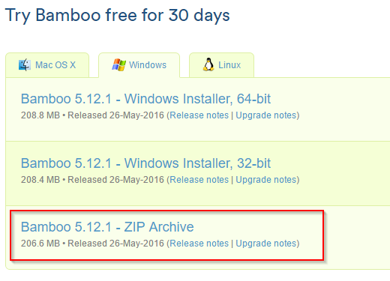

*Bamboo ports*

After that We can start the server by executing below command.

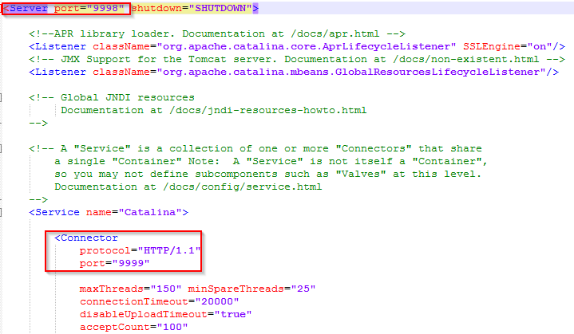

*Start Bamboo server using command prompt*

Then We can access the Bamboo at url <http://localhost:9999>

First time, you will to get license key from Bamboo. To get the license key, click on contact Atlassian link which will take you to license page. Once the license Key provided, you can click on express installation and then create an admin account.

