**Chef Setup**

**install chef-workstation**

install ruby

gem install chef

**Install Chef Server**

[Dockerhub link](https://hub.docker.com/r/cbuisson/chef-server/)

[Github link](https://github.com/c-buisson/chef-server)

Pull docker container

$docker pull cbuisson/chef-server[1]

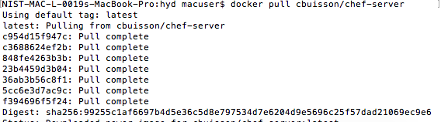

Run container

$ docker run --privileged -t --name chef-server -d -p 443:443 cbuisson/chef-server

To see the logs of installation

$ docker logs -f chef-server

**Setup Knife**

curl -Ok https://chef-server:$SSL_PORT/knife_admin_key.tar.gz

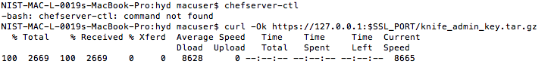

Extract pem files

$ tar -xzvf knife_admin_key.tar.gz



Copy .pem files to .chef dir

/Users/macuser/.chef

Craete config.rb

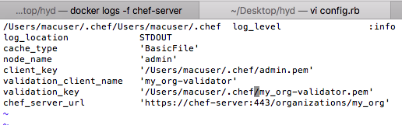

$ knife ssl fetch

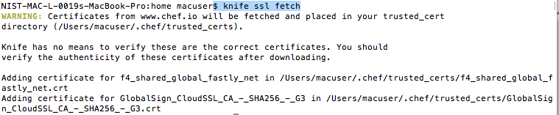

|  |
| --- |
| Opscode ubuntu-12.10 |

<http://opscode-vm-bento.s3.amazonaws.com/vagrant/virtualbox/opscode_ubuntu-12.10_chef-provisionerless.box>

$ vagrant box add {title} {url} $ vagrant init {title} $ vagrant up

ubumtu12

1. test