**Time Series Analysis**

Time series analysis is a specific way of analysing a sequence of data points collected over an interval of time. It provides an additional source of information and a set order of dependencies between the data.

Time series analysis typically requires a large number of data points to ensure consistency and reliability. It also ensures that any trends or patterns discovered are not outliers and can account for seasonal variance. Additionally, time series data can be used for forecasting—predicting future data based on historical data.

**Time series analysis examples**

Time series analysis is used for non-stationary data—things that are constantly fluctuating over time or are affected by time. Industries like finance, retail, and economics frequently use time series analysis because currency and sales are always changing. Stock market analysis is an excellent example of time series analysis in action, especially with automated trading algorithms. Likewise, time series analysis is ideal for forecasting weather changes, helping meteorologists predict everything from tomorrow’s weather report to future years of climate change.

**Models of time series analysis include:**

* **Classification:** Identifies and assigns categories to the data.
* **Curve fitting:** Plots the data along a curve to study the relationships of variables within the data.
* **Descriptive analysis:** Identifies patterns in time series data, like trends, cycles, or seasonal variation.
* **Explanative analysis:**Attempts to understand the data and the relationships within it, as well as cause and effect.
* **Exploratory analysis:**Highlights the main characteristics of the time series data, usually in a visual format.
* **Forecasting:** Predicts future data. This type is based on historical trends. It uses the historical data as a model for future data, predicting scenarios that could happen along future plot points.
* **Intervention analysis:**Studies how an event can change the data.
* **Segmentation:** Splits the data into segments to show the underlying properties of the source information.

## 

* 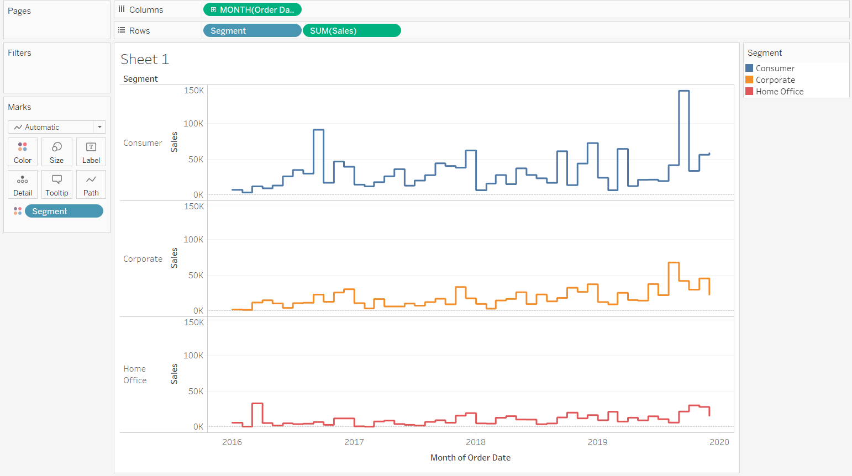

### **Data classification**

### Further, time series data can be classified into two main categories:

* **Stock time series data**means measuring attributes at a certain point in time, like a static snapshot of the information as it was.
* **Flow time series data** means measuring the activity of the attributes over a certain period, which is generally part of the total whole and makes up a portion of the results.

### **Data variations**

In time series data, variations can occur sporadically throughout the data:

* **Functional analysis**can pick out the patterns and relationships within the data to identify notable events.
* **Trend analysis** means determining consistent movement in a certain direction. There are two types of trends: deterministic, where we can find the underlying cause, and stochastic, which is random and unexplainable.
* **Seasonal variation**describes events that occur at specific and regular intervals during the course of a year. Serial dependence occurs when data points close together in time tend to be related.

### **Important Considerations for Time Series Analysis**

While time series data is data collected over time, there are different types of data that describe how and when that time data was recorded. For example:

* **Time series data** is data that is recorded over consistent intervals of time.
* **Cross-sectional data** consists of several variables recorded at the same time.
* **Pooled data** is a combination of both time series data and cross-sectional data.

**Time Series Analysis Models and Techniques**

Just as there are many types and models, there are also a variety of methods to study data. Here are the three most common.

* **Box-Jenkins ARIMA models:** These univariate models are used to better understand a single time-dependent variable, such as temperature over time, and to predict future data points of variables. These models work on the assumption that the data is stationary. Analysts have to account for and remove as many differences and seasonality’s in past data points as they can. Thankfully, the ARIMA model includes terms to account for moving averages, seasonal difference operators, and autoregressive terms within the model.
* **Box-Jenkins Multivariate Models:** Multivariate models are used to analyze more than one time-dependent variable, such as temperature and humidity, over time.
* **Holt-Winters Method:** The Holt-Winters method is an exponential smoothing technique. It is designed to predict outcomes, provided that the data points include seasonality.

**There are four type of time Series data:**

1. Secular trend, which describe the movement along the term;

When there is a long-term increase or decrease in the data

1. Seasonal variations, which represent seasonal changes;

The data changes over seasons, and repeat over years

Ex: Ice Cream Sales

1. Cyclical fluctuations, which correspond to periodical but not seasonal variations;

A cycle occurs when the data exhibit rises and falls that are not of fixed frequency.

Many people confuse cyclic behaviour with seasonal behaviour, but they are really quite different. If the fluctuations are not of a fixed frequency, then they are cyclic; if the frequency is unchanging and associated with some aspect of the calendar, then the pattern is seasonal. In general, the average length of cycles is longer than the length of a seasonal pattern

Ex: Covid 19

1. Irregular variations, which are other non-random sources of variations of series.

An irregular time series stores data for a sequence of arbitrary timepoints. Irregular time series are appropriate when the data arrives unpredictably, such as when the application records every stock trade or when electricity meters record random events such as low battery warnings or low voltage indicators.