**GPT**

**Abstract**

This paper looks into how AI, especially GPT-3, is reshaping our idea of intelligence. It discusses the difference between doing a task and truly understanding it. While AI can generate realistic content, it lacks awareness or emotion behind its output. The focus is on what this means for AI’s role in our future.**Introduction**

The intro compares a human and a robot doing the same task (like mowing a lawn) and shows how we can't always tell who did it just by looking at the result. It brings up the idea of "reversibility"—whether we can trace something back to its source. This sets up the Turing Test and how certain questions can still reveal whether the source is human or AI. But even then, passing the test doesn’t prove true intelligence.**GPT-3**

GPT-3, developed by Open-AI, is one of the most powerful language models ever built, with 175 billion parameters. It is based on the transformer architecture, specifically using the decoder-only version, and is capable of generating human-like text across a wide range of tasks. The model was trained using unsupervised learning, where it learned to predict the next word in a sentence using massive datasets including Common Crawl, Wikipedia, books, and web text, totaling over 45TB before filtering. It excels in few-shot, one-shot, and zero-shot learning, enabling it to perform tasks like translation, summarization, code generation, and question answering without task-specific fine-tuning.

Despite its capabilities, GPT-3 does not possess true understanding—it relies on statistical patterns rather than comprehension. It can generate biased, toxic, or factually incorrect content due to limitations in its training data. However, it produces fluent, grammatically correct, and contextually rich outputs, making it useful in areas like content writing, where it can generate blogs, scripts, and ads. In code generation, it powers tools like GitHub Copilot, transforming plain language into functional code. In question answering, it can respond to both factual and conversational queries, making it valuable for chatbots and education. While GPT-3 marks a significant step forward, it also raises ethical and technical challenges that must be managed as these models continue to evolve. **Some Consequences of GPT-3:**

GPT-3 is revolutionizing writing by enabling mass production of high-quality texts at minimal cost, transforming industries from journalism to technical writing. While it will support and reshape how writers work—emphasizing prompt engineering over manual writing—it also raises concerns. These include content overload, decline in quality, misuse for fake news, and clickbait exploitation. Readers may struggle to distinguish between human- and AI-generated texts. As AI-generated content proliferates, we’ll need new ethical standards, copyright laws, and a stronger digital culture to adapt responsibly to this shift in the infosphere.

## ****GPT-3 Summary****

**1. GPT-3 Architecture (175 Billion Parameters)**GPT-3 (Generative Pretrained Transformer 3) is an autoregressive language model developed by OpenAI. It belongs to the family of transformer-based models and is known for its massive scale—featuring **175 billion parameters**, making it the largest publicly known model at the time of its release (2020).

* **Autoregressive** means it generates text by predicting the next word based on previous words.
* GPT-3 is a **decoder-only** transformer architecture, meaning it focuses solely on generating outputs, not taking in pairs of input and output like an encoder-decoder model would (e.g., BERT uses encoders, GPT uses decoders).
* Parameters are the learned weights in the neural network—more parameters mean greater capacity to capture language patterns and nuance.

GPT-3’s large parameter count gives it the ability to perform a wide range of tasks with few or zero examples (few-shot/zero-shot learning), leveraging just the prompt and internal knowledge.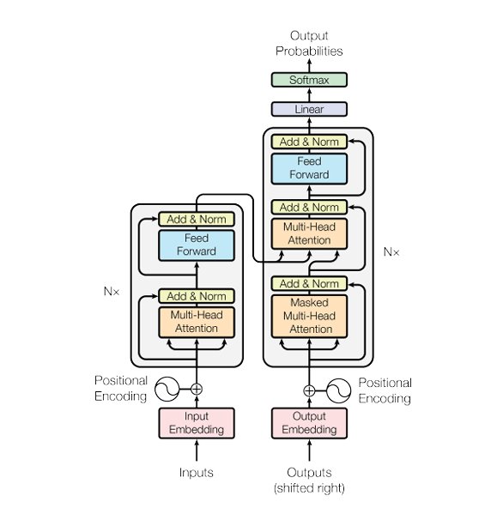**2. Training Method & Datasets**

GPT-3 was trained using **unsupervised learning**—no labeled data was needed. The model was trained to predict the next token in a sequence of text using the standard language modeling objective.

#### ****Training Process****:

* GPT-3 uses a variant of **maximum likelihood estimation (MLE)**, where it learns to predict the probability of the next word in a sentence given all previous words.
* The model was trained on **supercomputing infrastructure**, using thousands of GPUs over weeks.

#### ****Datasets Used****:

GPT-3 was trained on a diverse and massive corpus of text (around 300 billion tokens), including:

* **Common Crawl** (filtered and deduplicated)
* **WebText2**
* **Books1 & Books2**
* **Wikipedia (English)**

This gives GPT-3 exposure to:

* Online articles
* Books across genres
* Wikipedia-style encyclopedic content
* Social media text
* Programming code
* Conversation data

This diversity contributes to its generalizability across domains.

### ****3. Strengths vs. Limitations****

#### ****Strengths****:

* **Few-shot and zero-shot learning**: It can perform tasks without explicit training, just by observing examples in the prompt.
* **Language generation**: Can generate coherent, fluent, and contextually relevant text.
* **Knowledge retrieval**: Can recall factual information and explain concepts learned during training.
* **Multitasking**: One model can handle summarization, translation, question answering, code generation, and more.

#### ****Limitations****:

* **No true understanding**: GPT-3 doesn’t “understand” meaning like humans do—it operates statistically, not semantically.
* **Inconsistencies**: It may contradict itself or generate false or misleading information.
* **Biases**: Reflects and sometimes amplifies societal biases present in its training data (gender, race, culture, etc.).
* **No memory**: Each interaction is stateless—it cannot remember past chats or learn over time without retraining.
* **Inability to verify**: GPT-3 can “hallucinate” answers—confidently present falsehoods as facts.

### ****4. Use Cases of GPT-3 (In-Depth)****

#### ****A. Code Generation****

GPT-3 can write code based on natural language prompts. Tools like **GitHub Copilot** (powered by Codex, a GPT-3 variant) illustrate this capability.

* It can write code in multiple languages: Python, JavaScript, C++, HTML/CSS, etc.
* Prompts like “write a function to sort a list” or “create a responsive navbar” yield usable code.
* **Limitation**: While it can generate syntax-correct code, it might not always be optimized or secure.

**Example**: Prompt: “Create a function in Python that checks if a number is prime.”  
Output:

Python:

def is_prime(n):

if n <= 1:

return False

for i in range(2, int(n**0.5)+1):

if n % i == 0:

return False

return True

#### ****B. Content Writing & Story Generation****

GPT-3 excels at generating human-like text that reads fluently and coherently.

* It can write blog posts, poems, essays, marketing copy, and even full short stories.
* It can adapt to tone and style (formal, humorous, technical).
* **Limitation**: May lose coherence in long passages and sometimes generate repetitive or off-topic content.

**Example**: Prompt: “Write a short story about a robot discovering emotions.”  
Output: A 3–4 paragraph emotional sci-fi tale with dramatic tension and a clear plot.

#### ****C. Question Answering (Q&A)****

GPT-3 can respond to factual, conceptual, and even opinion-based questions.

* Works well for encyclopedic queries: “What is the capital of Canada?” → “Ottawa.”
* Can explain complex topics: “What is quantum entanglement?”
* **Limitation**: Answers can be outdated, incorrect, or overly confident in uncertain topics.

**Example**: Prompt: “Explain the difference between TCP and UDP.” Output:

“TCP is a connection-oriented protocol that ensures reliable data transmission, while UDP is connectionless and faster but doesn’t guarantee delivery.”