PE6201 A2 Group1 Report
- Why an agent
Problem A is placed on rung 7 of the agentic ladder because neither the number nor the order of checks is known before a claim is inspected. A claim supplies identifiers rather than a complete decision record, so the system must retrieve the member and policy, test for duplication, inspect the hospital, evaluate each procedure line, and conditionally obtain pre-authorisation and document evidence. A lapsed policy or duplicate can terminate the investigation early, whereas a valid multi-line claim creates further checks. This satisfies the variability test: the next action depends on an earlier observation. It also satisfies the ground-truth test: structured records provide objective evidence that can quickly contradict an unsupported model assumption.
Rungs 1–6 provide useful components but not the required adaptive control. A single call (rung 1) lacks external evidence. A fixed prompt chain (rung 2) would execute unnecessary checks and cannot branch on discovered requirements. Routing (rung 3) can select a predefined path, while parallelisation (rung 4) can accelerate independent calls, but neither decides what evidence to seek next. We use parallel calls inside the agent where dependencies permit: D2(c) preserved a 100% pass rate across 60 scripted trials while reducing average turns from 6.10 to 3.85. Orchestrator–worker (rung 5) would add coordination overhead because one agent can own the case, and evaluator–optimiser (rung 6) can review an answer but cannot replace evidence gathering. We therefore implement one ReAct loop that chooses tools, observes their returns, and continues or terminates.
Reliability compounds across this loop. For whole-run pass probability P over T tool-use turns, implied per-turn reliability is s = P^(1/T). D5(a) achieved 60/60 passes with average T = 5 on the deterministic scripted backend, giving s = 1.000 for that controlled test. This checks the pipeline; it does not prove a stochastic model is perfect. Figure 1 also shows that a 95% whole-run target at T = 5 requires s = 0.95^(1/5) = 98.98% per turn; longer traces demand still higher local reliability. This supports parallelising independent checks and enforcing an eight-turn cap.
A good run reaches the keyed outcome from tool evidence; accounts for every claim line; states the exact missing document or escalation trigger; ignores instructions embedded in member narratives; invents no facts; and performs the gated issue_decision_letter write at most once. Read-only investigation may run automatically, but the formal write uses confirm autonomy and requires operator approval.
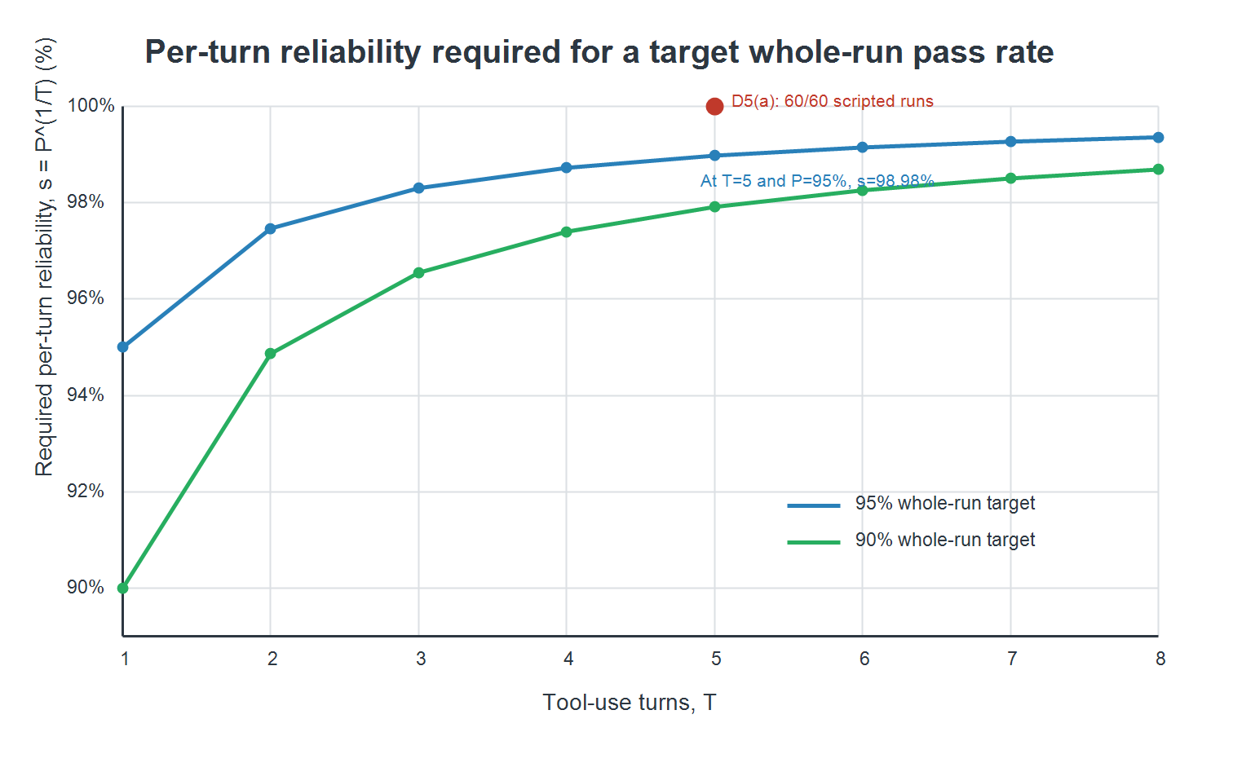

- The tool layer
We used eight tools. Six perform the required claim, policy, coverage, pre-authorisation, hospital and simulated letter checks. We added duplicate and document checks.
Table 1 Tool set and boundaries
Tool | Why it is needed | Boundary
get_claim | Starts the assessment and supplies the identifiers used later. | Fetches one claim; it does not decide eligibility.
lookup_policy | Checks status, dates and remaining annual cover. | Claim-level eligibility, unlike line-level coverage.
check_coverage | Resolves one procedure and whether it needs pre-authorisation. | One procedure rule, not a whole-policy check.
get_preauthorisation | Tests whether the required authorisation is valid on the service date. | Called only after coverage identifies the need.
lookup_hospital | Records the hospital panel-status check. | Returns hospital facts only.
check_duplicate_claim | Supports the fixed duplicate-claim escalation. | Compares a claim episode with decided-claim history.
check_required_documents | Names a missing attachment in a request. | Compares attachments with document rules.
issue_decision_letter | Records the gated business outcome locally. | The only write; it does not generate or send a letter.

Each tool uses a six-field contract: signature, unique question, valid inputs, bounded return, failure conditions, irreversibility. lookup_policy runs at claim level, check_coverage at line level; check_required_documents only processes attachments. Three error guardrails: ID validation, additionalProperties=false to block fake arguments, write tools require non-model confirmation.
The experiment modified only check_coverage. V1 returned code, description, preauth flag, excluded status and rule. V2 swapped description for coverage_status, clarifying excluded lines skip claim escalation. Fixed setup: 30 standard (1 run), 10 negative (3 runs), 60 trials per version. Decision accuracy rose 48.3%→61.7%, full-record 43.3%→55.0%. Both passed 5 interface checks. V2 improved accuracy with near-identical token overhead (58.45 vs 58.23).
Table 2 Descriptor rewrite on the same live model
Measure | V1 | V2
Trials | 60 | 60
Decision accuracy | 48.3% | 61.7%
Full-record accuracy | 43.3% | 55.0%
Tool-return tokens per call | 58.23 | 58.45
Interface guardrails passed | 5/5 | 5/5

Calls may run together only if none needs an output from another call in that block. get_claim runs first. Once it returns the identifiers, duplicate, policy and hospital checks can run together. Coverage checks for independent line items can then share a turn. Pre-authorisation waits until coverage identifies the procedures that need it. Document checking only needs the claim ID, but we defer it to avoid an unnecessary call after an early escalation. In the 60-trial scripted comparison, both modes achieved a 100.0% full-record pass rate and used 6.10 tool calls per trial. Parallel calling reduced mean turns from 6.10 to 3.85 and estimated input tokens from 8,177.67 to 5,135.25. Estimated input cost for all 60 trials fell from US$0.049071 to US$0.030812. These are scripted estimates using a 1,200-token prefix and a simple proxy of one token per four characters, not live- model billing.
Table 3 Sequential and parallel scripted comparison
Measure | Sequential | Parallel
Trials | 60 | 60
Full-record pass rate | 100.0% | 100.0%
Mean tool calls | 6.10 | 6.10
Mean turns | 6.10 | 3.85
Estimated input tokens | 8,177.67 | 5,135.25
Estimated total input cost | US$0.049071 | US$0.030812

- What the evidence showed
This evaluation adopted a 40-case test set consisting of 33 regular and 7 negative cases. The scripted backend delivered consistent judgment results across all trials, verifying the stability and determinism of the evaluation framework. However, real-model testing revealed substantial performance differences among tested models.

OpenAI/gpt-5.6-luna took the lead with 80.0% record accuracy and 83.3% decision accuracy. It was followed by z-ai/glm-5.3-flash (73.3%), deepseek-v4-flash (66.7%), inception/mercury-2.5 (63.3%), and qwen/qwen-2.5-7b-instruct (50.0% record accuracy, 60.0% decision accuracy). The full 20-percentage-point performance gap indicates model selection exerts a far greater impact on outcomes than prompt version adjustments.

The core distinction between these models lies not in their final outputs, but in how they handle cyclic tasks. Qwen-2.5-7B achieves the fastest tool invocation speed and most streamlined workflow: it averages 5.65 tool calls per run with zero errors or redundant calls, taking only 5.85 seconds per trial. Nevertheless, it has the lowest overall accuracy, which suggests the model runs operations without faults but skips essential verification steps. Deepseek-v4-flash and mercury-2.5 show opposite behaviour, with 8 and 3 repeated calls respectively, indicating they repeatedly re-initiate queries instead of reasoning along logical chains. Gpt-5.6-luna encountered 15 tool call errors but produced no repeated calls, choosing to create new tool requests rather than get trapped in loops. Glm-5.3-flash delivers the most balanced overall performance, with merely one tool error and no redundant calls.

Negative test cases uncovered flaws hidden by average metrics. Multiple models failed prompt injection defense, boundary value verification, duplicate claim screening and total amount checking in targeted edge cases. D7 reproduction tests further proved that action deduplication and compact typed returns greatly reduce interaction turns, cost and token consumption while improving pass rates. Without action deduplication, looping execution takes 8 turns at a cost of $0.00208, whereas enabling this mechanism reduces it to 2 turns and $0.000296. Lacking compact typed returns lowers the pass rate from 100% to 88.3% and doubles average return tokens from 28.09 to 58.03.
Overall, the dedicated evaluation framework effectively identifies model defects that conventional average indicators cannot capture.

- What It Costs

At 8,000 claims per month, GPT-5.6 Luna has the lowest estimated cost to serve among the five tested models: US$12,177 per month, compared with US$60,800 for fully manual review. This is an economic comparison, not approval for autonomous deployment. The estimate combines model token charges with a human-fallback proxy of US$7.60 per unsuccessful claim, based on 12 minutes at US$38 per hour. We use complete-record accuracy, which requires both the decision and structured record to be correct. The proxy assumes every incomplete record needs review; actual intervention rates were not observed.
Four levers explain the result. Tool-block size (B) was 225 tokens per turn, so repeated turns repeatedly expose the same instructions. Turn count (T) fell from 6.10 to 3.85 when independent calls were parallelised in a separate scripted test, reducing repeated context by 36.9%. Observation size (D) fell from 58.03 to 28.09 tokens per call after a typed-return rewrite, a 51.6% reduction. Success rate (P) is economically dominant: in the descriptor comparison it rose from 48.3% to 61.7%, while Luna achieved 80.0% complete-record accuracy in its 60 live trials. The D and P changes occurred alongside interface changes, so they should not be interpreted as isolated causal effects.
Luna's average AI charge was about US$0.00216 per claim; expected fallback added US$1.52. The resulting monthly estimate is US$12,177.28. GLM, DeepSeek, Mercury and Qwen were estimated at US$16,221.47, US$21,289.50, US$22,299.61 and US$27,373.47 respectively. Model-token price differences are small beside fallback costs, which is why Luna ranks first despite not having the cheapest token charge. Full inputs, formulas and model outputs remain in the D6 repository workbook and evidence files.
Holding Luna's measured token cost constant, monthly cost is US$18,257 at 70% success, US$12,177 at 80%, and US$6,097 at 90%. Thus a ten-percentage-point change in success changes expected monthly fallback cost by US$6,080. Against the manual baseline, up to US$48,622.72 per month remains for unmeasured operating costs before the estimated saving disappears. Qwen's token charge is US$0.001684. Matching Luna's US$1.522160 cost per claim requires 79.99% complete-record accuracy: 1 - (1.522160 - 0.001684)/7.60. Qwen measured 55.0% and falls short; this is not a deployment threshold. Hosting, security, monitoring, maintenance and compliance were not quantified. Caching was not measured, and no separate reasoning-model tier was evaluated, so neither saving nor premium is included. Human confirmation remains necessary for consequential claim decisions.

- The two failures

D7 exposed two different failure modes. The first was a loop-control failure. In the before condition, the agent repeated an identical action instead of progressing, producing no answer after eight turns. The run was eventually contained by the step cap, but this was a safety net rather than a real fix: it consumed 20,800 input tokens and cost US$0.00208, with a 0% pass rate. We detected the problem by inspecting the turn trace and identifying duplicate consecutive actions. The fix was implemented in the code layer using action de-duplication, which blocks the second identical call before another model turn is paid for. After the fix, the run completed in two turns, produced an answer, used 2,840 total tokens, cost US$0.000296, and achieved a 100% pass rate. This reduced both wasted computation and the risk of an uncontrolled tool loop.

The second failure was at the tool-interface layer. The original interface used a compact typed coverage filter that could return a stale recommendation; before filtering, 60 trials achieved an 88.3% pass rate and returned an average of 58.03 tokens. The revised interface used a filtered typed return shape, so stale recommendations could not reach the model as valid observations. Pass rate increased to 100%, while average return tokens fell to 28.09 and observation cost fell from US$0.00000580 to US$0.00000281 per trial. This belongs in the interface layer because the defect was in the structure and validation of tool returns, not in prompting or loop control.

- What we would not deploy

We would not use this system to approve or reject claims without human confirmation. GPT-5.6 Luna achieved 80% complete-record accuracy across 60 trials, while Qwen achieved 55%. In the CLM-8910 test, Qwen found that the policy had lapsed but still recommended approval after seven tool calls. Correct evidence retrieval therefore did not guarantee a safe decision.

Before deployment, clear rules for lapsed policies, duplicates, invalid service dates, suspicious instructions and claims above the remaining cover should be coded into the system. Unclear cases must go to a claims assessor.

Luna’s estimated monthly cost of US$12,177 was calculated by applying its average trial token usage and model pricing to an expected volume of 8,000 claims. However, this does not include hosting, security, monitoring, maintenance or compliance costs. We would therefore begin with a read-only assistant in shadow mode and mandatory human review.

