 | Department of Master of Computer Applications  DESIGN THINKING LAB – MCA427DL | 
TITLE: Efficient Beekeeping & Hive Box — Safe Inspection & Feeding Upgrade
🤝 EMPATHY | ➜ | 🎯 DEFINE | ➜ | 💡 IDEATE | ➜ | 🛠️ PROTOTYPE | ➜ | 🧪 TEST

🤝 EMPATHY → DEFINE Understanding the beekeeper

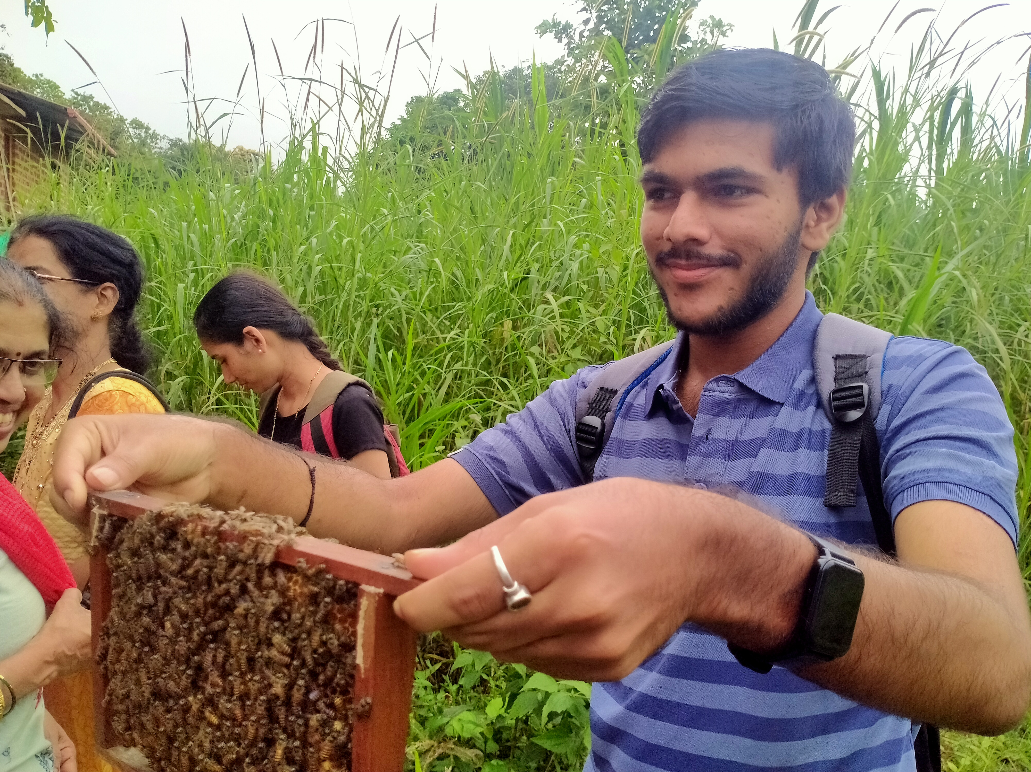  Field research — inspecting a live frame with local beekeepers | What we heard  • 7 interviews · field visits · survey + secondary research  • 19 pain points mapped (Says / Thinks / Does / Feels)  • Beginners fear stings; frames get glued by burr-comb  “Opening the box ruins the hive's temperature for two days.”  — Dhruv Bhat, commercial beekeeper | The challenge  Small-scale & novice beekeepers need a safer, simpler way to inspect & maintain hives — current methods feel risky, time-consuming & need expertise they lack.  • Low-risk inspection without disturbing bees  • Low-cost upgrade that fits existing boxes  • Fewer openings → protects hive micro-climate

💡 IDEATE From insights to a chosen concept

Brainstorm → dot-voting → selection matrix  • Acrylic inspection window (UV sliding cover)  • External gravity sugar-syrup feeder  • One-tap flow auto-harvest  • Donut ant-barrier / water ring on stand  ★ Selected: “Safe Inspection & Feeding Upgrade” — low-cost (<₹500) retrofit | 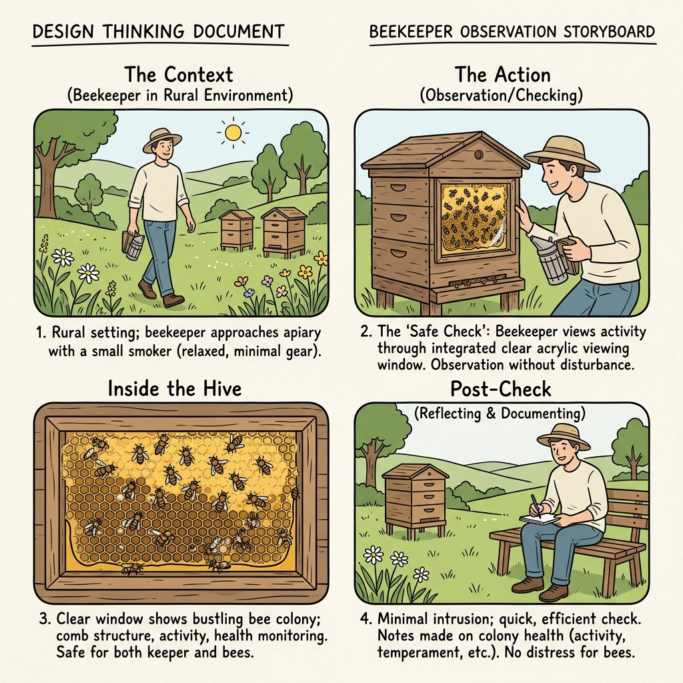  Storyboard: safe ‘window’ check | 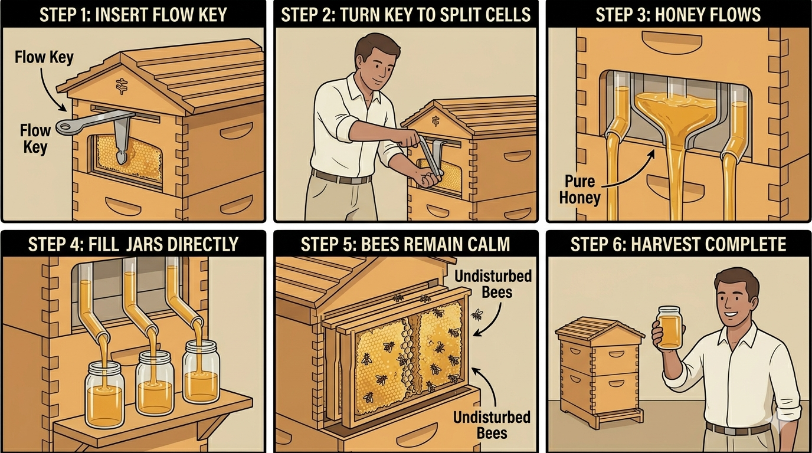  Storyboard: one-tap flow harvest — bees stay calm

🛠️ PROTOTYPE 3D model — Safe Inspection & Feeding Upgrade (ISI standard)

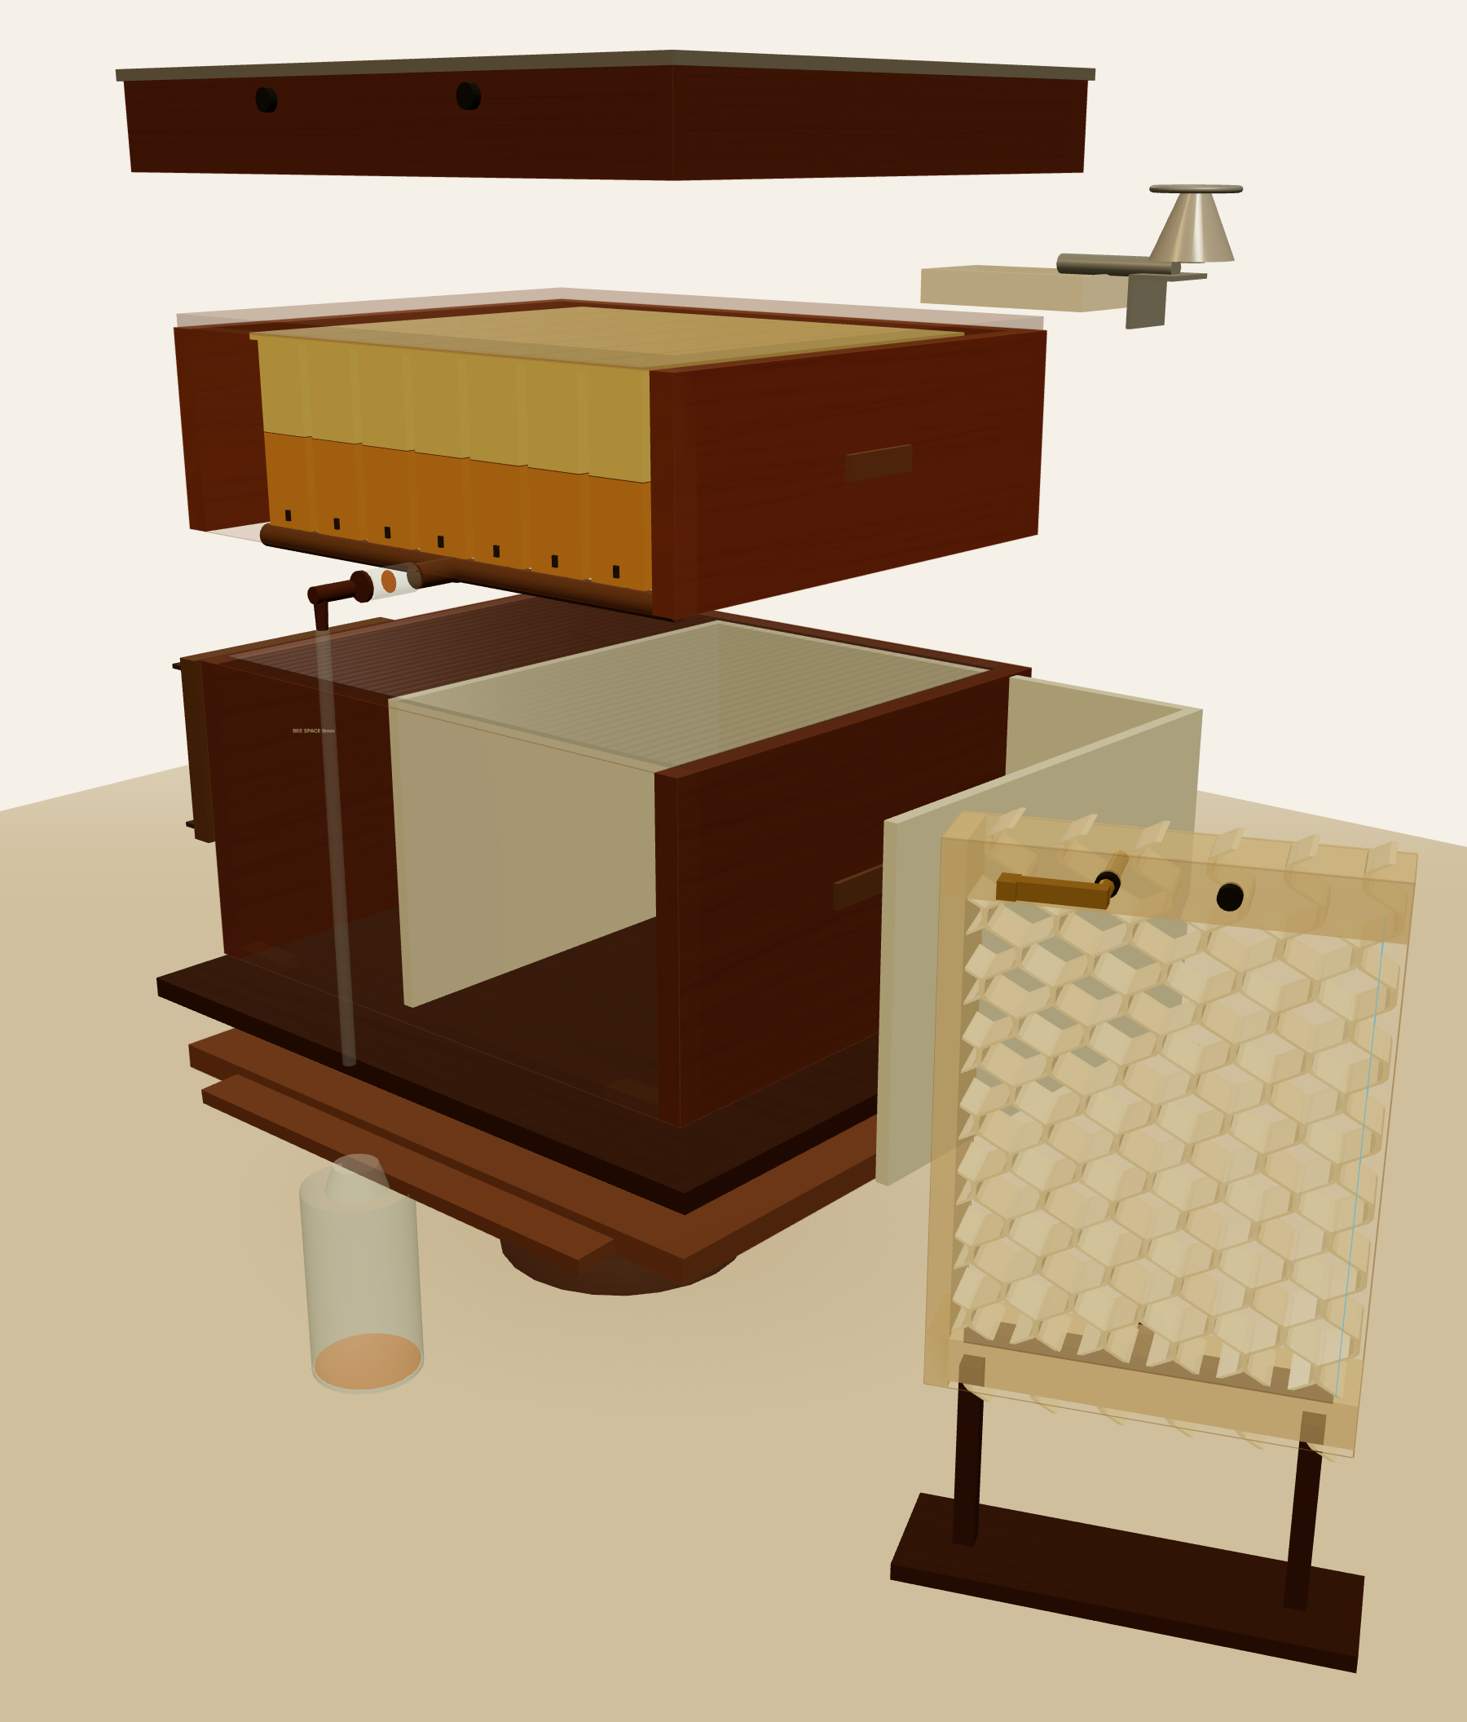  Exploded view — separate parts of the upgraded hive | Part breakdown  1 Telescopic roof  2 Flow super + one-tap harvest tap  3 Acrylic inspection window + UV shutter  4 Queen excluder  5 Brood box (ISI 505×405×245 mm, 9 mm bee space)  6 Floor + landing board  7 Elevated stand with ant / water ring  8 External syrup feeder + funnel  Key specs: <₹500 retrofit · ISI standard · 9 mm bee space · inspect & feed without opening  Interactive 3D model: beehive-prototype.html · flow-hive-simulation.html | 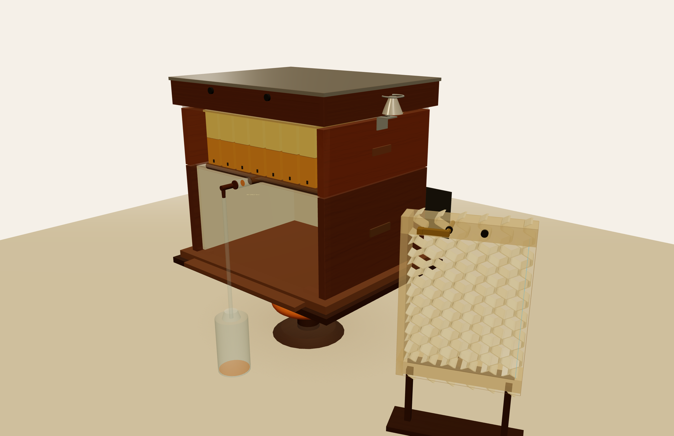 Assembled on stand 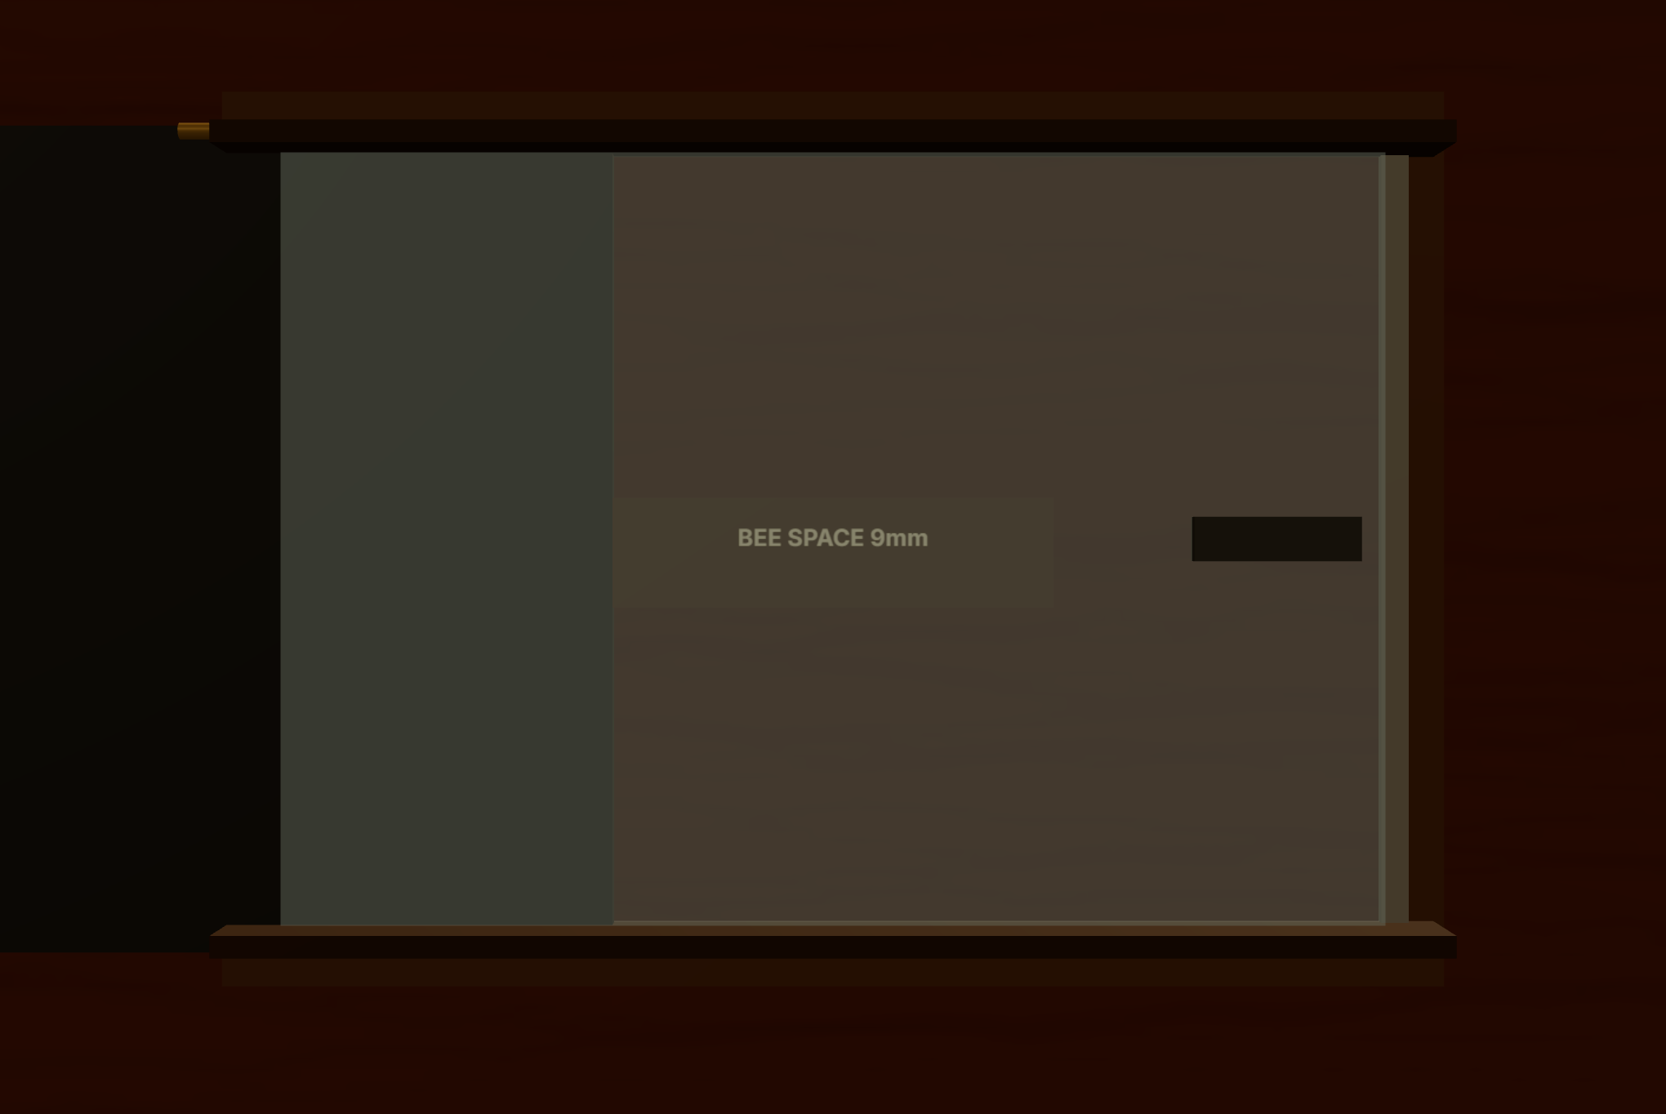 Acrylic window · 9 mm  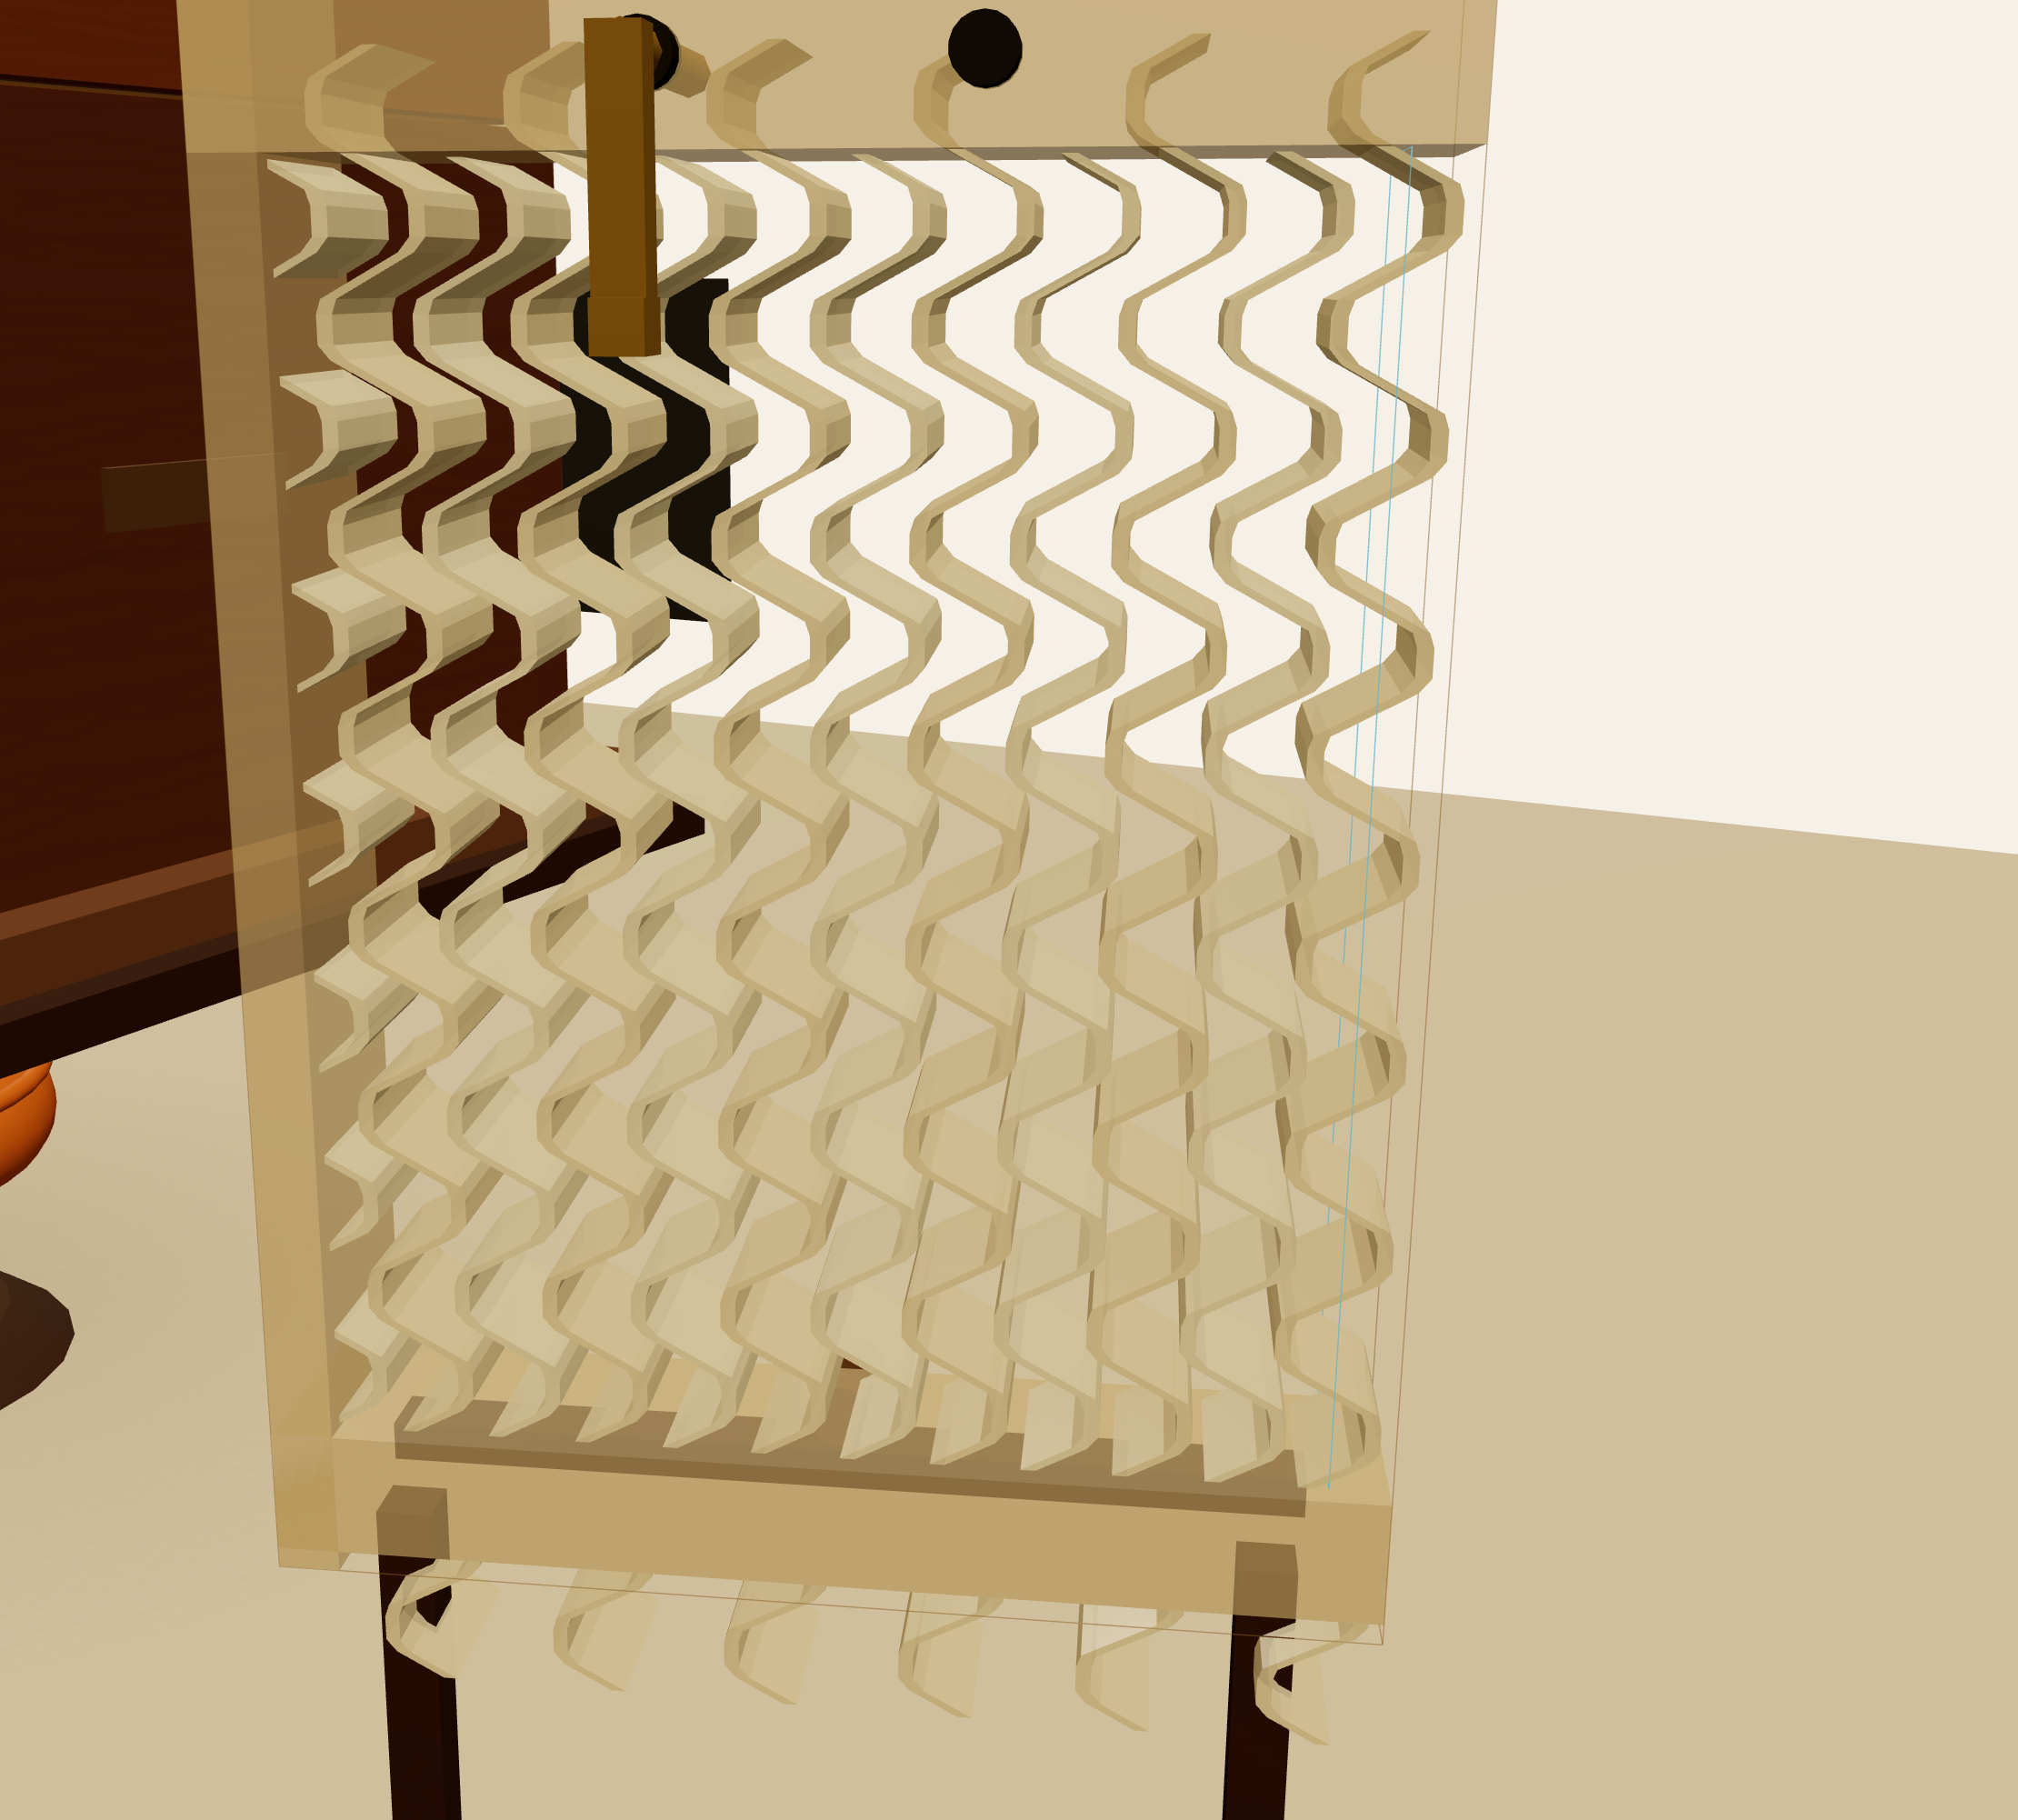 One-tap flow harvest 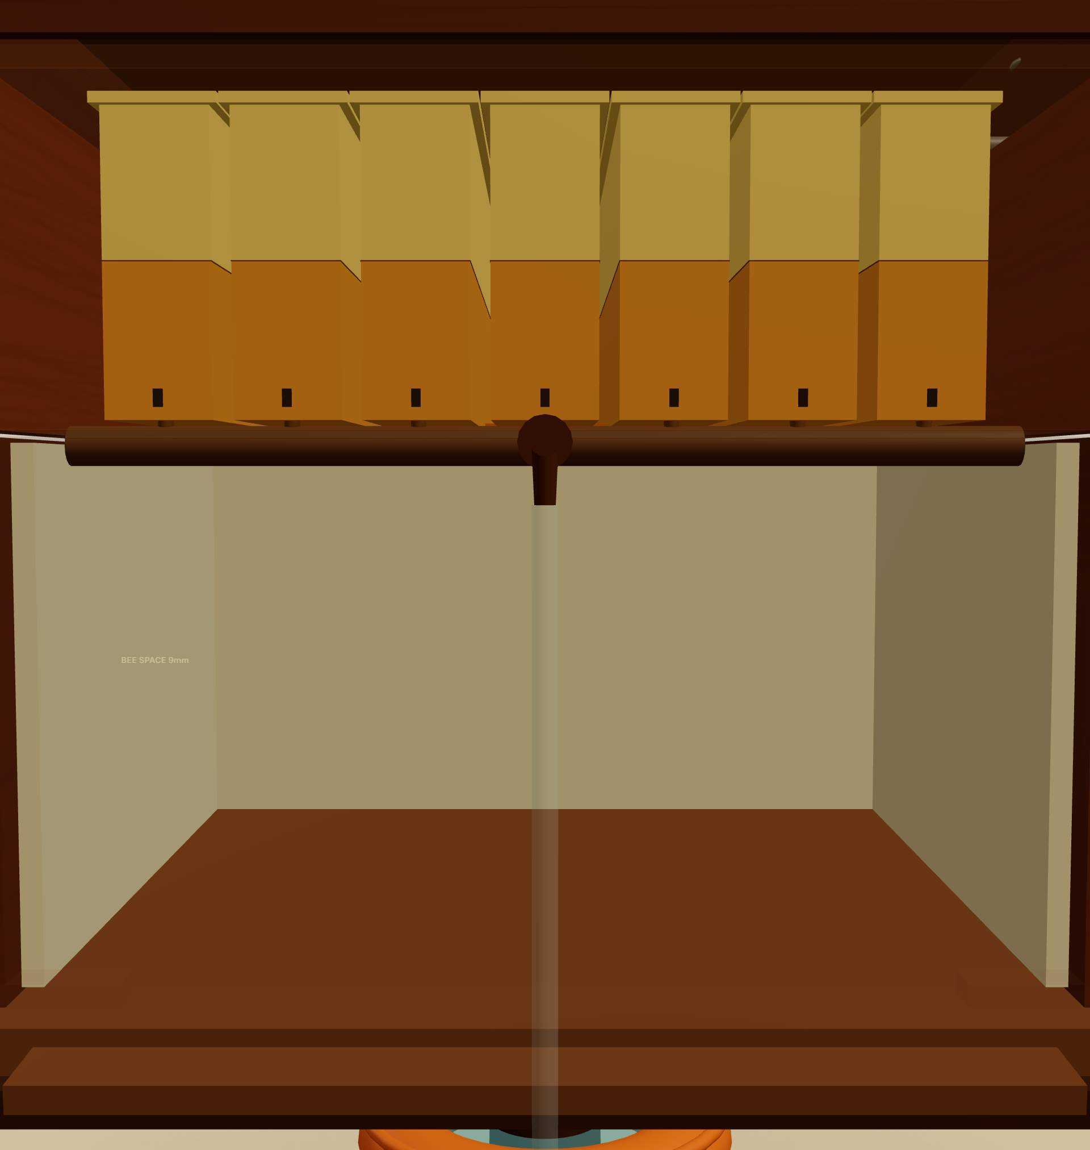 Closed-loop feeding

🧪 TEST & IMPACT Validation, beneficiaries and outcomes

Testing — 5 sessions / 6 weeks · 3 beekeepers  • Inspect & feed without opening; brood 33–36 °C; no rise in bee stress  • Targets: install <45 min · satisfaction ≥4/5 · zero bee drownings  • Iteration ITR-002: added 6.35 mm feeler-gauge bee-space step |  Beneficiaries  • Small / novice beekeepers  • Elderly & women farmers  • FPOs & cooperatives |  SDGs Addressed  • 1 No Poverty · 8 Decent Work  • 12 Responsible Consumption  • 15 Life on Land |  Expected Outcome  • Cuts colony loss · raises yield  • 20-min → 30-sec safe check  • Accessible to all skill levels

Group Members (Name – USN): Pavan Mohan Naik – 1RV25MC066 | Sumanth Bhaskar Hegde – 1RV25MC103 | Pramath Prakash Hegde – 1RV25MC070 | Mentor Name: Dr. Mohan Aradhya

