**Refugee Pre and Post Knowledge Efficacy**

**Tools: Excel and SPSS**

**Test 1:**

**Participant’s knowledge of US employment and Policies before and after the PRIDE program.**

**Null Hypothesis:** The PRIDE program did not help the participants improve their knowledge of US employment and policies for disabled and refugee immigrants.

**Alternate Hypothesis:** The PRIDE program helped the participants improve their knowledge of US employment and policies for disabled and refugee immigrants.

**Analysis:**

The Wilcoxon signed rank test is the non-parametric of the [dependent samples t-test](https://www.statisticssolutions.com/dependent-sample-t-test-2/).  Since the dependent samples t-test analyzes if the average difference of two repeated measures is zero, it requires metric (interval or ratio) and normally distributed data; the [Wilcoxon sign test](https://www.statisticssolutions.com/data-analysis-plan-wilcoxen-signed-rank-test/)uses ranked or ordinal data; thus, it is a common alternative to the dependent samples t-test when its assumptions are not met.

28 participants took both the pre- and post-survey. The expected answer key is matched with the participants response and a weighted difference of the values are considered as the data for both pre- and post-analysis.

E.g.: If a participant answered Yes (“1”) and the expected answer key is also Yes (“1”) then the weighted difference would be zero for that respective participant and the total of all the responses would be the sum of the differences across all the questions answered.

The dtaa is then fed into SPSS for the Wilcoxon Signed Rank test. The variable names are Post and Pre. On performing the test the following was observed.

**Negative rank: A decrease from Pre to Post**

**Positive rank: Rank increased from Pre to Post**

Looking at the p-value of the z-score we can concur that it is less thaan 0.05. Therefore reject the Null Hypothesis and accept the Alternative Hypothesis.

**The PRIDE program helped the participants improve their knowledge of US employment and policies for disabled and refugee immigrants.**

**Test 2: Participant’s confidence in their ability to take necessary steps to get their desired job.**

**Null Hypothesis:** Participants do not feel confident to get their desired job

**Alternative Hypothesis:** Participants feel confident to get their desired job

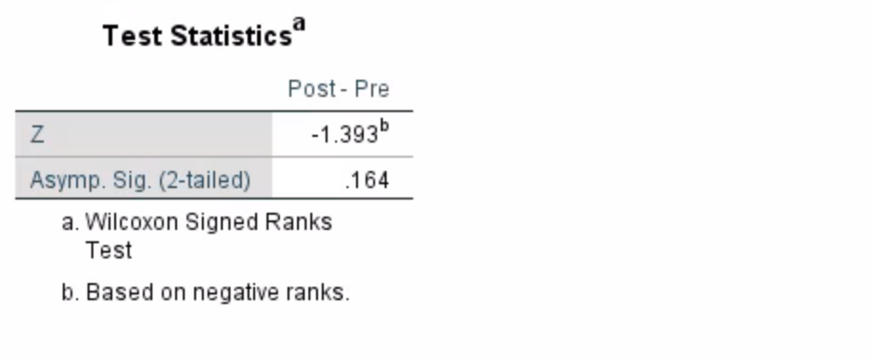

**The p value is greater than 0.05. Therefore, we cannot reject the null hypothesis.**

**Participants do not feel confident to get their desired job.**