Resident Satisfaction with Local Services in Tilak Nagar Mumbai
  - Community engagement project report
Pavan Pal
BSc Data Science
N G Acharya and D K Marathe College
University of Mumbai

Project summary
This project examines how surveyed residents of Tilak Nagar rate local services and what concerns they raise in optional suggestions. I used Python and Pandas to clean and summarise the responses, Matplotlib to produce charts, and Streamlit to build a simple interactive website.
The supplied file contains 32 responses, of which 26 are from Tilak Nagar. The main findings use those 26 responses. Their average overall satisfaction is 3.81 out of 5, and 14 respondents gave an overall rating of 4 or 5. Public toilets have the lowest service mean, 3.04 out of 5, and the highest dissatisfied share, 30.77 percent.
Survey coverage | Responses
Tilak Nagar used for main findings | 26
Chembur retained separately | 3
Other localities retained separately | 3
Total supplied responses | 32

Objectives
- Describe satisfaction with eight local services.
- Compare ratings and identify concerns for discussion.
- Review residents' suggestions using transparent keyword rules.
- Present the findings in an accessible website and propose community follow-up.

Status of the work
The data analysis, charts, notebooks, and website are complete. The report also proposes sharing the findings, discussing specific concerns, and documenting follow-up. Community meetings, complaint submissions, and service improvements are not claimed as completed. Actual collection dates, recruitment details, and fieldwork evidence should be added from the project records before submission.

Data and method

Source and study area
The source is survey_responses_raw(2).csv, preserved unchanged in the project as survey_responses_raw.csv. It contains 32 rows and 16 columns, including a timestamp, participation consent, locality, age group, residence duration, eight service ratings, reporting experience, overall satisfaction, and an optional suggestion.
The main analysis uses 26 Tilak Nagar respondents. Three Chembur and three Other records remain in the all-locality clean file. The website focuses on the Tilak Nagar sample. All 32 supplied records indicate participation consent. No recruitment method or population sampling frame was supplied, so the sample is not described as random or representative.

Cleaning procedure
- Preserve the original file and rename columns using the original question text.
- Check exact duplicate rows and retain consenting records. No exact duplicate raw rows were found.
- Standardise known locality spelling variants and age-range punctuation.
- Convert valid satisfaction answers to numeric ratings from 1 to 5. Keep non-use, not-applicable, and absent ratings missing rather than replacing them with zero.
- Retain the original online-service response to count non-use separately.
- Save the all-locality clean data and a separate Tilak Nagar subset.

Calculations
For each service, the mean is the sum of valid ratings divided by its valid-rating count. Satisfied means 4 or 5, and dissatisfied means 1 or 2. Percentages use the valid count for that service. Means summarise ordinal ratings and should be considered alongside category counts and sample sizes.

Respondent coverage
Age group in Tilak Nagar | Responses
18 to 30 | 18
31 to 45 | 3
46 to 60 | 2
Above 60 | 1
Below 18 | 2

Most respondents are younger adults. Guardian-permission information for the two existing under-18 records is unavailable and should be reviewed with the supervisor. Their age groups are preserved in the clean data for any additional review required by the college.

Service satisfaction findings
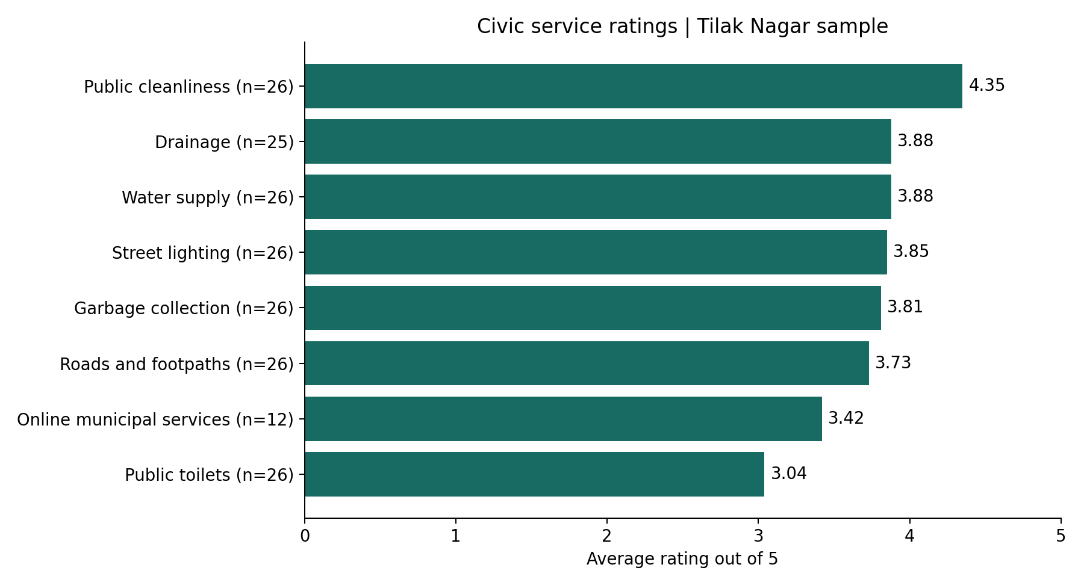
Figure 1. Mean ratings in the Tilak Nagar sample. Each service label shows its valid-rating count.
Service | Valid n | Mean / 5 | Satisfied
Water supply | 26 | 3.88 | 69.23%
Garbage collection | 26 | 3.81 | 73.08%
Public cleanliness | 26 | 4.35 | 80.77%
Roads and footpaths | 26 | 3.73 | 57.69%
Street lighting | 26 | 3.85 | 80.77%
Drainage | 25 | 3.88 | 64.00%
Public toilets | 26 | 3.04 | 34.62%
Online municipal services | 12 | 3.42 | 33.33%

Public cleanliness has the highest average rating, 4.35 out of 5. Public toilets have the lowest, 3.04 out of 5. The differences describe the sampled responses; they are not evidence of the opinions of every resident or independently verified service quality.
Drainage has 25 valid ratings because one response is not applicable. Online municipal services have 12 valid ratings because 14 respondents selected non-use. The average for online services therefore describes a different and smaller group than most service averages.

Overall satisfaction and civic participation
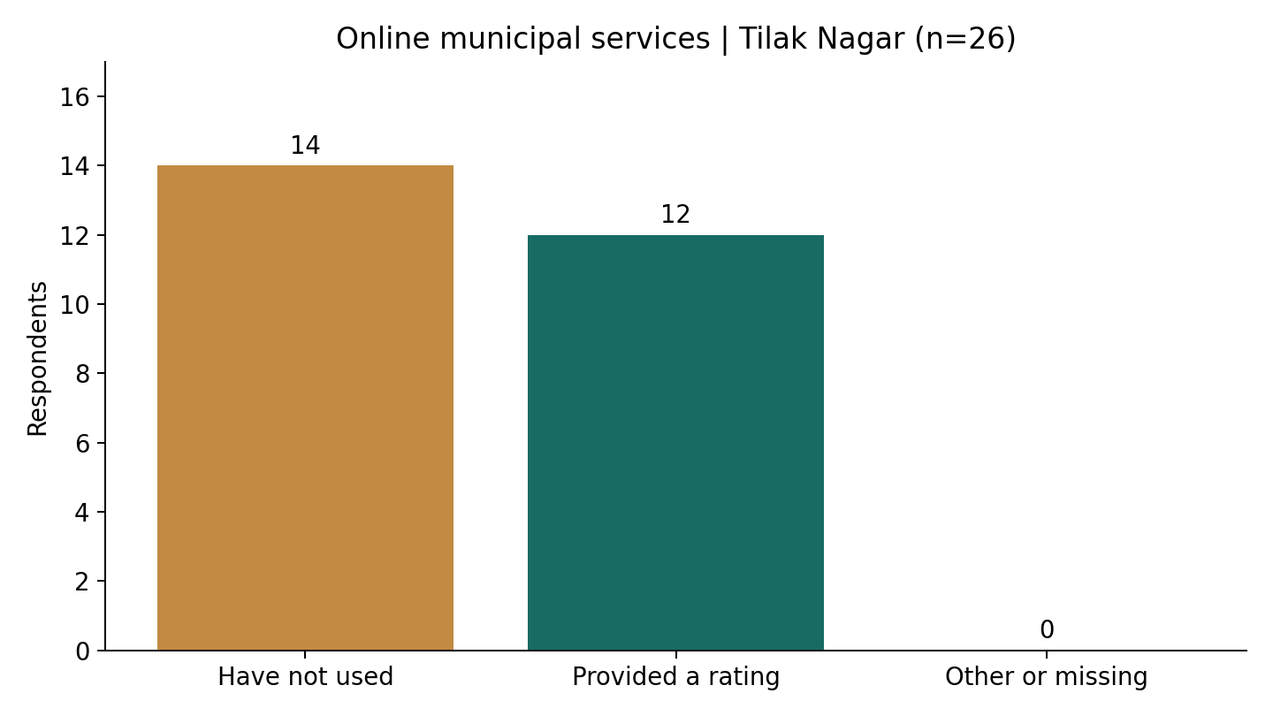
Figure 2. Explicit non-use of online municipal services is kept separate from numeric ratings.
Overall satisfaction ratings in Tilak Nagar are: zero ratings of 1, one of 2, eleven of 3, six of 4, and eight of 5. The rating sum is 99, giving a mean of 99 divided by 26, or 3.81 out of 5. Fourteen of 26 respondents selected 4 or 5, an overall satisfied share of 53.85 percent.
For online municipal services, 14 of 26 respondents reported non-use, also 53.85 percent. This is a separate measure with a coincidentally equal percentage. Twelve people provided a numeric service rating. Their sum is 41, giving a mean of 3.42 out of 5.
Have reported a civic problem | Responses
Yes | 8
No | 17
Do not know how to report one | 1

The reporting question did not specify whether the channel was online or offline. Non-use of online services also does not establish dissatisfaction, lack of access, or lack of skills. Those reasons were not measured in the questionnaire.

Interpreting the response pattern
The overall result includes substantial neutral feedback: 11 of 26 respondents selected 3. Reviewing service-specific concerns and discussing them with residents is more useful than assuming that one overall average captures every experience.

Suggestions from residents
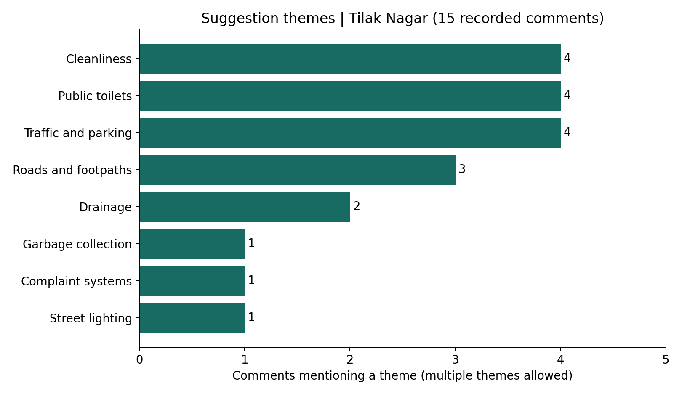
Figure 3. Keyword themes in 15 recorded Tilak Nagar comments. Multiple themes can occur in one comment.
Fifteen of the 26 Tilak Nagar respondents supplied a suggestion, while eleven left it blank. Public toilets, cleanliness, and traffic or parking each appear in four comments under the documented rules. Roads and footpaths appear in three, drainage in two, and garbage collection, street lighting, and complaint systems each in one.

How the text analysis works
The code converts comments to lower case and checks a short list of words or phrases. For example, “toilet” identifies a public-toilet theme. Each theme is counted at most once within one comment. A comment about a dirty toilet can also match cleanliness, so theme counts should not be added as though they represent different people.
This simple method is easy to inspect, but it can miss spelling variations and context. It does not understand negation, severity, or whether an issue is mentioned only in passing. Comments therefore require manual review before interpreting priorities. Blank suggestions are missing comments, not evidence of no concerns.

Using the comments constructively
Comments can guide a discussion about specific locations, timing, and practical requests. The original comments should remain unchanged. Any later explanation gathered from residents should be recorded as new feedback with its own collection details.

Discussion priorities and community action
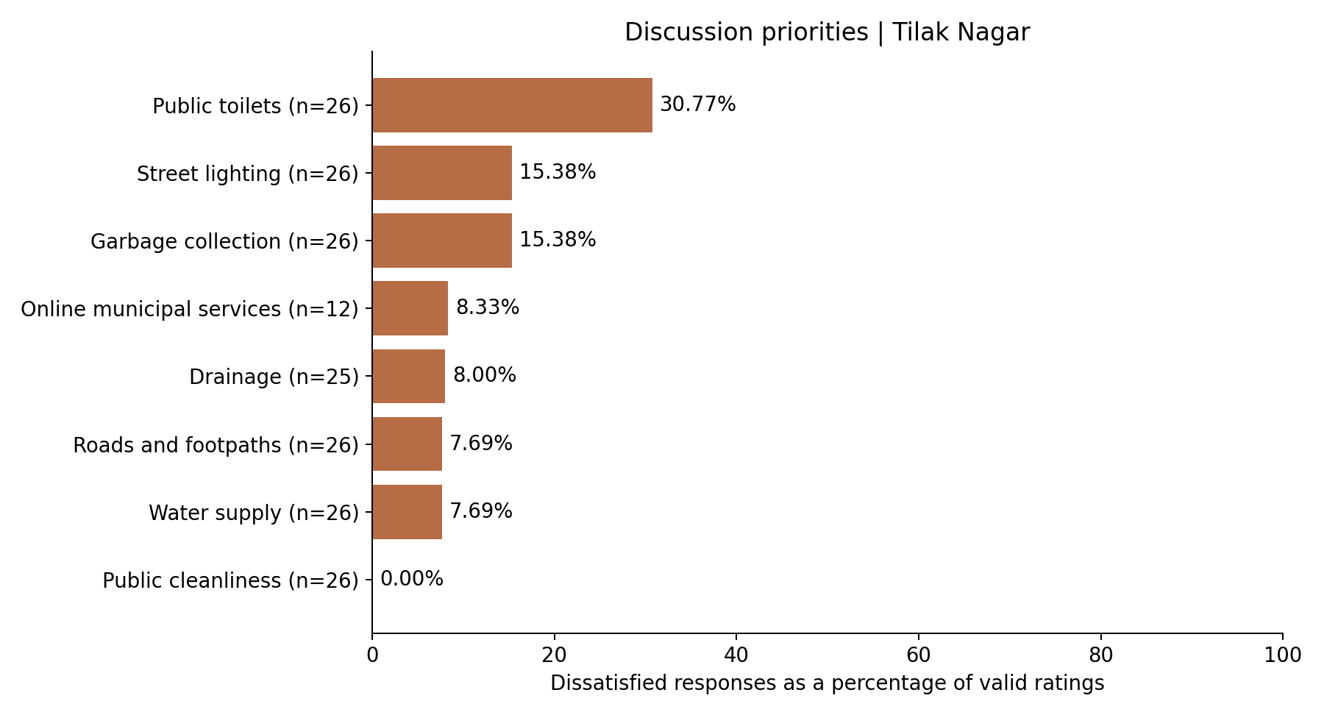
Figure 4. Dissatisfied share means ratings of 1 or 2 divided by each service's valid rating count.
Public toilets have the highest dissatisfied share, with eight of 26 valid ratings, or 30.77 percent. Garbage collection and street lighting each have four of 26, or 15.38 percent. This ranking is a discussion aid, not an official urgency score or a direct measure of problem severity.

Proposed community follow up
- Share the aggregate charts with participating residents and ask whether they reflect their experience.
- Discuss toilet cleanliness and availability, and identify the specific locations and changes residents want.
- Review garbage collection, lighting, roads, and other concerns before agreeing on priorities.
- Prepare a concise summary for the appropriate local representative or service office after verifying the correct contact.
- Record actual meetings, submissions, responses, and later resident feedback in the activity log.
No meeting, complaint submission, or improvement is recorded as completed in this report. The blank community_activity_log.csv provides fields for dates, participant counts, concerns, actions, follow-up status, and evidence references.

Website evaluation and conclusion

Website and code
The website has four pages: Overview, Satisfaction dashboard, Suggestions and priorities, and Community action plan. The simplified version consistently shows the Tilak Nagar sample. Summary tables and theme counts can be downloaded as CSV files. Individual comments are reviewed in the notebook rather than displayed as a public list on the website.
The application file contains comments above every executable statement and blank lines between steps. Three notebooks show cleaning, calculations, and keyword counting directly in small cells. The website reads their saved CSV files. After changing the raw survey, run notebooks 01, 02, and 03 again before refreshing the app. The report must be updated separately. The code uses basic variables, loops, and conditions; it does not train a machine-learning model.

Evaluation of community engagement
After actual follow-up, record what was discussed, who participated in aggregate, what request was made, and whether a response was received. A later survey using the same questions can describe changes. If different residents respond, the difference is between samples rather than a matched change for the same people. A change alone cannot prove that this project caused it.

Limitations
The analysis uses a small sample with undocumented recruitment and a high share of younger respondents. Ratings and comments are self-reported. Some service denominators differ, optional suggestions are incomplete, and keyword rules do not capture all language. These limits should accompany the charts whenever the findings are shared.

Conclusion
The sampled residents reported an average overall satisfaction of 3.81 out of 5. Public cleanliness received the highest mean rating, while public toilets received the lowest and had the largest dissatisfied share. The project makes these findings accessible through an interactive dashboard and provides a practical plan for sharing and discussing concerns. Documented follow-up is needed to establish any later community outcomes.

Sources and references
Primary source: survey_responses_raw(2).csv supplied for this project, 32 rows. The main analysis uses its 26 Tilak Nagar records. No synthetic responses or external population estimates were added. Report prepared on 5 October 2026.
Streamlit installation: https://docs.streamlit.io/get-started/installation
Streamlit widgets: https://docs.streamlit.io/develop/api-reference/widgets
Streamlit downloads: https://docs.streamlit.io/develop/api-reference/widgets/st.download_button
Project methods, complete code, and setup instructions: README.md, FULL_CODE.md, and the three notebooks.

