**CASE STUDY**

Saavn Hub: A music Platform

Submitted By

Name: Pavan Raju Patil

Roll no: 3054

Batch: B1

Academic Year 2024-25

**Contents**

1) Problem Statement

2) Abstract

3) Introduction

4) Use Case Diagram

5) Class Diagram

6) Activity Diagram

7) Software and Hardware Requirements

8) Graphical User Interface

**Problem Statement**

A music recommender system is designed to enhance the user experience on Jio Saavn by suggesting personalized songs, playlists, and artists. The goal is to increase user engagement and satisfaction by providing tailored music recommendations based on users' listening habits, preferences, and other relevant data.

**Abstract**

This report details the development of a music recommender system for Jio Saavn aimed at providing users with personalized song and playlist suggestions. By analysing user interactions such as song ratings, listening history, and demographics, the system uses collaborative filtering, content-based filtering, and hybrid recommendation techniques. The implementation aims to increase user engagement and improve the overall experience by delivering relevant and customized recommendations.

**Introduction**

The surge in online music streaming services like Jio Saavn has provided users with access to vast music libraries. To help users discover music that suits their preferences, a recommender system is crucial. This project develops a Jio Saavn music platform incorporating a recommender system leveraging machine learning algorithms like collaborative filtering and content-based filtering. The system considers user preferences, listening history, and song attributes to create a personalized music experience, thereby enhancing user engagement and satisfaction.

**Use Case Diagram:**

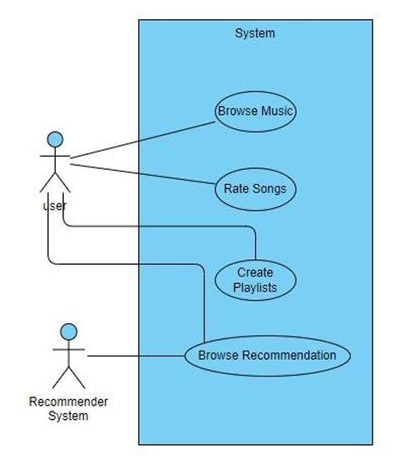

**Class Diagram:**

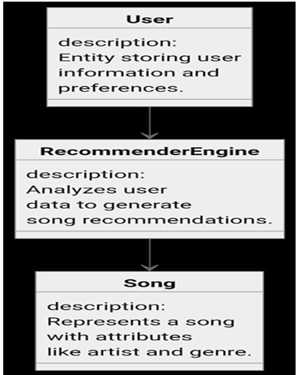

**Activity Diagram:**

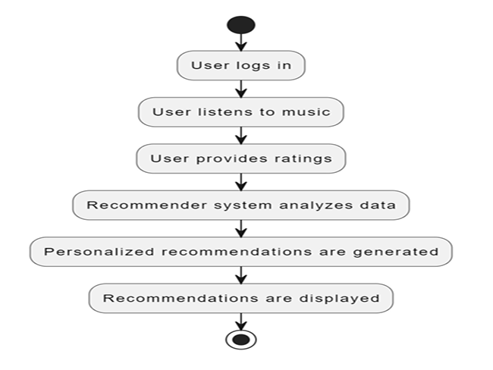

**Software and Hardware Requirements**

**Software Requirements**

* Programming Language: Python (for recommendation engine), Dart (for Flutter frontend)
* Frameworks: TensorFlow/PyTorch (for machine learning models), Flutter (for mobile app development)
* Database: MySQL/MongoDB (for storing user data and music metadata)
* Operating System: Windows/Linux/macOS (development and server environments)

**Hardware Requirements**

* Development Machine: Minimum 8 GB RAM, 256 GB SSD, Intel i5 Processor or equivalent
* Server: 16 GB RAM, 1 TB SSD, Intel Xeon Processor or equivalent (for hosting the backend and database)
* Mobile Device: Android or iOS smartphone for testing the mobile application

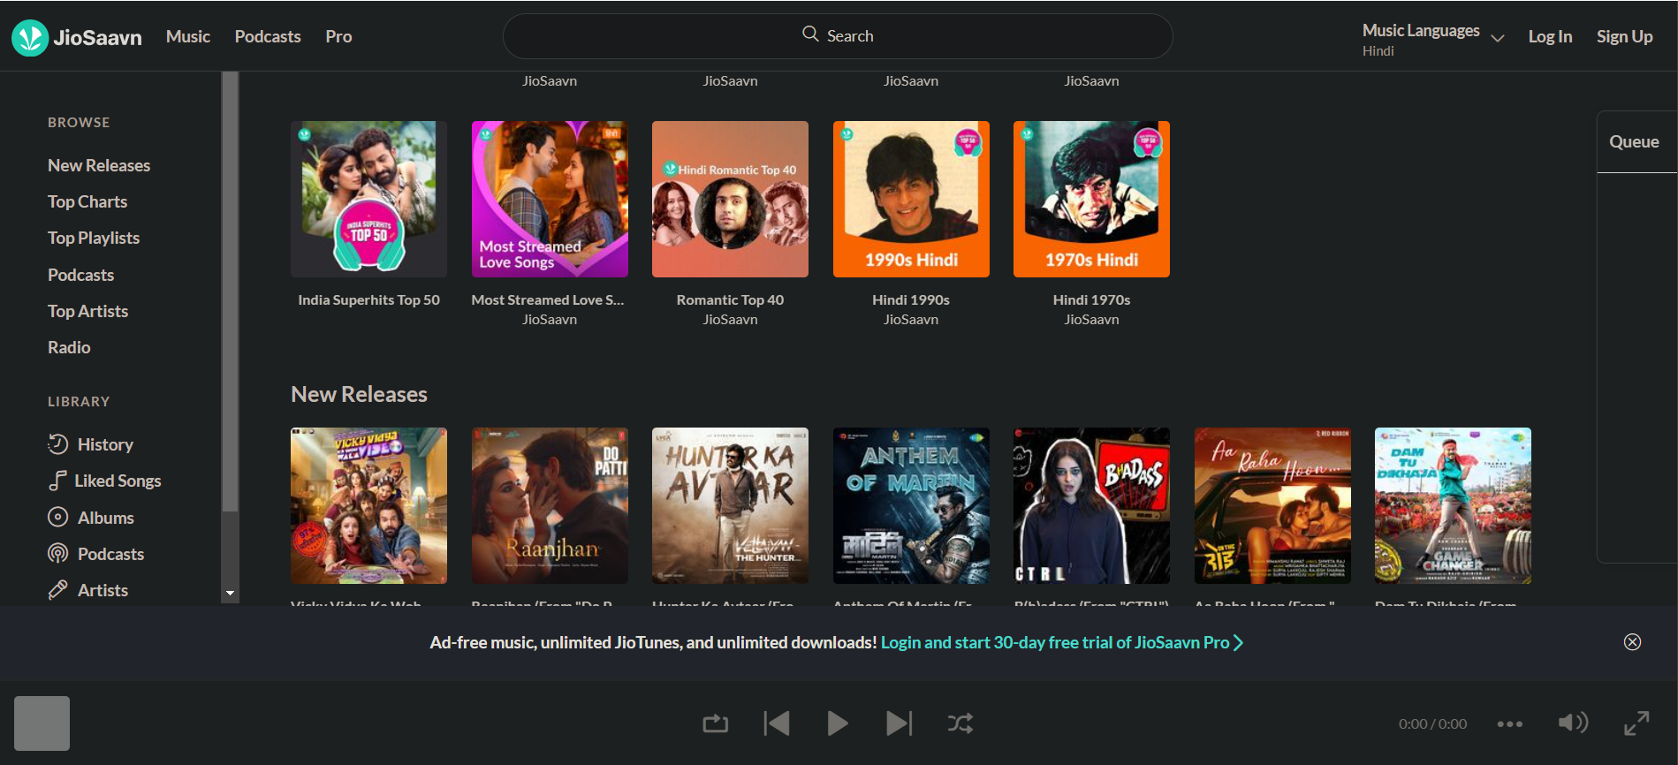**Graphical User Interface:**

