
Realtime Multi-Modal Monitoring Systemfor Assisted Living

Professional Seminar
Computer Science
Rivier University

Professor Vladimir Riabov
Professor David Pitts

Submitted By
Pavan Kumar Pekala
12/07/2025

Executive Summary
The Real-Time Multi-Modal Monitoring System (RTMMS) is designed to enhance safety, support clinical awareness, and improve response times within assisted-living environments by integrating multiple sensor inputs into a unified monitoring platform. Traditional monitoring systems rely on single-modality alerts which often lead to false positives and limited situational context whereas RTMMS leverages data from wearable devices, ambient sensing, motion tracking, and physiological signals to provide a richer, more accurate picture of resident well-being.
The system architecture combines edge preprocessing, multimodal feature fusion, incident detection, and structured evidence generation. A dual-interface dashboard supports both residents and caregivers: the Patient View offers simple vitals visualization and an emergency help button, while the Care Team View provides real-time alerting, configurable detection thresholds, live vitals, incident history, and dataset controls. Integrated workflows ensure that detected anomalies such as falls, wandering behavior, or abnormal vital patterns - are rapidly communicated to caregivers, who can acknowledge, relabel, or act upon them as needed.
RTMMS was developed using Python, Streamlit, and data processing libraries, with a modular design that supports future expansion. Testing included unit, integration, and functional evaluations to verify system correctness and performance. While the project demonstrates strong proof-of-concept results, opportunities remain for model optimization, improved sensor reliability, and broader deployment considerations.
Overall, RTMMS represents a meaningful advancement in real-time assisted living technologies, offering a scalable and intelligent approach to monitoring residents, reducing caregiver burden, and enabling timely interventions that can improve safety and quality of life.

Table of Contents
1. Introduction 5
2. Problem Description 6
3. System Request 6
3.1 Project Sponsor: 6
3.2 Business Need 6
3.3 Business Requirements 6
3.4 Business Value 7
3.5 Special Issues or Constraints 7
4. Workplan 8
5. Feasibility Analysis 9
5.1 Technical Feasibility 9
5.2 Operational Feasibility 9
5.3 Economic Feasibility 9
5.4 Schedule Feasibility 9
5.5 Legal & Ethical Feasibility 10
6. Requirements Definition 10
6.1 Functional Requirements 10
6.1.1 Sensor Data Acquisition & Processing 10
6.1.2 Event Detection & Alert Generation 10
6.1.4 EHR & Data Management 11
6.1.5 Machine Learning Model Interaction 11
6.1.6 User Authentication & Access Control 11
6.2 Non-Functional Requirements 11
6.2.1 Performance Requirements 11
6.2.2 Reliability Requirements 11
6.2.3 Security & Privacy Requirements 12
6.2.4 Scalability Requirements 12
6.2.5 Usability Requirements 12
6.2.6 Maintainability Requirements 12
6.2.7 Ethical & Accuracy Requirements 12
7. Functional Model 12
7.2 Business Rules 13
7.3 Use-Case Descriptions 15
7.4 Use-Case Diagram 22
7.5 Activity Diagram 23
8. Structural Model 24
8.2 Object Diagram 25
8.3 State Chart Diagram 26
9. Behavioral Model 26
9.1 Sequence Diagrams 27
9.2 Communication Diagram 28
9.3 Deployment Diagram 29
10. Design Model 30
10.1 Package Diagram 30
10.2 Contracts 31
10.3 Method Specifications 33
10.4 System Design Diagram 35
11. Data Management Layer Design 36
11.2 Entity–Relationship Diagram (ERD) 37
12. Human–Computer Interaction Layer (HCI) Design 38
12.1.1: Home Screen 38
12.1.2 Login Screen 39
12.1.3: Main Dashboard for Care team 40
12.1.4: Main Dashboard for Patient 41
12.2 Window Navigation Diagram 42
13. Physical Architecture Layer Design 43
13.1.1 Client Specifications 43
13.1.2 Web Server Specifications 43
13.1.3 Application Server Specifications 44
13.1.4 Database Server Specifications 44
13.2 Operational Requirements 45
13.2.1 Technical Environment Requirements 45
13.2.2 System Integration Requirements 46
13.2.3 Portability Requirements 46
13.2.4 Maintainability Requirements 46
13.3 Performance Requirements 46
13.3.1 Speed Requirements 46
13.3.2 Capacity Requirements 46
13.3.3 Availability & Reliability Requirements 47
13.4 Integration Test Plan 47
13.5 Functional Test Plan 48
14. Construction 49
14.2 Integration Test Results 52
14.3 Functional Test Results 55
15. Programming Environment and Tools 58
15.1 Development Environment 58
15.2 Tools and Libraries Used 58
15.3 Build & Run Instructions 59
15.3.1 Project Setup 59
15.3.2 Install Required Libraries 59
15.3.3 Running the Application 59
15.3.4 Online Application Access (Streamlit Cloud) 60
15.3.5 GitHub Repository 60
16. Demo Documentation 61
16.2 System Flow Walkthrough 62
17. Issues for Future Studies 64
18. Acknowledgement 64
19. Conclusion 64
20. References 65
21. Source Code 65

Introduction
The growing population of older adults has increased the demand for reliable, real-time monitoring systems capable of detecting critical events such as falls, wandering, and physiological deterioration. Traditional single-modality solutions - such as video monitoring or wearable-only devices - often struggle with accuracy, privacy concerns, and delayed response times. The proposed Real-Time Multi-Modal Monitoring System for Assisted Living integrates depth/mmWave sensing, wearable IMU and PPG/HR data, ambient IoT signals, and acoustic cues to provide sub-second detection and actionable alerts. By incorporating privacy-first design principles, cloud-based stream processing, and EHR integration through SMART on FHIR, this system aims to enhance caregiver support, reduce workload, and improve safety outcomes for elderly residents.

Problem Description
Assisted living facilities face persistent challenges in timely and accurate detection of resident emergencies. Falls often go unnoticed, wandering can lead to dangerous situations, and physiological deterioration may remain undetected until it becomes critical. Existing monitoring solutions frequently suffer from high false-alarm rates, limited sensor reliability, insufficient data fusion, and privacy risks. Additionally, caregivers experience alarm fatigue, network and cloud reliability issues, and operational constraints that hinder fast intervention. The proposed system addresses these gaps by introducing late-fusion decisioning, privacy-preserving data processing, edge-optimized inference, and a unified dashboard for rapid review and alerting. These enhancements seek to offer measurable improvements in clinical outcomes and overall care quality.

3. System Request
3.1 Project Sponsor: No Sponsor

3.2 Business Need
Assisted living environments require a reliable system that can detect falls, wandering incidents, and physiological deterioration with high accuracy and sub-second response time. Current video-only or wearable-only systems often fail due to limited sensor coverage, poor synchronization, high false-alarm rates, and operational inefficiencies. A multi-modal system is needed to fuse diverse sensor inputs, ensure continuous monitoring, and reduce caregiver workload. This system will directly support clinical decision-making and improve resident safety.

3.3 Business Requirements
The key high-level business requirements for the proposed Real-Time Multi-Modal Monitoring System include:
- R1: Detect falls, wandering, and deterioration events using multi-sensor fusion (depth/mmWave, IMU, PPG/HR, acoustic, ambient IoT).
- R2: Provide sub-second actionable alerts to caregivers through a unified dashboard.
- R3: Integrate with Electronic Health Records (EHR) using SMART on FHIR for secure data exchange.
- R4: Maintain strict data privacy by masking identifiers and ensuring PHI protection during processing.
- R5: Reduce false alarms through late-fusion decisioning and context-aware alerting.
- R6: Provide review and labeling tools for continuous ML model improvement.
- R7: Support scalable cloud-based stream processing and edge inference.
- R8: Ensure system reliability despite sensor drift, networking delays, or cloud interruptions.

3.4 Business Value
Implementing this system offers multiple tangible and intangible benefits:
- Improved resident safety through rapid detection of emergencies and reduced risks associated with undetected falls or deterioration.
- Reduced caregiver workload by minimizing alarm fatigue, improving alert quality, and enabling efficient monitoring.
- Higher clinical accuracy due to multi-modal sensing and privacy-preserving data fusion.
- Operational efficiency through automated data capture, streamlined review workflows, and EHR synchronization.
- Cost savings from avoided hospitalizations, reduced liability, and fewer false alarms requiring staff intervention.
- Better quality of care with continuous monitoring and actionable insights that support personalized care plans.

3.5 Special Issues or Constraints
Several constraints and considerations must be addressed during system design and deployment:
- Data Privacy & Compliance: All data must comply with HIPAA, GDPR, and internal privacy policies; PHI must remain masked during processing.
- Sensor Reliability: mmWave, IMU, and ambient IoT sensors may experience interference, calibration drift, or data loss.
- Networking & Cloud Dependence: Real-time inference requires low-latency connections; outages may impact detection accuracy.
- Model Bias & Generalization: ML models must avoid demographic or environmental bias and remain adaptable across facilities.
- Operational Costs: Hardware installation, cloud services, and continuous model retraining require budget planning.
- User Adoption: Both residents and caregivers must accept and trust the system; intuitive UI design is essential.
- Integration Constraints: SMART on FHIR and legacy EHR compatibility must be maintained without disrupting existing workflows.

4. Workplan
Phase 1: Requirements & Research
- Gather functional and non-functional requirements from assisted living operations.
- Review multimodal sensing technologies (mmWave, depth, IMU, PPG/HR, ambient IoT).
- Identify regulatory requirements (HIPAA, SMART on FHIR).
- Define the scope, constraints, and expected system outcomes.
Phase 2: System Architecture & Modeling
- Develop the overall system architecture integrating edge sensing, cloud stream processing, ML model serving, dashboards, and EHR connections.
- Create UML diagrams including use-case, activity, class, object, sequence, state, and deployment diagrams.
- Design data flows and fusion pipelines.

Phase 3: Data Integration & Preprocessing
- Connect sensors and ingest multimodal data streams.
- Implement synchronization, cleaning, masking of PHI, and multimodal feature extraction.
- Prepare datasets for model training (falls, wandering, deterioration signals).
Phase 4: Dashboard & API Development
- Build real-time dashboards for patients and care teams.
- Implement alerting logic, visualizations, review interfaces, and incident history views.
- Develop backend APIs for event summaries and EHR integration.
Phase 5: Testing, Evaluation & Deployment
- Conduct unit, integration, performance, and usability testing.
- Validate system accuracy, latency, sensor reliability, and privacy compliance.
- Prepare deployment documentation and user training materials.

5. Feasibility Analysis

5.1 Technical Feasibility
The system is technologically feasible due to the availability of low-cost sensors, mature cloud tools, event streaming frameworks, and model-serving technologies. mmWave radars, depth sensors, IMU wearables, and PPG/HR devices support reliable multimodal data acquisition. Cloud stream processing and SMART on FHIR integration ensure scalable, real-time operation. Potential challenges such as synchronization, drift, and network latency are solvable with appropriate engineering controls.

5.2 Operational Feasibility
This system aligns with caregiver workflows by providing real-time alerts, trend visualizations, and review capabilities, reducing manual monitoring and alarm fatigue. The dashboards are intuitive, enabling quick adoption by staff. Privacy-first design ensures resident acceptance and compliance with healthcare regulations.

5.3 Economic Feasibility
The cost of sensors, networking, and cloud services is justified by operational savings and reduced emergency incidents. Early detection of falls and deterioration prevents hospitalization expenses and lowers liability risks. Using open standards and scalable infrastructure minimizes long-term costs.

5.4 Schedule Feasibility
The project timeline fits within the semester academic structure. Architecture design, modeling, dashboards, and ML training can be completed within planned milestones. Advanced features (full EHR integration, broader dataset training) can be extended as future enhancements.

5.5 Legal & Ethical Feasibility
The use of masked PHI, HIPAA-compliant workflows, and SMART on FHIR safeguards ensures ethical and legal alignment. The system avoids personally identifiable visual data wherever possible and emphasizes non-intrusive sensing. Mitigation strategies for demographic bias ensure fair performance across populations.

6. Requirements Definition

6.1 Functional Requirements
The functional requirements describe what the system must do. These directly reflect the behaviors shown in your Use Case, Sequence, Activity, and Dashboard interaction diagrams.

6.1.1 Sensor Data Acquisition & Processing
6.1.1.1 The system shall ingest real-time data from depth/mmWave sensors, wearable devices (IMU, PPG/HR), ambient IoT, and acoustic sensors.
6.1.1.2 The system shall preprocess, clean, and synchronize multimodal sensor streams.
6.1.1.3 The system shall mask identifiable information before storing or processing data to preserve privacy.

6.1.2 Event Detection & Alert Generation
6.1.2.1 The system shall detect falls based on fused IMU, depth/mmWave, and acoustic signals.
6.1.2.2 The system shall detect wandering events using location patterns and motion cues.
6.1.2.3 The system shall identify signs of physiological deterioration using PPG/HR and respiration patterns.
6.1.2.4 The system shall generate sub-second alerts for confirmed fall, wandering, or deterioration events.
6.1.3 Dashboard & User Interaction
6.1.3.1 The system shall provide a patient dashboard for vitals, status visualization, and manual “Need Help” alerts.
6.1.3.2 The system shall provide a caregiver dashboard displaying real-time vitals, incident alerts, patient status, and historical events.
6.1.3.3 The caregiver dashboard shall allow acknowledgment, resolution, and documentation of alerts.
6.1.3.4 The system shall allow users to upload or interact with stored datasets for model evaluation and trend review.

6.1.4 EHR & Data Management
6.1.4.1 The system shall integrate with Electronic Health Records using SMART on FHIR.
6.1.4.2 The system shall write back event summaries to the EHR after caregiver review.
6.1.4.3 The system shall log all incidents and create downloadable summaries.

6.1.5 Machine Learning Model Interaction
6.1.5.1 The system shall support continuous model improvement via review and labeling tools.
6.1.5.2 The inference pipeline shall use late-fusion decisioning to reduce false alarms.

6.1.6 User Authentication & Access Control
6.1.6.1 The system shall authenticate patients, caregivers, and administrators.
6.1.6.2 The system shall manage role-based access to ensure patient data is visible only to authorized personnel.

6.2 Non-Functional Requirements
These define performance, reliability, security, and quality expectations. They align with constraints mentioned in your presentation: sensor reliability, privacy, model bias, real-time constraints, scalability, and usability.

6.2.1 Performance Requirements
6.2.1.1 The system shall process multimodal sensor streams and generate alerts within sub-second latency.
6.2.1.2 The system shall support continuous real-time monitoring without interruption.

6.2.2 Reliability Requirements
6.2.2.1 The system shall tolerate temporary network or device failures and resume data streaming automatically.
6.2.2.2 The system shall handle sensor drift, noise, and calibration issues through filtering and reprocessing.

6.2.3 Security & Privacy Requirements
6.2.3.1 The system shall comply with HIPAA and SMART on FHIR guidelines.
6.2.3.2 Personally Identifiable Information (PII/PHI) must be masked or encrypted during transmission and storage.
6.2.3.3 Access to dashboards and EHR data must require secure authentication.

6.2.4 Scalability Requirements
6.2.4.1 The system shall scale to monitor multiple patients simultaneously.
6.2.4.2 The architecture shall accommodate increased sensor types or higher-frequency data without redesign.

6.2.5 Usability Requirements
6.2.5.1 Dashboards shall be intuitive, requiring minimal training for caregivers and elderly users.
6.2.5.2 Alerts must be visually clear, prioritized by severity, and easy to acknowledge.

6.2.6 Maintainability Requirements
6.2.6.1 The system shall allow updates to ML models without downtime.
6.2.6.2 All components (device layer, dashboards, APIs, inference) must be modular for easy debugging and upgrades.

6.2.7 Ethical & Accuracy Requirements
6.2.7.1 The ML models must minimize demographic or environmental bias.
6.2.7.2 Model performance must be continuously evaluated using real-world data.

7. Functional Model
7.1 Verb/Noun Analysis to Determine Actors & Roles
Actors
- Resident
- Edge Agent
- Caregiver / Nurse
- Supervisor / Admin
- EHR System
Roles
- Generates sensor data and may trigger manual alerts (Resident)
- Processes raw sensor streams and produces edge events (Edge Agent)
- Receives alerts, reviews incidents, labels/acknowledges events (Caregiver / Nurse)
- Manages thresholds, rules, quiet hours, metrics, and audits (Supervisor / Admin)
- Stores clinical write-backs as Observations/DetectedIssues via SMART on FHIR (EHR System)
Methods
- detectFallInactivityWandering()
- generateAlert()
- routeAlert()
- reviewIncident()
- viewEvidence()
- labelIncident()
- acknowledgeIncident()
- writeBackToEHR()
- manageRulesAndThresholds()
- viewMetricsAndAudit()

7.2 Business Rules
BR-1: Incident Creation
- An Incident is created only when multimodal evidence (IMU, depth/mmWave, vitals, acoustic) collectively indicates a likely fall, wandering, or physiological deterioration event based on configured fusion thresholds.
BR-2: Evidence Requirements
- Every Incident must store at least one de-identified Evidence record (e.g., summary features, timestamps, URIs) without exposing raw PHI.
BR-3: Caregiver Acknowledgment
- Each Incident must be acknowledged by a logged-in caregiver or admin before it is considered resolved or closed.
BR-4: Labeling for Model Improvement
- Caregivers must apply a Label (true fall, non-fall, wandering, deterioration, false alarm) to each reviewed Incident to support continuous ML retraining and performance tracking.
BR-5: Alert Routing and Priority
- Alerts must be routed in near real time (< 1 second) to the responsible caregiver; severity and routing path are determined by FusionRules (thresholds, quiet hours, escalation policy).
BR-6: SMART on FHIR Write-Back
- EHR write-back occurs only for finalized Incidents (acknowledged and/or labeled) and must use SMART on FHIR resources (e.g., Observation, DetectedIssue) with pseudonym-to-patient mapping through a secure vault.
BR-7: Role-Based Configuration
- Only Supervisor/Admin roles may change FusionRules, alert thresholds, device preferences, or quiet hours; standard caregivers can only view and act on alerts.
BR-8: Privacy & PHI Protection
- All stored data must comply with HIPAA: identifiers are masked or encrypted, sensor data are de-identified where possible, and all access is authenticated and logged.
BR-9: Vital Sign Safety Limits
- If live vitals exceed configured safety limits (e.g., HR > 120 bpm, SpO₂ < 90%, RR > 24), the system must raise at least a warning advisory to the care team.
BR-10: Audit & Metrics Retention
- The system must retain audit logs (who acknowledged/changed what and when) and aggregated incident metrics for compliance reporting and quality-of-care analysis over the required retention period.

7.3 Use-Case Descriptions
Use Case Name: Detect Fall / Inactivity / Wandering | ID: 1 |  | Importance Level: High
Primary Actor: Edge Agent |  | Use Case Type: Detail, Essential
Stakeholders and Interests:
- Residents want reliable monitoring; caregivers want accurate detection; system needs to minimize false alarms.
Brief Description:
The Edge Agent analyzes sensor data to detect falls, inactivity, or wandering patterns and notifies RTMMS.
FR-1, FR-2, FR-3, FR-4, FR-5, FR-6, FR-7
Trigger: Continuous incoming sensor data stream. Type: External
Relationships:
Association: Edge Agent, Resident
Include: Generate Alert & Route
Extend: None
Generalization: None
Normal Flow of Events:
1. Edge Agent sends sensor data.
2. System preprocesses and synchronizes signals.
3. FusionEngine evaluates multimodal scores.
4. System identifies fall/inactivity/wandering event.
5. System forwards event to “Generate Alert & Route.”
Sub Flows: None.
Alternate/Exceptional Flows:
EF1: Sensor noise → fallback to last valid values.
EF2: Conflicting modalities → delay until confidence improves.
Fig1: Use-Case Description of Detect Fall / Inactivity / Wandering

Use Case Name: Generate Alert & Route | ID: 2 |  | Importance Level: High
Primary Actor: Caregiver / Nurse |  | Use Case Type: Detail, Essential
Stakeholders and Interests:
- Caregiver – needs timely alerts.
- Resident – needs quick help.
- Admin – wants low false alarms.
Brief Description:
System generates an alert and routes it to the appropriate caregiver based on severity.
FR-4, FR-5, FR-6, FR-7, FR-8, FR-9

Trigger: Incident received from detection module. Type: External
Relationships:
Association: Caregiver / Nurse
Include: None
Extend: Detect Fall / Inactivity / Wandering
Generalization: None
Normal Flow of Events:
1. System receives incident.
2. Determines severity (FusionRules).
3. Formats alert details.
4. Routes alert to caregiver dashboard.
5. Alert displayed in real time.
Sub Flows: None.
Alternate/Exceptional Flows:
EF1: Routing fails → retry fallback.
EF2: Quiet hours active → escalate only if severe.
Fig2: Use-Case Description of Generate Alert & Route

Use Case Name: Review Incident & Evidence | ID: 3 |  | Importance Level: High
Primary Actor: Caregiver / Nurse |  | Use Case Type: Detail, Essential
Stakeholders and Interests:
- Caregiver – needs clarity on incidents.
- Resident – must ensure incident accuracy.
Brief Description:
Caregiver examines incident details and corresponding evidence.
FR-8, FR-9, FR-10, FR-11
Trigger: Caregiver selects the alert in dashboard. Type: External
Relationships:
Association: Caregiver / Nurse
Include: Label / Acknowledge Incident
Extend: None
Generalization: None
Normal Flow of Events:
1. Caregiver selects incident.
2. System loads evidence.
3. Caregiver reviews metrics and fused signals.
4. Proceeds to labeling incident.
Sub Flows: None.
Alternate/Exceptional Flows:
EF1: Missing evidence → fallback summary displayed.
Fig3: Use-Case Description of Review Incident & Evidence

Use Case Name: Label / Acknowledge Incident | ID: 4 |  | Importance Level: High
Primary Actor: Caregiver / Nurse |  | Use Case Type: Detail, Essential
Stakeholders and Interests:
- Admin – needs labeled data for ML improvement.
- Caregiver – confirms incident status.
- Resident – ensures accurate classification.
Brief Description:
Caregiver labels incident (true/false fall, wandering, deterioration) and acknowledges resolution.
FR-10, FR-11, FR-12, FR-13, FR-14

Trigger: Caregiver selects “Label” or “Acknowledge.” Type: External
Relationships:
Association: Caregiver / Nurse
Include: EHR Write-back via SMART on FHIR
Extend: None
Generalization: None
Normal Flow of Events:
1. Caregiver opens incident.
2. Selects label.
3. Confirms acknowledgment.
4. System records final outcome.
5. Write-back to EHR triggered.
Sub Flows: None.
Alternate/Exceptional Flows:
EF1: Labeling cancelled → no updates saved.
Fig4: Use-Case Description of Label / Acknowledge Incident
Use Case Name: EHR Write-back via SMART on FHIR | ID: 5 |  | Importance Level: Medium
Primary Actor: EHR System |  | Use Case Type: Detail, Essential
Stakeholders and Interests:
- Clinicians – want accurate clinical history.
- Regulators – require auditable records.
Brief Description:
System sends Observations/DetectedIssues to EHR after caregiver confirmation.
FR-12, FR-13, FR-14
Trigger: Final labeling or acknowledgment of incident. Type: External
Relationships:
Association: EHR System
Include: None
Extend: Label / Acknowledge Incident
Generalization: None
Normal Flow of Events:
1. System resolves pseudonym to PatientID.
2. Generates SMART/FHIR resources.
3. Sends to EHR.
4. Receives confirmation.
5. Logs audit entry.
Sub Flows: None.
Alternate/Exceptional Flows:
EF1: EHR offline → queue write-back and retry later.
Fig5: Use-Case Description of EHR Write-back via SMART on FHIR

Use Case Name: Manage Rules & Thresholds | ID: 6 |  | Importance Level: Medium
Primary Actor: Supervisor / Admin |  | Use Case Type: Detail, Essential
Stakeholders and Interests:
- Supervisor – adjusts system behavior.
- Caregiver – reduces false alerts.
- Resident – improved safety.
Brief Description:
Admin updates detection thresholds, quiet hours, and alert policies.
FR-15, FR-16, FR-14
Trigger: Admin selects “System Settings.” Type: External
Relationships:
Association: Supervisor / Admin
Include: None
Extend: None
Generalization: None
Normal Flow of Events:
1. Admin logs in.
2. Opens settings.
3. Edits FusionRules.
4. Saves changes.
5. System updates engine parameters.
Sub Flows: None.
Alternate/Exceptional Flows:
EF1: Invalid threshold → System rejects change.
Fig6: Use-Case Description of Manage Rules & Thresholds

Use Case Name: View Metrics & Audit | ID: 7 |  | Importance Level: Medium
Primary Actor: Supervisor / Admin |  | Use Case Type: Detail, Essential
Stakeholders and Interests:
- Admin – wants analytical insights.
- Compliance – requires audit logs.
Brief Description:
Admin reviews incident history, false alarm rate, and audit logs.
FR-11, FR-16, FR-14
Trigger: Admin navigates to “Metrics & Audit.” Type: External
Relationships:
Association: Supervisor / Admin
Include: None
Extend: None
Generalization: None
Normal Flow of Events:
1. Admin logs in.
2. Opens Metrics & Audit.
3. System loads KPIs.
4. Admin reviews logs and charts.
Sub Flows: None.
Alternate/Exceptional Flows:
EF1: No data available → System shows empty-state notice.
Fig7: Use-Case Description of View Metrics & Audit

7.4 Use-Case Diagram
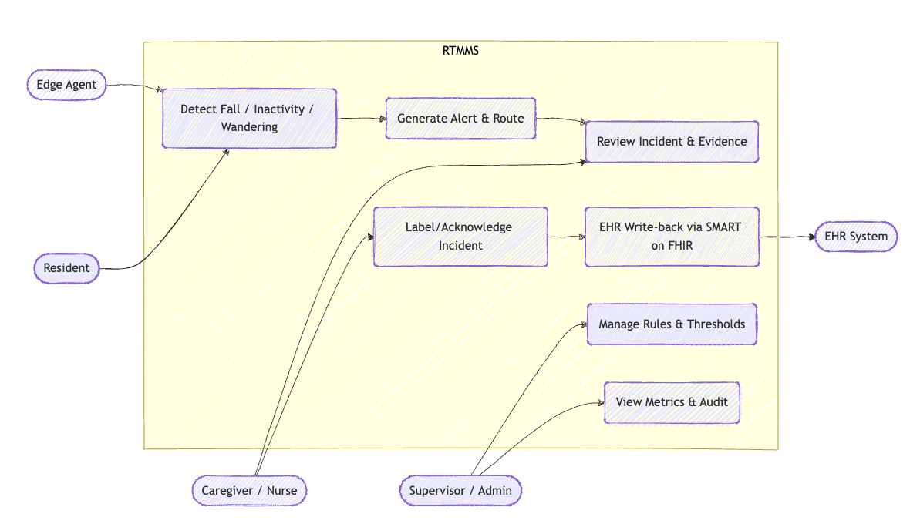
Fig8: Use-Case Diagram of RTMMS

The use-case diagram for the Real-Time Multi-Modal Monitoring System for Assisted Living (RTMMS) shows how external actors interact with the core services of the system. Inside the RTMMS boundary, the main use cases are: Detect Fall / Inactivity / Wandering, Generate Alert & Route, Review Incident & Evidence, Label / Acknowledge Incident, EHR Write-back via SMART on FHIR, Manage Rules & Thresholds, and View Metrics & Audit.

7.5 Activity Diagram
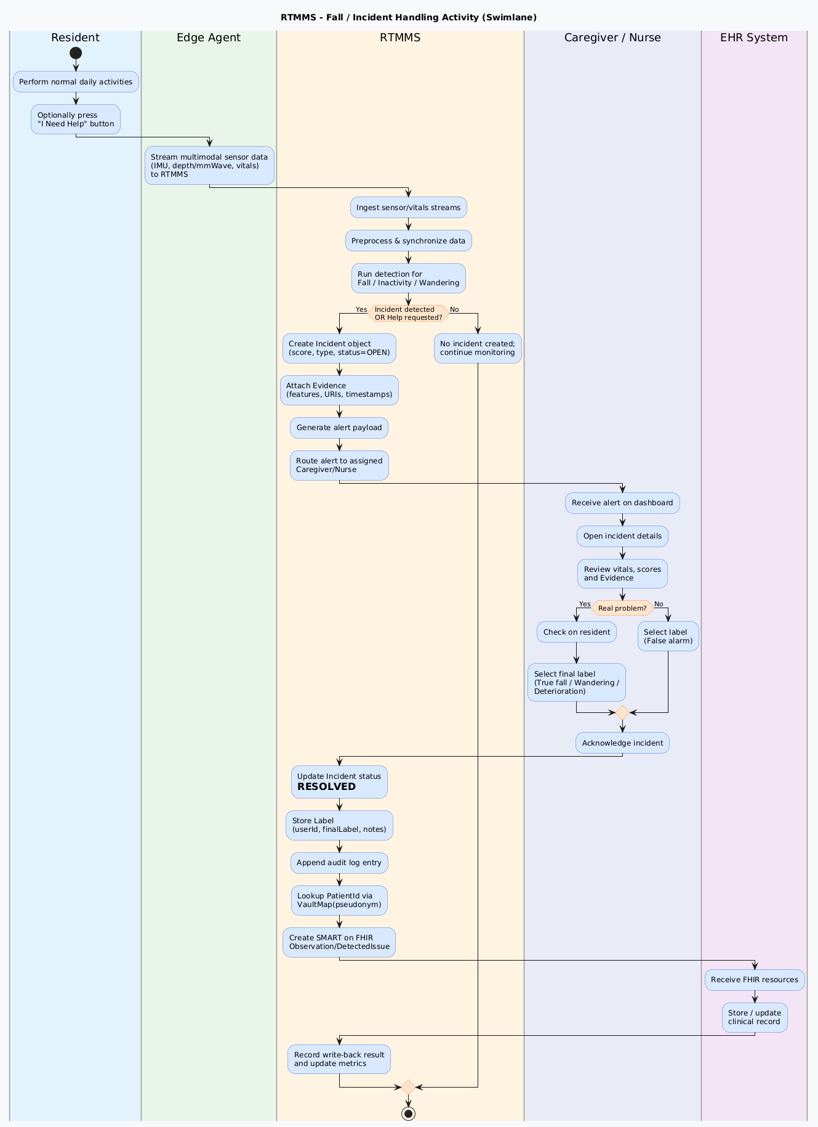
Fig9: Activity Diagram of RTMMS
The activity diagram illustrates the complete workflow of how RTMMS detects, processes, and resolves fall, inactivity, or wandering incidents across all system actors. Sensor data is captured at the Edge Agent, analyzed by RTMMS, and converted into incident objects with supporting evidence. Alerts are routed to caregivers, who review vitals, validate the incident, and assign a final label such as true fall or false alarm. Once acknowledged, RTMMS updates logs, synchronizes validated events to the EHR through SMART on FHIR, and records metrics for auditing and performance tracking. This diagram clearly shows the collaboration among Resident, Edge Agent, RTMMS, Caregiver, and EHR System during incident handling.

8. Structural Model
The Structural Model defines the static architecture of the RTMMS system by detailing its core classes, their attributes, and relationships. It provides a blueprint of how data is organized and interconnected, forming the foundation for system behavior, incident processing, and integration workflows.
8.1 Class Diagrams
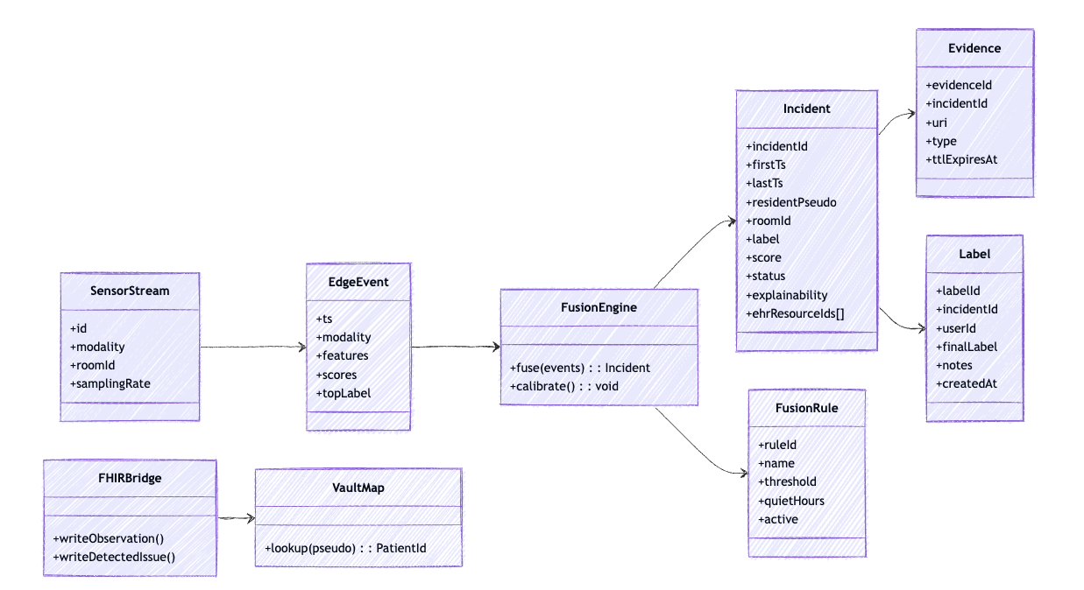
Fig10: Class Diagram of RTMMS
The class diagram (Fig10) defines the core data structures and relationships within the RTMMS system. It shows how sensor streams are transformed into Edge Event objects, which are then processed by the Fusion Engine according to configurable Fusion Rule thresholds. The resulting Incident class links to supporting Evidence and caregiver-generated Label entries, capturing the full lifecycle of an event. Integration with external clinical systems is enabled through the FHIR Bridge, which uses Vault Map to securely resolve pseudonyms to patient identifiers. Overall, the diagram models how data flows, is fused, and becomes actionable within the monitoring platform.

8.2 Object Diagram
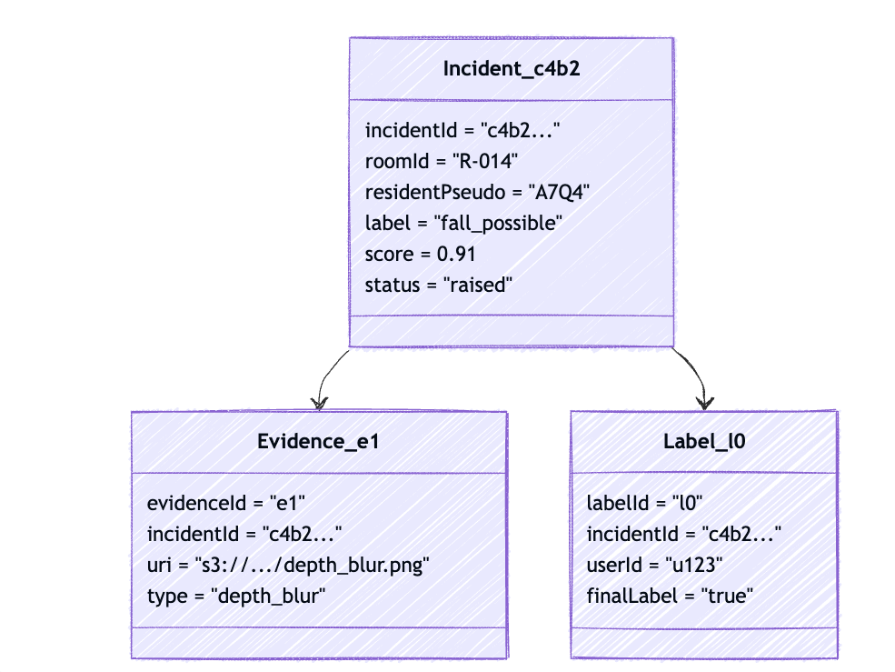
Fig11: Object Diagram of RTMMS

The object diagram (Fig11) provides a concrete snapshot of system data during runtime, illustrating an actual incident instance. It shows a specific Incident object with attributes such as room, score, label, and status, along with associated evidence images and caregiver labels. Each evidence item includes a URI and type, while each label captures the user ID and final decision. This real-world example demonstrates how the classes in the structural model are instantiated and linked during incident analysis and review.

8.3 State Chart Diagram
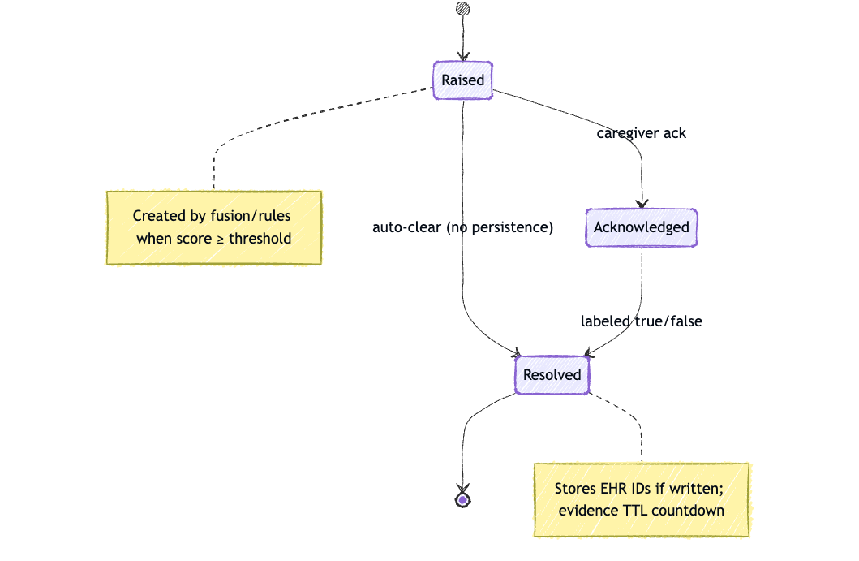
Fig12: State Chart Diagram of RTMMS
The diagram (Fig12) illustrates the lifecycle of an incident as it moves through the system. An incident begins in the Raised state when fusion and rule thresholds are met, and transitions to Acknowledged after caregiver review. Once labeled as true, false, or escalated, the incident moves to the Resolved state, where EHR synchronization and evidence TTL countdown processes occur. The diagram clearly represents how system rules and caregiver actions drive state transitions.

9. Behavioral Model
The Behavioral Model describes how system components interact over time to process events and deliver outcomes. It captures dynamic behavior, message flows, and runtime execution across system layers.

9.1 Sequence Diagrams
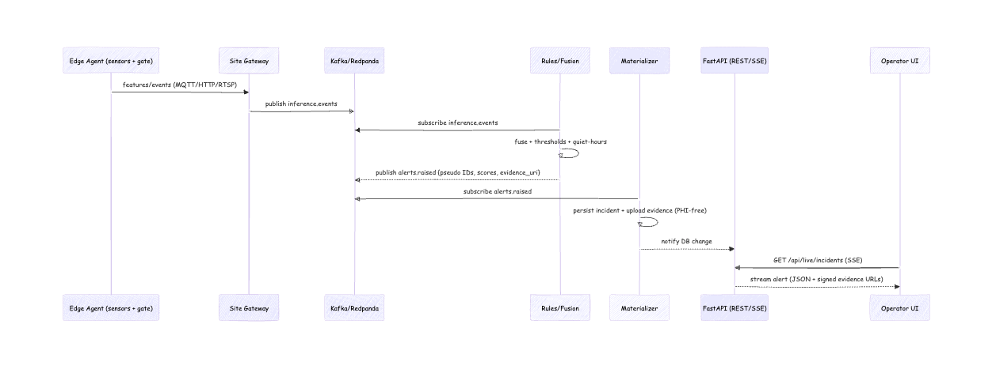
Fig13: Sequence Diagram of RTMMS
This sequence diagram illustrates how sensor data flows from the Edge Agent to the cloud pipeline for real-time incident detection. The Site Gateway publishes inference events, which are consumed by the Rules/Fusion engine to evaluate thresholds and determine alert conditions. Alerts containing pseudonymized IDs, scores, and evidence references are then published to the messaging layer. The Materializer persists in incidents and evidence, while the FastAPI service streams alerts to the Operator UI. This diagram highlights the asynchronous, event-driven architecture of the detection workflow.
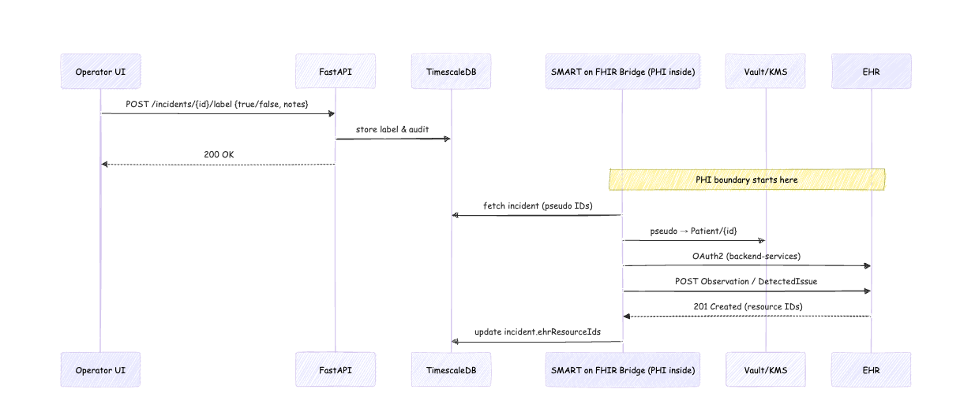
Fig14: Sequence Diagram of Label & EHR Write Back RTMMS
This diagram shows how caregivers submit incident labels through Operator UI and how the system processes clinical updates. FastAPI stores the label and audit logs, retrieving incident details from TimescaleDB as needed. The SMART on FHIR Bridge securely maps pseudonyms to patient identities and communicates with the EHR using OAuth2-protected APIs. Once the incident is written as a FHIR Observation or DetectedIssue, resource IDs are returned and stored. The sequence captures the secure, PHI-isolated workflow for integrating validated incidents into clinical Systems.
9.2 Communication Diagram
Fig15: Communication Diagram of RTMMS

The communication diagram highlights the key interactions among system components during incident creation and resolution. Messages flow from the Resident through the Edge Agent, Fusion Engine, and Incident manager, demonstrating how detection logic triggers downstream processes. Caregiver labeling initiates requests to the FHIRBridge, which communicates with the EHR to store clinical records. This diagram emphasizes object-to-object collaboration and shows how responsibilities are distributed across system elements.

9.3 Deployment Diagram
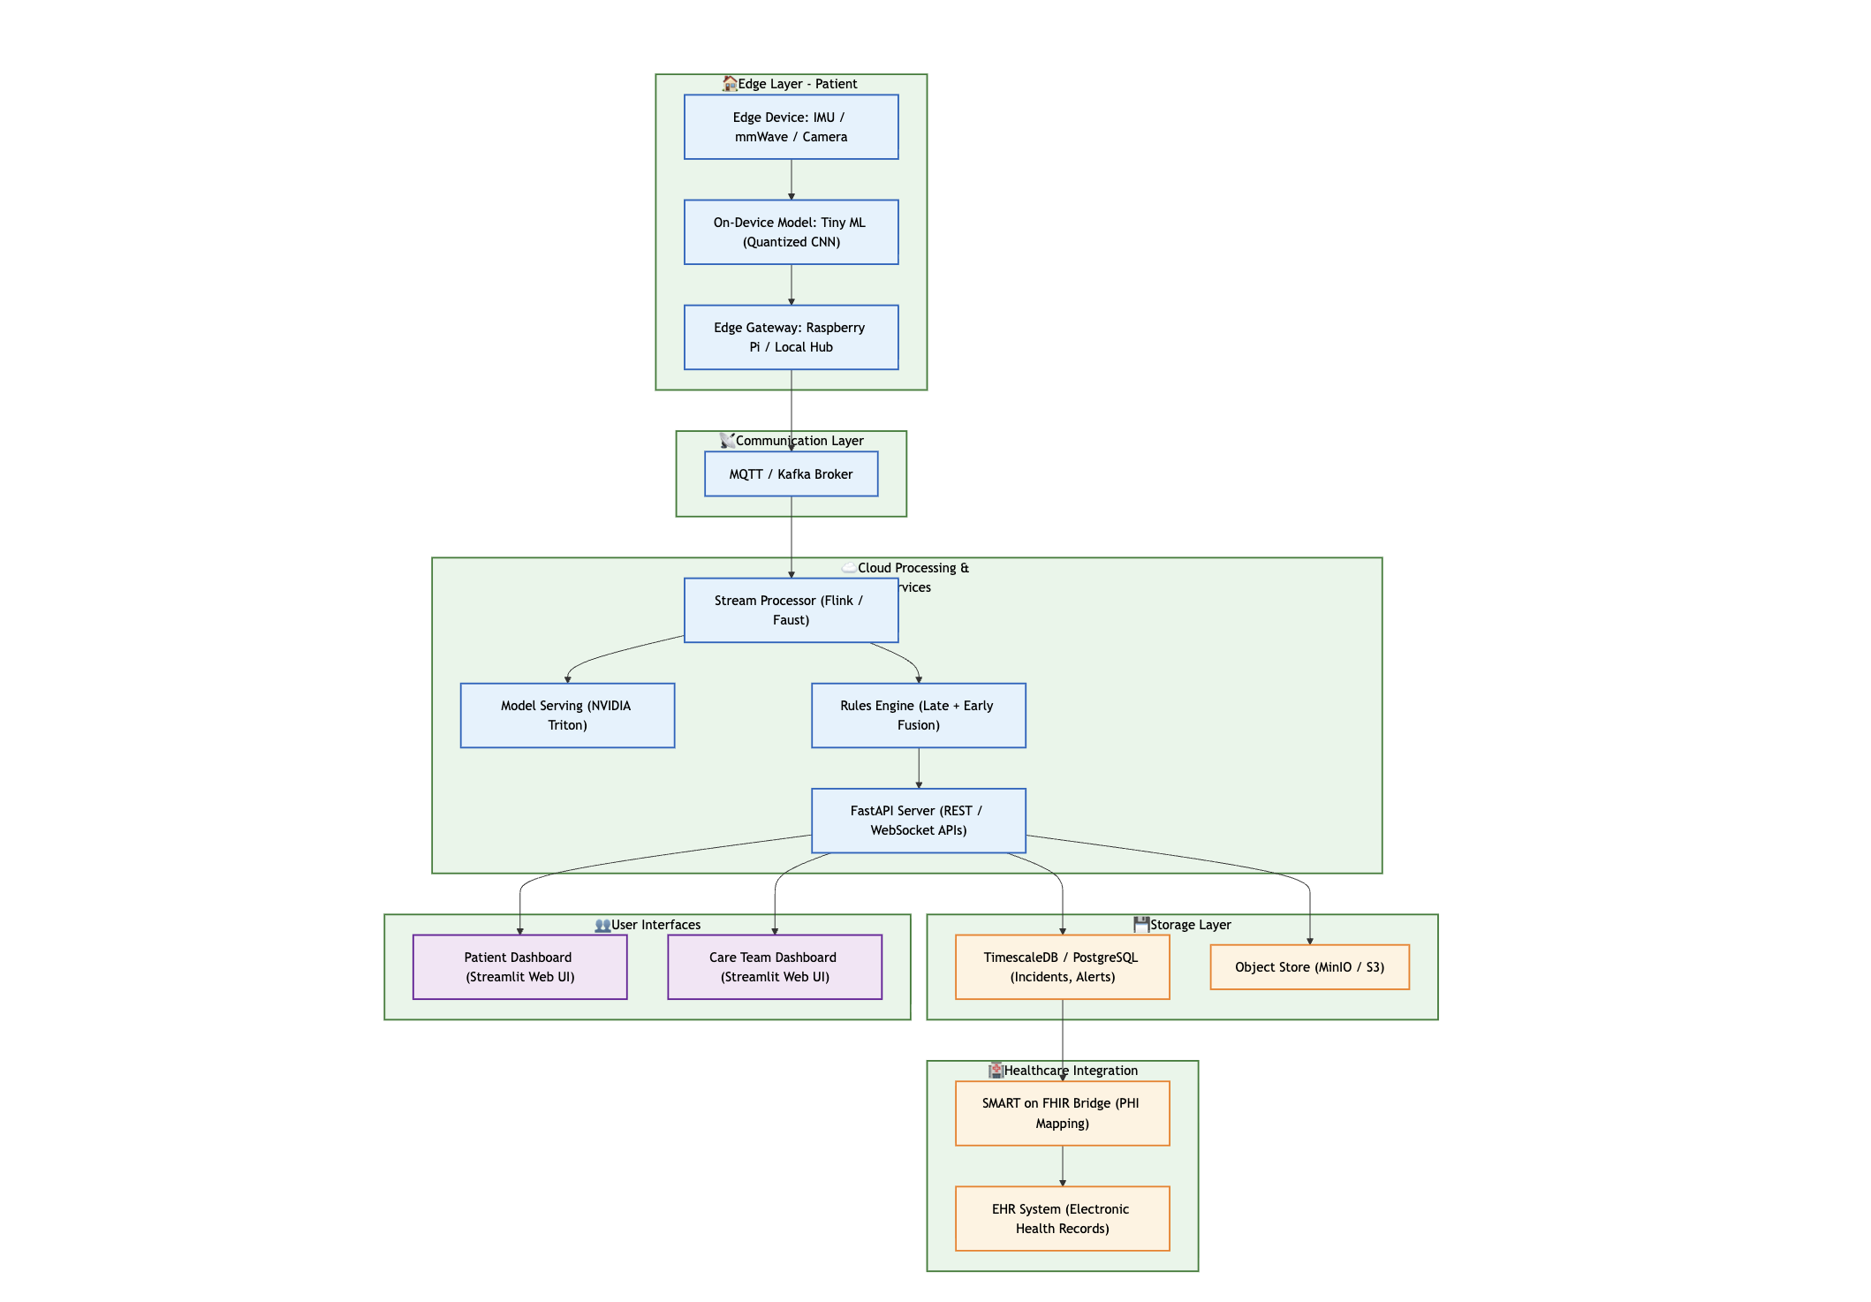
Fig16: Deployment Diagram of RTMMS

The deployment diagram presents the physical architecture of the RTMMS platform across the edge, communication, cloud, storage, UI, and healthcare integration layers. Edge devices run lightweight models and stream data via MQTT/Kafka to cloud processing services, including rules engines, Triton model serving, and FastAPI APIs. Incidents and alerts are stored in TimescaleDB and an object store, while dashboards provide interfaces for patients and care teams. The system connects to clinical infrastructure through a SMART on FHIR Bridge, ensuring secure PHI handling and interoperability with the EHR.

10. Design Model

10.1 Package Diagram
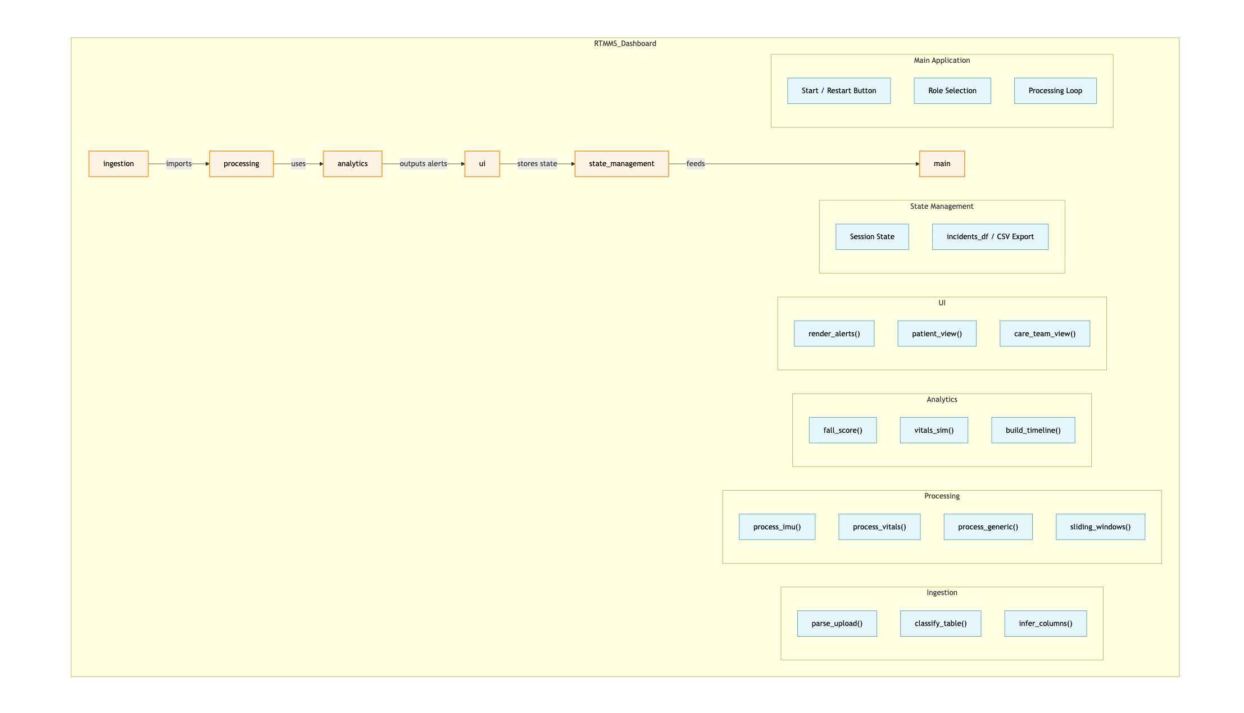
Fig17: Package Diagram of RTMMS
The package diagram organizes the RTMMS Dashboard into modular functional groups, including ingestion, processing, analytics, UI, and state management. Each package encapsulates related functions such as IMU/vitals processing, alert rendering, timeline generation, and CSV export. Dependencies illustrate how upstream ingestion feeds processing and analytics, which in turn support UI rendering and session state. This structure promotes maintainability by clearly separating responsibilities within the application.

10.2 Contracts
Method Name: fuse(events) | Class Name: FusionEngine | ID: C1
Clients (Consumers): Edge detection pipeline / Rules engine, Incident manager / Alert generator
Associated Use Cases: UC-1 Detect Fall / Inactivity / Wandering, UC-2 Generate Alert & Route
Description of Responsibilities: Combines a window of multimodal EdgeEvent inputs, applies configured FusionRule thresholds, and decides whether a new Incident should be created (fall, inactivity, wandering, deterioration).
Arguments Received: events: List<EdgeEvent> – time-ordered edge inference events for one resident/room.
Type of Value Returned: Incident object when thresholds are met; null/None if no incident is created.
Pre-Conditions:
- events list is non-empty and corresponds to a single resident/room.
- Active FusionRule configuration is loaded.
- Sensor timestamps have been synchronized and basic validation completed.
Post-Conditions:
- If scores exceed thresholds, a new Incident is instantiated with label UNCONFIRMED, a risk score, and references to supporting Evidence.
- If thresholds are not met, no new Incident is created, and only internal metrics are updated.
Fig18: Contract of fuse(events) Method

Method Name: writeDetectedIssue(incident) | Class Name: FHIRBridge | ID: C2
Clients (Consumers): Incident manager / EHR write-back component, Labeling workflow after caregiver acknowledgment
Associated Use Cases: UC-4 Label / Acknowledge Incident, UC-5 EHR Write-back via SMART on FHIR
Description of Responsibilities: Transforms a finalized Incident into one or more SMART on FHIR DetectedIssue (and related) resources, sends them securely to the EHR, and returns the created resource identifiers for auditing.
Arguments Received: incident: Incident – labeled and acknowledged incident ready for clinical documentation.
Type of Value Returned: List<String> or array of FHIR resource IDs (e.g., DetectedIssue/Observation IDs); empty list if write-back fails.
Pre-Conditions:
- incident.status is RESOLVED and has at least one final Label.
- Valid OAuth2 access token and FHIR endpoint configuration are available.
- VaultMap can resolve incident.residentPseudo to a real Patient ID.
Post-Conditions:
- Corresponding FHIR resources are created/updated in the EHR (or queued for retry on temporary failure).
- Returned resource IDs are stored in incident.ehrResourceIds.
- A write-back audit entry (timestamp, user, incidentId, outcome) is recorded.
Fig19: Contract of writeDetectedIssue(incident) Method

Method Name: lookup(pseudo) | Class Name: VaultMap | ID: C3
Clients (Consumers): FHIRBridge during EHR write-back, Any component needing to translate pseudonyms to real patient identifiers
Associated Use Cases: UC-5 EHR Write-back via SMART on FHIR
Description of Responsibilities: Securely maps a de-identified resident pseudonym to the corresponding EHR PatientId without exposing PHI to the rest of the RTMMS pipeline.
Arguments Received: pseudo: String – pseudonymous resident identifier stored on incidents and evidence.
Type of Value Returned: String – the EHR PatientId associated with the pseudonym; null/None if no mapping exists.
Pre-Conditions:
- pseudo exists in the secure mapping store.
- Vault/keystore connection is available and authenticated.
Post-Conditions:
- The resolved PatientId is returned only to authorized callers (e.g., FHIRBridge).
- No PHI persisted or logged outside the vault; any failures are logged with pseudonym only.

Fig20: Contract of fuse(events)Method

10.3 Method Specifications
Method Name: fuse | Class Name: FusionEngine | ID: MS1
Contract ID: C1 | Programmer: Pavan | Date Due: 12/07/2025
Programming Language: Python
Triggers/Events:
- Called whenever a new time window of EdgeEvent objects is ready for fusion for a given resident/room.
- Triggered by the real-time sensor pipeline or batch replay component.

Arguments Received:  Data Type: | Notes:
List<EdgeEvent> | Ordered list of multimodal sensor events belonging to one resident/room. Each event includes features, modality, topLabel, and scores.

Messages Sent & Arguments Passed:  ClassName.MethodName: | Argument  Data Type: | Notes:
FusionRule.getThresholds()  Incident.create()  Incident.addEvidence() | None  score: float, type: str, status: str, residentPseudo: str, roomId: str  Evidence | Retrieves rule thresholds used for fusion.  Creates a new Incident when rules are satisfied.  Attaches sensor-derived supporting evidence to the incident.

Argument Returned:  Data Type: | Notes:
Boolean | Returns an Incident object if thresholds are met; otherwise returns None to indicate no event detected.
Misc.Notes:
- Input events must be non-empty and validated before fusion.
- Fusion must not mutate the incoming event list.
- Output Incident is assigned status OPEN and forwarded to downstream components.
- Fusion is deterministic for auditing and reproducibility.
Fig21: Method Specification of fuse

10.4 System Design Diagram
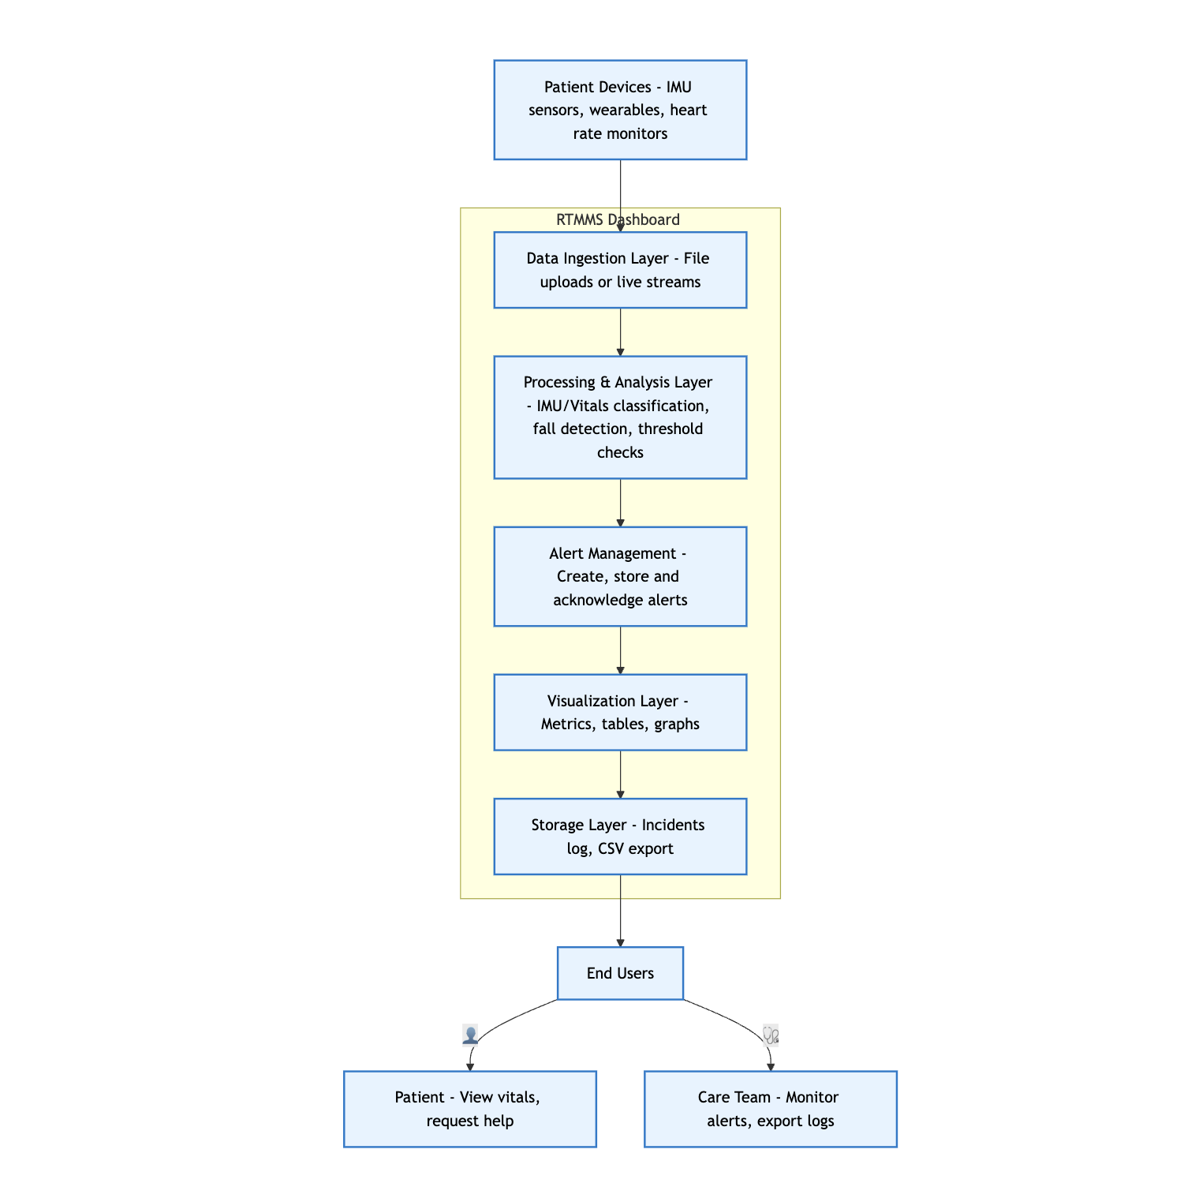
Fig22: System Design Diagram of RTMMS
The system design diagram provides a high-level view of how edge devices, communication layers, cloud services, and storage systems interact to deliver real-time monitoring. Edge devices run lightweight ML models and transmit sensor data through MQTT or Kafka to the cloud, where stream processors, fusion rules, and Triton inference servers analyze events. Processed results flow into FastAPI services, TimescaleDB, and object storage, enabling dashboards and EHR integration through SMART on FHIR. This holistic design ensures reliability, scalability, and HIPAA-aligned data flow.

11. Data Management Layer Design
11.1 Database Schema
The database schema defines the structured storage model for RTMMS, organizing incidents, evidence, labels, and sensor-related data into normalized tables. It establishes primary and foreign key relationships to ensure data integrity, traceability, and secure linking of events throughout the monitoring workflow. This schema supports efficient querying, auditing, EHR synchronization, and long-term analytics.
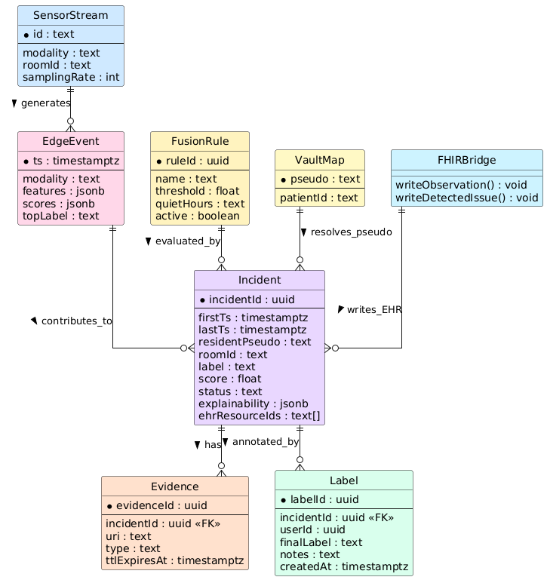
Fig23: Database Schema of RTMMS

11.2 Entity–Relationship Diagram (ERD)
The ERD visually represents how core system entities - such as SensorStream, EdgeEvent, Incident, Evidence, and Label - are related within RTMMS. It illustrates cardinality, dependencies, and the flow of information from sensor input to incident creation, annotation, and EHR documentation. This diagram clarifies the logical data structure and supports accurate implementation of the system’s data layer.

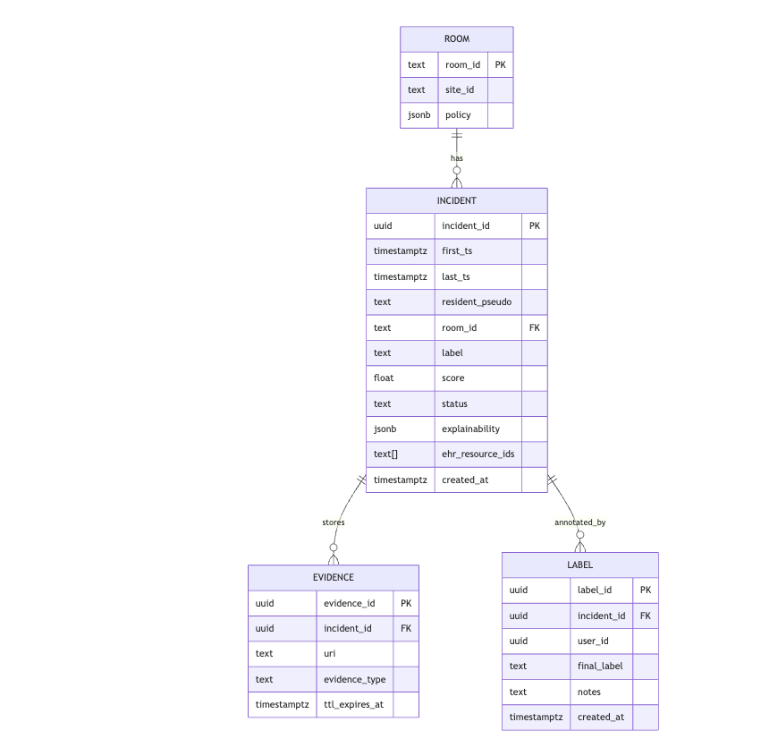
Fig24: Entity–Relationship Diagram (ERD) of RTMMS

12. Human–Computer Interaction Layer (HCI) Design
12.1 UI Wireframe Diagrams

12.1.1: Home Screen
The Patient Dashboard wireframe presents a simple, supportive interface tailored for assisted-living residents. A left-side panel displays session selection (Patient/Care Team) and real-time vital signs including heart rate, SpO₂, and respiratory rate. A prominent "I Need Help" emergency button ensures quick access to assistance. The right section focuses on personal monitoring, offering a vitals trend chart, prevention tips, and navigation for refreshing data or reviewing personal assistance information.
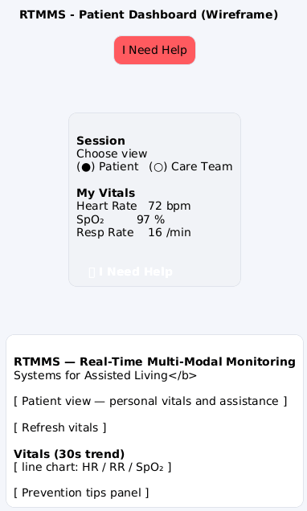
Fig25: UI Wireframe Diagrams for Home Screen

12.1.2 Login Screen
The Login wireframe provides a clean authentication interface for both users and administrators. The left session panel allows choosing between Patient or Care Team modes, ensuring role-appropriate access. The right login form includes username and password fields, tabs for forgotten credentials, and radio buttons to select User or Admin login type. The design prioritizes clarity, accessibility, and reduced cognitive load for assisted-living environments.
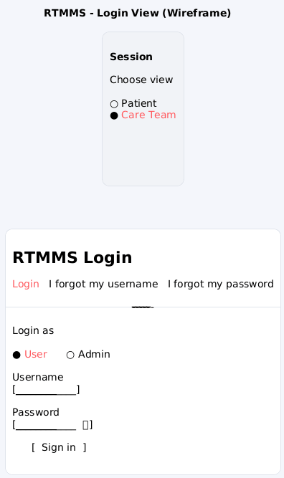
Fig26: UI Wireframe Diagrams for Login Screen

12.1.3: Main Dashboard for Care team
The Care Team Dashboard wireframe delivers a data-rich control panel for clinical staff. The left configuration card includes dataset selection, IMU settings, thresholds, device choices, timers, and start/restart controls. The right panel displays key vitals, current alerts, and dataset download options. Color cues highlight important medical thresholds and system status. The layout is optimized for monitoring multiple patients, reviewing real-time vitals, and responding quickly to incidents.
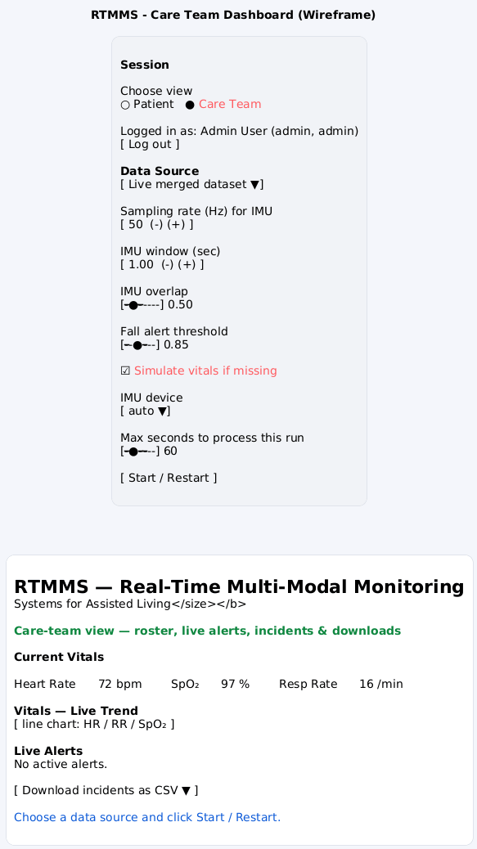
Fig27: UI Wireframe Diagrams for Main Dashboard for Care team

12.1.4: Main Dashboard for Patient
This wireframe shows a compact, mobile-optimized layout for patient use. The top features a large red Help button, while the central card displays session options and vital signs clearly. The main content panel presents system information, a quick link to the patient view, refresh controls, a small vitals trend placeholder, and prevention-tip reminders. The design emphasizes readability, minimal interactions, and quick access to emergency help.
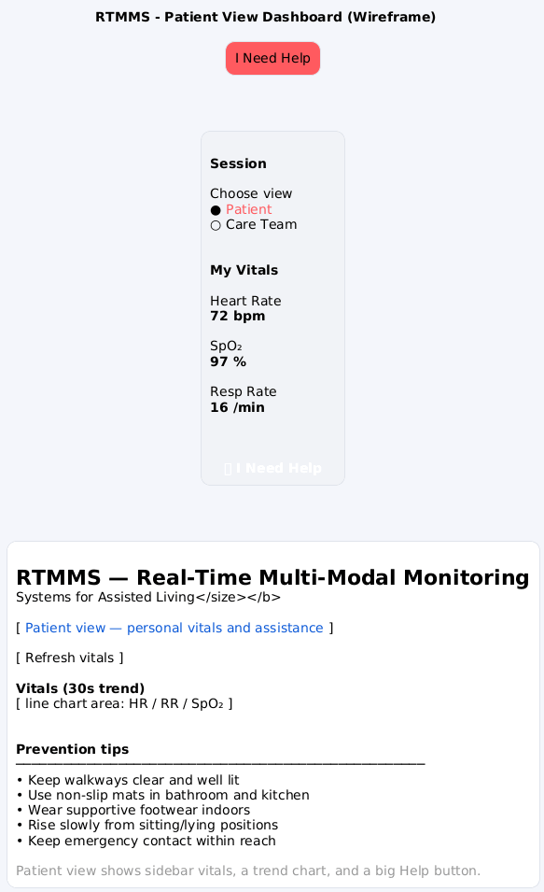
Fig28: UI Wireframe Diagrams for Main Dashboard for Patient

12.2 Window Navigation Diagram
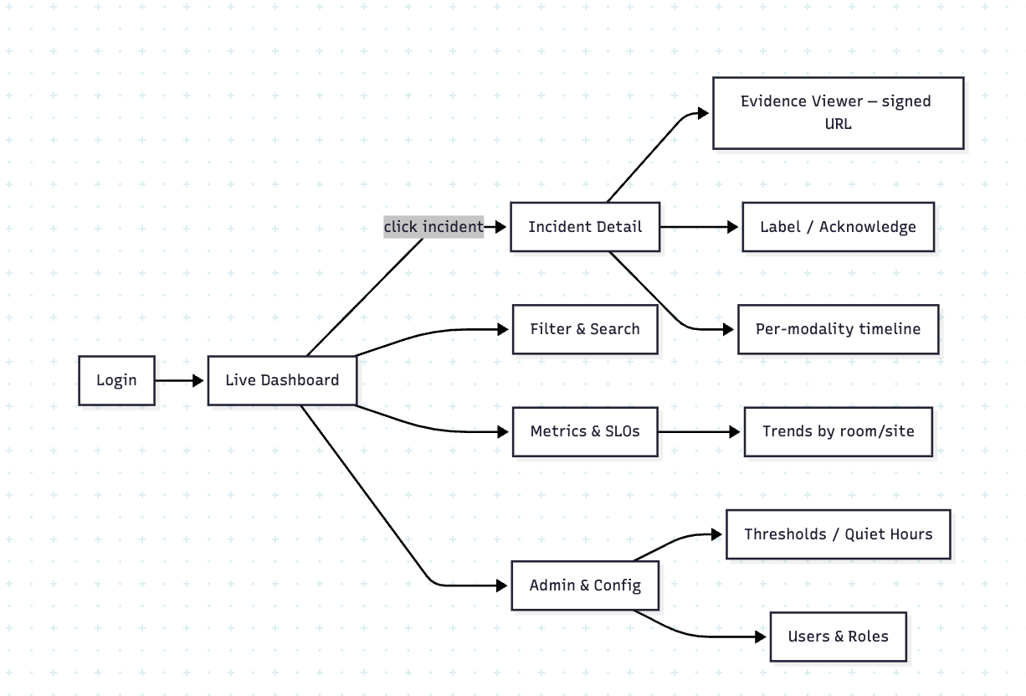
Fig29: Navigation Diagram of RTMMS
The navigation diagram maps how users move through the RTMMS interface, beginning with login and transitioning to the live dashboard. From there, operators can open incident details, review evidence, apply labels, or explore per-modality timelines. Additional paths allow filtering, viewing metrics and trends, and adjusting administrative settings such as roles, thresholds, and quiet hours. The diagram demonstrates a clear and intuitive workflow that supports fast decision-making in clinical environments.

13. Physical Architecture Layer Design
13.1 Hardware & Software Specifications

13.1.1 Client Specifications
Hardware Requirements:
- Smartphones, tablets, or desktop computers
- Minimum 2 GB RAM, 1.5 GHz processor
- Stable Wi-Fi or Ethernet connection (5 Mbps minimum)
- Optional wearable sensors or IMU devices for vitals streaming
Software Requirements:
- Modern web browser (Chrome, Safari, Edge, Firefox)
- Operating systems: iOS, Android, Windows, macOS, or Linux
- TLS 1.2+ enabled for secure communication

13.1.2 Web Server Specifications
Hardware Requirements:
- 4 vCPUs
- 8–16 GB RAM
- SSD storage (100 GB)
- Load-balancer support for horizontal scaling
Software Requirements:
- NGINX or Apache HTTP Server
- HTTPS with SSL certificates
- Reverse proxy routing to application services

13.1.3 Application Server Specifications
Hardware Requirements:
- 8 vCPUs
- 16–32 GB RAM
- High-speed SSD (200 GB+)
- GPU optional (if running ML inference on-device)
Software Requirements:
- Python 3.10+ environment or Node.js (depending on backend implementation)
- Frameworks: FastAPI, Flask, or Streamlit for dashboard execution
- Microservices for Fusion Engine, Incident Engine, FHIR integration
- Docker containers for isolated deployments
- Kafka or MQTT for real-time event streaming (optional)

13.1.4 Database Server Specifications
Hardware Requirements:
- 8 vCPUs
- 32 GB RAM
- Redundant SSD storage (RAID 10 recommended)
- Automatic backups and failover node
Software Requirements:
- PostgreSQL 14+ (with JSONB support for multimodal data)
- pgAdmin or cloud-managed PostgreSQL service
- Role-based access control (RBAC)
- Encryption at rest & in transit

Specification | Standard Client | Standard Web Server | Standard Application Server | Standard Database Server
Operating System | Windows 10 / macOS / iOS / Android | Linux (Ubuntu Server 22.04) / Windows Server 2019 | Linux (Ubuntu Server 22.04) | Linux (Ubuntu Server 22.04)
Special Software | Modern browser (Chrome/Safari/Edge), TLS 1.2+ support | NGINX / Apache, SSL Certificates | Python 3.10+, FastAPI/Flask/Streamlit, Docker, optional Kafka/MQTT | PostgreSQL 14+, pgAdmin, Backup & Replication tools
Hardware | 2 GB RAM, 1.5 GHz CPU, smartphone/tablet/PC | 4 vCPUs, 8–16 GB RAM, 100 GB SSD | 8 vCPUs, 16–32 GB RAM, 200+ GB SSD | 8 vCPUs, 32 GB RAM, RAID SSD storage
Network | Wi-Fi / 4G / Ethernet (5 Mbps) | High-speed LAN, HTTPS (443), Load balancer support | High-speed LAN/VLAN, Secure API communication | Secure isolated DB subnet, encrypted connections

Fig30: Hardware & Software Specifications

13.2 Operational Requirements

13.2.1 Technical Environment Requirements
- The system must operate within a distributed architecture consisting of client devices (web/mobile), a web server, an application server running the RTMMS processing modules, and a secure PostgreSQL database.
- All communication must occur over HTTPS with TLS 1.2+ encryption to protect sensitive health data.
- The environment must support Python 3.x, Streamlit, FastAPI, and PostgreSQL, along with containerization (Docker) for standardized deployment.

13.2.2 System Integration Requirements
- RTMMS must integrate sensor data pipelines (IMU, vitals), allowing ingestion from uploaded files or simulated data streams.
- The application must integrate with the analytics engine (FusionEngine) and state management services consistently through RESTful APIs.
- Optional integration with external EHR systems (e.g., FHIRBridge) must support secure message-based data exchange and follow HL7/FHIR standards.

13.2.3 Portability Requirements
- The client-facing interface must run on any modern web browser (Chrome, Edge, Firefox, Safari) and adapt to mobile/tablet displays.
- The application server must be portable across cloud platforms (AWS, Azure, GCP) or on-premises Linux servers using Docker containers.
- Database portability must be maintained through SQL-based storage structures and open-source tools.

13.2.4 Maintainability Requirements
- All services must follow modular design principles, allowing independent updates to ingestion, analytics, UI, and database components.
- System logs, error tracking, and monitoring dashboards must be available for diagnosing issues.
- Code must adhere to documented style guides and version control practices (Git) to simplify debugging and future enhancements.

13.3 Performance Requirements

13.3.1 Speed Requirements
- Sensor data ingestion must complete within 1–2 seconds for each processing batch.
- Analytics and incident scoring must execute within 500 ms to ensure real-time alerting.
- UI pages should load within 3 seconds under normal operating conditions.

13.3.2 Capacity Requirements
- The system must support up to 100 concurrent active users (patients + care team members).
- The database must handle at least 10,000 incident records and 50,000 evidence entries without degradation in performance.
- The analytics engine must support real-time processing of multiple simultaneous sensor streams.

13.3.3 Availability & Reliability Requirements
- The system must maintain 99% availability during operational hours.
- Automatic recovery mechanisms must restart failed services without impacting user sessions.
- Daily database backups and weekly full snapshots must be performed to prevent data loss.

13.4 Integration Test Plan
The integration test plan verifies that all modules communicate correctly and data flows across the architecture as expected.
Module Under Test | Integrated With | Expected Behavior
Data Ingestion (IMU/Vitals) | Processing Engine | Uploaded or streamed data is correctly parsed and sent for analysis.
Processing Engine | Analytics / FusionEngine | Features extracted and incidents generated accurately.
FusionEngine | Incident Manager | Alerts created and stored in DB with correct metadata.
Incident Manager | UI Dashboard | Alerts appear in real-time on care team and patient dashboards.
FHIRBridge | External EHR | Observations written according to FHIR guidelines.
Fig31: Integration Test Plan

13.5 Functional Test Plan
This plan verifies that the system meets all functional requirements (FRs).
Functional Requirement | Test Case | Expected Result
FR-1: User Login | Attempt login with valid/invalid credentials | Valid users access dashboard; invalid attempts rejected.
FR-2: Select Patient/Care Team View | Choose view from UI sidebar | Dashboard updates to show appropriate features.
FR-3: Upload Sensor Data | Upload IMU or vitals file | System ingests file and updates charts and metrics.
FR-4: Real-time Vitals Display | View vitals chart refresh | Chart updates every interval with new readings.
FR-5: Alert Generation | Simulate fall / abnormal vitals | Alert appears in live alerts panel with correct timestamp.
FR-6: Export Incidents | Click “Download CSV” | CSV file containing all incident logs is generated.
FR-7: Help Request | Patient clicks "I Need Help" | Notification logged and displayed for care team.
Fig32: Functional Test Plan

14. Construction
14.1: Unit Tests
Test Plan: BlackBox Testing
Program ID: RTMMS-LOGIN-UC01 Version Number: 1.0
Tester: P1 Date Designed: 11/21/2025 Date Conducted: 12/02/2025
Results: Pass Open items: None
Test ID: UT-LOGIN-01 Requirement addressed: The system must validate user credentials and allow access only to authorized roles (User/Admin).
Objective: To verify that the login module correctly authenticates valid credentials and rejects invalid ones using Black-Box testing techniques.
Test cases:
Interface ID | Data Field | Value Entered
Login-UI-01 | Username  Password  Role Selected | admin  admin123  Admin
Login-UI-02 | Username  Password  Role Selected | wronguser  admin123  Admin
Login-UI-03 | Username  Password  Role Selected | admin  wrongpass  Admin
Login-UI-04 | Username  Password  Role Selected | john  user123  User
Script
- Open the RTMMS Login screen.
- Enter the username and password shown in each test case.
- Select the appropriate role (User/Admin).
- Click Sign In.
- Observe system response.

Expected Results / Notes
- TC1: Valid Admin credentials → System logs user in, redirects to Care-Team Dashboard, session variable auth_user created.
- TC2: Invalid username → System displays error: "Invalid credentials"; login denied.
- TC3: Invalid password → System displays error: "Invalid credentials"; login denied.
- TC4: Valid User credentials → System logs user in, loads Patient Dashboard.
Actual Results / Notes
- TC1: Pass - Admin dashboard loaded successfully.
- TC2: Pass - Error message displayed; access denied.
- TC3: Pass - Error message displayed; access denied.
- TC4: Pass - Patient dashboard loaded successfully.
Test Plan: Whitebox Testing
Program ID: RTMMS-LOGIN-UC01-WB Version Number: 1.0
Tester: P1 Date Designed: 11/21/2025 Date Conducted: 12/02/2025
Results: Pass Open items: None Test ID: WB-LOGIN-01
Requirement Addressed:
System must validate user credentials using internal logic and return correct session state.
Objective:
To verify the correctness of internal login logic by examining code execution paths, conditional branches, and return outputs.
Test cases:
Interface ID | Data Field | Value Entered
WB-LOGIN-01 | username input variable  password input variable  role parameter | "admin"  "admin123"  "Admin"
WB-LOGIN-02 | username input variable  password input variable  role parameter | "admin"  "wrongpass"  "Admin"
WB-LOGIN-03 | username input variable  password input variable  role parameter | "unknown"  "admin123"  "Admin"
WB-LOGIN-04 | username input variable  password input variable  role parameter | "" (empty)  "user123"  "User"

Script:
- Call the login function in user_login.py with test inputs.
- Trace code branches:
- dictionary lookup for username
- password match condition
- role match condition
- return values for success/failure
- Record actual returned Python objects or state variables.
- Compare execution flow with expected branch outcomes.
Expected Results/Notes:
TC1:
- Branches executed: user found → correct password → correct role
- Expected return: {"status": "success", "role": "Admin"}
TC2:
- Branches executed: user found → wrong password
- Expected return: {"status": "failure", "reason": "invalid_password"}
TC3:
- Branches executed: username not in dictionary
- Expected return: {"status": "failure", "reason": "user_not_found"}
TC4:
- Branches executed: username empty → early validation fail
- Expected return: "status": "failure", "reason": "missing_username"}
Actual Results/Notes:
- All execution paths matched expected branches.
- The function returned correct states for valid and invalid cases.
- No errors or unhandled exceptions occurred.

14.2 Integration Test Results
System Requirements Test Plan
Program ID: RTMMS-INTEG-01 Version Number: 1.0
Tester: p1 Date Designed: 11/21/2025 Date Conducted: 12/03/2025
Results: Pass Open items: None Test ID: IT-REQ-01
Requirement Addressed:
The system shall allow a Care Team user to log in, select a data source, start streaming simulated vitals, and view current vitals + live trend + live alerts on the dashboard.
Objective:
To verify that the login module, dashboard UI, vitals-processing logic and summary API work together correctly as one integrated flow.
Script:
- Launch RTMMS web app.
- On Login View, choose Care Team, enter admin/admin123, click Sign in.
- Verify navigation to Care Team Dashboard.
- Select configuration values shown above and click Start / Restart.
- Observe Current Vitals, Vitals - Live Trend chart and Live Alerts area.
- After a short run, click Download incidents as CSV and confirm file is generated.
Expected Results / Notes:
- User successfully authenticated and routed to Care Team dashboard.
- Dashboard shows current vitals, trend chart, and “No active alerts” (or an alert if threshold is crossed).
- No errors in Streamlit/console.
- CSV downloads contain incident rows consistent with alerts shown on screen.

Actual Results / Notes:
- Behaviour matches expectations; vitals and alerts update correctly, and CSV exported without errors.
Program ID: RTMMS-INTEG-02 Test ID: IT-REQ-02
Requirement addressed:
System shall preserve session state (logged-in user) when switching between Patient and Care Team views.
Objective:
Verify that toggling the radio buttons updates the layout correctly without re-login or errors.
Test cases (summary):
- Interface ID: Session-01 – Data Field: Choose view – Values: Patient, then Care Team, then back to patient.
Script:
- Log in as Admin to Care-Team dashboard.
- Use Choose view radio to switch to patient, then back to Care Team.
- Confirm vitals panels, labels and controls match each view.
Expected Results / Notes:
- No login screen appears; same user stays authenticated.
- Patient view shows My Vitals + I Need Help; Care-Team views show Data Source & Live Alerts.
- No console errors / crashes.
Program ID: RTMMS-INTEG-03 Test ID: IT-REQ-03
Requirement addressed:
System shall use Sampling rate, IMU window, overlap and fall-alert threshold settings when computing incidents.
Objective:
Verify integration of UI controls → processing logic → Live Alerts panel.
Test cases (summary):
- Interface ID: Config-01 – Fields: Sampling rate, IMU window, IMU overlap, Fall alert threshold – Values: change from defaults to more sensitive (e.g., threshold 0.60).

Script:
- On Care-Team dashboard, start a run with default values; observe that Live Alerts is empty or low.
- Stop, then decrease Fall alert threshold to 0.60 and click Start / Restart again.
- Observe new alerts over the same time window.
Expected Results / Notes:
- Configuration values are accepted without error.
- With more sensitive settings, system produces more / earlier alerts in Live Alerts list.
- Incidents CSV reflects new threshold values indirectly via increased incidents count.
Test ID: IT-REQ-04
Requirement addressed:
System shall export incidents as a CSV readable by external analysis tools (e.g., Excel).
Objective:
Check end-to-end flow: run → generate incidents → download CSV → open in Excel.
Test cases (summary):
- Interface ID: Export-01 – Data Field: Download incidents as CSV - Value: button click.
Script:
- From Care-Team dashboard, run system for at least 30s so that some incidents are generated.
- Click Download incidents as CSV.
- Open the file in Excel (or similar) and verify structure.
Expected Results / Notes:
- File downloads with .csv extension and non-zero size.
- Columns such as incidentId, firstTs, lastTs, label, score appear as separate columns.
- No corrupted characters: timestamps and numeric scores formatted correctly.

14.3 Functional Test Results
System Performance Testing
Program ID: RTMMS-FUNC-01 Version Number: 1.0
Tester: p1 Date Designed: 11/21/2025 Date Conducted: 12/03/2025
Results: Pass Open items: None Test ID: FT-PERF-01
Requirement Addressed:
- The system shall allow a Patient to press “I Need Help” and raise a help/alert event.
- The system shall respond within an acceptable time (e.g., ≤ 2 seconds) and show clear feedback.
Objective:
To verify functional correctness of the Patient view + I Need Help button and check basic performance (response time and UI feedback).
Script:
- Open RTMMS app and ensure user is in Patient View Dashboard.
- Confirm vitals panel and “I Need Help” button are visible on the left sidebar.
- Click I Need Help and start counting time until the UI shows confirmation (e.g., banner / message / state change).
- Verify that the event appears in the system (e.g., logged in backend / alert visible when switching to Care Team view).
Expected Results / Notes:
- Button is enabled and clickable.
- Within ≤ 2 seconds, UI shows visible confirmation such as “Help request sent” or an updated alert entry.
- Corresponding alert/incident is available to the Care Team (when they open Live Alerts or related panel).
- No page crash or unhandled exception.
Actual Results / Notes:
- Help request triggered successfully; confirmation shown quickly (~1–2 seconds).
- Alert visible in Care Team interface; no errors observed.
Program ID: RTMMS-FUNC-02 Test ID: FT-PERF-02
Requirement addressed:
System shall reject invalid credentials with an error message and accept valid credentials within ≤ 2 seconds.
Objective:
Verify functional correctness of login validation and basic response time.
Test cases (summary):
- Interface ID: Login-01 – Username: wrongUser, Password: wrongPass.
- Interface ID: Login-02 – Username: admin, Password: admin123.
Script:
- On Login page, enter invalid credentials and click Sign in.
- Note message and ensure user stays on login page.
- Then enter valid admin/admin123, click Sign in, and measure time to reach dashboard.
Expected Results / Notes:
- Invalid login shows clear error (e.g., “Invalid username or password”) and no navigation.
- Valid login succeeds in ≤ 2 seconds and loads the correct dashboard with no errors.
Test ID: FT-PERF-03
Requirement addressed:
Patient dashboard shall refresh displayed vitals when Refresh vitals is pressed, without freezing the UI.
Objective:
Ensure the refresh control works and response is quick enough for real-time feel.
Test cases (summary):
- Interface ID: Patient-01 – Data Field: Refresh vitals button – Value: multiple clicks (3 times within 10 seconds).
Script:
- Log in as Patient and navigate to Patient dashboard.
- Note current HR/SpO₂/Resp values.
- Click Refresh vitals three times with a few seconds between each click.
- Watch the vitals numbers and trend chart.
Expected Results / Notes:
- Each click returns updated values or re-draws chart within about 1 second.
- UI does not become unresponsive or flicker excessively.
- No duplicate alerts or error dialogs are shown.
Test ID: FT-PERF-04
Requirement addressed:
System shall respect Max seconds to process this run and stop simulation/processing when limit is reached.
Objective:
Verify performance-related control and ensure system terminates runs gracefully.
Test cases (summary):
- Interface ID: Perf-01 – Data Field: Max seconds to process this run – Values: 10 seconds.
- Start / Restart button to initiate run.
Script:
- On Care-Team dashboard, set Max seconds to process this run to 10.
- Click Start / Restart and start timer.
- Observe vitals, trend, and alerts until the 10-second mark passes.
- Confirm that after ~10 seconds, new data stops streaming and UI indicates that processing finished.
Expected Results / Notes:
- Processing stops automatically close to the configured 10 seconds.
- No new points are added to charts after the run ends.
- System remains responsive and allows user to start a new run or change settings.

15. Programming Environment and Tools
This section describes the development environment, software tools, build process, and runtime instructions required to set up and execute the Real-Time Multi-Modal Monitoring System (RTMMS) application.

15.1 Development Environment
Component | Version / Description
Programming Language | Python 3.12+
IDE / Code Editor | Visual Studio Code
Package Manager | pip (Python package installer)
Version Control System | Git & GitHub
Runtime Framework | Streamlit (for dashboard UI)
Operating System Used for Development | macOS (MacBook environment)

15.2 Tools and Libraries Used
Tool / Library | Purpose
Streamlit | Web-based dashboard framework for building interactive UI
pandas | Data manipulation and processing
numpy | Numerical computations
matplotlib / altair | Visualization (for vitals trend display)
venv | Virtual environment manager
GitHub Repository | Stores project source code and version history

15.3 Build & Run Instructions
The following steps explain how to set up, build, and run the RTMMS dashboard on a MacBook system.

15.3.1 Project Setup
- Download and extract the code.zip folder to your system.
- Open Visual Studio Code.
- Select File → Open Folder and choose the Code directory.
- Open a new terminal inside VS Code.
- Create a virtual environment:
- python -m venv venv
- Activate the virtual environment (macOS):
- source venv/bin/activate
(Use full path if needed → source <path_to_env>/venv/bin/activate)

15.3.2 Install Required Libraries
Run the following command:
pip install -r requirements.txt
This installs:
- Streamlit
- pandas
- numpy
- other dependencies required for RTMMS

15.3.3 Running the Application
To launch the dashboard:
streamlit run rtmms_dashboard.py
Once the application starts:
- The RTMMS dashboard will open in your browser.
- You can switch between Patient and Care Team views.
- The Care Team view includes:
  - Login page for Admin and Users
  - Configuration options (sampling rate, thresholds, IMU window, etc.)
- Login Credentials
Role | Username | Password
Admin | admin | rtmms_admin
User 1 | amy_09 | rtmms_amy
User 2 | roger_98 | rtmms_roger
- You can change the data source using:
  - Live Merged Dataset
  - Upload Files
  - Live Device Vitals
- Click Start / Stop to run the data stream.
- Vitals (HR, SpO₂, Resp Rate) will be displayed and updated live.

15.3.4 Online Application Access (Streamlit Cloud)
You can also access the deployed application at:
https://comp699bpekala-rtmms-dashboard.streamlit.app/

15.3.5 GitHub Repository
https://github.com/pavanpekala1611/COMP_699_B_Pekala

16. Demo Documentation
16.1 Screenshots with Timestamps
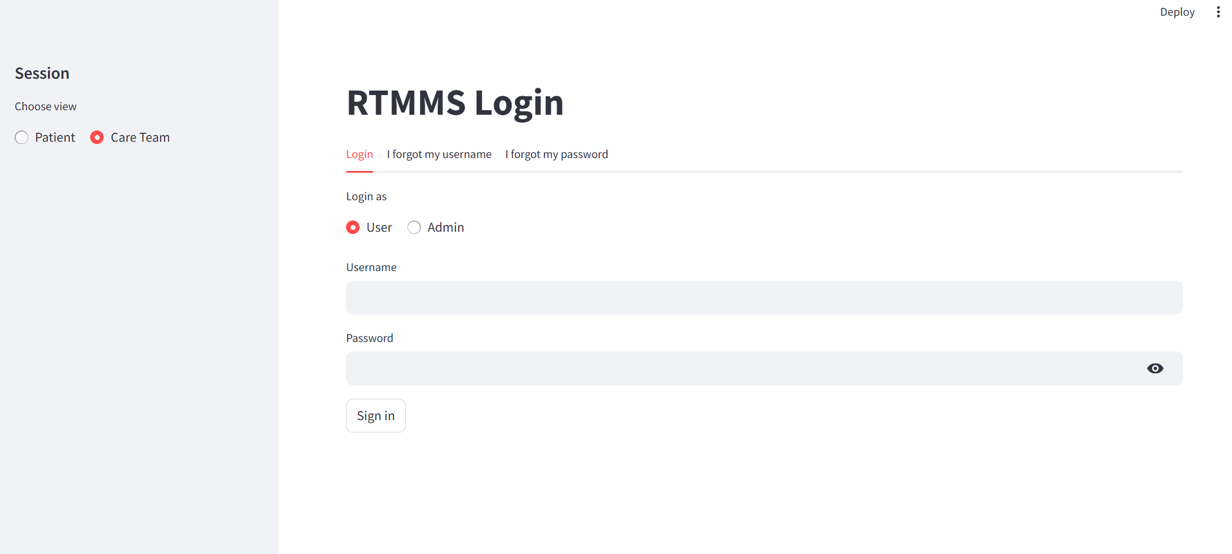

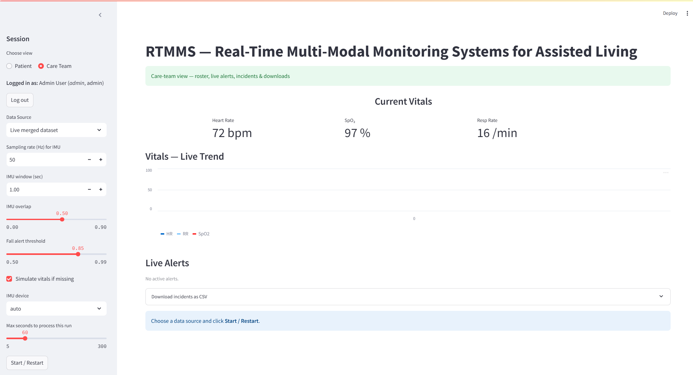

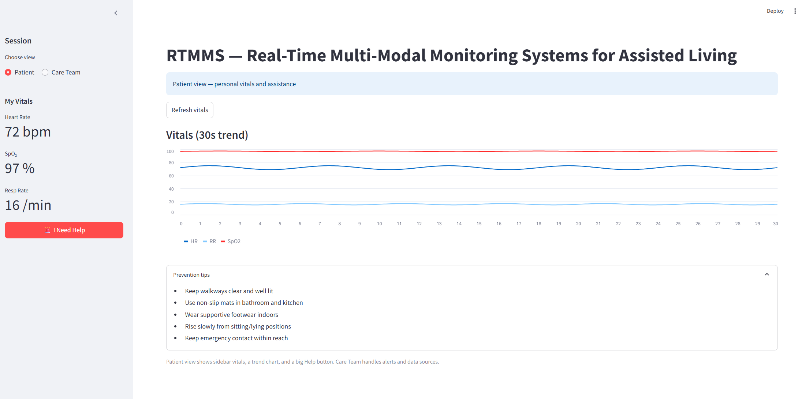

16.2 System Flow Walkthrough
The Real-Time Multi-Modal Monitoring System (RTMMS) follows a continuous end-to-end workflow that integrates sensing, fusion, detection, review, and EHR interaction. The walkthrough below summarizes what happens during normal system operation:
Step 1 - Sensor Data Acquisition
Multiple sensors (IMU, PPG/HR, mmWave, ambient IoT) continuously stream data from the resident’s living environment. Signals include motion, heart rate, respiration, and environmental cues. Each stream is timestamped and forwarded to the Edge Agent for preprocessing.
Step 2 - Edge Preprocessing
The Edge Agent performs lightweight filtering, normalization, and feature extraction. It masks sensitive information (e.g., video frames) and sends only de-identified sensor features to the fusion engine.
Step 3 - Fusion and Detection Pipeline
The Fusion Engine aggregates features from multiple modalities and evaluates them against fusion rules. Machine-learning models apply fall detection, deterioration analysis, wandering prediction, or anomaly scoring.
Detected events produce a structured Incident object containing:
- timestamps
- scores and labels
- evidence URIs
- explainability values
Step 4 - Caregiver Review & Labelling
In the Care Team dashboard, the clinician views the incident details, supporting sensor graphs, and evidence snippets. The clinician may:
- acknowledge
- correct the model label
- add notes
The system stores the annotated label for retraining and feedback loops.
Step 5 - Optional EHR Write-Back
If the incident severity meets clinical thresholds, RTMMS invokes the FHIR Bridge, which writes standardized Observation or Detected Issue resources to the patient’s EHR using SMART-on-FHIR APIs.
Step 6 - Dashboard Display
Both Patient View and Care Team View dashboards update with:
- live vitals
- alerts
- prevention tips
- charts and history
This allows users to take quick action and maintain safety in assisted living environments.

17. Issues for Future Studies
Several areas remain open for future study as the Real-Time Multi-Modal Monitoring System (RTMMS) continues to evolve. Although the current system integrates multiple sensor streams and provides real-time detection, improvements are needed in reducing false positives and enhancing the reliability of multimodal fusion models across diverse environments. Future research can explore more advanced privacy-preserving techniques, such as federated learning or encrypted computation, to strengthen resident confidentiality. Additionally, the system must be tested at scale to ensure stable performance when supporting many residents simultaneously, particularly in cloud-edge hybrid deployments. Integration with complex electronic health record (EHR) networks also requires further development to handle variations in clinical workflows and data formats. Finally, long-term user adoption studies should be conducted to evaluate how elderly residents and caregivers interact with the system, ensuring usability, comfort, and sustained engagement.

18. Acknowledgement
The successful development of the Real-Time Multi-Modal Monitoring System (RTMMS) was made possible using open-source tools, publicly available datasets, and community-driven documentation that supported system design and implementation. I am grateful for the software frameworks - such as Python, Streamlit, and related scientific libraries—that provided a strong foundation for building the prototype dashboard and processing pipeline. I also acknowledge the research community whose published work on fall detection, wandering prediction, and continuous vital monitoring informed several aspects of the system’s architecture. In addition, I appreciate the feedback and informal support provided by peers during the design, modeling, and evaluation stages of the project.

19. Conclusion
The Real-Time Multi-Modal Monitoring System (RTMMS) demonstrates the potential of combining multimodal sensing, real-time analytics, and user-centered dashboards to enhance safety and health monitoring in assisted-living environments. Through its integration of wearable and ambient sensors, structured incident modeling, and a dual-view interface for patients and caregivers, the system provides a clear, responsive, and informative monitoring experience. The project successfully delivered a functional prototype capable of visualizing vitals, generating alerts, and supporting configurable detection parameters. Although challenges remain—such as improving model accuracy, addressing privacy concerns, and scaling the system for broader deployment, the work completed offers a strong foundation for future development and real-world application. RTMMS ultimately represents a meaningful step toward more proactive, intelligent, and supportive care solutions for vulnerable populations.

20. References
- Martínez-Villasenor, L., Ponce, H., Brieva, J., Moya-Albor, E., Núñez-Martínez, J., & Peñafort-Asturiano, C. UP-Fall Detection Dataset: A Multimodal Approach. Sensors, 19(9), 1988. https://www.mdpi.com/1424-8220/19/9/1988
- Oliveira, R., Feres, R., Barreto, F., & Abreu, R. CNN for Elderly Wandering Prediction in Indoor Scenarios. https://pmc.ncbi.nlm.nih.gov/articles/PMC9019803/#Sec12
- Areia, C., Biggs, C., Santos, M., Thurley, N., Gerry, S., Tarassenko, L., Watkinson, P., & Vollam, S. Wearable Continuous Vital Sign Monitoring in Hospitalized Patients. Critical Care, 2021. https://ccforum.biomedcentral.com/articles/10.1186/s13054-021-03766-4

21. Source Code
Find full code here: https://github.com/pavanpekala1611/COMP_699_B_Pekala
from fastapi import FastAPI
from fastapi.middleware.cors import CORSMiddleware
from datetime import datetime, timedelta
from pathlib import Path
import pandas as pd
import traceback

app = FastAPI()

app.add_middleware(
CORSMiddleware,
allow_origins=["*"],
allow_methods=["*"],
allow_headers=["*"],
)

DATA_PATH = Path(__file__).parent / "all_merged.csv"
# Or, if you insist on an absolute path, make sure this is REAL:
DATA_PATH = Path("/Users/pavan/Documents/Capstone Project/Dataset/all_merged.csv")

@app.get("/rtmms_dashboard/summary")
def get_summary():
try:
if not DATA_PATH.exists():
return {
"monitored_patients": 0,
"active_alerts_5min": 0,
"median_response_sec": 0,
"critical_5min": 0,
"warnings_5min": 0,
"error": f"Data file not found at: {DATA_PATH}",
}

df = pd.read_csv(DATA_PATH)

# Try to parse timestamp if present
if "ts" in df.columns:
df["ts"] = pd.to_datetime(df["ts"], errors="coerce")
now = datetime.utcnow()
window_start = now - timedelta(minutes=5)
last5 = df[df["ts"] >= window_start]
else:
last5 = df

monitored_patients = (
df["patient_id"].nunique() if "patient_id" in df.columns else 0
)
active_alerts = len(last5)

if "response_time_sec" in df.columns:
median_response = df["response_time_sec"].median()
else:
median_response = 0

if "severity" in last5.columns:
critical_5 = (last5["severity"] == "critical").sum()
warning_5 = (last5["severity"] == "warning").sum()
else:
critical_5 = 0
warning_5 = 0

return {
"monitored_patients": int(monitored_patients),
"active_alerts_5min": int(active_alerts),
"median_response_sec": float(median_response) if pd.notna(median_response) else 0,
"critical_5min": int(critical_5),
"warnings_5min": int(warning_5),
}

except Exception as e:
# Print full traceback in terminal for you
traceback.print_exc()
# And return a JSON error to the frontend instead of crashing the server
return {
"monitored_patients": 0,
"active_alerts_5min": 0,
"median_response_sec": 0,
"critical_5min": 0,
"warnings_5min": 0,
"error": f"{type(e).__name__}: {e}",
}

@app.get("/")
def root():
return {"status": "ok", "data_path": str(DATA_PATH)}

