**main.tf**

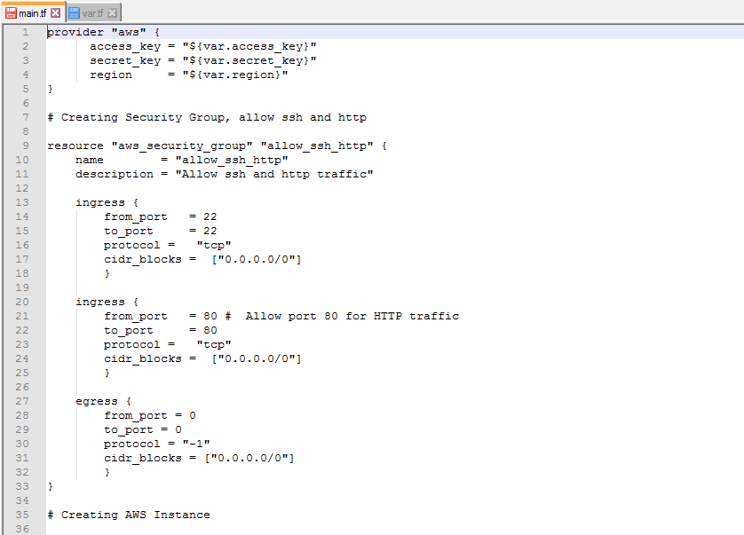

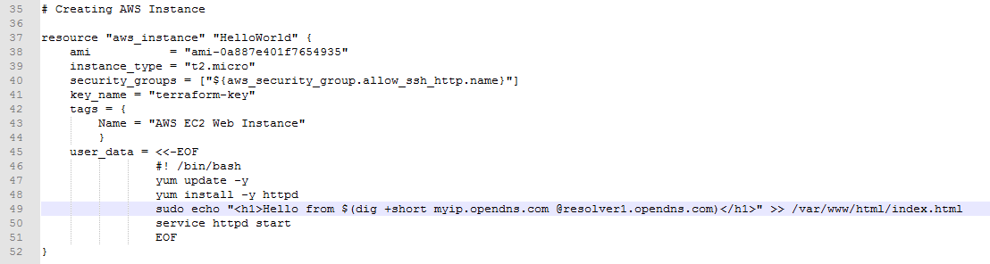

**The variables file var.tf is not added in Git repo.**

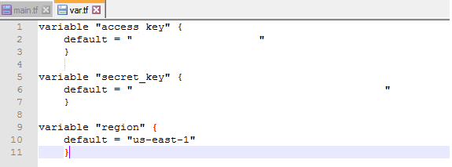

**Before Initializing Terraform:**

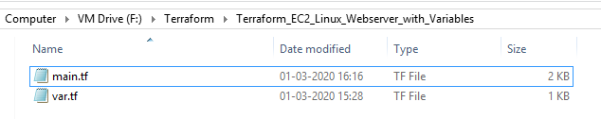

**After Initializing Terraform:**

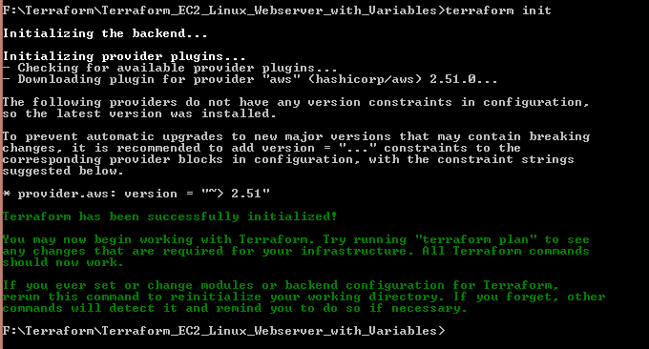

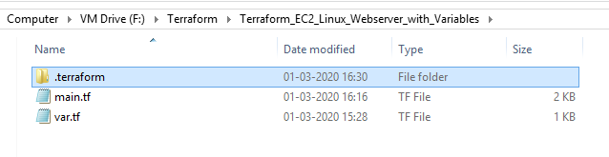

**terraform validate:**

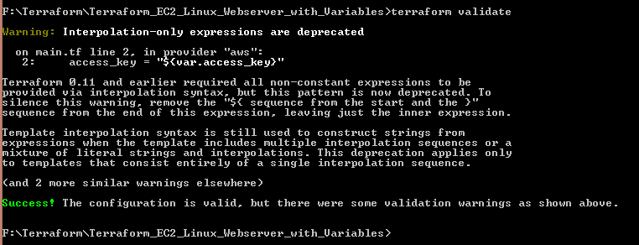

**terraform apply:**

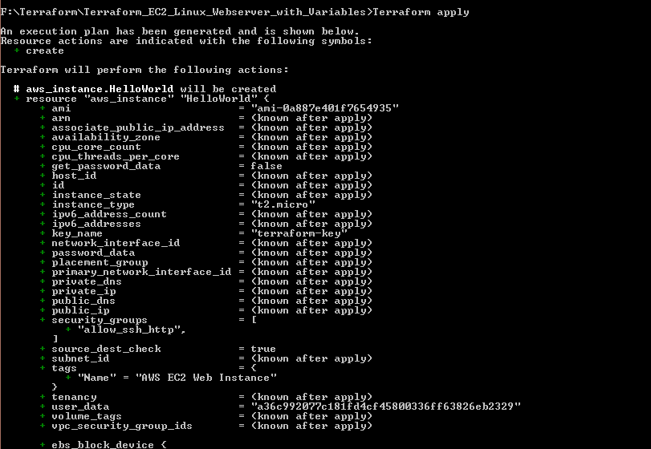

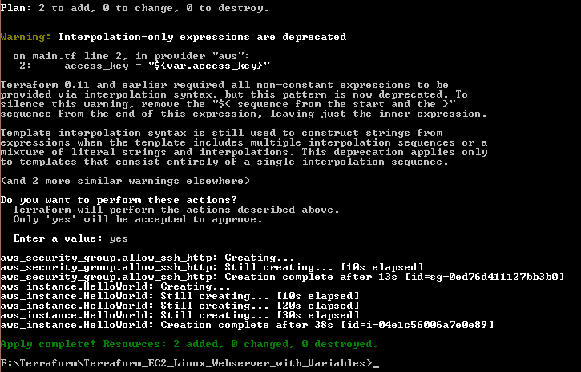

**EC2 Websever Instance Launched:**

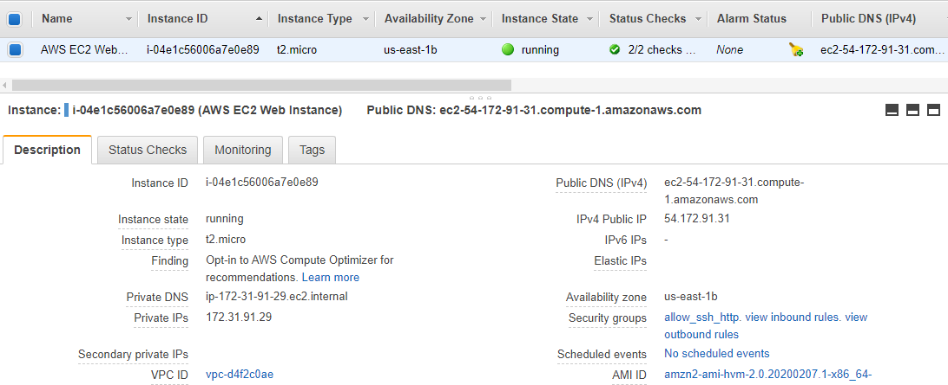

**Tags:**

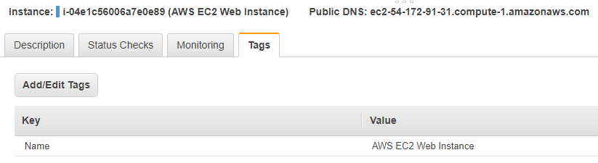

**Security group restricting traffic to port 80 and 22:**

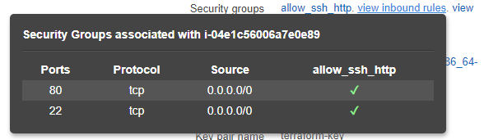

**SSH access should be possible via key-based authentication, but not by password:**

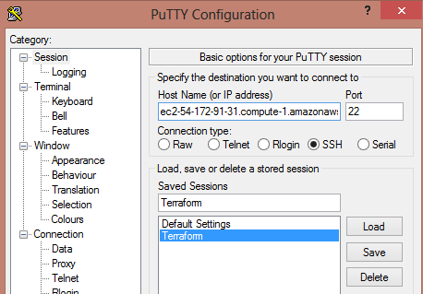

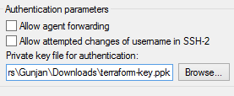

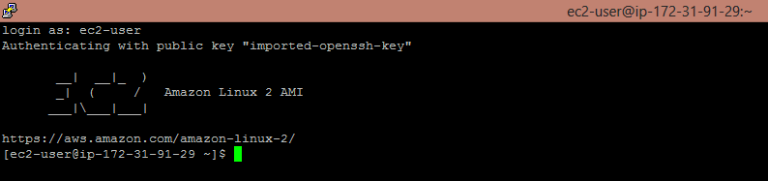

**EC2 Instance should be running Apache server:**

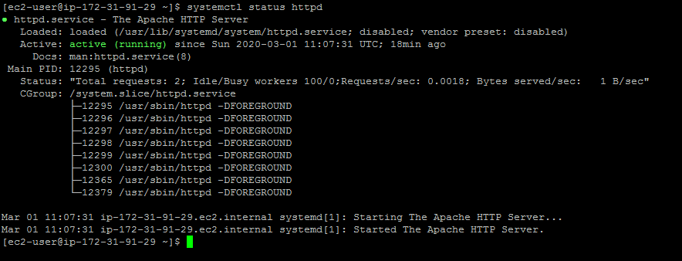

**Default web site -> “Hello from AAA.BBB.CCC.DDD”, where AAA.BBB.CCC.DDD is the public IP address:**

