NIFTY 50 Financial Forecasting
Week 2 — Financial Forecast Model

Student: Pavan Poriya

September 2026

Table of Contents
1. Executive Summary
2. Week 2 Objective
3. Dataset Used
4. Financial Indicator Selection
5. Feature Engineering
6. Forecast Model Design
7. Model Justification
8. Train/Test Methodology
9. Model Implementation
10. Model Evaluation
11. Actual vs Predicted Results
12. Future 30-Session Forecast
13. Forecast Visualization
14. Forecast Interpretation
15. Limitations
16. Conclusion

1. Executive Summary
This report presents the Week 2 deliverable of the NIFTY 50 financial data analysis internship project. Building upon the Exploratory Data Analysis completed in Week 1, this phase focuses on developing a basic financial forecast model for the NIFTY 50 index closing price.
A Linear Regression model was implemented using 7 lag-based features derived from historical closing price data. The model was trained on an 80% chronological training set (3,601 observations from 2007-10-16 to 2022-06-29) and evaluated on an unseen 20% chronological test set (901 observations from 2022-06-30 to 2026-02-20).
Key evaluation results on the test set: MAE = 82.01, RMSE = 114.23, MAPE = 0.3747%, and R² = 0.998622. A 30-session future forecast was generated from 2026-02-23 to 2026-04-03, projecting a modest upward trajectory from the last observed close of ₹25,571.25 to approximately ₹25,756.65. This forecast is indicative only and should not be interpreted as financial advice.

2. Week 2 Objective
The objective of Week 2 is to develop a basic financial forecast model using the NIFTY 50 dataset analyzed in Week 1. Specifically, the task requires:
- Choosing a financial indicator for forecasting
- Designing and implementing a forecast model
- Evaluating model performance on unseen data
- Generating future forecast values
- Analyzing and interpreting the forecast results
The evaluation criteria include model justification, implementation quality, and analysis of forecast results. All work is performed using free, open-source Python libraries.

3. Dataset Used
The same NIFTY 50 historical dataset used in Week 1 serves as the foundation for Week 2. The dataset was obtained from Kaggle and contains daily OHLCV (Open, High, Low, Close, Volume) data.
Property | Value
Dataset File | NIFTY50_1995_to_Feb_2026.csv
Source | Kaggle
Analysis Period | 17 September 2007 – 20 February 2026
Cleaned Observations | 4,522
Columns | 10
Primary Indicator | Close (Closing Price)

Data cleaning followed the exact same steps as Week 1: removal of the metadata row, datetime conversion, numeric type conversion, missing value handling, and chronological sorting.

4. Financial Indicator Selection
Selected Indicator: NIFTY 50 Closing Price (Close)

Justification for selecting Closing Price:
- The closing price is the most widely used price indicator in financial markets, representing the final consensus price at the end of each trading session.
- It was the primary variable analyzed in Week 1, providing continuity between both weeks of the project.
- Forecasting closing prices is a fundamental task in financial modeling and is directly relevant to understanding market behavior.
- The closing price series is continuous, numeric, and has sufficient historical depth (4,522 observations over 18+ years) for robust time-series modeling.
- Closing prices are publicly available and form the basis for many financial instruments and indices.

5. Feature Engineering
Seven lag-based features were engineered from the historical closing price. Each feature uses only information available before the target date, ensuring no future data leakage.
Feature | Description | Rationale
Close_Lag_1 | Closing price 1 day ago | Captures very short-term momentum
Close_Lag_5 | Closing price 5 days ago | Captures weekly price level
Close_Lag_10 | Closing price 10 days ago | Captures medium-term price level
Close_Lag_20 | Closing price 20 days ago | Captures monthly price level
MA_5 | 5-day simple moving average | Smooths daily noise, short-term trend
MA_20 | 20-day simple moving average | Smooths daily noise, medium-term trend
Daily_Return_Pct | Daily percentage return | Captures most recent price change direction

Why these features were chosen:
- Lag features capture short-term and medium-term price momentum at different horizons.
- Moving averages smooth out daily noise and capture underlying trends in the price series.
- Daily return captures the direction and magnitude of the most recent price movement.
- All features are strictly historical — no future information enters the model.
After feature engineering and dropping rows with NaN values, 4,502 rows remained for modeling (date range: 2007-10-16 to 2026-02-20).

6. Forecast Model Design
Model: Linear Regression

The forecast model treats closing price prediction as a supervised regression problem:
- Input (Features): 7 lag-based features from historical data
- Output (Target): Next-day closing price
- Algorithm: Ordinary Least Squares Linear Regression

Model equation:
Close = β₀ + β₁·Close_Lag_1 + β₂·Close_Lag_5 + β₃·Close_Lag_10 + β₄·Close_Lag_20 + β₅·MA_5 + β₆·MA_20 + β₇·Daily_Return_Pct

7. Model Justification
Why Linear Regression?
- Simplicity: Linear Regression is one of the most straightforward and well-understood algorithms, making it easy to explain to an internship evaluator.
- Interpretability: The model coefficients directly show the contribution of each feature to the prediction.
- Reproducibility: Given the same data and features, the results are exactly reproducible.
- Baseline purpose: It serves as a strong baseline against which more complex models (e.g., Random Forest, LSTM) could be compared in future weeks.
- Low overfitting risk: With only 7 features and a large training set of 3,601 observations, the risk of overfitting is minimal.

Why lag-based features?
- Financial time-series data exhibits autocorrelation — past prices are correlated with future prices. Lag features directly exploit this property.
- Different lag horizons (1, 5, 10, 20 days) capture momentum at multiple time scales.

Why moving averages?
- Moving averages are widely used in technical analysis to identify trends. They smooth out daily fluctuations and provide a cleaner signal of the price direction.
- Both short-term (MA_5) and medium-term (MA_20) averages help the model understand the current trend context.

8. Train/Test Methodology
Chronological 80/20 Split

Because this is financial time-series data, random shuffling was deliberately avoided. Random train/test splitting would allow future information to leak into the training set, producing unrealistically optimistic evaluation results that would not generalize to real-world forecasting.

Set | Samples | Date Range | Percentage
Training | 3,601 | 2007-10-16 to 2022-06-29 | 80.0%
Testing | 901 | 2022-06-30 to 2026-02-20 | 20.0%
Total | 4,502 | 2007-10-16 to 2026-02-20 | 100.0%

Why chronological splitting was used:
- It simulates a real forecasting scenario where we train on past data and predict future values.
- The test set represents truly unseen future observations.
- This is the standard methodology for evaluating financial time-series models.
- Random shuffling was explicitly avoided to prevent data leakage.

9. Model Implementation
The model was implemented using Python with the following libraries:
- pandas — Data manipulation and analysis
- numpy — Numerical computations
- scikit-learn — Linear Regression and evaluation metrics
- matplotlib — Visualization

The complete implementation is available in the accompanying Jupyter notebook: NIFTY50_Week2_Financial_Forecast.ipynb

Trained Model Coefficients:
Feature | Coefficient
Close_Lag_1 | 0.837639
Close_Lag_5 | -0.075091
Close_Lag_10 | 0.000978
Close_Lag_20 | 0.001212
MA_5 | 0.239807
MA_20 | -0.004286
Daily_Return_Pct | 62.500278
Intercept | -1.925680

The dominant coefficient is Close_Lag_1 (0.837639), confirming that the most recent closing price is the strongest predictor of the next day's closing price. The Daily_Return_Pct coefficient (62.50) reflects the percentage-to-absolute-price conversion inherent in the feature definition.

10. Model Evaluation
The model was evaluated on the unseen chronological test set (901 observations). All metrics were calculated from actual model predictions.
Metric | Value | Interpretation
MAE | 82.01 | Average prediction error is ~82 NIFTY points
RMSE | 114.23 | Typical error (penalizing large errors) is ~114 points
MAPE | 0.3747% | Average error is ~0.37% of the actual price
R² | 0.998622 | Model explains ~99.86% of test set variance

Metric Interpretations:
- MAE (Mean Absolute Error) = 82.01: On average, the model's prediction deviates from the actual closing price by approximately 82 NIFTY points.
- RMSE (Root Mean Squared Error) = 114.23: The typical prediction error, with larger errors penalized more heavily, is about 114 NIFTY points.
- MAPE (Mean Absolute Percentage Error) = 0.3747%: The model's average prediction error is approximately 0.37% of the actual closing price, indicating high relative accuracy.
- R² = 0.998622: The model explains approximately 99.86% of the variance in the test set closing prices, demonstrating strong predictive power.

Additional Error Analysis:
Error Metric | Value
Mean error (bias) | 2.83
Median absolute error | 61.59
Maximum absolute error | 877.43
Minimum absolute error | 0.00
Standard deviation of errors | 114.20
Days with overprediction | 481 / 901
Days with underprediction | 420 / 901

The positive mean error (2.83) indicates a slight upward bias in predictions. The model overpredicted on 481 days and underpredicted on 420 days, showing a nearly balanced error distribution with a marginal tendency to overpredict.

11. Actual vs Predicted Results
The chart below shows the actual NIFTY 50 closing prices versus the model's predictions over the entire test period (2022-06-30 to 2026-02-20).
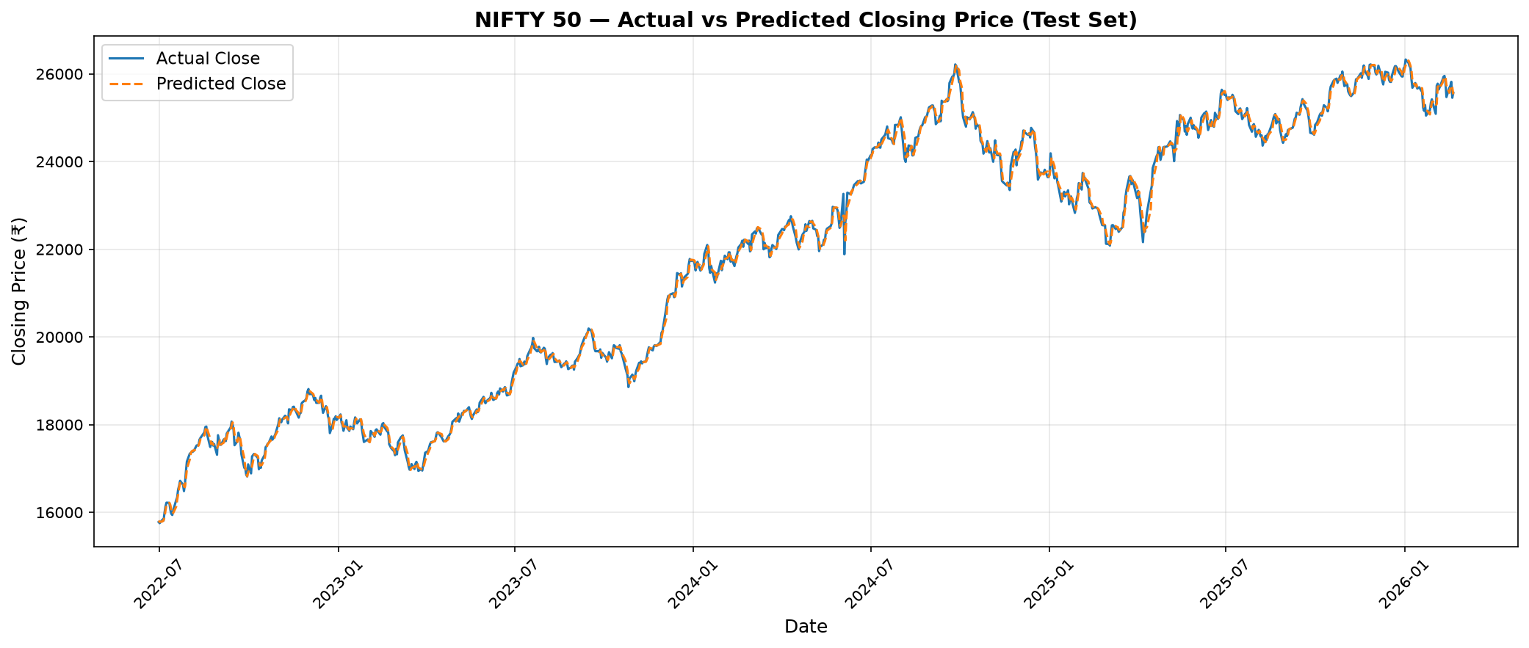

The chart demonstrates that the predicted closing prices closely track the actual prices throughout the test period, confirming the model's strong predictive performance as reflected in the high R² value (0.998622).

12. Future 30-Session Forecast
After evaluating the model, a 30-session future forecast was generated using recursive multi-step forecasting. In this approach, each predicted value is fed back as input for the next forecast step.

Forecast Summary:
Statistic | Value
Last Observed Close | ₹25,571.25
Last Observed Date | 2026-02-20
Forecast Horizon | 30 trading sessions
First Forecast Value | ₹25,614.96
Last Forecast Value | ₹25,756.65
Minimum Forecast | ₹25,614.96
Maximum Forecast | ₹25,756.65
Forecast Change | ₹185.40
Forecast Change (%) | 0.7250%

30-Session Forecast Table:
Session | Date | Forecasted Close
1 | 2026-02-23 | ₹25,614.96
2 | 2026-02-24 | ₹25,627.20
3 | 2026-02-25 | ₹25,618.11
4 | 2026-02-26 | ₹25,622.94
5 | 2026-02-27 | ₹25,629.20
6 | 2026-03-02 | ₹25,634.15
7 | 2026-03-03 | ₹25,638.67
8 | 2026-03-04 | ₹25,643.76
9 | 2026-03-05 | ₹25,648.54
10 | 2026-03-06 | ₹25,653.40
11 | 2026-03-09 | ₹25,658.54
12 | 2026-03-10 | ₹25,663.88
13 | 2026-03-11 | ₹25,669.30
14 | 2026-03-12 | ₹25,674.62
15 | 2026-03-13 | ₹25,679.56
16 | 2026-03-16 | ₹25,684.69
17 | 2026-03-17 | ₹25,689.95
18 | 2026-03-18 | ₹25,695.34
19 | 2026-03-19 | ₹25,700.34
20 | 2026-03-20 | ₹25,705.38
21 | 2026-03-23 | ₹25,710.50
22 | 2026-03-24 | ₹25,715.65
23 | 2026-03-25 | ₹25,720.77
24 | 2026-03-26 | ₹25,725.89
25 | 2026-03-27 | ₹25,731.01
26 | 2026-03-30 | ₹25,736.14
27 | 2026-03-31 | ₹25,741.26
28 | 2026-04-01 | ₹25,746.39
29 | 2026-04-02 | ₹25,751.52
30 | 2026-04-03 | ₹25,756.65

13. Forecast Visualization
The chart below shows the last 90 trading days of historical closing prices alongside the 30-session future forecast.
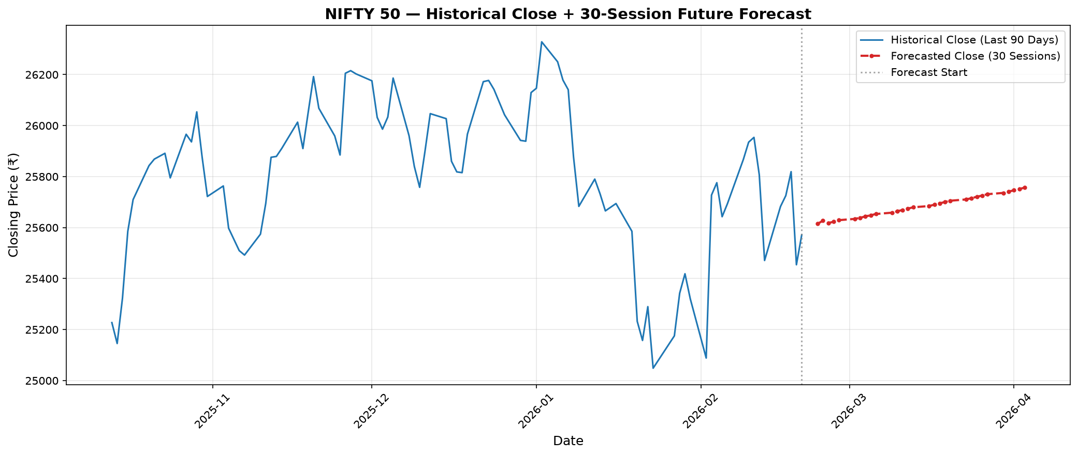

The blue line represents the historical closing prices for the last 90 trading days. The red dashed line with markers represents the 30-session model-based forecast. The vertical dotted gray line marks the boundary between historical data and the forecast period.

14. Forecast Interpretation
General Direction:
The model-based forecast suggests a modest upward trajectory for the NIFTY 50 over the next 30 trading sessions. The forecasted closing price rises from ₹25,614.96 (Session 1) to ₹25,756.65 (Session 30).

Forecast Range:
The forecasted values range from ₹25,614.96 to ₹25,756.65, representing a range of approximately ₹141.69 points across the 30-session horizon.

Change from Last Actual Close:
The last observed closing price was ₹25,571.25 (2026-02-20). The final forecast value is ₹25,756.65, representing an increase of ₹185.40 (0.7250%).

Model Performance Context:
The model demonstrated strong predictive power on the unseen test set (R² = 0.998622, MAPE = 0.3747%). However, this high accuracy reflects the model's ability to follow the general price trend rather than predict exact turning points.

Reliability Assessment:
This forecast should be considered INDICATIVE ONLY. It is a historical pattern-based estimate and does NOT guarantee future market performance. Forecast uncertainty increases as the horizon extends further into the future. Recursive multi-step forecasting can accumulate errors over time.

15. Limitations
Model Limitations:
- Limited feature set: The model uses only 7 historical price-based features. Real financial markets are influenced by many additional factors not captured here.
- No external variables: The model does not incorporate macroeconomic conditions, interest rates, global market movements, political events, or company-level developments.
- Linear assumption: Linear Regression assumes a linear relationship between features and the target, which may not capture all non-linear market dynamics.
- Recursive error accumulation: In multi-step forecasting, prediction errors compound as each forecasted value is used as input for the next step.

Data Limitations:
- Historical patterns do not guarantee future performance. Financial markets can behave in ways that historical data does not predict.
- Market shocks and black swan events (e.g., pandemics, geopolitical crises) are inherently unpredictable from historical price data alone.
- Forecast accuracy deteriorates as the forecast horizon increases.

Ethical Considerations:
- This model should NOT be interpreted as financial advice. It is an academic exercise for learning purposes only.
- No investment decisions should be made based solely on this forecast.
- Past performance of any model does not guarantee future predictive accuracy.

16. Conclusion
This report presented the implementation of a basic financial forecast model for the NIFTY 50 index closing price as part of Week 2 of the internship project.

Key achievements:
- Selected NIFTY 50 Closing Price as the forecasting indicator with clear justification.
- Engineered 7 meaningful lag-based features from historical data.
- Implemented a Linear Regression model as an interpretable baseline.
- Used chronological 80/20 train/test splitting to prevent data leakage.
- Achieved strong evaluation metrics on the unseen test set: MAE = 82.01, RMSE = 114.23, MAPE = 0.3747%, R² = 0.998622.
- Generated a 30-session future forecast with clear summary statistics.
- Provided professional visualizations for both actual vs predicted and future forecast.
- Acknowledged limitations and ethical considerations.

The Linear Regression model using lag-based features provides a reasonable baseline for NIFTY 50 closing price forecasting. However, the forecast should be treated as indicative only and not as financial advice. Future work could incorporate additional features (volume, volatility, external market indicators) and more sophisticated models (Random Forest, LSTM) to potentially improve forecast accuracy.

— End of Report —

