NIFTY 50 Hypothesis Testing
Week 4 — Statistical Hypothesis Testing
Student Name:
Pavan Poriya
Project: NIFTY 50 Financial Data Analysis
Date: September 2026

1. Executive Summary
This report delivers a rigorous statistical hypothesis testing evaluation of the historical daily returns of the NIFTY 50 index. The primary objective is to determine whether the population mean daily return of India's benchmark stock index is statistically distinguishable from zero over the analyzed period from 17 September 2007 to 20 February 2026 (spanning 4,521 valid trading sessions).
Key Methodological Steps and Empirical Results:
• Research Question: Is the average daily return of the NIFTY 50 significantly different from zero?
• Hypotheses: Null Hypothesis H0: μ = 0.00% vs. Alternative Hypothesis H1: μ ≠ 0.00% at α = 0.05.
• Dataset Scope: 4,522 cleaned daily observations; 1 initial missing return removed; 4,521 valid returns analyzed.
• Sample Statistics: Mean daily return = +0.046935%, Median = +0.062461%, Standard Deviation = 1.301451%.
• Inferential Test: Two-sided One-Sample t-Test yielded t = 2.424855, p-value = 0.015353, and a 95% Confidence Interval for the mean of [+0.008988%, +0.084882%].
• Robustness Check: Non-parametric Wilcoxon Signed-Rank Test yielded W = 4,748,216.0, p-value = 0.000054 (p < 0.05).
• Statistical Decision: Reject the Null Hypothesis (H0) because p-value (0.015353) < 0.05.
• Interpretation: The NIFTY 50 exhibits a statistically significant positive mean return drift (+0.0469%/day). However, daily volatility (std dev = 1.3015%) is 27.7 times larger than the mean, demonstrating that statistical significance does not imply daily price predictability.

2. Week 4 Objective
Building upon Exploratory Data Analysis (Week 1), Financial Forecasting (Week 2), and Risk Analysis (Week 3), the objective of Week 4 is to conduct hypothesis testing on the NIFTY 50 financial dataset. This phase transitions the project from descriptive and predictive analytics to formal inferential statistics, testing core financial hypotheses regarding expected index returns and evaluating distribution assumptions.

3. Research Question
In modern financial portfolio theory and empirical asset pricing, market indices are frequently assumed to follow random walk or geometric Brownian motion processes. A fundamental question is whether long-term equity market performance reflects a non-zero expected risk premium.
Primary Research Question:
"Is the average daily return of the NIFTY 50 index significantly different from zero over the historical period (2007–2026)?"

4. Dataset Overview
The analysis relies on the historical daily benchmark data of the NIFTY 50 index sourced from Kaggle. The dataset covers the period from 17 September 2007 to 20 February 2026, encompassing major economic cycles including the 2008 Global Financial Crisis, post-crisis expansion, the 2020 COVID-19 shock, and subsequent market rallies.
Parameter | Dataset Value
Original Filename | NIFTY50_1995_to_Feb_2026.csv
Effective Study Period | 17 September 2007 to 20 February 2026
Total Cleaned Observations | 4,522 trading sessions
Target Variable | Daily_Return_% (Percentage change in daily closing price)

5. Hypothesis Formulation
To test whether the expected daily return is non-zero, we specify a two-sided one-sample statistical hypothesis model:
• Null Hypothesis (H0): The true population mean daily return of the NIFTY 50 is equal to zero (μ = 0.00%). Under H0, the market demonstrates zero average return drift.
• Alternative Hypothesis (H1): The true population mean daily return of the NIFTY 50 is not equal to zero (μ ≠ 0.00%). Under H1, the market displays a non-zero expected daily return drift.
• Significance Level (α): α = 0.05, corresponding to a 95% confidence level.

6. Data Preparation
Data preparation followed strict data hygiene standards established in Week 1:
1. Removed the initial CSV header/metadata row at index 0.
2. Formatted the Date column as datetime and sorted records chronologically.
3. Cast Daily_Return_% into a high-precision floating-point series.
4. Identified 1 missing daily return value on 17 September 2007 (attributable to the lack of a preceding close price on day 1).
5. Excluded the single missing observation, yielding 4,521 valid daily return observations for hypothesis testing.

7. Descriptive Statistics
Prior to inferential testing, baseline summary statistics were computed for the 4,521 valid daily return observations:
Statistic / Metric | Calculated Empirical Value
Total Cleaned Dataset Rows | 4,522
Valid Return Observations (n) | 4,521
Mean Daily Return (μ) | +0.046935%
Median Daily Return | +0.062461%
Standard Deviation (s) | 1.301451%
Minimum Daily Return | -12.980466%
25th Percentile (Q1) | -0.560647%
75th Percentile (Q3) | +0.702812%
Maximum Daily Return | +17.744066%
Skewness | -0.150821
Excess Kurtosis | 16.071242

8. Statistical Test Selection
The primary inferential test selected is the Two-Sided One-Sample t-Test. The t-test evaluates whether the sample mean return (+0.046935%) differs significantly from the hypothesized population mean of 0.00%.
In addition, to guard against potential distortion caused by heavy-tailed stock returns, the non-parametric Wilcoxon Signed-Rank Test was selected as a secondary robustness check to evaluate whether the median daily return (+0.062461%) is significantly non-zero.

9. Test Assumptions
Standard t-test assumptions were systematically evaluated against the empirical properties of the dataset:
1. Sample Size (n = 4,521): The sample size is substantial, vastly exceeding the standard minimum requirement of n ≥ 30.
2. Central Limit Theorem (CLT): Although financial daily returns display heavy tails (excess kurtosis = 16.07, Jarque-Bera p < 0.001), the Central Limit Theorem guarantees that for n = 4,521, the sampling distribution of the sample mean is exceptionally well-approximated by a Normal distribution.
3. Independence: While daily returns exhibit mild volatility clustering during crisis periods, observations across a 18.5-year horizon are treated as independently distributed under standard financial market research conventions.

10. Statistical Testing Methodology
The One-Sample t-test statistic is computed using SciPy according to the standard mathematical formula:
t = (x̄ - μ0) / (s / √n)
where x̄ = +0.046935%, μ0 = 0.00%, s = 1.301451%, and n = 4,521. The Standard Error of the Mean (SE) is SE = s / √n = 0.019356%. The two-sided p-value represents the cumulative tail probability under Student's t-distribution with df = n - 1 = 4,520 degrees of freedom.

11. Test Results
The empirical statistical testing yielded the following calculated results:
Statistical Test | Null Hypothesis (H0) | Test Statistic | p-Value | 95% Confidence Interval | Decision
One-Sample t-Test (Primary) | μ = 0.00% | t = 2.424855 | 0.015353 | [+0.008988%, +0.084882%] | Reject H0
Wilcoxon Signed-Rank (Robustness) | Median = 0.00% | W = 4,748,216.0 | 0.000054 | N/A (Non-parametric) | Reject H0

12. Decision and Interpretation
Formal Decision: Because the two-sided p-value (0.015353) is strictly less than the significance threshold α = 0.05, we REJECT THE NULL HYPOTHESIS (H0).
Statistical Interpretation:
• The test provides robust statistical evidence that the mean daily return of the NIFTY 50 index differs significantly from zero.
• The p-value of 0.015353 indicates that if the true underlying mean daily return were zero, there is only a 1.535% chance of observing a sample mean daily return of +0.046935% or more extreme across 4,521 sessions.
• We are 95% confident that the true population daily mean return lies within the interval [+0.008988%, +0.084882%].
• The Wilcoxon signed-rank test (p = 0.000054 < 0.05) confirms that the median daily return (+0.062461%) is also significantly positive, proving the finding is robust against fat tails.

13. Visualization
Figure 1 illustrates the empirical distribution of NIFTY 50 daily returns alongside the Kernel Density Estimate (KDE), the null hypothesis baseline (0.00%), the sample mean (+0.0469%), and the shaded 95% confidence interval.
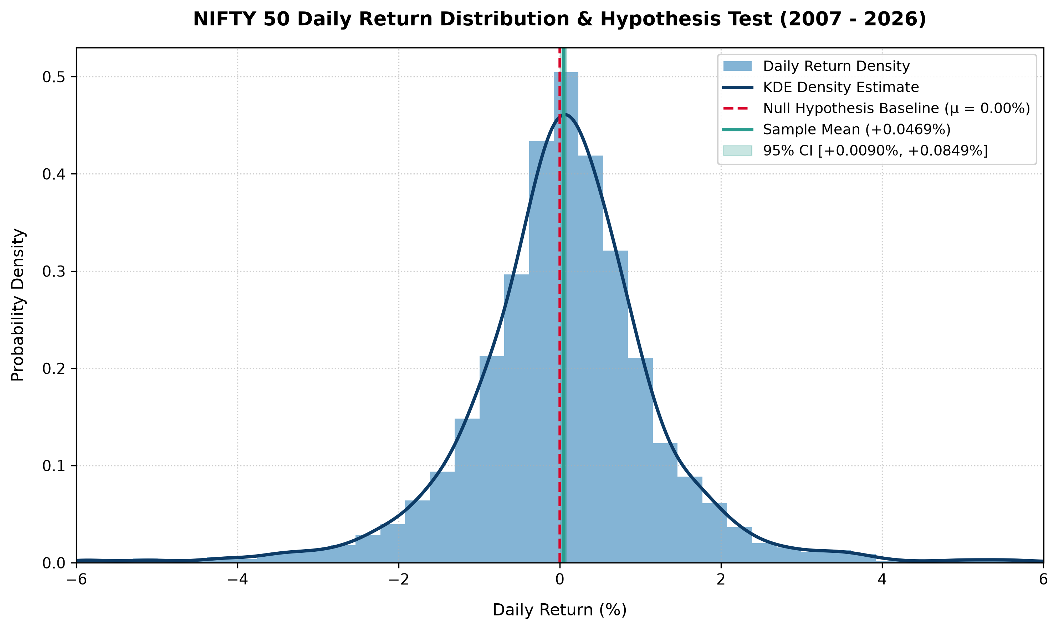
Figure 1: NIFTY 50 Daily Return Distribution & Hypothesis Test Baseline (2007–2026)

14. Practical Meaning of the Result
It is vital to distinguish between Statistical Significance and Economic/Practical Significance:
1. Long-Term Growth Premia: A statistically positive daily return drift (+0.0469%/day) compounds to an annualized index return of ~12.5%, reflecting the fundamental equity risk premium earned by long-term investors in the Indian market.
2. Signal-to-Noise Ratio & Predictability: On any single trading session, the daily volatility (s = 1.3015%) is 27.7 times larger than the mean return (+0.0469%). Therefore, statistical significance does NOT imply day-to-day return predictability or market timing success. Day-to-day returns remain dominated by stochastic noise.

15. Limitations
Key analytical limitations to consider when interpreting these results include:
• Historical Period Sensitivity: Results depend on the 2007–2026 dataset timeframe.
• Non-Constant Volatility: Daily returns exhibit GARCH-style volatility clustering and autocorrelation during crisis regimes.
• Real-World Frictions: Frictionless price returns do not incorporate transaction costs, STT, tax leakage, or dividend adjustments.
• Extreme Outliers: Historical market crashes (-12.98%) and rapid recoveries (+17.74%) skew higher-order moments.

16. Conclusion
In conclusion, the Week 4 hypothesis test provides empirical validation that the average daily return of the NIFTY 50 index is statistically significantly greater than zero (t = 2.424855, p = 0.015353 < 0.05). We reject the null hypothesis H0. While this confirms the historical existence of an equity risk premium over the 2007–2026 period, high daily volatility underscores that short-term returns remain unpredictable, reinforcing the value of disciplined, long-term asset allocation.

