NIFTY 50 Historical Financial Data Analysis
Week 1 — Exploratory Data Analysis Report
―――――――――――――――――――――――――――――――――――――――――――――
Project Title: NIFTY 50 Historical Financial Data Analysis
Milestone: Week 1 — Exploratory Data Analysis
Historical Period Covered: September 2007 – February 2026
Domain / Focus: Financial Data Analysis / Technical Index Research
Student Name: Pavan Poriya

2. Project Objective
This report presents an exploratory data analysis (EDA) of historical daily market data for the NIFTY 50 index, covering the period from 17 September 2007 to 20 February 2026. The NIFTY 50 is the benchmark stock market index representing the weighted performance of 50 major blue-chip Indian companies listed on the National Stock Exchange (NSE).
The primary objective of this Week 1 task is to conduct a rigorous, data-driven initial evaluation of the dataset to understand long-term price behavior, daily return distributions, market risk dynamics, and structural index relationships. Specifically, the analysis encompasses eight core technical dimensions:
- Historical Price Trends: Long-term closing price trajectories and major secular trends over an 18-year dataset horizon.
- Daily Return Behavior: Statistical properties of daily index percentage returns, including central tendency and dispersion.
- Return Distribution Properties: Symmetrical properties and tail-risk attributes evaluated via skewness and kurtosis metrics.
- Extreme Market Movements: Frequency, magnitude, and impact of severe single-day positive and negative price shocks.
- Cumulative Price-Return Growth: Compounded index return growth alongside a hypothetical ₹100 investment tracking model.
- Moving-Average Trend Regimes: Short-term (MA50) and long-term (MA200) trend relationships and structural regime crossovers.
- Market Volatility Dynamics: Time-varying return volatility assessed through 30-day rolling standard deviations and annual rankings.
- Data Quality and Integrity Validation: Logical price boundary checks, missing value diagnostics, and structural type conversions.
3. Dataset Overview
The analysis relies on historical market data stored in the source file NIFTY50_1995_to_Feb_2026.csv. Although the filename suggests historical coverage extending back to 1995, initial data inspection established that valid, continuous daily market observations in the file actually commence on 17 September 2007 and conclude on 20 February 2026. After data cleaning, the final workspace dataset comprises exactly 4,522 daily observations across 10 fields.
Field Name | Data Type | Description / Analytical Purpose
Date | datetime64[us] | Trading session calendar date (17-Sep-2007 to 20-Feb-2026).
Close | float64 | Daily official closing price index level of NIFTY 50.
High | float64 | Highest price index level recorded during the trading session.
Low | float64 | Lowest price index level recorded during the trading session.
Open | float64 | Opening price index level at session commencement.
Volume | int64 | Total recorded trading volume units associated with index components.
Ticker | string | Ticker identifier representing the security (^NSEI).
Daily_Return_% | float64 | Pre-calculated daily percentage change in closing price.
MA_50 | float64 | 50-day simple moving average of the closing price index.
MA_200 | float64 | 200-day simple moving average of the closing price index.

4. Tools and Technologies Used
The quantitative workflow was developed and executed using standard open-source Python libraries within an interactive environment. Only technologies explicitly present in the source notebook were utilized:
- Python 3.x: Programming language used for data manipulation, array transformation, and mathematical logic.
- Pandas: Primary data manipulation library used for dataset loading, datetime parsing, indexed slicing, aggregation, missing value auditing, and cumulative products.
- NumPy: Numerical library supporting underlying vectorized math operations and floating-point computations.
- Matplotlib: Visualization framework used for rendering technical time-series line plots, distribution histograms, and annual volatility bar charts.
- Jupyter Notebook: Interactive execution environment providing code block reproducibility and inline analytical output logging.
5. Data Loading and Initial Inspection
The raw dataset was loaded from DataSet/NIFTY50_1995_to_Feb_2026.csv using pandas.read_csv(). Initial structural inspection revealed an initial dataset shape of 4,523 rows and 10 columns.
Inspection of the raw table head (df.head()) identified that row index 0 contained non-data metadata. Specifically, row 0 contained string ticker symbols ('^NSEI') populated across market price columns (Close, High, Low, Open, Volume). Because of this metadata header row, pandas initially imported all price and volume columns as generic object (string) data types, requiring explicitly structured type conversion during data cleaning.
The initial null value scan (df.isnull().sum()) on the raw dataframe yielded:
- Date: 1 missing value (contained in row index 0).
- Close, High, Low, Open, Volume: 0 missing values in raw strings.
- Ticker: 1 missing value (row index 0).
- Daily_Return_%: 2 missing values.
- MA_50: 50 missing values.
- MA_200: 200 missing values.
6. Data Cleaning
Data cleaning was executed in a systematic four-step workflow to transition the raw dataset into a clean, strongly-typed analytical structure:
- Step 1 — Metadata Row Removal: The metadata header row (row index 0 containing ticker strings) was permanently dropped via df.drop(index=0), reducing total dataframe rows from 4,523 to 4,522.
- Step 2 — Datetime Conversion: The Date column was converted from string format to pandas datetime64[us] using pd.to_datetime(), enabling chronological sorting and time-series plotting.
- Step 3 — Numeric Coercion: The Close, High, Low, Open, and Volume columns were explicitly coerced to appropriate numeric types (float64 for price series, int64 for volume) via pd.to_numeric().
- Step 4 — Missing Value Audit: Post-cleaning null audits (df.isnull().sum()) confirmed zero missing values across all core market variables (Date, Close, High, Low, Open, Volume, Ticker).
Post-cleaning missing value counts across derived metric columns were recorded as follows:
- Daily_Return_% (1 missing): Exactly 1 null value at row index 1 (17-Sep-2007). This missing return is logically expected because no preceding closing price exists in the dataset to compute a 1-day percentage change.
- MA_50 (49 missing): Exactly 49 null values spanning the first 49 trading sessions. This is an expected warm-up period because a 50-day simple moving average requires 50 historical observations.
- MA_200 (199 missing): Exactly 199 null values spanning the first 199 trading sessions, representing the required 200-day historical window.
NOTE: Missing Data Handling Principle
The missing values in Daily_Return_%, MA_50, and MA_200 were NOT removed or imputed with mean values. In financial time-series analysis, dropping initial rows or filling rolling window warm-up periods distorts chronological indices and introduces bias. Preserving these rows maintains exact calendar alignment across all 4,522 trading sessions.

7. Data Quality Validation
To guarantee analytical integrity, a series of automated logical consistency checks were executed across the cleaned dataset. Financial market observations must obey strict intra-day pricing boundaries. The results of the data validation checks are summarized below:
Validation Condition Checked | Logical Condition Evaluated | Violations Identified
High is lower than Low | (High < Low).sum() | 0 (Passed)
High is lower than Open | (High < Open).sum() | 0 (Passed)
High is lower than Close | (High < Close).sum() | 0 (Passed)
Low is greater than Open | (Low > Open).sum() | 0 (Passed)
Low is greater than Close | (Low > Close).sum() | 0 (Passed)
Additionally, trading volume integrity was validated by scanning for negative volume values ((Volume < 0).sum()). Exactly 0 negative volume records were found. The dataset passed all logical sanity tests without identifying invalid price or volume observations.
8. Descriptive Statistics
Summary descriptive statistics generated via df.describe() provide a foundational numerical summary of the NIFTY 50 price index, trading volume, daily returns, and moving average series over the 4,522 cleaned observations:
Stat | Close | High | Low | Open | Volume | Daily Return % | MA 50 | MA 200
count | 4522 | 4522 | 4522 | 4522 | 4522 | 4521 | 4473 | 4323
mean | 11028.40 | 11092.47 | 10961.46 | 11034.68 | 212,464 | 0.0469% | 10979.91 | 10823.55
std | 6441.13 | 6462.05 | 6418.81 | 6443.48 | 205,361 | 1.3015% | 6360.71 | 6103.10
min | 2524.20 | 2585.30 | 2252.75 | 2553.60 | 0 | -12.9805% | 2784.18 | 3369.81
25% | 5691.07 | 5726.74 | 5650.67 | 5693.31 | 0 | -0.5211% | 5714.39 | 5677.92
50% | 8744.15 | 8792.05 | 8703.55 | 8756.63 | 189,800 | 0.0625% | 8702.34 | 8696.73
75% | 15788.38 | 15863.10 | 15720.90 | 15799.56 | 295,675 | 0.6521% | 15865.32 | 15464.11
max | 26328.55 | 26373.20 | 26210.05 | 26333.70 | 1,811,000 | 17.7441% | 25971.74 | 25322.44

9. Historical Price Analysis
The historical closing price plot documents the long-term structural expansion of the NIFTY 50 index over the analyzed period from 17 September 2007 to 20 February 2026. The index increased from an initial level of 4,494.65 in September 2007 to a closing level of 25,571.25 on 20 February 2026, reaching a maximum High value observed within the analyzed dataset: 26,328.55.
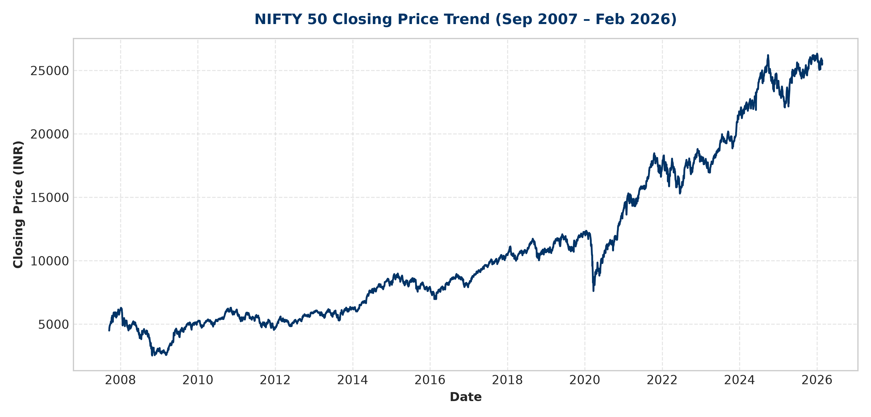
Figure: NIFTY 50 Historical Closing Price Trend (September 2007 – February 2026)
Observation: The price visualization documents substantial long-term growth interrupted by major cyclical contractions. The most pronounced drawdown occurs during the 2008 global financial crisis, where the index declined to its dataset minimum of 2,524.20. A second severe, rapid decline is observed in early 2020 during the COVID-19 market panic. In both instances, the index subsequently entered extended multi-year bull cycles. While the overall trajectory demonstrates robust nominal price growth, the line chart alone does not reflect day-to-day volatility dynamics.
10. Trading Volume Analysis
Trading volume reflects the reported quantity of index component shares or contracts traded during each session. Visualizing volume across the 18-year dataset highlights significant structural changes in data recording over time.
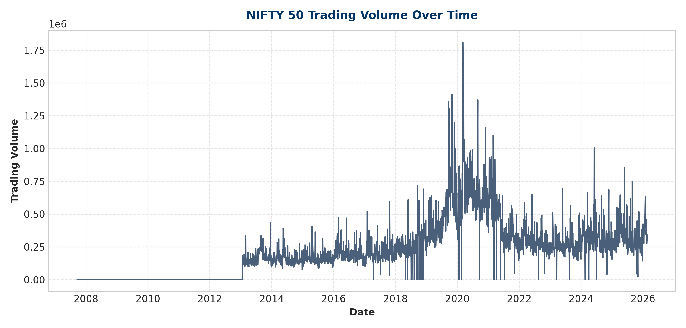
Figure: NIFTY 50 Historical Trading Volume Over Time
Observation: The volume series displays substantial variability. A large portion of early observations (2007 through early 2014) show zero reported volume, reflecting data recording gaps in index volume aggregation during earlier periods. In later years, reported volume becomes continuously populated, exhibiting prominent spikes around 2020 and 2024 (reaching a maximum recorded volume of 1,811,000 units).
Because the dataset represents a aggregate stock market index rather than an individual equity security, the volume field should be interpreted with caution. Consequently, volume is treated as a supplementary diagnostic field rather than a primary driver for return or risk conclusions.
11. Daily Return Analysis
Daily percentage returns (Daily_Return_%) measure session-to-session relative price changes. Analyzing daily returns isolates market volatility from absolute price index scaling.
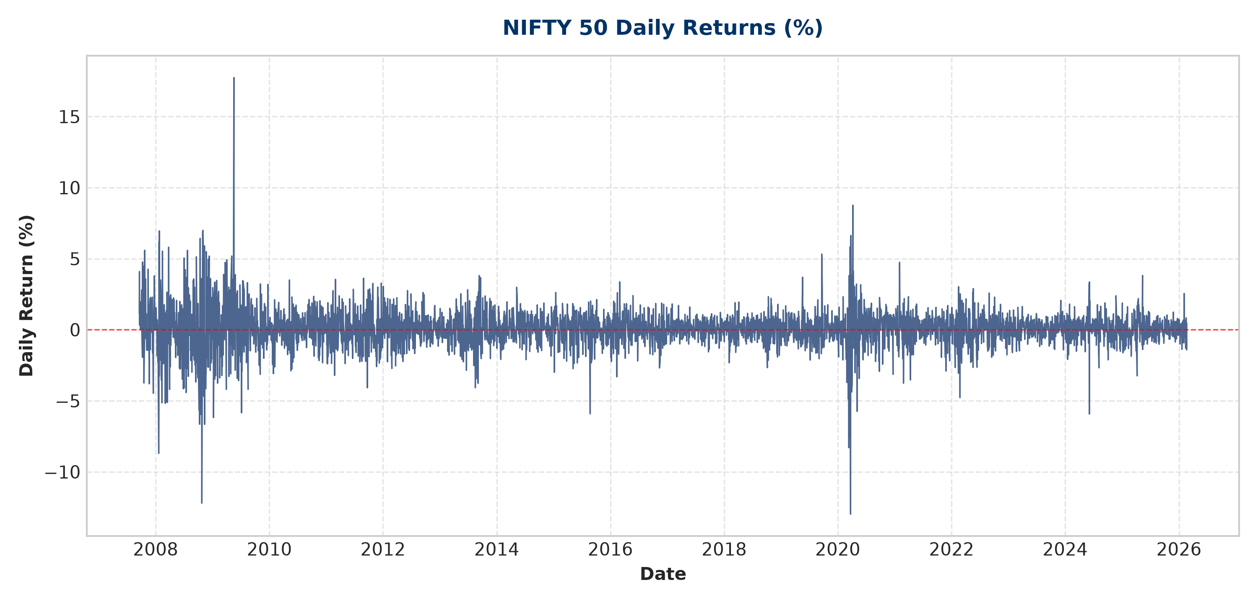
Figure: NIFTY 50 Daily Return Percentage Series (%)
Confirmed numerical metrics from daily return analysis:
- Maximum Daily Return: +17.744066% recorded on 18 May 2009.
- Minimum Daily Return: -12.980466% recorded on 23 March 2020.
- Positive Return Days: 2,399 trading sessions (53.06% of non-null sessions).
- Negative Return Days: 2,118 trading sessions (46.85% of non-null sessions).
- Zero Return Days: 4 trading sessions (0.09% of non-null sessions).
- Average Positive-Day Return: +0.854256% across positive-return sessions.
- Average Negative-Day Return: -0.867407% across negative-return sessions.
- Total Positive Return Contribution: +2,049.36% (simple arithmetic sum).
- Total Negative Return Contribution: -1,837.17% (simple arithmetic sum).
- Net Return Contribution: +212.19% (simple arithmetic sum).
Observation: Daily returns are tightly clustered around zero during normal market conditions. However, the time-series plot reveals significant volatility clustering—periods of high volatility (drawdowns and rapid rebounds) group together in time, punctuated by long periods of low daily return variance.
12. Return Distribution Analysis
A 50-bin histogram was constructed to evaluate the empirical frequency distribution of daily returns against standard statistical distribution models.
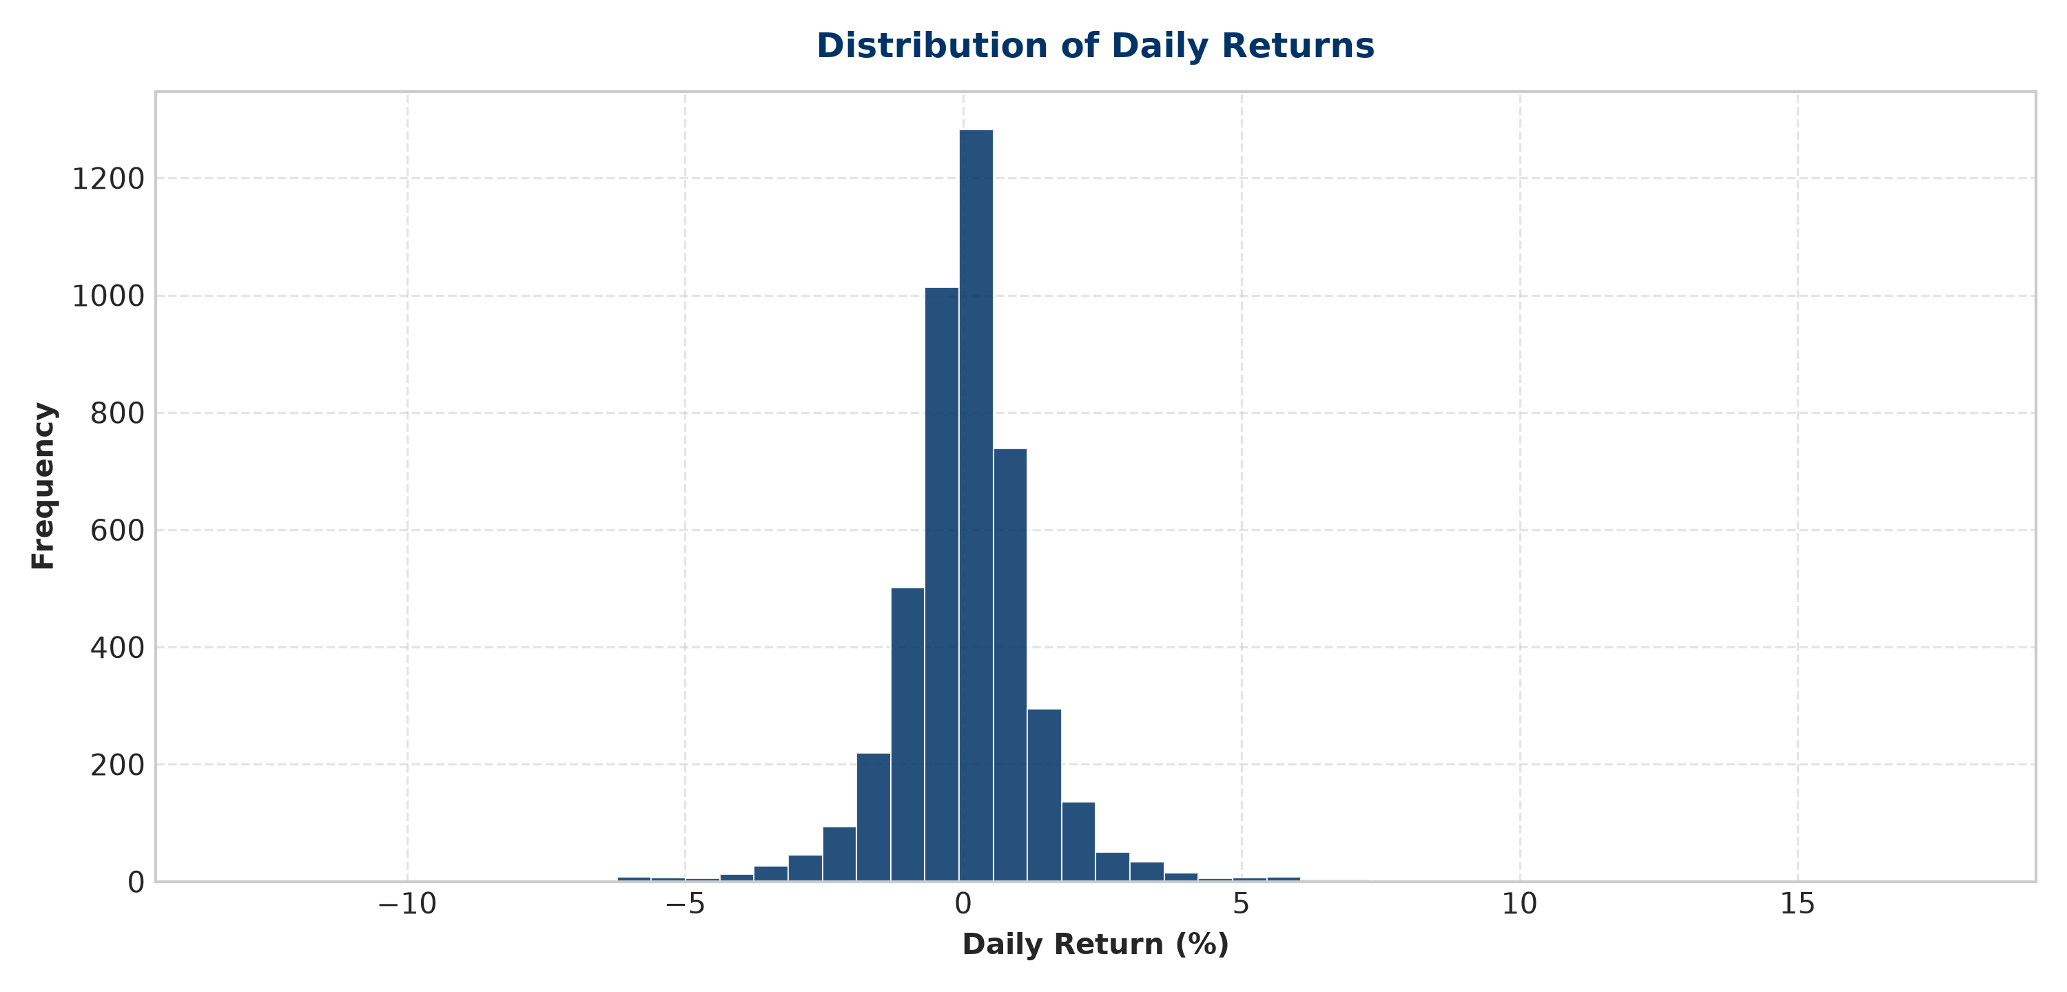
Figure: Distribution Histogram of NIFTY 50 Daily Percentage Returns
Distribution Higher-Order Moments:
- Skewness: 0.05605835144439669
- Kurtosis: 16.067178626140414
Statistical Interpretation: Skewness measures distribution asymmetry. A skewness value of +0.0561 is very close to zero, indicating that the overall distribution of daily returns is approximately symmetric around its central axis. Positive and negative daily return occurrences exhibit comparable structural shapes.
Kurtosis measures tail thickness and peak height relative to a normal distribution. Using Pandas Series.kurt(), which calculates Fisher's excess kurtosis, a standard normal distribution has a theoretical reference value of 0.0. The observed excess kurtosis of 16.07 indicates severe leptokurtosis (heavy tails and a high central peak). This is consistent with extreme daily price moves occurring far more frequently in the NIFTY 50 index than predicted by standard Gaussian models.
13. Extreme Return Analysis
To further investigate heavy-tail behavior, large single-day price movements were audited using a ±2.0% daily return threshold:
- Large Positive Returns (> +2.0%): 193 days (4.27% of trading sessions).
- Large Negative Returns (< -2.0%): 194 days (4.29% of trading sessions).
- Average Magnitude of Large Positive Moves: +3.212628%
- Average Magnitude of Large Negative Moves: -3.230241%
Observation: Extreme movements display remarkable directional symmetry. Large positive sessions (193 days) and large negative sessions (194 days) occurred with almost identical frequency. Furthermore, the average magnitude of large gains (+3.21%) closely matches the average magnitude of large losses (-3.23%). This demonstrates that market shocks in the NIFTY 50 are non-directional in probability—large positive and negative movements occurred with similar historical frequency.
14. Cumulative Return Analysis
Cumulative index return represents the total compounded price growth achieved across the analyzed timeframe. Proper financial methodology requires compounding daily fractional returns rather than summing percentage changes arithmeticly.
Mathematically, the compounded cumulative return is calculated as:
Cumulative Return = ∏ (1 + r_t / 100) - 1
where r_t represents the daily percentage return on day t.
Exact Result: Confirmed Compounded Cumulative Return Result: 468.92640262516744% (+468.93%).
Validation Check: To verify dataset return accuracy, daily percentage returns were independently calculated from raw closing prices using df['Close'].pct_change() * 100 and compared against the dataset's Daily_Return_% column. The maximum absolute difference across all 4,521 return pairs was 1.7763568394002505e-15. This near-zero difference (within standard IEEE 754 floating-point machine precision) confirms that the dataset daily returns are 100% accurate.
15. Hypothetical ₹100 Growth Analysis
To provide a clear intuitive benchmark of cumulative growth, a hypothetical investment model tracking an initial principal of ₹100 invested on 17 September 2007 was constructed using compounded daily returns: Investment_Value = 100 * ∏ (1 + r_t / 100).
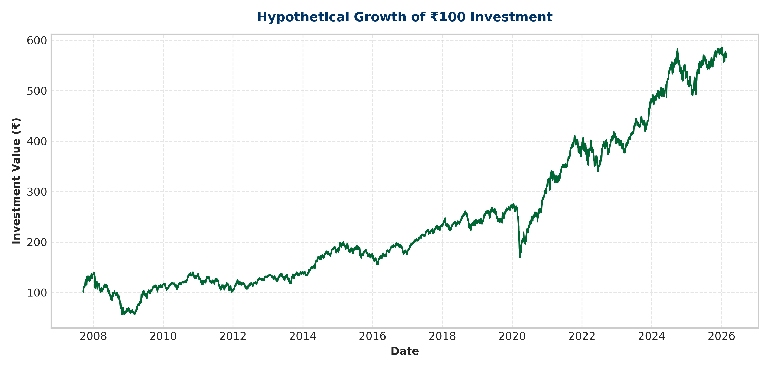
Figure: Hypothetical Growth Trajectory of ₹100 Compounded Daily (Sep 2007 – Feb 2026)
Final Value: Confirmed Final Portfolio Value (as of 20 February 2026): ₹568.93 (exact: ₹568.9264026251674).
NOTE: Hypothetical Investment Calculation Scope Disclaimer
This growth model represents a theoretical price-return calculation based solely on historical NIFTY 50 index closing levels. It does NOT account for cash dividend yields, index expense ratios, fund management fees, brokerage commissions, STT/taxes, market impact costs, or execution slippage. It is presented strictly for analytical baseline modeling, not as an achievable retail investment result.

16. Moving Average Analysis
Moving averages smooth price fluctuations to isolate underlying directional trends. The 50-day simple moving average (MA50) captures medium-term momentum, while the 200-day simple moving average (MA200) defines long-term structural market trends.
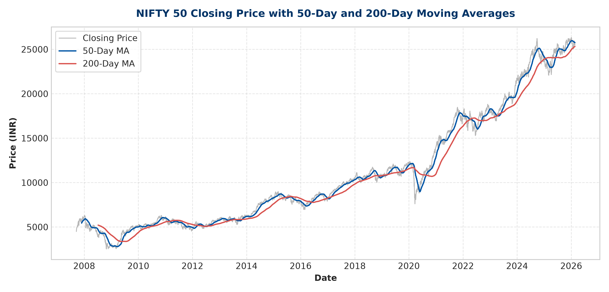
Figure: NIFTY 50 Closing Price overlaid with 50-Day and 200-Day Moving Averages
Observation: MA50 reacts rapidly to short-term market adjustments, frequently tracking close to the daily price line. MA200 exhibits strong smoothing characteristics, acting as a macro baseline during major market cycles. During sustained bull markets (e.g., 2014–2018 and 2020–2024), the closing price consistently trades above both moving averages.
17. MA50 vs MA200 Relationship Analysis
Quantitative analysis of the structural relationship between MA50 and MA200 was performed across all valid comparison sessions (df.dropna(subset=['MA_50', 'MA_200'])).
Confirmed Numerical Results:
- Valid MA Comparison Days: 4,323 trading sessions.
- MA50 > MA200 (Bullish Trend Regime): 3,062 trading sessions.
- Percentage of Valid Days MA50 > MA200: 70.83044182280823% (approx 70.83%).
- MA50 <= MA200 (Bearish / Correction Regime): 1,261 trading sessions (29.17%).
- Number of MA Trend Changes: 24 structural crossovers across the 18-year period.
- Latest Observation Date: 20 February 2026
- Latest MA50 Level: 25,760.2261328125
- Latest MA200 Level: 25,322.43859375
- Latest State: MA50 is ABOVE MA200 (+437.79 points spread).
NOTE: Trend Indicator Disclaimer
The MA50/MA200 relationship is a lagging descriptive trend classification metric. While a positive spread (MA50 > MA200) reflects historical medium-term outperformance relative to long-term baselines, it should NOT be interpreted as a predictive standalone trading signal or investment recommendation.

18. Rolling Volatility Analysis
Market risk dynamics were evaluated by computing a 30-trading-day rolling standard deviation of daily percentage returns (returns.rolling(window=30).std()).
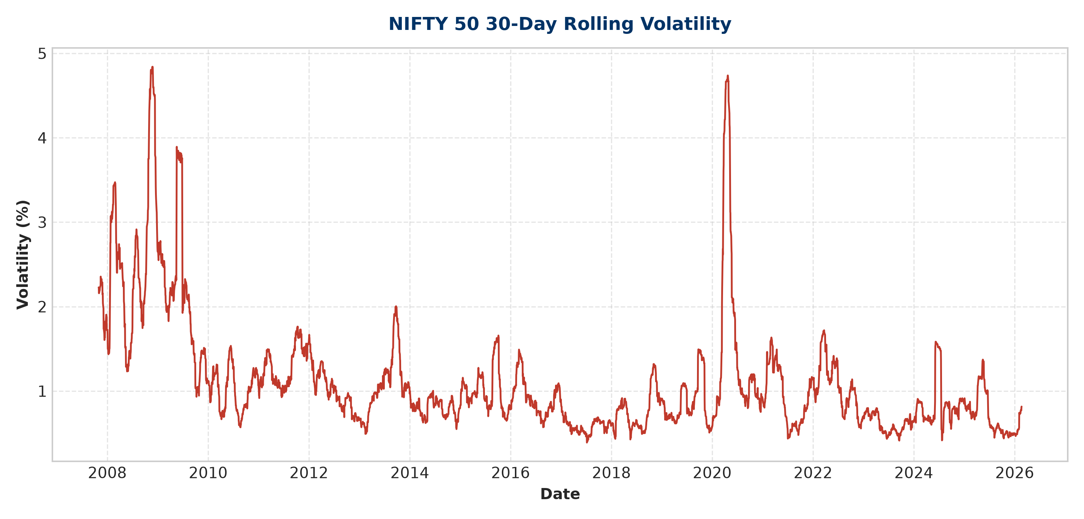
Figure: NIFTY 50 30-Day Rolling Volatility (%) Series
Confirmed Volatility Metrics:
- Average 30-Day Rolling Volatility: 1.1027887945952781% (approx 1.10%).
- Maximum 30-Day Rolling Volatility: 4.840942691965477% (approx 4.84%).
- Date of Peak Volatility: 24 November 2008 (during the height of the 2008 global financial crisis).
NOTE: Methodological Clarification on Rolling Volatility
It is critical to distinguish rolling volatility from single-day price returns. The peak value of 4.84% is NOT a single-day loss or gain; it represents the standard deviation of daily returns computed over a 30-trading-day rolling window. It measures return dispersion and risk intensity, not index price change.

19. Yearly Volatility Analysis
To compare risk regimes across calendar years, the mean 30-day rolling volatility was aggregated by year (df.groupby(df['Date'].dt.year)['Rolling_Volatility'].mean()).
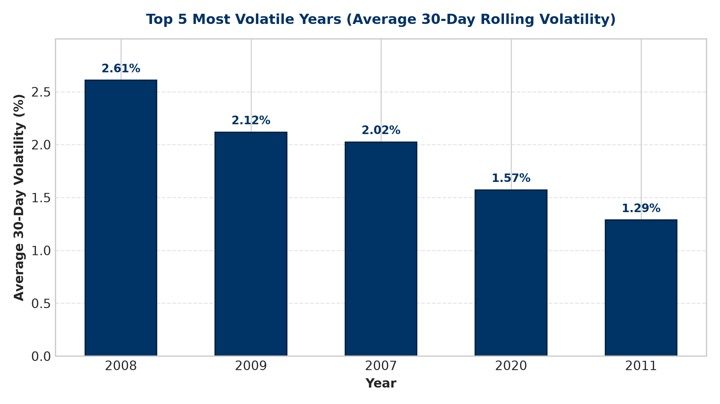
Figure: Top 5 Most Volatile Years by Average 30-Day Rolling Volatility (%)
Top 5 Most Volatile Years Summary Table:
Rank | Calendar Year | Mean 30-Day Rolling Volatility (%)
1 | 2008 | 2.608346%
2 | 2009 | 2.117138%
3 | 2007 (Partial) | 2.024431%
4 | 2020 | 1.571958%
5 | 2011 | 1.286525%
Partial-Year Data Limitations: Year 2007 contains data starting on 17 September 2007 (73 sessions), capturing the volatile Q4 2007 bull run. Year 2026 contains data through 20 February 2026 (34 sessions). These partial-year averages should be interpreted with appropriate context when making full-year comparisons.
20. Key Findings
The exploratory analysis yields nine core empirical findings supported strictly by the dataset:
- 1. Long-Term Growth Trajectory: Over the 18-year period from Sep 2007 to Feb 2026, the NIFTY 50 index expanded from 4,494.65 to 25,571.25, demonstrating strong secular index expansion despite major intermediate contractions.
- 2. Daily Return Balance: Daily returns averaged +0.0469% with 2,399 positive days (53.06%), 2,118 negative days (46.85%), and 4 zero days.
- 3. Extreme Single-Day Events: The maximum single-day gain was +17.74% on 18 May 2009; the minimum single-day drop was -12.98% on 23 March 2020.
- 4. Heavy-Tailed Return Distribution: Skewness (+0.0561) confirms approximate directional symmetry, but high excess kurtosis (16.07) is consistent with severe leptokurtic tail behavior.
- 5. Balanced Shock Frequency: Large moves (> ±2.0%) occurred on 193 positive days (avg +3.21%) and 194 negative days (avg -3.23%), exhibiting symmetrical shock frequency.
- 6. Compounded Growth Metric: Compounding daily index returns yields a total cumulative return of +468.93%, growing a theoretical ₹100 principal to ₹568.93.
- 7. Dominant Moving Average Regime: The MA50 resided above the MA200 on 3,062 of 4,323 valid sessions (70.83%), where MA50 was above MA200 on approximately 70.83% of valid observations across 24 MA trend relationship changes/crossovers.
- 8. Volatility Clustering & Peaks: Average 30-day rolling volatility stood at 1.10%, peaking at 4.84% on 24 November 2008 during the global financial crisis.
- 9. Annual Risk Concentration: The year 2008 recorded the highest mean 30-day rolling volatility (2.61%), followed by 2009 (2.12%) and 2020 (1.57%).
21. Conclusion
This Week 1 Exploratory Data Analysis report provides a comprehensive, empirically validated baseline of NIFTY 50 index performance spanning September 2007 to February 2026. The structured cleaning workflow successfully verified data integrity, resolved header metadata issues, and established zero logical boundary violations.
The quantitative findings are consistent with the observation that while the NIFTY 50 has delivered substantial long-term compounded growth (+468.93%), the underlying return series exhibits non-Gaussian tail behavior, volatility clustering during macro shocks, and recurring trend crossovers. The cleaned dataset and validated metrics establish a reliable foundation for subsequent Week 2 financial modeling and technical tasks.

