NIFTY 50 Financial Forecasting

Week 2 — Financial Forecast Model

━━━━━━━━━━━━━━━━━━━━━━━━━━━━━━

Prepared by
Pavan Poriya

September 2026

Table of Contents
1. Executive Summary
2. Week 2 Objective
3. Dataset Used
4. Financial Indicator Selection
5. Feature Engineering
6. Forecast Model Design
7. Model Justification
8. Train/Test Methodology
9. Model Implementation
10. Model Evaluation
11. Actual vs Predicted Results
12. Future Forecast
13. Forecast Visualization
14. Forecast Interpretation
15. Limitations
16. Conclusion

1. Executive Summary
This report presents the Week 2 deliverable of the NIFTY 50 financial data analysis internship project. Building upon the Exploratory Data Analysis (EDA) completed in Week 1, this phase develops a basic financial forecast model for the NIFTY 50 index closing price.
A Linear Regression model was implemented using 7 lag-based features derived from historical closing price data. The model was trained on a chronological 80% training set (3,601 observations from 2007-10-16 to 2022-06-29) and evaluated on an unseen chronological 20% test set (901 observations from 2022-06-30 to 2026-02-20).
The model achieved the following evaluation results on the unseen test set: MAE = 82.01, RMSE = 114.23, MAPE = 0.3747%, and R² = 0.998622, indicating strong predictive performance. A 30-session future forecast was generated from 2026-02-23 to 2026-04-03, projecting a modest upward trajectory from the last observed close of ₹25,571.25 to approximately ₹25,756.65.
This forecast is a model-based, indicative estimate and should not be interpreted as financial advice or a guaranteed market prediction.

2. Week 2 Objective
The objective of Week 2 is to develop a basic financial forecast model using the NIFTY 50 dataset analyzed during Week 1. The internship task specifically requires:
- Choosing a financial indicator for forecasting
- Designing and implementing a forecast model
- Evaluating the model on unseen data
- Generating future forecast values
- Analyzing and interpreting the forecast results

This model is intended as an educational and basic forecasting exercise. It demonstrates fundamental time-series forecasting principles and should not be treated as a guaranteed market prediction tool.

3. Dataset Used
The same NIFTY 50 historical dataset used in Week 1 serves as the foundation for this forecasting exercise. The dataset was obtained from Kaggle and contains daily OHLCV (Open, High, Low, Close, Volume) data.
Property | Value
Dataset File | NIFTY50_1995_to_Feb_2026.csv
Source | Kaggle
Analysis Period | 17 September 2007 – 20 February 2026
Raw Observations | 4,523 (including 1 metadata row)
Cleaned Observations | 4,522
Columns | 10
Primary Column Used | Close (Closing Price)

Data cleaning followed the same steps as Week 1: removal of the metadata row, datetime conversion, numeric type conversion, and chronological sorting. After feature engineering and dropping rows required for lag computation, 4,502 rows remained for modeling (date range: 2007-10-16 to 2026-02-20).

4. Financial Indicator Selection
Selected Indicator: NIFTY 50 Closing Price (Close)

The closing price was selected as the primary forecast target for the following reasons:
- The closing price is the most widely used price indicator in financial markets, representing the final consensus price at the end of each trading session.
- It was the primary variable analyzed in Week 1, providing continuity between both weeks of the project.
- Forecasting closing prices is a fundamental task in financial modeling and is directly relevant to understanding market behavior.
- The closing price series is continuous, numeric, and has sufficient historical depth (4,522 observations spanning 18+ years) for robust time-series modeling.
- Closing prices are publicly available and form the basis for many financial instruments, indices, and technical analysis tools.

5. Feature Engineering
Seven lag-based features were engineered from the historical closing price. Each feature uses only information available before the target date, ensuring no future data leakage.
Feature | Description | Purpose
Close_Lag_1 | Closing price 1 day ago | Very short-term momentum
Close_Lag_5 | Closing price 5 days ago | Weekly price level
Close_Lag_10 | Closing price 10 days ago | Medium-term price level
Close_Lag_20 | Closing price 20 days ago | Monthly price level
MA_5 | 5-day simple moving average | Short-term trend signal
MA_20 | 20-day simple moving average | Medium-term trend signal
Daily_Return_Pct | Daily percentage return | Recent price change direction

Feature Justification:
- Lag features capture short-term and medium-term price momentum at different time horizons. Because financial prices exhibit autocorrelation, past values are informative predictors of future values.
- Moving averages smooth out daily noise and capture underlying trends. Both short-term (MA_5) and medium-term (MA_20) averages help the model understand the current trend context.
- Daily return captures the direction and magnitude of the most recent price movement, providing a signal about immediate market momentum.
- All features are strictly historical — no future information enters the model. Lag features by construction use only past values, and moving averages are computed using a rolling window ending before the target date.
After feature engineering and dropping rows with NaN values (caused by the lagging operations), 4,502 rows remained for modeling (date range: 2007-10-16 to 2026-02-20).

6. Forecast Model Design
Model: Linear Regression

The forecast model treats closing price prediction as a supervised regression problem. Given a set of 7 lag-based features computed from historical data, the model predicts the next day's closing price.
Linear Regression finds the best-fitting linear relationship between the input features and the target variable by minimizing the sum of squared residuals (Ordinary Least Squares).

Model Equation:
Close = β₀ + β₁·Close_Lag_1 + β₂·Close_Lag_5 + β₃·Close_Lag_10 + β₄·Close_Lag_20 + β₅·MA_5 + β₆·MA_20 + β₇·Daily_Return_Pct

7. Model Justification
Why Linear Regression?
- Simplicity: Linear Regression is one of the most straightforward and well-understood algorithms, making it easy to explain and justify to an internship evaluator.
- Interpretability: The model coefficients directly show the contribution of each feature to the prediction, enabling transparent analysis of feature importance.
- Reproducibility: Given the same data and features, the results are exactly reproducible with no randomness in the training process.
- Baseline purpose: It serves as a strong baseline against which more complex models (e.g., Random Forest, LSTM neural networks) could be compared in future work.
- Low overfitting risk: With only 7 features and a large training set of 3,601 observations, the model has sufficient data relative to its complexity.

Why lag-based features?
- Financial time-series data exhibits autocorrelation — past prices are correlated with future prices. Lag features directly exploit this well-documented statistical property.
- Different lag horizons (1, 5, 10, 20 days) capture momentum at multiple time scales, from very short-term to monthly.

Why moving averages?
- Moving averages are widely used in technical analysis to identify trends. They smooth out daily fluctuations and provide a cleaner signal of the price direction.
- Both short-term (MA_5) and medium-term (MA_20) averages help the model understand the current trend context beyond individual daily prices.

Why chronological splitting?
- Financial time-series data has a natural temporal order. Random shuffling would allow future information to leak into the training set, producing unrealistically optimistic evaluation results.
- Chronological splitting simulates a real forecasting scenario where we train on past data and predict future values, which is the only valid evaluation methodology for time-series models.

8. Train/Test Methodology
Chronological 80/20 Split

An 80/20 chronological split was used to divide the modeling data into training and testing sets. The first 80% of observations (chronologically earlier) form the training set, and the remaining 20% (chronologically later) form the test set.
Set | Observations | Date Range | Proportion
Training | 3,601 | 2007-10-16 to 2022-06-29 | 80.0%
Testing | 901 | 2022-06-30 to 2026-02-20 | 20.0%
Total | 4,502 | 2007-10-16 to 2026-02-20 | 100.0%

Why this approach was chosen:
- It simulates a real forecasting scenario where we train on past data and predict future values.
- The test set (901 observations spanning nearly 4 years) represents truly unseen future data.
- Random shuffling was explicitly avoided to prevent any form of data leakage.
- This is the standard and accepted methodology for evaluating financial time-series models.

9. Model Implementation
The model was implemented in Python using the following libraries:
- pandas — Data manipulation, cleaning, and feature engineering
- numpy — Numerical computations and array operations
- scikit-learn — Linear Regression model and evaluation metrics (MAE, RMSE, R²)
- matplotlib — Chart and visualization generation

Implementation Workflow:
- Step 1: Load the cleaned NIFTY 50 historical CSV dataset.
- Step 2: Clean the data (replicate Week 1 cleaning steps).
- Step 3: Create 7 lag-based features from historical closing prices.
- Step 4: Remove rows with NaN values caused by lagging operations.
- Step 5: Preserve chronological order throughout the pipeline.
- Step 6: Split into training (80%) and testing (20%) sets using chronological indices.
- Step 7: Train the Linear Regression model on the training set.
- Step 8: Generate predictions on the unseen test set.
- Step 9: Evaluate predictions using MAE, RMSE, MAPE, and R².
- Step 10: Generate a 30-session future forecast using recursive multi-step forecasting.

Trained Model Coefficients:
Feature | Coefficient
Close_Lag_1 | 0.837639
Close_Lag_5 | −0.075091
Close_Lag_10 | 0.000978
Close_Lag_20 | 0.001212
MA_5 | 0.239807
MA_20 | −0.004286
Daily_Return_Pct | 62.500278
Intercept | −1.925680

The dominant coefficient is Close_Lag_1 (0.837639), confirming that the most recent closing price is the strongest predictor of the next day's closing price. This is consistent with the well-known autocorrelation in financial price series. The Daily_Return_Pct coefficient (62.500278) reflects the percentage-to-absolute-price conversion inherent in the feature definition.

10. Model Evaluation
The model was evaluated on the unseen chronological test set (901 observations). All metrics were calculated from actual model predictions — no values were manually entered or assumed.

Metric | Value | Interpretation
MAE (Mean Absolute Error) | 82.01 | Average prediction error ≈ 82 NIFTY points
RMSE (Root Mean Squared Error) | 114.23 | Typical error (large errors penalized) ≈ 114 points
MAPE (Mean Absolute % Error) | 0.3747% | Average error ≈ 0.37% of actual price
R² (Coefficient of Determination) | 0.998622 | Model explains ≈ 99.86% of test set variance

Metric Interpretations:
- MAE = 82.01: On average, the model's prediction deviates from the actual closing price by approximately 82 NIFTY points. This provides a straightforward measure of typical prediction error.
- RMSE = 114.23: The root mean squared error is higher than MAE because it gives more weight to larger errors. This indicates that while most predictions are close, a few days have larger deviations.
- MAPE = 0.3747%: The model's average prediction error is approximately 0.37% of the actual closing price. This is a very low percentage error, indicating high relative accuracy.
- R² = 0.998622: The model explains approximately 99.86% of the variance in the test set closing prices. This demonstrates very strong predictive power, though R² alone should not be the sole evaluation criterion.

Additional Error Analysis:
Error Metric | Value
Mean error (bias) | 2.83
Median absolute error | 61.59
Maximum absolute error | 877.43
Minimum absolute error | 0.00
Standard deviation of errors | 114.20
Days with overprediction | 481 / 901
Days with underprediction | 420 / 901

The positive mean error (2.83) indicates a slight upward bias in predictions. The model overpredicted on 481 days and underpredicted on 420 days, showing a nearly balanced error distribution with a marginal tendency to overpredict. The maximum absolute error of 877.43 occurred on a day with an unusual price movement, which is expected in financial data.

11. Actual vs Predicted Results
Figure 1 below shows the actual NIFTY 50 closing prices versus the model's predictions over the entire test period (2022-06-30 to 2026-02-20).
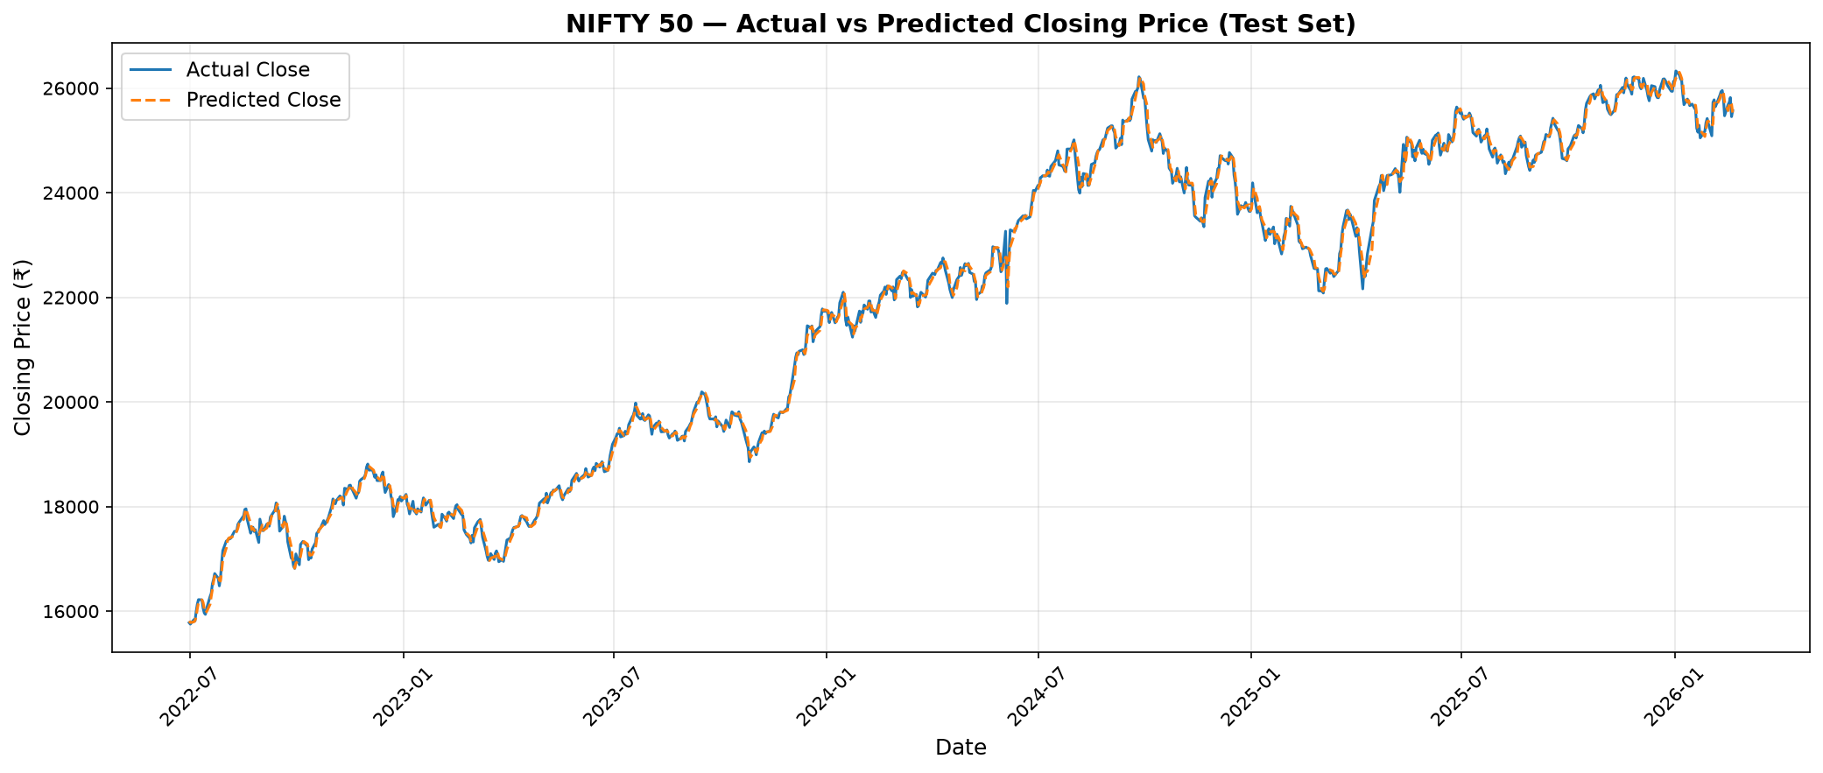
Figure 1: Actual vs Predicted NIFTY 50 Closing Price — Test Set (2022–2026)

The chart demonstrates that the predicted closing prices (orange dashed line) closely track the actual prices (blue solid line) throughout the test period. The predictions follow the general trend and capture most of the price movements, confirming the model's strong predictive performance as reflected in the high R² value (0.998622) and low MAPE (0.3747%).
However, a closer inspection reveals that the model tends to smooth out some of the sharper price movements, which is expected from a linear model that primarily captures trend-following behavior. This smoothing is reflected in the RMSE (114.23) being higher than the MAE (82.01), indicating that larger prediction errors occur on days with significant price swings.

12. Future Forecast
After evaluating the model, a 30-session future forecast was generated using recursive multi-step forecasting. In this approach, each predicted value is fed back as input for the next forecast step.

Forecast Summary:
Statistic | Value
Last Observed Close | ₹25,571.25
Last Observed Date | 2026-02-20
Forecast Horizon | 30 trading sessions
Forecast Period | 2026-02-23 to 2026-04-03
First Forecast Value | ₹25,614.96
Last Forecast Value | ₹25,756.65
Minimum Forecast | ₹25,614.96
Maximum Forecast | ₹25,756.65
Forecast Change (Absolute) | ₹185.40
Forecast Change (Percentage) | 0.7250%

30-Session Forecast Table:
Session | Date | Forecasted Close
1 | 2026-02-23 | ₹25,614.96
2 | 2026-02-24 | ₹25,627.20
3 | 2026-02-25 | ₹25,618.11
4 | 2026-02-26 | ₹25,622.94
5 | 2026-02-27 | ₹25,629.20
6 | 2026-03-02 | ₹25,634.15
7 | 2026-03-03 | ₹25,638.67
8 | 2026-03-04 | ₹25,643.76
9 | 2026-03-05 | ₹25,648.54
10 | 2026-03-06 | ₹25,653.40
11 | 2026-03-09 | ₹25,658.54
12 | 2026-03-10 | ₹25,663.88
13 | 2026-03-11 | ₹25,669.30
14 | 2026-03-12 | ₹25,674.62
15 | 2026-03-13 | ₹25,679.56
16 | 2026-03-16 | ₹25,684.69
17 | 2026-03-17 | ₹25,689.95
18 | 2026-03-18 | ₹25,695.34
19 | 2026-03-19 | ₹25,700.34
20 | 2026-03-20 | ₹25,705.38
21 | 2026-03-23 | ₹25,710.50
22 | 2026-03-24 | ₹25,715.65
23 | 2026-03-25 | ₹25,720.77
24 | 2026-03-26 | ₹25,725.89
25 | 2026-03-27 | ₹25,731.01
26 | 2026-03-30 | ₹25,736.14
27 | 2026-03-31 | ₹25,741.26
28 | 2026-04-01 | ₹25,746.39
29 | 2026-04-02 | ₹25,751.52
30 | 2026-04-03 | ₹25,756.65

13. Forecast Visualization
Figure 2 below shows the last 90 trading days of historical closing prices alongside the 30-session future forecast.
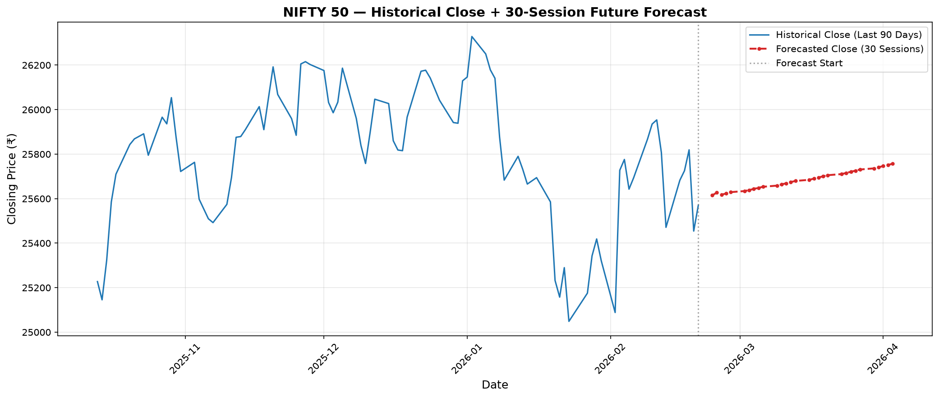
Figure 2: Historical Close (Last 90 Days) + 30-Session Future Forecast

Chart Description:
- The blue solid line represents the historical NIFTY 50 closing prices for the last 90 trading days.
- The red dashed line with markers represents the 30-session model-based forecast.
- The vertical dotted gray line marks the boundary between historical data and the forecast period.
- The forecast period extends from 2026-02-23 to 2026-04-03.

14. Forecast Interpretation
General Direction:
The model-based forecast suggests a modest upward trajectory for the NIFTY 50 over the next 30 trading sessions. The forecasted closing price rises gradually from ₹25,614.96 (Session 1) to ₹25,756.65 (Session 30).

Forecast Range:
The forecasted values range from ₹25,614.96 to ₹25,756.65, representing a range of approximately ₹141.69 points across the 30-session horizon. This relatively narrow range reflects the model's tendency to project a gradual, smooth path rather than volatile movements.

Change from Last Actual Close:
The last observed closing price was ₹25,571.25 (2026-02-20). The final forecast value is ₹25,756.65, representing an increase of ₹185.40 (0.7250%) over 30 sessions.

Model Performance Context:
The model demonstrated strong predictive power on the unseen test set (R² = 0.998622, MAPE = 0.3747%). However, this high accuracy primarily reflects the model's ability to follow the general price trend rather than predict exact turning points or sudden market shifts.

Reliability Assessment:
This forecast should be considered indicative only. It is a historical pattern-based estimate and does not guarantee future market performance. The forecast represents the model's best estimate based solely on historical price patterns and does not account for external factors that may influence future market movements.
Forecast uncertainty increases as the horizon extends further into the future. Recursive multi-step forecasting can accumulate errors over time, as each forecasted value is used as input for subsequent predictions.

15. Limitations
Model Limitations:
- Limited feature set: The model uses only 7 historical price-based features. Real financial markets are influenced by many additional factors not captured in this model.
- No external variables: The model does not incorporate macroeconomic conditions, interest rates, global market movements, political events, or company-level developments.
- Linear assumption: Linear Regression assumes a linear relationship between features and the target, which may not capture all non-linear market dynamics.
- Recursive error accumulation: In multi-step forecasting, prediction errors compound as each forecasted value is used as input for the next step.

Data Limitations:
- Historical patterns do not guarantee future performance. Financial markets can behave in ways that historical data does not predict.
- Market shocks and black swan events (e.g., pandemics, geopolitical crises, sudden policy changes) are inherently unpredictable from historical price data alone.
- Forecast accuracy generally deteriorates as the forecast horizon increases.

Ethical Considerations:
- This model should not be interpreted as financial advice. It is an academic exercise completed for learning purposes as part of an internship project.
- No investment decisions should be made based solely on this forecast.
- Past performance of any forecasting model does not guarantee future predictive accuracy.

16. Conclusion
This report presented the implementation of a basic financial forecast model for the NIFTY 50 index closing price as part of Week 2 of the internship project.

Summary of Achievements:
- Selected NIFTY 50 Closing Price as the forecasting indicator with clear justification based on its relevance, data availability, and alignment with Week 1 analysis.
- Engineered 7 meaningful lag-based features (Close_Lag_1, Close_Lag_5, Close_Lag_10, Close_Lag_20, MA_5, MA_20, Daily_Return_Pct) from purely historical data, ensuring no future data leakage.
- Implemented a Linear Regression model as a simple, interpretable, and reproducible baseline.
- Used an 80/20 chronological train/test split (3,601 training / 901 testing observations) to prevent data leakage and simulate real-world forecasting conditions.
- Achieved strong evaluation metrics on the unseen test set: MAE = 82.01, RMSE = 114.23, MAPE = 0.3747%, R² = 0.998622.
- Generated a 30-session future forecast (2026-02-23 to 2026-04-03) projecting a modest upward trajectory from ₹25,571.25 to ₹25,756.65 (+0.7250%).
- Provided professional visualizations for both actual vs predicted results and the future forecast.
- Acknowledged limitations including restricted feature set, absence of external variables, and the inherent uncertainty of financial market forecasting.

Key Takeaway:
The Linear Regression model using lag-based features provides a reasonable and interpretable baseline for NIFTY 50 closing price forecasting. The low MAPE (0.3747%) and high R² (0.998622) indicate that the model captures the general price trend effectively. However, the forecast should be treated as an indicative, model-based estimate — not as financial advice or a guaranteed prediction of future market behavior.
Future work could incorporate additional features (trading volume, volatility indicators, external market data) and more sophisticated models (Random Forest, gradient boosting, or LSTM neural networks) to potentially improve forecast accuracy and capture non-linear dynamics.

────────────────────────────────────────────────────────────
— End of Report —

