NIFTY 50 Financial Data Analysis
Final Internship Report
Weeks 1–6
Student:
Pavan Poriya
Dataset: NIFTY 50 Historical Index Data — 17 September 2007 to 20 February 2026
Scope: Exploratory Data Analysis · Financial Forecasting · Risk Analysis · Hypothesis Testing · Data Visualization
Educational internship project — all statements describe historical data; nothing in this report is investment advice.

Table of Contents
1. Executive Summary
2. Project Objective
3. Dataset Overview
4. Week 1 — Exploratory Data Analysis
5. Week 2 — Financial Forecasting
6. Week 3 — Financial Risk Analysis
7. Week 4 — Hypothesis Testing
8. Week 5 — Data Visualization
9. Integrated Findings Across the Project
10. Key Findings
11. Analytical Insights
12. Recommendations for Future Analysis
13. Limitations
14. Final Conclusion

1. Executive Summary
This report consolidates a six-week analysis of the NIFTY 50 index using 4,522 daily observations covering 17 September 2007 to 20 February 2026. The project progressed through five analytical stages — exploratory data analysis, forecasting, risk analysis, statistical hypothesis testing, and data visualization — and this final stage connects them into one coherent picture.
The analysis indicates a market with strong long-term growth and severe interim risk. The index closed at ₹4,494.65 on 17 September 2007 and ₹25,571.25 on 20 February 2026, a compounded price return of +468.93%; measured from its lowest close (₹2,524.20, October 2008) to its highest (₹26,328.55, January 2026) the range represents 943.05% of price movement. Growth, however, was interrupted by a maximum drawdown of -59.86% during the 2008 Global Financial Crisis, which took 743 days to recover, and a -38.44% crash drawdown in March 2020.
Daily returns averaged +0.0469% with a standard deviation of 1.3015% — noise roughly 28 times larger than the mean — and the distribution is strongly fat-tailed (excess kurtosis 16.07): 387 sessions (8.56%) moved more than ±2%, with the worst single-day loss of -12.98% (23 March 2020) and the best single-day gain of +17.74% (18 May 2009). A one-sample t-test rejected the null hypothesis of zero mean daily return (t = 2.424855, p = 0.015353 < 0.05), providing statistical evidence of a small positive drift that is far too weak for short-term predictability.
A lag-feature Linear Regression forecast model achieved strong in-sample-style fit on the chronologically held-out test set (R² = 0.9986, MAPE = 0.3747%, MAE = 82.01 points) and projected a modest +0.73% drift over the next 30 sessions — but the near-perfect R² reflects how strongly each close depends on the previous one, not economic forecasting power. Risk metrics (95% daily VaR of -1.83%, CVaR of -3.04%) and the volatility analysis (30-day volatility averaging 1.10% but peaking at 4.84%) quantify the uncertainty the point forecast does not convey.
The main recommendation is methodological: extend the model set beyond linear lag models, add exogenous variables, validate out-of-sample across regimes, and treat risk monitoring — volatility, drawdown, and tail metrics — as inseparable from any return analysis.

2. Project Objective
The internship project used historical NIFTY 50 index data to build, step by step, a complete descriptive and inferential picture of the index's historical behavior. The specific objectives were:
- Understand the structure and quality of the financial dataset, and prepare it reliably for analysis (Week 1).
- Explore historical price and return patterns, including trends, distributions, and volatility (Week 1).
- Develop a basic forecast model for the closing price using historical patterns (Week 2).
- Identify, quantify, and rank the principal financial risks, with mitigation strategies (Week 3).
- Test a precise statistical hypothesis about long-run returns rather than only describing them (Week 4).
- Convert the analyses into meaningful, well-explained visualizations (Week 5).
- Synthesize all findings into recommendations for future analysis (Week 6).
Each stage fed the next: the cleaned dataset from Week 1 is the input to every later week; the return and volatility structure discovered in Week 1 defines the risks measured in Week 3; the distributional properties found in Week 1 shaped the statistical methodology of Week 4; and Week 5 made every stage visually verifiable. Week 6 integrates the results.

3. Dataset Overview
The same dataset was used throughout all six weeks, so every number in this report refers to one consistent source.
Table A. Dataset summary
Property | Value
Source | Kaggle — NIFTY 50 Historical Data (NIFTY50_1995_to_Feb_2026.csv)
Valid period | 17 September 2007 – 20 February 2026
Raw rows | 4,523 (including 1 metadata row, removed)
Cleaned observations | 4,522 daily rows
Columns | Date, Open, High, Low, Close, Volume, Ticker, Daily_Return_%, MA_50, MA_200
Derived in later weeks | Rolling 30-day volatility, running peak, drawdown %, lag features, monthly/yearly aggregates
Valid daily-return observations | 4,521 (first day has no prior close)

3.1 Data Cleaning and Quality Validation
Cleaning performed in Week 1 (and reused unchanged in Weeks 2–5):
- Removed the metadata row present in the source CSV.
- Converted dates to datetime and sorted chronologically.
- Coerced price and volume columns to numeric types.
Validation checks all passed with zero violations:
- No High < Low inconsistencies; no Close/Open outside the High–Low range.
- No negative volume; no duplicate records.
- Recomputed MA_50/MA_200 and Daily_Return_% matched the source columns exactly (maximum absolute difference 0.0).

4. Week 1 — Exploratory Data Analysis
Week 1 established the descriptive foundation used by every later week.

4.1 Price and Cumulative Return Analysis
The index closed at ₹4,494.65 on the first day of the sample and ₹25,571.25 on the last, a compounded cumulative price return of +468.93% computed by compounding daily returns. A separate measure — the range from the lowest close (₹2,524.20 on 2008-10-27) to the highest close (₹26,328.55 on 2026-01-02) — spans 943.05%. The two numbers answer different questions: the first is the return of buying on day one and holding; the second is the total low-to-high price movement the index traversed. Both are used consistently in this report under those names.
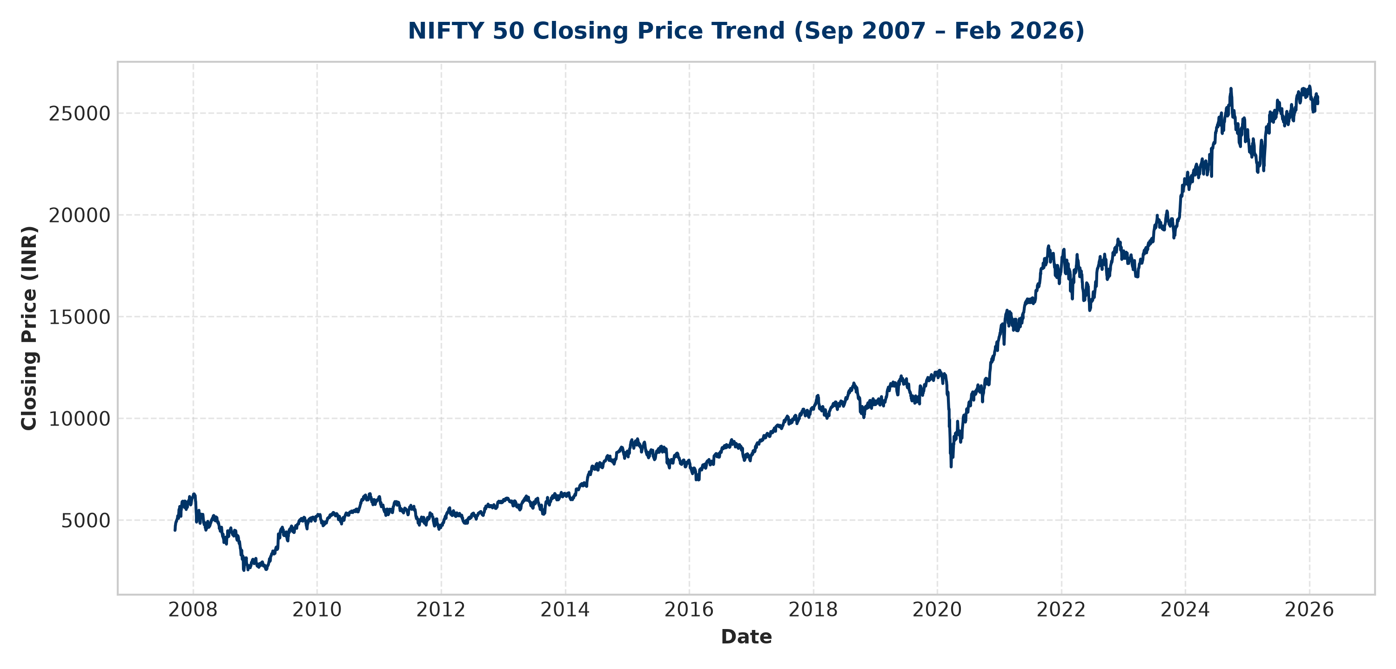
Figure 1. NIFTY 50 Long-Term Closing Price Trend (2007–2026)
Key observation: a sustained upward trend interrupted by deep, visible declines in 2008–09 and 2020.

4.2 Daily Return Behavior and Distribution
Daily returns averaged +0.0469% with a standard deviation of 1.3015%. Positive days (2,399) outnumbered negative days (2,118), and the average gain on positive days (+0.854%) slightly exceeded the average loss on negative days (-0.867%). Extremes were far larger: +17.74% (2009-05-18) and -12.98% (2020-03-23), with 193 days above +2% and 194 days below -2%.
The distribution is near-symmetric (skewness 0.056) but extremely fat-tailed (excess kurtosis 16.07 against 0 for a normal distribution) — a property that shaped both the risk methodology of Week 3 and the non-parametric robustness check of Week 4.
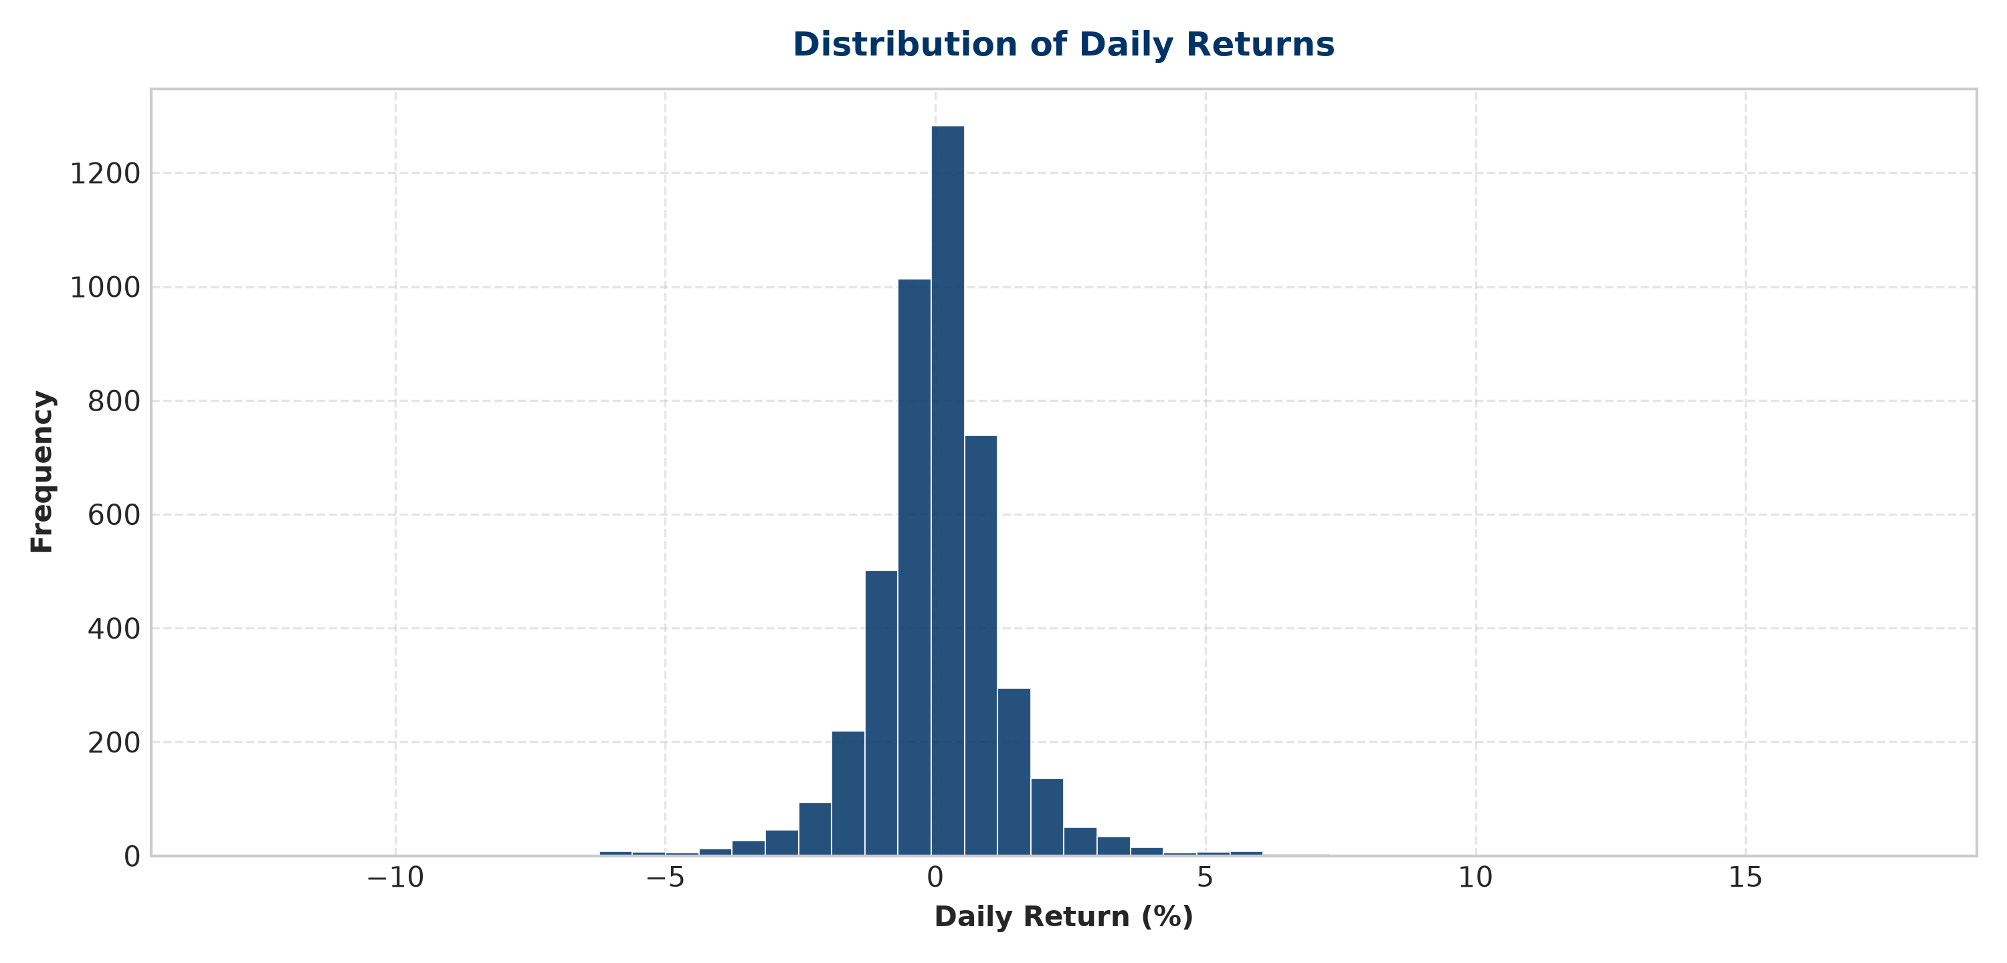
Figure 2. Distribution of Daily Returns (%)
Key observation: tall, narrow center with tails far heavier than any normal distribution.

4.3 Moving Averages and Volatility
The 50-day moving average sat above the 200-day average on 3,062 of 4,323 valid observations (70.83%); the exceptions cluster around the 2008 and 2020 crises. Average 30-day rolling volatility was 1.10%, peaking at 4.84% on 2008-11-24; 2008 recorded the highest yearly average volatility (2.61%) and 2017 the lowest (0.58%). A hypothetical ₹100 grew to ₹568.93 under compounded price returns.

5. Week 2 — Financial Forecasting

5.1 Model and Methodology
The forecast target was the next-day NIFTY 50 closing price. Seven lag-based features were engineered: Close_Lag_1, Close_Lag_5, Close_Lag_10, Close_Lag_20, MA_5, MA_20, and Daily_Return_Pct. A Linear Regression was chosen deliberately as a transparent baseline: its coefficients are interpretable, it trains deterministically, and it establishes an honest reference point before any complex model is considered.
The split was strictly chronological to avoid look-ahead bias: the model trained on 3,601 samples (2007-10-16 to 2022-06-29) and was tested on 901 unseen samples (2022-06-30 to 2026-02-20), an 80/20 split with no random shuffling.

5.2 Evaluation Results
Table B. Forecast model evaluation (test set: 2022-06-30 to 2026-02-20, n = 901)
Metric | Result | Interpretation
MAE | 82.01 | Average prediction error of about 82 NIFTY points per session
RMSE | 114.23 | Typical error with large misses penalized; some large errors exist
MAPE | 0.3747% | Average error is ~0.37% of the actual price level
R² | 0.998622 | Explains 99.86% of test-set price variance
Mean error (bias) | +2.83 | Negligible average bias; 481 over- vs 420 under-predictions
Max absolute error | 877.43 | Worst single-session miss — evidence of genuine uncertainty

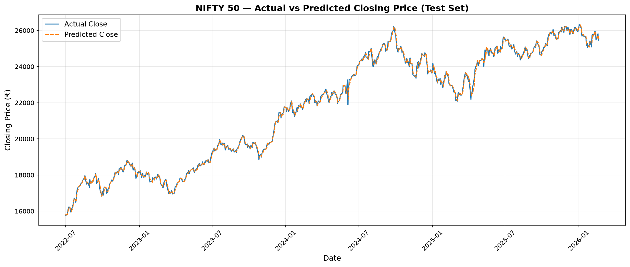
Figure 3. Actual vs Predicted Closing Prices, Test Set
Key observation: predictions track actuals closely, but the near-perfect fit mostly reflects the strong one-day autocorrelation of prices.
The near-perfect R² requires careful reading. Because the dominant feature is yesterday's close, a model can score R² = 0.9986 while knowing nothing beyond momentum — the R² measures price-level tracking, not genuine forecasting skill. The more informative numbers are MAE (82 points) and the 877-point worst miss, which quantify the real uncertainty around any single-day prediction.

5.3 Future Forecast
Iterating the model 30 sessions ahead (2026-02-23 to 2026-04-03) produced a first forecast of ₹25,614.96 and a last forecast of ₹25,756.65 — a change of +₹185.40 (+0.7250%) from the last observed close of ₹25,571.25. The path is a smooth, slightly upward drift, which is precisely what a lag-based linear model produces; it carries no information about shocks. The forecast is indicative of historical pattern continuation only, and its uncertainty grows with the horizon.
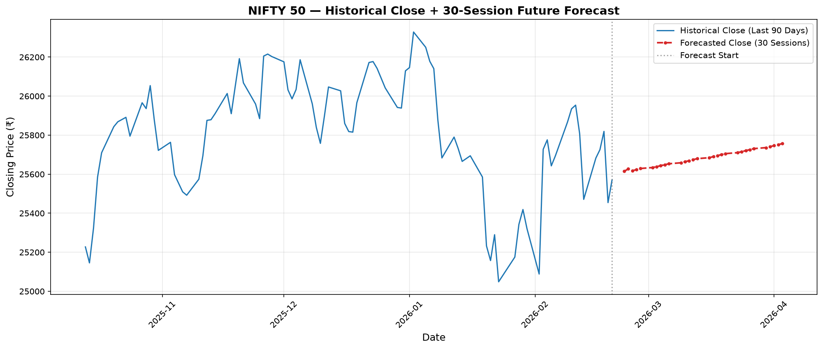
Figure 4. 30-Session Future Forecast (2026-02-23 to 2026-04-03)
Key observation: a near-linear upward path — the signature of a momentum model, not a shock-aware one.

6. Week 3 — Financial Risk Analysis
Week 3 converted the descriptive patterns of Week 1 into quantified, ranked risks with mitigation strategies.

6.1 Risk Categories and Evidence
Table C. Risk summary — evidence, impact, severity, and mitigation (from Week 3)
Risk | Evidence | Potential Impact | Severity | Mitigation
Market / Price Risk | Price range ₹2,524–₹26,329; max drawdown -59.86% | Large capital losses during downturns; extended recovery periods | Very High | Diversification; position sizing; exposure limits
Drawdown Risk | Max drawdown -59.86% (₹3,764.65 peak-to-trough); recovery took 743 days | Prolonged portfolio decline; slow compounding for years | Very High | Drawdown limits; rebalancing; recovery planning
Volatility Risk | Avg 30-day vol 1.10%; peak 4.84% (2008-11-24); 227 high-vol days (5.05%) | Larger-than-expected daily moves; unstable risk estimates | High | Volatility monitoring; risk budgets; reduced exposure in high-vol periods
Extreme Return / Shock Risk | Worst day -12.98%; best +17.74%; 387 days (8.56%) beyond ±2%; kurtosis 16.07 | Sudden single-session losses; VaR breaches | High | Stress testing; scenario analysis; liquidity buffers
Downside Risk | 46.85% negative days; VaR95 -1.83%; VaR99 -3.57%; CVaR95 -3.04% | Persistent negative days eroding value; tail losses beyond VaR | Moderate | Downside dashboards (VaR/CVaR); stop-loss rules; diversification

6.2 Key Quantitative Findings
- Maximum drawdown: -59.86% from a peak of ₹6,287.85 (2008-01-08) to a trough of ₹2,524.20 (2008-10-27); recovery took 743 days (achieved 2010-11-09). The five largest drawdowns were -59.86% (2008), -38.44% (2020), -27.89% (2011), -22.52% (2016), and -17.23% (2022).
- Volatility regime: average 30-day volatility 1.10%, but the top of the range (4.84%) is 4.4× the average; 227 days exceeded the high-volatility threshold (mean + 2σ = 2.47%). The five most volatile years were 2008 (2.61%), 2009 (2.12%), 2007 (2.02%), 2020 (1.57%), and 2011 (1.29%).
- Tail behavior: VaR at 95% confidence is -1.83% daily and CVaR (expected shortfall) is -3.04% — the average loss on the worst 5% of days is nearly double the VaR itself, a direct consequence of fat tails. At 99% confidence the gap widens: VaR -3.57% vs CVaR -5.33%.
- Asymmetric extremes: the best day (+17.74%) was larger in magnitude than the worst day (-12.98%); both belonged to the 2008–09 and 2020 stress clusters.

7. Week 4 — Hypothesis Testing

7.1 Research Question and Hypotheses
Research question: is the average daily return of the NIFTY 50 significantly different from zero over 2007–2026?
- Null hypothesis (H0): the mean daily return equals zero.
- Alternative hypothesis (H1): the mean daily return differs from zero.
- Significance level: α = 0.05.

7.2 Test Results and Decision
Table D. Hypothesis test results (n = 4,521 valid daily returns)
Test | Statistic | p-Value | Decision
One-sample t-test (primary) | t = 2.424855 (df = 4,520) | 0.015353 | Reject H0
Wilcoxon signed-rank (robustness) | W = 4,748,216.0 | 0.000054 | Reject H0

Before testing, Jarque-Bera rejected normality (JB = 48,516.68, p ≈ 0; excess kurtosis 16.0672), justifying the non-parametric Wilcoxon check alongside the t-test. Both tests agree: since p = 0.015353 < 0.05, the null hypothesis is rejected. The 95% confidence interval for the mean daily return is [+0.008988%, +0.084882%], entirely above zero.
In plain English: the historical evidence is statistically consistent with a small positive daily drift of about +0.047% per day, rather than pure chance around zero.

7.3 What the Result Does Not Prove
Statistical significance is not predictability. The daily standard deviation (1.3015%) is about 28 times larger than the mean (+0.0469%), so although the drift is statistically distinguishable from zero across 4,521 observations, it is far too small to predict the direction of any single day, week, or month. Compounded over years the drift is economically meaningful (~12.5% annualized price drift over this sample); over short horizons it is invisible inside the noise. The result also describes the past sample only — it does not establish that the drift will persist, and it is not investment advice.

8. Week 5 — Data Visualization
Week 5 produced eleven presentation-ready visualizations, each tied to one financial question. Four of the most informative are reproduced here because they carry the project's central story.
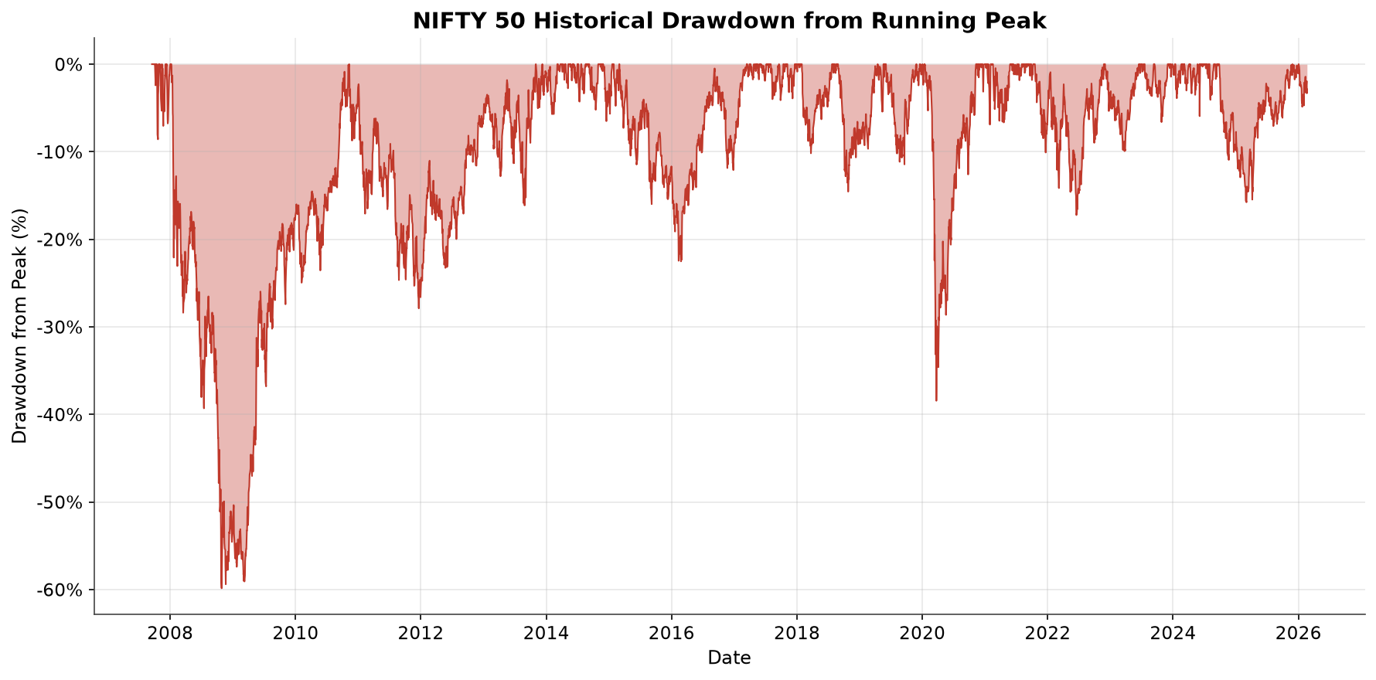
Figure 5. NIFTY 50 Historical Drawdown from Running Peak
Key observation: the 2008 crisis (-59.86%) kept the index below its prior peak for years, while the 2020 crash (-38.44%) recovered within months — depth and duration are different risks.
Why it matters: drawdown converts risk into the quantity an investor actually experiences — the loss from peak to trough. A -59.86% decline needs a +149% gain to undo, which is why Week 3 rated drawdown risk Very High even though returns eventually recovered.
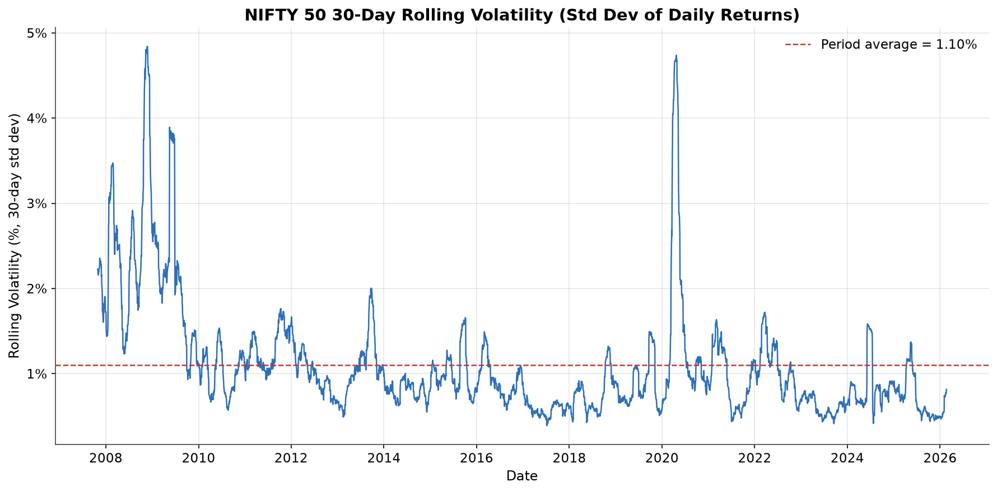
Figure 6. NIFTY 50 30-Day Rolling Volatility
Key observation: volatility is episodic — long calm stretches near 1% interrupted by bursts peaking at 4.84% (November 2008).
Why it matters: risk measured in calm periods understates crisis risk. Any forecast, VaR figure, or risk budget calibrated to the average would have been overwhelmed in 2008 and 2020.
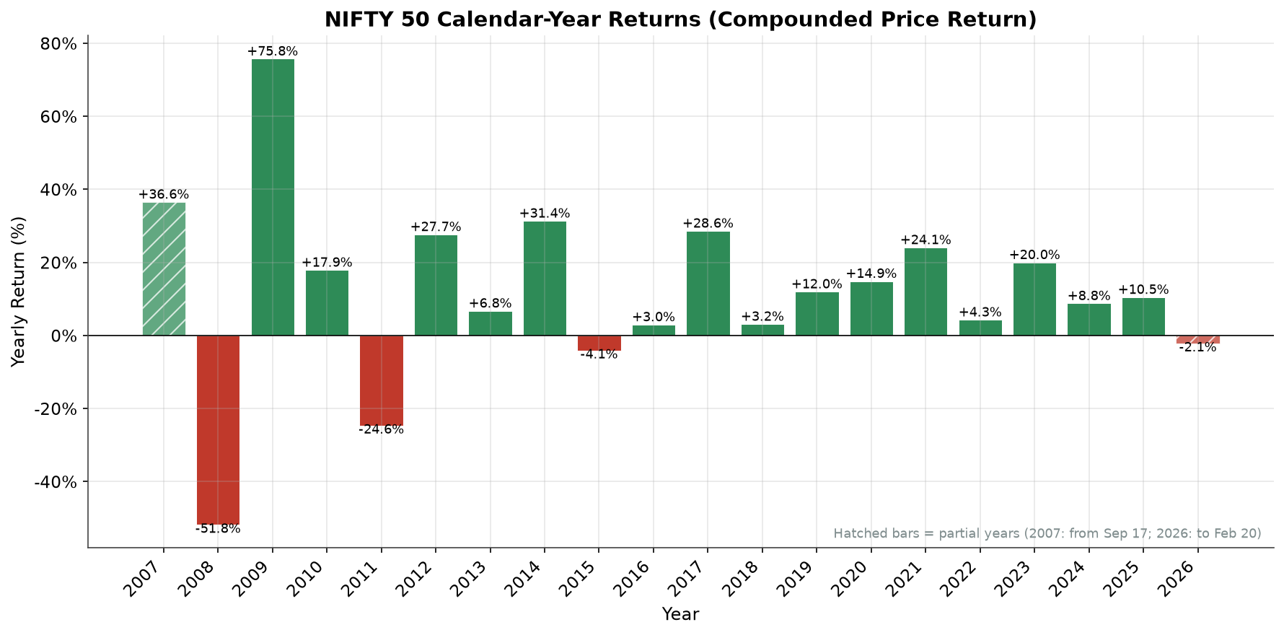
Figure 7. NIFTY 50 Calendar-Year Returns (Compounded)
Key observation: returns range from -51.79% (2008) to +75.76% (2009); 16 of 20 calendar years were positive, but the worst negative year dwarfs most positive years in magnitude.
Why it matters: yearly aggregation exposes the asymmetry that daily charts understate, and demonstrates why returns must be compounded — -51.79% followed by +75.76% still leaves the index about 15.3% below its end-2007 level.
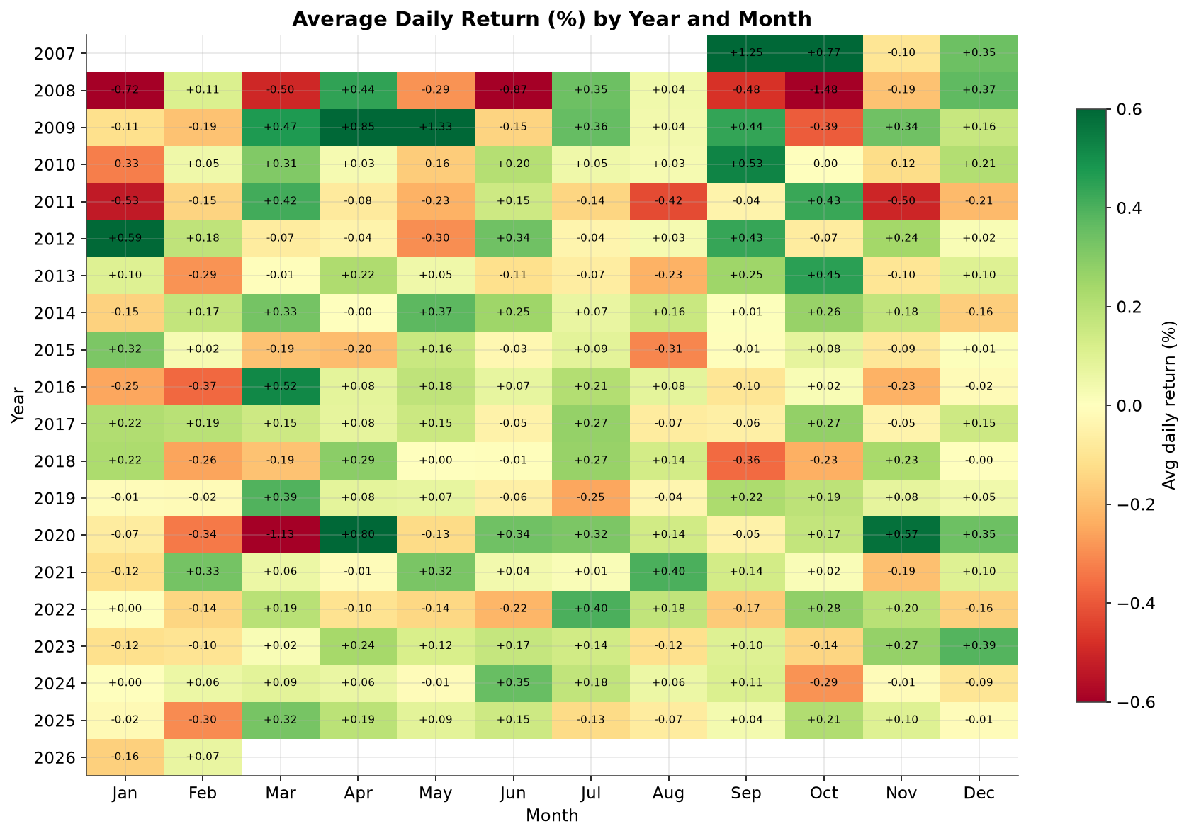
Figure 8. Average Daily Return by Year and Month
Key observation: no month column keeps a consistent color across years — the visible extremes belong to 2008 and March 2020.
Why it matters: the absence of a persistent monthly pattern is a useful negative result; it is consistent with Week 4's finding that short-horizon returns are not reliably predictable. The remaining visualizations (long-term trend, daily return behavior, return distribution, moving averages, volatility-vs-drawdown, and extreme-day charts) are included in the Week 5 notebook and report.

9. Integrated Findings Across the Project
The five analyses are components of one argument. Read together, they connect as follows.

9.1 EDA → Risk Analysis
The distributional facts established in Week 1 — a noise-dominated return series (σ = 1.3015% vs mean +0.0469%) with excess kurtosis of 16.07 — are precisely what made the Week 3 risk categories necessary. Fat tails motivated the VaR/CVaR tail metrics; volatility clustering (calm years like 2017 at 0.58% vs 2008 at 2.61%) motivated the rolling-volatility monitoring and the high-volatility threshold. The risk ranking is a direct re-expression of the EDA statistics.

9.2 EDA → Forecasting
The forecast model of Week 2 is built from the same return/price structure that Week 1 described: its features (lags, moving averages, daily return) are the quantities EDA found most informative. The strong autocorrelation of prices that made the trend visible in Week 1 is also what produces the model's near-perfect R² — the same property helps the model and limits what its skill means.

9.3 Risk → Forecasting
The test-set MAE of 82.01 points should be read next to the Week 3 risk metrics: 82 points is roughly the same order as the -1.83% daily VaR at 2022–26 price levels, and the 877-point worst miss is of the same order as a ±2% day. The risk analysis therefore quantifies exactly the uncertainty band around the point forecast — and explains why the smooth 30-session forecast path should be treated as indicative only.

9.4 Hypothesis Testing → EDA
Week 4 added inferential weight to Week 1's description. The +0.0469% mean daily return visible in the EDA was shown to be statistically distinguishable from zero (p = 0.015353), so the long-term upward drift is a property of the data rather than an artifact of the sample window. The same test, however, quantified how small the drift is relative to daily dispersion — confirming, rather than contradicting, the EDA conclusion that daily direction is unpredictable.

9.5 Visualization → All Analyses
Week 5 made each stage checkable by eye: the price chart makes the +468.93% growth and its interruptions visible; the drawdown and volatility charts locate the exact episodes behind Week 3's severity ranking; the histogram makes kurtosis concrete; the yearly chart exposes the loss-recovery arithmetic; and the heatmap disciplined the project against imagined calendar effects. The 2008–09 and 2020 episodes appear in every single analysis — as price dips (Week 1), forecast-error risk (Week 2), the two largest drawdowns (Week 3), the tails of the tested distribution (Week 4), and the spikes of the volatility and drawdown charts (Week 5). That convergence across independent methods is the strongest evidence the project produced.

10. Key Findings
Table E. Key analytical findings across Weeks 1–5
# | Finding | Result | Why It Matters
1 | Long-term compounded price growth | +468.93% (₹4,494.65 → ₹25,571.25) | Sustained exposure to the index historically produced large price appreciation
2 | Maximum drawdown | -59.86% (2008), 743-day recovery; -38.44% (2020) | Deep, prolonged losses are part of the same series as the growth — risk and return are inseparable
3 | Daily returns are noise-dominated | Mean +0.0469% vs σ = 1.3015% (≈28× larger) | Daily direction is effectively unpredictable; only long horizons reveal the drift
4 | Fat-tailed return distribution | Excess kurtosis 16.07; 8.56% of days beyond ±2% | Normal-based risk models understate extreme-day frequency; VaR must be paired with CVaR
5 | Volatility is episodic | 30-day vol: 0.39% (2017) to 4.84% (2008); avg 1.10% | Risk estimates from calm periods understate crisis risk by multiples
6 | Positive drift is statistically significant | t = 2.424855, p = 0.015353 < 0.05 | The long-run upward drift is statistically real in this sample — but tiny relative to daily noise
7 | Forecast model tracks, but does not predict | R² = 0.9986, MAPE 0.3747%, MAE 82.01 pts, worst miss 877 pts | The R² reflects price autocorrelation; real uncertainty is the MAE/tail band, not the fit
8 | Yearly returns are highly asymmetric | -51.79% (2008) to +75.76% (2009); 16 of 20 years positive | Compounding arithmetic makes surviving rare deep losses essential to capturing the trend
9 | VaR/CVaR quantify tail risk | VaR95 -1.83%, CVaR95 -3.04% daily | Expected shortfall nearly doubles VaR — the tail is materially worse than the threshold
10 | No exploitable calendar pattern | Monthly heatmap shows no consistent month effect | Negative finding that guards against seasonality-based rules

11. Analytical Insights
Read as a whole, the project suggests the following about the historical behavior of the NIFTY 50 over this sample:
- Growth and deep risk coexist in one series. The same 18-year window produced +468.93% compounded growth and a -59.86% drawdown with a two-year recovery. The historical evidence indicates that neither can be reported without the other.
- The distribution, not the average, drives risk. With near-zero skew but kurtosis of 16.07, the character of this market is defined by how often extreme days occur, not by the modest average day. CVaR exceeding VaR by 66% is the practical expression of that shape.
- Volatility clusters, it does not stay constant. The analysis is consistent with a regime-like volatility process: multi-year calm stretches punctuated by crisis bursts. Risk monitoring should therefore be state-aware, not average-based.
- Statistical evidence supports a drift, not a signal. The rejected null hypothesis gives inferential backing to long-term growth, while the 28:1 noise-to-drift ratio explains why no short-term predictability follows from it.
- Forecast quality must be judged against risk metrics. A lag model can look near-perfect and still miss by 877 points in a session; the project's risk metrics are the honest yardstick for what any point forecast is worth.
- Recovery asymmetry governs compounding. -59.86% followed by years of recovery, and -51.79% followed by +75.76%, both illustrate that post-loss gains must be disproportionately large; avoiding the deepest losses matters more than capturing the average year.

12. Recommendations for Future Analysis
The following recommendations are methodological extensions of this project. None of them constitutes investment advice.
Table F. Recommendations for future analysis
# | Recommendation | What Could Be Done | Why It Would Help
1 | Compare multiple forecasting models | Benchmark ARIMA, random walk with drift, and gradient-boosted models against the linear baseline | Establishes whether complexity genuinely improves accuracy over a transparent benchmark
2 | Add macroeconomic and exogenous variables | Include interest rates, inflation, USD/INR, crude oil, and FII flows as features | Lag-only models cannot anticipate external shocks; exogenous drivers may explain part of the residual error
3 | Forecast intervals instead of point forecasts | Attach prediction intervals (e.g., quantile regression) to each forecast session | Communicates uncertainty honestly; the 877-point worst miss shows point forecasts alone mislead
4 | Out-of-sample validation across regimes | Use walk-forward validation with multiple train/test windows, including 2008- and 2020-like stress periods | The current single 80/20 split favors one regime; regime-spanning validation tests robustness
5 | Compare volatility models | Fit GARCH-family models and compare against the 30-day rolling standard deviation | Volatility clustering suggests conditional models would improve risk estimates and VaR accuracy
6 | Stronger statistical testing | Add subsample tests (per decade), bootstrap confidence intervals, and multiple-testing correction | Confirms the drift is stable across sub-periods rather than driven by one episode
7 | Constituent- and sector-level analysis | Extend the pipeline to NIFTY 50 constituents or sector indices (the NIFTY 100/500 files already exist in the project) | Index-level averages hide concentration and dispersion; sector views reveal the drivers of index moves
8 | Regime-change investigation | Apply structural-break tests (e.g., Bai-Perron) or Hidden Markov models to returns and volatility | Would formalize the calm/crisis regimes visible in the volatility and drawdown charts
9 | Sensitivity analysis of risk metrics | Recompute VaR/CVaR and drawdown statistics under rolling windows and alternative confidence levels | Shows how much the risk ranking depends on the chosen sample and parameters
10 | Backtest regime filters rigorously | If moving-average or volatility filters are considered, test them out-of-sample with transaction costs | Prevents overfitting to the two visible crises; the project's MA analysis is descriptive only

13. Limitations
- Historical data describes the past. Every figure in this report reflects 2007–2026 market behavior; historical patterns do not guarantee future outcomes.
- No causation is established. The analyses identify associations (e.g., volatility and drawdown co-moving); none of them proves that one variable causes another.
- Limited feature set in the forecast model. The model uses only lagged prices, moving averages, and the daily return; macroeconomic, geopolitical, and flow variables are absent, so the model cannot anticipate externally driven shocks.
- Point forecasts understate uncertainty. The 30-session forecast is a single path; uncertainty grows with the horizon and is not visualized in the current chart.
- Index-level analysis hides constituent risk. NIFTY 50 aggregates 50 large companies; individual-stock and sector risks do not appear in index statistics.
- Statistical significance is not economic significance. A significant +0.047% daily drift is statistically real across 4,521 observations but is 28× smaller than daily dispersion and implies no short-term predictability.
- Risk metrics depend on the sample and method. VaR, CVaR, drawdown, and volatility figures are conditional on the 2007–2026 window and historical (non-parametric) methodology; a different window or parametric assumption would give different numbers.
- Index-level volume is indicative only. The vendor Volume field cannot be reconciled against exchange turnover records, and pre-2013 values are largely zero; volume findings are directional at best.
- Single index, single market. Conclusions about growth, risk, and drift apply to this index in this period; they do not automatically extend to other markets or asset classes.

14. Final Conclusion
Over six weeks, the project moved from raw data to an integrated understanding of the NIFTY 50's historical behavior. Week 1 established reliable data and its descriptive structure: strong long-term growth (+468.93%), noise-dominated daily returns, and heavy tails. Week 2 showed that a transparent lag-based model can track price levels with high fidelity (R² = 0.9986, MAPE 0.37%) while making clear that this fidelity reflects price autocorrelation, not forecasting power. Week 3 quantified the cost of the same series: a -59.86% maximum drawdown with a 743-day recovery, episodic volatility from 0.39% to 4.84%, and tail risk (VaR95 -1.83%, CVaR95 -3.04%). Week 4 added inference: the small positive daily drift is statistically significant (p = 0.015353) yet economically invisible at short horizons. Week 5 made every claim visually verifiable and exposed the recurring 2008–09 and 2020 stress episodes that connect all analyses.
The central analytical lesson is that return and risk in this dataset are two faces of one series. Every method — descriptive, predictive, inferential, and visual — converged on the same episodes and the same trade-off: substantial long-term growth earned through deep, episodic losses, with daily outcomes dominated by noise around a tiny positive drift. That convergence, across independent methods, is what gives the project's conclusions their strength.
The results are useful as a rigorous historical baseline. The natural next steps are the methodological extensions in Section 12: multi-model comparison, exogenous variables, forecast intervals, regime-aware validation, and constituent-level analysis. The analysis remains descriptive throughout: it establishes no causation, validates no trading rule, and offers no investment advice.

Appendix — Project Deliverables
Table G. Complete project deliverables
Week | Deliverable | Type / Location
1 | Exploratory Data Analysis | Notebook: NIFTY50_Financial_Data_Analysis.ipynb
1 | EDA report | Word report in Report/ folder
2 | Financial Forecasting | Notebook: NIFTY50_Week2_Financial_Forecast.ipynb
2 | Forecasting report | Word report in Report/ folder
3 | Financial Risk Analysis | Notebook: NIFTY50_Week3_Risk_Analysis.ipynb
3 | Risk analysis report | Word report in Report/ folder
4 | Hypothesis Testing | Notebook: NIFTY50_Week4_Hypothesis_Testing.ipynb
4 | Hypothesis testing report | Word report in Report/ folder
5 | Data Visualization | Notebook: NIFTY50_Week5_Data_Visualization.ipynb
5 | Visualization report + 11 charts | Word report in Report/ folder; charts in assets/week5/
6 | Final consolidated report | Word report in Report/ folder (this document)

