NIFTY 50 Data Visualization Analysis
Week 5 — Financial Data Visualization
Student: Pavan Poriya
Dataset: NIFTY 50 Historical Index Data (17 September 2007 – 20 February 2026)
Educational internship project — descriptive analysis only, not investment advice

1. Executive Summary
This report presents the Week 5 deliverable of the NIFTY 50 financial data analysis internship project: a set of eight core data visualizations, supported by three appendix charts, built from the same cleaned NIFTY 50 historical dataset used in Weeks 1–4 (4,522 daily observations, 17 September 2007 to 20 February 2026).
Each visualization was selected to answer a specific financial question — long-term price trend, daily return behavior, return distribution, moving-average trend, rolling volatility, drawdown, yearly performance, and trading volume — and is accompanied by its purpose, chart-type justification, description, financial interpretation, and key takeaway.
The main patterns the visualizations reveal are:
- Long-term growth: the index rose from ₹4,494.65 to ₹25,571.25, a compounded price gain of 468.93%, with an all-time closing high of ₹26,328.55 on 2 January 2026.
- Deep interim losses: a maximum drawdown of -59.86% (trough 27 October 2008) and a -38.44% COVID crash drawdown (trough 23 March 2020).
- Fat-tailed daily returns: mean +0.0469% versus a standard deviation of 1.3015%, excess kurtosis of 16.05, worst day -12.98%, best day +17.74%.
- Episodic volatility: 30-day rolling volatility averaged 1.10% but peaked at 4.84% (24 November 2008); high volatility and deep drawdowns co-move (correlation -0.74).
- Uneven yearly outcomes: calendar-year returns ranged from -51.79% (2008) to +75.76% (2009); 16 of 20 years were positive.
Visualization matters for this dataset because a single summary statistic hides the interaction between these patterns. The same series that compounds +468.93% over 18 years also spends 589 trading days more than 20% below its previous peak. Charts make that coexistence visible in a way tables of averages do not.

2. Week 5 Objective
The Week 5 internship task is to create data visualizations using the financial dataset and to deliver a report in which every chart is relevant, high-quality, and clearly explained.
Accordingly, this report:
- selects variables from the NIFTY 50 dataset that answer meaningful financial questions,
- creates presentation-ready visualizations with an appropriate chart type for each question,
- explains every chart — purpose, chart-type rationale, what it shows, financial interpretation, and takeaway, and
- compares findings across visualizations rather than treating each chart in isolation.
This is an educational internship project. All statements are descriptive of historical data and none constitutes investment advice.

3. Dataset Overview
The analysis uses the same cleaned NIFTY 50 historical dataset as Weeks 1–4:
- Source: Kaggle — NIFTY 50 Historical Data (file: NIFTY50_1995_to_Feb_2026.csv).
- Valid observations: 4,522 daily rows after removing the source metadata row.
- Period: 17 September 2007 to 20 February 2026.
- Columns used: Date, Close, Volume, and the derived Daily_Return_% (verified identical to Close-to-Close percentage change).
- Derived for this week: MA_50, MA_200 (verified identical to the source columns), 30-day rolling standard deviation of daily returns, running peak, and drawdown %.
Data preparation was limited to what visualization requires: datetime conversion, numeric coercion, chronological sorting, and the derived columns above. No observations were dropped or altered, and the recomputed indicators match the source columns exactly (maximum absolute difference 0.0).

4. Visualization Approach
Eight required visualizations plus three appendix charts were built. Each answers one question:
Table 1 — Visualization plan
Visualization | Variables | Financial question
1. Long-term price trend | Date, Close | How has the index price changed over 2007–2026?
2. Daily return behavior | Date, Daily_Return_% | How variable are daily returns, and when were the largest moves?
3. Return distribution | Daily_Return_% | What shape do daily returns take (center, spread, tails)?
4. Moving-average trend | Close, MA_50, MA_200 | How do short-term and long-term trend measures relate?
5. Rolling volatility | 30-day rolling std dev | When did market uncertainty increase?
6. Drawdown analysis | Close, running peak | How severe and prolonged were declines from prior peaks?
7. Yearly performance | Close by calendar year | How did calendar-year returns differ?
8. Volume analysis | Date, Volume | How did trading volume vary over time?
A.1 Monthly return heatmap | Daily_Return_% by Year × Month | Is there recurring monthly return behavior?
A.2 Volatility vs drawdown | Rolling volatility, Drawdown % | Do high-volatility episodes align with deep drawdowns?
A.3 Extreme return days | Daily_Return_% | Which single days produced the largest gains and losses?

All charts use a shared presentation style: consistent 12×6-inch figures at 150 dpi, readable fonts, gridlines, thousands separators on price axes, percent formatting on return axes, two-year date ticks, and a uniform color scheme (green for gains, red for losses). Charts are 2D only; no 3D or pie charts are used. Every figure is saved to assets/week5/ with a descriptive filename and embedded below with its explanation.

Visualization 1 — Long-Term Price Trend
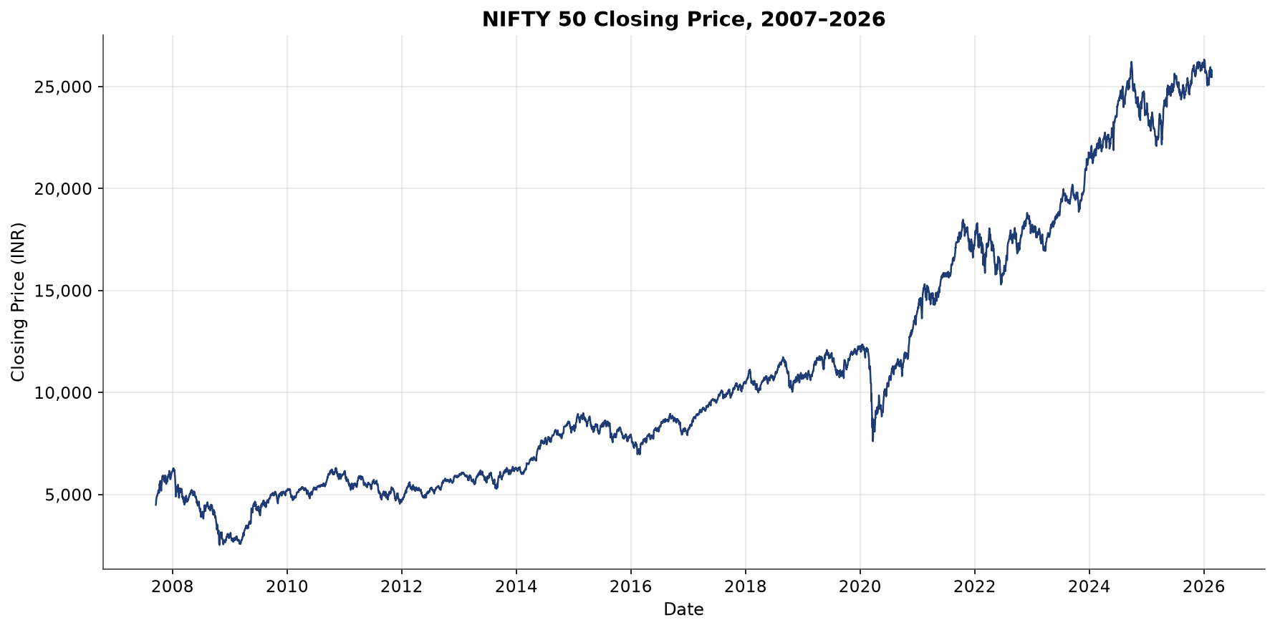
Figure 1: Long-Term Price Trend

Purpose
How has the NIFTY 50 closing price changed over the analyzed period (17 September 2007 – 20 February 2026)?

Why this chart type?
A line chart is appropriate for a single continuous variable measured through time: the x–y encoding preserves chronological order and makes the slope of the series directly visible.

What the chart shows
The closing price starts at ₹4,494.65 (17 September 2007) and ends at ₹25,571.25 (20 February 2026) — a compounded price increase of approximately 468.93%. The line rises with a clearly upward slope from early 2009 onward, interrupted by pronounced dips:
2008–2009: a deep decline associated with the Global Financial Crisis.
2020: a sharp, short drop associated with the COVID-19 shock.
2025–early 2026: the index reaches its highest closes in the dataset — an all-time closing high of ₹26,328.55 on 2 January 2026 — before pulling back through February 2026.

Financial interpretation
The long upward slope indicates that exposure to the NIFTY 50 held through the full 18-year window produced substantial price appreciation despite multiple large interruptions. The interruptions matter as much as the trend: holding the index through 2008 or 2020 meant experiencing severe temporary losses before recovery. This is why the trend chart is read together with the volatility and drawdown charts (Visualizations 5 and 6) rather than in isolation.

Key takeaway
The historical series shows a strong long-term upward trend (+468.93% price change) punctuated by deep but temporary declines — long-term growth and severe interim risk coexist in the same series.

Visualization 2 — Daily Return Behavior
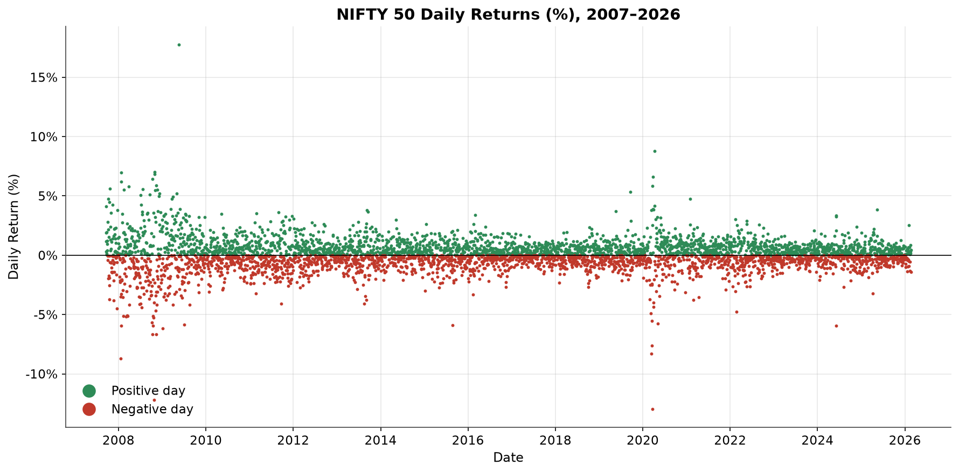
Figure 2: Daily Return Behavior

Purpose
How variable are daily NIFTY 50 returns, and when did the largest single-day movements occur?

Why this chart type?
Daily returns are used instead of raw prices because returns remove the price-level trend and expose day-to-day variability, making stress periods comparable across different price levels. Positive and negative days are colored separately so the sign structure of the series is visible.

What the chart shows
The series fluctuates around zero with most days inside a narrow ±1% band. Extreme spikes stand out: the worst single-day loss of -12.98% (23 March 2020, the COVID-19 lockdown reaction) and the largest single-day gain of +17.74% (18 May 2009, following the 2009 election result). Clusters of taller spikes are visible around 2008–2009 and 2020. Positive days (2,399; 53.05%) slightly outnumber negative days (2,118; 46.84%), and 387 days (8.56%) moved more than ±2%.

Financial interpretation
Day-to-day price changes are dominated by noise: the mean daily return (+0.0469%) is roughly 28 times smaller than the daily standard deviation (1.3015%), so the direction of any single day is effectively unpredictable. The visible clusters of large moves show that volatility is not constant — turbulent periods arrive together, a property known as volatility clustering. This justifies the rolling-volatility analysis in Visualization 5 and is consistent with the fat-tailed distribution in Visualization 3.

Key takeaway
Typical daily moves are small (mostly within ±1%), but 387 days (8.56%) moved more than ±2% in clusters around crises — daily return behavior is noise-dominated with episodic stress.

Visualization 3 — Return Distribution
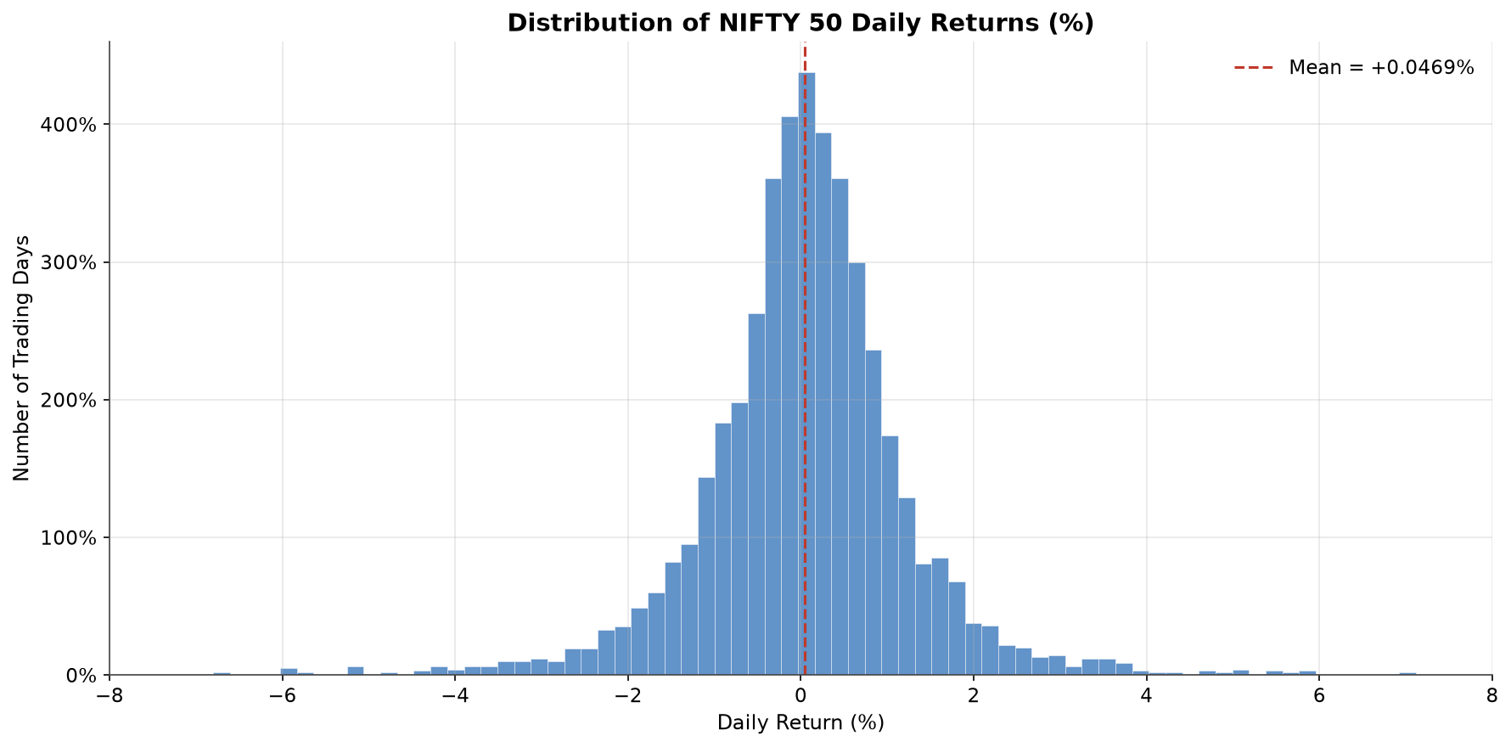
Figure 3: Return Distribution

Purpose
What does the distribution of daily returns look like — where is it centered, how spread out is it, and how heavy are the tails?

Why this chart type?
A histogram is the appropriate chart for the frequency of a single continuous variable. The mean is marked; a normal-density overlay is intentionally not included because the empirical distribution visibly deviates from normality, and a fitted normal curve would misrepresent the tails.

What the chart shows
The distribution is tall and narrow around a center slightly above zero (mean +0.0469%, median +0.0625%), with most trading days between roughly -1% and +1%. Skewness is close to zero (+0.06, essentially symmetric) while excess kurtosis is extremely high (+16.05) — the classic signature of a fat-tailed distribution. 69 days (1.53%) fall more than 3 standard deviations from the mean, roughly five times more than a normal distribution would predict for 4,521 observations.

Financial interpretation
The center of the distribution tells only a small part of the story. Heavy tails mean large single-day losses and gains occur far more often than a normal model predicts: Value-at-Risk estimates based on normality understate tail risk, and leveraged positions require larger buffers. Because the distribution is near-symmetric but fat-tailed, upside and downside surprises are equally frequent in form — what matters for risk is that both tails are heavier than normal theory suggests. This is consistent with the fat-tail-aware and non-parametric methods used in Weeks 3 and 4.

Key takeaway
Daily returns are centered marginally above zero, near-symmetric (skewness +0.06), but strongly fat-tailed (excess kurtosis +16.05); risk models that assume normality would understate the frequency of extreme days.

Visualization 4 — Moving Average Trend
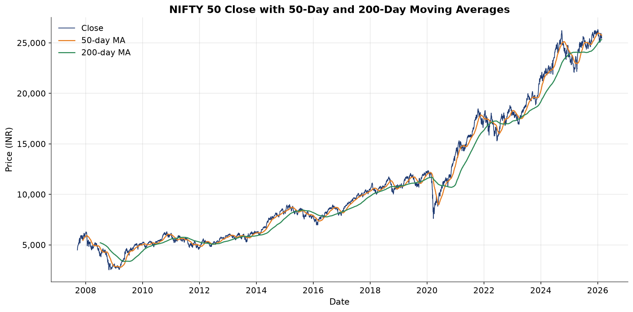
Figure 4: Moving Average Trend

Purpose
What does the relationship between the short-term (50-day) and long-term (200-day) moving averages look like relative to the price?

Why this chart type?
A multi-line chart lets the three series share one price axis, so the distance between the price and its smoothed trends is directly readable. Moving averages smooth daily noise to expose trend direction; the 200-day average serves as a commonly referenced long-term benchmark.

What the chart shows
The 50-day MA tracks the price closely with mild smoothing; the 200-day MA is much smoother and lags major turning points. The usual ordering — MA50 above MA200 — holds on 3,062 of 4,323 valid observations (70.83%). The ordering inverts during the 2008–2009 crisis and again during the 2020 COVID shock, when the price and MA50 dropped below MA200; the two averages switched ordering 23 times in the valid window, concentrated around crisis episodes.

Financial interpretation
Moving averages reveal the trend regime the index is in, which is why they are widely used as trend filters. The chart supports regime description: when the fast average sat below the slow average, the index was in a sustained decline phase. However, the chart can not establish that a crossover predicts future returns — moving averages are backward-looking transformations of the price itself, and crossover timing on this dataset has not been tested for profitability. Any statement beyond trend description would require out-of-sample validation.

Key takeaway
The MA50/MA200 relationship was consistent with the prevailing trend regime (MA50 above MA200 on 70.83% of valid observations, inverting during the two major crises), but moving-average crossovers describe past trends and are not validated buy/sell signals.

Visualization 5 — Rolling Volatility
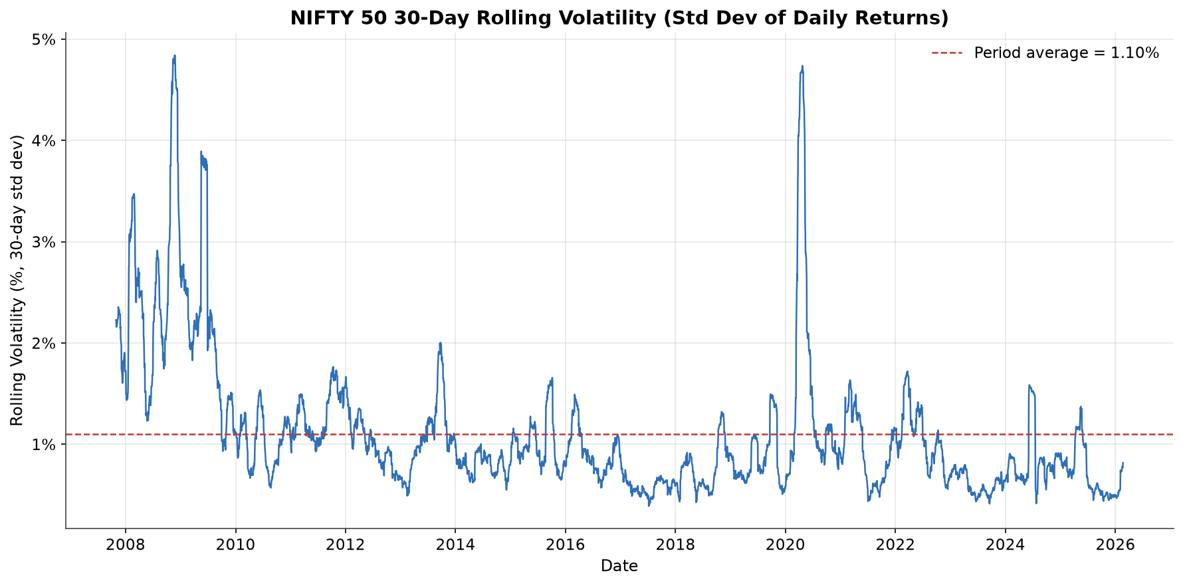
Figure 5: Rolling Volatility

Purpose
When did market uncertainty increase?

Why this chart type?
A line chart of the 30-day rolling standard deviation of daily returns is used because the analytical object is variability through time. Unlike a full-sample standard deviation, the rolling window reveals when variability changed, making it the right tool for locating stress episodes.

What the chart shows
Rolling volatility averages 1.10% over the period but is far from constant. Two large spikes dominate: 2008–2009, peaking at 4.84% on 24 November 2008 (Global Financial Crisis), and 2020, with a secondary spike during the COVID-19 crash. At the other extreme, the calmest reading is 0.39% (July 2017). Between crises, volatility reverts toward the 1% level, and in the extended calm stretch of 2014–2019 it falls well below it.

Financial interpretation
Volatility clustering is clearly visible: uncertainty arrives in bursts and decays gradually rather than switching abruptly. This matters for risk management because risk measured during a calm period understates the risk that will prevail during the next stress episode. The 2008 peak is roughly 4.4× the long-run average — risk budgets, margin requirements, and position sizing calibrated to the average would have been overwhelmed in 2008. This is why Week 3 treated volatility as a distinct risk category rather than a single average number.

Key takeaway
Market uncertainty is episodic: 30-day volatility ranged from 0.39% (2017) to a 4.84% crisis peak (24 November 2008), and calm-period risk estimates understate stress-period risk.

Visualization 6 — Drawdown Analysis
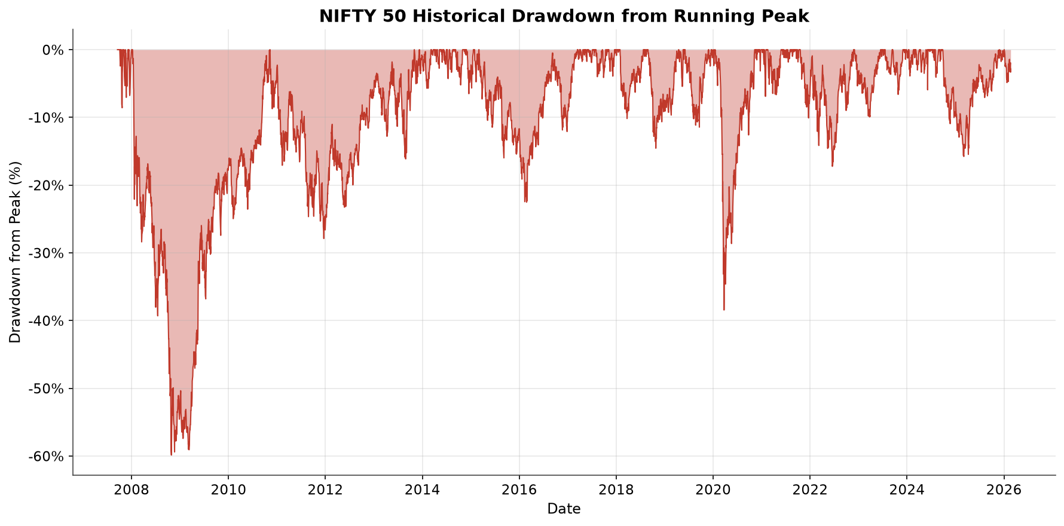
Figure 6: Drawdown Analysis

Purpose
How severe and how prolonged were historical declines from previous price peaks?

Why this chart type?
Drawdown measures the percentage decline of the price from its running maximum: Drawdown% = (Close / Running Peak − 1) × 100. It answers a question the return series cannot — once the index makes a new high, how much of that high does it give back before recovering? The filled area chart makes both the depth and the duration of declines visually immediate.

What the chart shows
The series stays at 0% whenever the index is at a new peak (341 such days). Two deep loss episodes dominate: the 2008 Global Financial Crisis, with a maximum drawdown of -59.86% (trough on 27 October 2008), and the 2020 COVID crash, a much sharper but shorter decline of -38.44% (trough on 23 March 2020). Smaller corrections (typically -10% to -20%) appear throughout the 2010s and mid-2020s. The index spent 589 trading days in drawdown worse than -20%. The 2008 recovery took years; the 2020 hole is visibly narrow.

Financial interpretation
Drawdown converts the abstract idea of risk into a concrete quantity: the actual loss experienced from peak to trough. The contrast between 2008 and 2020 is instructive — a -59.86% decline requires a +149% gain to return to the prior peak, whereas a -38.44% decline requires about +62%. The long recovery after 2008 shows that deep drawdowns damage compounding for years, not weeks. For any long-horizon participant, the relevant planning quantity is not the average return but the worst peak-to-trough loss the strategy can survive. This chart is the visual counterpart of the Week 3 drawdown-risk category.

Key takeaway
The worst historical peak-to-trough decline was -59.86% (27 October 2008), and recovery from deep drawdowns took years — a -60% loss requires a +150% gain to undo.

Visualization 7 — Yearly Performance
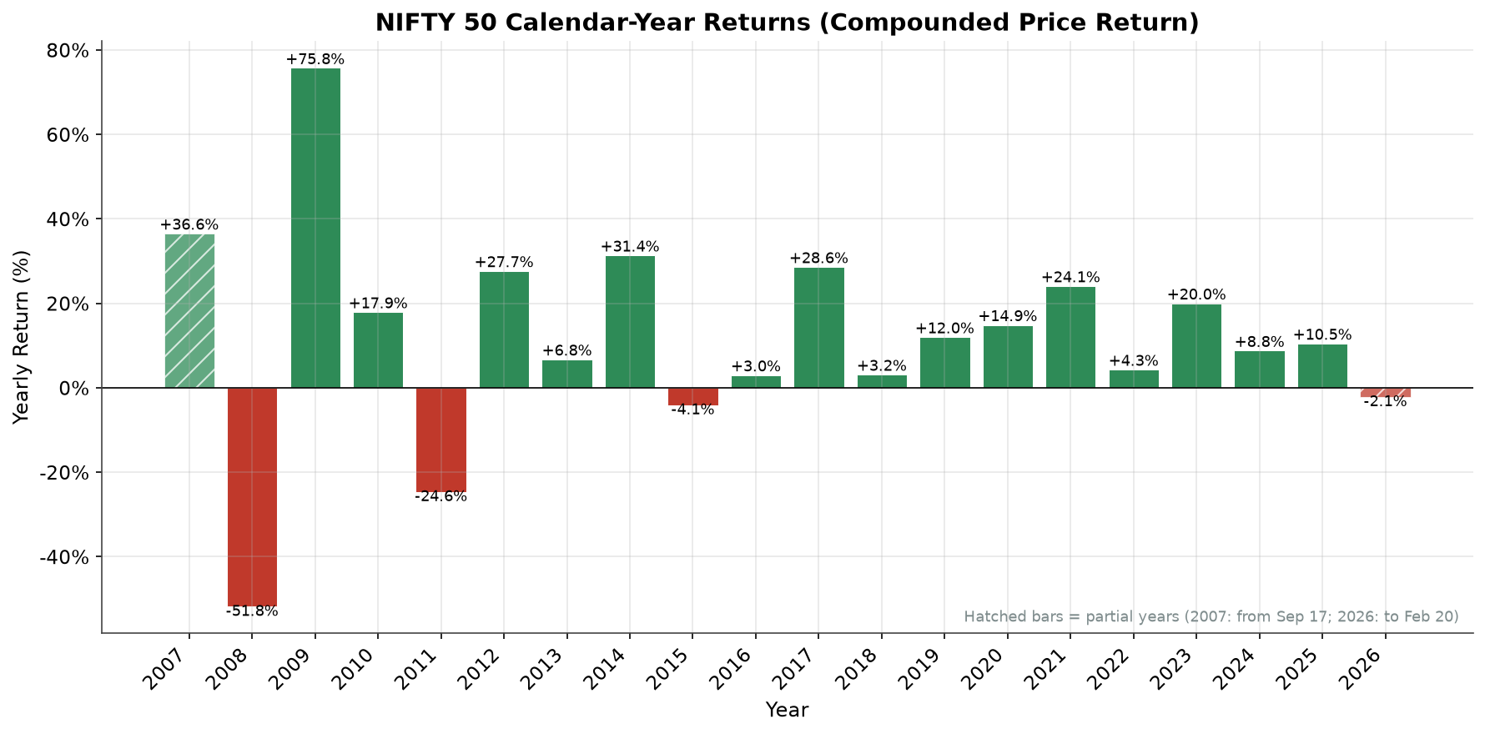
Figure 7: Yearly Performance

Purpose
How did NIFTY 50 performance vary across calendar years?

Why this chart type?
A bar chart is appropriate for comparing a small number of discrete categories (calendar years) on one metric. Green bars mark positive years and red bars negative years; value labels give exact percentages. Yearly return is computed as the compounded price return within each calendar year — (last Close of the year / last Close of the previous year − 1) × 100 — the standard geometric method. Summing daily percentage changes would ignore compounding and give incorrect yearly figures.

What the chart shows
Outcomes are strongly uneven. The worst year is 2008 (-51.79%); the strongest is 2009 (+75.76%), immediately after. 16 of 20 calendar years are positive. Because the dataset starts on 17 September 2007 and ends on 20 February 2026, 2007 (+36.58% within its partial span) and 2026 (-2.14% year-to-date) are partial years, marked with hatched bars and not directly comparable to full years. Full-year values include 2011 (-24.62%), 2015 (-4.06%), 2014 (+31.39%), and 2017 (+28.65%).

Financial interpretation
Yearly aggregation exposes an asymmetry that daily charts understate: catastrophic years are rarer but much larger in magnitude than typical positive years. The 2008 collapse followed by the 2009 rebound also shows why yearly returns must be compounded, not averaged — the sequence -51.79% then +75.76% leaves the index roughly 15.3% below its end-2007 level at the end of 2009 (0.4821 × 1.7576 = 0.847), even though the arithmetic average of the two yearly figures is +12%. The pattern is consistent with a long-run equity risk premium: most years reward exposure, while rare years impose deep losses.

Key takeaway
Calendar-year returns range from -51.79% (2008) to +75.76% (2009); the magnitude of the worst negative year dwarfs most single positive years, which is why compounding and survival both matter.

Visualization 8 — Volume Analysis
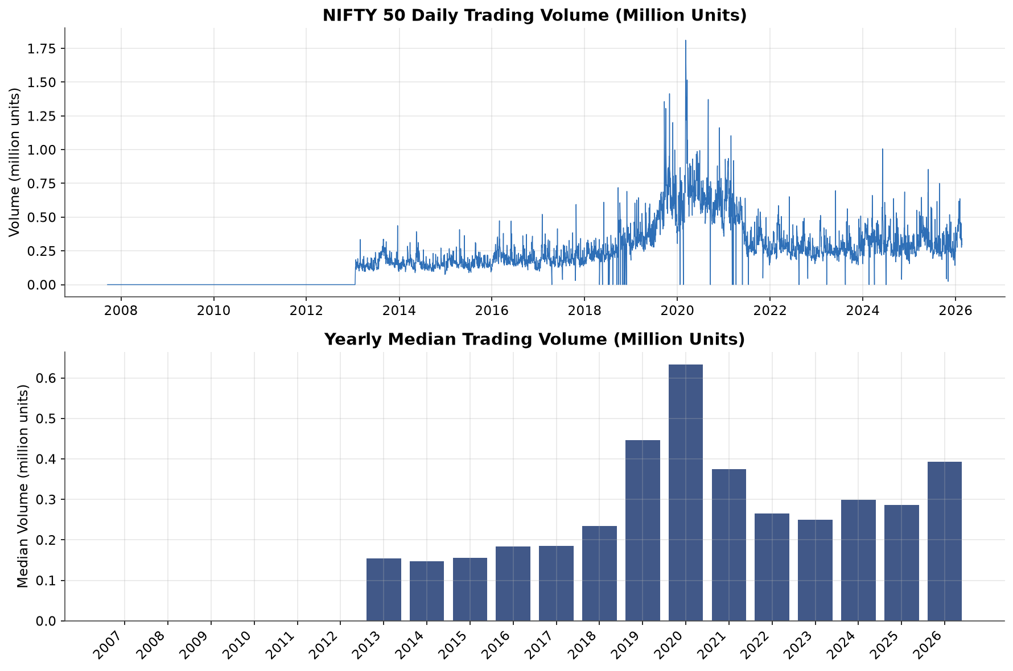
Figure 8: Volume Analysis

Purpose
How did trading volume vary over time?

Why this chart type?
A two-panel chart combines the daily volume time series (top) with yearly median volume bars (bottom): the time series preserves episode-level spikes, while the yearly median filters noise to show the level shift. Volume is plotted in million units.

What the chart shows
Daily volume is zero or unrecorded for roughly the first six years of the sample — 3,189 of 4,522 sessions have positive volume and the yearly median is 0 through 2012. After that a noisy baseline appears that rises over time: the yearly median grows from about 0.19 million units (2013–2019) to 0.31 million (2020–2026). Spikes coincide with stress windows — the single largest day is 1.81 million units on 6 March 2020, the start of the COVID crash. The overall level remains noisy, with no smooth trend.

Financial interpretation
Volume measures market participation. The step-up in the 2020s is consistent with broader market participation and improved data availability, though the index-level nature of this field prevents precise attribution. The largest volume day falls at the start of the COVID crash, and other volume spikes coincide with stress windows — consistent with the general pattern that high-uncertainty periods generate elevated trading activity, supporting but not proving the standard interpretation of volume as a stress indicator. Because index-level vendor volume cannot be audited against exchange records, and because pre-2013 values are largely zero, conclusions from this chart are kept deliberately modest.

Key takeaway
Traded volume rises from a 0.19 M median (2013–2019) to 0.31 M (2020–2026) and spikes during crisis windows (largest day 1.81 M on 6 March 2020), but the pre-2013 zeros and index-level source mean volume should be read as an indicative participation measure, not a verified turnover series.

13. Cross-Visualization Insights
The eight required visualizations plus the three appendix charts are connected by several relationships that appear consistently across them. Each claim below is backed by the specific charts or the computed statistics in the accompanying notebook.
1. Trend and risk are inseparable in the same series. The long-term price trend (Visualization 1) shows a +468.93% compounded gain, but the drawdown chart (Visualization 6) shows the price spent 589 trading days more than 20% below its running peak, most of them after the 2008 crisis. The upward slope and the deep loss episodes are properties of the same data — one cannot be reported without the other.
2. Volatility spikes mark drawdown episodes. Comparing Visualization 5 with Visualization 6 — and directly in Appendix Chart A.2 — the same stress windows appear in both: the 2008 volatility peak (4.84% on 24 November 2008) sits inside the same crisis window as the -59.86% drawdown trough (27 October 2008), and the 2020 volatility spike coincides with the -38.44% drawdown trough of 23 March 2020. The measured correlation between the two series (-0.74) quantifies this alignment. The charts highlight co-movement, not causation; both are functions of the same price path.
3. Fat tails show up in three different visual forms. The daily return series (Visualization 2) shows isolated giant spikes; the histogram (Visualization 3) quantifies them as excess kurtosis of +16.05; the extreme-day chart (Appendix A.3) dates them precisely to October 2008 and March 2020. Three independent presentations of one property raise confidence that heavy tails are a genuine feature of this dataset, not an artifact of one chart.
4. Yearly aggregation hides regime changes that the moving-average chart reveals. The yearly bar chart (Visualization 7) quantifies the 2008 collapse (-51.79%) and 2009 rebound (+75.76%); the moving-average chart (Visualization 4) shows the same episode as a regime shift in which MA50 fell below MA200 and remained there for an extended period. The bar chart quantifies the damage; the MA chart shows how long the damaged regime lasted.
5. Recovery asymmetry is visible across charts. Visualization 6 shows the 2008 drawdown took years to repair; Visualization 7 shows 2009's +75.76% rebound still left the index roughly 15.3% below its end-2007 level — the 2008 loss was not yet repaired two years later. Together the charts demonstrate that post-crash gains must be disproportionately large to restore prior wealth levels — the arithmetic of loss governs both charts.
6. Volume behaves like a stress echo, not a leading indicator. In Visualization 8, volume spikes coincide with the 2008 and 2020 price stress windows and the median level steps up after 2020. No chart in this report shows volume leading price turns, so volume is interpreted as a coincident participation measure only.
7. The absence of a monthly pattern supports the Week 4 statistical result. The heatmap (Appendix A.1) shows no month column with a persistent sign across years, consistent with Week 4's finding that mean daily return, while statistically positive, is tiny (+0.047%) relative to daily dispersion (1.30%) — nothing in the visual record suggests calendar-based predictability.

Appendix — Supporting Visualizations
Three additional charts are included because each provides insight not visible in the required eight.

A.1 Monthly Return Heatmap
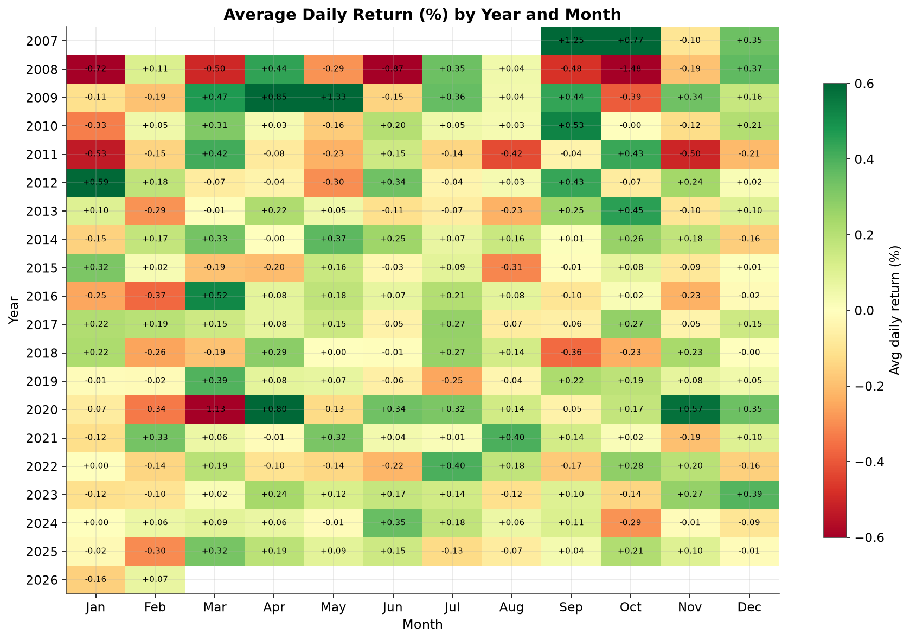
Figure A.1: Average daily return (%) by year and month

Purpose
Is there recurring monthly return behavior across the 18-year sample? Average daily return per calendar month, per year, is arranged as a Year × Month matrix; color encodes the average daily return in percent.

What the chart shows
The heatmap is dominated by the 2008 row (deep red across most months) and the March 2020 cell — the extreme months already identified. Away from those extremes, no month column is uniformly green or uniformly red across years. Averaged across all years, monthly means cluster in a narrow band (best month April at +0.16%, weakest January at -0.06% — both close to the overall daily mean of +0.047%).

Financial interpretation
If a reliable monthly effect existed, its column would repeat a consistent color across years. The chart does not show that structure: apparent monthly tendencies in any single year do not persist across the sample. This is a useful negative finding — consistent with Week 4's conclusion that short-horizon returns are not reliably predictable — and it warns against acting on calendar-based rules estimated from a small number of episodes.

Key takeaway
No calendar month shows a consistent return pattern across 18 years; the visible extremes belong to 2008 and March 2020, and the data is consistent with the absence of exploitable monthly seasonality.

A.2 Volatility Clustering vs Drawdown
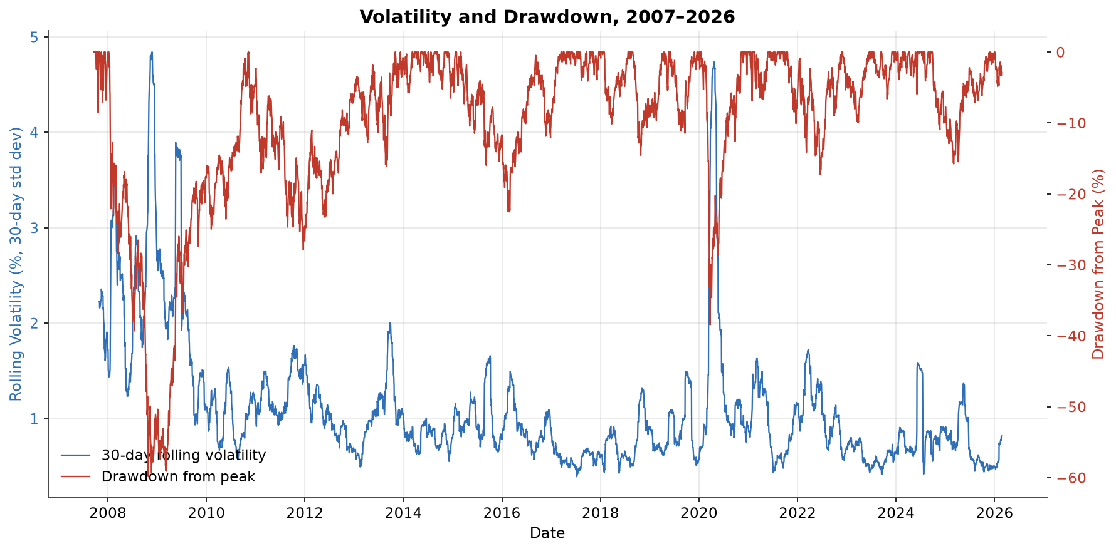
Figure A.2: 30-day rolling volatility (left axis) vs drawdown from peak (right axis)

Purpose
Do high-volatility episodes align with large drawdowns? Rolling 30-day volatility and drawdown are plotted on twin axes. Both derive from the same price series but emphasize different risk facets: dispersion of daily moves versus depth of cumulative loss.

What the chart shows
The two series spike together in 2008–2009 and 2020: as drawdown deepens, rolling volatility rises sharply and stays elevated while the drawdown remains large. The Pearson correlation between the two series is -0.74, and the average drawdown when rolling volatility exceeds 2% is -33.75%, versus -7.42% in calmer periods. In the 2014–2019 calm stretch, both series sit near their benign states (volatility ≈ 1%, drawdown ≈ 0%).

Financial interpretation
The alignment indicates the two risk measures capture the same underlying stress episodes from different angles: when prices fall fast and far, daily dispersion rises. Practically, a risk dashboard does not need many independent stress indicators — volatility and drawdown tend to escalate together, so monitoring one provides early warning about the other. The relationship is correlational and derived from the same price series, so no causal claim is made.

Key takeaway
High volatility and deep drawdowns co-occur (correlation ≈ -0.74; mean drawdown -33.75% when volatility exceeds 2% vs -7.42% otherwise); the two measures are complementary views of the same stress episodes rather than independent risks.

A.3 Extreme Return Days
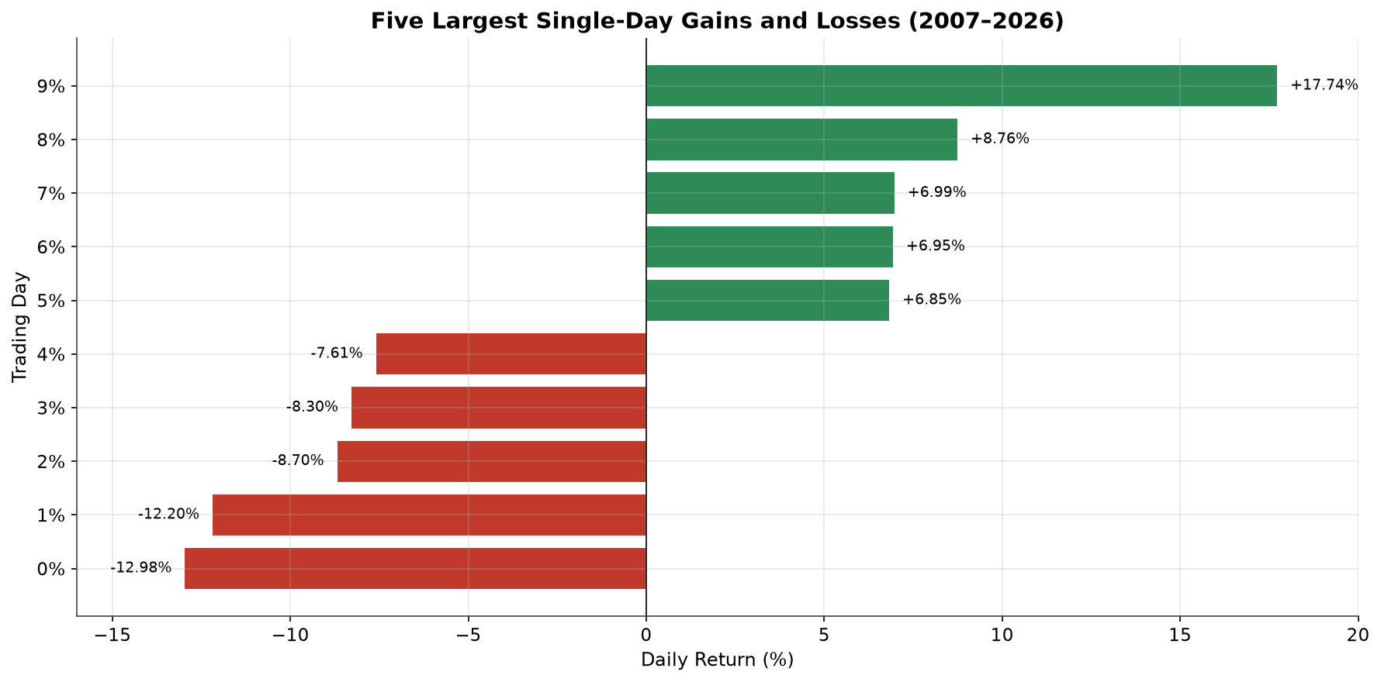
Figure A.3: Five largest single-day gains and losses, 2007–2026

Purpose
Which single days produced the largest gains and losses, and do they cluster in time? The five largest gains and five largest losses are charted side by side with their dates.

What the chart shows
The largest losses occurred in 2008 (24 October: -12.20%; 21 January: -8.70%) and March 2020 (23 March: -12.98%; 12 March: -8.30%; 16 March: -7.61%). The top gains cluster around May 2009 (+17.74% on 18 May), early April 2020 (+8.76% on 7 April), and the late-October 2008 rebound days (+6.99% on 31 October; +6.85% on 29 October). The largest single-day gain (+17.74%) is larger in magnitude than the largest single-day loss (-12.98%).

Financial interpretation
Extreme days cluster within a handful of crisis windows instead of spreading evenly across 18 years — the same volatility-clustering message as Visualization 5, seen from the tail of the distribution. The May 2009 giant gain shows how quickly sentiment can reverse after a prolonged drawdown: the best days historically occurred while the index was still far below its former peak, not after calm had returned. This is why exiting during drawdowns removes exposure to the strongest recovery days.

Key takeaway
The ten most extreme days belong to the 2008 and 2020 crisis episodes (losses) and their immediate rebounds (gains), and the biggest single-day gains fired while the market was still in or near drawdown — missing those days materially changes long-run compounding.

14. Key Findings
- Long-term growth: The NIFTY 50 rose from ₹4,494.65 (17 Sep 2007) to ₹25,571.25 (20 Feb 2026), a compounded price gain of +468.93%; the all-time closing high in the dataset is ₹26,328.55 (2 Jan 2026).
- Two deep crises interrupted growth: a maximum drawdown of -59.86% (trough 27 Oct 2008) and a second, sharper-but-shorter crash drawdown of -38.44% (trough 23 Mar 2020); the index spent 589 trading days in drawdown worse than -20%.
- Daily returns are noise-dominated with fat tails: mean +0.0469% vs std dev 1.3015%; excess kurtosis +16.05 with near-zero skew; worst day -12.98% (23 Mar 2020), best day +17.74% (18 May 2009); 387 days (8.56%) moved more than ±2%.
- Volatility is episodic: 30-day rolling volatility averaged 1.10% but peaked at 4.84% (24 Nov 2008) and bottomed at 0.39% (Jul 2017); high-volatility episodes coincide with deep drawdowns (correlation ≈ -0.74).
- Yearly returns are highly uneven: from -51.79% (2008) to +75.76% (2009); 16 of 20 calendar years were positive, but the worst negative year dwarfs most positive years in magnitude.
- Trend regime confirmed by moving averages: MA50 above MA200 on 70.83% of valid observations, inverting during the 2008 and 2020 crises (crossovers describe trends, not validated signals).
- Volume stepped up after 2020: yearly median volume rose from ≈0.19 M (2013–2019) to ≈0.31 M (2020–2026), with the largest day (1.81 M) on 6 Mar 2020; index-level volume limits interpretation.
- No reliable monthly seasonality: no calendar month shows a consistent return pattern across 18 years.

15. Limitations
- Historical patterns describe the past. All visualizations reflect market behavior from Sep 2007 to Feb 2026; historical patterns do not guarantee future outcomes.
- Charts describe, they do not explain. Visualization can reveal associations (e.g., volatility and drawdown co-moving) but cannot establish causation between variables.
- Index, not individual stocks. NIFTY 50 aggregates 50 large constituents; the charts do not represent the behavior of any individual stock, sector, or the broader market (e.g., NIFTY 500).
- Index-level volume is indicative only. The vendor-supplied Volume field for an index cannot be reconciled against exchange turnover records, and pre-2013 values are largely zero; volume findings are directional at best.
- Partial years. 2007 (from 17 Sep) and 2026 (to 20 Feb) cover only part of their calendar years; their bars are hatched and should not be compared directly with full years.
- Price return only. Returns are computed from the Close series and exclude dividends; total returns would be higher.
- Period and variable selection matter. Different windows (e.g., a 10-year slice) or additional variables (e.g., India VIX, FII flows) could change the visual picture; conclusions are conditional on the analyzed period and variables.

16. Conclusion
The Week 5 visualizations convert the NIFTY 50 dataset into a coherent analytical picture. The price trend establishes long-term growth; the return and distribution charts establish how that growth was delivered — small average moves with rare, extreme days; the volatility and drawdown charts establish what it cost — episodic, sometimes years-long losses; and the yearly, volume, and heatmap charts place those dynamics on the calendar.
Across all eleven visualizations, the single most consistent message is that return and risk in this dataset are two faces of the same series: a +468.93% long-term price gain was earned alongside a -59.86% maximum drawdown, a 4.84% peak rolling volatility, and daily returns whose tails are far heavier than a normal distribution (excess kurtosis +16.05). The cross-visualization analysis shows these facets align on the same dates (2008–2009, 2020), which is precisely why financial analysis must examine trend, volatility, and drawdown jointly rather than reporting any single number in isolation.
The analysis remains descriptive: no chart in this report establishes causation, validates a trading rule, or constitutes investment advice.

