NIFTY 50 Risk Analysis
Week 3 — Financial Risk Assessment

Student: Pavan Poriya

September 2026

Table of Contents
1. Executive Summary
2. Week 3 Objective
3. Dataset Overview
4. Risk Analysis Methodology
5. Market / Price Risk
6. Volatility Risk
7. Extreme Return / Shock Risk
8. Downside Risk
9. Drawdown Risk
10. Risk Impact Assessment
11. Risk Ranking
12. Risk Mitigation Strategies
13. Key Findings
14. Limitations
15. Conclusion

1. Executive Summary
This report presents a structured financial risk analysis of the NIFTY 50 index using historical daily data from 17 September 2007 to 20 February 2026 (4,521 trading days with returns). The analysis identifies five key risk categories, quantifies their impact using actual data-driven calculations, and proposes realistic mitigation strategies.
Key findings include: a maximum drawdown of -59.86% during the 2008 global financial crisis (₹3,764 absolute loss), worst single-day loss of -12.98% on 23 March 2020, average 30-day volatility of 1.10% (peaking at 4.84%), and a return distribution with kurtosis of 16.07 (indicating significantly fat tails). The most severe risks identified are Market/Price Risk and Drawdown Risk (both rated Very High), followed by Volatility Risk and Extreme Return Risk (both rated High).

2. Week 3 Objective
The objective of Week 3 is to conduct a comprehensive risk analysis of the NIFTY 50 index using the historical dataset analyzed in Weeks 1 and 2. The task requires:
- Risk identification: identifying potential risks from historical data
- Risk impact assessment: quantifying the severity and potential consequences of each risk
- Risk mitigation: proposing realistic strategies to manage identified risks

This is an educational internship project. The analysis is not personal investment advice and should not be used as the sole basis for financial decisions.

3. Dataset Overview
The same NIFTY 50 historical dataset used in Weeks 1 and 2 serves as the foundation for this risk analysis. The dataset was obtained from Kaggle.
Property | Value
Dataset File | NIFTY50_1995_to_Feb_2026.csv
Source | Kaggle
Analysis Period | 17 September 2007 – 20 February 2026
Cleaned Observations | 4,522
Trading Days with Returns | 4,521
Columns Used | Date, Close, High, Low, Open, Volume
Derived Column | Daily_Return (pct_change of Close)

Data cleaning followed the same steps as Week 1: removal of the metadata row, datetime conversion, numeric type conversion, and chronological sorting. Daily returns were computed as percentage changes in the closing price.

4. Risk Analysis Methodology
The risk analysis employs the following quantitative methods, all applied to the NIFTY 50 historical daily closing price and return data:
Variables Analyzed:
- Daily closing prices (Close)
- Daily returns (percentage change in Close)
- Rolling 30-day standard deviation of daily returns (volatility)

Calculations Performed:
- Price extremes: minimum, maximum, range, and appreciation
- Drawdown analysis: running maximum, drawdown percentage, maximum drawdown, recovery
- Volatility analysis: rolling 30-day volatility, yearly averages, high-volatility threshold
- Extreme return analysis: maximum gain/loss, frequency of ±2% moves, kurtosis
- Downside analysis: negative return frequency, VaR (5% and 1%), CVaR (Expected Shortfall)

Risk severity was assessed qualitatively based on the magnitude and frequency of observed risk metrics relative to typical financial market benchmarks. Categories used: Low, Moderate, High, Very High.

5. Market / Price Risk
Market risk refers to the potential for financial loss due to adverse movements in market prices. For the NIFTY 50 index, this manifests as significant declines in the index value.
Key Statistics:
Metric | Value
Minimum Close | ₹2,524.20 (2008-10-27)
Maximum Close | ₹26,328.55 (2026-01-02)
Price Range | ₹23,804.35
Latest Close | ₹25,571.25 (2026-02-20)
Total Appreciation | 943.05%
Maximum Drawdown | -59.86%
Absolute Drawdown Loss | ₹3,764

The NIFTY 50 has experienced an extraordinary price range over the analyzed period. While the total appreciation of 943.05% demonstrates the long-term growth potential, the maximum drawdown of -59.86% during the 2008 financial crisis highlights the severe market risk that investors faced. A peak price of ₹6,287.85 on 2008-01-08 declined to ₹2,524.20 by 2008-10-27, representing a loss of ₹3,764 per index unit.

6. Volatility Risk
Volatility risk refers to the uncertainty and magnitude of price fluctuations over time. Higher volatility means greater uncertainty and potentially larger losses in short periods.
Key Statistics:
Metric | Value
Average 30-day Volatility | 1.1028%
Maximum 30-day Volatility | 4.8409% (2008-11-24)
Minimum 30-day Volatility | 0.3897% (2017-07-07)
Volatility Range | 4.4512%
Median 30-day Volatility | 0.9080%
High-Volatility Days | 227 (5.1% of observed days)
Most Volatile Year | 2008 (avg 2.6083%)
Least Volatile Year | 2017 (avg 0.5842%)

The 30-day rolling volatility varied substantially over the analyzed period. The peak volatility of 4.84% was observed on 24 November 2008 during the global financial crisis, representing more than 4 times the average volatility level. During calm periods (e.g., 2017), volatility dropped below 0.4%. The 227 high-volatility days (5.1% of observed days) represent periods where risk was significantly elevated.
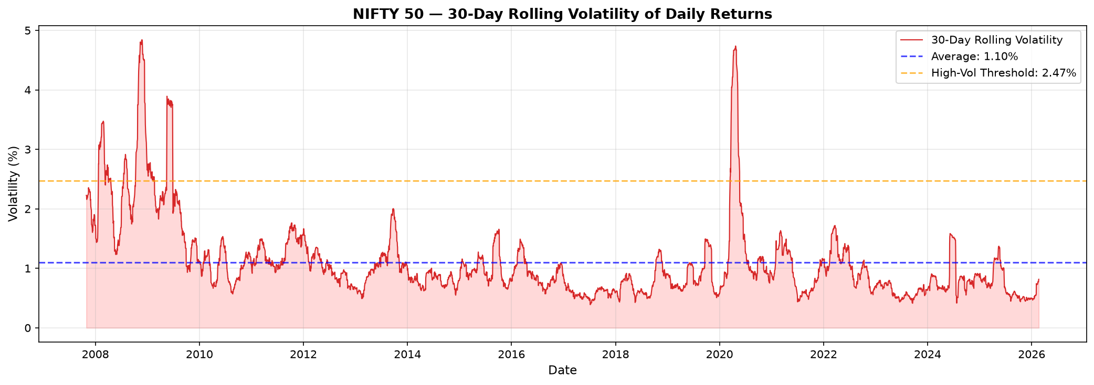
Figure 1: 30-Day Rolling Volatility of Daily Returns

7. Extreme Return / Shock Risk
Extreme return risk refers to the possibility of unusually large positive or negative price movements in a single trading day. These shock events can cause significant portfolio losses.
Key Statistics:
Metric | Value
Maximum Daily Gain | +17.74% (2009-05-18)
Maximum Daily Loss | -12.98% (2020-03-23)
Large Positive Moves (>2%) | 193 days
Large Negative Moves (<-2%) | 194 days
Total Extreme Days (±2%) | 387 days (8.56%)
Avg Magnitude of Large Positive | +3.21%
Avg Magnitude of Large Negative | -3.23%
Mean Daily Return | 0.0469%
Std Dev of Daily Returns | 1.3015%
Skewness | 0.0561
Kurtosis | 16.0672

The NIFTY 50 has experienced 387 days with moves exceeding ±2%, representing 8.56% of all trading days. The return distribution exhibits a kurtosis of 16.07, which is significantly higher than a normal distribution (kurtosis = 0), indicating fat tails — extreme events occur much more frequently than a normal distribution would predict. The worst single-day loss of -12.98% occurred on 23 March 2020 (COVID-19 market crash), while the best single-day gain of +17.74% occurred on 18 May 2009.
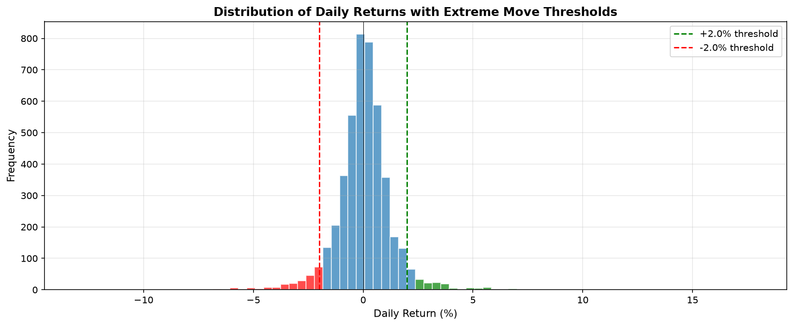
Figure 2: Distribution of Daily Returns with Extreme Move Thresholds (±2%)

8. Downside Risk
Downside risk focuses specifically on the probability and magnitude of negative returns. This is directly relevant to investors because losses typically have a greater psychological and financial impact than equivalent gains.
Key Statistics:
Metric | Value
Total Trading Days | 4,521
Negative Trading Days | 2,118 (46.85%)
Positive Trading Days | 2,403 (53.15%)
Average Negative Return | -0.8674%
Average Positive Return | +0.8528%
Worst Single-Day Loss | -12.98%
Worst 5th Percentile Loss | -2.61%
Worst 1st Percentile Loss | -5.06%

Value at Risk (VaR) and Conditional VaR:
Metric | Value | Interpretation
VaR at 95% | -1.83% | 5% chance of losing more than 1.83% in a day
VaR at 99% | -3.57% | 1% chance of losing more than 3.57% in a day
CVaR at 95% | -3.04% | Average loss when loss exceeds VaR 95%
CVaR at 99% | -5.33% | Average loss when loss exceeds VaR 99%

Negative trading days occurred on 46.85% of all trading days, with an average negative return of -0.8674%. The VaR at 95% confidence (-1.83%) indicates that on any given day, there is a 5% probability of losing more than 1.83%. The Conditional VaR (Expected Shortfall) at 95% (-3.04%) shows that when losses exceed the VaR threshold, the average loss is -3.04%. These metrics provide a quantitative framework for understanding downside exposure.
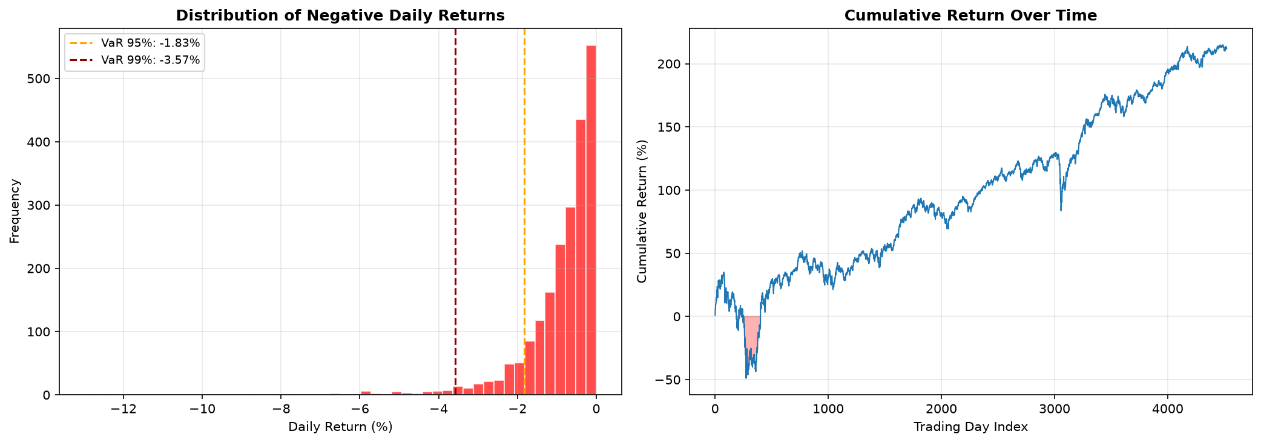
Figure 3: Distribution of Negative Returns and Cumulative Return Over Time

9. Drawdown Risk
Drawdown measures the decline from a historical peak in the index value. It represents the maximum loss an investor would have experienced from the peak to the subsequent trough. Drawdown analysis is critical for understanding worst-case scenarios.
Key Statistics:
Metric | Value
Maximum Drawdown | -59.86%
Peak Price | ₹6,287.85 (2008-01-08)
Trough Price | ₹2,524.20 (2008-10-27)
Absolute Loss | ₹3,763.65
Recovery Date | 2010-11-09
Recovery Time | 743 days (approximately 2.0 years)

The maximum drawdown of -59.86% occurred during the 2008 global financial crisis. The NIFTY 50 peaked at ₹6,287.85 on 8 January 2008 and declined to ₹2,524.20 by 27 October 2008, representing an absolute loss of ₹3,763.65. The index did not recover to its pre-crash peak until 9 November 2010, requiring 743 days (approximately 2.0 years) for full recovery. This demonstrates that investors who bought near the peak faced a prolonged period of underwater investments.
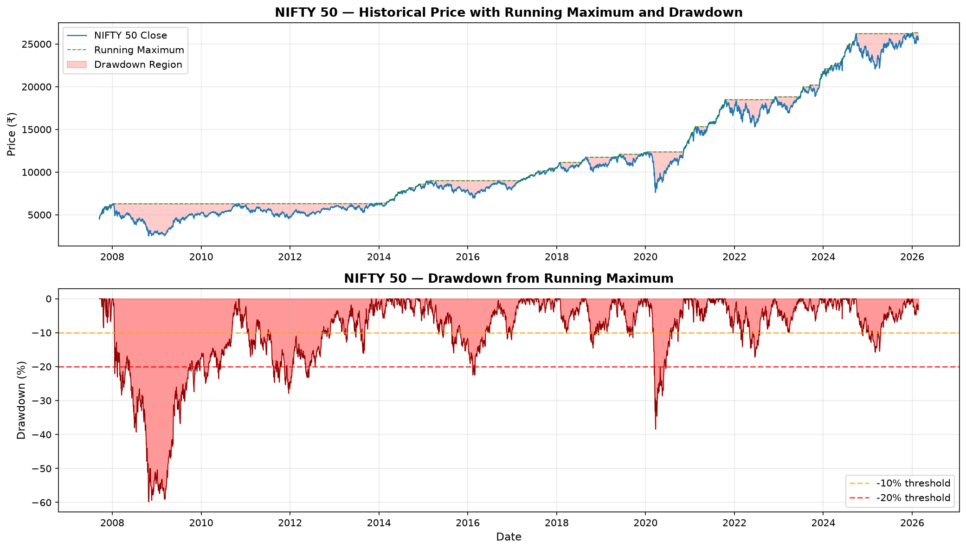
Figure 4: Historical Price with Running Maximum and Drawdown Analysis

10. Risk Impact Assessment
For each identified risk, the following assessment explains what the risk is, what causes it, what evidence exists in the dataset, and its potential financial impact.
Market / Price Risk — Severity: Very High
- What it is: The risk of significant decline in the NIFTY 50 index value due to adverse market conditions.
- Causes: Macroeconomic downturns, geopolitical events, policy changes, or market sentiment shifts.
- Evidence from data: Maximum drawdown of -59.86% during 2008 crisis; price range ₹2,524–₹26,329.
- Potential impact: Large capital losses; extended recovery periods; psychological stress for investors.

Volatility Risk — Severity: High
- What it is: The risk that price fluctuations become unusually large and unpredictable.
- Causes: Market uncertainty, information shocks, changes in market microstructure.
- Evidence from data: Peak volatility of 4.84% (4.4× average); 227 high-volatility days (5.1%).
- Potential impact: Larger-than-expected daily moves; increased portfolio variance; difficulty in risk planning.

Extreme Return / Shock Risk — Severity: High
- What it is: The risk of unusually large single-day price movements (positive or negative).
- Causes: Black swan events, policy announcements, global crises, algorithmic trading cascades.
- Evidence from data: Worst day -12.98% (2020); 387 extreme days (8.56%); kurtosis 16.07.
- Potential impact: Sudden large losses; portfolio value shocks; potential liquidity issues.

Downside Risk — Severity: Moderate
- What it is: The risk of consistent or severe negative returns eroding portfolio value.
- Causes: Prolonged bear markets, structural economic weaknesses, sector-specific declines.
- Evidence from data: 46.85% negative days; VaR 95% = -1.83%; CVaR 95% = -3.04%.
- Potential impact: Gradual portfolio erosion; difficulty recovering from sustained losses.

Drawdown Risk — Severity: Very High
- What it is: The risk of peak-to-trough portfolio declines and the time required for recovery.
- Causes: Severe market corrections, systemic crises, contagion effects.
- Evidence from data: -59.86% max drawdown; ₹3,764 absolute loss; 743-day recovery period.
- Potential impact: Prolonged underwater investments; forced liquidation risk; missed opportunities.

11. Risk Ranking
Based on the quantitative analysis, the following table ranks identified risks from most to least severe. Severity is justified by the magnitude and frequency of observed risk metrics.
Rank | Risk Category | Key Evidence | Severity
1 | Market / Price Risk | Max drawdown -59.86%; ₹23,804 price range | Very High
2 | Drawdown Risk | -59.86% max drawdown; 743-day recovery | Very High
3 | Volatility Risk | Peak vol 4.84%; 227 high-vol days (5.1%) | High
4 | Extreme Return Risk | Worst day -12.98%; 387 extreme days; kurtosis 16.07 | High
5 | Downside Risk | 46.85% negative days; VaR95 -1.83% | Moderate

The ranking reflects the severity of observed historical events. Market/Price Risk and Drawdown Risk are rated Very High due to the extreme magnitude of the 2008 crisis drawdown (-59.86%) and the extended recovery period (743 days). Volatility Risk and Extreme Return Risk are rated High due to the frequency of extreme events (8.56% of trading days) and the fat-tailed distribution (kurtosis 16.07). Downside Risk is rated Moderate because while negative days are frequent (46.85%), the average negative return (-0.87%) is relatively contained.

12. Risk Mitigation Strategies
The following mitigation strategies are presented as general risk-management approaches. They are not personalized investment advice.
Market / Price Risk:
- Diversification: Spread investments across asset classes (equity, debt, gold) to reduce single-market exposure.
- Position Sizing: Limit the proportion of portfolio allocated to any single index or sector.
- Exposure Limits: Set maximum allocation thresholds for equity exposure based on risk tolerance.
- Long-Term Horizon: Maintain a long investment horizon to ride through short-term market declines.

Volatility Risk:
- Volatility Monitoring: Track rolling volatility metrics regularly to identify unusual market conditions.
- Risk Budgets: Allocate risk budgets across portfolio components; reduce exposure when volatility exceeds thresholds.
- Adaptive Allocation: Consider adjusting portfolio allocation during periods of elevated volatility.
- Options Hedging: Use protective strategies to limit downside during volatile periods (where available).

Extreme Return / Shock Risk:
- Stress Testing: Regularly test portfolio performance under extreme historical scenarios.
- Scenario Analysis: Model the impact of hypothetical extreme events on portfolio value.
- Liquidity Buffers: Maintain adequate liquid reserves to meet obligations during market shocks.
- Circuit Breaker Policies: Implement automatic risk-reduction triggers when losses exceed thresholds.

Downside Risk:
- Downside Monitoring: Track downside-specific metrics (VaR, CVaR) alongside standard volatility.
- Stop-Loss Mechanisms: Implement systematic rules for reducing exposure after significant declines.
- Diversification: Use assets with low or negative correlation to reduce portfolio downside.
- Risk Parity: Weight portfolio positions by their risk contribution rather than capital allocation.

Drawdown Risk:
- Maximum Drawdown Limits: Set acceptable maximum drawdown thresholds; take action when breached.
- Periodic Rebalancing: Regularly rebalance portfolio to maintain target risk levels.
- Drawdown Recovery Planning: Prepare action plans for different drawdown severity levels.
- Historical Worst-Case Preparedness: Use maximum drawdown data to stress-test portfolio resilience.

13. Key Findings
- The NIFTY 50 index has experienced a price range of ₹2,524 to ₹26,329 over the analyzed period (2007-09-17 to 2026-02-20), representing a total appreciation of 943.0%.
- The maximum drawdown observed was -59.86% (₹3,764 absolute loss), which occurred around 2008-10-27 during the global financial crisis. This drawdown has since recovered.
- Average 30-day rolling volatility was 1.10%, with a peak of 4.84% observed on 2008-11-24. 227 days exceeded the high-volatility threshold.
- The worst single-day loss was -12.98% on 2020-03-23 (COVID-19 crash), and the best single-day gain was +17.74% on 2009-05-18.
- There were 387 days with moves exceeding ±2.0%, representing 8.56% of all trading days.
- The return distribution has a kurtosis of 16.07, indicating significantly fat tails compared to a normal distribution (kurtosis = 0).
- Historical VaR at 95% confidence is -1.83% daily, meaning there is a 5% chance of losing more than 1.83% in a single day.
- Negative trading days occurred on 46.8% of all trading days, with an average negative return of -0.8674%.
- The year 2008 recorded the highest average volatility at 2.6083%, while 2017 was the least volatile at 0.5842%.
- The most severe risk categories are Market/Price Risk and Drawdown Risk (both rated Very High), followed by Volatility Risk and Extreme Return Risk (both rated High).

14. Limitations
The following limitations apply to this risk analysis:
- Historical data cannot capture every future market event. Past risk measures may not fully predict future risk.
- External macroeconomic and geopolitical factors are not fully represented. The analysis relies solely on price and return data.
- Historical risk measures do not guarantee future outcomes. Risk levels can change significantly.
- Index-level analysis does not represent the risk of every individual constituent. The NIFTY 50 is a composite index.
- Risk classifications are analytical judgments based on the selected methodology and thresholds.
- The analysis is educational and not financial advice. No investment decisions should be based solely on this analysis.
- Volume data quality issues: The dataset contains zero volume values for many earlier observations, limiting volume-based risk analysis.
- Survivorship bias: The NIFTY 50 constituents change over time; the index only includes current constituents.

15. Conclusion
This Week 3 risk analysis examined five key risk dimensions of the NIFTY 50 index using historical data from September 2007 to February 2026.

Main Risks Identified:
- Market/Price Risk (Very High): The NIFTY 50 has exhibited extreme price movements, including a maximum drawdown of -59.86%.
- Drawdown Risk (Very High): Peak-to-trough declines can be substantial, requiring long recovery periods (743 days for the 2008 crisis).
- Volatility Risk (High): Rolling volatility varies significantly across time, with periods of elevated uncertainty (peak 4.84%).
- Extreme Return Risk (High): The index has experienced single-day moves exceeding ±12%, with fat-tailed return distribution (kurtosis 16.07).
- Downside Risk (Moderate): Approximately 46.8% of trading days have been negative, with meaningful VaR levels.

Key Mitigation Approaches:
- Diversification across asset classes
- Position sizing and exposure limits
- Volatility monitoring and adaptive allocation
- Stress testing and scenario analysis
- Maximum drawdown limits and rebalancing policies

This analysis is based on historical data and should be used for educational purposes. Risk measures are estimates based on past behavior and do not guarantee future outcomes. Continuous risk monitoring is essential for effective risk management.

