**ST JOSEPH ENGINEERING COLLEGE**

**MANGALURU, KARNATAKA - 575028**



Mini - Project Report on

**Global suicide Analysis Dashboard**

*Submitted in partial fulfillment of the requirements for the award of the degree*

# Bachelor of engineering

**in**

**ARTIFICIAL INTELLIGENCE AND MACHINE LEARNING**

By

**Pavan 4SO22AI041**

Under the guidance of

[Teena Annamma James](mailto:teenaaj@sjec.ac.in)

Assistant Professor

Department of Intelligent Computing & Business Systems

**ST JOSEPH ENGINEERING COLLEGE**

**MANGALURU 575028**

**2024-2025**

**ST JOSEPH ENGINEERING COLLEGE**

**MANGALURU, KARNATAKA - 575028**



**DEPARTMENT**

**OF**

**INTELLIGENT COMPUTING & BUSINESS SYSTEMS**

***CERTIFICATE***

Certified that the mini-project work entitled “**Global Suicide Analysis Dashboard**” is carried out by **Pavan, 4SO22AI041** a Bonafide students at **St Joseph engineering College, Mangaluru**, in partial fulfillment for the award of degree **Bachelor of Engineering** in **Artificial Intelligence and Machine Learning** from **Visvesvaraya Technological University, Belagavi** during the academic year 2024-2025. It is certified that all the corrections/suggestions indicated during the interim evaluation have been incorporated in the report. The mini-project report has been approved as it satisfies the academic requirements in respect of the mini-project work prescribed for the said degree.

Signature of Faculty-In Charge

**Teena. A. James**

Assistant Professor

Dept. of Intelligent Computing and Business Systems

SJEC, Mangalore

Signature of HoD

**Dr Shreenath Acharya**

Head of Department

Department of Intelligent Computing & Business Systems

SJEC, Mangalore

**ST JOSEPH ENGINEERING COLLEGE**

**MANGALURU, KARNATAKA - 575028**



**DEPARTMENT OF INTELLIGENT COMPUTING & BUSINESS SYSTEMS**

**DECLARATION**

I, **Pavan** the student of Fifth semester, Department of Intelligent Computing & Business Systems, St Joseph Engineering College, Mangaluru, hereby declare that the work being presented in the dissertation titled “**Global Suicide Analysis Dashboard**” is an authentic record of the work that has been carried out under the guidance of **Teena. A. James, Assistant Professor, St Joseph Engineering College.** This mini-project work is submitted in partial fulfillment of the requirements for the award of the degree - Bachelor of Engineering in Artificial Intelligence and Machine Learning during the academic year 2024 – 2025. Further the matter embodied in the report has not been submitted in part or full to any other University, Institution or Professional body for the award of any degree or diploma.

Team Members:

**Pavan 4SO22AI041**

Date:12/12/20024

Place: Mangaluru

**ABSTRACT**

Suicide is a pressing global issue, impacting individuals, families, and communities worldwide. Understanding the patterns, trends, and contributing factors of suicide is crucial for policymakers, researchers, and organizations striving to address mental health challenges. To support these efforts, we developed an interactive dashboard using Streamlit, offering users an intuitive and engaging way to explore and analyse global suicide data.

The dashboard incorporates a range of visualizations, including choropleth maps, bar charts, line charts, histograms, box plots, and heatmaps. These tools enable users to examine the data from various perspectives. For instance, the choropleth map provides a global overview of suicide rates by country, while the bar chart highlights countries with the highest suicide rates for a selected year. The line chart allows users to observe trends over time for individual countries or demographic groups, and the histogram illustrates the distribution of suicide rates across the world.

Users can interact with the dashboard by selecting specific years, countries, or demographic filters such as gender, age group, or generation, allowing for a customized analysis. The application preprocesses the dataset to clean missing or irregular values, handle outliers, and ensure consistent formatting, guaranteeing accurate and reliable insights. A visually appealing color scheme enhances readability and engagement across all visualizations.

This project is designed to make complex suicide statistics accessible to a diverse audience, including policymakers seeking to prioritize mental health interventions, researchers investigating contributing factors, and the general public aiming to understand the global context of this critical issue. Future enhancements could include integrating real-time data, incorporating advanced predictive analytics, and adding detailed regional analyses to further enrich the dashboard’s functionality.

By providing a clear and interactive platform for analyzing suicide data, this project aims to deepen understanding and support informed decision-making in addressing one of the world’s most urgent public health challenges

**ACKNOWLEDGEMENT ________________________________________________**

The successful completion of this project, Global Suicide Analysis Dashboard, is the result of collective effort, guidance, and support from several individuals and organizations. We would like to express our deepest gratitude to all those who contributed to its realization.

First and foremost, we extend our heartfelt thanks to our teacher and guide, Mrs. Teena Annamma James, for their valuable guidance, consistent encouragement, and timely help. Despite their busy schedule, they have provided cordial support throughout the development of this project.

We are also indebted to Dr Shreenath Acharya, Head of the Department - Intelligent Computing and Business Systems, for offering the best facilities the department can provide. We extend our heartfelt gratitude to the College Principal, Dr. Rio D’Souza, for providing us with this opportunity during our third year.

We are grateful to the lab assistants for their support and assistance during the project. Additionally, we wish to express our sincere appreciation to all the other students in our batch for their encouragement and camaraderie, which made this journey more enriching.

We are deeply thankful to the organizations and researchers who have made the global suicide dataset publicly available. Their commitment to transparency and data sharing has been pivotal in enabling this project to explore critical global mental health challenges through technology.

We also acknowledge the contributions of the open-source community, particularly the developers behind Streamlit, Matplotlib, Seaborn, and other Python libraries, whose tools and resources were integral to building this interactive and user-friendly dashboard.

Finally, we extend our gratitude to our peers, family, and friends for their unwavering belief in our abilities and their constant support and inspiration throughout this journey.

This project is a testament to the power of collaboration, shared knowledge, and institutional support. We hope it serves as a meaningful contribution towards understanding and addressing the pressing issue of suicide worldwide.

**TABLE OF CONTENTS**

**Abstract**

**Acknowledgements**

**List of Figures**

**Chapter 1 - Introduction**

**Chapter 2 - Requirement Analysis**

**Chapter 3 - Implementation**

**Chapter 4 - Testing**

**Chapter 5 - Screen Outputs**

**Chapter 6 - Cognitive Merits and Demerits of Project**

**Chapter 7 - Conclusion**

**Chapter 8 - Future Enhancements**

**Chapter 9 – References**

**LIST OF FIGURES**

**1. Bar Plot, Line Plot of Suicide by Country**

**2. Yearly Trends by Age Group**

**3. Analysis Based on Gender**

**4. GDP vs Suicides**

**5. Correlation of GDP vs Suicides**

**6. Correlation of Related Data**

**7. Analysis Based on Generation**

**8. Pie Chart of Contribution**

1. **INTRODUCTION**

The issue of suicide is one of the most pressing global public health challenges, affecting individuals, families, and societies worldwide. The **Global Suicide Analysis Dashboard** was developed to address the growing need for clear, interactive, and accessible data visualization tools to analyse suicide trends. By leveraging modern data science methodologies, this project aims to provide policymakers, researchers, and the general public with actionable insights into suicide rates and contributing factors across the globe.

Suicide refers to the intentional act of taking one's life, often influenced by factors such as mental health conditions, social pressures, economic instability, and cultural norms. While substantial data exists regarding global suicide trends, the challenge lies in effectively organizing and visualizing this data to make it understandable and impactful. This dashboard employs choropleth maps, bar charts, line graphs, histograms, and other visualization techniques to explore suicide patterns across countries, age groups, genders, and generations over time.

At its core, the dashboard provides a user-friendly interface that allows users to filter and analyse data by year, region, country, gender, age group, and generation. Key visualizations include the prevalence of suicide rates per 100,000 population, identification of countries with the highest suicide numbers, and historical trends for specific demographic groups. Additionally, the dashboard incorporates advanced functionalities like scatterplots and heatmaps to provide deeper insights into the relationships between suicide rates and variables such as GDP and population.

The significance of this dashboard lies in its ability to present complex data in an intuitive and accessible manner. By enhancing data-driven decision-making, it has the potential to guide global efforts towards addressing suicide prevention and mental health strategies. Through this project, we aim to empower users with the knowledge and tools necessary to understand and combat suicide as a critical global health issue.

**Problem Definition**

Suicide is a serious global issue that impacts individuals, families, and societies, with significant social and economic consequences. This problem is influenced by various factors, including mental health disorders, social pressures, economic instability, and cultural norms. Although extensive data on global suicide trends is available, the challenge lies in making this data accessible, understandable, and actionable.

Main challenges include:

1. **Complex Data**: Suicide-related information is often scattered and presented in varying formats, making it difficult to analyze and draw meaningful conclusions.
2. **Limited Accessibility**: Existing reports and tools are often too technical, static, or specialized, making them challenging for non-experts or the general public to use effectively.
3. **Demographic and Regional Variability**: Suicide rates differ significantly across age groups, genders, generations, and countries, requiring tools that can provide detailed and localized analysis.
4. **Difficulty Tracking Trends**: Understanding long-term trends in suicide rates is critical for evaluating the effectiveness of interventions, yet current tools often fail to offer intuitive views of these trends over time.
5. **Lack of Decision-Support Tools**: Policymakers, researchers, and organizations need user-friendly tools to analyze this data and develop informed strategies for suicide prevention. Existing solutions often lack interactive features that support decision-making.

This project addresses these challenges by creating an interactive and easy-to-use dashboard that transforms global suicide data into clear and insightful visualizations. Users can explore patterns, compare regions, filter data by demographics, and analyze trends over time. This tool empowers governments, researchers, and the public to better understand suicide trends and make informed decisions to combat this global health crisis.

The goal is to make complex data understandable, accessible, and actionable, encouraging collaboration and targeted efforts to address suicide prevention worldwide.

**Methodology**

The development of the **Global Suicide Analysis Dashboard** followed a structured approach to effectively visualize and analyze global suicide data. The following steps were employed:

1. **Data Loading and Preprocessing**

* The dataset was loaded using the Pandas library. This dataset included key fields such as Year, Country, Sex, Age, Generation, Population, Suicides_no, GDP, and Suicide Rates.
* Columns like 'gdp_for_year ($)' and 'population' were cleaned by removing irregular values (e.g., commas) and converting them into numerical formats for precise analysis.
* Duplicate records were identified and removed to ensure data accuracy and reliability.
* Missing values, particularly in columns like 'HDI for year', were handled appropriately to avoid analysis errors.

**2. User Interface with Streamlit**

* A sidebar was implemented to provide dynamic filtering options:
  + **Year selection**: Enabled users to filter data for specific years or a range of years.
  + **Country selection**: Allowed individual and multiple country analysis.
  + **Gender and Age Group Filters**: Facilitated demographic-specific analyses.

The dashboard was designed in wide mode to optimize the layout and enhance the presentation of visualizations.

**3. Visualizations and Insights**

* **Scatterplot:** Showed the relationship between GDP, population, and suicide rates, using an intuitive color gradient for clarity.
* **Bar Chart:** Displayed the top 10 countries or groups with the highest suicide numbers or rates.
* **Line Chart:** Illustrated suicide trends over time for selected countries or demographic groups, identifying patterns and changes.
* **Heatmap:** Visualized the correlation between numerical variables such as GDP, population, and suicide rates, offering comparative insights.

**4. Implementation and Tool Selection**

* **Streamlit**: Served as the core framework for building an interactive and user-friendly dashboard.
* **Matplotlib and Seaborn:** Generated high-quality, static and interactive visualizations for deeper exploration of the data.
* **Python**: Powered the backend, ensuring seamless data handling and integration.

This methodology facilitated the creation of a comprehensive and interactive dashboard that empowers users to analyze, interpret, and understand global suicide trends effectively.

**Application Modules Overview**

The **Global Suicide Analysis Dashboard** is designed with modular components to ensure clarity, usability, and seamless interaction. Each module serves a distinct purpose, allowing users to explore, analyze, and visualize global suicide data efficiently. Below is an overview of the application’s main modules:

**1. Data Loading and Verification Module**

* **Purpose**: To load the dataset and validate its structure.
* **Functionality**:
  + Reads the CSV file containing global suicide data using pandas.
  + Verifies the presence of required columns like year, suicides_no, country, sex, age, gdp_for_year ($), and population. If any required column is missing, the application halts and displays an error.
  + Displays dataset information in the sidebar, including column names, data types, and sample records, for user verification.

**2. Data Preprocessing Module**

* **Purpose**: To clean and prepare the data for accurate visualization.
* **Functionality**:
  + Processes numerical columns like 'gdp_for_year ($)' by removing commas and converting them to a numeric format.
  + Handles missing or irregular values in key columns such as HDI for year and population.
  + Removes duplicate entries to ensure data integrity.

**3. Sidebar Filters Module**

* **Purpose:** To provide dynamic filtering options for a personalized user experience.
* **Functionality**:
  + Allows users to select a specific year for analysis.
  + Enables selection of a single country for trend analysis.
* Offers demographic filters, including gender, age group, and generation.
* **Output:** Ensures visualizations are tailored to user preferences and analysis requirements.

**4. Visualization Module**

* **Purpose**: To provide a variety of graphical representations of the data.
* **Key Components**:
  + **Scatterplot**: Displays the relationship between GDP, population, and suicide numbers across countries for the selected year.
  + **Bar Chart**: Highlights the top 10 countries with the highest suicide numbers or rates.
  + **Line Chart:** Tracks suicide trends over time for a selected country, gender, or age group.
  + **Heatmap:** Visualizes suicide trends across selected countries or demographic groups over multiple years.

**5. Error Handling and Notification Module**

* **Purpose**: To ensure smooth application operation by identifying and addressing potential issues.
* **Functionality**:
  + Alerts users to missing required columns or unsupported operations.
  + Displays error messages and stops the application if critical data requirements are not met.

**6. User Interface and Layout Module**

* **Purpose**: To enhance the user experience with a clean and intuitive interface.
* **Functionality**:
  + Utilizes Streamlit's wide layout for optimal space usage.
  + Ensures interactive components (filters and graphs) are responsive and visually appealing.
  + Displays subheadings and explanatory text for each visualization to guide user interpretation.

By organizing the dashboard into these functional modules, the application ensures a seamless and intuitive user experience while enabling insightful exploration of global suicide trends and contributing factors.

**Application Functionalities**

The **Global Suicide Analysis Dashboard** offers a comprehensive suite of functionalities designed to help users explore, analyze, and interpret global suicide data effectively. Each functionality addresses specific user needs and ensures an intuitive, interactive experience. Below is a detailed explanation of the application’s core functionalities:

**1. Dataset Loading and Inspection**

* **Functionality**:
  + Allows users to load the master.csv dataset.
  + Displays dataset content for verification, including:
    - The first few rows of the dataset for a quick preview.
    - The list of column names.
    - Data types of each column for accuracy checking.
* **Purpose**:
  + To provide transparency and ensure that users can inspect the raw data.

**2. Dynamic Data Filtering**

* **Functionality**:
  + Sidebar filters enable users to narrow down the data:
    - Select a specific year for analysis.
    - Choose a single country to view trends over time.
    - Multi-select countries for comparative analyses like heatmaps.
* **Purpose**:
  + To offer flexibility and customization, ensuring users can focus on specific aspects of the data relevant to their needs.

**3. Data Cleaning and Validation**

* **Functionality**:
  + Cleans and converts columns like gdp_for_year ($) and population into numerical formats for accurate analysis.
  + Identifies and removes duplicate records.
  + Handles missing values in key columns such as HDI for year.
  + Checks for missing required columns and halts the application if they are absent.

**Purpose**:

* + To ensure the accuracy and integrity of data used for visualization.

**4. Visual Data Representation**

* **Scatterplot**:
  + Displays suicide numbers across countries, highlighting patterns and outliers.
  + Highlights patterns and outliers in the data.
* **Line Chart**:
  + Tracks suicide trends over time for selected countries, genders, or age groups.
* **Heatmap**:
  + Offers a comparative view of suicide trends for multiple selected countries or demographic groups over time.
* **Purpose**:
  + To provide varied perspectives on the data, catering to different analytical needs.

**5. Error Notifications and Alerts**

* **Functionality**:
  + Automatically identifies missing required columns in the dataset.
  + Displays error messages and stops execution if critical issues are detected.
* **Purpose**:
  + To maintain operational integrity and guide users in resolving dataset issues.

**6. User-Friendly Interface**

* **Functionality**:
  + Organized layout with clearly labeled sections.
  + Subheadings and descriptions accompany each visualization for better understanding.
  + Wide-screen layout maximizes the visual appeal of graphs and charts.
* **Purpose**:
  + To make the dashboard intuitive and accessible to users of varying expertise levels.

By integrating these functionalities, the **Global Suicide Analysis Dashboard** empowers users to gain meaningful insights, fostering better understanding and promoting informed decision-making to address global mental health challenges.

**REQUIREMENT ANALYSIS**

The **Global Suicide Analysis Dashboard** is designed to provide an interactive platform for analyzing global suicide data. The dashboard aims to simplify complex insights by leveraging dynamic visualizations and intuitive user interfaces, allowing users to explore suicide trends across various countries, demographics, and time periods. To ensure the application meets its objectives and aligns with user expectations, a comprehensive requirement analysis has been conducted, detailing the key features, modules, and functionalities critical to the successful implementation of the project.

**Functional Requirements:**

**Core Features:**

1. **Date Range Filter**:

* Allow users to specify a date range (e.g., years) to filter displayed suicide data.
* Update visualizations dynamically based on the selected date range.

1. **Content Switching**:
   * Enable toggling between different views, such as suicide trends by country, gender, age group, and generation.
   * Dynamically load corresponding data and visualizations upon switching.
2. **Data Integration**:
   * Utilize the master.csv dataset as the primary data source, which contains global suicide data.
   * Support future extensibility for additional data formats (optional: CSV, JSON).
3. **Visualizations**:
   * Display global suicide insights through interactive charts and graphs (e.g., bar charts, line charts, pie charts, heatmaps).
   * Use appropriate libraries like **Plotly**, **Matplotlib**, or **Seaborn** for dynamic and visually appealing visualizations.
4. **User Interaction**:
   * Provide a clean, intuitive, and user-friendly interface for data exploration.
   * Allow real-time interaction with filters, such as year, country, gender, and age group, to adjust the data and visualizations accordingly.

**Performance Requirements:**

**Fast Data Loading**:

* + Ensure the dashboard can load and process large datasets efficiently.
  + Enable smooth interaction when changing filters or switching between content views.

**Non-Functional Requirements:**

1. **Usability**:
   * The application should have a simple and intuitive interface suitable for both technical and non-technical users.
   * Provide tooltips or labels for filters and switches for improved accessibility.
2. **Scalability**:
   * The app should be scalable, allowing it to handle increasing amounts of data and additional visualizations or features in the future.
3. **Compatibility**:
   * Ensure compatibility across different operating systems (Windows, macOS, Linux).
   * The dashboard should be accessible via web browsers without requiring local installation.
4. **Security**:
   * If sensitive or proprietary data is involved, restrict access to the application and ensure that it is securely handled.
5. **Maintainability**:
   * The code should follow best practices for readability, modularity, and maintainability.
   * Include documentation and comments for ease of future maintenance and updates.

**Technical Requirements:**

1. **Software**:

* Frontend Framework: Streamlit
* Data Processing: Pandas
* Visualization Libraries: Plotly, Matplotlib, Seaborn
* Backend Logic: Python
* File Handling: Pandas (to read CSV files)

1. **Hardware**:

* A machine capable of running Python and Streamlit efficiently, with sufficient RAM and processing power to handle global suicide data.

1. **Dependencies**:

* Python 3.9+
* Streamlit
* Pandas
* Plotly (or other visualization libraries)
* Seaborn (optional for advanced visualizations)

**Deliverables:**

* A fully functioning Streamlit dashboard application for global suicide analysis.
* Source code repository (GitHub or equivalent).
* Documentation:
* User guide for interacting with the dashboard.
* Codebase documentation for understanding and extending the project.
* Sample dataset for testing and demonstration (e.g., master.csv).

This Requirement Analysis outlines the essential functionalities, performance, usability, and technical needs of the **Global Suicide Analysis Dashboard**, ensuring its ability to provide meaningful insights into global suicide trends and contribute to decision-making processes for suicide prevention.

**IMPLEMENTATION**

The **Global Suicide Analysis Dashboard** is implemented using a combination of Python, Streamlit, Plotly, and Pandas to create an interactive and user-friendly web application. The implementation emphasizes efficient data handling, dynamic visualizations, and an easy-to-use interface. Below is a step-by-step explanation of the implementation process:

**1. Setting Up the Streamlit App**

Streamlit is used as the framework for building the dashboard because of its simplicity and the ability to quickly create interactive web applications with minimal code. The app is set up by configuring the page settings, including the title, layout, and default settings. The title is displayed at the top of the app, and the layout is configured to provide a wide display, ensuring a better user experience for viewing detailed visualizations.

**2. Data Loading and Preprocessing**

The dataset is loaded into the app using **Pandas**, a powerful Python library for data manipulation and analysis. The dataset, assumed to be in CSV format, is loaded using Pandas' read_csv() function, which converts the data into a DataFrame. After loading the data, the app allows users to inspect it through the sidebar, where the first few rows, column names, and data types are displayed.

Data preprocessing ensures that the dataset is clean and ready for analysis:

* The **Year** column is processed to extract the middle year from a range (e.g., "1985-1990" to "1987").
* The **gdp_for_year ($)** and **population** columns are cleaned and converted to numeric formats to ensure accurate calculations.
* Duplicate entries are removed to maintain data integrity.

**3. Sidebar Filters for Interactive Selection**

The sidebar provides users with dynamic filtering options to personalize their analysis:

* Year: A slider or dropdown menu allows users to select a specific year or range of years.
* Country: A dropdown menu enables users to choose a specific country for detailed trend analysis.
* Country Selection for Heatmap: A multi-select box allows users to choose multiple countries for comparative visualizations, such as heatmaps, which visualize suicide trends across several countries over time.

**4. Data Visualization**

Plotly is used to generate interactive visualizations to represent the global suicide data in various forms. These visualizations provide users with a detailed and interactive way to explore the data:

* **Scatterplot**: Displays suicide rates by country for the selected year, with the x-axis representing countries and the y-axis showing suicide rates per 100,000 population.
* **Line Chart**: Displays the trend of suicides over time for a specific country, helping users understand whether the situation is improving or worsening.
* **Heatmap**: Visualizes how suicide rates have changed over time across selected countries, offering an intuitive comparison of trends over multiple years.

**5. User Interaction and Output**

The app updates visualizations dynamically based on the user’s selections from the sidebar. This provides real-time feedback, allowing users to interact with the data and explore different dimensions of the dataset. For example, when a user selects a new country or year, the displayed graphs and charts automatically adjust to reflect the updated data, ensuring a smooth and interactive experience.

**6. Deployment**

The app is deployed on a cloud service or a local server for easy access by users. Streamlit’s simple deployment process allows the dashboard to be hosted on platforms like **Heroku**, **AWS**, or **Google Cloud**, making it accessible to users across different regions without the need for local installation. This ensures the application can be used by a global audience, facilitating data-driven decision-making and insights on suicide trends.

**TESTING**

**Test Cases**

**Scenario 1:** Check whether the dataset has been loaded into the system.

* **Test Case Description:**
  + Ensure that the CSV file containing global suicide data (master.csv) is loaded correctly into the application.
* **Expected Result:**
  + The dataset should be successfully loaded and available for analysis.
  + Display the first few rows, column names, and data types in the sidebar for user verification.

**Scenario 2:** Validate the accuracy of visualizations that represent suicide trends for a specific year and country.

* **Sub-scenarios**:
  + Frequency distribution of suicide rates
    - Test Case Description: Validate that the histogram correctly represents the distribution of suicide rates for the selected year.
    - Expected Result: A histogram showing the distribution of suicide rates for the selected year across different countries. The x-axis should represent the range of suicide rates, and the y-axis should show the frequency of countries in that range.
  + Heatmap of suicide rates across selected countries
    - Test Case Description: Ensure the heatmap visualizes suicide rates accurately for multiple countries over several years.
    - Expected Result: A heatmap that clearly shows the variation in suicide rates across countries for the selected years. The intensity of the color should indicate the severity of the suicide rate.
  + Pie chart representing the proportion of suicides among countries
    - Test Case Description: Check if the pie chart accurately displays the percentage contribution of each country to total suicides for the selected year.
    - Expected Result: A pie chart where each slice represents a country’s contribution to total suicides in the selected year. The percentage labels should add up to 100%.
  + Scatterplot showing suicides by country
    - Test Case Description: Verify that the scatterplot correctly plots the suicide rates of countries for the selected year.
    - Expected Result: A scatter plot with countries on the x-axis and their respective suicide rates on the y-axis. Each point should be color-coded based on the severity of the suicide rate.
  + Line plot showing suicide trends for a specific country
    - Test Case Description: Ensure the line plot shows the correct trend of suicide rates for a selected country over time.
    - Expected Result: A line chart that shows the suicide rate trend for the selected country across available years, clearly indicating spikes or reductions in the suicide rate.
  + Bar chart showing the top 10 countries with the highest suicide rates
    - Test Case Description: Validate that the bar chart correctly displays the top 10 countries with the highest suicide rates for the selected year.
    - Expected Result: A horizontal bar chart with the top 10 countries ranked by their suicide rates for the selected year. The length of each bar should be proportional to the country’s suicide rate.

**Common Bugs**

1. Dataset Loading Issues
   * Bug Description: The dataset fails to load due to incorrect file format, missing required columns, or an invalid path.
   * Solution:
     + Ensure that the file exists and is in CSV format before loading.
     + Check for missing or extra columns, such as country, year, suicides_no, population, and handle these appropriately before loading the data.
2. Data Preprocessing Errors
   * Bug Description: Crashes or errors occur when the Year or Value columns have missing or improperly formatted data.
   * Solution:
     + Implement data validation and cleaning functions that handle missing or malformed entries in the Year, Value, or any other critical columns before proceeding with further processing.
3. Filter Errors
   * Bug Description: Sidebar filters fail to update the data or display incorrect data based on user selection.
   * Solution:
     + Ensure the filters are correctly implemented to handle missing or default values.
     + Update the visualizations dynamically based on the selected filter criteria (e.g., country, year, gender, age group).
4. Visualization Issues
   * Bug Description: Charts fail to render or display incorrect data due to missing or NaN values in the dataset.
   * Solution:
     + Validate the dataset before generating visualizations to ensure there are no NaN or invalid values in critical columns like suicides_no or population.
     + Provide default fallback visualizations when necessary data is missing.
5. Performance Problems
   * Bug Description: The application slows down or crashes when working with large datasets or rendering multiple visualizations at once.
   * Solution:
     + Optimize data processing by filtering out unnecessary data points or aggregating them for faster computations.
     + Implement efficient data handling and consider using caching techniques to speed up visualization rendering.

**SCREEN OUTPUTS**

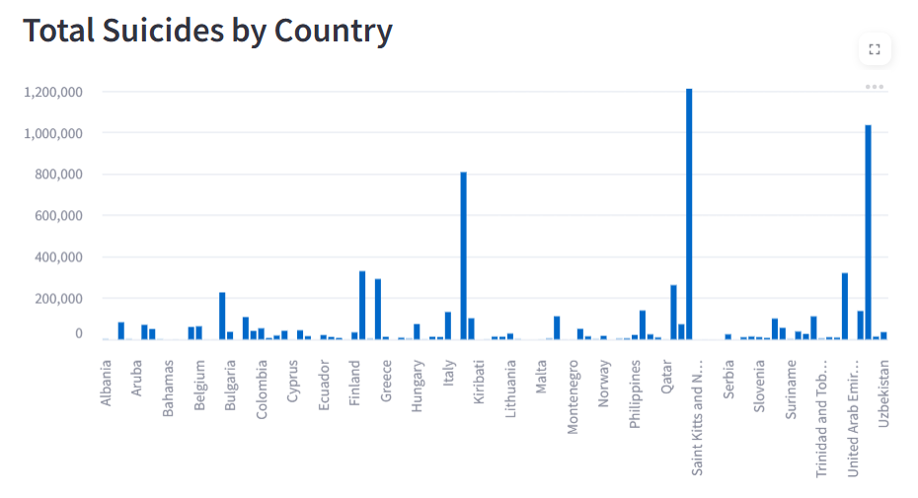

**1.Bar plot of total suicides over country**

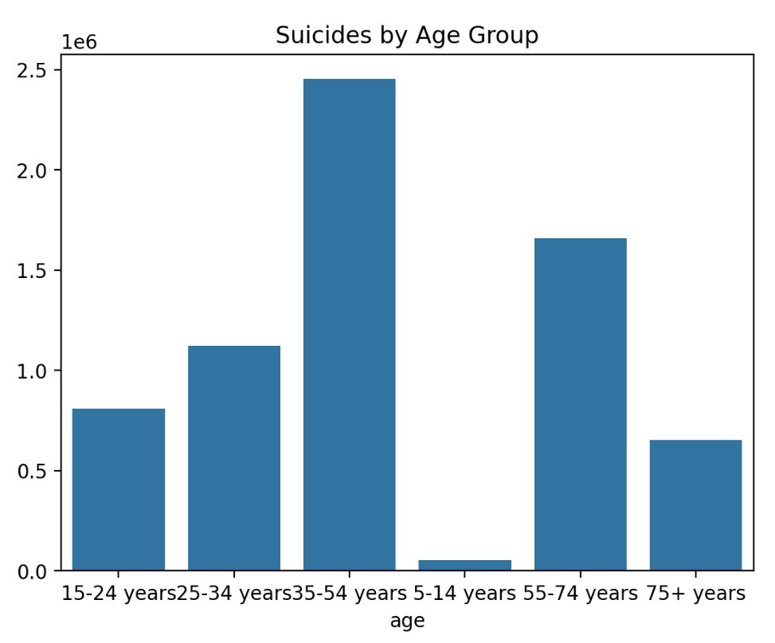

**2.Bar plot of suicides over age group**

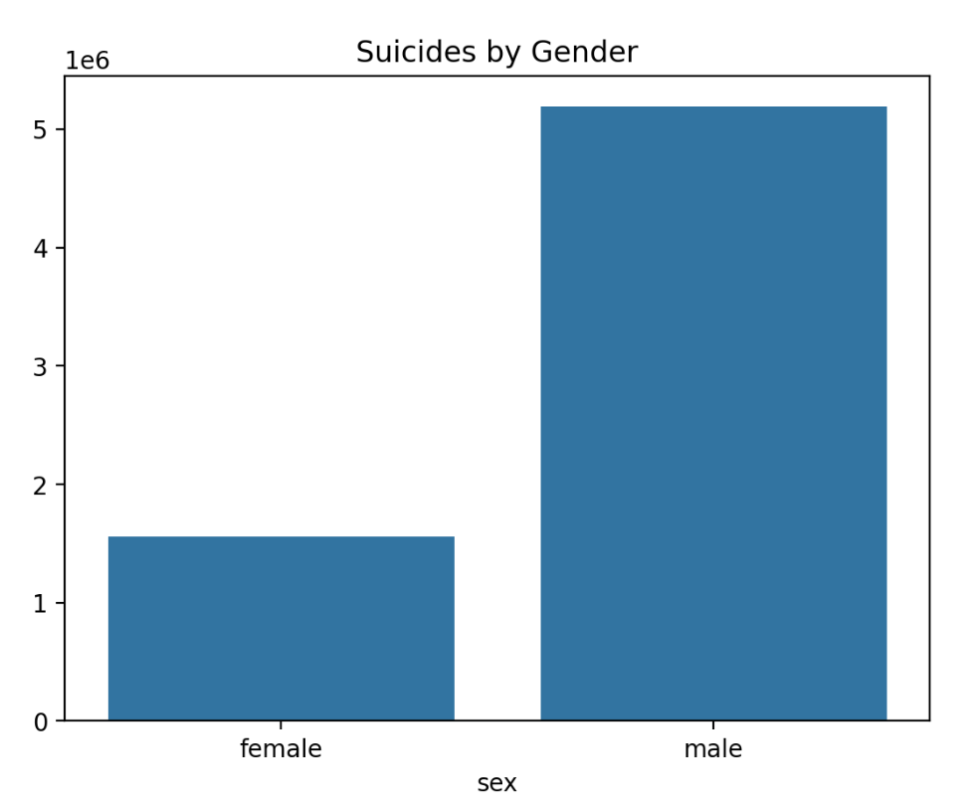

**3.Bar plot of suicides over gender**

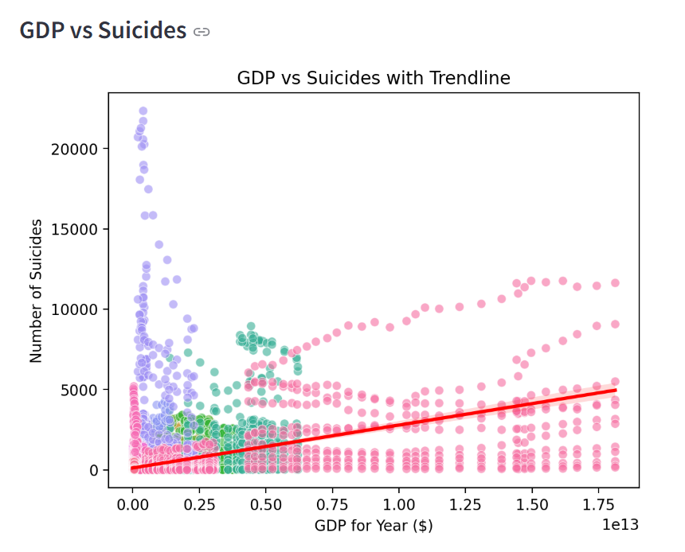

**4.GDP vs suicides**

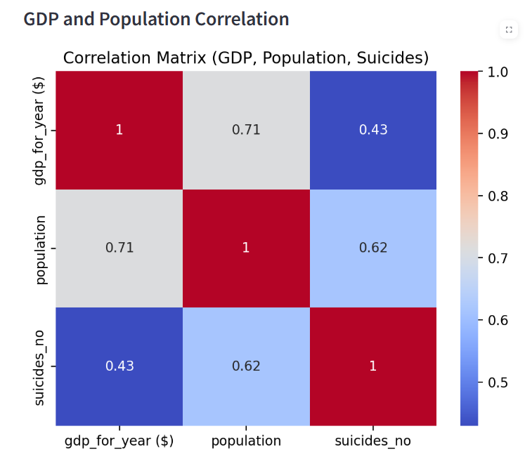

**5.Correlation of suicides over GDP**

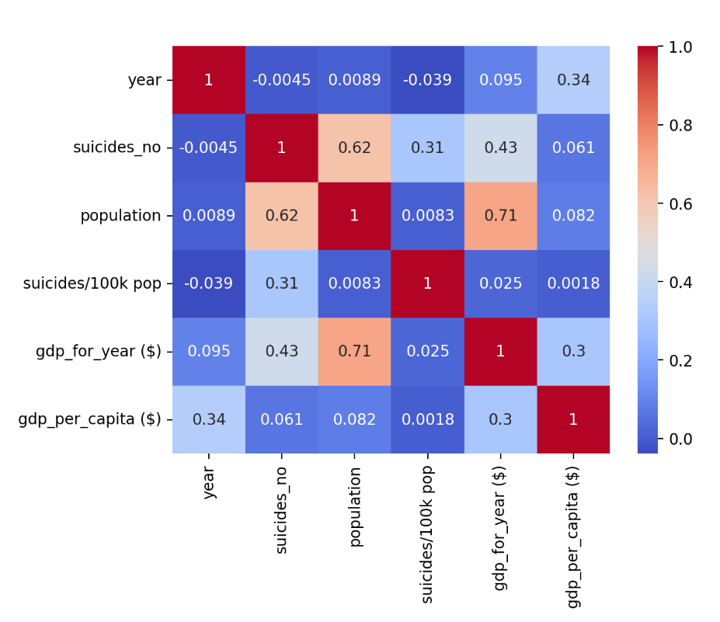

**6.Heat map of correlated data**

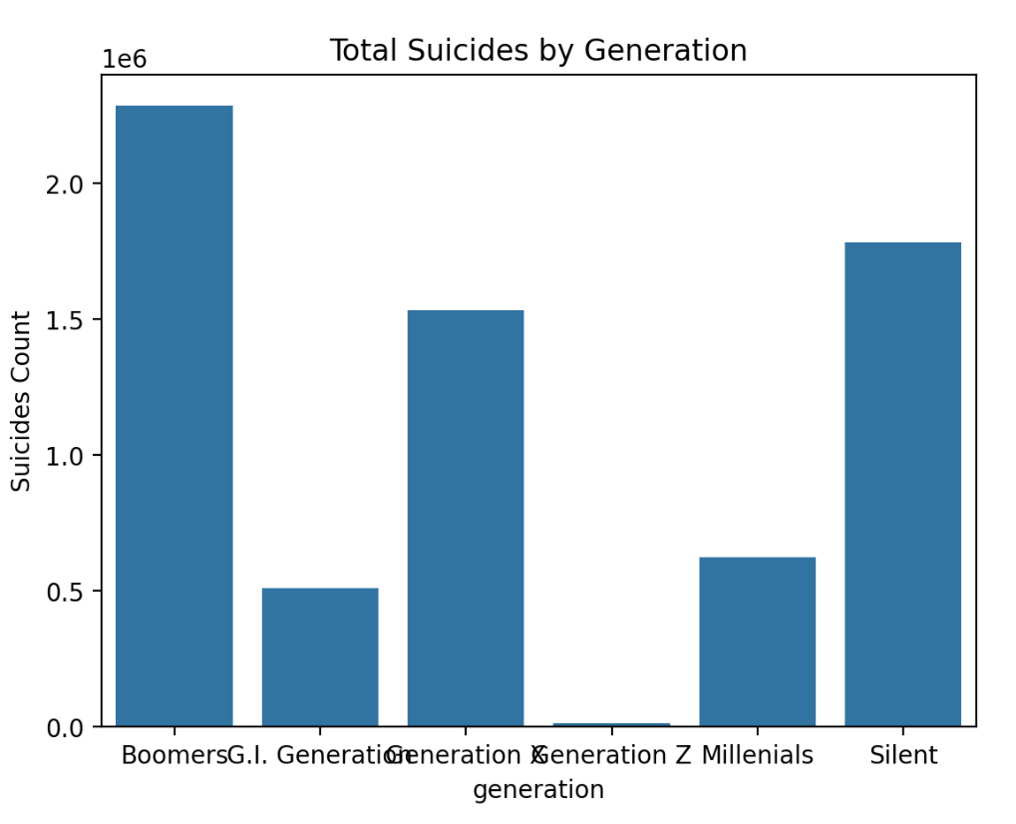

**7.Bar plot of suicides over generation**

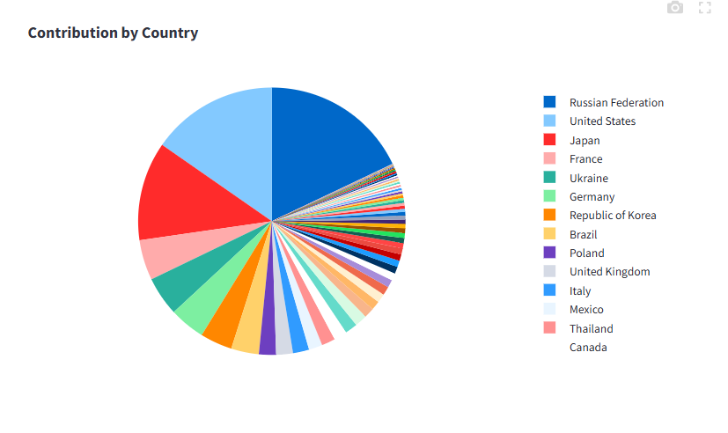

**8.Pie plot of contribution to suicides by countries**

**COGNITIVE MERITS AND DEMERITS OF PROJECT**

**Merits**

1. Improved Understanding of Suicide Trends
   * The dashboard provides a clear and visual understanding of global suicide trends through intuitive charts, maps, and graphs, helping users grasp complex patterns in suicide data across different countries and years.
2. Data-Driven Insights
   * By analysing and comparing country-specific and demographic data, the dashboard helps users make informed decisions related to mental health policies and interventions. It allows for a deeper understanding of the factors affecting suicide rates.
3. Interactive Exploration
   * Users can explore the data interactively through various filters such as year, country, gender, age group, and generation. This interactivity fosters engagement, curiosity, and a personalized analysis experience, helping users uncover trends relevant to their specific interests.
4. Simplified Data Representation
   * The dashboard simplifies complex global suicide data into easy-to-understand visual formats like scatter plots, pie charts, and bar graphs. This approach aids users in comprehending data that might otherwise be overwhelming or difficult to interpret.
5. Promotes Awareness
   * The visualizations highlight critical areas with high suicide rates, encouraging users to think critically about the underlying causes and potential solutions. This can raise awareness about the importance of mental health care and prevention programs.

**Demerits**

1. Over-Simplification
   * While the dashboard makes data more accessible, visual abstractions can oversimplify complex socio-economic factors influencing suicide rates, potentially leading to the misinterpretation of nuanced trends or regional differences.
2. Limited Dataset Scope
   * Insights are restricted to the dataset used, which may not be fully comprehensive or include the most recent data. This limitation can affect the accuracy of trends and may not represent certain regions or demographic groups fully.
3. Potential Bias
   * If there are inaccuracies in the dataset or preprocessing steps, such as missing or inconsistent values, these may introduce unintended biases, skewing the results and affecting users’ cognitive interpretation of the data.
4. Learning Curve
   * While the interactive features are powerful, some users, especially those unfamiliar with data visualization tools, may find navigating the dashboard challenging. A more intuitive or guided experience may be required for less experienced users.
5. Technical Dependence
   * The dashboard requires users to have access to technology and basic technical skills to interact with the system effectively. This limits its accessibility for all audiences, especially those in areas with limited internet access or technological infrastructure.

**CONCLUSION**

The **Global Suicide Analysis Dashboard** is a significant project aimed at shedding light on the critical issue of suicide rates worldwide. Suicide is a pressing global challenge that affects millions of lives, yet the complexity of the data and the diversity of contributing factors often obscure the full scope of the problem. This dashboard bridges that gap by presenting suicide data in an accessible, interactive format that allows users to explore the issue from multiple perspectives. Researchers, policymakers, mental health professionals, and the general public can all benefit from the insights it provides.

One of the primary strengths of this project lies in its ability to make complex data more approachable and engaging. Through dynamic visualizations like choropleth maps, scatter plots, bar charts, and heatmaps, the dashboard transforms raw data into meaningful narratives. Users can explore suicide trends over time, compare different countries and demographic groups, and identify regions most affected by suicide. For example, the choropleth map feature enables users to visually see how suicide rates vary across countries in a specific year, while the line chart tracks suicide trends over multiple years, offering insights into whether the situation is improving or worsening.

In addition to offering valuable insights, the dashboard encourages a deeper understanding of the causes and consequences of suicide. By allowing users to compare data across regions and time periods, the tool facilitates informed discussions on how factors such as economic instability, mental health resources, and cultural attitudes influence suicide rates. Policymakers can use the dashboard to pinpoint areas in need of intervention, while researchers can explore correlations between suicide rates and other variables. The dashboard’s interactive features, such as filtering by country, year, gender, and age group, make it adaptable to a wide range of use cases and interests.

Moreover, the **Global Suicide Analysis Dashboard** highlights the role of technology in addressing complex global health challenges. By combining advanced data processing techniques with clear visualizations, the project demonstrates how digital tools can be used not only for analysis but also for advocacy and action. The dashboard empowers users to reflect on the global suicide crisis and consider collective solutions, aligning with broader efforts to improve mental health awareness and prevention.

Despite its many strengths, the project also demonstrates the need for ongoing improvement and expansion. As more data becomes available, future versions of the dashboard could incorporate additional metrics, enhanced visualizations, and more functionalities to increase its utility and impact. Nonetheless, the current version represents a significant achievement, showing how data-driven approaches can educate, engage, and inspire meaningful action.

In conclusion, the **Global Suicide Analysis Dashboard** is more than just a tool for data visualization; it is a call to action. By presenting the stark reality of global suicide trends in a way that is both clear and compelling, it empowers users to learn, reflect, and contribute to finding solutions. In a world where mental health challenges continue to rise, projects like this highlight the urgent need to address suicide prevention collectively. The dashboard not only informs but inspires, fostering a shared commitment to creating a healthier, more supportive world for everyone.

**FUTURE ENHANCEMENTS**

1. **Integration of Additional Datasets**
   * Include data on factors like mental health care access, unemployment rates, education levels, and social support systems.
   * Incorporate social determinants of health, such as substance abuse, homelessness, and poverty, for deeper analysis.
   * Add real-time data updates for dynamic and up-to-date insights.
2. **Improving Accessibility**
   * Introduce multilingual support to cater to users from diverse linguistic backgrounds.
   * Develop a mobile-friendly version or dedicated app to enhance accessibility for users in low-resource or rural areas.
3. **Advanced Data Visualizations**
   * Implement animated charts, interactive 3D maps, and dynamic storytelling tools.
   * Enable intuitive visualization of complex trends, such as changes in suicide rates over time or across demographic groups.
4. **User-Centric Features**
   * Allow customizable reports and alerts for significant changes in suicide trends.
   * Provide options to save or share visualizations for better usability.
   * Introduce collaboration features like shared dashboards and discussion forums to foster teamwork among stakeholders.
5. **Partnerships and Credibility**
   * Collaborate with global organizations like WHO or the United Nations to access richer datasets and authoritative resources.
6. **Exploration of Environmental and Socio-Economic Factors**
   * Analyze the impact of economic instability, climate change, and mental health.
   * Study the relationship between socio-economic and environmental factors with suicide rates for holistic prevention strategies.

By implementing these improvements, the dashboard can evolve into a more impactful tool for suicide prevention, enabling informed strategies and fostering global collaboration.

**References**

1.Streamlit, *Streamlit Documentation*, Streamlit, 2021, pp. 1-15. Available at <https://docs.streamlit.io/>.

2. Plotly Technologies, *Plotly for Python*, Plotly Technologies, 2020, pp. 22-40. Available at <https://plotly.com/python/>.

3. Data Set, Kaggle, Available at <https://www.kaggle.com/datasets/russellyates88/suicide-rates-overview-1985-to-2016>

4. <https://en.wikipedia.org/wiki/List_of_countries_by_suicide_rate>

5. **SkillCurb**, *How to Build Web Apps with Streamlit Tutorial*, YouTube, Available at <https://www.youtube.com/watch?v=P1gBmwc6xFo&t=342s> Accessed December 9, 2024.