**DATA MANAGEMENT FOR IOT**

**ASSIGNMENT**

**BY**

**UPPADA PAVAN PREM KUMAR**

**2020MT12361**

**M.Tech Software Systems (Data Analytics)**

**III Semester**

**WORK INTEGRATED LEARNING PROGRAMME**

**BITS PILANI**

**Smart Home System**

Home includes a plurality of electronic devices which may be a refrigerator, a microwave oven, a furnace, a dishwasher, an air conditioner, and the like. These electronic devices require energy to operate. Such devices can be controlled by using their operation data in order to optimize the energy consumed by them. To that end, a smart home system utilizes different sensors within these devices. The sensors such as a temperature sensor, a humidity sensor, and a pressure sensor monitor the operational state of the electronic devices. The data from sensors is further transmitted to a corresponding nearby node, where the data from the sensors to the corresponding nearby node is transmitted via the short-range communication methods such as Bluetooth, Zigbee, or Wi-Fi. Further, the data from each data node in the smart home system is received by a sensor data aggregation node. The sensor data aggregation node can also be present within the home premises as an edge device. The sensor data aggregation node perform analysis on the data before transmitting the data to a cloud network. In particular, the sensor data aggregation node utilizes a Kalman Filter algorithm to analyse the sensor data and fix errors in the data. The Kalman filter is configured to predict states and noise measurements, to produce optimal, unbiased estimates of the states of the smart home system. Further, the sensor data is transmitted to the cloud network via the medium range or long-range communication methods (such as Wi-Fi/4G/5G). The sensor data is further stored and analysed by the cloud network. Accordingly, further control is applied to the electronic devices to ensure optimal performance.

Dataset :-

It consists of 5+Lakh records producing data in 1minute interval. We included overall house power consumption along with individual device consumption readings & sensor data also.

**Context Diagram:**

**Location 1**

**Sensor a1**

**Location N**

**Sensor aN**

**Sensor Node**

**Sensor bN**

**Sensor b1**

**Storage**

**Gateway (Data Prediction and Data Filtering)**

**Sensor Node**

**Sensor Node**

**Architecture of Smart Home System**

**Data Access Tier**

(Wi-Fi or mobile network such as LTE/5G is used for transmission to cloud network)

**Resource Tier**

(Wi-Fi/Zigbee is used for transmission to Sensor nodes)

**Responding to Clients**

**Data Consolidation/Integration Tier**

**Devices/Sensors**

**Home Premises**

**Furnace**

**Dishwasher**

**Temperature**

**WindSpeed**

**Fridge**

**Solar**

**windBearing**

**Pressure**

**Humidity**

**Microwave**

**Sensor Data Aggregation Node (Gateway)**

**Storage**

**Apply Prediction**

**Prediction Model Based on Kalman Filter**

**No**

**Yes**

**Acquired Sensor Data from Multiple Sensors/Sensor Nodes**

**Is the best Parameter?**

A kalman filter is used to reduce the noises and serve better sensors’ readings.

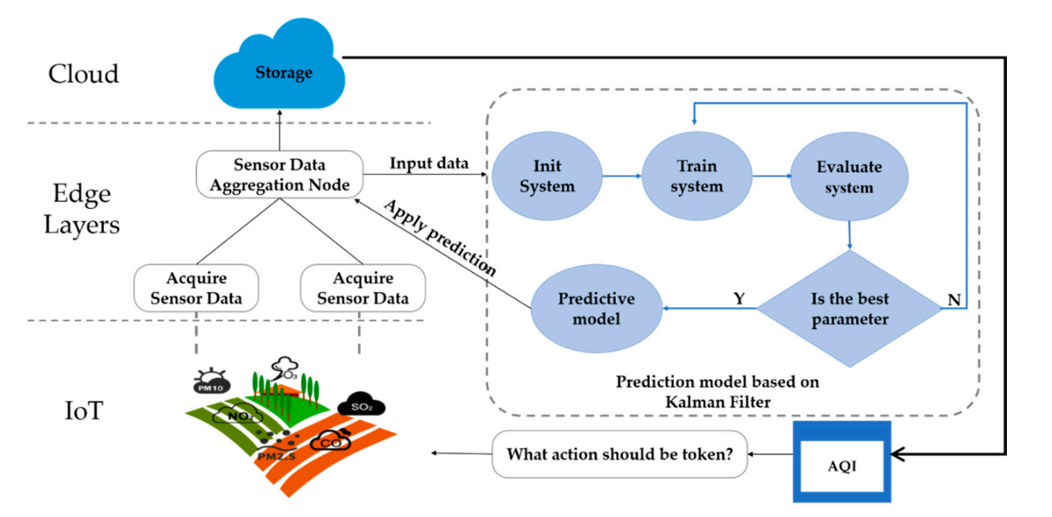

**PE**

Smart Home

Figure 3: Machine learning in edge-to-cloud environment (PE: Power Output)

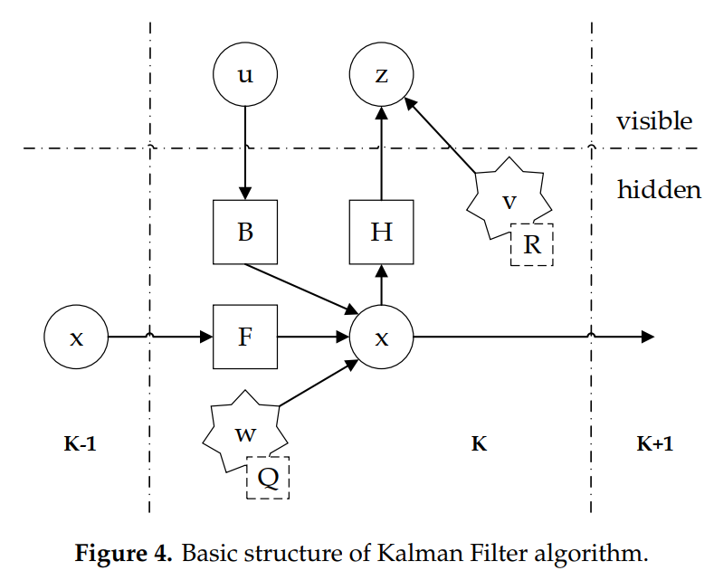

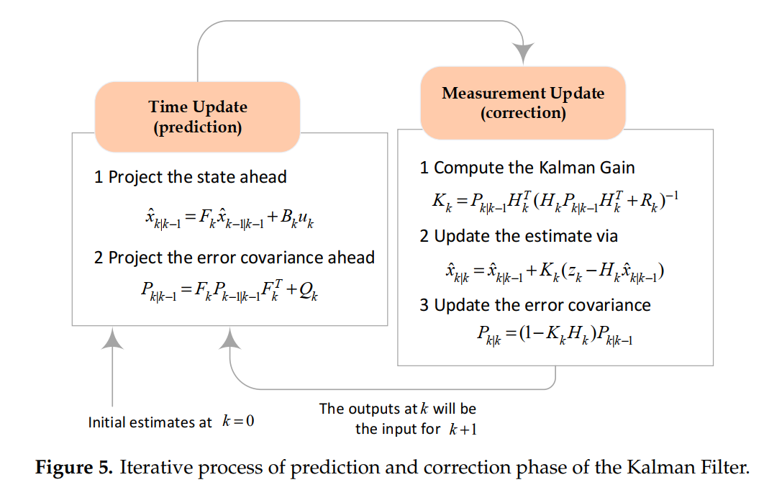

Kalman filter does time series prediction. There are two stages:

* Prediction stage
* Correction Stage

1. Data Cleaning:

The data set produced from the sensor data has been imported into a jupyter notebook and data cleaning has been done.

1. Data Visualization:

The cleaned data was then used to visualize and compare different devices in Smart Home and their usages.

Code regarding Point 2 & 3 are attached in the python file & output is attached along with the pdf file.

DM_IOT_Assignment_2020Mt12361.ipynb

DM_IOT_Assignment_2020Mt12361.pdf

References:

1. A.Winursito, I.Masngut, G.N.P.Pratama, “Development and Implementation of Kalman Filter for IoT Sensors: Towards a Better Precision Agriculture.”
2. X.Lai, T.Yang, Z,Wang, P.Chen, “IoT implementation of Kalman Filter to Improve Accuracy of Air Quality Monitoring and Prediction,” Applied sciences, 2019.
3. J.C.Negrete, “A Kalman Filter uses in Mexican Agriculture”, Arch Agri Res Technol. 2020.
4. S.M.Patil, R.Sakkaravarthi, “Internet of Things based Smart Agriculture system using Predictive analytics”, Asian Journal of Pharmaceutical and Clinical Research, 2017.