SELECT * FROM Customers;
SELECT CustomerName, City FROM Customers;
SELECT DISTINCT Country FROM Customers;
SELECT COUNT(DISTINCT Country) FROM Customers;
SELECT * FROM Customers WHERE Country='Mexico';

SELECT * FROM Customers WHERE Country='Germany' AND City='Berlin';
SELECT * FROM Customers WHERE City='Berlin' OR City='München';
SELECT * FROM Customers WHERE Country='Germany' OR Country='Spain';
SELECT * FROM Customers WHERE NOT Country='Germany';
SELECT * FROM Customers
WHERE Country='Germany' AND (City='Berlin' OR City='München');
SELECT * FROM Customers
WHERE NOT Country='Germany' AND NOT Country='USA';

SELECT * FROM Customers ORDER BY Country;
SELECT * FROM Customers ORDER BY Country DESC;
SELECT * FROM Customers ORDER BY Country, CustomerName;
SELECT * FROM Customers ORDER BY Country ASC, CustomerName DESC;

INSERT INTO Customers (CustomerName, ContactName, Address, City, PostalCode, Country)
VALUES ('Cardinal', 'Tom B. Erichsen', 'Skagen 21', 'Stavanger', '4006', 'Norway');

INSERT INTO Customers (CustomerName, City, Country)
VALUES ('Cardinal', 'Stavanger', 'Norway');

How to Test for NULL Values?
SELECT CustomerName, ContactName, Address FROM Customers
WHERE Address IS NULL;

SELECT CustomerName, ContactName, Address FROM Customers
WHERE Address IS NOT NULL;

UPDATE Customers SET ContactName='Juan' WHERE Country='Mexico';
DELETE FROM Customers WHERE CustomerName='Alfreds Futterkiste';

SELECT * FROM Customers LIMIT 3;
SELECT * FROM Customers WHERE Country='Germany' LIMIT 3;

SELECT MIN(Price) AS SmallestPrice FROM Products;
SELECT MAX(Price) AS LargestPrice FROM Products;

SQL COUNT(), AVG() and SUM() Functions(we can use where condition)
SELECT COUNT(ProductID) FROM Products;
SELECT AVG(Price) FROM Products;
SELECT SUM(Quantity) FROM OrderDetails;
Like operator: The LIKE operator is used in a WHERE clause to search for a specified pattern in a column.
SELECT * FROM Customers WHERE CustomerName LIKE 'a%';
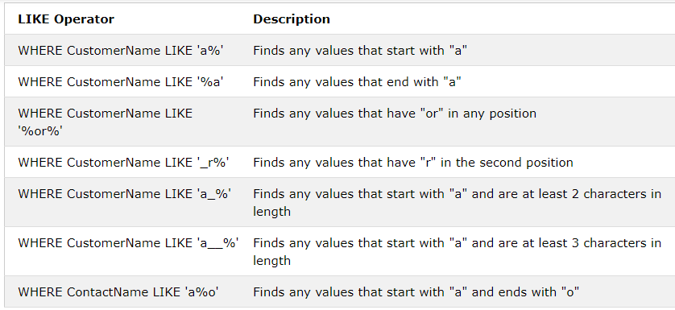
The following SQL statement selects all customers with a CustomerName that does NOT start with "a":
SELECT * FROM Customers WHERE CustomerName NOT LIKE 'a%';

A wildcard character is used to substitute one or more characters in a string.

SELECT * FROM Customers WHERE City LIKE 'ber%';
SELECT * FROM Customers WHERE City LIKE '%es%';
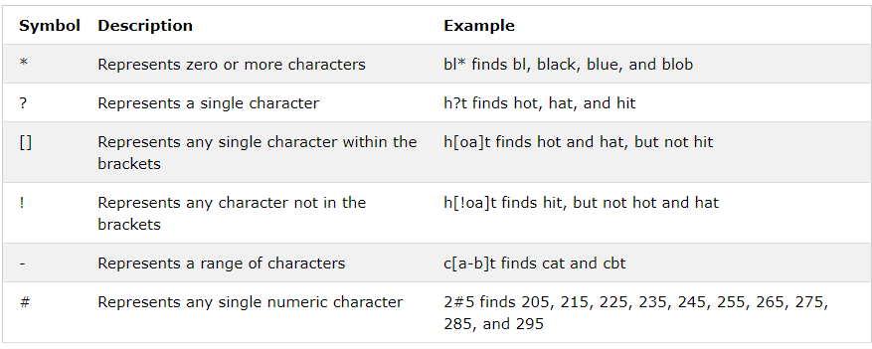

SELECT * FROM Customers WHERE City LIKE '_ondon';
SELECT * FROM Customers WHERE City LIKE 'L_n_on';
SELECT * FROM Customers WHERE City LIKE '[bsp]%';
SELECT * FROM Customers WHERE City LIKE '[a-c]%';
SELECT * FROM Customers WHERE City LIKE '[!bsp]%';
SELECT * FROM Customers WHERE City NOT LIKE '[bsp]%';

In operator
SELECT * FROM Customers WHERE Country IN ('Germany', 'France', 'UK');
SELECT * FROM Customers WHERE Country NOT IN ('Germany', 'France', 'UK');
SELECT * FROM Customers
WHERE Country IN (SELECT Country FROM Suppliers);

The BETWEEN operator selects values within a given range. The values can be numbers, text, or dates.
The BETWEEN operator is inclusive: begin and end values are included.
SELECT * FROM Products WHERE Price BETWEEN 10 AND 20;
SELECT * FROM Products WHERE Price NOT BETWEEN 10 AND 20;

BETWEEN with IN Example
The following SQL statement selects all products with a price between 10 and 20. In addition; do not show products with a CategoryID of 1,2, or 3:
SELECT * FROM Products
WHERE Price BETWEEN 10 AND 20
AND CategoryID NOT IN (1,2,3);
SELECT * FROM Products
WHERE ProductName BETWEEN 'Carnarvon Tigers' AND 'Mozzarella di Giovanni'
ORDER BY ProductName;
SELECT * FROM Products
WHERE ProductName BETWEEN "Carnarvon Tigers" AND "Chef Anton's Cajun Seasoning"
ORDER BY ProductName;
SELECT * FROM Products
WHERE ProductName NOT BETWEEN 'Carnarvon Tigers' AND 'Mozzarella di Giovanni'
ORDER BY ProductName;
SELECT * FROM Orders
WHERE OrderDate BETWEEN '1996-07-01' AND '1996-07-31';

Alias
SELECT CustomerID AS ID, CustomerName AS Customer FROM Customers;
SELECT CustomerName AS Customer, ContactName AS [Contact Person]
FROM Customers;
Note: It requires double quotation marks or square brackets if the alias name contains spaces:
SELECT o.OrderID, o.OrderDate, c.CustomerName
FROM Customers AS c, Orders AS o
WHERE c.CustomerName='Around the Horn' AND c.CustomerID=o.CustomerID;

JOINS: A JOIN clause is used to combine rows from two or more tables, based on a related column between them

Different Types of SQL JOINs
Here are the different types of the JOINs in SQL:
- (INNER) JOIN: Returns records that have matching values in both tables
- LEFT (OUTER) JOIN: Returns all records from the left table, and the matched records from the right table
- RIGHT (OUTER) JOIN: Returns all records from the right table, and the matched records from the left table
- FULL (OUTER) JOIN: Returns all records when there is a match in either left or right table
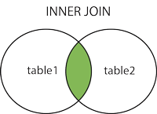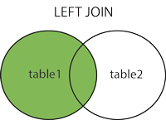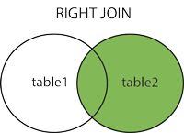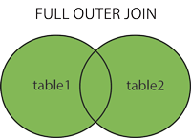

SELECT Orders.OrderID, Customers.CustomerName, Orders.OrderDate
FROM Orders
INNER JOIN Customers ON Orders.CustomerID=Customers.CustomerID;
SELECT Orders.OrderID, Customers.CustomerName
FROM Orders
INNER JOIN Customers ON Orders.CustomerID = Customers.CustomerID;

SELECT Orders.OrderID, Customers.CustomerName, Shippers.ShipperName
FROM ((Orders
INNER JOIN Customers ON Orders.CustomerID = Customers.CustomerID)
INNER JOIN Shippers ON Orders.ShipperID = Shippers.ShipperID);

SELECT Customers.CustomerName, Orders.OrderID
FROM Customers
LEFT JOIN Orders ON Customers.CustomerID = Orders.CustomerID
ORDER BY Customers.CustomerName;
SELECT Orders.OrderID, Employees.LastName, Employees.FirstName
FROM Orders
RIGHT JOIN Employees ON Orders.EmployeeID = Employees.EmployeeID
ORDER BY Orders.OrderID;
SELECT Customers.CustomerName, Orders.OrderID
FROM Customers
FULL OUTER JOIN Orders ON Customers.CustomerID=Orders.CustomerID
ORDER BY Customers.CustomerName;

The UNION operator is used to combine the result-set of two or more SELECT statements.

Language:
Advantage: process the data
Disadvantage: Cannot Store data

Issues with Flat File
Size issues :
Security :
Retrieve the data : slow
C language : Complex
No Indexes : Processing Slow
Concurrency : at a time multiple customers cannot be allowed.
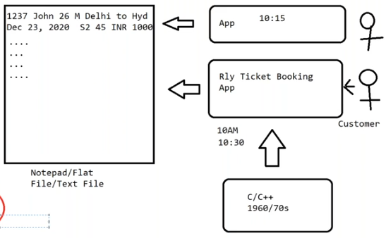

In 1970’s IBM introduced the Data Base Management System (DBMS) concept and language is SQL

RDBMS: It is a type of database management system (DBMS) that stores data in a row-based table structure which connects related data elements.
It Includes functions that maintain the Security, accuracy, integrity and consistency of the data

SQL: It is a standard language for storing, manipulating and retrieving data in databases

Types of DBMS:
- Network Data Base Management System(Failed)
- Hierarchical Data Base Management System(Failed)
- Relational Data Base Management System(Success) IBM company by Dr. E F Codd

RDBMS Software/Tools:
- Oracle
- SQL Server
- IBM DB2 (IBM company)
- Natezza (IBM company)
- MySQL
- Tera Data
- PostGre SQL
SQL Server History:
- SQL Server 1.0 version in 1989
- SQL Server 2005 (RDBMS + MSBI(SSIS, SSAS, SSRS))
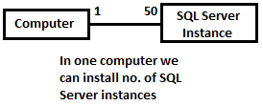
SQL Server DB Architecture
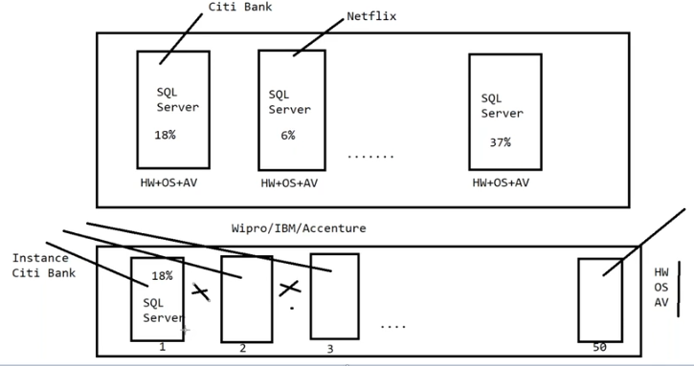
The below figure contains multiple virtual servers with 1 hardware, 1 OS, 1 anti Virus

If we have a multiple instances then 1st instance is called Default instance and remaining Instances are called named instances

If windows name( pavan ) and instance server name( pavan ) is same then it is called Default instance

Hardware Prerequisites:
- 2 GB RAM
- 200 GB Hard disk
- Any processor
- Windows 10
- Pdf
- Winzap
- MS office
- SQL Server

Open SQL Server: Start SSMS Enter
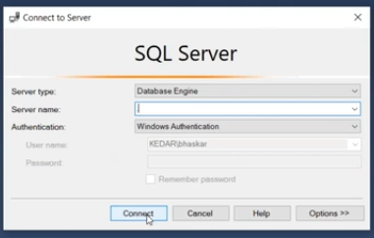
Default Server name = . or localhost or pavan means local SQL Server
Named erver name = .\citibank or localhost\citibank or pavan\citibank
$ select @@servername
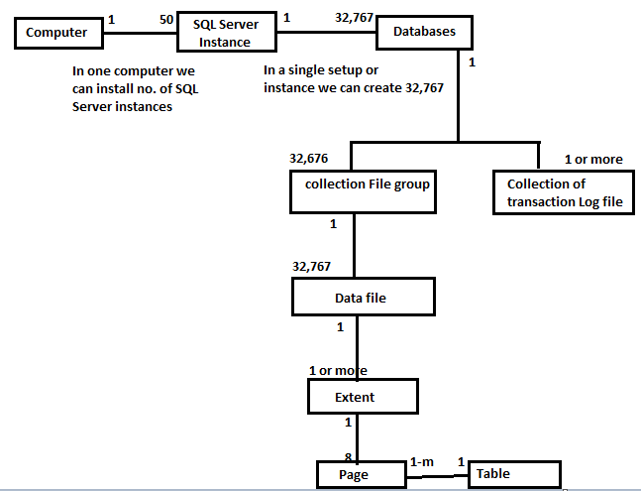

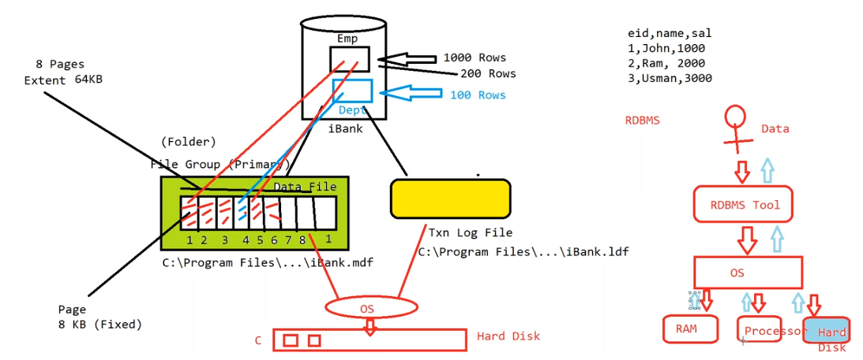

Why Transaction log file?
- To recover the data in emergency
- Minimum one transaction log file per DB
Can I have a db without log file?
- No

SQL Server Data types
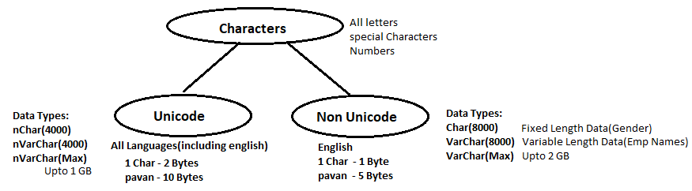

$ use <database>
go

$ select * from <tablename>
go

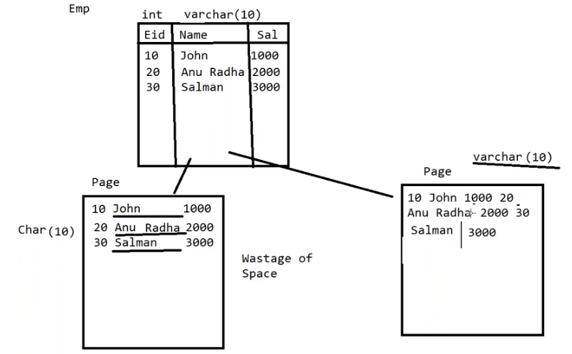
In future we need to update the name then Char can update easily better than varchar
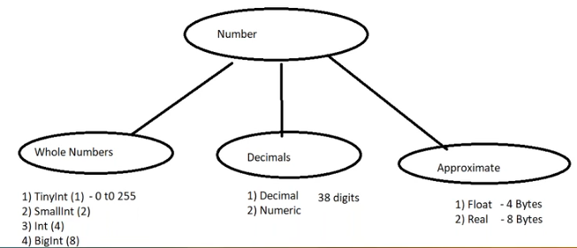

Monetary data
- Small money(4 bytes)
- Money(8 bytes)

Date and Time
- Smalldatetime (4 bytes) : January 1, 2022, through June 26,2100
- Datetime (6 bytes) : January 1, 2022, through June 26,2100
- Datetime2( 7 bytes) : 0001-01-01 through 9999-12-31
- Date (3 bytes) : 0001-01-01 through 9999-12-31
- Time
- DateTimeOffSet (7 byte)

Binary Data
- Binary Data(for HexaDecimal data)
  - Binary(<8k fixed)
  - Varbinary(<8k)
  - Varbinary(max)
- To store pictures, media files, docs etc
- To migrate data from one platform to another
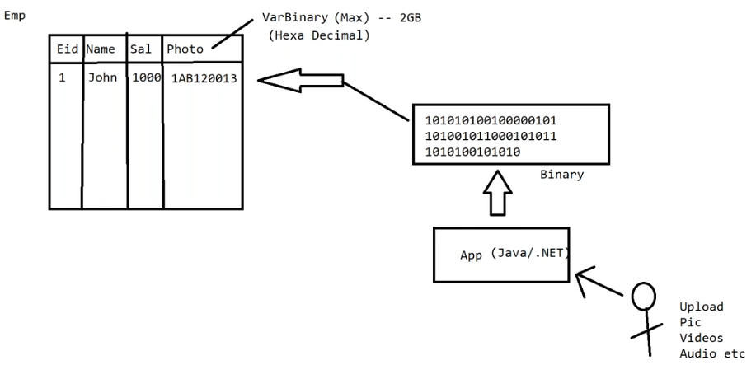

Data:
Structured data (Tables) RDBMS/ BI
Semi Structured data
Unstructured data (files, chat, pic, audio, video) Hadoop

Select * from production.ProductPhoto
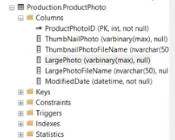

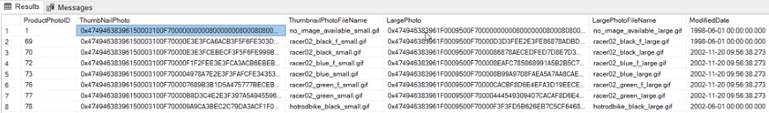

Timestamp (8 byte)
- Indicate activity
- Known as “Row Version” column
- Changed whenever a row is modified
- Not related to date and time
- Updated by SQL Server engine itself
- Only one per table

Bit
- 0 or 1 or NULL

Example: Sometimes we will maintain the same table in two servers for backup at that time how to update the table values in another server. For that we have a ROW Version number column(Time stamp)
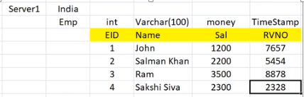
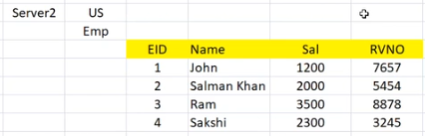

If you observe in above INDIA emp table 4th row was updated then according to the timestamp will modify the US emp table.

Note : To move the data from one server to another server we use ETL services

Global Unique Identifier
- GUID (16 byte)
- One per table
- Hexa Decimal Data
- SQL Server insert new GUID per each row using NewID() function
- Eg: Bar code Number on the products
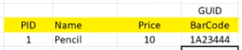

Example: when two companies are getting merge then we need to use the guid
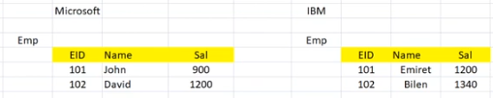
We will get the duplicate the EID. For that we use GUID
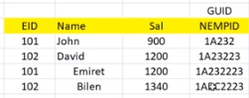

Spatial Data Types:
- Geometry
- Geography
  - To store maps
- HierarchyId
  - To get the level in a hierarchy

XML Data type
- XML(Extensible Markup Language)
- To store XML Data
Why XML?
- To remove the platform dependency
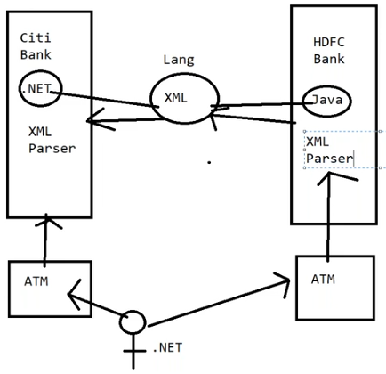
XML parser will read the XML data

Business Integrity (honesty, truth): business has to maintain the correct data

How to ensure that to maintain correct data?
- Employee Id, Department ID, passport Number, Driving License should be unique
- Transaction amount cannot be negative
- The transaction date should be the same as current date
- Grade ‘A’ employees Salary should be <5000 and
Grade ‘B’ employee’s Salary >5000 and <=10000
- Project Id can be 1,2,3,4
- Account holder in a bank cannot make more than 3 txns per day
- Account holder in a bank can withdraw maximum of 50,000/- per day
- When a Transaction is altered, the difference between the old amount and the new amount cannot be more than 10%
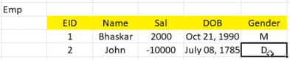

In above table incorrect data was entered negative transaction, DOB, gender
Someone has to validate the data i.e Machine (SQL Software) has to validate the data
To validate we have to apply conditions for columns
- Sal > 0
- Age <= 60
- Gender M or F

Application:
- Correct data
- Application must be faster
- Maintainance
- Easy

Constraints in SQL Server:
NULL: Represents 'unspecified' value
For example: Hobbies, Mobile No columns
Storing NULL values as part of table is bad. Avoid storing NULL value, replace it with
DEFAULT value
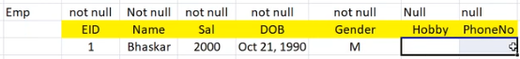

Why Storing NULL values are bad?
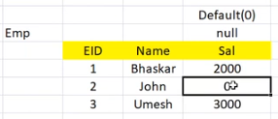
Cannot perform arithmetical and string operation such as sort etc Any Value + Null → Null
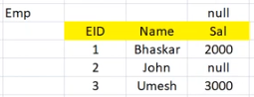
Total salary = 2000+null+3000 = null

Defaults:
The following ways in which we can provide default value in a table:
- Constant Value
  - Eg: 0, 1, N/A etc
- Expression
  - Eg: Price*qty
- Built in Function
  - Eg: Getdate()
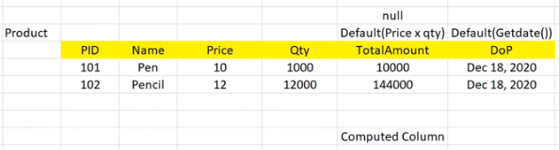

Key : key means which is an attribute(column) or multiple attributes using which anyone can retrieve a single instance from the group of instances
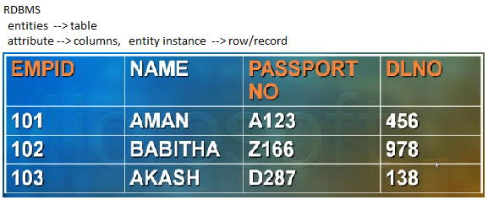

Candidate keys: EMPID, PASSPORT NO, DLNO (no duplicate values)
Primary key: EMPID
Alternate keys (Unique keys): PASSPORT NO, DLNO

Note: Candidate keys = PK + AK

What is a key?
- Key is an attribute which does not allow duplicate values

What is the purpose of the key?
- To retrieve the single instance

What is a composite key?
- A key which has multiple attributes called as composite key

What is a candidate key?
- Collection of key columns

Composite Key: A key which has multiple attributes called as composite key
Ex: 1. Tower no. + house no.
2. Class + Section + Roll no.
6th B 46
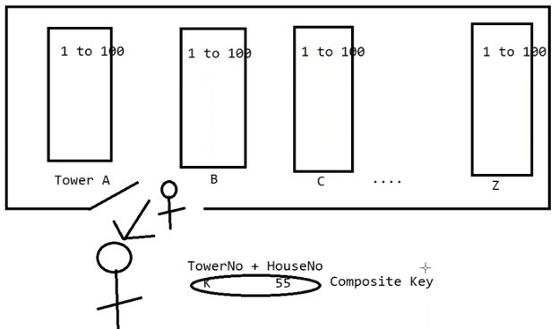
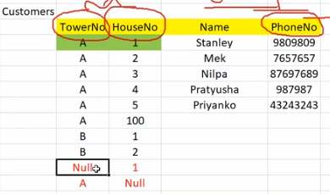
No part of the primary key will have null

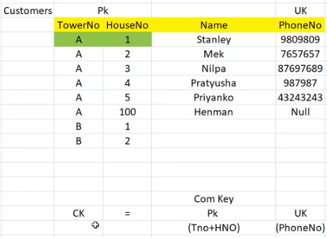

Primary Key:
- Ensures uniqueness
- No NULL
- Auto creation of index (Clustered)
- One per table
- Composite Primary key
- Not mandatory (Recommended)

Composite Primary Key:
- Made up of more than 1 column
- Each combination of values must be unique
- Order of the columns in PK should match the order of the columns as shown in the table.
- No Null values allowed in any part of the PK
- Examples:
  - Train No + Coach No + Seat No
  - Tower No + House No
Unique Key:
- For Alternate Keys
- Ensures uniqueness
- Allows NULL : Only ONE NULL Value
- Auto-creation of Index (Non-Clustered)
- Many Unique Keys per table
- Composite Unique Keys

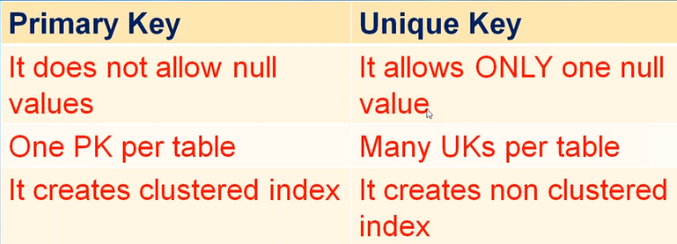

RDBMS
- Entities tables
- Attributes columns
- Entity instances row/record
- Primary key primary key
- Alternate keys unique keys

Relationships / Cardinality (Data Modeling):
There are 3 types of relations between the tables
- 1 1 (Any PK can become FK) 2 Tables, 2 PK’s, 2 FK’s
- 1 M (Parent table PK – FK in the child Table) 2 tables, 2 PK, 1 FK(P -- C)
- M M (Bridge table will be needed) 3 tables, 2 PK, 2 FK
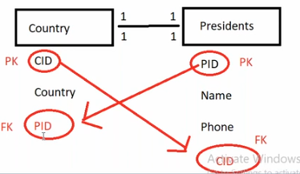
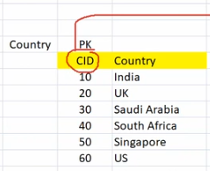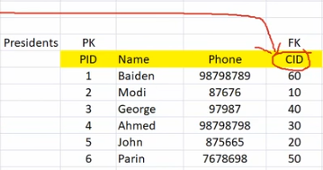

A primary key can become a foreign key in opp table
A composite primary

Foreign Key :
- It is used to establish relationship between tables in RDBMS tools
- It also performs the existence check
- Foreign keys contains lot of null values
- It allows duplicate values

Can I use unique key to create a foreign key?
- Yes

How many FK’s per table?
- Many FF’s per table
How many PK per table?
- Only one
How many UK per table?
- many

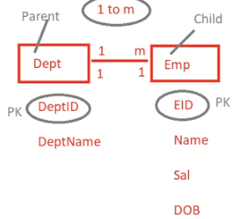
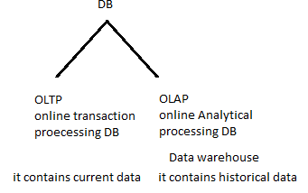
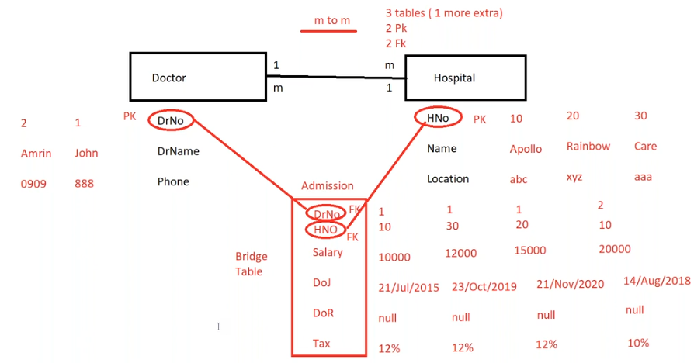
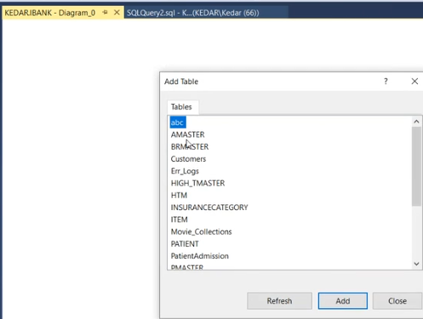
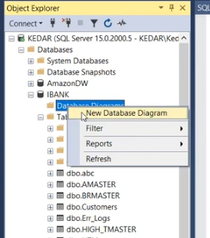

- Check Constraints
- Triggers
- Identity
- Note: The above features are used to validate the data in SQL Server
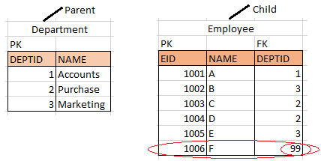

Above is one to many relation
If you enter some data RDBMS software it takes the value of that FK and checks in the parent table.
If the value does not exist the entire row will get deleted

SQL Server performs existence check when we create relationship this existence check is called as “Referential Integrity”

ERROR: FK violation error No employee can have a non existent dept id

Self Referential table: A FK is referring its own table PK
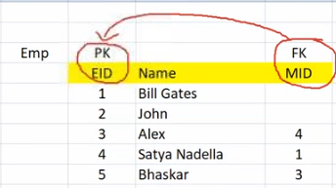
Cascade Features:
- What if PK/UK column in parent table changes?
- What if a row in parent table is deleted?
- Solution: Cascaded update, delete features
- Note: Cascade features cannot be implemented on self referential table
Cascade Delete ON
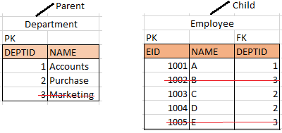
Cascade delete OFF: 1st update the FK value then delete the Parent row
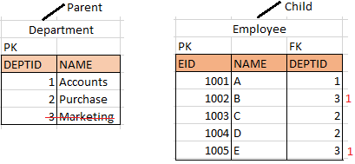

Cascade UPDATE ON:
- If you update the parent table PK then automatically child table FK values get updated
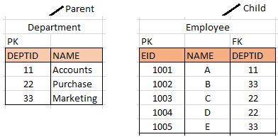

Cascade UPDATE OFF:
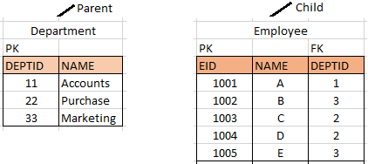
Check Constraints:
- Column Level
  - Expression Involving only 1 column
- Table Level
  - Expression can involve more than one column from the same table
- Multiple constraints per column
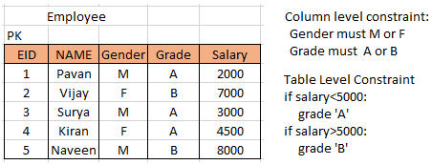

It will allow following operators =, <>,> <, <=, ~, IN, OR, AND, NOT etc
No Programming IF...ELSE, LOOP etc
It always works within the same table; cannot work across tables
Use check constrains when the requirement is simple; else use Triggers
Check constraints are faster in performance

Identity Property:
- Set for INTEGER or Decimal Columns
- Identity Seed (initial value) & Increment or Decrement
  - Integers
  - Negative integers
- Only one column per table
- No NULL & Default Values
- Unique Values
- It may have gaps when data is deleted
  - DBCC CHECKIDENT(<<Table>>,RESEED,<Deleted Record No>)
Eg: Automatically generate EmpID for each new employee,
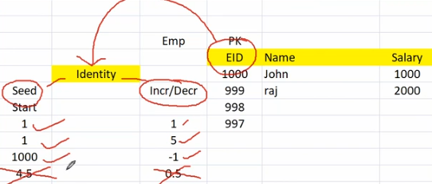

10. SQL Commands
Structured Query Language (SQL) provides four types of languages based on type of operation to be performed on a database. These languages can be considered as subsets of SQL and logical groups only. Physically commands for all these languages are executed from the same interface provided by the database.
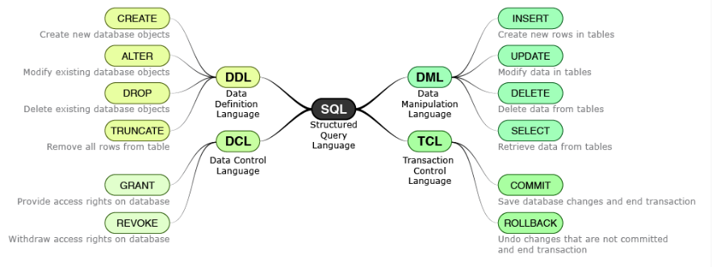
DENY SAVE POINT

To open Microsoft SQL Server Management Studio
Start ssms Enter
Create New Database
- .mdf (data file)
- .ldf (log file)
Create table and store data

Databases are of two type
- System Databases
  - Master : configurations, all other db info, user and passwords
  - Model : Template database
  - Msdb : create lot jobs (backup of db) and alerts (sms and email)
  - Tempdb : it is just like a rough, it is a global resource
- User defined databases

What happens when master db is deleted?
- SQL server will not start
Master contains configurations, all other db info, user and passwords

Comments -- single line comments
/* Multi line comments */

DDL commands
Create database syntax :
create database <dbname>
go

drop database syntax:
drop database <dbname>
go

modify database syntax:
alter database <dbname>
go

after creating the database now change database context
use company
go

create table syntax:
create table <tablename>
(
columnName datatype primary key identity(seed, incr),
columnName datatype null,
columnName datatype not null,
columnName datatype null default (value),
columnName datatype not null check (expression),
columnName datatype null foreign key references PKTableName(pk column)
)
Go
Example:
Create table Dept
(
DeptID int primary key,
DeptName varchar(100) not null
)
go

Find the schema of the table:
sp_help tablename
go
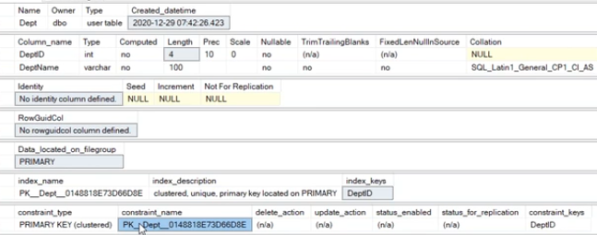

see the table:
select * from Dept
insert the data into the table: insert into <tablename> values(v1,v2..)
insert into Dept values(1, ‘sales’)
insert into Dept values(2, ‘marketing’)

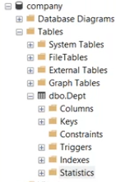

Delete all rows from the table:
Delete from <tablename>
go

Delete one row from the table:
Delete from <tablename> where condition
go

update the table data:
update <tablename>
set colname = “new value”
where condition

Note: be careful while updating and deleting

Transactional Command Language:
begin tran
query
commit/rollback

begin tran
update Dept set DeptName = “Tech R and D”
rollback

begin tran
delete from Dept
rollback

begin tran
insert into Dept values(60,’aaa’)
update Dept set DeptName=”abc” where DeptID=20
rollback
Note: Once you commit we cannot do rollback
Find the schema of the database:
sp_helpdb <database name>
go

sp_helpdb ‘iBank’
go

create a table:
create table Emp
(
Eid int primary key,
Empname varchar(100) not null,
salary money not null check( salary > 0),
gender char(1) not null check( gender = ‘M’ or gender = ‘F’),
dob datetime not null,
phone char(10) null unique,
emailID varchar(50) null unique,
passportNo Char(10) not null unique,
DeptID int null foreign key references Dept(DeptID)
)
Note: one table can have 1 primary key and many unique keys

Requirement gathering team
Software Architect
Software developer

Software Development Life Cycle:
- Requirements Domain Experts Software Requirement Specification(SRS) document
  - Ex: I want swimming pool size, depth, color (specifications)
- Analysis and Design Domain + Tech Diagram
- Coding code
- Testing Test cases
- Release hardware infrastructure team or build team
- Maintain Devloper’s
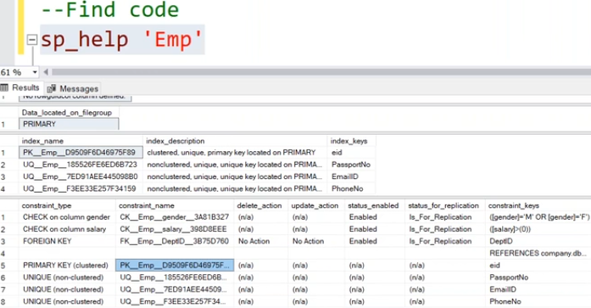
Read the data in the table
Select * from Emp
Select * from Dept

Insert the data
Insert into Emp values(1, ‘pavan kumar’,10000,’M’, ’1993/12/9’, ‘8143256414’, ‘pkumar.datascience@gmail.com’, ‘R552554’,30)
Wrong data
Insert into Emp values(2, ‘pavan kalyan,10000,’K’, ’1980/12/9’, ‘8143256414’, ‘pkumar.datascience@gmail.com’, ‘R552554’,30)

Identity:
Use company
go

Create table Product
(
PID int primary key identity(1,1),
ProdName varchar(100) not null,
Qty int null default(0),
UnitPrice money not null
)
go

--Find schema of the table:
Sp_help ‘Product’
go
--Read the data
Select * from Product
--insert the data
Insert into Product values(‘Pen’, 1000, 10)
Insert into Product values(‘Pencil’, 2000, 7)
Insert into Product values(‘Eraser’, 1000, 5)
Insert into Product values(‘sketch’, 1000, 12)
--last inserted identity value
Select @@IDENTITY
go
--delete all rows
Delete from product
Go
--delete any specific row
Delete from product where PID = 2
go
--drop the table
Drop table Product
go
--fill in the gaps

Note: if you delete the row that will not going to repeated again

--delete all rows using the truncate command
Truncate table Product

Difference between delete and truncate
- Both are used to delete the rows in the table
- Delete truncate
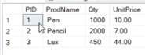
- 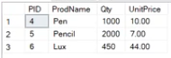

- It creates lot of gaps It does not creates any gaps
- It is a DML command it is a DDL command
- It supports where clause no support for where clause
- It is logged operation it is non logged operation
- It is slower it is faster
- It can be rolled back cannot be rollback
- More log space required less log space required
- It does not reset identity value it resets the identity value
- It invoke triggers it does not invoke trigger

--No Default value:
Insert into Product values(‘dettol’, null, 70)
--Default value:
Insert into Product values(‘dove’, ‘ ’, 120)
--Explicit Insert:
Insert into Product(ProdName, UnitPrice) values(‘Lenovo’, 10000)
Insert into Product(UnitPrice, ProdName) values(10000, ‘Apple’)

Adding a column to a Table:
ALTER TABLE <tablename>
ADD column_name datatype;

Alter table Product
Add Rating tinyint
--update the data
Update product set Rating=2 where PID>2

Drop a column from a table:
ALTER TABLE <table_name>
DROP COLUMN <column_name>

Alter table Product
Drop column UnitPrice

Drop a Constraint column: first we need to drop a constraint then drop the column
Alter table <table_name>
Drop CONSTRAINT <constrain_name>
Alter table Product
Drop constraint

Whenever we are creating a new database all the configurations and settings will store in the master DB
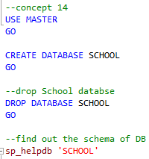
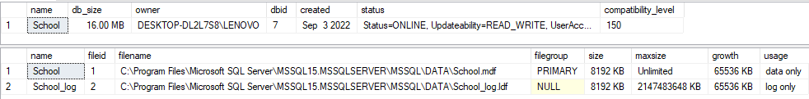
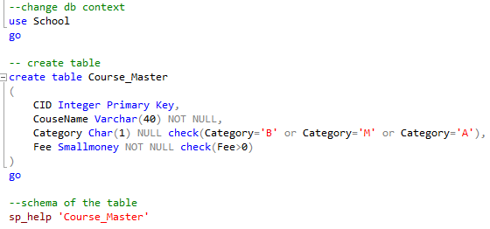
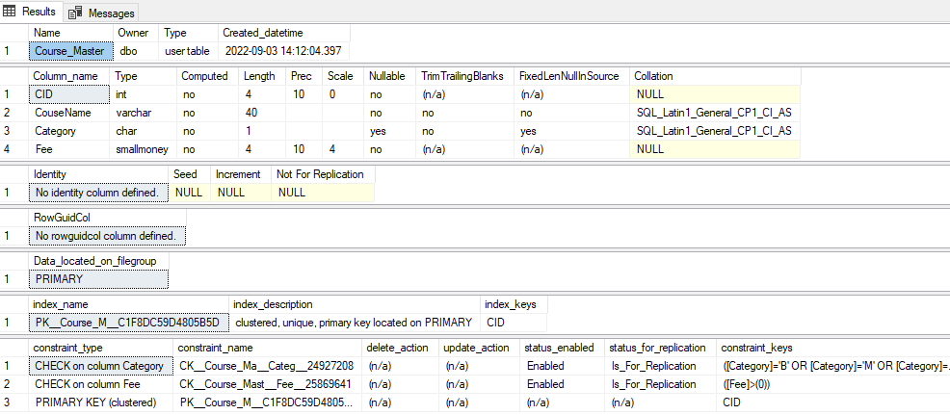
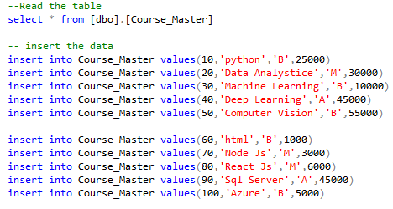
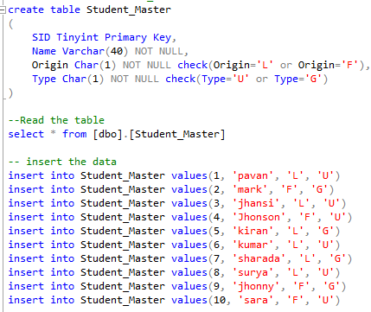
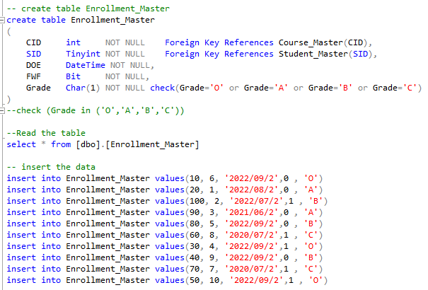
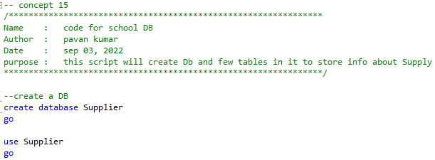
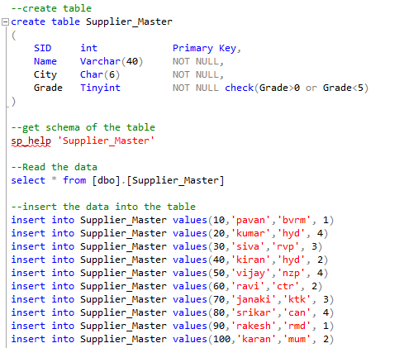
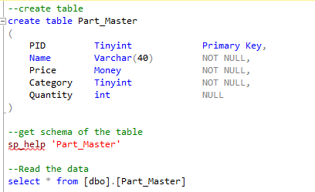

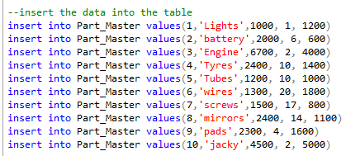
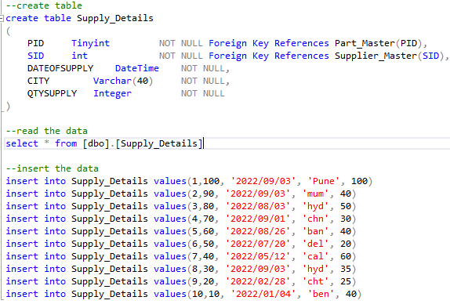
Retrieving Data
Filtering
Sorting
Grouping
Joins
Sub Queries and correlated Sub Queries
Derived Tables
Ranking Function and CTE

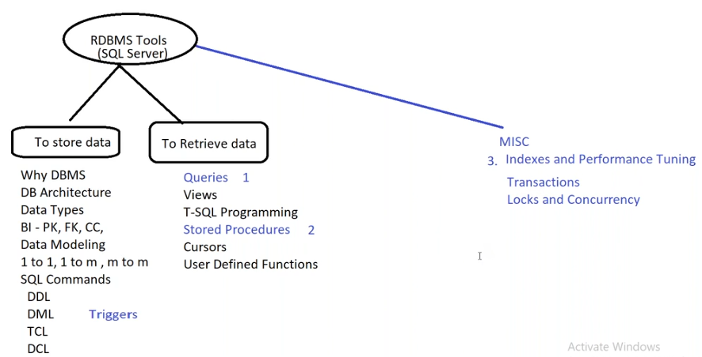
Retrieving Data
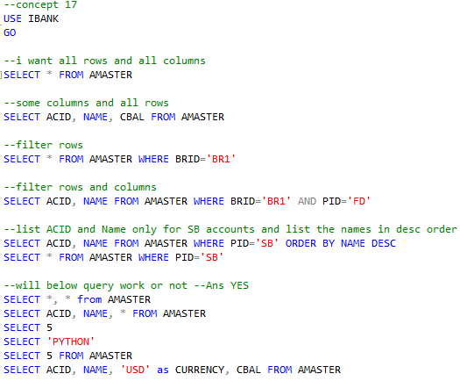
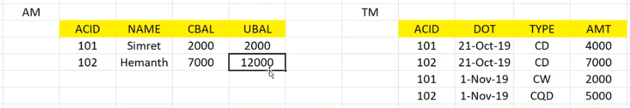

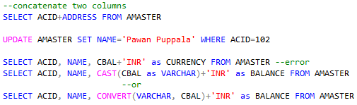
- Convert Types
- CAST (ColName as DataType)
- CONVERT (DataType, ColName, StyleNum)
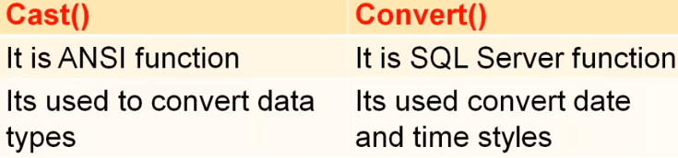
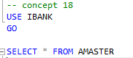
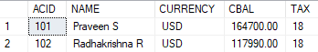
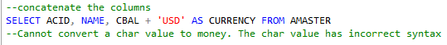
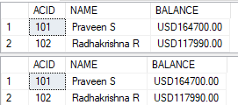
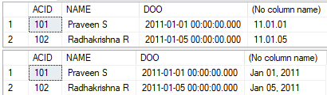
Aggregating Data to Information
- COUNT, SUM, MIN, MAX, AVG
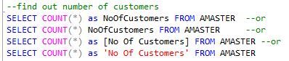
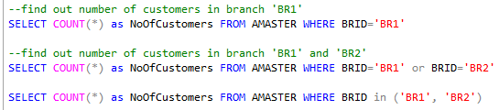
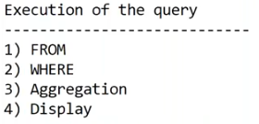
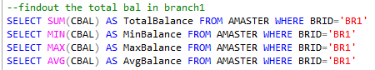

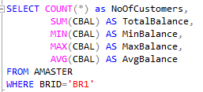
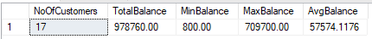
Count(*) and Count(12345) yes it will work and give same output

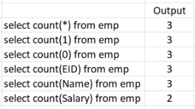
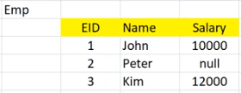

Note: diff b/w count(*) and count(ColName)
- Count(ColName) does not count the null values

Group By
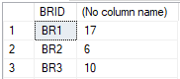
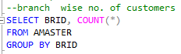

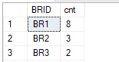
Where and Group By
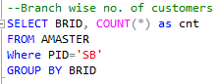

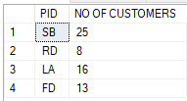
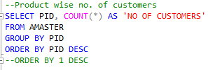

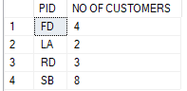
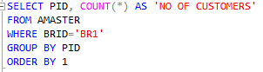

Group with in a Group
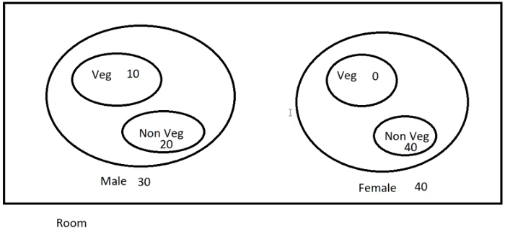
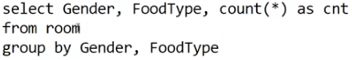

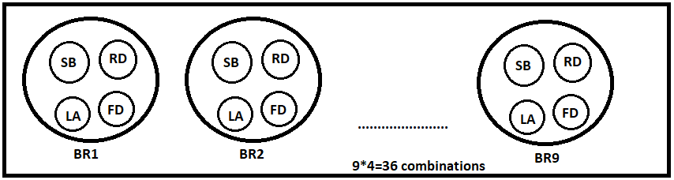
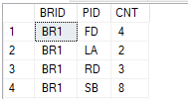
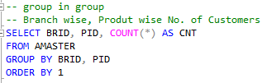

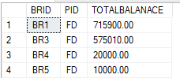
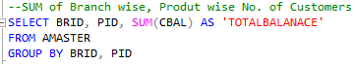

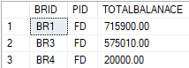
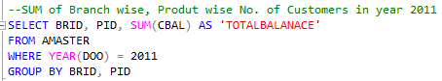

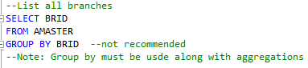
What is the purpose of Group by clause?
- Group by clause needs to be used only for aggregations
- Do not use group by clause if there is no aggregation
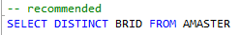

USE DISTINCT with Aggregates
How many branches are there in our bank?
- SELECT COUNT(DISTINCT BRID) FROM AMASTER

Date and Time Functions
- Getdate() : it returns the current date time from system

- DateDiff() : it returns diff b/w 2 dates in terms of days/months/weeks/years etc.
It takes 3 parameters

- DatePart() : it returns the part of the date. It returns always an integer. it takes 2 args

- DateName() : it returns the name of the day or month. It always returns string.
It takes 2 args

- Day(), Month(), Year() : Day(DateCol), Month(DateCol), Year(DateCol)

- DateAdd() : it adds/ subtracts days or months or years to the given data and
returns the future /past date and it takes 3 parameters

- EOMonth() : it gives us last day from the given date. It takes 1 argument

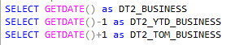
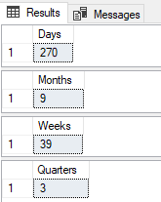
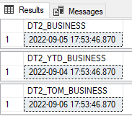

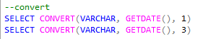

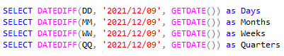
--what is my age
SELECT DATEDIFF(YY, '1994/12/09', GETDATE()) as Age

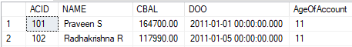
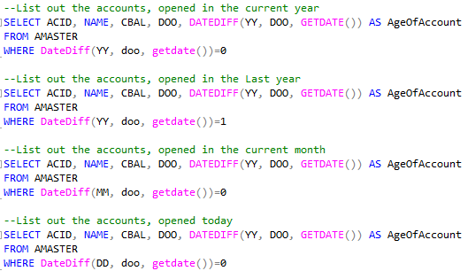

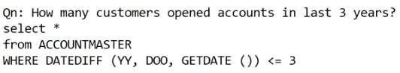

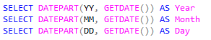
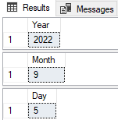
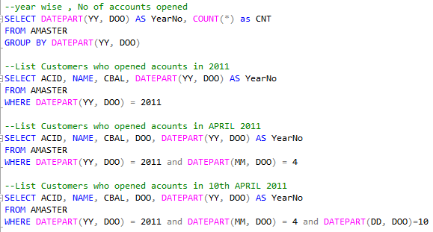

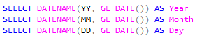
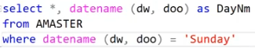

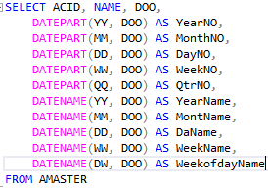
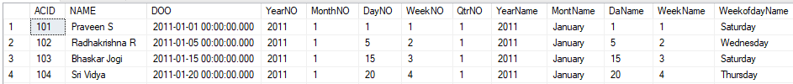

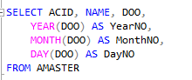
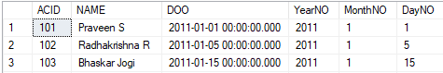

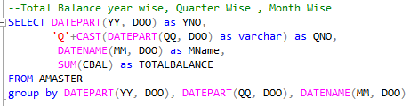
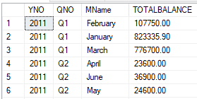

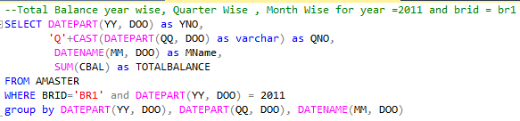
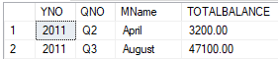

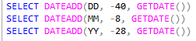
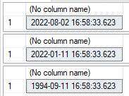

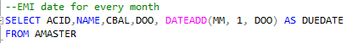
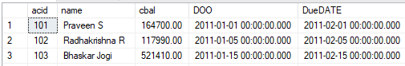
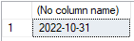
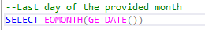

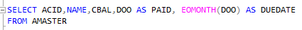
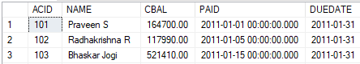

Week wise no. of accounts opened in last month

List the names of account holders who have opened accounts in the last 5 days

List branch wise, product wise total amount as on last Friday

List the customers, who opened accounts in the first week of last month

How many customers opened accounts in last date of previous month

Find out the last month name

Find out the last day of the current month

Find out the first day name of the current month

23. Having Clause & Into keyword & Temp tables
Top(n) : Gets the first n rows from table
Top(n) PERCENT: Gets the first n percent rows from table
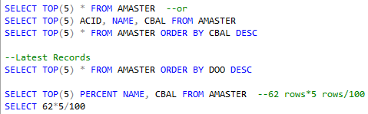

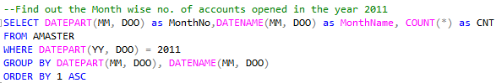
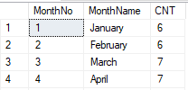

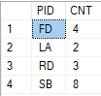
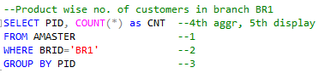

After GROUP BY and Aggregation if want to filter the data again we use HAVING
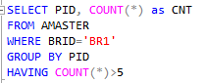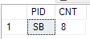

Note: Where Clause can filter the data before aggregation and Having clause will filter after the Aggregation and apply condition on Aggregate column and also it don’t take alias

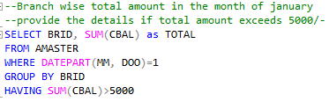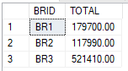

Filter, Aggregate and Filter
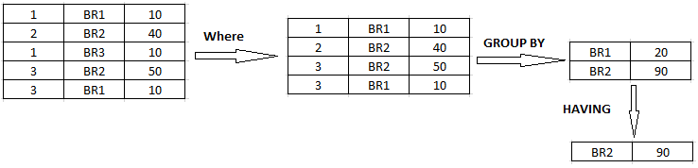
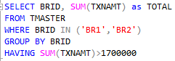

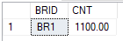
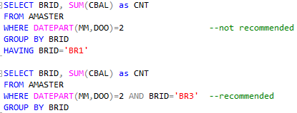

Because always having clause must be applied on aggregate columns

SELECT
FROM
WHERE
GROUP BY
HAVING
ORDER BY

INTO: it will create a new table and also it improves performance, to create backup table
No Constraints will be created
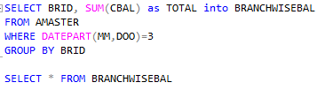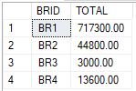

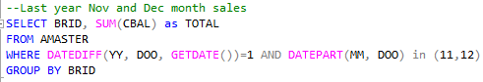

Temp Table: add # as pre fix to table name, created in tempdb
As you close the connection all temp tables were deleted
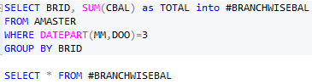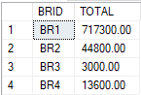

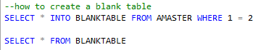
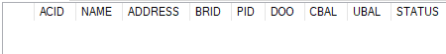

24. inner and outer join
Why joins?
- To retrieve the data from multiple tables

How many tables we can join?
- 255 tables

Note: to join the columns we must have the common column
- If we go to the database diagrams you can get the relations and also domain knowledge
- Null cannot be compared

There are 4 types of Joins
- Inner join/ simple join/ natural join/Equi join
- Outer join
Left
Right
Full
- Cross join(Cartesian Product)
- Self join
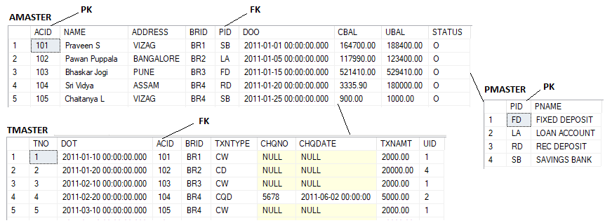
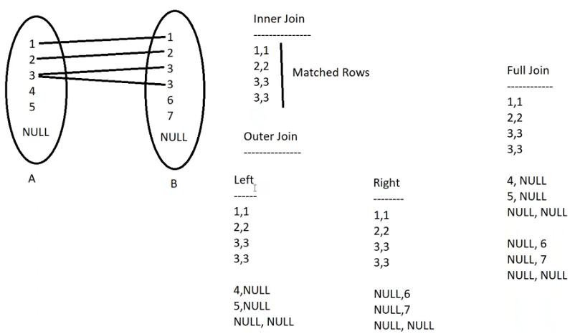
INNER JOIN Syntax
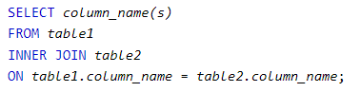
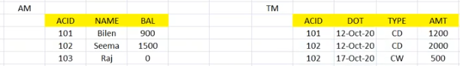
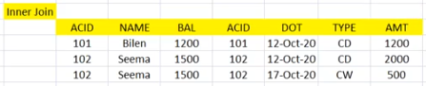
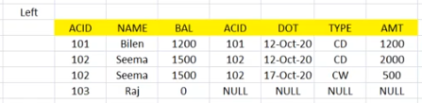
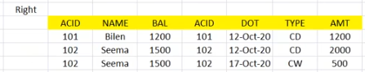
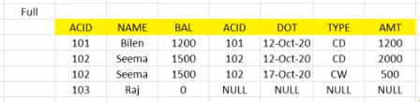

SELECT column_name(s)
FROM table1
INNER JOIN table2 ON table1.column_name = table2.column_name
INNER JOIN table3 ON table1.column_name = table3.column_name

Note: When we have n tables we have n-1 joining conditions
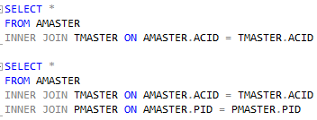

Left Join
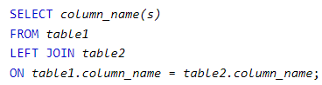
Right Join
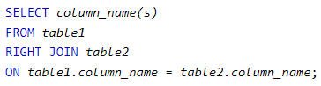
Full Outer Join
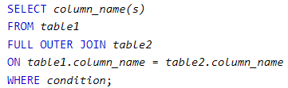

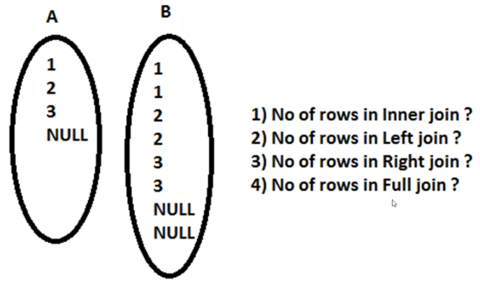
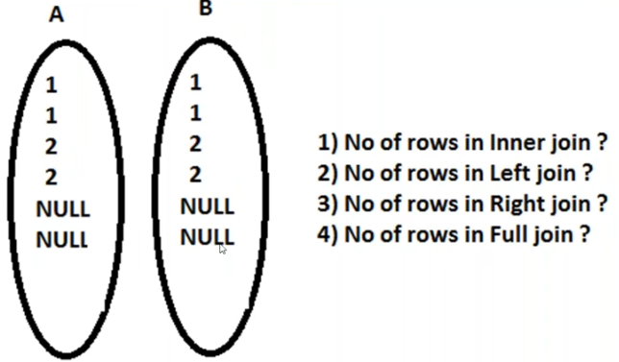

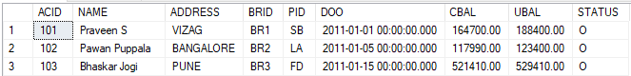

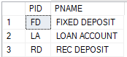

List Names of the Account Holders and their product names
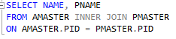
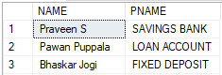

Find out customer Name wise, txn type wise, number of Transactions
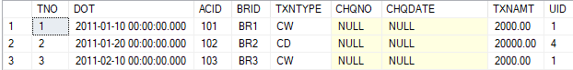

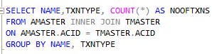
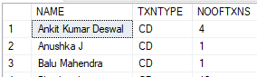

Last Month Transactions Last Year Transactions
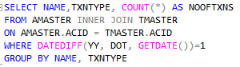
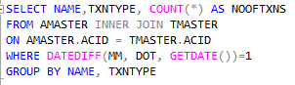
If they ask about last month, current month then use datediff
If they ask for a specific date or year then use datepart
If they mention wise means use groupby

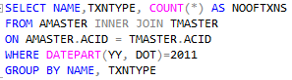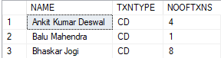

List Names of the account holder who deposited cash and their product names
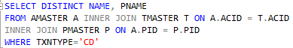
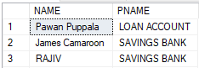

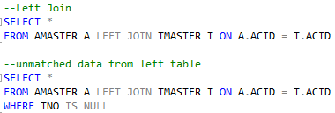

List of names who did not do any transactions
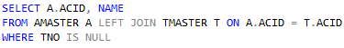

NOTE: if the column present in two tables we must use alias of the table(A.ACID)
For null always use is, is not

25. Cross Join: returns all records from both tables
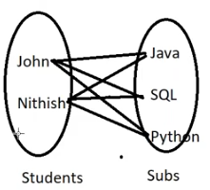
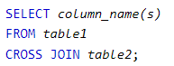
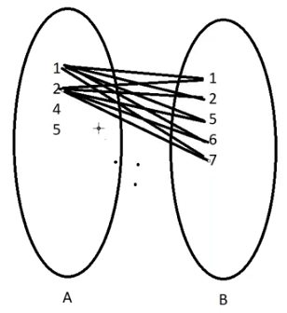

26. Self join: A self join is a regular join, but the table is joined with itself.
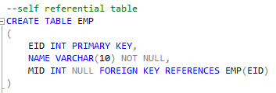
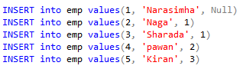

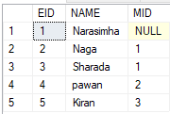

Here I am creating two tables in ram
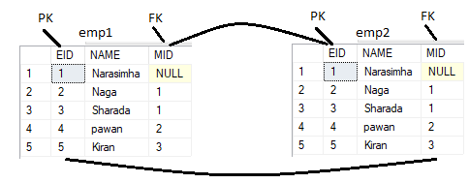
empName Boss
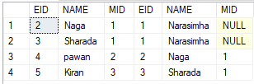

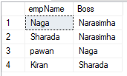
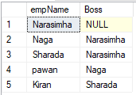
Customer Vendor
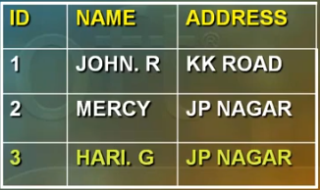
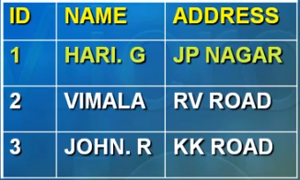

Above tables are two independent tables

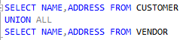
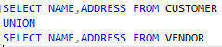
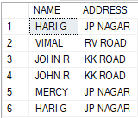
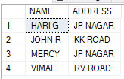

- Combine the results of two or more select statements
- Same no. of columns in each query
- Corresponding columns to be of same data type
- Duplicates eliminated by default
- Union sorts the data
- ‘UNION ALL’ keeps the duplicates
- ‘UNION ALL’ is faster

Wild card operators:
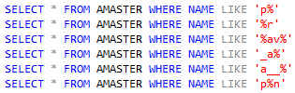

Isnull(): it returns CONSTANT value when the column contains NULL value

Update NULL Column
- Increment the salary for all employees by 1000/- as bonus
UPDATE EMP
SET salary = salary+1000 it will not update the null values so it is invalid

UPDATE EMP
SET salary = ISNULL(salary, 0)+1000

COALESCE():
- Returns first non-NULL value
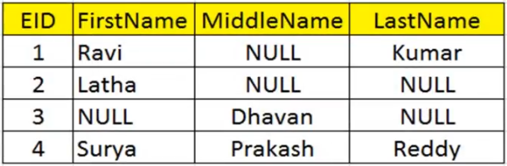

27. String Functions
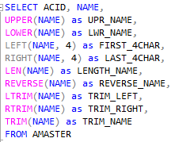
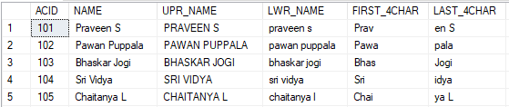
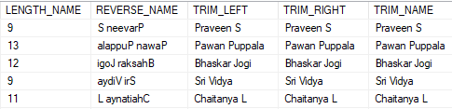

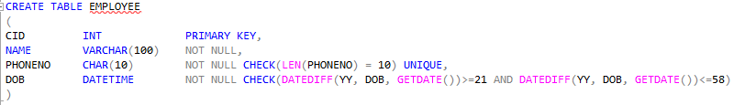

Substring()
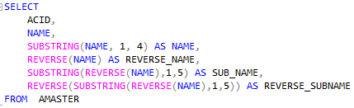
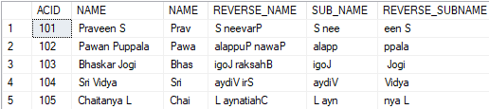

Stuff(source string, start, length, add_string): no condition
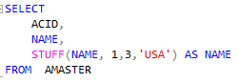
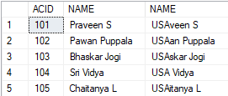

Replace(): based on condition
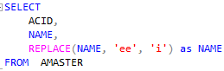
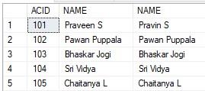

Space(): it gives us the space in between strings
CHARINDEX(searching Letter, column name):
- This function returns the starting position of the specified
- expression in a string
- it accepts 3 parameters with the 3rd parameter being optional
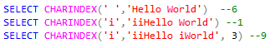
PATINDEX(‘%pattern%’, expression):
Returns the starting position of the first occurrence of a pattern in a specified expression
Or 0’s if the pattern is not found

28. String_agg(), between and case statements
** concatenate rows using string_agg()
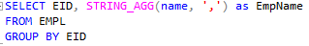
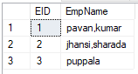
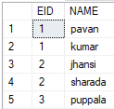

Concatenate columns
- Select EID, isnull(Fname, ‘ ’) + isnull(Lname, ‘ ’) as FullName from Employee

Between operator
- List the names of the customers whose balance between 10000 and 50000
- It includes lower limit(10000) and upper limit(50000)
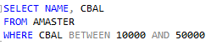
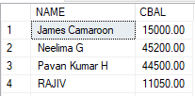
- List the names of the customers who have opened accounts between 2010 and 2012
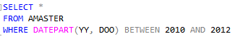
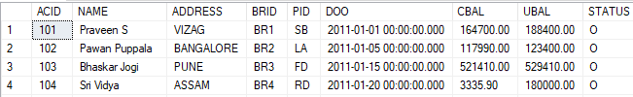

Case Statement syntax
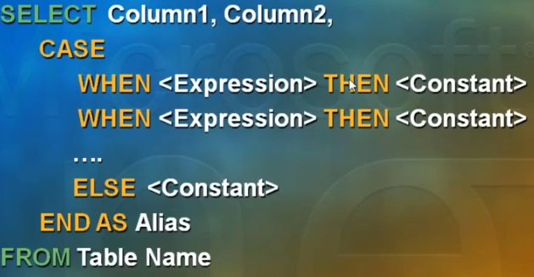
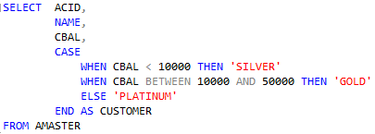
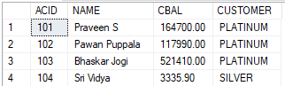
If else block is missing then the value in the column is null

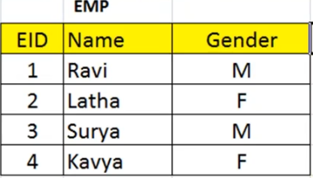
SELECT EID,
EmpName =
CASE
WHEN Gender = 'M' THEN 'Mr.'+Name
ELSE 'Ms.'+Name
END
FROM EMP
Update the gender M with F and F with M
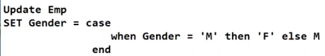

29. Sub query: A query in the where clause is called a sub query
NULLIF()
- Returns a null value if the two specified expressions are equal
- Else gets the first value
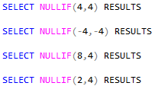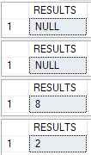

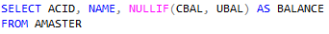
Note: If cbal and ubal both are equal we will get the null

Interview question
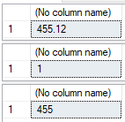
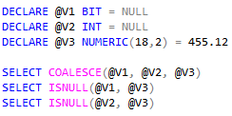

Who has the highest balance in the bank?
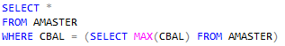

Sub Query: A Query in the WHERE/ SELECT/ HAVING clause is called as sub query
- Sub query execution from bottom to top
- Always sub query gets executed first and the result is passed to the outer query and then finally outer query is executed.
NOTE:
Use ‘= ’ operator, when sub query returns a single value(single column)
Use ‘IN ’ operator, when sub query returns Multiple values(single column)
Sql server does not support multiple columns in sub query

30. correlated sub queries
Difference CBAL and AVG(CBAL)
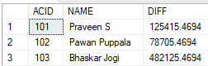

Who has the 2nd highest balance in the bank?
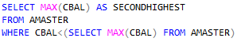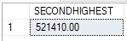

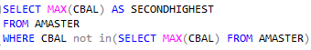

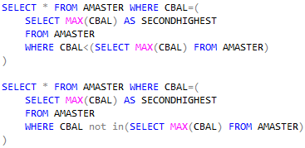

Note: Max 32 levels of nesting is allowed for sub queries

Who has the 10th highest balance in the bank?
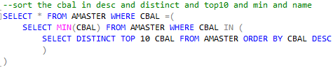

Correlated Sub query
- It is similar to Loop in a loop concept of any programming language
- In this, Outer query is executed first and then result is passed to the inner query
- Then Inner query is executed repeatedly for each value of the outer query
- Here, the execution is from Top to Bottom
- Inner query is dependent on outer query

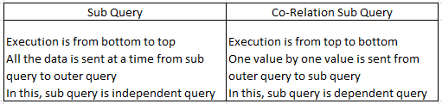

List the names of account holders who have done transactions
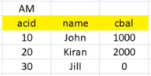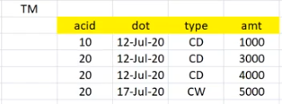
Exists()
- It is a Boolean function returns true or false
- It is used to find the existence of at least on matched rows
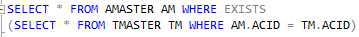
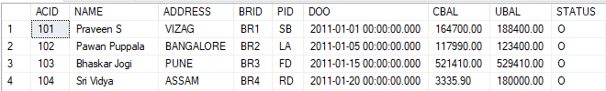
We can achieve above output using Joins but the performance is low.

31. system tables
When will I use joins?
- Display data from all tables
When will I use sub query?
- Display data from one table on a condition

Databases:
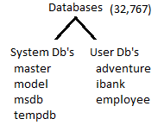
Tables:
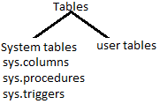
sys.tables
sys.databases
sys.columns
sys.views
sys.triggers
sys.procedures
sys.objects
To check the number of tables present in a database
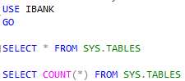

To get all columns in a database

To get all columns in a table

Find out number of columns in table
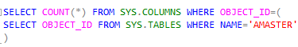

Identify the tables where column cbal present
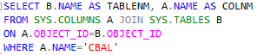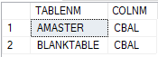
Requirement: if Emp table exists in db, then drop it and create it
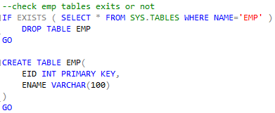

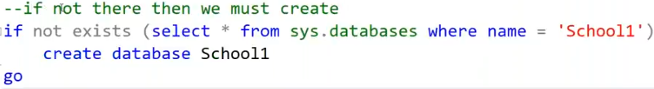
32. Derived tables
In MSBI we have 3 tools
- SSIS : SQL Server Integration Services
- SSAS : SQL Server Analysis Services
- SSRS : SQL Server Reporting Services

A query in the FROM Clause is known as Derived Table
- Derived Table must have alias
- Derived Tables can also be used in Joins

List the ACID, Name and No of Transactions where the account holder has done more than 3 transactions for the year 2011?
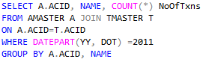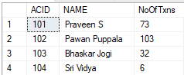

But performance wise the above query is poor
- Joining of tables is a costliest object
- Where clause filtering the unwanted data after joining
- Group by lengthy column values(lengthy names) is very bad

Query Performance Tips:
- Always filter rows as early as possible and join as late as possible
- Avoid using lengthy columns in GROUP BY clause

To Overcome above problems we use derived tables:
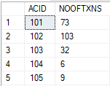
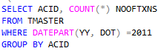
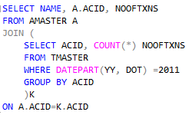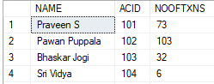

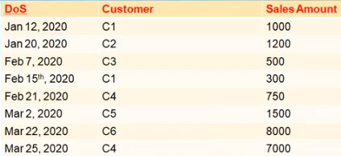
Month wise number of new customers?
Jan 2
Feb 2
Mar 2
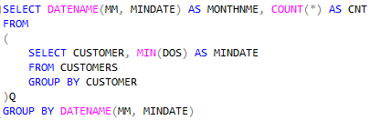
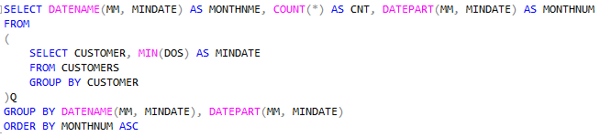

Find Employees with Salary Higher than their Department Average
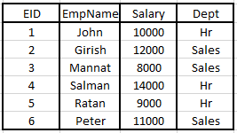

- find average salary by department wise
- join the two table on deptname column
- apply where condition at last
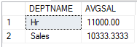
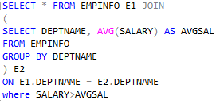
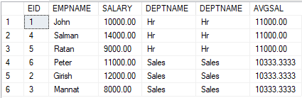
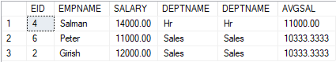
33.Cube and rollup operators
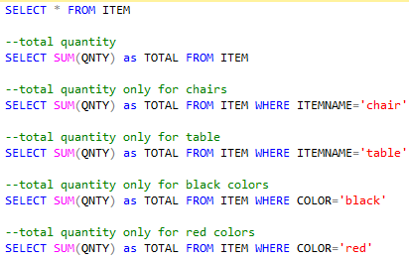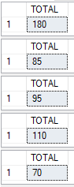
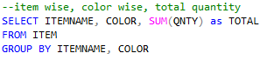
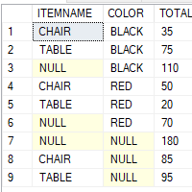
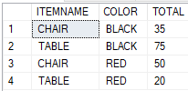
Cube: it will give all permutations and combinations
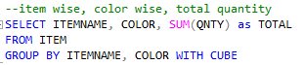
Rollup: it will give less permutations and combinations
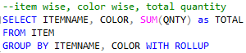
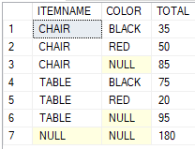

34. Ranking Functions
- These are used to provide ranking for rows based on one or more conditions.
- Ranking Functions
- Row_Number() : Returns the sequential number starting from 1
- Rank() : Returns the rank for each row, with Gap
- Dense_Rank() : Returns the rank for each row without gaps
- NTILE() : splits the data into ‘n’ no. of groups
Assigns an unique number to each group starting from 1
- Partition By : groups the data

Syntax: SELECT Columns,
Rank Function Name()
OVER (ORDER BY COLUMN DESC/ASC)
As Alias
FROM TABLE

Using row_number()

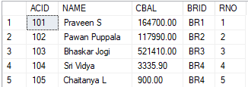

Get the 5th row
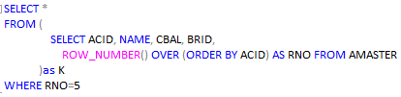
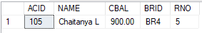

Get rows between the values
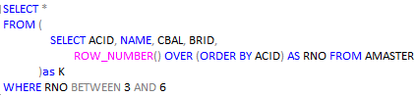
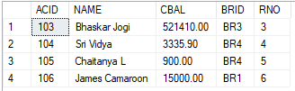

Using partition by
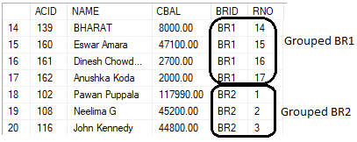
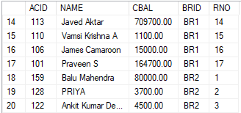

For every branch first customer
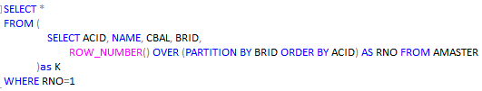
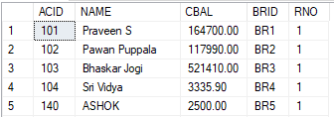

For every branch 5th row from the table
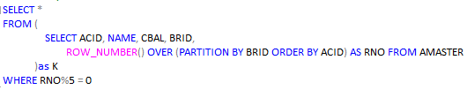
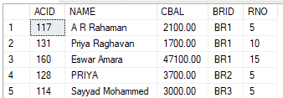

Alternate rows
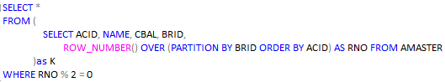
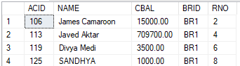
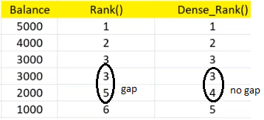
Rank() function
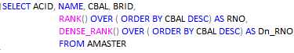
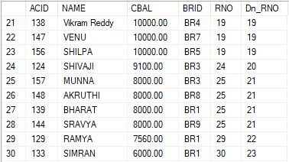

10th highest balance
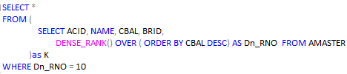
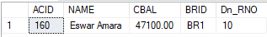

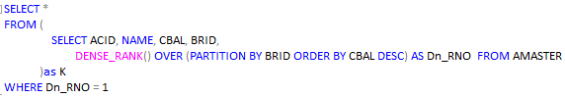
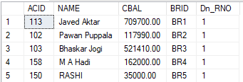

Common Table Expression(CTE)
- It is similar to Derived table
- CTE is introduced in SQL Server 2005
- CTE can be declared once use it many times

Syntax:
With <CTE name>
As
(
select statement
)

To read data: select * from <CTE Name>
5th row using CTE
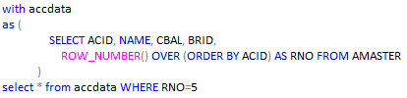
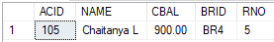

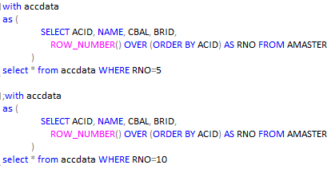

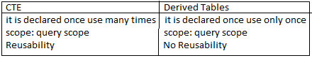
These tables are faster these tables are slower
Find out the branch which has highest number of customers
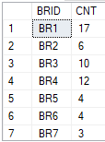
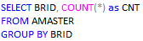

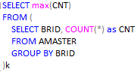

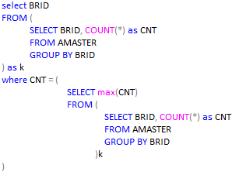
Using CTE
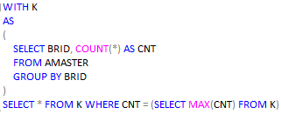
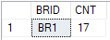
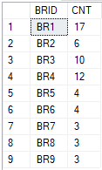
Temp tables
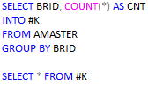

Local temp table #k
Global temp table ##k
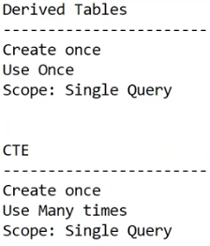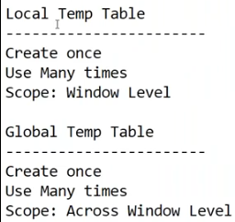

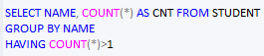
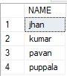
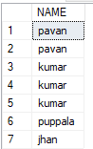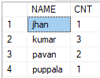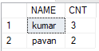
Cte with select query
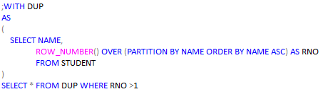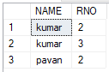
Cte with Delete query
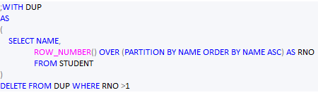

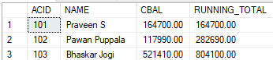

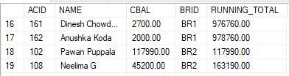

36. merge statement to perform incremental loading
- To perform incremental loading
- It is one of the DML statement placed newly in SQL server 2008
- Merge statement is a combination statement that can perform INSERT, UPDATE, DELETE statements based on whether rows that match the selection criteria exist in the target table or not
Syntax: MERGE target_table as target
USING source_table as source
ON condition
WHEN Matched THEN
UPDATE
SET column = source.column,………….
WHEN target not matched THEN
INSERT VALUES(source.column1, source.column2……)

