1. Client Server Architecture
Q) A 1000
B 2000
C 1000
D 1200
E 2000
Who is getting the same salary? Ans: A,C B,E
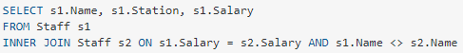
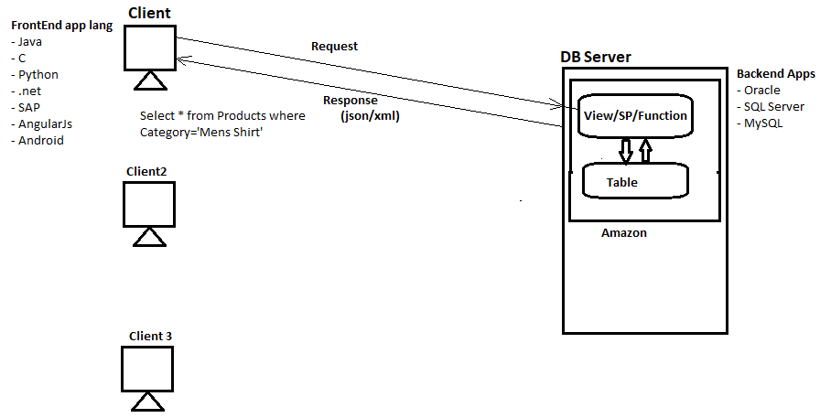
The following are the disadvantages when we keep the code at client side
- Network traffic is high
- Maintenance of the code is difficult(if we make any changes in server side we need to do lot of changes in client side)
- No security for the code at the client side that means code can be tampered easily
- Performance of the code is low

To get the syntax of table:
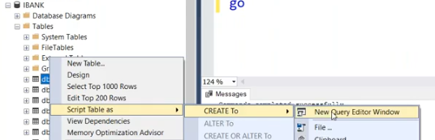

Except Create query remaining all queries will not save anywhere
To centralized data we created the tables

To overcome the above issues, we need to centralize the code at Server Side
If I want to centralized code we can create
- View ( no input parameters, no programming)
- Stored Procedure (Unique feature called Cache Execution Plan)
- Function (Only Select ; No I/U/D)
2. View: A view is a virtual table based on the result-set of an SQL statement.
A view contains rows and columns, just like a real table. The fields in a view are fields from one or more real tables in the database.

CREATE VIEW <view name> As
Select * from Products where Category=”Mens Shirt”;

NOTE: Never give permissions directly to the table (data) give to View/SP/Functions

Views: only select query will work on view, view can take only one query
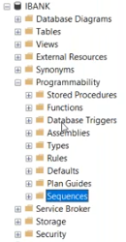
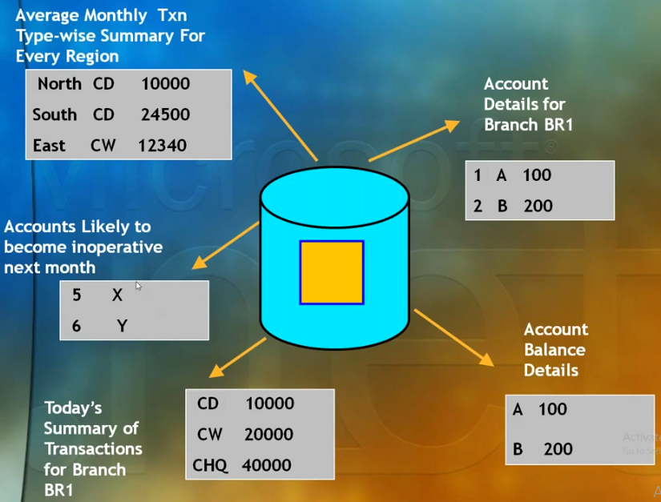
Select * from AMASTER where BRID=”BR1”

People who made transactions from Last 6 months

People who did not made transactions from Last 6 months

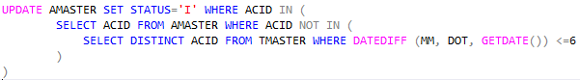
If we write the queries then we close the query will delete. To centralize the code we use views
1. Need:
- Focus on specific data: I don’t need entire data
- Centralize the code
- Reusability of the code: once write call many times
- Security
- Simplify Data Manipulation
- Customized Perception
- Combine Partitioned data.
2. Features:
- Tables in more than one database
- More than 1 server
- On base tables or on views
- No defaults, Triggers, Constraints
- No temporary Views
- Explicit name for very column if expressions, constants, aggregates, duplicate names in base tables
- Order by keyword is not supported
3. Limitations of view:
- Only single query is allowed
- No programming
- No insert/update/delete
- No order by clause
- No parameters
- Views always executes the query hence Slow, when the data is in large size
- Views get fresh data

Options with Views
Indexed Views

Syntax:
CREATE VIEW <view name>
As
<query>
Read data from the view:
SELECT * from <view name>
Drop a view:
DROP VIEW <view name>

Creating a view
CREATE VIEW vw_GetCustomers_BR1
as
SELECT * FROM AMASTER WHERE BRID='BR1'

Reading a view
SELECT * FROM vw_GetCustomers_BR1

CREATE VIEW vw_DidNotMake_txn
as
SELECT * FROM AMASTER WHERE ACID NOT IN (
SELECT DISTINCT ACID FROM TMASTER WHERE DATEDIFF(MM, DOT, GETDATE()) <=6)

SELECT * FROM vw_DidNotMake_txn

Note: To see the view code :- sp_helptext 'vw_DidNotMake_txn' or right click on viewDesign
We cannot write multiple queries inside view
we can write only select query inside a view

Stored Procedures: we can write multiple queries, we can write update, delete queries
CREATE PROC sp_update_status
As
Update AMASTER set status=’Inactive’ where acid in (
Select * from AMASTER where accid not in (
Select distinct accid from TMASTER where datediff (mm, dot, getdate()) <=6)
)
Ex: in Naukri we can fetch the data according to location

ALTER VIEW vw_didnotmake_txn
As
SELECT ACID, NAME, CBAL FROM AMASTER WHERE ACID NOT IN (
SELECT DISTINCT ACID FROM TMASTER WHERE DATEDIFF (MM, DOT, GETDATE()) <=6)

Get all the views:
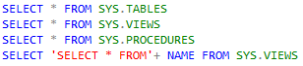

3. views part 2( we can join a view with table )
CREATE VIEW vw_GetBranchWiseCustomers_count
As
SELECT BRID, COUNT(*) AS CNT FROM AMASTER GROUP BY BRID

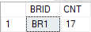view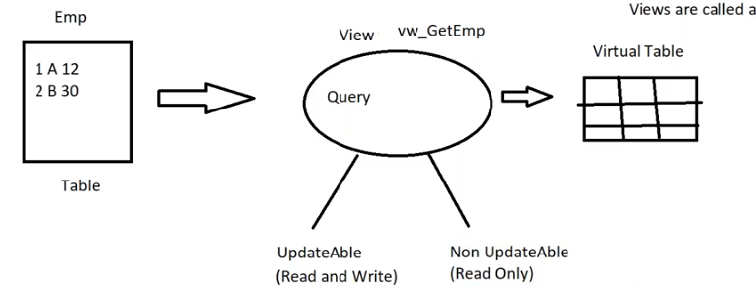
View are called virtual tables or subset to table
4. Types of Views
- Updatable views(read/write)
  - Same no of columns to be there in table and views, otherwise remaining columns in the base table must allow null values
  - No aggregate functions, having clause etc.
- Non- updatable views(read only)
  - Contains aggregate functions
  - Less no of columns than the base table etc.

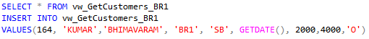

It will insert the data into base table

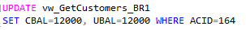
The record which we want to update/delete is available in view. So, first do select operation and update.

If the view contains less no. of columns(selected columns or aggregate functions) then it is called Non Updatable views

q) what is a view?
- view is a virtual table
q) does view store data anywhere?
- view does not store the data, always get the fresh data
q) can I store data in a view? Or can I store data in a table using a view?
- No, it always get the data from the base table
q) can I insert data in a view? Or can I insert data in a table using a view?
- Yes
q) can I insert data in a view? Or can I insert data in a table using a view?
- Yes
q) can I update data in a view? Or can I update data in a table using a view?
- Yes
q) can I delete data in a view? Or can I delete data in a table using a view?
- Yes
q) can I update data in a view?
- No
q) can I delete data in a view?
- No
q) can we join tables with view?
- Yes
4. views part3
q) can we join a table and view:
Create a view: this view contains last 11years data
CREATE VIEW vw_CurrentYearTxns
AS
SELECT DOT, ACID, BRID, TXNTYPE, TXNAMT
FROM TMASTER WHERE DATEDIFF(YY, DOT, GETDATE())=11

Call view:

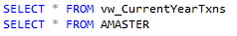
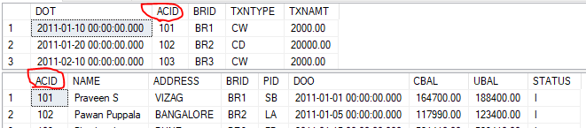

Joining:
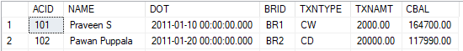

Create a view on join query:
CREATE VIEW vw_GetCustNameandTxns
As
SELECT A.ACID, NAME, DOT, A.BRID, TXNTYPE, TXNAMT, CBAL
FROM vw_CurrentYearTxns AS A JOIN AMASTER AS B ON A.ACID=B.ACID
Call a view:
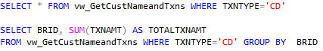

q) can we join view with another view?
- Yes, we need a common column to join
Create 1st view:
CREATE VIEW vw_GetFDCustomers
As
Select * from AMASTER where PID = 'FD'
Create 2nd view from 1st view:
CREATE VIEW vw_GetBR1FDCustomers
As
SELECT * FROM VW_GETFDCUSTOMERS WHERE BRID = 'BR1'

Join 1st view with 2nd view:
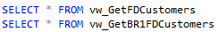
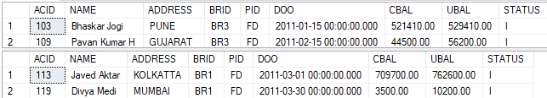

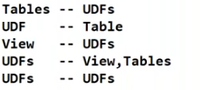
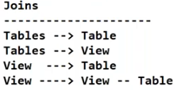
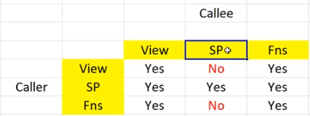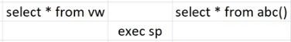

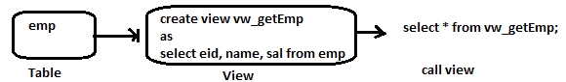
Now someone changed the table name
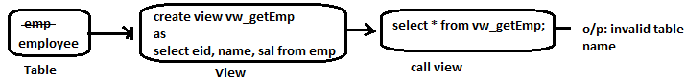
Note: if make any changes on meta data(table name, columns, data type, null, PK, FK) then views, stored procedure will not work(impact analysis)

To overcome from above error: we add security to the base table so we can’t do any operations

WITH SCHEMABINDING option: schema of a base table/view cannot be modified/deleted
Create view [dbo].[vw_getEmp]
with SCHEMABINDING
As select ACID, name from dbo.emp

WITH ENCRYPTION option: code is encrypted. Once encrypted no one can decrypt
Create view [dbo].[vw_getEmp]
with ENCRYPTION
As select ACID, name from dbo.emp

Select * from AMASTER;
Select * from v_getcustomers_B1;
Insert into AMASTER values(167, ‘pavan’, ‘bvrm’, ‘BR1’, ‘SB’, getdate(), 1000, 1000, ‘0’)

Insert into v_getcustomers_B1 values(168, ‘kumar’, ‘kvp’, ‘BR1’, ‘SB’, getdate(), 2000, 2000, ‘0’)
Insert into v_getcustomers_B1 values(169, ‘kumaran’, ‘kvp’, ‘BR3’, ‘SB’, getdate(), 4000, 4000, ‘0’)
Update v_getcustomers_B1 set cbal=12000, ubal=12000 where acid=101;
Delete from v_getcustomers_B1 where acid=168;

WITH CHECK option: satisfied rows by WHERE clause, cannot be modified using view

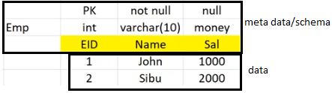
Views part4: Schemas and Indexed Views
Why schema?
- To create the logical grouping.
- Db Security Schemas

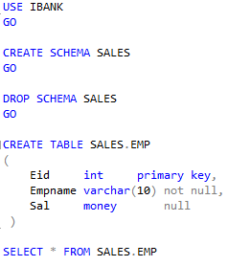
Note: to drop schema first we need to drop table

What are the roles associated with the user?
- Security Logins Right click “New Login” search username: puppapav check names
- New Login Users Mapping IBANK and roles: db owner & public ok
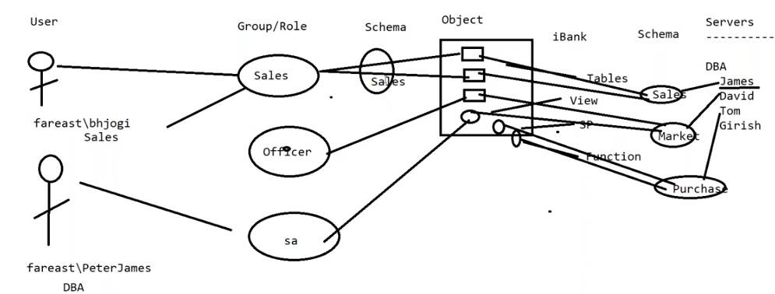
Advantages of schema:
- Schema is going to own lot of tables or the objects so, if you want to get the permission for table
- To provide more security to tables, views, SP, functions etc.
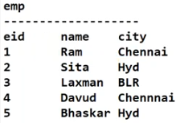
Example:
CREATE VIEW vw_GetChennaiEmp
As
Select * from Emp where city=’chennai’
WITH CHECK OPTION
Go

Read: Select * from vw_GetChennaiEmp;
Update: update vw_GetChennaiEmp SET City=’pune’ where eid = 1
This update is not allowed since the row would vanish from the view
Note: using view you cannot modify. Directly we need to update the table

Indexed Views/Materialized Views:
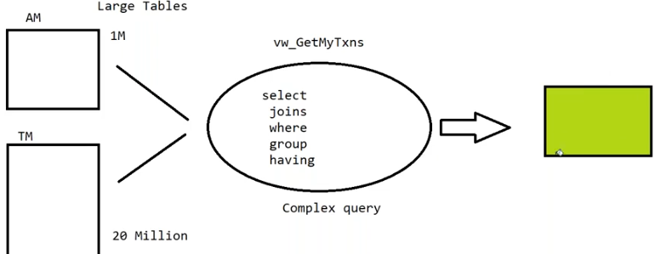
To get the data from the view (Slow, when the data is in large size)
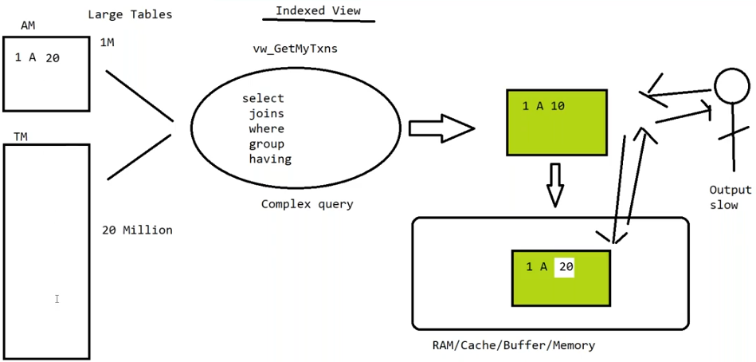
Indexed views are faster then the normal views because they are stored in Ram.
It is used in when we have large amounts of data, joins, aggregation, Group by, query with complex logic, High Response Queries (Critical Queries)

Disadvantage:
- Maintenance
- Hard disk space

Syntax:
CREATE VIEW dbo.v_GetBrWiseCustomers
WITH SCHEMABINDING
As
SELECT a.BRID, COUNT_BIG(*) as CNT FROM dbo.Amaster as a join dbo.Tmaster as b on a.acid=b.acid WHERE year(DOO) = 2011 GROUP BY a.BRID
Go

CREATE UNIQUE CLUSTERED INDEX indx1 ON dbo.v_GetBrWiseCustomers(BRID);

Select * from dbo.v_GetBrWiseCustomers;

Views vs indexed views
- views do not store data
- indexed views store/cache data
- OLTP will have views
- OLAP(DWH) will more indexed views

6. Create Variables
Pre requisites: C language
- Variables
Local Variables (User defined variables)
Global Variables (System defined variables)
- If.. else
- loops (only while)
- print() function
- try catch blocks)
- Temp Tables
Local temp tables
Global temp tables
- Table Variables

- To centralize the data we use Table
- To centralize (reusability of the code and security) the code we use Views, SP, UDF’s
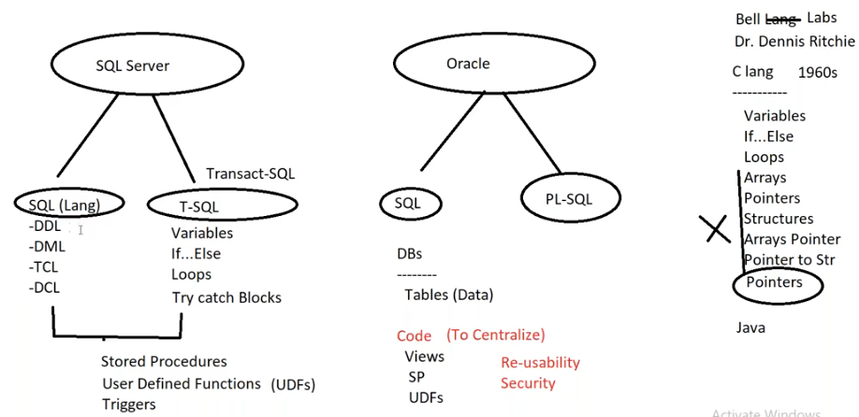
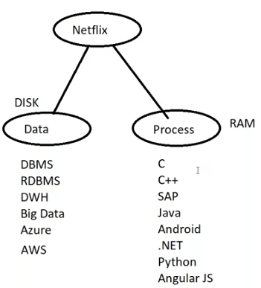
Variables: To store the data in RAM and move the data from one place to another place.
Variables are declared in the memory/RAM but not in SQL Server/Hard disk
There are 2 types of variables
- Local Variables:
- These are created using ‘@’ symbol.
- Removed when the connection is closed.
- Who ever created them, They can only use but not others
Syntax:
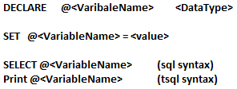
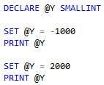
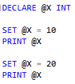
Ex1: declaring a variable

Storing data in a variable
Read

Ex2: declare @salary int
@salary is a variable, which is capable of storing an integer.
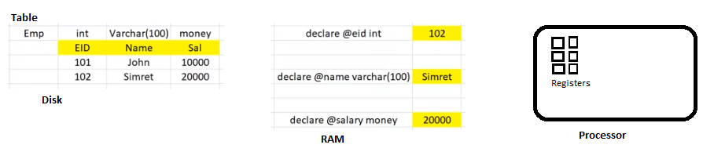
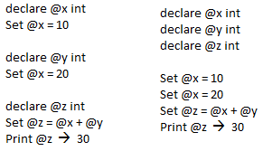
7. Intro to Stored Procedures
Views 10% usage database disk
SP 50% usage programming ram
UDF’s 10% usage
Triggers 5% usage

Select @x + @y as Total
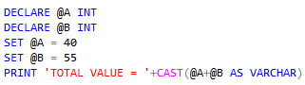

How to store the above program:
SP syntax:
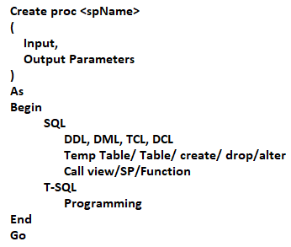
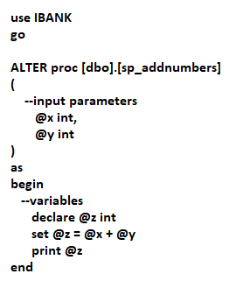
Create a SP
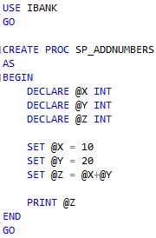
call a SP: exec/execute <SPname>
Call SP: exec sp_addnumbers 50,400
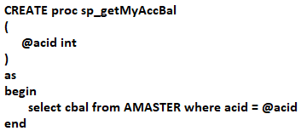
Call:

If we are select any product in e-commerce websites mostly it invokes SP
8. Global Variables and SP
Ex3. Add 500 to existing value
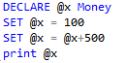
Ex4. swap two numbers
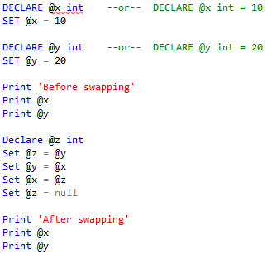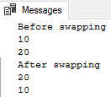

Here every time I have to provide the acid as a static value

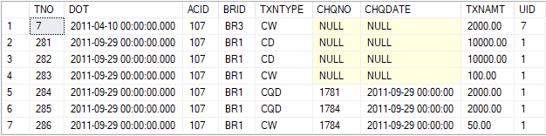
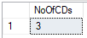

To provide dynamically
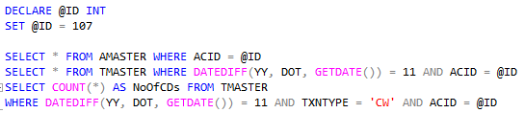
-------------------------------------------------------------------------------------------------------------------------
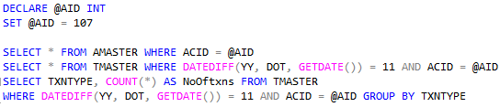
for code reusability purpose we use SP
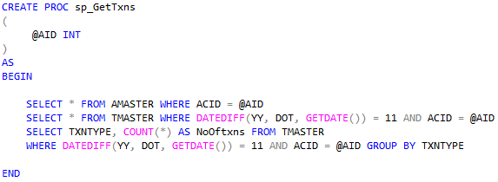
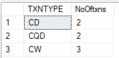
To see the SP code : sp_helptext ‘sp_GetTxns’
To call SP:

To make another variable as dynamic
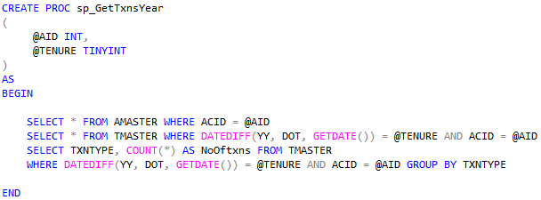
To call SP:
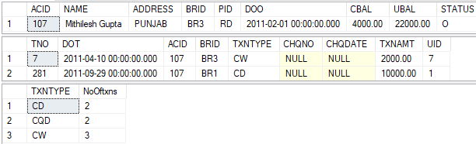
For example if the client provide wrong acid
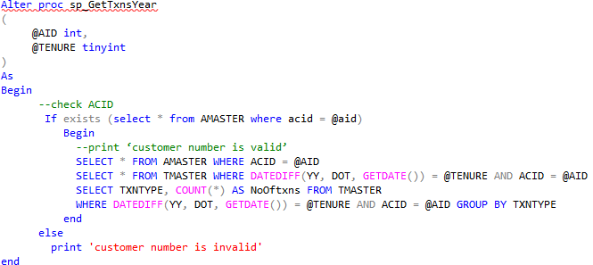To call SP: exec sp_GetTxns 1001,1
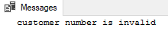

Get all SP: Select * from sys.procedures

To drop the SP: Select ‘drop proc’+name from sys.procedures

Drop proc sp_GetTxns;

Global Variables:
- These are given by SQL Server
- Created using ‘@@’ symbol
- Already declared with values
- “read only” variables
- We can only print/select them
@@VERSION
SELECT @@VERSION or PRINT @@VERSION
SELECT @@SERVERNAME or PRINT @@ SERVERNAME
SELECT @@ERROR 0 means True and non zero means false

@@ROWCOUNT
It returns no. of rows effected by the previous DML statement
Select * from AMASTER where BRID = “BR4”
Select @@ROWCOUNT

@@FETCH_STATUS
It returns – if the fetch is successful else returns non zero
10. Indexes: (same as index page in books)
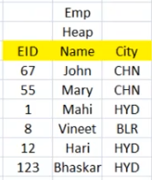
Why index?
- If you want to retrieve the data very quickly.
If a table don’t have any PK, FK, UK then it is called HEAP Structure (data is not organized properly)
Table Scanning (Row by Row Searching) : It is very slow operation

Select * from Emp where City = ‘BLR’

Ex: if we have a go down with unorganized all materials then it is very difficult to find a wanted material
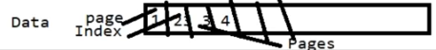
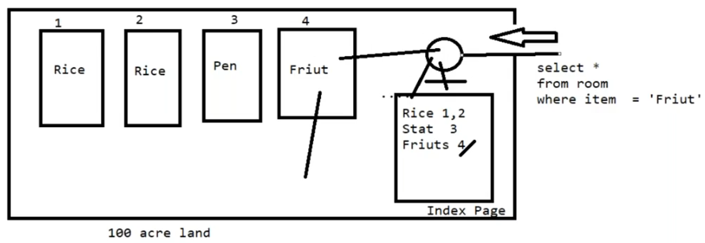
Types of indexes:
- Clustered index more than 1 clustered index
Determines the physical storage of data in a table
Only one per table
One or more columns
- Non Clustered index max 999 non clustered indexes per table, one or more columns

Steps to create an index (Clustered index): indexes are created on columns.
- Organize the data (sort the data in ASC order)
- index pages are created internally
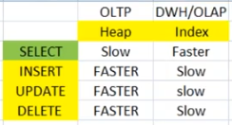
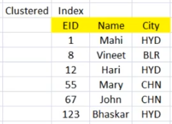
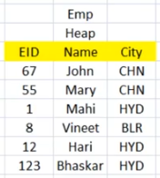
Disadvantages of indexes;
- Insert, update, delete operations are slow.
- When we delete a row then the row was deleted but the gaps will occur in that particular row (fragments)
- Defragmentation is nothing but removing the gaps between rows
Note: when we create the PK by default it will create the Clustered index
11. Index part 2
When the index is bad?
- When we want to write the data

When does SQL server not use an index?
- Full data (ex: select * from Emp )
- When table size is small

Need for indexes:
- Speed up the retrieval data
- Instead of table scan
- Depends on the query made
- Give choices to query optimizer.

Indexing Criteria:
- Should data be present in a specific order in the table?
- How many columns to index?
- What impact on hard disk space, DML operations, Performance
Clustered index architecture:
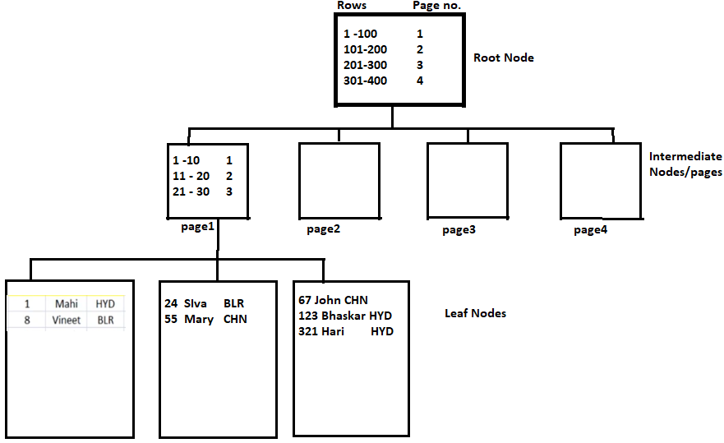
Select * from Emp where eid = 8

If I have a non index column after where clause
Select * from Emp where City = ‘Hyd’
Then we will use Non clustered indexes
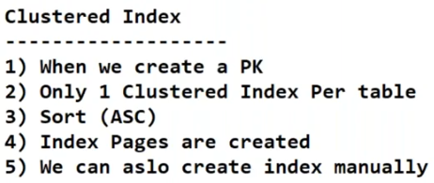
We can create index manually
Create clustered index <indexName> on (TableName) (ColumnName)

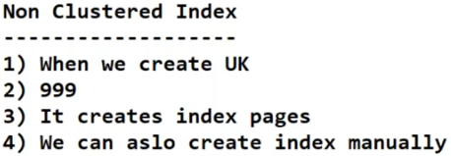
Create index <indexName> on (TableName) (ColumnName)

Non Clustered Index:
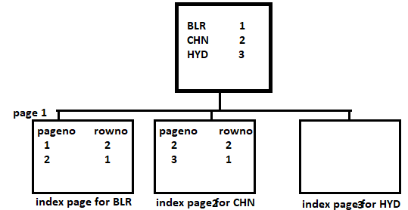
12. Index part 3
Read index from table
- Sp_helpindex Emp
Why only 1 clustered index?
- Sort
Why PK/UK needs an index?
- To verify that duplicates are present or not
Can I delete a index but I need PK?
- No
Can I create a clustered index without PK?
- Yes, but the duplicate values insertion is possible
Note: Cannot create more than 1 clustered index

Disable index
ALTER INDEX <IndexCol> ON EMP
DISABLE

Enable index
ALTER INDEX <IndexCol> ON EMP
ENABLE

Drop index syntax
DROP INDEX <indexCol> on <table Name>

13. security and SP with execution plan cache

Advantages of SP:
- No network traffic from client to server
- Maintenance is very easy
- Security will be very high
- There is a unique feature called CACHE Execution plan. Because of this feature SP’s are faster compared to other features like Views and Functions
- Create once call multiple times
- Centralized code
- Reusability
Security:
- Authentication(1st level)
- Authorization (2nd level)

Features
- DB object
- Only in the current DB
- Maximum 128 MB
- Only syntax check during creation
- Deferred name Resolution (even though the table is not available we can create a SP)
- Temporary Procedures
Local
Global
DB:
- Tables
- Views
- Sp
- Functions
- Triggers
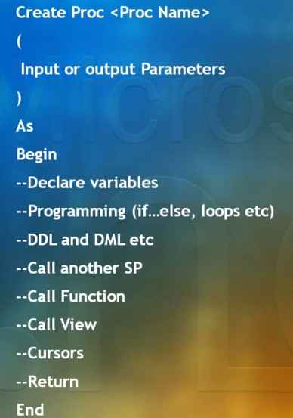
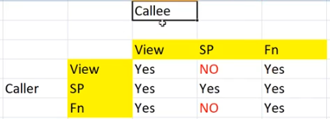
Call SP: Exec <sp_name>
Disadvantage: cannot be called as part of Select/ insert/ update/ delete
At the time of SP creation:
- Parameters
Parameter name
Data type
Default value
IN/OUT
- Encryption
- Re- compilation option
First Time Execution of SP
- Existence checks for all objects referenced
- Validations
Compatibility of a column Data type with variables used
- Creation of Execution plan
Volume of data
Nature & presence of Indexes
Comparison Operators
Presence of joins, unions, group by and order by keywords
- Plans cached and re-used for subsequent calls

Programming in SP
- Some Create statements Not allowed
- Can reference objects in other db’s and other Servers
- Can reference temporary tables
- Creation of temporary table inside a procedure
→ Removed when the SP exits
- Calling another procedure
→ Can access all objects created by the caller

Nesting Stored Procedures
- Upto 32 levels
- No Limit on no. of procedures invoked from a procedure
- RETURN statement to pass return codes
- Recursion allowed
- @@NESTLEVEL

