**PHP for Beginners**

How to create a table in PhpMyAdmin XAMPP

To start any kind of project in PHP you need to create a table in PhpMyAdmin.

To create a table in PhpMyAdmin first you have to create a database.

So first of all i am going to show you how to create a database in PhpMyAdmin. Please follow the below step to easily create a database PhpMyAdmin.

Step1:

First of all start your XAMPP or WAMPP server. Then go to the link bar of your browser and type localhost/phpmyadmin and click enter

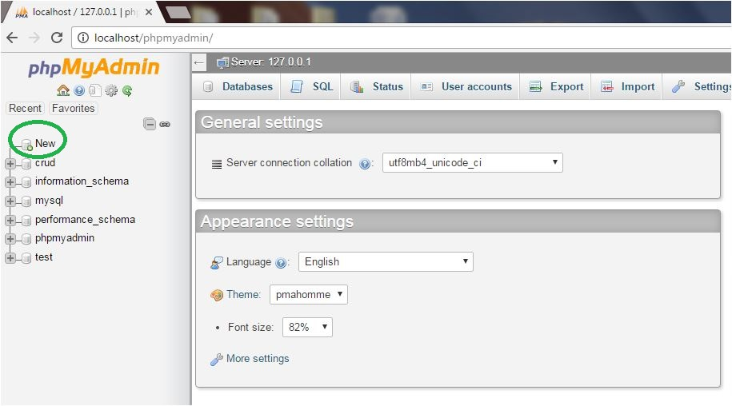

Step 2

After click on the new button you find a page like that

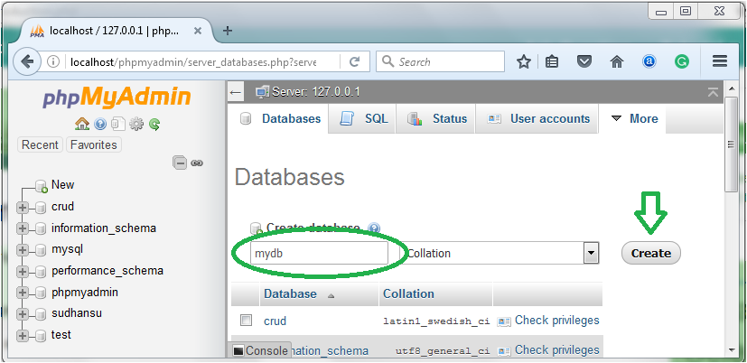

Here put a name of your own choice on the create database field and click on the create button and you get a successful message on the screen that you create database successfully and will appear in the database list.

Now i am going to show you how to create a table in PhpMyAdmin under the database that i have create currently.

Step 3:

Click on the database name in which under you create a table.After click on the database name you find a page like that.

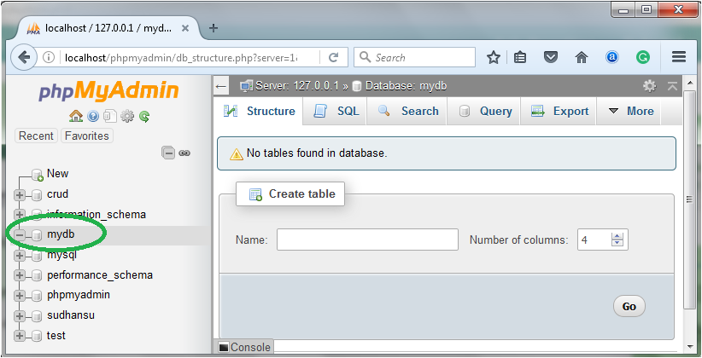

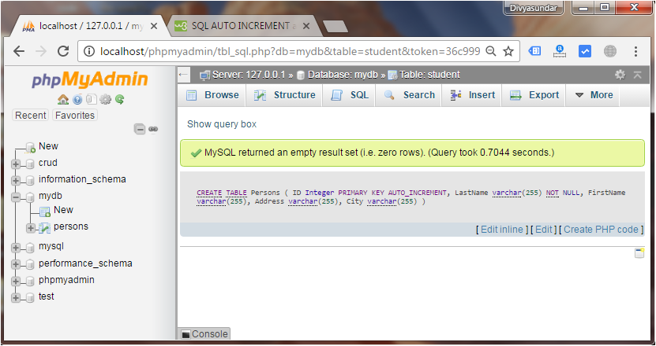

**Database Connection:**

<?php

$servername = "localhost";

$username = "root";

$password = "password";// Put your password here

// Create connection

$conn = mysqli_connect($servername, $username, $password);

// Check connection

if (!$conn) {

die("Connection failed: " . mysqli_connect_error());

}

mysqli_close($conn);

?>

**Insert Data:**

Insert Data Into MySQL Using PHP

Here we using 3 file for insert data in MySQL:

database.php:For connecting data base

insert.php:for getting the values from the user

process.php:A PHP file that process the request

database.php

<?php

$servername='localhost';

$username='root';

$password='';

$dbname = "crud";

$conn=mysqli_connect($servername,$username,$password,"$dbname");

if(!$conn){

die('Could not Connect My Sql:' .mysql_error());

}

?>

insert.php

<!DOCTYPE html>

<html>

<body>

<form method="post" action="process.php">

First name:<br>

<input type="text" name="first_name">

<br>

Last name:<br>

<input type="text" name="last_name">

<br>

City name:<br>

<input type="text" name="city_name">

<br>

Email Id:<br>

<input type="email" name="email">

<br><br>

<input type="submit" name="save" value="submit">

</form>

</body>

</html>

process.php

<?php

include_once 'database.php';

if(isset($_POST['save']))

{

// variables for input data

$first_name = $_POST['first_name'];

$last_name = $_POST['last_name'];

$city_name = $_POST['city_name'];

$email = $_POST['email'];

// sql query for inserting data into database

mysqli_query($conn,"insert into employee(first_name,last_name,city_name,email) values ('$first_name','$last_name','$city_name','$email')") or die(mysqli_error());

echo "<p align=center>Data Added Successfully.</p>";

}

?>

At End of course you’ll able to answer this bunch of examples demonstrating the various use-cases and its features in real action.

* Create a Database connection.
* Insert data into table.
* Retrieve data from table.
* Update data in table of particular row.
* Delete data based on id.
* Login and Signup using sessions & display name
* check for duplicate username or email
* Search Operation based on particular field and multiple fields
* Change Password
* Simple login and logout Sessions Example
* Insert image
* Retrieve image
* File Upload
* Count number of rows in a SQL table
* Insert multiple checkbox value in a single column
* SMS/OTP
* Visitor Counts
* Export MySQL data to excel sheet