2520030417
P.Pavan Sai
Skill – 01
Step 1: Open PowerShell as Administrator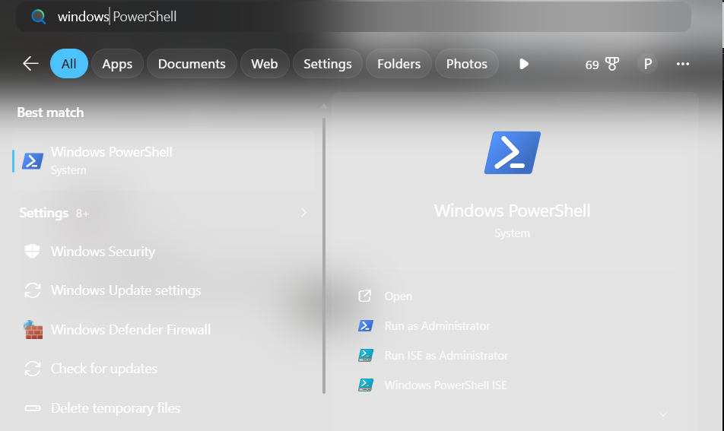

STEP 2: OPEN and Type wsl –install
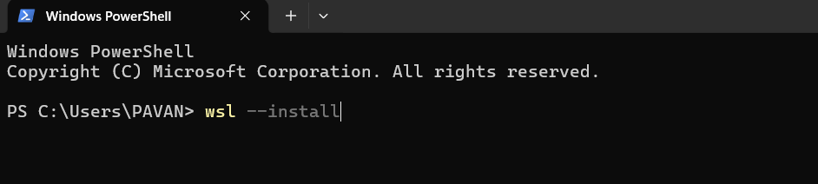
Step 3: Restart Your Computer After installation, restart your PC when prompted.
Step 4: Complete Ubuntu Setup After restarting:
1. Ubuntu opens automatically (or search for Ubuntu in the Start menu).
2. Wait for the installation to finish.
3. Create a Linux username.
Step 5: Create a Password You'll then be prompted to create a password.
New password: ****
Retype new password:****
Step 6: Update Ubuntu : sudo apt update
Step 7: Install GCC (C Compiler) : sudo apt install build-essential
Step 8: Verify the Installation : gcc --version
Step 9: Create Your C Program Example: nano process.c
Step 10: Compile the Program
