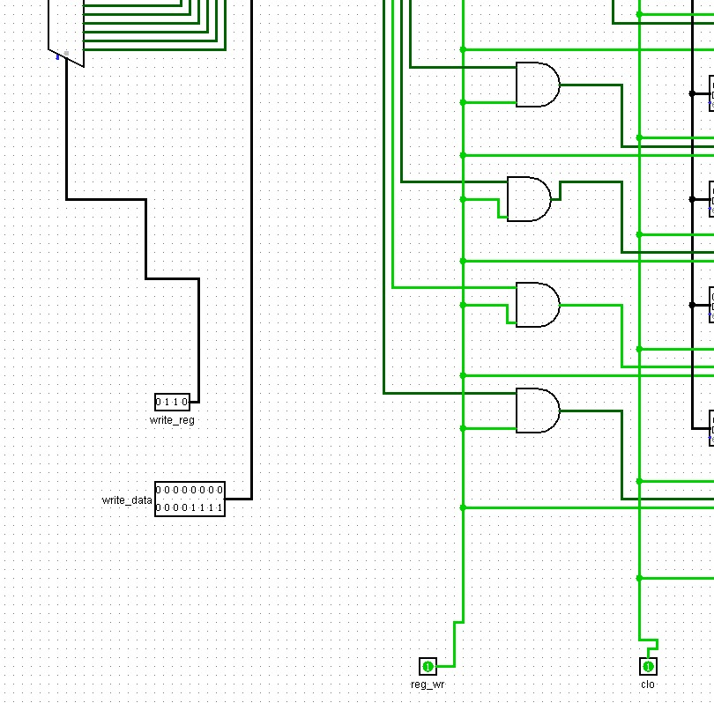
To write data into a register, the desired data value 0000_0000_0000_1111 is applied along with the write address 0110, which corresponds to register 6. During the write phase, the reg_wr signal must be enabled and a clock pulse must be applied, as register updates occur only on the rising edge of the clock.
After the write operation is completed, the reg_wr signal is disabled to prevent unintended overwriting of data

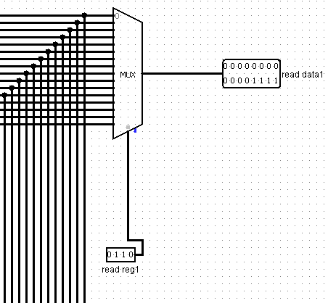
At the read phase, the read address is set to 0110, and the output correctly reflects the data stored in register 6. This confirms that the register file performs correct write and read operations.

Future scope:
• The register file can be connected to an ALU so that arithmetic operations can be performed using the values stored in the registers.
• The design can be extended into a complete processor datapath with pipelining, helping to understand how instructions move through different stages of a processor.

