 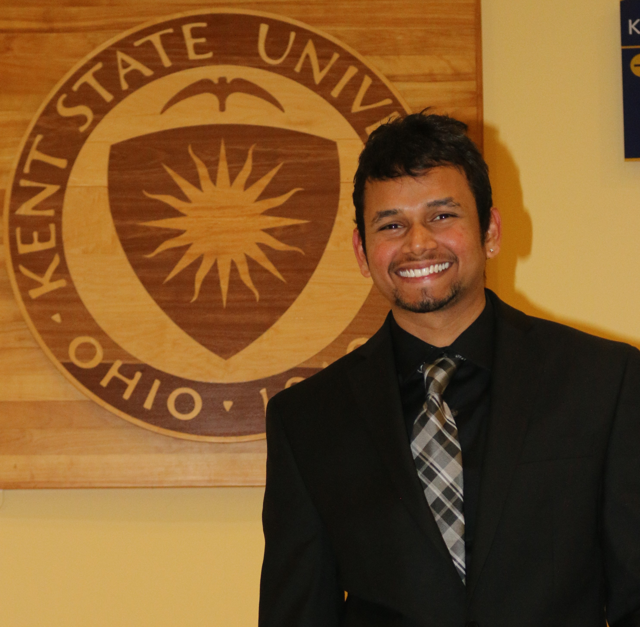

Masters student actively seeking for a full time position

**PAVAN**

**SARISA**

working balance

GITAM University

Visakhapatnam, India.

**Bachelors: Information Technology**

**Masters: Software Development**

EDUCATION

Built an e-commerce website that resembles websites like Amazon, E Bay. Collected the requirements, setup the tools, designed wire frames, created web pages, laying down ER Diagrams, implemented a database, populating or retrieving data from post and get services respectively.

Technologies Used: HTML5, CSS3, JavaScript, JQuery, JSON, T-SQL.

The main goal of this project is to design a database for online course registration which includes the Implementation functionalities pertaining to a database administrator which involved creating schema, ER Diagrams, tables. Implemented the features using PL/SQL procedures and functions.

Technologies Used: Oracle 10g, Oracle SQL Developer.

Developed a web page, which retrieves the data of an artist, which is designed in an alphabetical order through a drop-down menu, and with a backend database to save the content of the same.

Technologies Used: HTML, CSS, JavaScript, Angular JS.

Kent,OH

It is a snapbook consists of images and given a like or unlike option developed in Angular JS framework where the images are showed up in the view, controller is used to store an array containing the objects and directives are used to simplify the code.

Technologies: HTML, CSS, JavaScript, Angular JS, Bootstrap.

I am self-motivated masters student specializing in Software Development, at Kent State University, Kent, which I am interested in Web Development in turn act as a Web Developer. Currently seeking for a Full-Time position as a UI Developer.

Developed an application using Angular JS, where I have built a location-based service using a third-party custom directive in which I will fetch the data from Wikipedia API and display it to the map. I have mapped URL’s to different views using routing. Technologies: Angular JS, Bootstrap, HTML, CSS.

**50**

**25**

**25**

Web Design

UX Design

Graphic

Design

PROFESSIONAL SKILLS

HTML/CSS

JavaScript

JQuery

Angular JS

Bootstrap

WordPress

**90**

**80**

**70**

**75**

**75**

**80**

**50**

**65**

**70**

Photoshop

Illustrator

InDesign

PROGRAMMING LANGUAGES

**80**

**75**

**85**

PL/SQL

C++

C

PORTFOLIO

username

**Tel:**

**Email:**

**Address:**

sarisapavan@gmail.com

1654 ASPEN CT, APT#137

Kent, OH-44240.

+1 (864)-365-8732

WHO AM I?

HOBBIES & INTERESTS

**2010 - 2014**

**2014 - 2016**

Kent State University

Kent, OH

Kent, OH

**database setup for Online course registration** at Kent State University.

**January 2015 / May 2015**

Kent, OH

**shopping cart** at Kent State University.

**August 2015 / December 2015**

**May 2016**

**artist directory.**

Kent, OH

Kent, OH

**SNAP BOOK.**

**May 2016**

**June 2016**

**nearme app.**

WORK EXPERIENCE

**SMITH**

**More info on:**

linkedin.com/AdamSmi

 DESIGNING

**\*References will be given upon request\***

Pencil Art Photography Travelling Cricket Cooking

**  C:\Users\pavan sarisa\AppData\Local\Microsoft\Windows\INetCache\Content.Word\1468446640_road.png  **

Pavan S <http://pavansarisa.com/>

