**Experiment 4: React Components**

**This is the basic code we write in App.js file**

**App.js**

import './App.css';

function App() {

  return (

    <div className="App">

      <div className="content">Hello Pavan</div>

    </div>

  );

}

export default App;

**OUTPUT:**

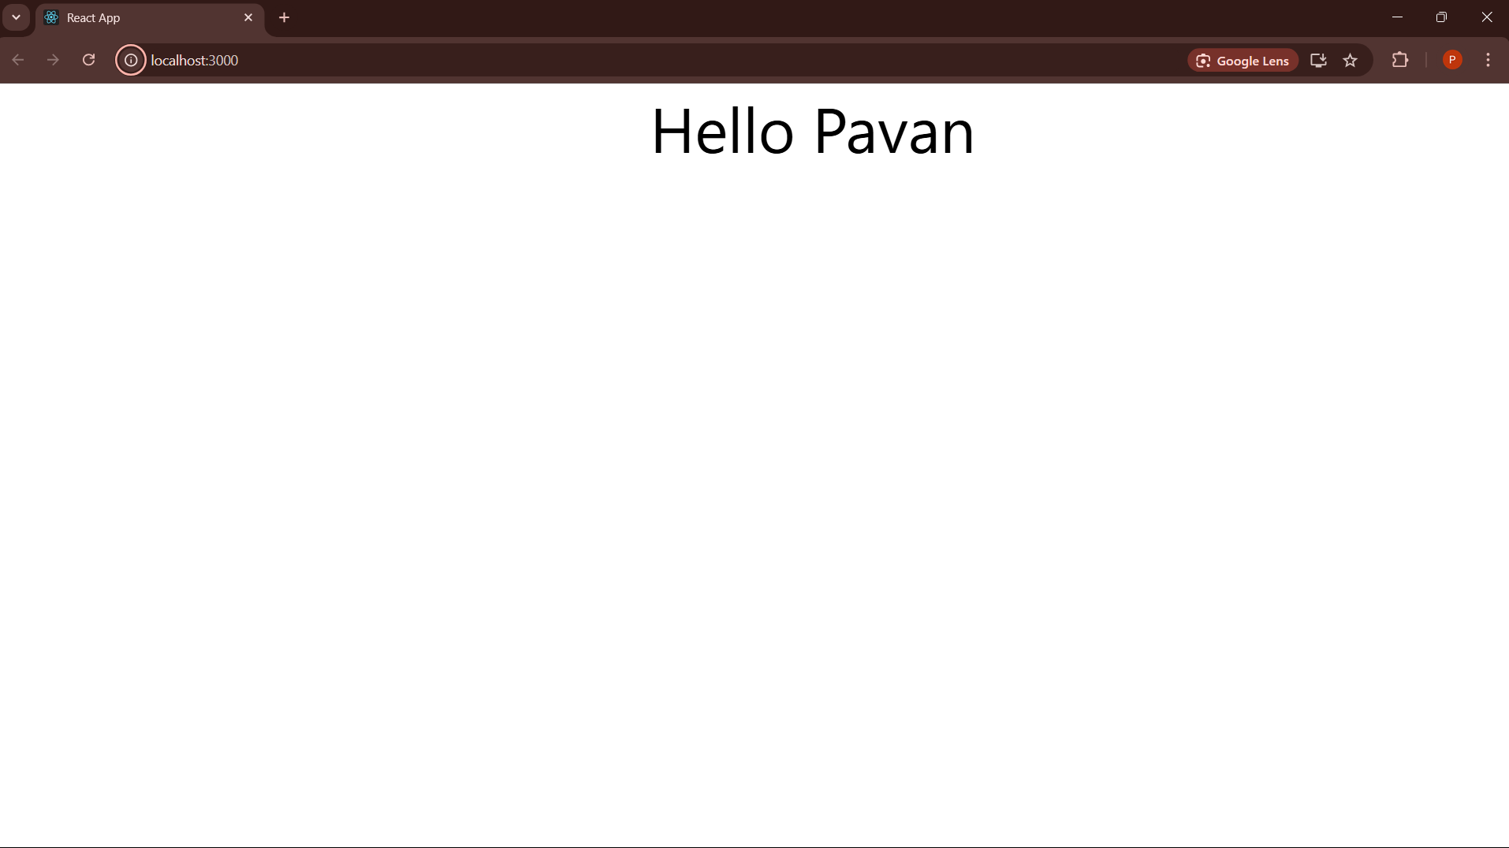

**Dynamic Values in Templates**

**App.js**

import './App.css';   
function App() {   
  const myStr="Nice to meet you";   
  const a=7;   
  const myLink="https://www.google.com";   
  return (   
    <div className="App">   
     <div className="content">   
      <h1>Hello Pavan</h1>   
      <h1>{myStr}</h1>   
      <h1>{a}</h1>   
      <a href={myLink}>My Link</a>   
     </div>   
    </div>   
  );   
}   
export default App;

**OUTPUT  
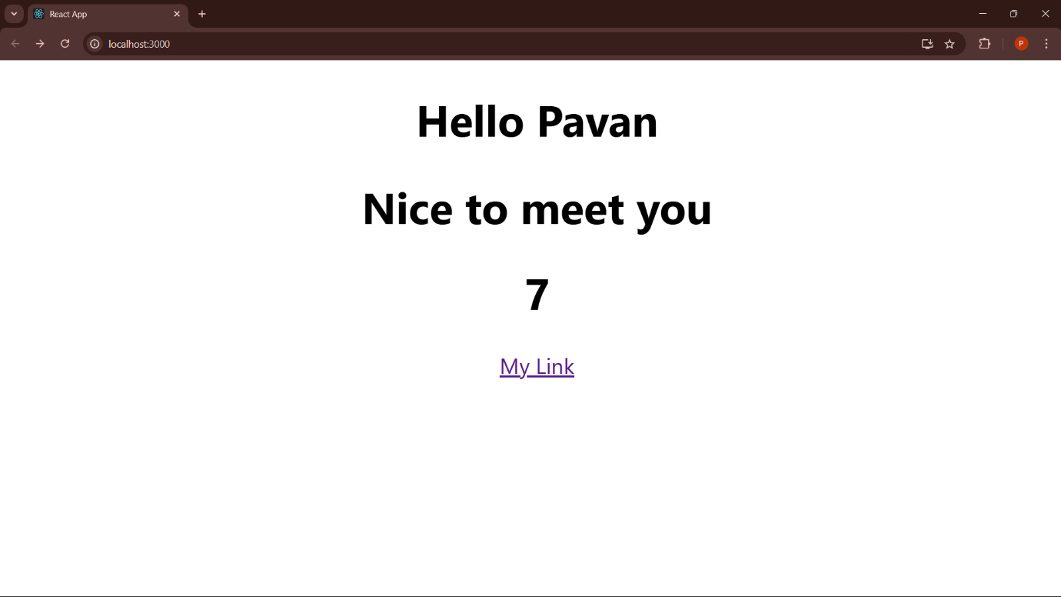**

**Experiment 5: Multiple Components**

**Navbar.js**

const navbar = () => {

    return (

        <nav className="navbar">

            <h1>My App </h1>

            <div className="links">

                <a href="/"> Home </a>

                <a href="/create"> New Blog </a>

            </div>

        </nav>

     );

}

export default navbar;

**Home.js**

const home = () => {

    return (

        <div className="home">

            <h2> Home Page</h2>

        </div>

     );

}

export default home;

**App.js**

import Navbar from './navbar.js';

import Home from './home.js';

function App() {

  return (

    <div className="App">

      <Navbar/>

      <div className="content">Hello Pavan</div>

      <Home />

    </div>

  );

}

export default App;

**Stylising the webpage by removing the App.css and replace the code of the index.css**

**Index.css**

@import url('https://fonts.googleapis.com/css2?family=Quicksand:wght@300;400;500;600;700&display=swap');  
/* base styles */  
* {  
  margin: 0;  
  font-family: "Quicksand", sans-serif;  
  color: #333;  
}  
.navbar {  
  padding: 20px;  
  display: flex;  
  align-items: center;  
  max-width: 600px;  
margin: 0 auto;  
 border-bottom: 1px solid #f2f2f2;  
  background-color: #2c3e50; /* Dark Slate Blue background */  
}  
.navbar h1 {  
  color: #3498db; /* Light Blue */  
}

.navbar .links {  
  margin-left: auto;  
}  
.navbar a {  
  margin-left: 16px;  
  text-decoration: none;  
  padding: 6px;  
  color: #ecf0f1; /* Light Gray links */  
}

.navbar a:hover {  
  color: #3498db; /* Light Blue on hover */  
}

.content {  
max-width: 600px;  
  margin: 40px auto;  
  padding: 20px;  
  background-color: #ecf0f1; /* Light Gray */  
  border-radius: 10px;  
}

**OUTPUT**

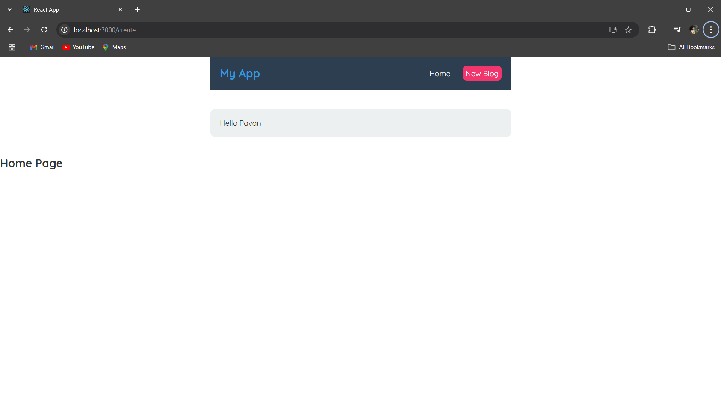

**Experiment 6: Click Events**

**Home.js**

const Home = () => {

  const handleClickAgain = (name) =>  {

      alert("Hello "+name);

  }

  return (

      <div className="home">

          <h2> Home Page</h2>

          <button onClick={() => handleClickAgain('Pavan')}>Click me</button>

      </div>

   );

}

export default Home;

**OUTPUT**

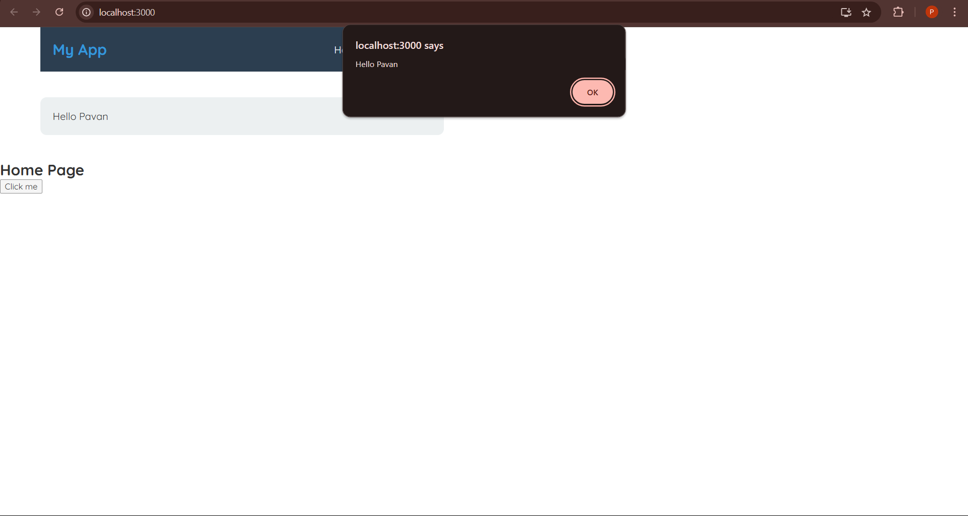

**Experiment 7: useState Hook**

**Home.js**

import { useState } from "react";

const Home = () => {   
const [name,setName]=useState('Pavan');   
const [age,setAge]=useState('19');   
const handleClick = () =>  {   
alert("BYE Pavan");   
setAge('36');   
setName("Padmaja");   
    }   
return (    
<div className="home">   
<h2> Home Page</h2>   
<p> Name: {name}, Age: {age} </p>   
<button onClick={handleClick}>Click   
me</button>

</div>   
     );   
}   
export default Home;

**Output before clicking the button**

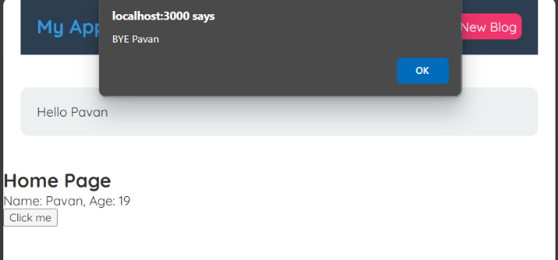

**Output after clicking the button**

