**SEM - VII - 2022-23**

**High Performance Computing Lab**

Assignment - 1

Name: Pavan Krishnat Shinde

PRN: 2019BTECS00110

Q1. Write Program for Hello World by making use of openmp

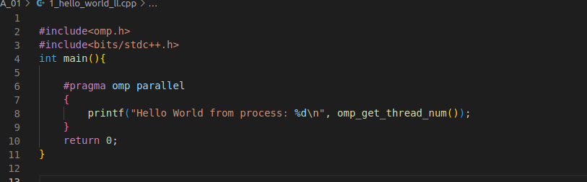

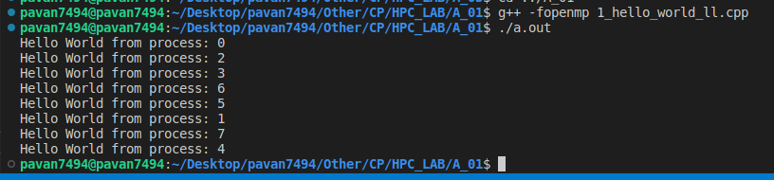

Q2. Get sum of square of first n natural num using openmp

