**SEM - VII - 2022-23**

**High Performance Computing Lab**

Assignment - 3

**Study and Implementation of schedule, nowait, reduction, ordered and collapse clauses**

Name: Pavan Krishnat Shinde

PRN: 2019BTECS00110

Q1: Analyse and implement a Parallel code for below program using OpenMP.

**Sequential Code :** 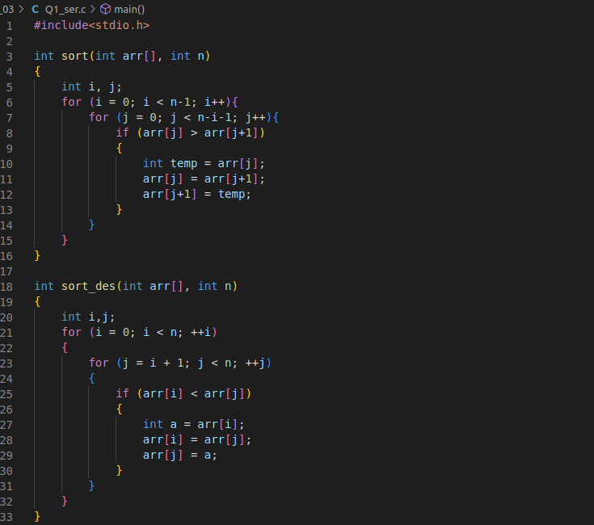

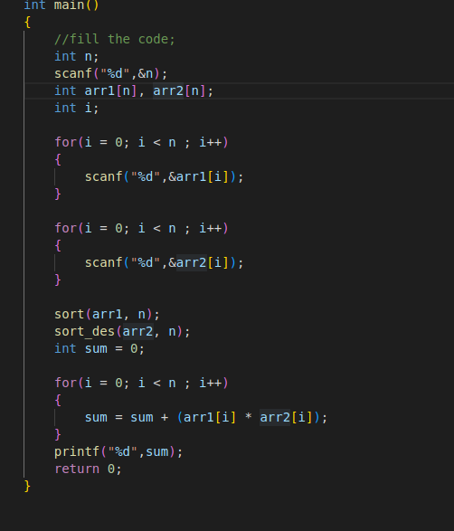



**Parallel Code :**

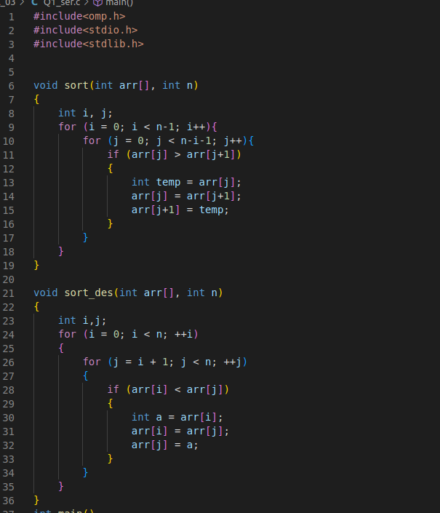

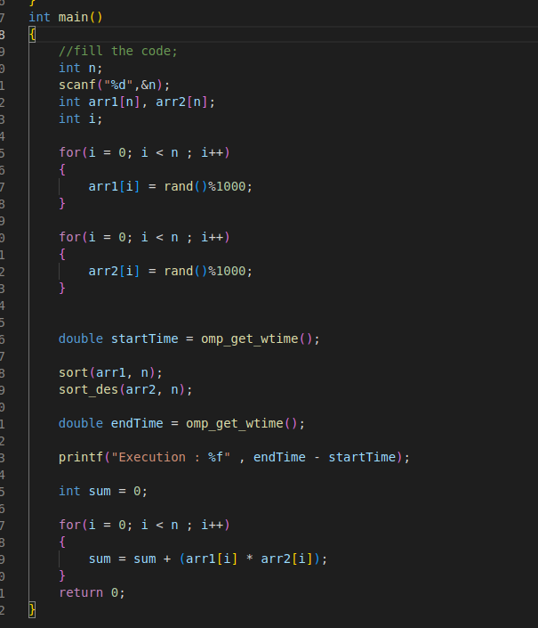



Q2. Write OpenMP code for two 2D Matrix addition, vary the size of your matrices from 250, 500, 750, 1000, and 2000 and measure the runtime with one thread (Use functions in C in calculating the execution time or use GPROF)

i. For each matrix size, change the number of threads from 2,4,8., and plot the

speedup versus the number of threads.

ii. Explain whether or not the scaling behavior is as expected.

Sequential Program:

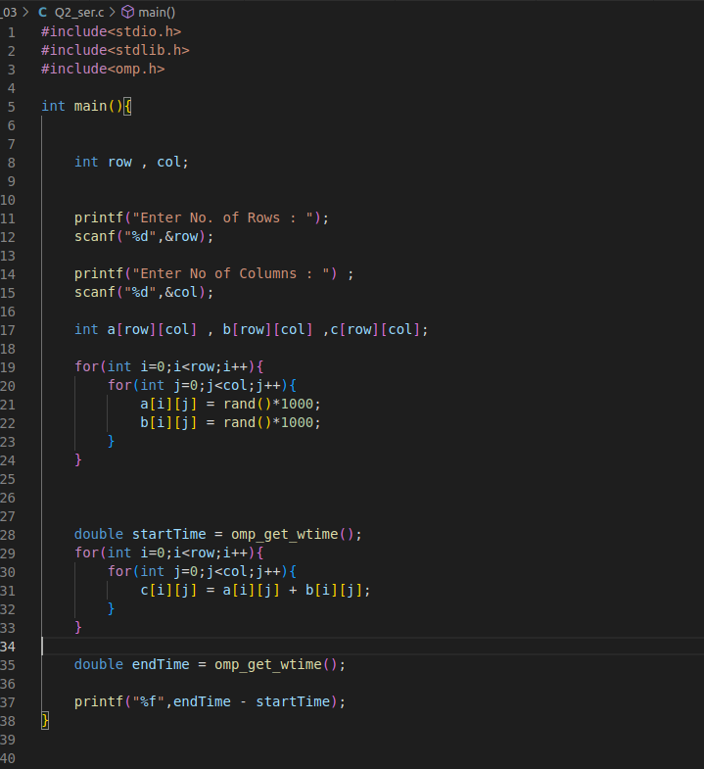

| Size of Matrix | 250 | 500 | 750 | 1000 | 2000 |
| --- | --- | --- | --- | --- | --- |
| Runtime | 0.000452 | 0.000736 | 0.002858 | Seg. Fault | Seg. Fault |

Parallel Program :

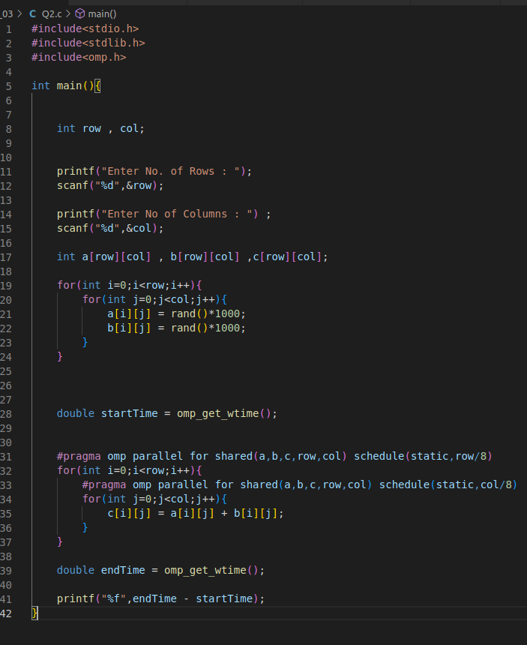

| Size of Matrix /  No.of threads | 250 | 500 | 750 | 1000 | 2000 |
| --- | --- | --- | --- | --- | --- |
| 2 | 0.000656 | 0.000847 | 0.009830 | Seg. Fault | Seg. Fault |
| 4 | 0.000447 | 0.000589 | 0.007251 | Seg. Fault | Seg. Fault |
| 6 | 0.000444 | 0.000815 | 0.013948 | Seg. Fault | Seg. Fault |
| 8 | 0.029674 | 0.020178 | 0.026631 | Seg. Fault | Seg. Fault |

Q3. For 1D Vector (size=200) and scalar addition, Write a OpenMP code with the following:

i. Use the STATIC schedule and set the loop iteration chunk size to various sizes

when changing the size of your matrix. Analyze the speedup.

ii. Use the DYNAMIC schedule and set the loop iteration chunk size to various sizes

when changing the size of your matrix. Analyze the speedup.

iii. Demonstrate the use of nowait clause.

i. Use the STATIC schedule and set the loop iteration chunk size to various sizes when changing the size of your matrix. Analyze the speedup.

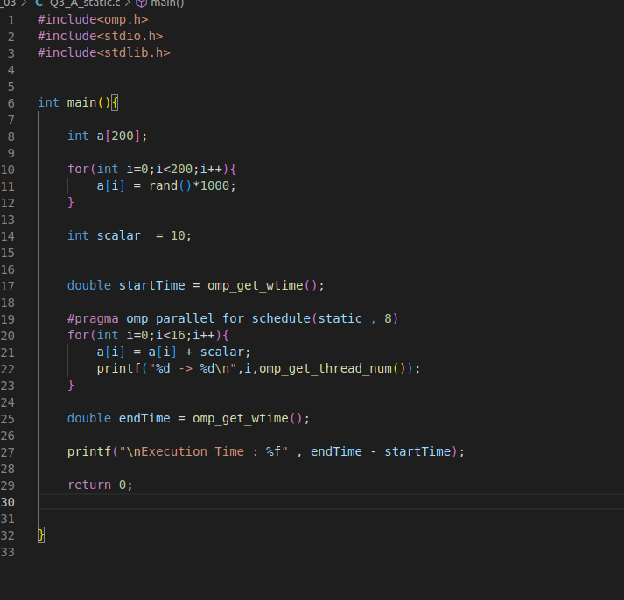

| Chunk Size | 2 | 4 | 6 | 8 |
| --- | --- | --- | --- | --- |
| Runtime | 0.023053 | 0.026576 | 0.028262 | 0.025873 |

ii. Use the DYNAMIC schedule and set the loop iteration chunk size to various sizes when changing the size of your matrix. Analyze the speedup.

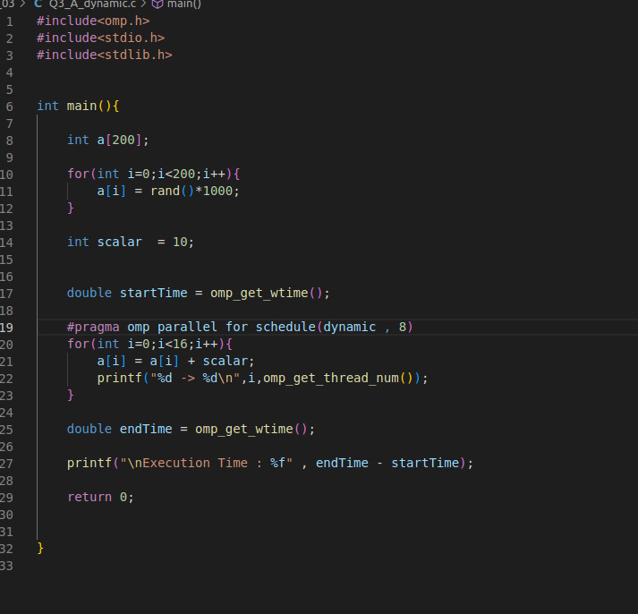

| Chunk Size | 2 | 4 | 6 | 8 |
| --- | --- | --- | --- | --- |
| Runtime | 0.032318 | 0.022752 | 0.023094 | 0.033200 |

iii. Demonstrate the use of nowait clause.

