**SEM - VII - 2022-23**

**High Performance Computing Lab**

Assignment - 4

Name: Pavan Krishnat Shinde

PRN: 2019BTECS00110

# Q1: Analyse and implement a Parallel code for below programs using OpenMP considering synchronization requirements. (Demonstrate the use of different clauses and constructs wherever applicable)

Sequential Code :

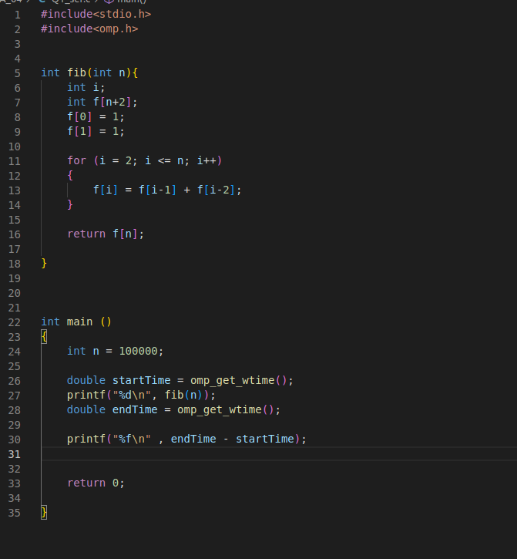

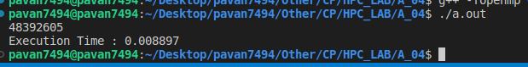

Parallel Code :

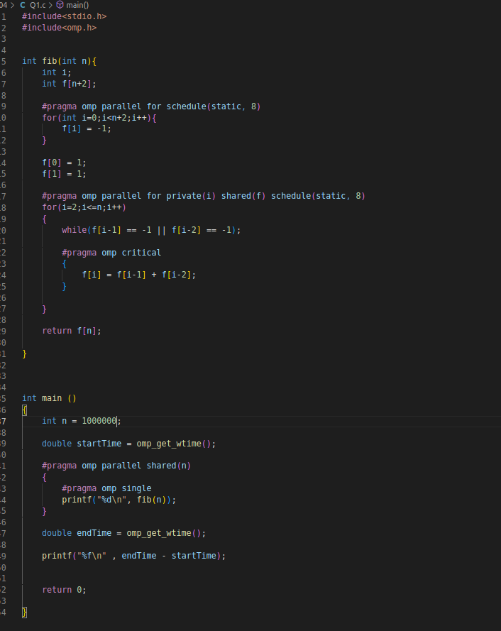



# Q2: Analyse and implement a Parallel code for below programs using OpenMP considering synchronization requirements. (Demonstrate the use of different clauses and constructs wherever applicable)

Serial Code :

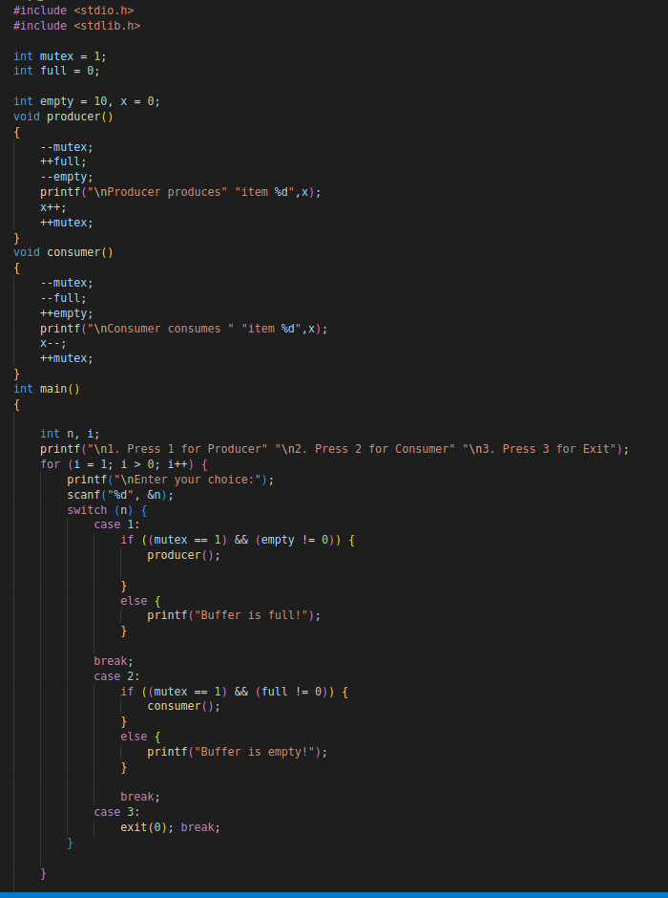

Parallel Code :

