**SEM - VII - 2022-23**

**High Performance Computing Lab**

**Assignment - 9**

**Name: Pavan Krishnat Shinde**

**Title of practical:**

Implementation of Vector-Vector addition & N-Body Simulator using CUDA C

**Problem Statement 1:**

Implement Vector-Vector addition using CUDA C. State and justify the speedup using different size of threads and blocks.

#include <stdio.h>

void initWith(int num, int *a, int N)

{

for(int i = 0; i < N; ++i)

{

a[i] = num;

}

}

__global__

void addVectorsInto(int *result, int *a, int *b, int N)

{

int index = threadIdx.x + blockIdx.x * blockDim.x;

int stride = blockDim.x * gridDim.x;

for(int i = index; i < N; i += stride)

{

result[i] = a[i] + b[i];

}

}

void checkElementsAre(int target, int *array, int N)

{

for(int i = 0; i < N; i++)

{

if(array[i] != target)

{

printf("FAIL: array[%d] - %d does not equal %d\n", i, array[i], target);

exit(1);

}

}

printf("SUCCESS! All values added correctly.\n");

}

int main()

{

const int N = 2<<20;

size_t size = N * sizeof(int);

int *a;

int *b;

int *c;

cudaMallocManaged(&a, size);

cudaMallocManaged(&b, size);

cudaMallocManaged(&c, size);

initWith(3, a, N);

initWith(4, b, N);

initWith(0, c, N);

size_t threadsPerBlock;

size_t numberOfBlocks;

threadsPerBlock = 256;

numberOfBlocks = (N + threadsPerBlock - 1) / threadsPerBlock;

addVectorsInto<<<numberOfBlocks, threadsPerBlock>>>(c, a, b, N);

cudaDeviceSynchronize();

checkElementsAre(7, c, N);

cudaFree(a);

cudaFree(b);

cudaFree(c);

}

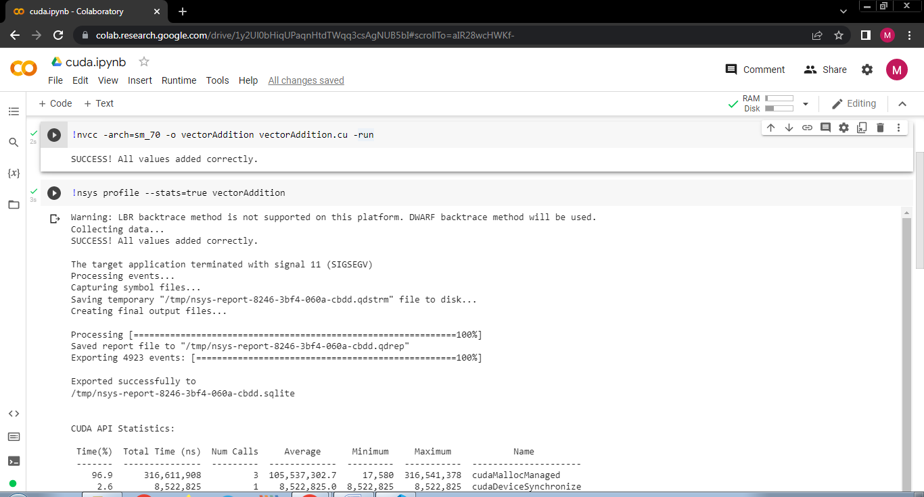

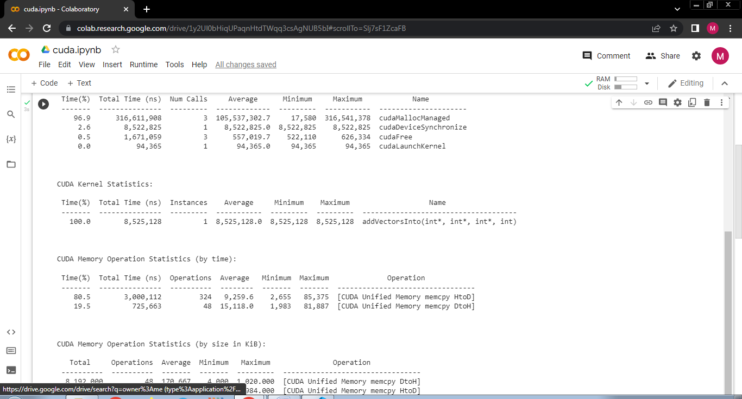

**Problem Statement 2:**

Implement N-Body Simulator using CUDA C. State and justify the speedup using different size of threads and blocks.

#include <math.h>

#include <stdio.h>

#include <stdlib.h>

#include "timer.h"

#include "files.h"

#define SOFTENING 1e-9f

/*

* Each body contains x, y, and z coordinate positions,

* as well as velocities in the x, y, and z directions.

*/

typedef struct

{

float x, y, z, vx, vy, vz;

} Body;

/*

* Calculate the gravitational impact of all bodies in the system

* on all others.

*/

__global__ void bodyForce(Body *p, float dt, int n)

{

int index = threadIdx.x + blockIdx.x * blockDim.x;

int stride = blockDim.x * gridDim.x;

for(int i = index; i < n ; i += stride)

{

float Fx = 0.0f;

float Fy = 0.0f;

float Fz = 0.0f;

for (int j = 0; j < n; j++)

{

float dx = p[j].x - p[i].x;

float dy = p[j].y - p[i].y;

float dz = p[j].z - p[i].z;

float distSqr = dx * dx + dy * dy + dz * dz + SOFTENING;

float invDist = rsqrtf(distSqr);

float invDist3 = invDist * invDist * invDist;

Fx += dx * invDist3;

Fy += dy * invDist3;

Fz += dz * invDist3;

}

p[i].vx += dt * Fx;

p[i].vy += dt * Fy;

p[i].vz += dt * Fz;

}

}

int main(const int argc, const char **argv)

{

int deviceId;

int numberOfSMs;

cudaGetDevice(&deviceId);

cudaDeviceGetAttribute(&numberOfSMs, cudaDevAttrMultiProcessorCount, deviceId);

// The assessment will test against both 2<11 and 2<15.

// Feel free to pass the command line argument 15 when you generate ./nbody report files

int nBodies = 2 << 11;

if (argc > 1)

nBodies = 2 << atoi(argv[1]);

// The assessment will pass hidden initialized values to check for correctness.

// You should not make changes to these files, or else the assessment will not work.

const char *initialized_values;

const char *solution_values;

if (nBodies == 2 << 11)

{

initialized_values = "09-nbody/files/initialized_4096";

solution_values = "09-nbody/files/solution_4096";

}

else

{ // nBodies == 2<<15

initialized_values = "09-nbody/files/initialized_65536";

solution_values = "09-nbody/files/solution_65536";

}

if (argc > 2)

initialized_values = argv[2];

if (argc > 3)

solution_values = argv[3];

const float dt = 0.01f; // Time step

const int nIters = 10; // Simulation iterations

int bytes = nBodies * sizeof(Body);

float *buf;

cudaMallocManaged(&buf, bytes);

Body *p = (Body *)buf;

read_values_from_file(initialized_values, buf, bytes);

double totalTime = 0.0;

/*

* This simulation will run for 10 cycles of time, calculating gravitational

* interaction amongst bodies, and adjusting their positions to reflect.

*/

for (int iter = 0; iter < nIters; iter++)

{

StartTimer();

/*

* You will likely wish to refactor the work being done in `bodyForce`,

* and potentially the work to integrate the positions.

*/

size_t threadsPerBlock = 256;

size_t numberOfBlocks = 32 * numberOfSMs;

bodyForce<<<numberOfBlocks, threadsPerBlock>>>(p, dt, nBodies); // compute interbody forces

cudaDeviceSynchronize();

/*

* This position integration cannot occur until this round of `bodyForce` has completed.

* Also, the next round of `bodyForce` cannot begin until the integration is complete.

*/

for (int i = 0; i < nBodies; i++)

{ // integrate position

p[i].x += p[i].vx * dt;

p[i].y += p[i].vy * dt;

p[i].z += p[i].vz * dt;

}

const double tElapsed = GetTimer() / 1000.0;

totalTime += tElapsed;

}

double avgTime = totalTime / (double)(nIters);

float billionsOfOpsPerSecond = 1e-9 * nBodies * nBodies / avgTime;

write_values_to_file(solution_values, buf, bytes);

// You will likely enjoy watching this value grow as you accelerate the application,

// but beware that a failure to correctly synchronize the device might result in

// unrealistically high values.

printf("%0.3f Billion Interactions / second\n", billionsOfOpsPerSecond);

cudaFree(buf);

}

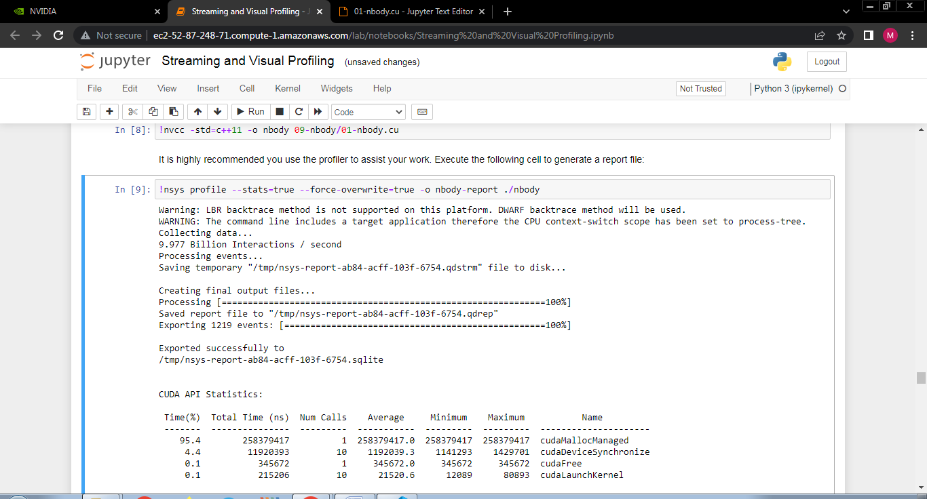

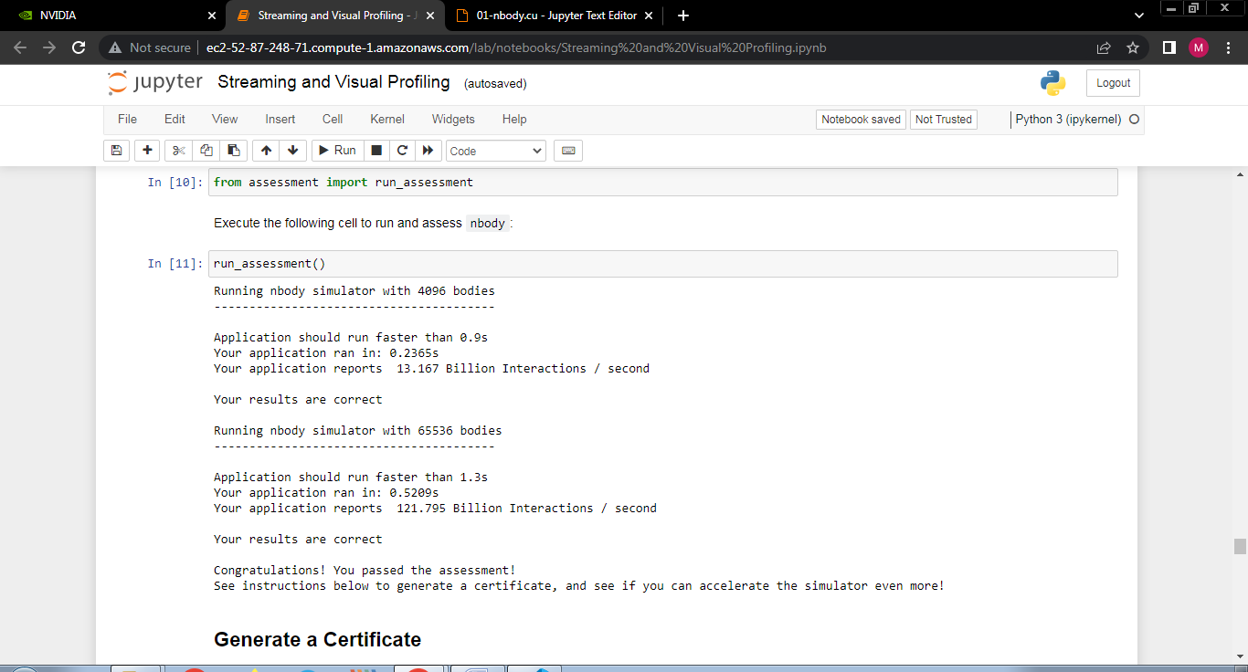

**Github Link:**

<https://github.com/pavanshinde7494/HPC-Assignment>