Walchand College of Engineering, Sangli
Department of Computer Science and Engineering

Name: Pavan Krishnat Shinde
PRN: 2019BTECS00110
Course: High Performance Computing Lab

Practical No. 5

Title : Installation of MPI and implementation of basic functions of MPI Installation of MPI on Window

MPI is a library specification for message-passing, proposed as a standard by a broadly based committee of vendors, implementors, and users.

The MPI standard is available.
MPI was designed for high performance on both massively parallel machines and on workstation clusters.
MPI is widely available, with both free available and vendor-supplied implementations.
MPI was developed by a broadly based committee of vendors, implementors, and users.
Implement a simple hello world program by setting the number of processes equal to 10 .

Code -
#include <mpi.h>
#include <stdio.h>

int main(int argc, char** argv) {
// Initialize the MPI environment MPI_Init(NULL, NULL);

// Get the number of processes int world_size;
MPI_Comm_size(MPI_COMM_WORLD, &world_size);

// Get the rank of the process int world_rank;
MPI_Comm_rank(MPI_COMM_WORLD, &world_rank);

// Get the name of the processor
char processor_name[MPI_MAX_PROCESSOR_NAME]; int name_len;
MPI_Get_processor_name(processor_name, &name_len);

// Print off a hello world message
printf("Hello world from processor %s, rank %d out of %d processors\n",
processor_name, world_rank, world_size);

// Finalize the MPI environment. MPI_Finalize();
}

Output –
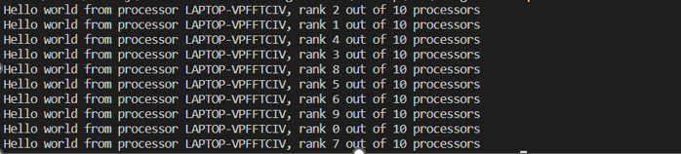
- Implement a program to display rank and communicator group of five processes.

Code -
#include <mpi.h>
#include <stdio.h>
int main( int argc, char *argv[] )
{
MPI_Init( &argc, &argv ); int rank;
MPI_Group group;
MPI_Comm_group(MPI_COMM_WORLD, &group); MPI_Comm_rank(MPI_COMM_WORLD, &rank);
printf("Rank: %d, Group: %d \n", rank, group); MPI_Finalize();
return 0;
}

Output –
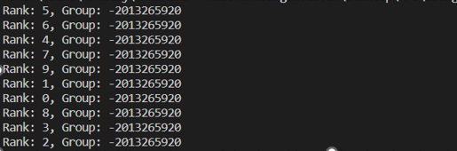

Github Link :- https://github.com/pavanshinde7494/HPC-Assignment

