Class: Final Year (Computer Science and Engineering)
Year: 2022-23 Semester: 1
Course: High Performance Computing Lab
Practical No. 11
Exam Seat No: 2019BTECS00110
Name: Pavan Krishnat Shinde

Q1. Execute the all-to-all broadcast operation (Program C) with varying message sizes.
Plot the performance of the operation with varying message sizes from 1K to 10K (with
constant number of processes, 8). Explain the performance observed.

Code:
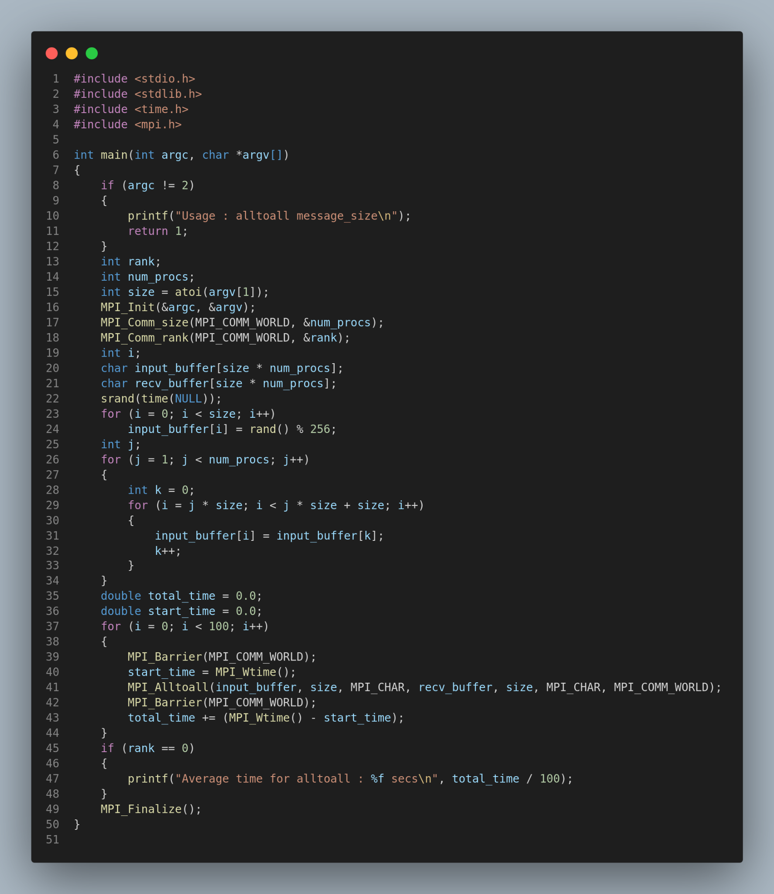

Output:
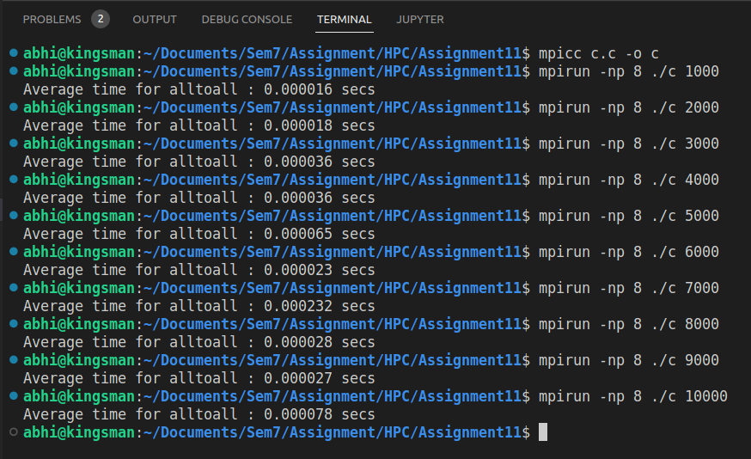
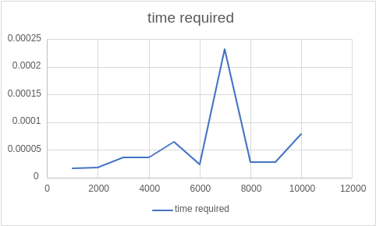

Conclusion:
So, as we can see when we increase the number of Processors for execution of the code the execution time also increases. This observation is not because of the computation time but as we increase the number of processes the communication overhead between the processors increases and thus there is increase in execution time.

Q2. Execute the all-reduce operation (Program D) with varying number of processes (1
to 16) and fixed message size of 10K words. Plot the performance of the operation with
varying number of processes (with constant message size). Explain the performance
observed.
Code:
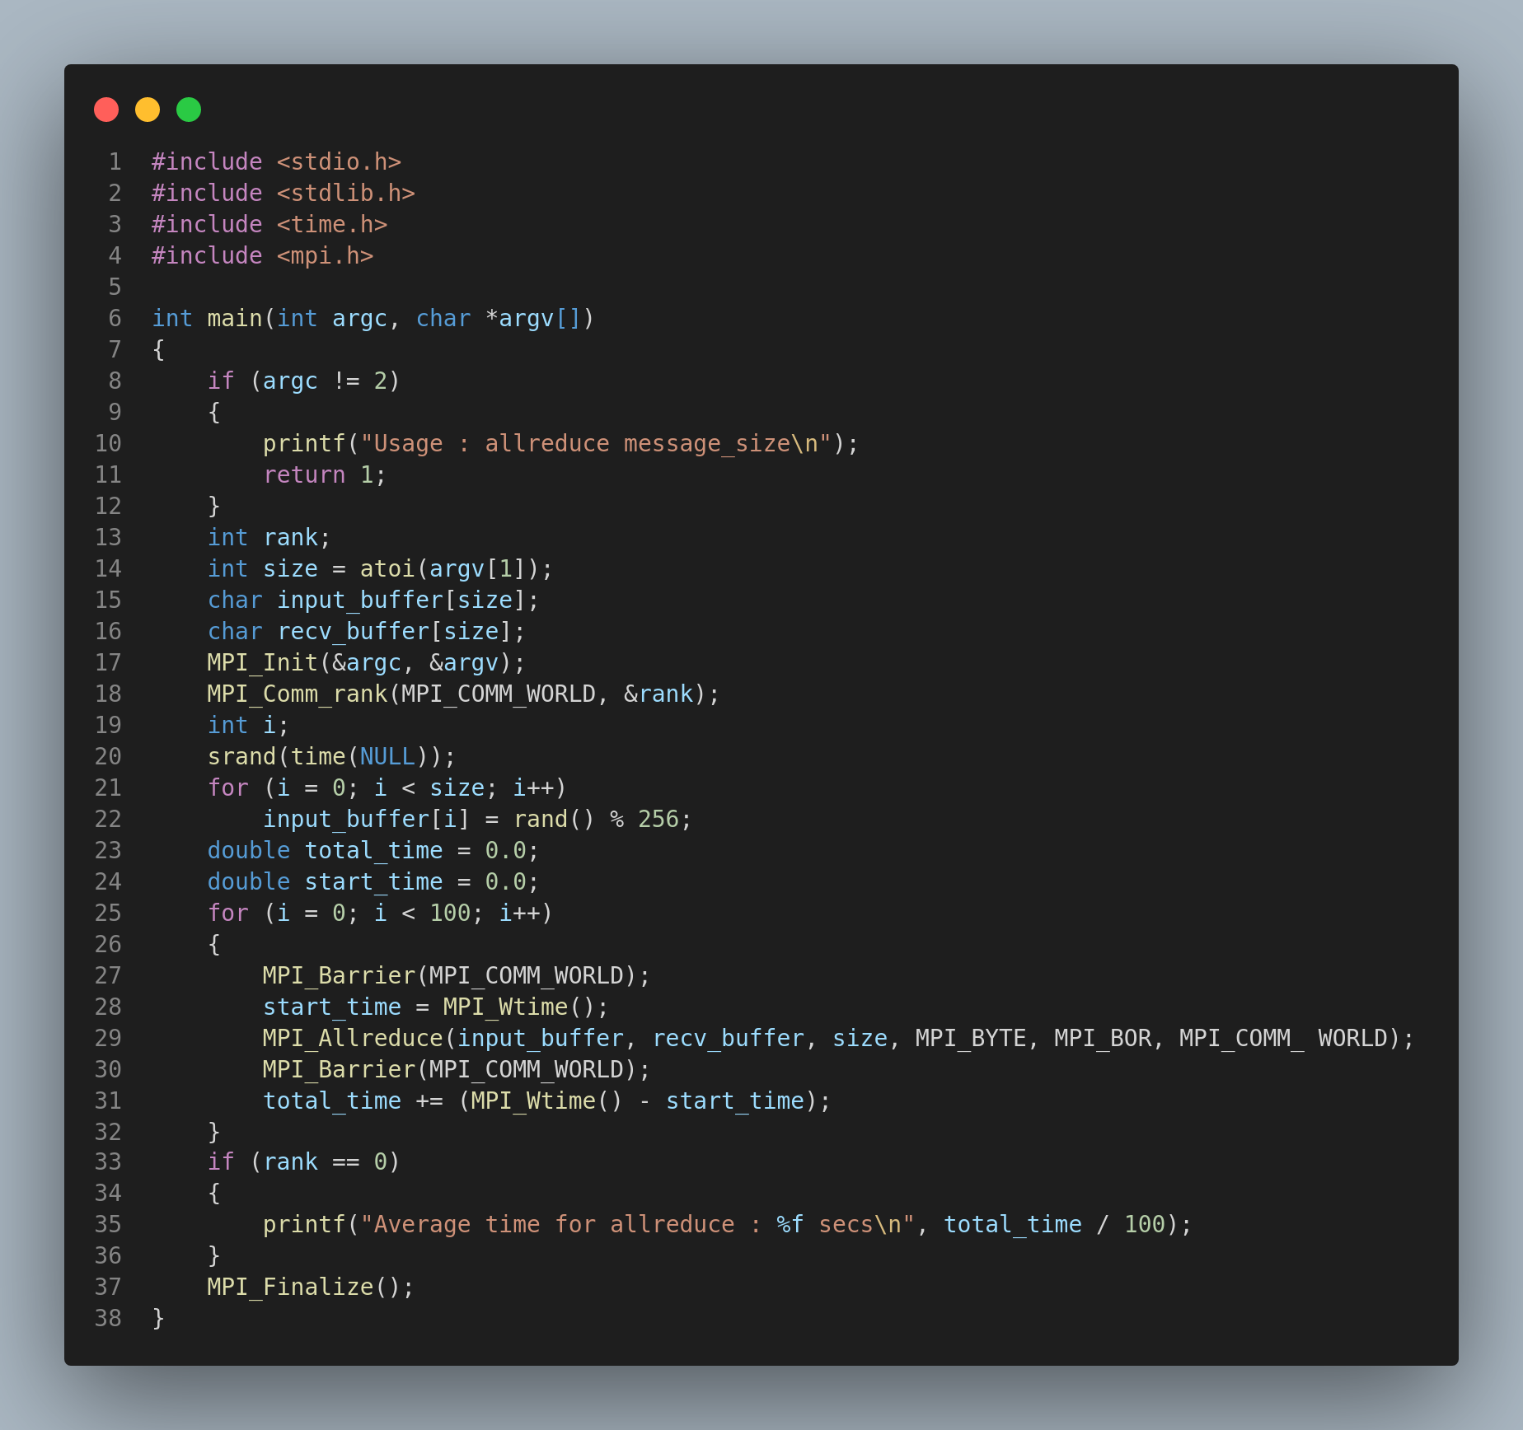

Output:
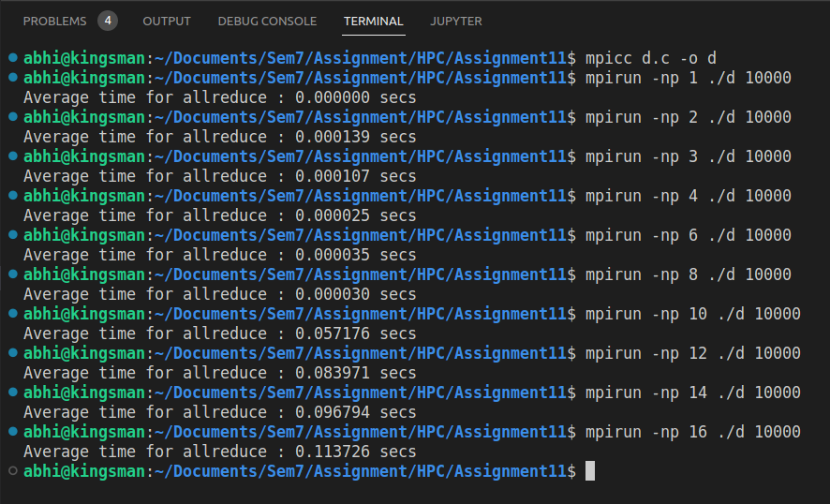
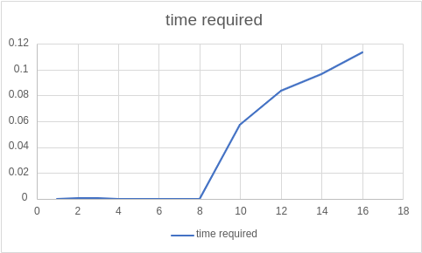

Conclusion:
So, as we can see when we increase the number of Processors for execution of the code the execution time also increases. This observation is not because of the computation time but as we increase the number of processes the communication overhead between the processors increases and thus there is increase in execution time.

Github Link : https://github.com/pavanshinde7494/HPC-Assignment

